Transition in Early Years:



A Handbook for Practitioners

Contents

What are transitions? 3

The needs of the child 5

The role of the adult 9

Partnerships 11

Interventions 13

Prosed outcomes 16

Reference list 17

Welsh Government (2017a) state that when considering a child transitioning, practitioners should be inclusive and accessible to all. Consider the specific needs of the individual child, by also respecting the family’s needs. Use of a strength-based method and that professionals understand the struggles our families encounter.
What are transitions?
Education Scotland (2017) suggests that transitions are the moves children make; these could be from home to school or significant transitions, such as moving through stages. Education Scotland (2017) believes that transitions are a part of everyone’s life. They believe that most children see transitions as positive, but some can find transitioning difficult. It is stated that support from parents and staff supports children through the transitioning process. Birth To 5 Matters (No Date a) supports the idea that if transitions in the early years are supported correctly, the child will develop positive feelings towards transitions that they will overcome in their lifetime. Transitions are a process, not an event, that are not just movements between settings but are also movements from room to room within the same setting. Birth To 5 Matters (No Date a) believe that some children’s vulnerability is increased at times of transition, as this can increase insecurities about having their needs met.
HSE (2018) expresses that within children’s first five years of life, they will reach significant changes in their developmental milestones. They include developing gross and fine motor skills, communication and listening skills, problem-solving skills, and physical development. Although HSE (2018) suggests that all children are different and that the article is based on an average guide. Educational Technology (2020) supports the idea that children should be supported through stage, not age; this has been influenced by the Vygotsky theory of the ‘zone of proximal development’.
PACEY (2016) suggests that environmental changes such as moving home, a change in parental relationship, bereavement, or changes in family dynamics impact children transitioning. PACEY (2016) suggests that allowing time for the professional to gradually build a trusting and secure relationship with the child and caregivers will allow a child to be more curious about exploring and playing within the setting. Barnardo's (No Date) support that good quality relationships must be prioritized to support children's well-being, growth, and health, particularly in children who have experienced trauma or adversity.
SENDIASS (No Date) suggests that children can also face care and educational transitions, these could be from an early years provision to primary school settings, following transitioning to comprehensive school, following transitioning from comprehensive school to extended education or employment. NACNS (No Date) identify that a care transition is a transition between healthcare practitioners or locations as the child’s physical needs change.
According to RCT (No Date) there are two types of transitions, Vertical transitions, and Horizontal transitions. RCT (No Date) believe that good practice highlights the importance of transitions being managed and thoroughly planned by considering the individual child’s need while respecting the parents as a part of the transition process. WYECPLC (2020) support there are two types of transitions. WYECPLC (2020) support that ‘vertical’ transitions are bigger transitions and’ horizontal’ transitions are more of everyday transitions. They believe both transitions can happen alongside each other or separately. Birth to 5 Matters (No Date a) also value that there are ‘horizontal’ transitions that children face daily. Having support with these transitions this will create foundations for positive feelings towards facing transitions.

RCT (No Date) explains that transitions are of the highest quality when the practitioners are supportive and inclusive. Second, that the family and child are at the heart of the process, through creating positive relationships and work closely to best support the child. Third, that the environments are accessible and welcoming, and that there is a continuity in the child’s care, development and learning by maintaining a holistic approach to the child’s needs during transitions. Last, keeping the core purpose in mind whilst managing transitions, by ensuring support throughout the transition process for the individual and relatives.

The Needs of the Child.
Tower Hamlets Early Years Service (No Date) suggests that transitions are opportunities to create new experiences, allowing children to grow. They believe that transitions within school are difficult times for children and this can impact their emotional development. However, by maintaining stability through these times, the child’s emotional development will progress. News Wise (2017) believe that the environment that children are raised in has long-lasting effects on their emotional and social development. This article is based on several theories, such as Valliant, 2012: Waldinger & Schulz, 2016. The article states it is necessary for children to feel emotionally and physically secure to experience, explore, and comprehend their feelings. This is based on Sroufe (2000), where he believes that how caregivers respond to the child's emotions influences the child's response to their emotions.
ChangeKidsLives.org (No Date) supports both Tower Hamlets Early Years Service (No Date) and Welsh Government (2017a), stating that practitioners should meet children at their current level of need before expecting them to reach their potential. These needs may include a basic level such as food, water, warmth, and rest and without this basic level of needs met, the child is unlikely to reach their full potential.
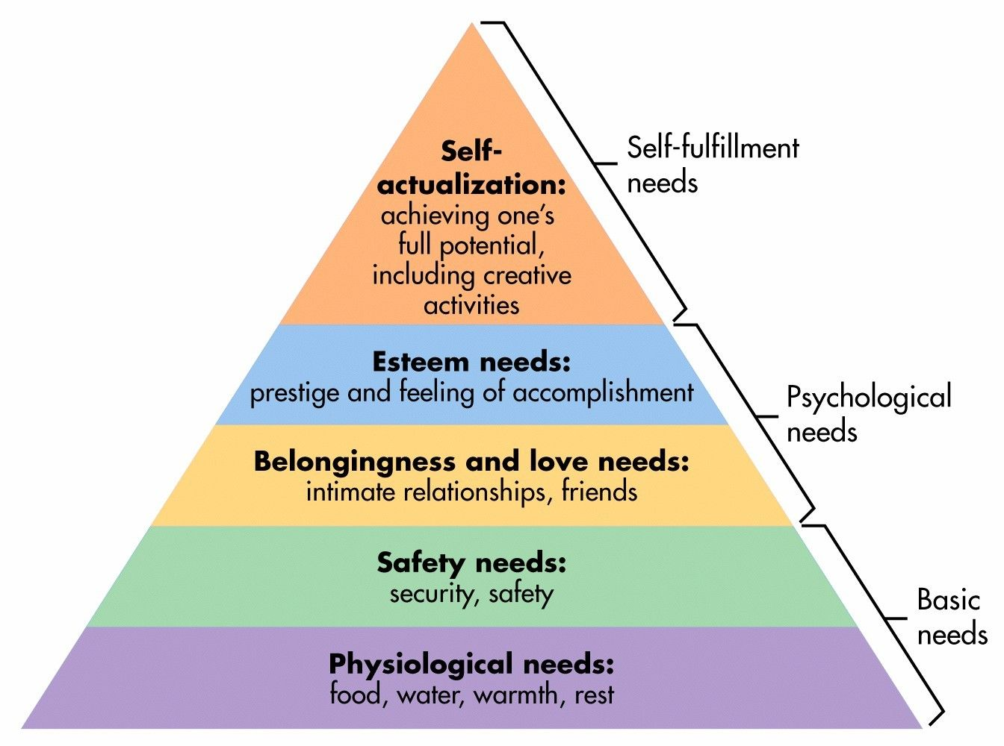
Maslow’s (1943) Hierarchy of Needs.

Simply Psychology (2020a)
Why Maslow’s (Hierarchy of needs) & Bowlby’s (Attachment) theory are important in practice?
Ealing Educational Psychology Service (2020) support Maslow’s (1943) pyramid of hierarchy of needs theory and believe that children will not achieve their potential unless their foundation level of basic needs are met. Whilst this guidance focuses on transitioning back into school after COVID-19 the principles of transitioning remain the same. The guidance suggests that key people should acknowledge common lived experiences that children face and suggest that key adults should ensure the children are given compassion, empathy, and time to talk to help with their transitions. NSPCC Learning (2021) believe that attachment described by Bowlby (1997) as a term that is defined as a lasting psychological connection between people. They state that the attachment theory identifies the importance of the connection between a child and a caregiver. If this connection does not form or become affected, this could impact the child’s emotional and psychological development, impacting future relationships.
According to Mentally Healthy Schools (No Date) it is important to support children that are more likely to find transitioning difficult. They believe children with additional needs, suffer with mental health, have behavioural difficulties, limited support, have experienced transient living, who are anxious or have experienced bullying are more vulnerable when transitioning. Devon County Council (No Date) support this and suggest there are three levels to transitioning support. They believe that there are key differences between the levels, firstly there is a universal level that is in place for every individual child. Secondly, there is targeted support for children who are relatively vulnerable. These children are likely to become distressed when they experience change. Additionally, these children are not likely having their basic level of needs met within Maslow’s pyramid. Finally, there is specialist support for children with complex level needs, these children benefit from enhanced transition arrangements. Addition to these the practitioners should be mindful of the difference in transitions whilst supporting individuals.

Vygotsky’s theory ‘Zone of proximal development and scaffolding’
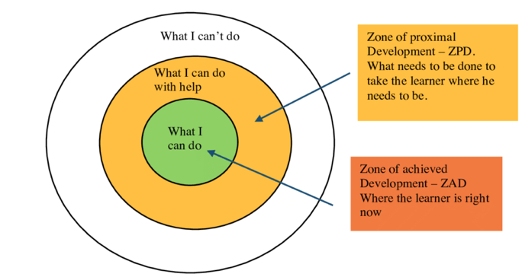

Educational Technology (2020)
Welsh Government (2017a) suggests that the UNCRC provides a framework that warrants that children are enabled to lead a happy, safe, and a fulfilled life. The UNCRC's core values are non-judgmental and a responsibility to meet the child's best interests. Giving them permission to life, survive, develop and have consideration of the voice of the child. Birth to 5 Matters (No Date) support the view that quality transitions acknowledge the importance of the child’s voice. Hwb (2020) state that each learner should access topics that best support their learning with use of a content-focused curriculum. This is supported by Vygotsky’s theory ‘Zone of proximal development and scaffolding’.
Vygotsky’s theory is supported in Educational Technology (2020), they suggest a child communicates when they are born through emotional responses and continues learning through interactions with others around them. Educational Technology (2020) emphasises the values of a practitioner holds in a child’s life. Educational Technology (2020) highlight that Vygotsky introduced the theory that there is no ideal age for learning but there was an ideal stage, this was of a similar opinion to Piaget. Vygotsky’s views on cognitive development are summarized into four key points. First, that the connection between the child and adult is significant to learning. Second, that society and culture influence the child’s attitude towards their learning. Following by language being the primary tool used to a child’s development. Last, learners benefit in learner lead activities as they can use social interactions to promote development.

Welsh Government (2017a) believe that when children are placed in the centre of the transition planning and can identify their need to feel secure and confident through the process, enabling the child the highest quality of transition. Birth to 5 Matters (No Date b) support this and suggest that vulnerable children are more likely to face difficulties whilst transitioning, as this can make them feel insecure and feel that their needs are not being met.

The role of the Adult.
Department for Education (2023) believe that each individual child must have a key adult that can meet the individual child’s needs. This will support the child by forming a trusting relationship and consistency to become familiar with the setting.
Early Years Educator (No Date) suggests that some use of an attachment-based approach to finding a key adult can also be used. They state children would form this naturally where the child and practitioner form a natural relationship. NSPCC (2021a) support that it is important that practitioners working with children should develop an understanding of attachment.
The Attachment Research Community (2019) suggests that attachment is a primary need that increases the child's survival potential. Children are not born able to meet their own basic needs but can form attachments with caregivers. When the child is supported when they need their basic needs met, this creates a secure attachment that enables the child to explore the world. Birth to 5 Matters (No Date) support The Attachment Research Community (2019), NSPCC (2021a) and Early Years Educator (No Date) statements in highlighting that practitioners should recognise the importance of attachment and the emotional well-being of the individual child and their family. Head Start Kernow (2023) support and state that each interaction is an opportunity for a child to grow.
How can a relationship be developed?
Safe environment.
ChangeKidsLives.org (No Date) suggests that practitioners should consider Maslow’s hierarchy of needs whilst supporting children. The basic needs of the child are physiological needs, safety, moving up towards having the sense of belonging, support to encourage self-esteem and self-evaluation. Education Library (2020) support ChangeKidsLives.org (No Date) by stating that teachers should encourage an environment that encourages children to take risks in a healthy manner. By encouraging questioning and answering, open mind sharing and healthy choices.
The voice of the child.
Welsh Government (2015b) believe that being committed to the children’s rights, focus on the child’s greatest interests, accounting all aspects that may impact the child’s well-being within the transitioning period. Welsh Government (2015b) support Vygotsky’s theory that communication is key to developing the child’s learning, both City & Guilds (No date) and Orey (2014) believe that practitioners should take non-verbal communication into account whilst building relationships and communicating with children.
Communication.
Tower Hamlets Early Years Service (No Date) state that close involvement from the caregiver ensures the practitioner is well informed of any needs that need to be met while the child transitions. Birth to 5 Matters (No Date b) support this and suggest the child’s key person should make essential connections. Such as a child, being greeted with a warm welcome will make this easier for the child. Both Tower Hamlets Early Years Service (No Date) and Birth to 5 Matters (No Date b) highlight that key practitioners should support the child and family by becoming the link between home and the setting. This will encourage reassurance by creating a close, supportive and an ongoing relationship with the family.
Tower Hamlets Early Years Service (No Date) state that information regarding the transitions needs to be passed from class teacher to class teacher before each transition. They state transitions should be evaluated to enable the transition process can be improved each time. Birth to 5 Matters (No Date b) support communication between practitioners to ensure children are supported individually.



Partnerships
UK Government (No Date) suggests that working in corporation with caregivers is central within early years settings. UK Government (No Date) believe that inviting families to share information about themselves personally, family, community, and culture to support building trusting relationships. They highlight that working together to share information, help identify the child’s interests early and help discover how best to support the child.
Welsh Government (2018c) believe that practitioners should continuously maintain what matters to the child and caregivers. It is suggested that developing co-productive working relationships, for the child to feel respected and understanding of what is taking place. They believe that when practitioners are open and honest, the child and family feel confident to provide relevant information around the child and family circumstances.
Bronfenbrenner’s ecological systems theory. (1977).

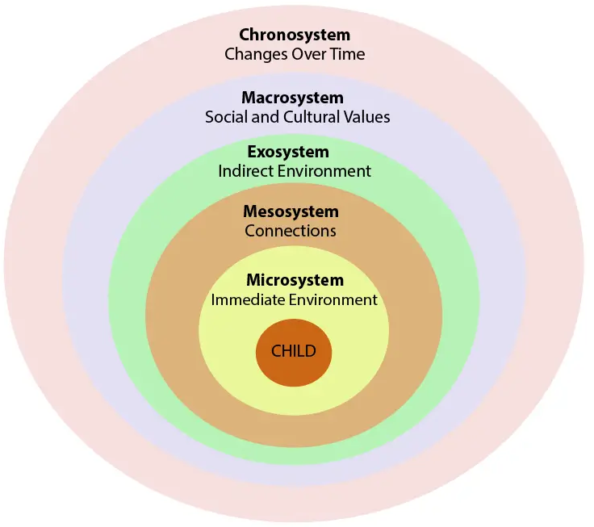
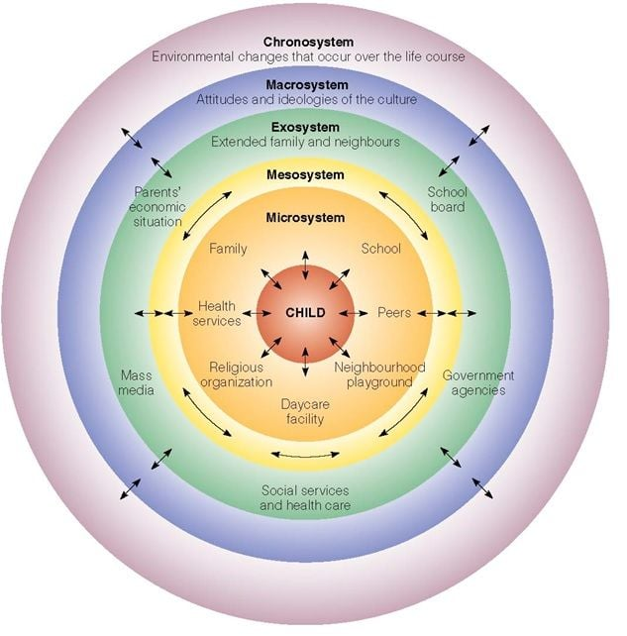

Simply Psychology (2023b)
The Psychology Notes HQ (2021) support Bronfenbrenner (1977) theory of the Ecological Systems Theory. They state that Bronfenbrenner’s theory investigates at how social environments impact the development or children. They believe that the theory highlights the importance of seeing children in multiple environments to help gain a better understanding of the child’s development. Onwuegbuzie, A.J. et al. (2013) support this and states that this theory consists of four levels, where each level impact the person's development differently. First, the first level consists of an immediate environment, where a child interacts closely with others such as the home, classroom, playground. Second, the next level refers to connections between environments. The third level is where the people's experiences at home might influence in other settings. Last, the fourth level is where the community and society's surroundings influence the person. El Zaatari, W. and Maalouf, I. (2022) support this and suggest that there are influences that affect children’s sense of belonging, such as the learning conditions, key adult relationships, safety, additional activities, peer communication and parents’ involvement.
NSPCC (2023b) support Bronfenbrenner (1977) and suggests that a multi-agency is a key approach to support affective working, as families can seek many provisions during a child’s development. This approach helps create an overview of the family’s circumstances and organizations can work collectively when supporting the child.

Interventions
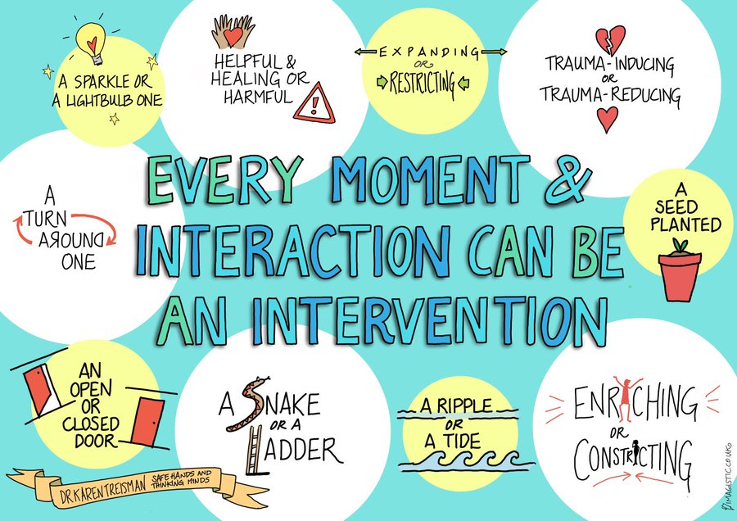
Head Start Kernow (2023)
Early intervention foundation (No Date) suggests that early intervention decreases risk factors children feel and support them to increase their protective factors. It suggests that risk factors can threaten children’s development, this can increase the risk of vulnerability in adulthood. Protective factors are characterised by the people closest to the child.
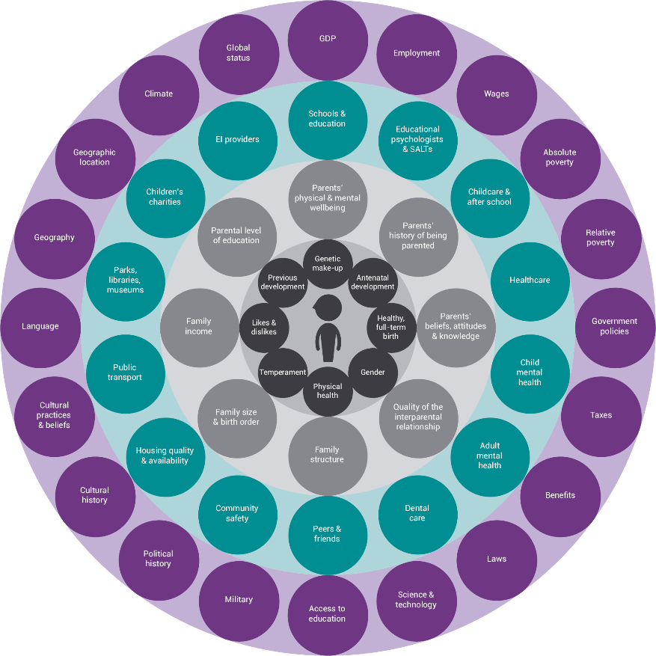
Early intervention foundation (No Date)
Tower Hamlets Early Years Service (No Date) state that practitioners should receive adequate information when preparing children, particularly children with additional needs when transitioning. They suggest ensuring the children have access to visits with friends to the new classroom for the children to become familiar with their new environment. Birth to 5 Matters (No Date b) support that there are many ways practitioners can support children with transitions. They suggest ensuring that practitioners gather key information while planning the child’s transition plan.
Tower Hamlets Early Years Service (No Date) suggests that this would be done with access to key adults, this could be done by creating a relationship with the child/children prior to the transition. This will help support the child, as the practitioner will have access to observing the child in a familiar setting prior to the transition. Birth to 5 Matters (No Date b) support this and suggest that children need practitioners that recognise the importance of attachment and emotional well-being of the individual child.
Tower Hamlets Early Years Service (No Date) suggested creating a transition book for the child to familiar themselves with the photographs where the caregivers can support the child at home. Birth to 5 Matters (No Date b) support Tower Hamlets Early Years Service (No Date) also suggests use of transition books to help familiar the child with setting.

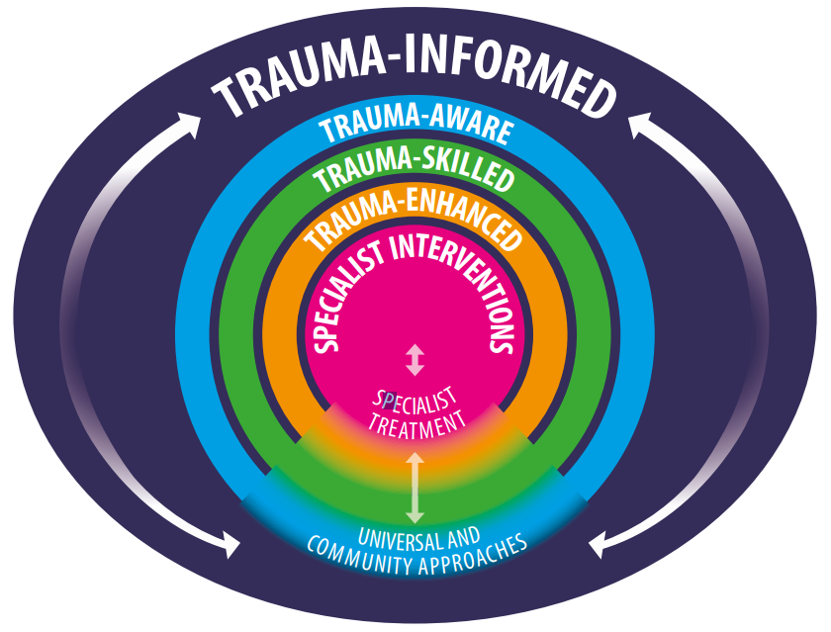
ACE Hub Wales (2022)

As NSPCC Learning (2021) prior stated attachment theory identifies the value of the relationship between a child and a caregiver. If this connection is not formed the child’s emotional and psychological development this would go on to impact their future relationships.

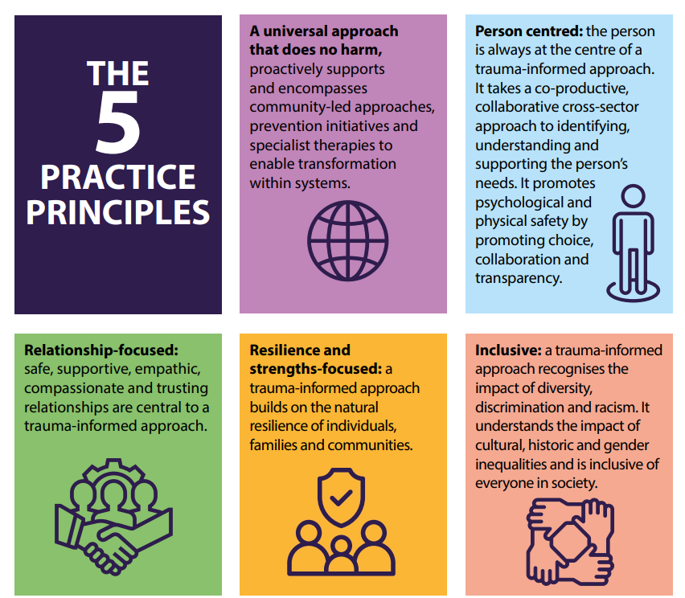
ACE Hub Wales (2022)

NASEN (2022) suggest that practitioners should consider what is needed to support the child. They identify 6 key principles of trauma informed practice, safety, trust, choice, collaboration, empowerment, and cultural consideration.

Prosed Outcome.
Hwb Cymru (2020a) states that the four purposes provide the learners with the ability to become healthy, confident individuals that will be valued members of society in the future. The aims are to support the child to be ambitious capable learners in education and beyond. The curriculum ensures children are ethical and informed citizens of their country and the world. They lastly support children in becoming creative individuals that are ready to participate in life and work.
Welsh Government (2018) highlight the importance of play when encouraging a child’s development in finding themselves and gaining confidence. Welsh Assembly Government (2002) believe that play is valuable to all children’s development. Welsh Assembly Government (2002) support UNCRC in acknowledging the significance of play in children’s progression. According to Save the Children (No Date), Article 31 in the UNCRC states that children have the right to participate in play, cultural, and artistic activities. ICO (No date) suggest the UNCRC recognises the value of the rights of children. They state the UNCRC suggest that every individual child warrant recognition, respected, and viewed as a single person that’s valued.
Flying start (No Date) state that schematic play allows children to understand the meaning of what they are doing. They suggest children learn through opportunities of active learning by experiencing hands-on activities. Flying Start (No Date) suggests that practitioners with a basic level of understanding schema they can understand their observations that can support the child’s development.
According to West Sussex County Council (2015) observations, assessment and planning support children’s development and learning. Birth to 5 matters (2021c) suggest that effective practice begins with the child and grows through the aspects within the cycle taking into consideration each individual child’s own unique pathway of development and learning.
To conclude, there are multiple ways of supporting children with transitions, and that each child should be seen as an individual within this process. It is important to recognise the above information to help support the child whilst transitioning, and that the child is supported with an individual plan with the support of practitioners to help the child develop a secure attachment.

Reference list.
- ACE Hub Wales (2022) Trauma Informed Wales: A societal approach to understanding, preventing and supporting the impacts of trauma and adversity. Available at: https://traumaframeworkcymru.com/wp-content/uploads/2022/07/Trauma-Informed-Wales-Framework.pdf (Accessed: 02/12/2023).
- Barnardo’s (No Date) It’s all about relationships: Embedding relational, trauma sensitive approaches in education settings. Available at: https://www.barnardos.org.uk/sites/default/files/uploads/Film%20notes%20-%20Final%20-%20digital.pdf.org.uk (Accessed: 27th November 2023).
- Birth To 5 Matters (No Date a) Transitions. Available at: https://birthto5matters.org.uk/transitions/ (Accessed: 19th November 2023).
- Birth To 5 Matters (No Date b) All about transitions. Available at: https://birthto5matters.org.uk/wp-content/uploads/2021/03/All-about...-transitions.pdf (Accessed: 27th November 2023).
- Birth to 5 matters (2021c) Learning and Development: Observation, assessment and planning. Available at: https://www.birthto5matters.org.uk/wp-content/uploads/2021/03/Explaining-the-OAP-Cycle.pdf (Accessed: 3rd December 2023).
- ChangeKidsLives.org (No Date) Applying Masolw’s hierarchy of needs in our classrooms. Available at: http://www.changekidslives.org/actions-4 (Accessed: 24th November 2023).
- City & Guild (No date) Principles and Values of Children’s Care, Play, Learning and Development (0-19 years of age) The importance of effective communication in children’s care, play, learning and development: Effective communication. Available at: https://moodle.uwtsd.ac.uk/pluginfile.php/721015/mod_resource/content/1/EFFECT~1.PDF (Accessed: 27th November 2023).
- Devon County Council (No Date) Transition in early years: Guidance for schools and settings. Available at: https://www.devon.gov.uk/support-schools-settings/inclusion/transition/transition-in-the-early-years/ (Accessed: 24th November 2023).
- Department for Education (2023) Statutory framework for the early years foundation stage: Setting the standards for learning, development and care for children from birth to five. Available at: https://assets.publishing.service.gov.uk/government/uploads/system/uploads/attachment_data/file/1170108/EYFS_framework_from_September_2023.pdf (Accessed: 24th November 2023).
- Early Years Matters (No Date) Key person and attachment. Available at: https://www.earlyyearsmatters.co.uk/eyfs/positive-relationships/key-person-attachment/ (Accessed: 26th November 2023).
- Early intervention Foundation (No Date) What is early intervention? Available at: https://www.eif.org.uk/why-it-matters/what-is-early-intervention#:~:text=Early%20intervention%20approaches%20often%20focus,benefits%20throughout%20a%20person%27s%20life. (Accessed: 3rd December).
- El Zaatari, W. and Maalouf, I. (2022) ‘How the Bronfenbrenner Bio-ecological System Theory Explains the Development of Students’ Sense of Belonging to School?’, SAGE open, 12(4), pp.1-18. Available at: https://doi.org/10.1177/21582440221134089 (Accessed: 1st December 2023).
- Education Library (2020). Maslow’s hierarchy of needs in education. Available at: https://educationlibrary.org/maslows-hierarchy-of-needs-in-education/ (Accessed: 24th November 2023).
- Education Scotland (2017) What are transitions?. Available at: https://education.gov.scot/parentzone/my-child/transitions/what-are-transitions/# (Accessed: 19th November 2023).
- Educational technology (2020) Zone of proximal development and scaffolding. Available at: https://educationaltechnology.net/vygotskys-zone-of-proximal-development-and-scaffolding/ (Accessed: 27th November 2023).
- Ealing Educational Psychology Service (2020) Advice for schools: Transition and back to school during COVID 9. Available at: https://view.officeapps.live.com/op/view.aspx?src=https%3A%2F%2Fwww.egfl.org.uk%2Fsites%2Fdefault%2Ffiles%2FEPS%2520Guidance%2520and%2520Support%2520for%2520Schools%2520on%2520transition%2520during%2520COVID19.docx&wdOrigin=BROWSELINK (Accessed: 26th November 2023).
- Flying Start (No Date) What is a schema? Available at: https://www.flyingstart.uk.com/wp-content/uploads/2014/08/Schema.pdf (Accessed: 1st December 2023).
- Head Strat Kernow (2023) Relationships and Belonging. Available at: https://www.headstartkernow.org.uk/universal-/wsa-ethos--environment/relationships/ (Accessed: 27th November 2023).
- HSE (2021) Your Child’s Developmental Milestones. Available at: https://www2.hse.ie/babies-children/checks-milestones/developmental-milestones/3-5-years/ (Accessed: 22nd November 2023).
- HWB (2020a) Introduction to Curriculum for Wales guidance. Available at: https://hwb.gov.wales/curriculum-for-wales/introduction (Accessed: 27th November 2023).
- Hwb (2020b) Developing a vision for curriculum design. Available at: https://hwb.gov.wales/curriculum-for-wales/designing-your-curriculum/developing-a-vision-for-curriculum-design/#curriculum-design-and-the-four-purposes (Accessed: 24th November 2023).
- ICO (No Date) The United Nations Convention on the rights of the child and what it means for online services. Available at: https://ico.org.uk/for-organisations/uk-gdpr-guidance-and-resources/childrens-information/childrens-code-guidance-and-resources/how-to-use-our-guidance-for-standard-one-best-interests-of-the-child/the-united-nations-convention-on-the-rights-of-the-child/#:~:text=It%20is%20the%20most%20widely,unique%20and%20valuable%20human%20being. (Accessed: 3rd December 2023).
- Illinois Early Learning Project (2016) Supporting adult-child relationships. https://illinoisearlylearning.org/tipsheets/adultchild/ Available at: (Accessed: 27th November 2023).
- Lindon, J. (2012) Understanding Child Development: 0-8 years. London: Hodder.
- Mentally Healthy Schools (No Date) Transitions. Available at : https://mentallyhealthyschools.org.uk/factors-that-impact-mental-health/school-based-risk-factors/transitions/ (Accessed: 19th November 2023).
- Mind Tools (No Date) Bridges' Transition Model. Available at: https://www.mindtools.com/afhbe6s/bridges-transition-model (Accessed: 19th November 2023).
- My Cute Graphics (No Date) School Girl Wearing a Backpack. Available at: https://www.mycutegraphics.com/graphics/school/school-kids/school-girl-backpack.html (Accessed: 23rd November).
- National Association of Clinical Nurse Specialists (No Date) Definitions of Transitional Care. Available at: https://nacns.org/resources/toolkits-and-reports/transitions-of-care/definitions-of-transitional-care/#:~:text=For%20example%2C%20in%20the%20course,at%20a%20skilled%20nursing%20facility. (Accessed: 27th of November 2023).
- NASEN (2022) New guidance on trauma informed practice within schools. Available at: https://nasen.org.uk/news/new-guidance-trauma-informed-practice-within-schools (Accessed: 3rd December 2023).
- News Wise (2017) Supporting children in distress: the power of perental emotion coaching. Available at: https://www.newswise.com/articles/supporting-children-in-distress-the-power-of-parental-emotion-coaching (Accessed: 26th November 2023).
- NSPCC Learning (2021a) Attachment and child development. Available at: https://learning.nspcc.org.uk/child-health-development/attachment-early-years (Accessed: 26th November 2023).
- NSPCC (2023b) Multi-agency working. Available at: https://learning.nspcc.org.uk/child-protection-system/multi-agency-working-child-protection (Accessed: 27th November 2023).
- Orey, M. (2014) Communication Skills Training. Virginia: ATD Press.
- Pacey (2016) Transitions and settling in. Available at: https://www.pacey.org.uk/pacey/media/website-files/pacey%20member%20practice%20guides%20(pdfs)/pg10-transitions-and-settling-in.pdf (Accessed: 22nd November 2023).
- Rhondda Cynon Taff (No Date) Transition information for Early Years. Available at: https://www.rctcbc.gov.uk/EN/Resident/SchoolsandLearning/AccessandInclusiontoEducation/WorkinginPartnershipwithParents/SchoolTransitionAdvice/TransitioninformationforEarlyYears.aspx (Accessed: 22nd November 2023).
- Save The Children (No Date) A summary of the United Nations convention on the rights of the child. Available at: https://www.savethechildren.org.uk/content/dam/gb/reports/humanitarian/uncrc19-summary2.pdf (Accessed: 1st December 2023).
- Simply Psychology (2020a) Maslow’s Hierarchy of Needs [on-line] Available at: https://www.simplypsychology.org/maslow.html (Accessed: 24th November 2023)
- Simply Psychology (2023b) https://www.simplypsychology.org/bronfenbrenner.html#The-Five-Ecological-Systems (Accessed: 27th November 2023).
- Special Educational Needs and Disabilities Information Avice and Support Services (SENDIASS) (No Date) Moving Schools and through education (transition). Available at: https://sendiass.leeds.gov.uk/parents-and-carers/my-childs-ehcp/educational-transitions (Accessed: 22nd November 2023).
- The Attachment Research Community (2019) Attachment. Available at: https://the-arc.org.uk/attachment (Accessed: 26th November 2023).
- Tower Hamlets Early Years Service (No Date) Moving On: supporting children’s transitions in the early year. Available at: https://www.towerhamlets.gov.uk/Documents/Children-and-families-services/Early-Years/Moving_On_Supporting_Childrens_Transitions_in_the_Early_Years.pdf (Accessed: 19th November 2023).
- UK Government (No Date) Working in partnerships with parents and carers. Available at: https://help-for-early-years-providers.education.gov.uk/get-help-to-improve-your-practice/working-in-partnership-with-parents-and-carers#:~:text=It%27s%20about%20working%20together%20to,best%20to%20support%20their%20learning. (Accessed: 27th November 2023).
- Welsh Assembly Government (2002) Welsh Assembly Government Play Policy. Available at: https://moodle.uwtsd.ac.uk/pluginfile.php/724026/mod_resource/content/1/playpolicye.pdf (Accessed: 1st of December 2023).
- Welsh Government (2017a) Transition Guidance. Flying start-Annex. Available at: https://www.gov.wales/sites/default/files/publications/2019-07/flying-start-transition-guidance-for-professionals.pdf (Accessed: 19th November 2023).
- Welsh Government (2015b) Foundation Phase Framework revised 2015. Available at: https://www.gov.wales/sites/default/files/publications/2018-02/foundation-phase-framework-revised-2015.pdf (Accessed: 27th November 2023).
- Welsh Government (2018c) Social Services and Well-being (Wales) Act 2014. Working Together to Safeguard People Volume 5 – Handling Individual Cases to Protect Children at Risk. Available at: https://www.gov.wales/sites/default/files/publications/2019-05/working-together-to-safeguard-people-volume-5-handling-individual-cases-to-protect-children-at-risk.pdf (Accessed: 27th November 2023).
- West Sussex County Council (2015) Effective Practice: Observation, Assessment and Planning. Available at: https://www.westsussex.gov.uk/media/5555/effective_poa_and_planning.pdf (Accessed: 3rd December 2023).
- WYECPLC (2020) Understanding and supporting transitions in Early Childhood Education. Available at: https://wyecplc.org/index.php/professional-learning-library/supporting-transitions (Accessed: 22nd November 2023).

