Terrorism and Public Services Responses

The ‘Manchester Arena bombing’ terrorist attack - an evaluation of the effectiveness of emergency services and partner agencies response
Lecturer: Wynne Jones
Module Code: BMPS5004
Student ID number: 1900875

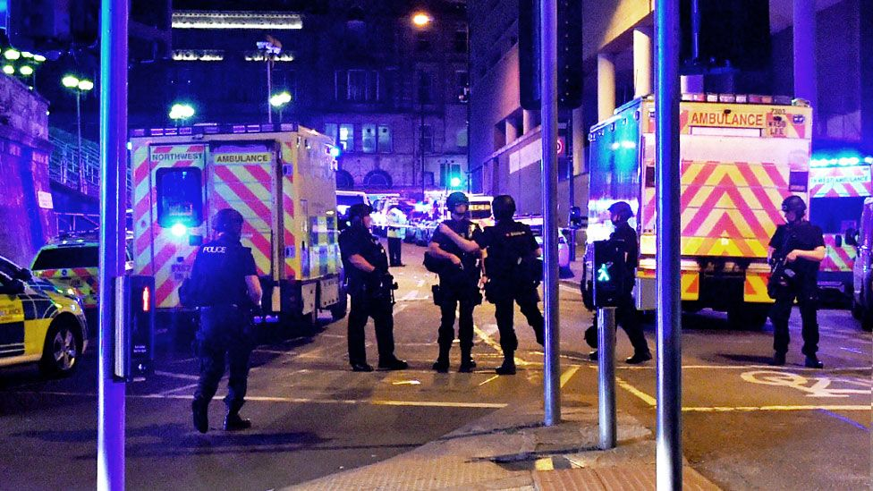

Executive Summary
In this report it consists of an evaluation of the effectiveness of emergency services and partner agencies' response on the night of the Manchester bombing which occured on the 22nd of May 2017. There were 14,000 innocent people who attended a concert hosted by Ariane Grande. At 22:31 this where a suicide bomber by the name of ‘Salman Abedi’ killed 22 people from the blast that he cause and over 200 people were injured and traumatised thousands more. The importance of the emergency services to attend and handle the situation with efficiency was key as this was a terrorist attack where many people were injured and in danger and therefore required the assistance and help of the public services. However there were many crucial mistakes which meant the effectiveness and efficiency of the emergency services on that night was not up to standard. This is where the fire services were nearly 2 hours to the arena due to communication problems with their radio links and the passing information between the chief of police and chief of the fire service. This led to another mistake as all of the emergency services were supposed to meet at a rendezvous point to discuss their plan of tasks to handle the situation in an efficient manner, however none of the emergency services met at this rendezvous point and went straight to the arena. Despite the mistakes and lack of efficiency in the end the emergency services managed to handle the situation well by helping all those who were traumatized and injured from the explosion as they were brought to the hospital to be treated.

Introduction
The purpose of this report is to evaluate the effectiveness of emergency services responses to a terrorist attack within the United Kingdom. The report will also include recommendations on how to potentially improve the efficiency of responses to these attacks. There have been multiple terrorist attacks committed within the United Kingdom however this report will focus on the ‘Manchester Arena bombing’. According to Sky News (2020) the Manchester bombing occurred on the 22nd of May 2017, where a suicide bomber by the name of ‘Salman Abedi’ killed 23 people (including the attacker) from the blast that he cause and over 200 people were injured therefore being the deadliest terrorist attack since the London bombing back in 2005. During a crisis like this it is important for the United Kingdom's public service to be prepared, efficient, alert, and prompt to the scene in order to assess and handle the situation to the best of their ability in order to save those involved and prevent any further injuries or destruction. The objectives of this report will be to assess the efficiency of the emergency services during the Manchester bombing and point out any factors that may have delayed their operation and what can and has been done to improve any problems noticed. Furthermore, researching what the United Kingdom's police force has done in order to make it more secure from terrorists and to also make the public and country feel safe and protected from any future harm.

Main Findings
As reported by BBC News (2018) on the 22nd of May 2017 ‘Ariana Grande’ a famous celebrity was performing a concert in front of 14,000 people where suddenly a bomb was set off by ‘Salman Abedi’ at 22:31 BST and killed 23 people (including the attacker) with over 200 people being injured. In Manchester Kerslake (2018, p.6) states that there is an organisation called the ‘Greater Manchester Resilience Forum’ (GMRF) which plan and carry out many exercises in order to prepare for any catastrophic events, however the arena bombing on the 22nd May was an event that no member of the GMRF had ever encountered before and therefore being their first real life scenario and to test what they have been planning and training for. In this incident the effectiveness of emergency services to respond to the scene was crucial as there were many people needing medical help, fires to be put out and a crowd to keep calm. The response of the emergency services was slow and not up to an efficient standard which in turn slowed the process of the situation being handled. This was due to police forces who were first at the scene and were the reason the fire services response and arrival to the arena was delayed. The chief fire officer at the time of the bombing was Peter O'Reilly and he explained that the police officers at the scene who failed to contact the fire service were to blame for their slow response, BBC news (2018) reported that O’Reilly explained his disappointment to why his special rescue teams would have been sent in if they knew sooner as these firefighters who were trained for this were not there fast enough to help the people in their ‘darkest hours’ due to the police not living up to their obligation of contacting the fire service. This was a crucial mistake that the police officers made not contacting the fire services as soon as they arrived at the scene as Kerslake (2018, p.61) reported that the armed police arrived at the arena as soon as possible at 22:43hrs in order to assess the arena for any further threats, twelve ambulances arrived at the scene 6 minutes later responding and arriving at efficient time to when the bomb exploded. However the fire services did not arrive at the scene until 00:37 that being 1 hour and 54 minutes later. As stated by the BBC (2018) the apparent problem of the delayed arrival of the fire service was due to the lack of communications via their radio link between the police services and fire services and therefore the lack of information provided for both sides to determine the safety of the area was unsure and only suspected that it was a terrorist firearms attack and believed they could not go in the arena and had to stay 500 metres away from the situation due to national guidance until they had confirmation to do so. Even though there were two fire crews nearby as Pidd (2018) states that they were only 3 miles away and should have heard the bomb explode but as previously mentioned were not allowed to enter due to precautions of the national guidance. As reported by BBC News (2021) later on the chief of police named ‘Robin Smith’ admits to the poor effectiveness of emergency services and partner agencies' response to the arena bombing. He claimed that it was a crucial mistake not contacting the commanding officer in the fire department to respond to the scene and also being unaware of his other commanding officer who was supposed to guide the ground units was an hour late which could have caused this delay. Nonetheless Smith claimed that he made the correct strategic decisions in order to handle the situation efficiently as possible but the factors such as trouble with the communication to contact other emergency service was out of his hands. This shows a poor effectiveness from the partner agencies response with the delayed information in turn delaying the response of special rescue teams to aid the medical team and other services that were present. However alternatives should have been made on the night by both the police and fire service in order to make good out of the delayed response as it was a catastrophic event that needed all the help possible at the arena. Craigie et al. (2020) mentions that the preparation for mass casualty incidents (MCI) has always been necessary to be prepared for any scenario that may occur, as well as using anti-terrorist methods to debunk the situation another main focus is the health and safety of the public. Therefore this can include methods such as full scale exercises carried out by public agencies in order to know their roles and responses in an emergency, there are also mock hospital exercises, and virtual real life scenarios and skills development for healthcare professionals in trying to manage the little to serious injury problems that would be expected and likely to occur in such a catastrophic event. However sometimes even the best-prepared departments within emergency services can still struggle in such disasters due to the unpredictability of such scenarios. It can also cause significant challenges considering the many factors that could be present such as the pressure timing, preparation, casualties, amount of staff and even the correct gear. The MCI is always coming up with new ideas and spreading the information nationwide assessments can be carried out as they are essential to measure the efficiency of the responses to such events, as well as to focus on areas where lessons can be learned and analyse these in order for them to be included in future planning.
As we know in the United Kingdom the National Health service (NHS) does struggle as The King’s Fund (2021) explains that there is a shortage of 84,000 nurses, midwives and other departments in the health sector, which means the NHS would struggle if hospitals become overwhelmed with patience as they did during the peak of the COVID-19 pandemic. Bowley et al. (2020). States the importance of the role of the NHS staff are and that they are well prepared for situations like this due to previous experiences such as the London bombing and even world war 2 where there were many injuries and chaos, learning from previous mistakes lessons are made to be better prepared for any other oncoming scenarios. This meant during the Manchester bombing not all emergency services were inefficient and ineffective as Kerslake (2018, p.61) said that the United Kingdom's National Health Service responded to the scene of the bombing within 28 minutes with 12 ambulances in order to tend and aid the people that were injured and were prepared to treat all types of injuries. We are able to see how prepared the paramedics were at the scene as they has roles and tasks (shown on table 1) on how to prioritize and handle the injured patients depending on the severity of their injuries, this is effective as they can treat each patient accordingly which in turn brings stability and prevents further chaos in the area. Being organised was of importance as Dark et al. (2021) that there was 109 adults and 44 children that needed to be admitted to the hospital bringing the most injured being top priority to bring to hospital first in order to treat their wounds safely and with the correct equipment as there is only so much the paramedics can do at the arena but stabilise and prepare them for the hospital. The NHS was efficient and effective as the data gathered by the surrounding hospitals that admitted the injured people from the arena showed, all the patients treated was done systematically and worked well following and using the protocol, preparation and training they had for a situation like this to happen.
When evaluating the effectiveness of emergency services and partner agencies response to the Manchester bombing it was noticed that it had many issues as with an event like this it is as Gardham (2021) stated that the emergency services were supposed to meet at a rendezvous point that the Police suggested in order to plan how they would enter the arena, secure it and help people as efficient as possible, however none of the other emergency services use this rendezvous point and went straight to the arena. The consequence of not meeting at the rendezvous point to discuss a plan caused the emergency services to meet up at different locations and in turn not meet at one part of the arena and therefore caused delay of entry for some of theses services and it was due to security checks that the armed police were conducting to ensure that there was not another bomber. If the emergency services did meet up they could have worked together which in turn would have reduced delay, spread required information to the other services and worked in a more efficient manner.

Conclusion

All things considered an evaluation of the effectiveness of emergency services and partner agencies' response to the Mancheester problems had many flaws which could have made the night be much more effective for the emergency services and those involved if these mistakes were sooner noticed and avoided. The bombing in the arena was unexpected for everybody including the emergency services, as not all of the emergency services arrived there quickly, while the police and ambulance units arrived at the arena within 30 minutes, the fire service arrived nearly 2 hours late. This is where the chief of the fire department blamed the police department for not informing them sooner. There were many factors that caused delay such as the problems with communication links on the night, making it a struggle for the services to contact each other and pass on information of what was happening at the arena, this led to the emergency services not meeting at the rendezvous established by the police officials which meant that they were not able to discuss and plan their method to carry out each and every departments responsibility to avoid further chaos/ panic and to resolve and help the people that were injured in an efficient manner. Despite all the mistakes and the slow response from the fire service on the night which could have been avoidable. The chief of police Smith admitted that the delayed response was his fault but the night was successful in the context where the area was secured by the armed police, to where it posed no threats for the other emergency services to enter and save people’s lives.

Recommendations
Based on my findings it was noticeable that there were multiple cases which reduced the effectiveness of the emergency services and the partner agencies response to the scene of the bombing. There are multiple suggestions which can help improve their effectiveness in preparation for a terrorist attack occuring in the future, one problem that they had was their method of communications which caused the further delay of the police being able to notify the fire service to aid them at the scene. Lowe, D (2020) states a better recommendation for a source of communication rather than relying on radio links is to explore and look into a range of encrypted social media networks specific to any threats. There are two major benefits of doing this one is that they can keep all emergency service staff updated on any recent updates as social media is the first place people post an event on and see the accuracy of such posts so that they can avoid any false accusations or pranks people may pull. The second reason being that the emergency services can use official, secured work related social media groups with all of the emergency staff present in order to keep each other informed and updated without worrying about failed communications like the vodaphone radio link did on the night of the bombing. Another recommendation Dodd, V. et al.(2017) reported that the government is to increase the level of security detail, thorough checks of the people attending, restricting any dangerous equipment from entering events. The best way to implement this is through the use of evidence based policing as College of Policing (2021) that with the evaluation from previous mistakes and what works best the policing staff can share ideas to come up with the best solutions to prevent mistakes happening and using the best methods of security and safety and implementing them in such big events.

Appendices
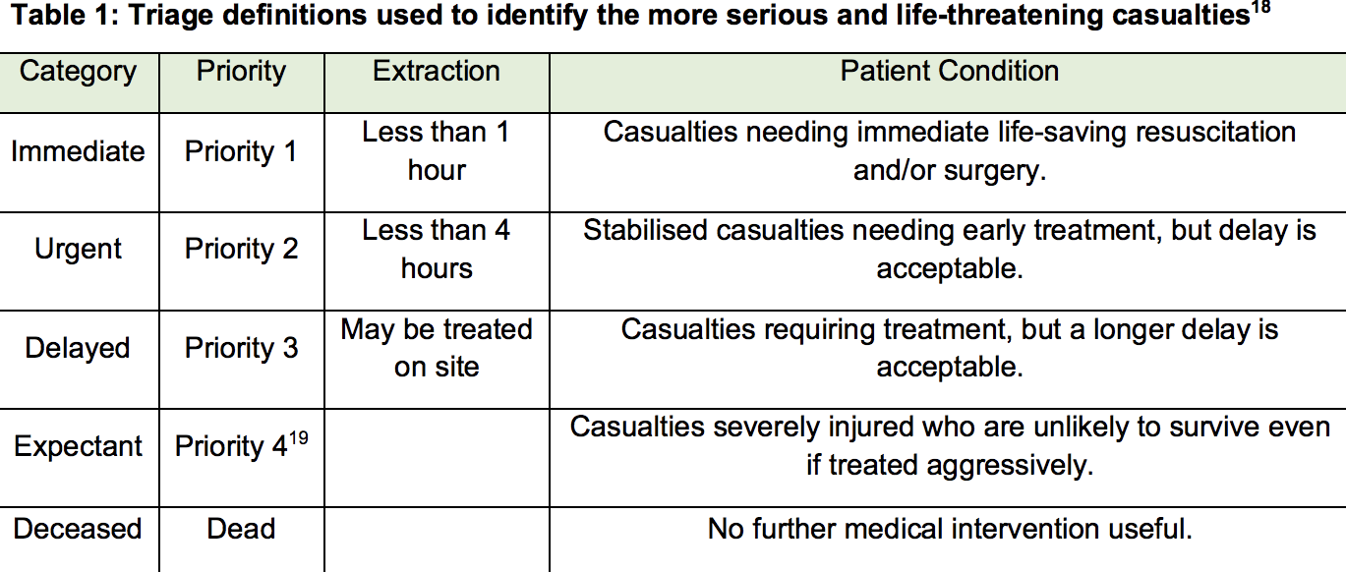

Bibliography
- BBC News (2018) ‘Manchester Arena bomb: Fire chief blames police for delay’, 20 August. Available at: https://www.bbc.com/news/uk-england-manchester-45246673 (Accessed: 4 May 2021).
- Sky News, (2020) Terror in the UK: Timeline of attacks, Available at: https://news.sky.com/story/terror-in-the-uk-timeline-of-attacks-11833061 (Accessed: 5 May 2021).
- Kerslake, B. (2018), ‘An independent review into the preparedness for, and emergency response to, the Manchester Arena attack on 22nd May 2017’ Available at: https://www.kerslakearenareview.co.uk/media/1022/kerslake_arena_review_printed_final.pdf (Accessed: 5 May 2021).
- Craigie, R. J., Farelly, P. J., Smith, S. R., Pollard J. S., Jones, D. J. (2020) ‘Manchester Arena bombing: lessons learnt from a mass casualty incident’, BMJ Mil Health, 166(2), pp. 72–75. doi: 10.1136/jramc-2018-000930.
- Pidd, H., (2018), Manchester Arena bombing: fire service arrived two hours late, says report the Guardian. Available at: http://www.theguardian.com/uk-news/2018/mar/27/manchester-arena-bombing-fire-service-arrived-two-hours-late-says-report (Accessed: 5 May 2021).
- Lowe, D (2020), ‘Manchester Arena Bombings Main Lessons That Have Been Learnt’. Available at: http://eprints.leedsbeckett.ac.uk/id/eprint/7450/1/ManchesterArenaBombingsMainLessonsThatHaveBeenLearntPV-LOWE.pdf (Accessed: 5 May 2021).
- BBC News (2021) ‘Manchester Arena Inquiry: Police chief admits bomb response failings’, 27 April. Available at: https://www.bbc.com/news/uk-england-manchester-56905189 (Accessed: 6 May 2021).
- Bowley, D. M., Davis, N., Ballard, M., Orr, L., Eddleston, J. (2020) ‘Military assistance to the civil authority: medical liaison with the Manchester clinicians after the Arena bombing’, BMJ Mil Health, 166(2), pp. 76–79. doi: Available at: 10.1136/jramc-2018-000944.(Accessed: 6 May 2021).
- The King’s Fund, (2021), NHS workforce: our position Available at: https://www.kingsfund.org.uk/projects/positions/nhs-workforce (Accessed: 6 May 2021).
- Dark, P.,Smith, M., Ziman, H., Carley, S., Lecky, F. (2021) ‘Healthcare system impacts of the 2017 Manchester Arena bombing: evidence from a national trauma registry patient case series and hospital performance data’, Emergency Medicine Journal. doi: Available at: 10.1136/emermed-2019-208575. (Accessed: 6 May 2021).
- Dodd, V., Pidd, H., Rawlinson, K., Siddique, H., MacAskill, E.,(2017), At least 22 killed, 59 injured in suicide attack at Manchester Arena the Guardian. Available at: http://www.theguardian.com/uk-news/2017/may/22/manchester-arena-police-explosion-ariana-grande-concert-england (Accessed: 6 May 2021).
- Gardham, D. (2021), Emergency services had ‘extraordinary’ disagreement on night of Manchester Arena attack, inquiry hears. Sky News. Available at: https://news.sky.com/story/emergency-services-had-extraordinary-disagreement-on-night-of-manchester-arena-attack-inquiry-hears-12260195 (Accessed: 6 May 2021).
- College of Policing, (2021), What is evidence-based policing? | What Works Centre for Crime Reduction. Available at: https://whatworks.college.police.uk/About/Pages/What-is-EBP.aspx (Accessed: 6 May 2021).

