Learning in the Digital Era
ACCA4025
Component 1: E-portfolio

Submitted by
Fernando Bruno Peternella Moreira
Student number:
2523396
Date: 23 March 2026

Table of contents
Contents
Learning in the Digital Era 1
Professional Development Plan (PDP) link 3
Professional Development Plan (PDP) Fernando.pptx Screenshot of cover slides / welcome 3
Screenshot of Introduction 4
Screenshot of SELF EVALUATION 5
Screenshot of my long-term goals 6
Screenshot of GOAL PROGRESS 7
Screenshot of SUMMARY 8
Screenshot of Conclusion 9
Screenshot of References 10

Professional Development Plan (PDP) link

Professional Development Plan (PDP) Fernando.pptx

Screenshot of cover slides / welcome

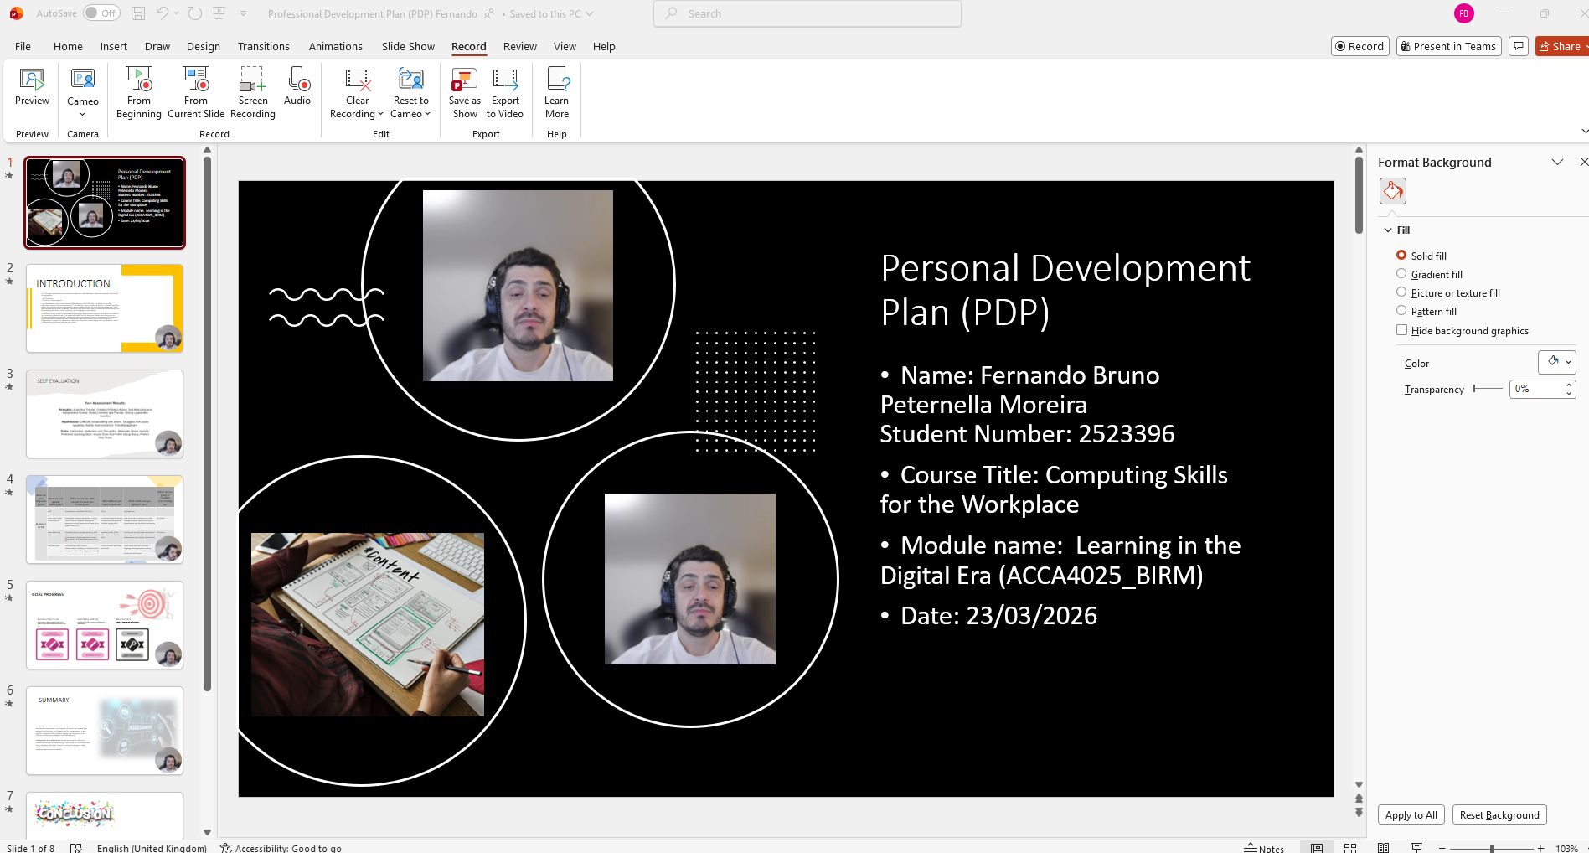

Screenshot of Introduction

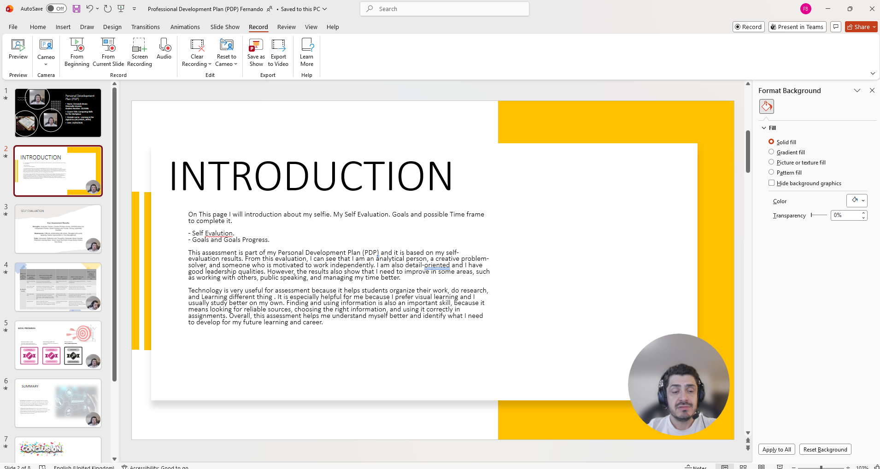

Screenshot of SELF EVALUATION

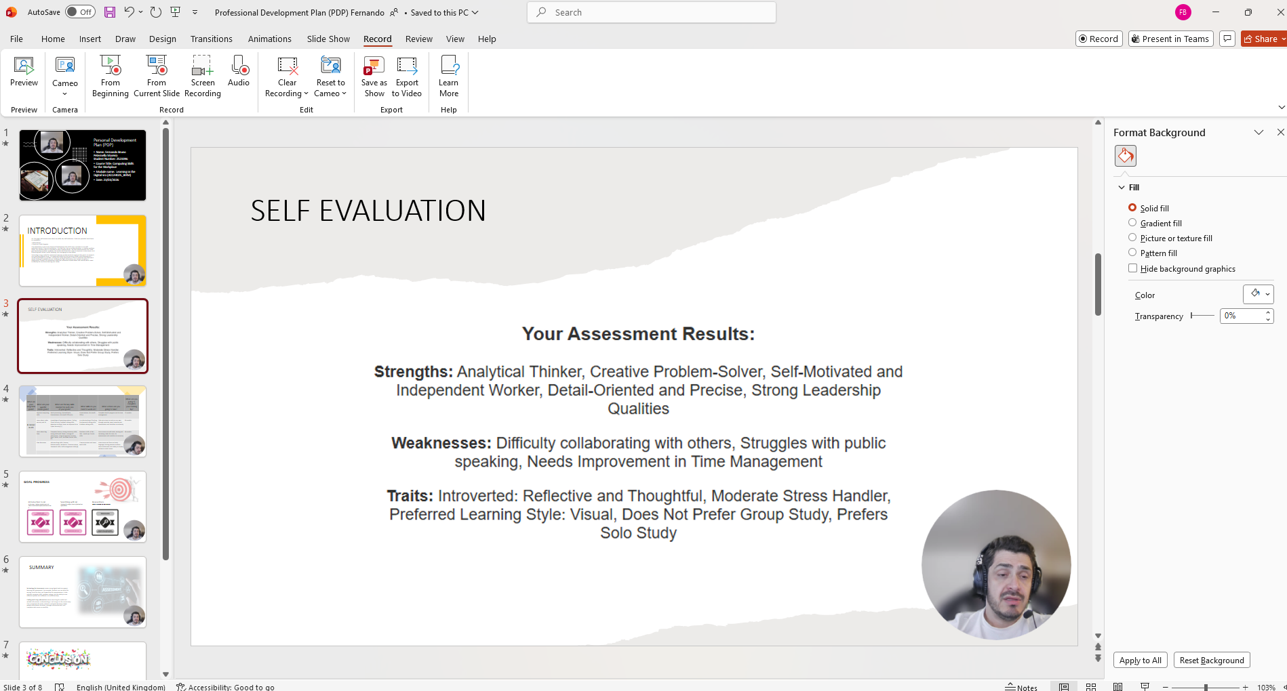

Screenshot of my long-term goals

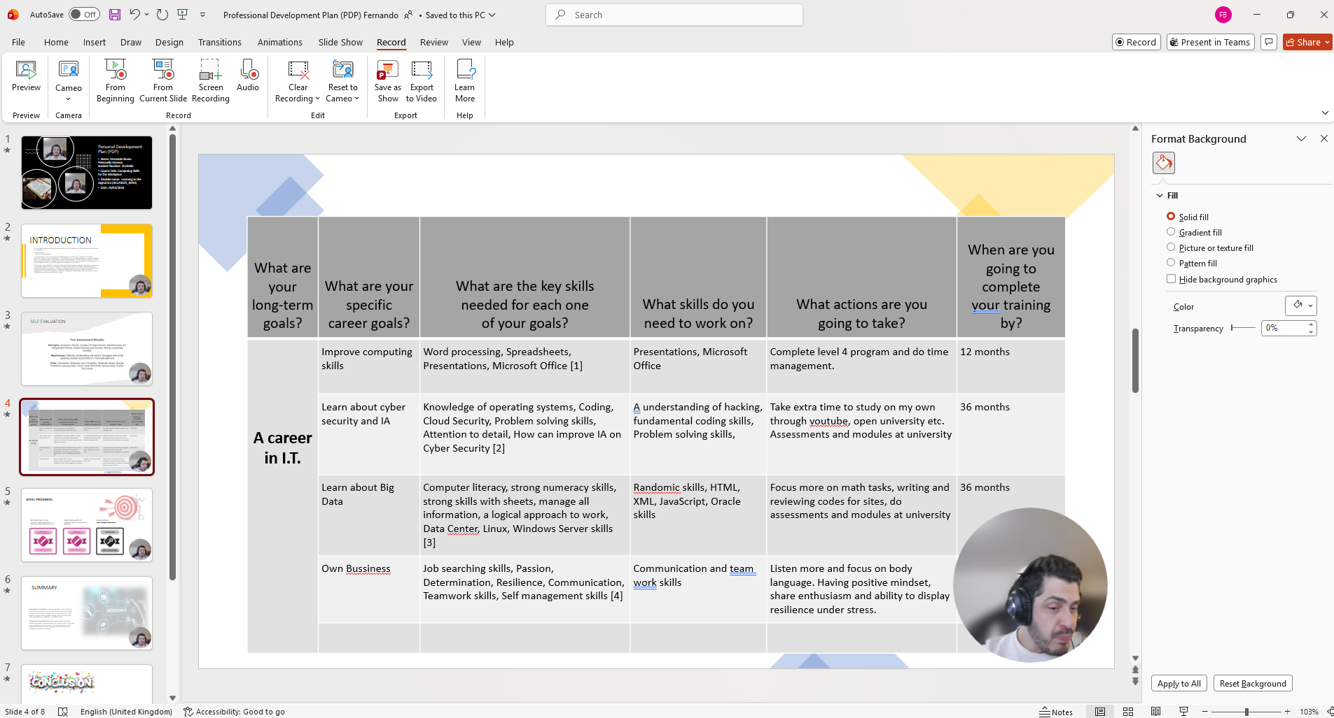

Screenshot of GOAL PROGRESS

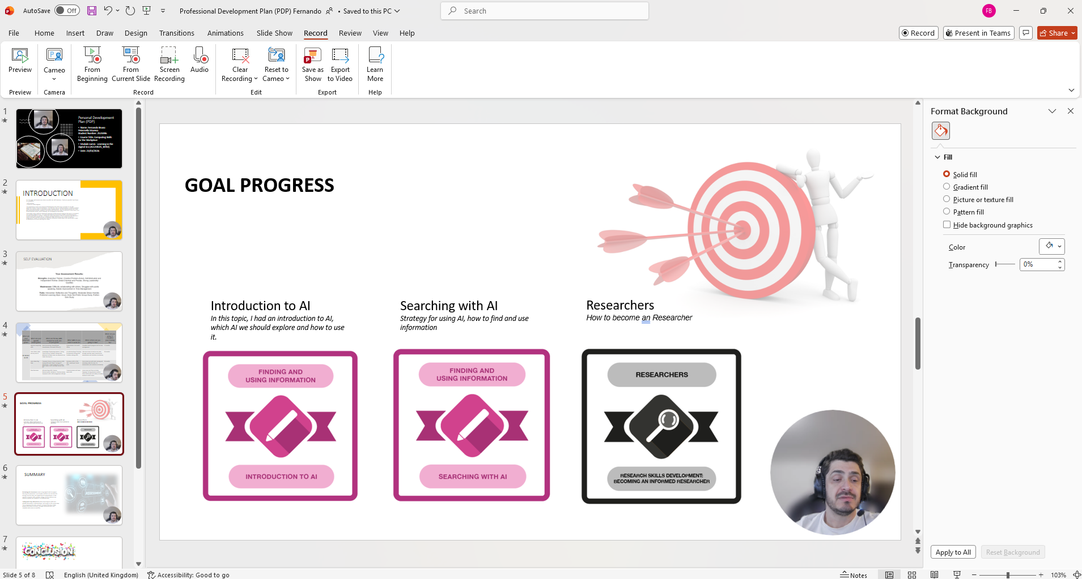

Screenshot of SUMMARY
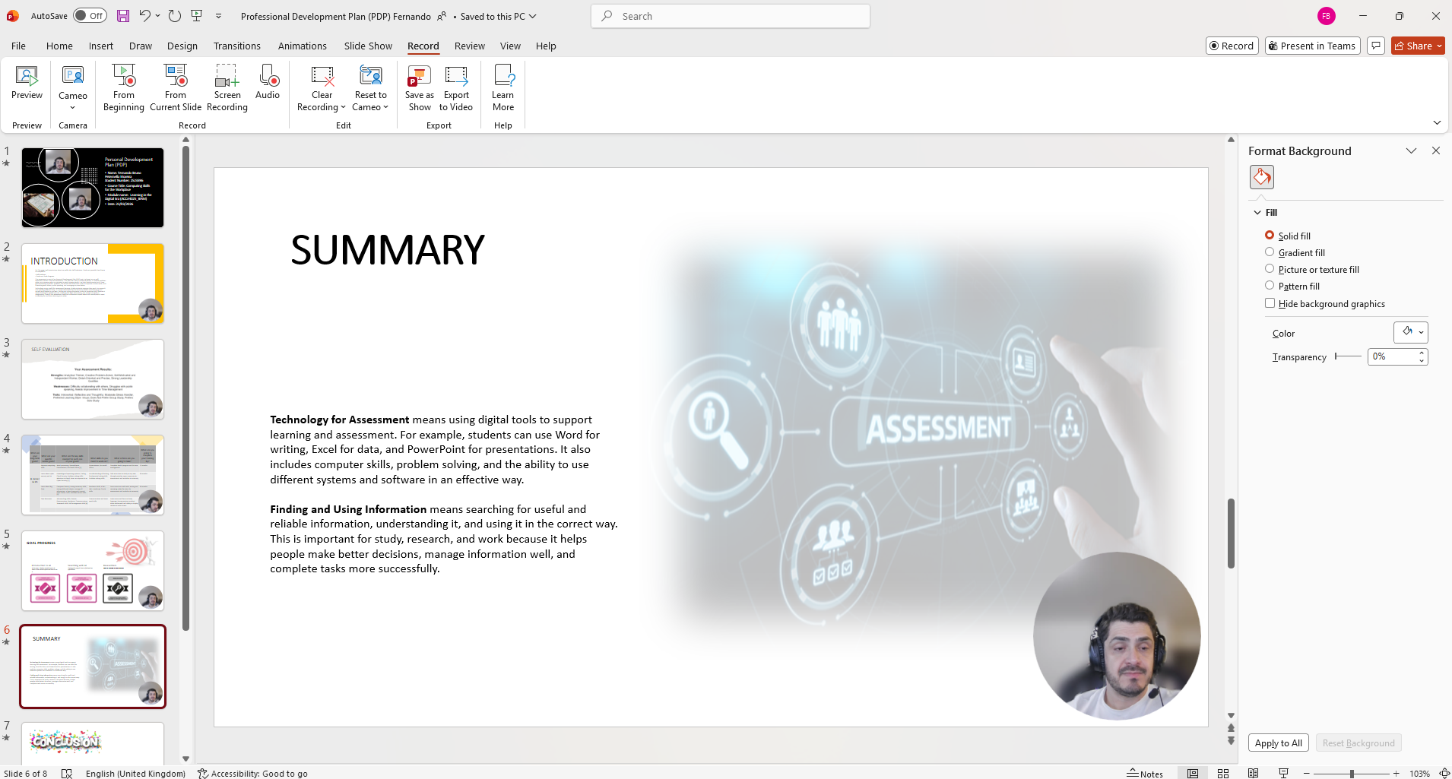

Screenshot of Conclusion
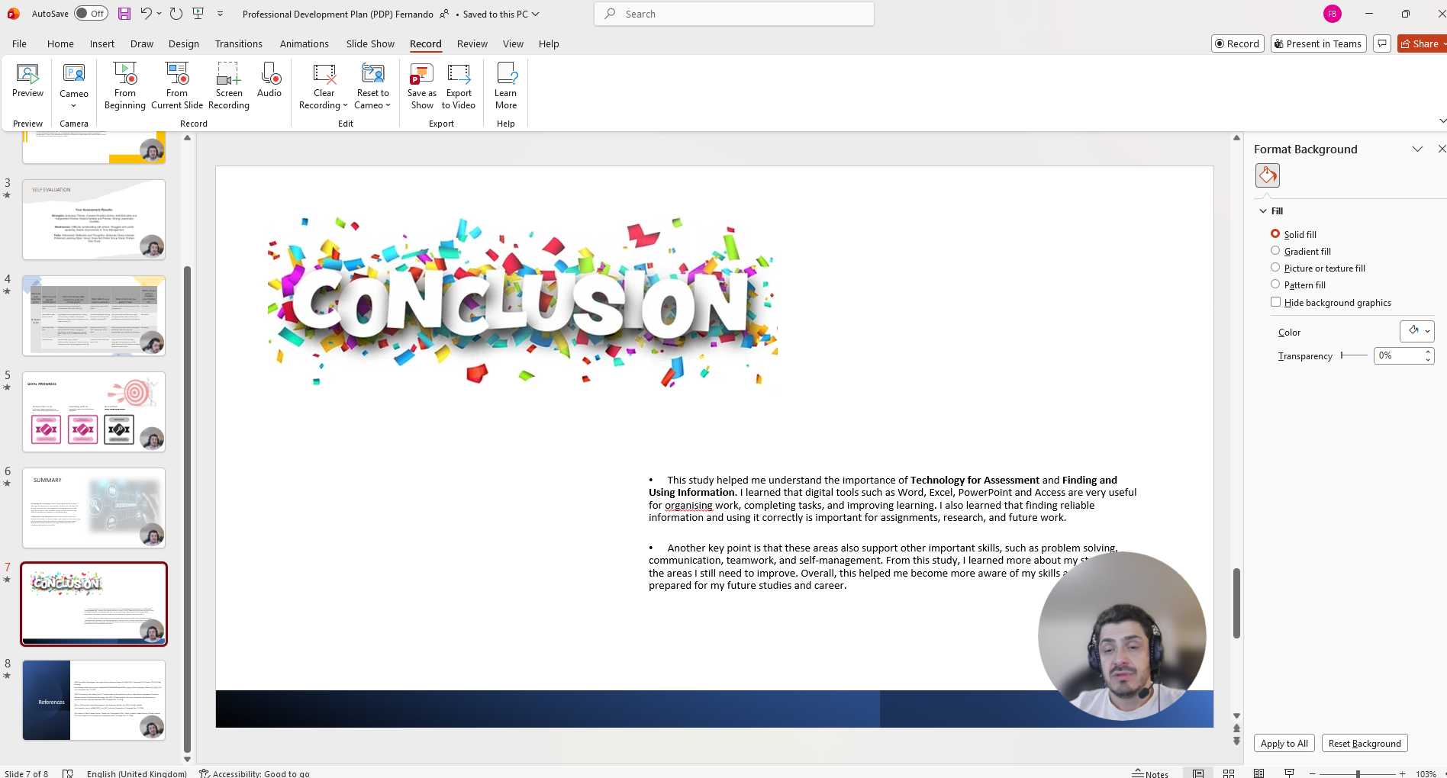

Screenshot of References


