

LEVEL 5

SEMESTER 1 & 2

MODULE CODE: SHSS5084
Expedition Skills

aSSESSMENT TYPE: Project
Assessment/Component: 2
COMPONENT WEIGHTING: 70%
WORD COUNT: 5,000 WORDS
MODULE TUTOR: DENISE LEONARD

Expedition Portfolio

Produce a detailed log of the planning for your expedition. This will include comprehensive risk assessments, route plans, emergency procedures, transport arrangements, medical forms, pre-expedition training/ preparation and any other relevant details. Further information related to this assessment can be found on Moodle under Expedition Portfolio Resources as well as on-going tutorial support.

SUBMISSION DETAILS:

Deadline:
Date: 7th February 2020
Time: 3.00pm
Portal: Turnitin

School of Sport, Health & Outdoor Education

Assessment Feedback Sheet

Student No./Name:
Module: SHSS5084
Module Code: Expedition Skills

Personal Evaluation – to support your academic progress please complete the section below BEFORE submitting your work.
What do you consider to be the best aspects of this work? |  |  | The group members and team
Which aspects do you consider could have been improved in this piece of work? |  |  | Finding more information about the campsites and how far they are from each other.
What have you found most satisfying whilst undertaking this submission? |  |  | Planning the expedition ourselves
ASSESSMENT CRITERIA | Learning  Outcomes |  | GRADE
ASSESSMENT CRITERIA |  |  | Poor  0 – 25% | Unsatisfactory  26-39% |  | Satisfactory  40 – 49% | Good  50 – 59% | Very Good  60 – 69% | Excellent  70 – 85% |  | Exceptional  86– 100% | %
Produce a well presented and comprehensive expedition planning log with logical format and clarity of purpose | 1,2,4,6 |  |  |  |  |  |  |  |  |  |  | 80%
Use of appropriate reference material | 6 |  |  |  |  |  |  |  |  |  |  | 20%
It is expected that students will present work that is proof read, correctly referenced and adheres to the Assessment Checklist. Therefore a range of 0 – 10 marks will be deducted for non-completion of any of the points on the checklist below.
TUTOR COMMENTS:

Submission date:  via Turnitin |  | Return date:  (at least within 4 weeks) |  |  | Tutor: Denise Leonard |  |  |  |  | Mark:

Assignment Checklist

- Please complete the Personal Evaluation section of the Assessment Feedback sheet, add your name and details, and paste the whole of this assignment document into the front of your assignment

- Submission is a single word file, clearly labelled with your name and module code
- Font style - Times New Roman, size -12 for text and 14 for headings
- Ink colour – black only
- Line spacing – 1.5 line spacing and 2cm- 2.5cm page margins
- Quotations more than three lines to be indented 1 line spacing
- One line space between paragraphs, paragraphs must be left aligned
- Pagination (your assignment should have page numbers)
- All tables and figures are internally referenced and have a title
- Word count checked and written at end of text (before references and any appendix)
- Assignment is within 10% of the word limit (excluding references and any appendices)
- All references in the text are included in the reference list
- Correct referencing following the Harvard style, as described in the Palgrave study skills book ‘Cite them Right’.
- Correct spelling using UK English
- Correct use of punctuation
- Grammar and syntax correct- double check anything that has a green line under it
- I have read my assignment out loud to myself and it makes sense and is easy to read
- Somebody else has read my work and it makes sense to him or her!
- I have checked and I have not plagiarised
Failure to follow these guidelines will cost you marks!

Expedition Overview
The expedition will take place in North Wales. The first day will take place in the Ogwen Valley and the mountain we will be doing is Tryfan and we will then be summiting Tryfan (SH 66391 59428) by the north ridge which is well known for the scrambling route the first route of the day is only 1.2km. We will be camping in the Bwlch between the Glyder fach and tryfan. The second day will be for us to summit glider fach (SH 65614 58251) and to descend via the Gribin we will then travel by car to a campsite in Llanberis. The third day will be summiting Snowdon we will be going up via the Watkin path which will then merge onto the Snowdon ranger path and we will follow this all the way to the summit, we will then be going down via the Watkin path all the way back down to the campsite in Llanberis. I will be driving myself and the group up to the starting point to ensure that we re there with enough time and that we have transportation throughout the expedition if required in an emergency or for traveling from one place to the other. Throughout this whole experience I aim to deliver a very well planned out expedition in which everyone ir able to learn and gain some sort of new information from the whole experience.

Aims and Objectives
The primary aim for the expedition will be for the students to gain some knowledge and history about the area while looking at the famous landmarks such as the cantilever stone in North Wales.

How will you meet your Aims and Objectives?

To achieve the aims and objectives I will have to gather the vital information which I require to lead
the expedition. The information will be important because I must know what I am talking about and
where the landmarks are on the mountain, I will also have to research some geology because here
are different types of rocks and the environment is completely different on top of some of the
mountains in which we are visiting such as the Glyder. By knowing this information, I will be abl to
get the students involved and to get them to connect to the natural environment while we are
walking through it. The expedition will be video logged to track all the progress and from this if we see anything that is of interest, we can capture it on video and reflective media presentation. Through research and previous knowledge I hope to deliver a very informative expedition and an expedition in which the participants are able to learn a number of different sills.

Description of Route

The first day will be started by climbing up tryfan, we will be taking the north ridge o tryfan which is iconic for its bouldering, we will then keep going until we reach the landmark which is the cannon. From then on we will be summiting and spending some time at the top so that everyone Can have a breather. When we descend, we will be descending into the bwlch which is the gap between Tryfan and Glyder Fach. This si where we will be spending the first night unless the plan changes while we are already up there.

The next day we will start nice and early to then summit the Glyder Fach, this is a shorter day and a much easier day than any other because we do not want to work too hard with us then having to summit Snowdon the next day. We will summit Glyder Fach and then again spend some time at the top, we will then descend following the Gribin. After reaching the bottom we will then drive to Llanberis and spend the night in a campsite ready for the third day.

The third day consists of startying to walk up the Watkin path up Snowdon but we then cut off the Watkin path and ascend via the Snowdon ranger path. We then follow this path all the way to the top. And finally, to descend Snowdon we will then walk down the Llanberis path back to the campsite in which will then spend the last night.

The fourth day will consist of us packing everything up into my car and traveling back to cynefin to return the kit ad anything that we borrowed.

Expedition Leader Profile Competencies/Qualifications

The leader of the expedition will be myself as I have devised the route that we are going to take. I have the one who has gone and done the routes beforehand so that i know the best possible routes and where we will be able to get out safely if something happens. My qualifications and competencies are vast, I worked in an outdoor centre for a year and have freelanced for 2 years now this gives me the basic leadership skills which are required to take a group out for a few days. I have several different qualifications which vary from water sports to archery and high ropes courses, this will allow me to safely conduct the expedition. I have also been on a 3-day canoeing expedition on the River Severn in which we all participants took in turns to lead different aspects of the expedition. As I have grown up in Anglesey the mountain range of Snowdonia was where I went walking all the time therefore, I have grown up on the mountains in which we intend on summiting. I believe that I am competent to lead such expedition in a safe environment and for the whole group to be in a learning environment as we go day to day on the mountains. I also have 2 different first aid qualifications which are still in date and will be throughout the expedition. I have my Red Cross first and and I also hold a recreational first aid certificate. Throughout my childhood I have been visiting these mountains and with this prior knowledge of what to look out for and the skills I require to lead safely on a mountain I will be able to deliver a safe and exciting expedition.

Expedition Assistant Leader Profile Expedition
The expedition team leader will me Sam Hamer, he is a very competent walker and climber who has
Summited a number of different mountains around Wales and England, he is currently working for
Preseli Adventure in which he must take groups to do certain activities. This clearly shows there is
Some leadership skills there and the ability to adapt because a session is always different because of
the people that you take with you. This is a very good quality to have as an Assistant leader. Sam
also has the skills to navigate in the mountains which means he can also help me with teaching the
rest of the group how to use a map and a compass. I have also been going on days out with Sam so that I am able to see if he has the capability to lead a group and to ensure that everything that everything and every decision he makes is safe and that everyone is able to follow the decision made.

Team Profiles
The team I have chosen is Edward and Niall, I have chosen these two to be part of the expedition
because the expedition itself is not easy, there is a lot of ground to cover and there are a number of
different obstacles in which we need to overcome and these two have proven to me by going on
mountain days with them that they have the ability and the competence to be able to take on this
long and hard expedition. Edward is a keen camper and a keen walker which means he can very well
teach us a thing or two while undertaking the expedition.

Expedition Support Person
The expedition support person will be my father, he knows the area very well as he is the one to go with me Every time that I have gone so he is competent with all the walking, he has also worked for the RAF (RoyalAir Force) and from this experience he knows how to read a map and how to use a compass therefore if we are lost and don’t know where we are but know the grid reference, he will then be able to locate us safely he also has friends which are in the mountain rescue team if the expedition takes a big turn for the worst.
He has no qualifications but has 28 years’ experience with these sorts of things.

Another expedition support person will be my old teacher from my secondary school, she is a trained ML Leader and is more than competent enough to find us and to walk on the different terrain in which we plan on doing. I have been on many mountain days with her and I have seen firsthand that she is competent and reliable as a support person.

First Aid Provisions
I will be carrying a first aid kit which includes the following:
In addition to this all of our team members are first aid trained.

Medication
- 16 x Paracetamol Tablets (not included in EU kit)
- 16 x Ibuprofen Tablets (not included in EU kit)

Bandages
- 2 x Open Woven Bandages 7.5cm x 5m
- 1 x Crepe Bandage 5cm x 4.5m
- 1 x Crepe Bandage 7.5cm x 4.5m
- 2 x Triangular Calico Bandage 90 x 127cm

Preparations, Disposables & Tapes
- 10 x Hygienic Cleansing Wipes (11 x in EU kit)
- 1 x Micropore Tape 2.5cm x 5m
- 1 x Zinc Oxide Tape 2.5cm x 2m
- 1 x Duct Tape 2m Roll
- 10 x 4-Ply Gauze Swabs 5 x 5cm
- 3 x Burn Gel Sachets 3.5g

Dressings
- 1 x Pack of Assorted Plasters
- 2 x Medium Wound Dressing 12 x 12cm
- 2 x Low Adherent Dressings 5 x 5cm
- 2 x Low Adherent Dressings 10 x 10cm
- 1 x Small Plaster Fabric Strip 4cm x 1m
- 1 x Large Plaster Fabric Strip 7.5cm x 1m
- 6 x Wound Closure Strips (9 x in EU kit)
- 1 x Small Eyepad Wound Dressing
- 2 x Blister Plasters

Accident Report Form
If someone has an accident then we will then have to fill out one of these forms, we will then have to deliver these forms to the university. All of the correct data will be filled and from then there will be a record of what happened and what was needed to be used on the person such as plasters or tablets etc.

Medical Declaration form
To ensure that I am aware of any sort of medical condition within my team I have asked the participants to all ill out a medical declaration from so that I am able to see if anyone needs anything specific.

Behavioural Expectations
- There are several behavioural expectations when undertaking this expedition:
- Consider the local community and other people enjoying the outdoors
- Leave gates and property as you find them and follow paths unless wider access is available
- Protect the natural environment
- Enjoy the outdoors
Meal Plan
We will be gathering closer to the time to ensure that we all have food that we like and make sure that everyone brings enough for them to function for 3 days.
Group Kit List
- Group shelter
- Tarp
- Tarp poles
Essential kit
• Walking boots
• Waterproof jacket and trousers
• Warm winter socks / ski socks
• Thermal base layer (synthetic fibers, NOT cotton)
• Fleece mid layer
• Mountain trousers (synthetic fabric, NOT Jeans)
• Hat and Buff / balaclava
• Insulated waterproof gloves
• Spare warm layer (fleece / synthetic or down jacket)
• Rucksack (around 50L with a waterproof liner bag)
• Survival Bag
• Water bottle / bladder
• Food (high energy and substantial)
• Head torch and spare batteries / spare torch
• Sunglasses and sun cream
• Whistle
• Maps of area
• Compass
• Personal first aid and medication
• Mobile phone
• Sleeping bag
• Insulating mat
• Spoon
• Mug
• Bowl
• Stove and pans
• Food to cook
• Snacks & Hot drinks
• Set of spare clothing and socks to sleep in
• Poop Kit
• Deck of cards / games / book (Optional)
• Lighter and fuel

Equipment Request Form
There is an equipment request from which each participant mst fill out if they are taking any sort of kit from the university stores. The lecturers will have a copy of this as well to ensure that they can keep track of who has what and how many things we have taken out. This will ensure that we will not take any sort of kit on the mountains or at campsites.

Preparatory Training
The training that I have concluded is for me to go to a different mountain and start off in different locations, in some of the days I have not planned the route I am taking but to only use a map and a compass to manoeuvre myself around to find a path and to follow it to the summit. The training I have done, and the other participants is we have all spent days climbing and walking mountains, we went at least once a week with the university, and from these experiences everyone will be gaining knowledge. I have also been up these specific mountains several times and I know them very well. From this I will be able to use my experience of going up these specific mountains to aid us in the navigation part of the whole expedition. I will e holding weekly sessions in the gym on the treadmills where we will use them for altitude training so that everyone is getting used to walking long distances uphill. Through this fitness will increase and this will then make it easier. We will then push on and do some more treadmill work carrying bags which have a weight of around 40-50kg so that we are used to carrying heavy weight while walking at an ascent because we will be carrying a number of different kit up the mountains so we will not be as fatigued when walking up. We will also be meeting closer to the time to ensure that everyone has an idea of the route and hat everyone knows everything that’s necessary to the expedition and for everyone to be able to have a second look through everything and make sure that they themselves are prepared for the whole expedition.

Undertaken Reconnaissance of Expedition Route
For the reconnaissance I have gone to the north ridge of Tryfan and I have completed the path 3 times, with the extension of looking for the landmarks in which I did find all 3 times that I went there. The Glyder Fach I have summited 3 times also and have an understanding of the terrain while up there. Snowdon, I have summited over 20 times and the path in which we are planned to take I have done 6 times in different weather conditions, I have walked this path in complete darkness and I have also completed the path when it was gusting over 70mph. Therefore, I do believe that I am competent enough to complete the task that is at hand. I have also done a lot of research to ensure that I know which paths to take depending on the weather and how long each part of the journey is going to be so that we do not fall behind on anything. It is a very hard few days so if we fall behind at any point it will not benefit us at all because we have a lot of walking to do and we also have a lot of meters to climb each day. There are a number of different ways that we can go up the mountains and they may be subject to change so I have planned out a number of different routes that we are able to take and I have also planned out some shortcuts just in-case we ae running low on how much time we have to complete the day and reach the place we are spending the night.

Route Cards
Because we are going to summit 3 different mountains, I have made a brief overview and specific things we need to look out for when we are out there on our expedition. These route cards will be printed out and everyone will have one, they will also be able to access them online. Included in the route cards are the grid references of specific things that we need to look out for. There will be altitude as well because we are going to go up mountains, so altitude is an especially important part of this specifically because we are going to go up mountains. The route cards are basic but there will be a number of different things that will help us on mountains such as landmarks or even signs, from this and my previous knowledge we will be able to follow a route and navigate it well. The carpark only has a portaloo, but better than nothing. The Snowdon Ranger Youth Hostel is the most convenient accommodation for those walking this path, and part of the history of the trail.

Escape Routes
The escape routers are going t be vital to the expedition, there are plans if we need to get off any mountain at any time.
On the first day when we are going to summit Tryfan there are a number of different ways in which you are able to summit this mountain and we are going to go up the north ridge which requires some more climbing and scrambling. Because of this there isn’t much we can do for an escape route, but running alongside the climbing part is a path and we are able to take this down to the bottom of the mountain where we will be able to get everything under control ad take further actions from there.

On the second day when we are going to summit the Glyder fach if something happens during that climb there are several ways of getting back down to a road or a path which we can gather everything and again assess the situation from that.

On the last day which is to summit Snowdon there are a number of different paths leading up to the top which means there are a number of different paths we are able to use just in case anything goes wrong, depending on where we are on the mountain will determine which path we will take because of the different locations that are on the mountain.

In any instance of injury or if something goes wrong, we will head straight down the mountain onto a road and phone for assistance and for guidance on any specific thing which has happened while we were undertaking the task.

Contingency Planning
If the weather takes a turn for the worst the contingency plan is to move away from the Ogwen valley and instead to try and summit Moel Shabod, this mountain lies further south than the other mountains and the weather might not be the same as it is up in the Ogwen Valley. If the weather is completely inadequate for any sort of mountain terrain we will then make our way to Bedd Gelert and we will do a lowland walk around the area also talking about the history that comes along with the area which is the famous welsh dog Gelert. It all depends on what the weather is doing because if the weather is very bad we will have to change it and we will then have to do a lowland walk instead and there are a number of different walks we can do. We can stay in the ogwen valley and walk around the lake if the weather takes a turn for the worst, we can then continue our planned route but we wont be going up any mountains if it gets too dangerous.

Camping Location
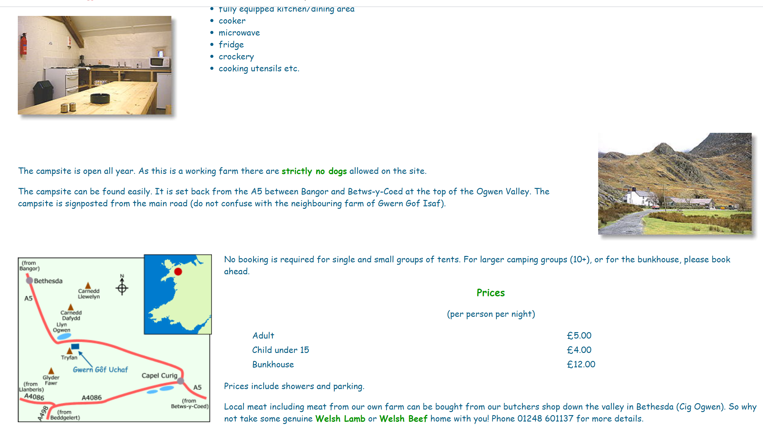

This is the second campsite in which we intend to use, which isn’t far from where we will be coming down from the mountains. There is a small fee for these but the only fee from this whole expedition will be the food that everyone brings and the camping fees. We will be traveling by car which I own and I will not ask for any sort of petrol money to make it as cheap as possible for the other participants.


This campsite is the one we will use for our last day it is based in Nant Peris which isn’t too far from the town itself and not far from the Llanberis path either and there is where we intend to start out journey.

The campsites are up for discussion because there is an option for us to not stay at a campsite, we can stay in bothies if we want a change of scenery. There are a number of possible bothies that we could use along the way so if people wanted to we are able to to go to these and use them. Bothies are of course first come first serve so if people do decide to stay in a bothie and other people are there, we are then able to use the campsite as a plan B which will then ensure that we have somewhere to stay during the nights. It is important we conduct ourselves correctly while staying in Bothies we are representing the university so again the code of conduct must come into play because if other people are in the bothie as well, we must conduct ourselves in a professional manner. I have acquainted myself with the Bothies Code of Practice and will ensure that everyone is aware of the code as well to ensure that we do not break any rules and that we again conduct our way in a professional manner.

Weather Forecast
This is the weather forecast of the 3 days in which we plan to go on the expedition, something to bear in mind is these forecasts are not directly from the summit but from locations very near to them. Therefore, we must take into consideration when analysing this data for when the expedition takes place. More and more data will be collected nearer to the date so we can have the best possible results, these will then be cross referenced wit other sites to ensure that we get a suitable and accurate reading on the weather. Another thing to bear in mind is for every 100 meters you gain the temperature will drop 1 degrees Celsius.

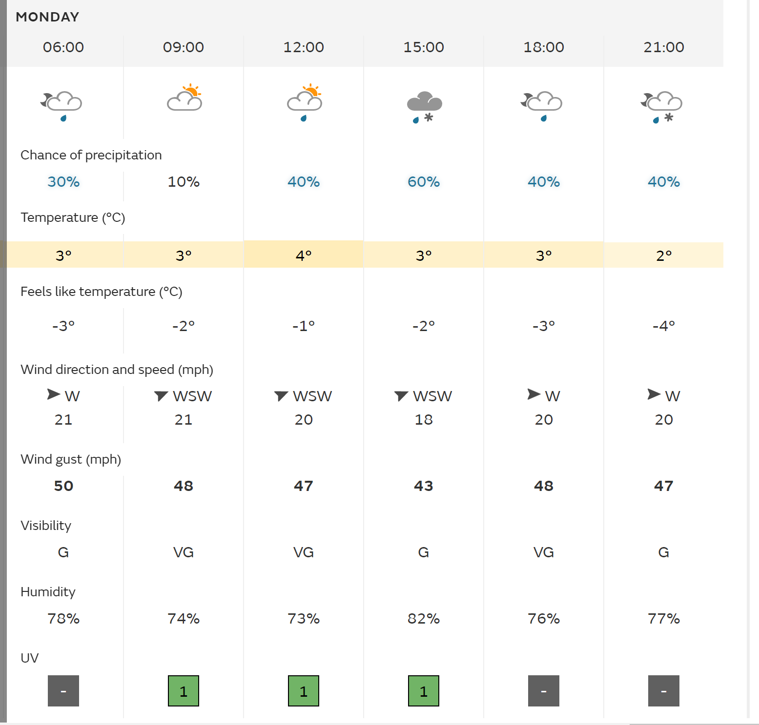

The first day doesn’t look bad at all only that we have heavy rain from 3 o’clock this is only a 60% chance that it is going to rain but we need to make sure that everything we wear and pack will be waterproof o that we are not sleeping in a sopping wet tent. The wind is gusting upwards to 48mph and this is a very big factor to take into consideration when we are going to go walking up mountains because you are more exposed. On the first day we will be walking up Tryfan from the north ridge, will in terms mean that the wind will be to your left and behind us which will be pushing us onto the rocks. The visibility is between Good and Very Good so there wont be a problem finding the landmarks and there will not be much of a problem with seeing the views and speaking about the subjects in which I have researched. The temperature on the day feels like 3-4 degrees Celsius.

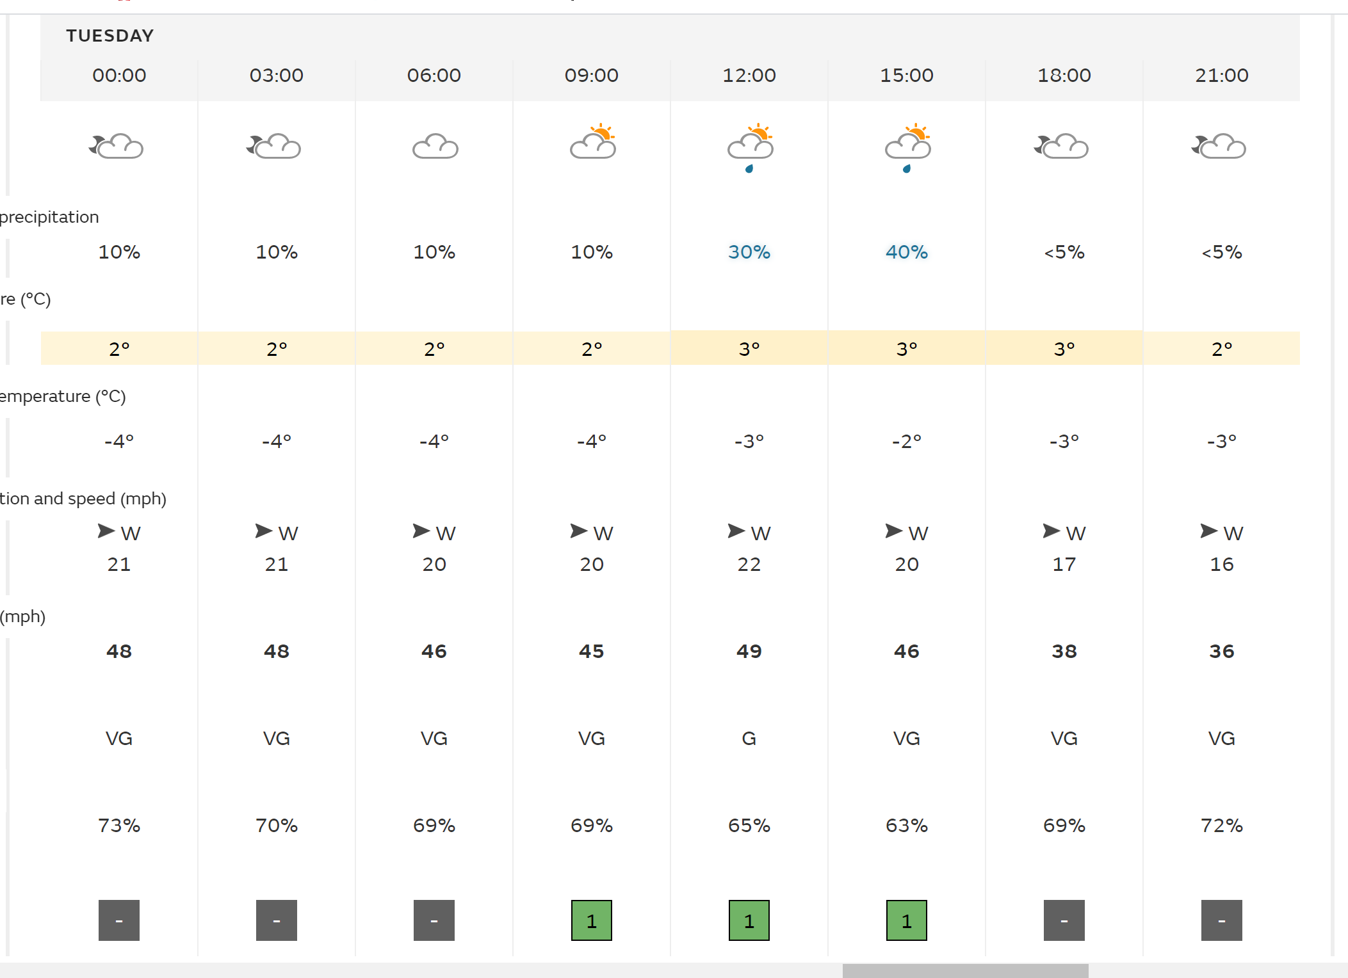

The second day is much nicer there is only a maximum of 40% chance of rain and that is at 3 o’clock, the wind is starts off very gusty at a rate of approximately 48 mph but as they day goes on the wind slows down a little and start to enter the 30mph range. Throughout the day the visibility will be Very Good this means when we are going to be at the summit, we will be able to see many things and it will not be hard to find the landmarks. The temperature feels like -4 degrees Celsius. (L, 2007)
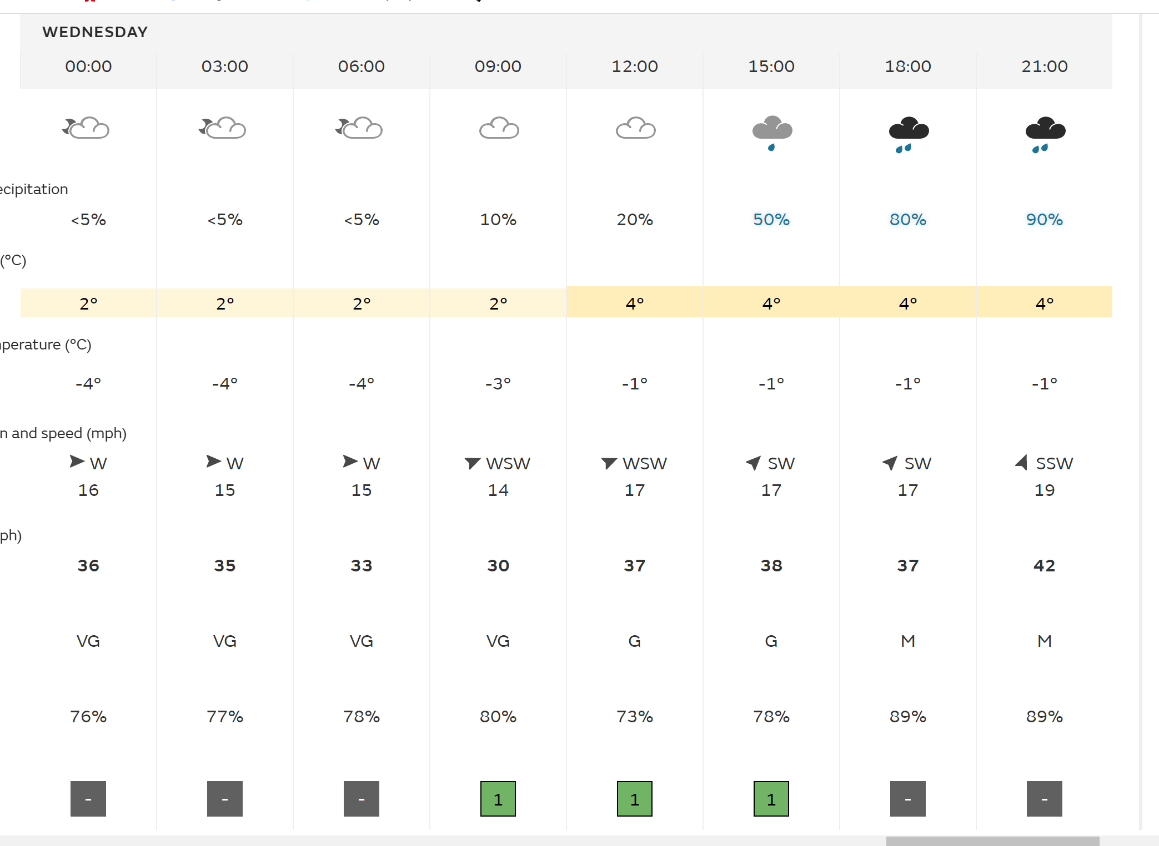
On the third day it there is a 50% chance of rain from 3 o’clock but from 10 o’clock there is a 80% chance of rain, this mean we need to make sure that the camp is properly set up so that no rain comes into the tent on the final day. The visibility is Very Good but as it hits 10 o’clock it goes down to moderate, but by this time we will most definitely be off the mountain and this will only affect us if ad when we are at camp. The temperature for that day feel like -4 degrees Celsius so plenty of warm clothing must be prepared before hand to ensure that we all have a warm day and night. (Government, 2020)

I will be checking much closer to the time when we actually go on our expeditions if the weather is going to change or not, the whole expedition depends on how the weather is and when we are going to go and where we are going to go. It is vital that I do check to see if the weather changes because if it takes a turn for the worst then worst comes to worst we will not even be able to go on the expedition due to it being up in the mountains and when it rains it becomes way more dangerous and it’s a completely different ball game when the surfaces are slippery.

General Risk assessment
I have created a general risk assessment for the expedition which is based around hill walking and hiking to ensure that we have covered all the possible dangers ao that everyone is aware of the potential risks hat they are going to be exposed to while hill walking. A university risk assessment will always also be kept on my person to ensure that safety of others around us.

Drivers Licence

I am a full drivers licence holder
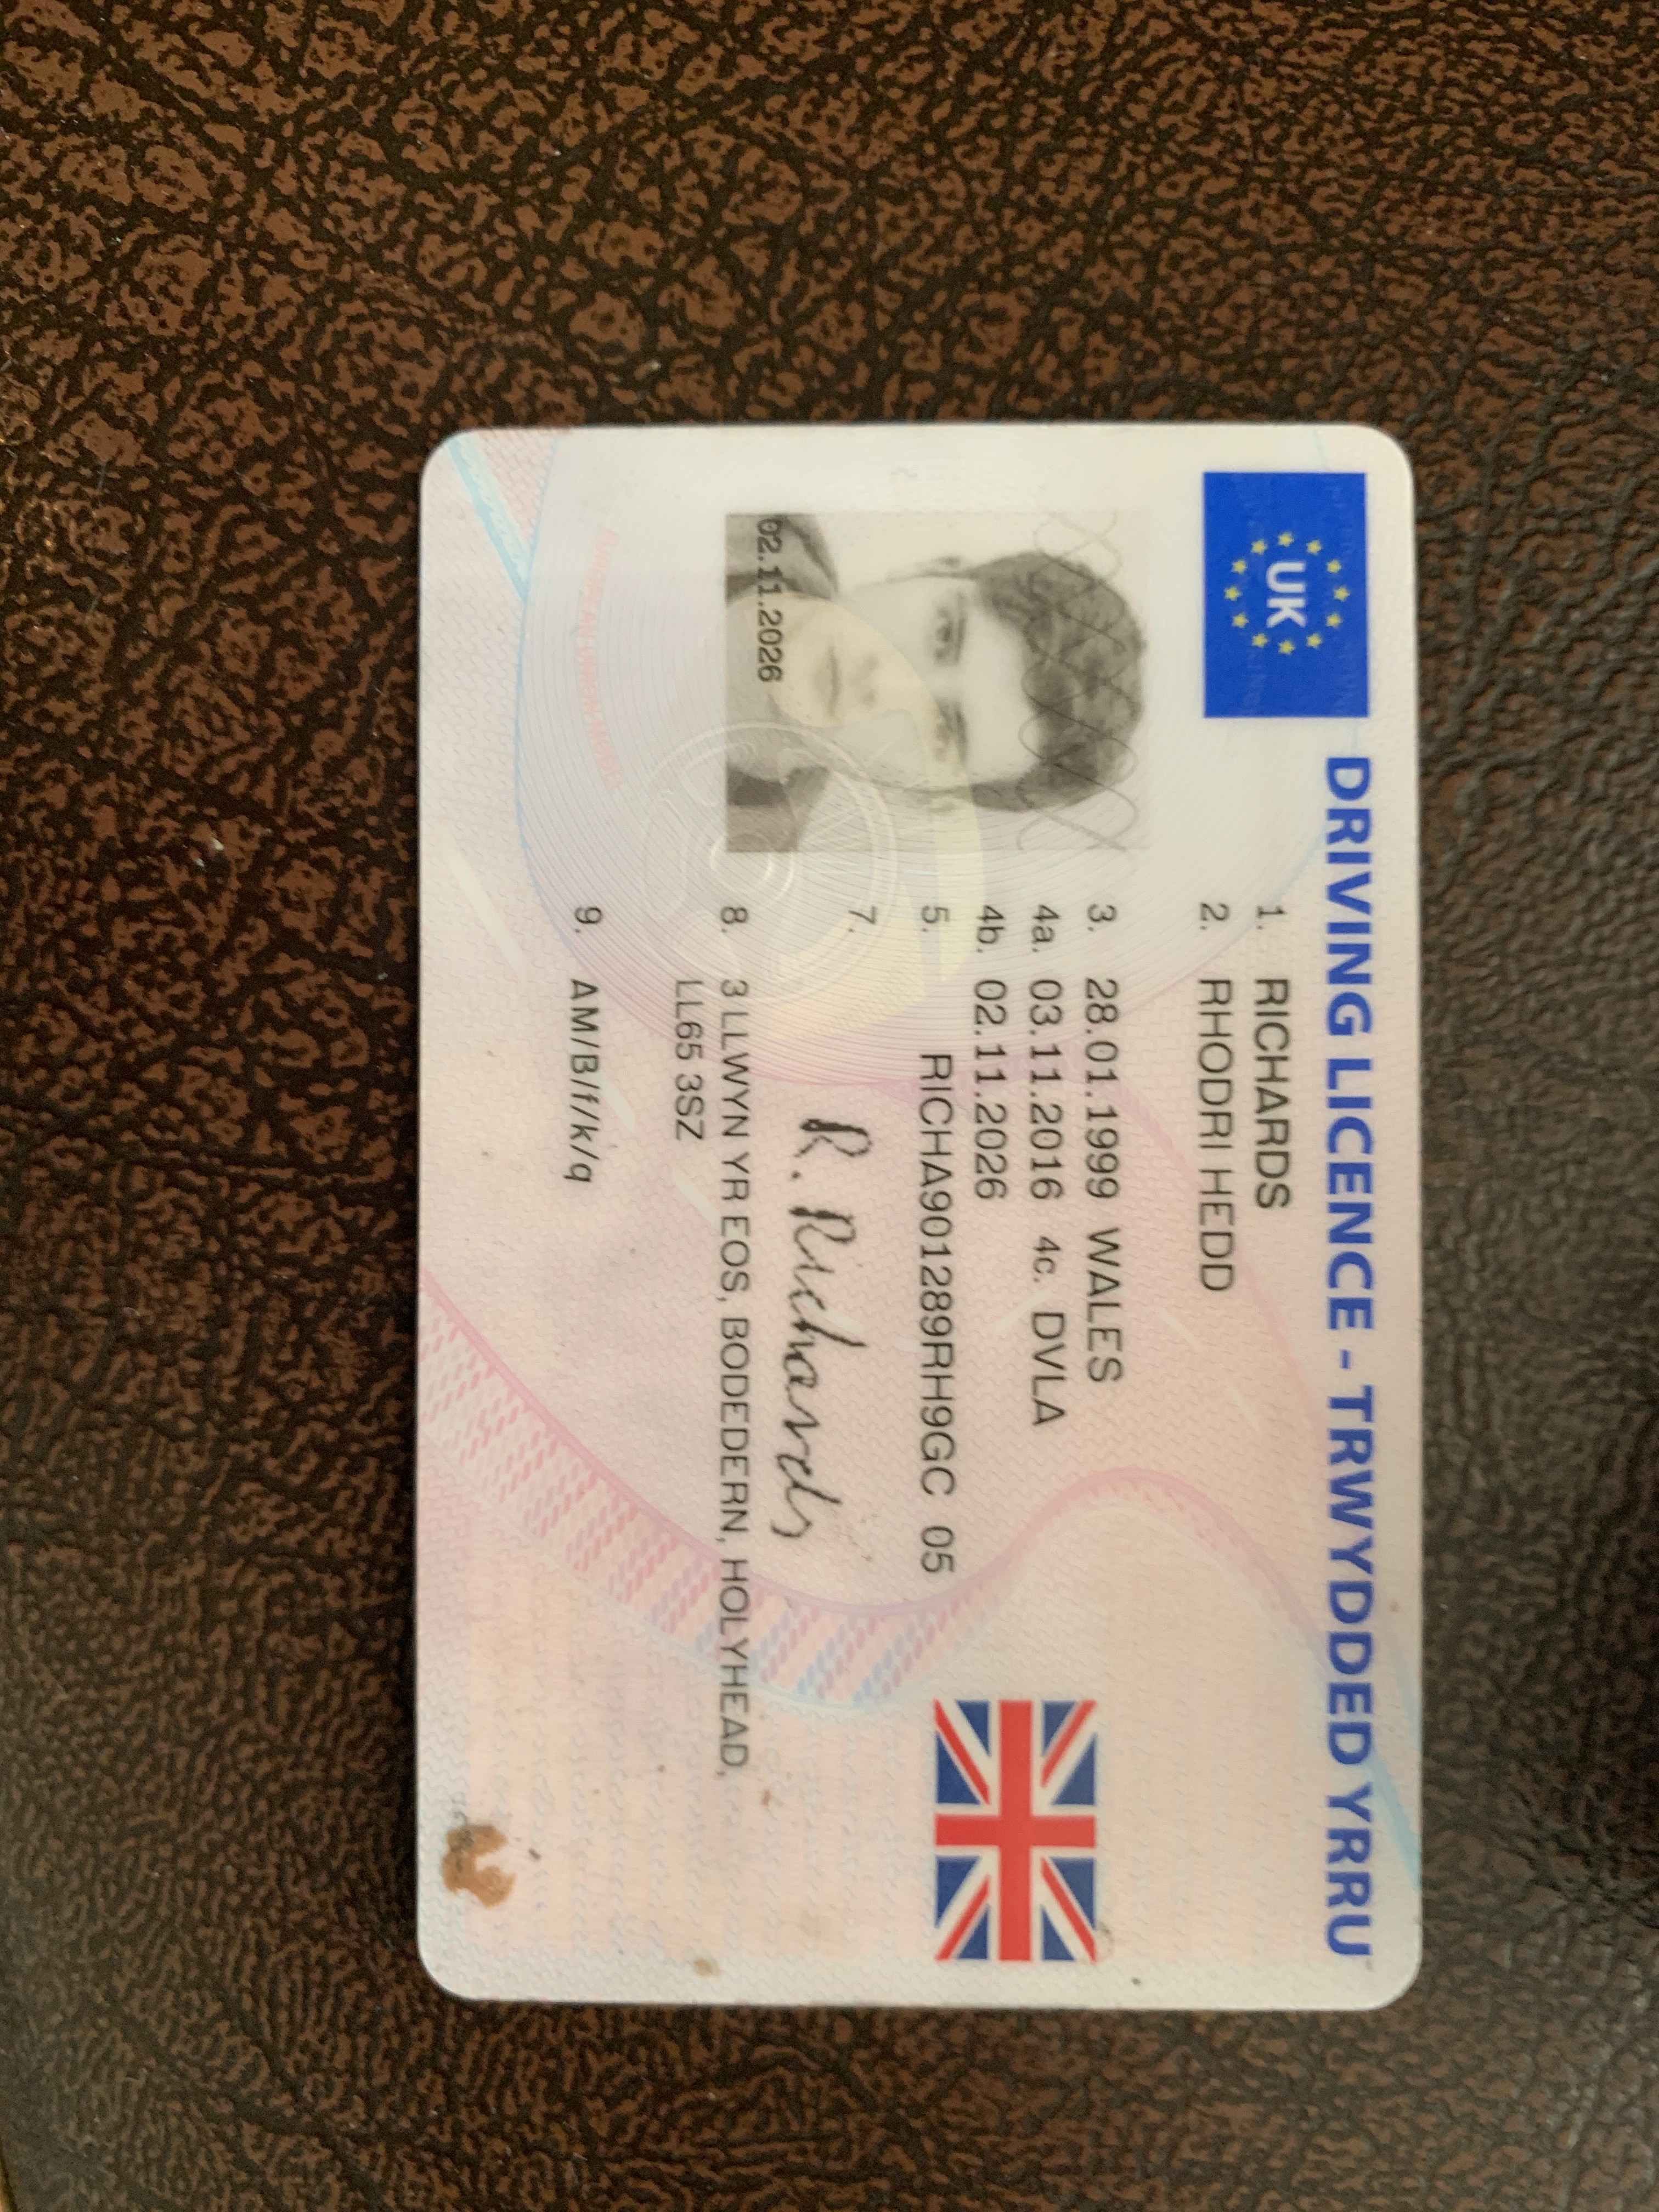

Drivers Insurance
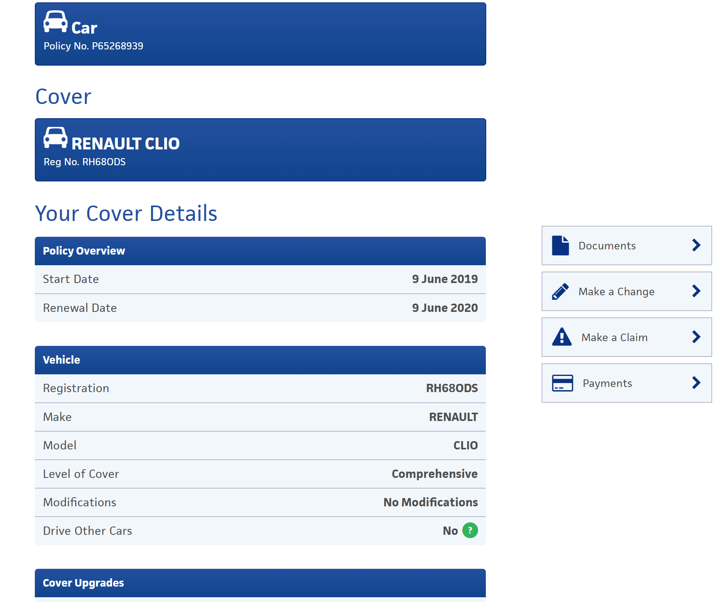

I am fully insured on the car which I have already payed for, I am not insured to drive other vehicles, but other vehicles are not needed throughout this expedition.

Road Worthiness of Vehicle

My car does not currently have a MOT due to it being a brand-new car which was made at the end of 2019 and is not due a MOT until 2022

I will be able to use my car and fir everyone in with all of the equipment so we will be able to use my car for any necessary journeys such as having to go to the hospital if needed and coming home.

Important Contact Details
Marc Richards- 07957536839
Carol Gryffyth- 07879075632

Accident and Emergency Procedures

Accident and Emergency Procedures relate to the need to deal with any event throughout the duration of your expedition, in which a physical injury occurs to any expedition team member.

You are expected to deal with accidents, to the best of your abilities, and within the recommendations and remit of your first aid qualification. Where recruitment of further assistance (Emergency Services) is essential, you are required to inform a member of module staff, as soon as possible.

If it is necessary to send an expedition member to hospital, you must ensure that at least one other member accompanies the injured party.

To facilitate the processes outlined above, it is essential you complete the following, specific to your expedition:

Word Count: 4601

Bibliography
Government, 2020. Met Office. [Online]
Available at: https://www.metoffice.gov.uk/
[Accessed 2 Febuary 2020].
L, F., 2007. Different methods for estimating the mean radiant temperature in an outdoor urban setting. International Journal of Climatology, 27(14), p. 45.

Appendix

Equipment Request Form

Name:

Dates of Expedition:

Date of collection:

Date of Return:

Item/s | Serviceable check or | Date of Return

I have checked and agree that all the equipment is complete and serviceable.

Signature:

Date:

Activity: Hill Walking

Hazard | Control Measures | Monitoring
Standard of Instruction | - All staff leading activities shall hold appropriate, current qualifications | - All qualifications and training will be verified and logged in the Staff Training Log
 | - On going CPD | - CPD Files
Hostile Environment | - Students clothing assessed as appropriate before departure | - Students who repeatedly attend inappropriately clothed will not be aloud to attend sessions.
 | - Appropriate resources available at Ystrad
 | - Due consideration to weather forecast
Medical Emergency | - Students’ medical records are checked and relevant precautions taken. | - Student Medical Forms
 | - Staff are trained in first aid and carry appropriate first aid equipment | - Staff Training Log
 | - A complete list of all students and staff and any relevant medical information made available to all staff before departure
Falling Objects | - Correctly fitting rock climbing helmets to be worn when appropriate | - Staff to ensure correct fitting and monitor and enforce
Falling | - Correctly fitting rock climbing helmets to be worn when appropriate | - Staff to ensure correct fitting and monitor and enforce
 | - Use of appropriate footwear | - Staff to ensure correct fitting and monitor and enforce
Being Lost | - Staff and students to agree being lost procedure.  - All students to have staff mobile contact numbers | - Staff to ensure correct fitting and monitor and enforce

Activity: Camping

Hazard | Control Measures | Monitoring
Standard of Instruction | - All staff leading activities shall hold appropriate, current qualifications | - All qualifications and training will be verified and logged in the Staff Training Log
 | - On going CPD | - CPD Files
Hostile Environment | - Students clothing assessed as appropriate before departure | - Students who repeatedly attend inappropriately clothed will not be aloud to attend sessions.
 | - Appropriate resources available at Ystrad
 | - Due consideration to weather forecast
Medical Emergency | - Students’ medical records are checked and relevant precautions taken. | - Student Medical Forms
 | - Staff are trained in first aid and carry appropriate first aid equipment | - Staff Training Log
 | - A complete list of all students and staff and any relevant medical information made available to all staff before departure
Fire | - Cooking, Barbecuing and Smoking only permitted safe distance from tents
Being Lost | - Staff and students to agree being lost procedure.  - All students to have staff mobile contact numbers | - Staff to ensure correct fitting and monitor and enforce

Emergency Information:

Local Hospital:
Name:
Address:
Tel:
A&E: Yes / No

Local GP Service:
Name:
Address:
Tel:

Local Dentist:
Name:
Address:
Tel:

Media Guidance
If at any point during your expedition, the media approaches you, please adopt a “No Comment” response and refer them to a member of module staff.

Expedition Team Contact Details

Expedition Leader:
Name: Number:

Expedition Assistant Leader:
Name: Number:

Expedition Support Person:
Name: Number:

Expedition Team Member:
Name: Number:

Expedition Team Member:
Name: Number:

Expedition Team Member:
Name: Number:

Expedition Team Member:
Name: Number:

Expedition Team Member:
Name: Number:

Expedition Date:
Venue:

Campsite 1 Date:
Location:

Campsite 2 Date:
Location:

Campsite 3 Date:
Location:

Campsite 4 Date:
Location:

Expedition Contract

I will run my expedition between the dates of

I will at all times, conduct myself as professionally as possible, adhering to the University’s Code of Conduct, and only operate within the agreed parameters of my signed-off expedition, as outlined below.

I will be running an expedition by foot / bike

The aims and objectives of my expedition are:

The venues I have chosen to use are:
Day 1:
Day 2:
Day 3:
Day 4:

My appointed assistant leader is:

The members of my expedition group are:
1:
2:
3:
4:
5:

I have checked the abilities of all expedition group members and deem them able to partake in the expedition.

I have collected relevant and up-to-date medical details from each expedition group member and am aware of any condition that may affect their ability during the expedition.

In signing this document I agree to everything listed overleaf. I understand that I must adhere to all the documents and risk assessments I have submitted for which my expedition has been signed off.

Expedition Leader Module Staff

Name: Name: Tom Moore

Signed: Signed:

Date: Date:

Assumption of Risk Form.

SHSS5084 EXPEDITION SKILLS
ASSUMPTION OF RISK FORM

(Please read this document carefully)

Expedition’s that are run as part of module SHSS5084 Expedition Leadership inherent in the Outdoor Adventure Education programme at the University of Wales: Trinity Saint David, can take place both at day and night and in different environments, which might be considered remote or hostile, often without easy access to advanced medical or other facilities.

I (full name) ________________________________________ ____________
acknowledge and accept that participation in an expedition of this nature entails both known and unanticipated risks, which could result in damage to my property, physical or emotional injury, paralysis or death. I understand that such risks cannot be eliminated without jeopardising the fundamental qualities of the expedition. By participating in this expedition I accept these risks and take responsibility for my own actions and involvement.

I accept the fact that I have a personal duty and responsibility to learn and to follow safety guidelines and procedures established by the expedition leaders:
Expedition Leader: Harry Bowler
Assistant Leader: Sam Chivers

I undertake to inform those named above, at any point during the expedition process, should I not understand what is expected of me or should I not wish to further participate in the expedition. However, due to the venues being used, I understand that it might not always be possible to simply stop or withdraw immediately from the expedition.

I am physically and mentally fit to participate in this expedition. I have completed a medical form that is accurate and true. I agree to notify the expedition leaders of any changes to my health or fitness. If I become ill or injured I give my consent for first aid to be administered and for provision of other medical treatment or rescue services as required.

Signed: ________________________________ Date: _____________________

Accident report form

This form must be completed and sent to the module coordinator as soon as possible after an accident. If operating in a remote area it must be sent within 24 hours of returning to the expeditions operating base.

A verbal notification and a brief account of circumstances of the incident must be phoned through to the module coordinator as soon as possible after the accident.

Expedition Leader:

Second in Charge:

Date of Accident:

Place of Accident:

Name of Casualty

or Casualties:

Circumstances leading up to the accident including details of the route being followed or activity being undertaken, the weather, conditions underfoot, etc:

Description of the accident:

Description of the injuries sustained by the casualty(s):

Details of actions taken to treat the casualty(s):

Details of actions taken to safeguard the rest of the group:

Recommended actions to be taken by Expedition Leader to prevent a similar case recurring:

Details of any witnesses to the accident include on a separate sheet a written statement from the witness if possible:

Name:

Address:

Post Code: Tel:

Name:

Address:

Post Code: Tel:

Name:

Address:

Post Code: Tel:

Details of police officer or other relevant authorities informed:

Name:

Status/authority:

Address:

Post Code: Tel:

Name:

Status/authority:

Address:

Post Code: Tel:

Medical Decleration form

Please complete this form as accurately and truthfully as possible. The information you disclose will be confidential and will only be used to help the expedition leaders respond to an injury or illness.

Name: _____________________________________________ D.O.B.:______________________

Address: ________________________________________________________________________

________________________________________________________________________________

Mobile Number: __________________________________________________________________

Next of Kin/Guardian Name: ________________________________________________________

Next of Kin/Guardian Contact Number: ________________________________________________

If you answer yes to any of the following questions, please give brief details in the space provided.

1. Do you currently suffer from any physical or psychological medical conditions/ailments?
________________________________________________________________________________

2. Are you currently taking any form of medication?
________________________________________________________________________________

3. Do you have any form of allergy?
________________________________________________________________________________

4. Do you currently have any injuries or ailments?
________________________________________________________________________________

5. Do you have history of any physical or psychological medical conditions, injuries or ailments that may affect your participation in any aspect of the programme?
________________________________________________________________________________

If you have answered yes to any of the questions above, please use the space provided on the back of this sheet to give further details, and ensure you discuss this with the expedition leaders.

I declare that the information on this form is as accurate and truthful as possible.
I acknowledge it is my responsibility to keep expedition leaders informed of any information stated here in, or changes to this information, that may affect my participation in the expedition.

Signature: _________________________ Date: ________
ASSUMPTION OF RISK FORM

(Please read this document carefully)

Expedition’s that are run as part of module SHSS5084 Expedition Leadership inherent in the Outdoor Adventure Education programme at the University of Wales: Trinity Saint David, can take place both at day and night and in different environments, which might be considered remote or hostile, often without easy access to advanced medical or other facilities.

I (full name) ________________________________________ ____________
acknowledge and accept that participation in an expedition of this nature entails both known and unanticipated risks, which could result in damage to my property, physical or emotional injury, paralysis or death. I understand that such risks cannot be eliminated without jeopardising the fundamental qualities of the expedition. By participating in this expedition, I accept these risks and take responsibility for my own actions and involvement.

I accept the fact that I have a personal duty and responsibility to learn and to follow safety guidelines and procedures established by the expedition leaders:
Expedition Leader: _____________________________________________________
Assistant Leader: _____________________________________________________

I undertake to inform those named above, at any point during the expedition process, should I not understand what is expected of me or should I not wish to further participate in the expedition. However, due to the venues being used, I understand that it might not always be possible to simply stop or withdraw immediately from the expedition.

I am physically and mentally fit to participate in this expedition. I have completed a medical form that is accurate and true. I agree to notify the expedition leaders of any changes to my health or fitness. If I become ill or injured I give my consent for first aid to be administered and for provision of other medical treatment or rescue services as required.

Signed: ________________________________ Date: _____________________

