

Critical Analysis of Factors Affecting Performance of Clinical Desk Clinicians within Integrated Care.
A Case Study.

A Dissertation submitted for Master of Art
Strategic People Management
2021 – 2024

Module BMMB7003
Student: 2114731
Supervisor: Julie Thomas
Submitted May 3rd, 2024

Declaration/Statements page

DECLARATION
This work has not previously been accepted in substance for any degree and is not being concurrently submitted in candidature for any degree.

Signed Dawn Jones (candidate)
Date May 4th, 2024

STATEMENT 1
This work is the result of my own investigations, except where otherwise stated.
Other sources are acknowledged by explicit references. A Reference list is appended.

Signed Dawn Jones (candidate)
Date May 4th, 2024.

STATEMENT 2
I hereby give consent for my work, if accepted, to be available for photocopying and for inter-library loan, and for the title and summary to be made available to outside organisations.

Signed Dawn Jones (candidate)

Date May 4th, 2024.

Word Count
Chapter | Word Count
Introduction | 2,421
Literature Review | 5,011
Methodology | 3,725
Data Analysis | 1,648
Discussion, Conclusion and Recommendations | 3,482
Total word count | 16, 287

Acknowledgements

First, I would like to say thank you to Julie Thomas, for her support, supervision and advice, throughout the duration of the dissertation.

Second, thank you to the Welsh Ambulance Service University NHS Trust for allowing me the study time to complete my master’s programme. Without this motivational need the research would never have been achieved.

Third it gives me great pleasure to thank my husband and my children for their continuous support and help throughout my studies.

I am dedicating this Dissertation to my sons, Jaydn and James, who have been my inspiration and drive to begin studying in the first place. The last 3 years of hard work and determination, has all been to provide them with a role model to show them how to work to succeed.

Abstract
Your dissertation should include an abstract, summarising the contents of the dissertation; this should include, for example, the issues you discuss or the data analysed, the main structure of your argument or the hypothesis tested, and the conclusions reached. It can be summarised as follows:

- The research question
- A brief explanation of why the question is interesting
- An outline of the materials and methods (perhaps the key theories or experiments used)
- A summary of the findings
- The most interesting of the implications

1. Highlight the main objective and the conclusions (check your introduction, discussion and perhaps conclusion)
2. Bracket information in the methods section that contains keyword information
3. Highlight the results from the discussion or results section.
4. Compile the above highlighted and bracketed information into a single paragraph
5. Condense the bracketed information into key words and phrases that identify your methods (you do not need to explain them in an abstract)
6. Delete extra words and phrases.
7. Delete any background information.
8. Rephrase the first sentence so that it begins by identifying what is new or particular about your dissertation rather than the general topic. One way of doing this is to begin the first sentence with the phrase "this dissertation" or "this study."
9. Revise the abstract so that it conveys the essential information.

Table of Contents
Declaration/Statements Page 2
Word Count Page 3
Acknowledgements Page 3
Abstract Page 4
Contents of Tables and Graphs Page 8
List of Abbreviations Page 10

1.0 Chapter One. Page 11
1.1 Introduction. Page 11
1.2 Introducing the Target Organisation. Page 13
1.3 People Performance Management. Page 13
1.4 Defining Performance Management in WAST. Page 14
1.5 NHS Performance Management. Page 15
1.6 How Performance Management is implemented in the NHS. Page 16
1.7 Significance of the Case Study. Page 17
1.7.1 Justification for the study. Page 17
2.0 Background to current targets in Integrated Care. Page 18
2.1 Significance of Measuring Performance. Page 19
3.0 The Sample and Characteristics. Page 19
4.0 Delivering Improvements in Quality and Performance. Page 20

5.0 Chapter Two – Literature Review Page 21
5.1 Introduction. Page 21
5.2 Background. Page 22
5.3 Performance Management: A Travel Through the Decades, Page 23
1990–2024.
5.4 How is the NHS held to account? Page 24
5.5 The Significance of Performance Management in today’s NHS. Page 26
5.6 Performance Measures in the Integrated Care Team. Page 27
5.7 Performance Management and Knowledge Workers. Page 28
5.8 Employee Performance Improvement – Intrinsic Page 31
and Extrinsic Motivation.
5.9 Motivation - Job satisfaction and Self- Determination. Page 34
6.0 Performance, Engagement and Job Crafting/ Co-Production. Page 36
6.1 Performance, Key Performance Indicators and Variability. Page 37
6.2 Unintended Consequences. Page 39
6.3 Financial Implications of Employee Performance Management. Page 40
6.4 Conclusion and Summary. Page 41

7.0 Chapter Three – Methodology. Page 42
7.1 Introduction. Page 42
7.2 Aims and Objectives. Page 43
7.3 Research Process – The Onion. Page 44
7.4 Brief Analysis of Research Methodology. Page 46
7.5 Knowledge Production Modes. Page 47
7.6 Research Philosophy. Page 48
7.7 Understanding Epistemology. Page 48
7.8 Research Sample Framework and Characteristics. Page 49
7.9 Research Tool/ Design – Survey. Page 51
8.0 Pilot Study. Page 55
8.1 Response Rates and Reliability. Page 55
8.2 Data Collection and Analysis. Page 57
8.3 Validity and Limitations Page 58
8.4 Ethical Considerations.

9.0 Chapter Four - Data Analysis.
9.1 Introduction. Page 61
9.2 Data Preparation. Page 62
9.3 Exploratory Data Analysis (EDA). Page 63
9.4 Data Analysis. Page 63
9.4.1 Types of Variables in Sample. Page 63
10.0 Frequency Distribution. Page 63
10.1 Question One. Page 63
10.2 Question Two. Page 63
10.3 Question Three. Page 64
10.4 Question Four. Page 64
10.5 Question Five. Page 65
10.6 Question Six. Page 66
10.7 Question Seven. Page 67
10.8 Question Eight. Page 67
10.9 Question Nine. Page 69
11.0 Question Ten. Page 71
11.1 Question Eleven. Page 72
11.2 Question Twelve. Page 74
11.3 Question Thirteen. Page 75
12.0 SPSS Statistical Data Analysis. Page 76
12.1 Non-Parametric Tests. Page 76
12.2 Frequencies. Page 77

13.0 Chapter Five - Findings and Discussion.
13.1 Introduction. Page 86
13.2 Findings Summary. Page 87
13.2.1 Performance Management and Knowledge Workers. Page 88
13.2.2 Employee Performance Improvement – Intrinsic Page 90
and Extrinsic Motivation.
13.2.3 Motivation - Job satisfaction and Self- Determination. Page 91
13.2.4 Engagement and the role of feedback. Page 92
13.2.5 Key Performance Indicators and Employee Development. Page 94

14.0 Conclusion and Recommendations
14.1 Recommendation 1. Page 96
14.2 Recommendation 2. Page 97

References Page 98

Appendices Page 125
Appendix One – Link to Primary Survey Tool

Tables and Figures
Table 1. Breakdown of characteristics of sample. Page 50
Table. 2. Cross tabulation of location and frequency of feedback.
Table 3. Table of Strengths and Weaknesses of Surveys as Primary Page 53
Research Tools.
Table 4. Table of Strengths and Weaknesses of Semi-structured Page 54
Interviews.

Fig.1. The Research Onion. Page 45
Fig.2. Four paradigms of social science research. Page 45
Fig. 3. Sample Size Calculator. Page 56
Fig.4. Margin of Error Calculator. Page 57
Fig. 5. Demographics of respondents by job title. Page 64
Fig. 6. Time in post. Page 64
Fig. 7. Location of work. Page 65
Fig. 8. Comparison of Q5 location of work and Page 66
Q6 frequency of feedback.
Fig. 9. Pie chart depicting if respondents receive feedback. Page 66
Fig. 10. Pie chart depicting frequency of feedback. Page 67
Fig. 11. Satisfaction of feedback received. Page 68
Fig. 12. Quality of feedback received. Page 68
Fig. 13. Satisfaction of support and resources. Page 69
Fig. 14. Use of skills and abilities in job role. Page 71
Fig. 15. Percentage of home workers saying they are Page 71
able to use their skills and abilities.
Fig. 16. Likert Scale of clarity of performance indicators. Page 72
Fig. 17. Likert Scale of the understanding of performance indicators. Page 72
Fig. 18. Likert Scale of the understanding of link with individual Page 73
and organisational performance indicators.
Fig. 19. Individual rating of own performance. Page 74
Fig. 20. Comparison percentage of own performance rating Page 75
of ‘good’ and frequency of feedback.
Fig. 21. Scales of improvement of individual and teams performance Page 75
and communication.
Fig. 22. Spearman’s Correlation showing correlation between Page 76
remote/home working and frequency of feedback.
Fig. 23. Dependant variable frequency on regular performance Page 77
feedback and location of work the coefficient.
Fig. 24. Dependant variable on frequency of performance feedback. Page 78
Fig. 25. ANOVA Test of dependant variable and predictor Page 78
of frequency of feedback and location of work.
Fig. 26. Spearman’s Correlation showing correlation. Page 80
between support and resources and location of work.
Fig. 27. Cross tabulation of location and frequency of feedback. Page 81

Graphs
Graph. 1. Cross tabulation of motivational factors and Page 79
understanding of key performance indicators.
Graph. 2. Cross Tabulation of location and satisfaction score Page 80
for support and resources.
Graph. 3. Cross tabulation of location and frequency of feedback. Page 81
Graph. 4. Cross tabulation of frequency of feedback and ability Page 82
to improve individual and team performance.
Graph.5. Cross tabulation of personal performance ratings Page 83
and achieving current key performance indicators.
Graph.6. Cross tabulation of individual performance Page 84
and understanding of the link between this and WASTs
wider organisational goals.
Graph.7. Cross tabulation analysis of frequency of feedback Page 85
and ability to achieve monthly targets.

List of Abbreviations
C&C- Consult and Close
IMTP – Integrated Medium-Term Plan
CSD - Clinical Support Desk
ICT - Integrated Care
WAST- Welsh Ambulance Service University NHS Trust
NHS – National Health Service
EPM – Employee Performance Management
OP – Organisational Performance
PM – Performance Measures
CIPD – Chartered Institute of Personnel and Development
WG – Welsh Government
SPM – Strategic People Management
SMART – Specific, Measurable, Achievable, Realistic, Time Bound.
EASC – Emergency Ambulance Service Committee
ROI – Return on Investment
KPI – Key Performance Indicators
SDT – Self Determination Theory
AP – Advanced Practitioners

1.0 Chapter One
1.1 Introduction
The NHS has a wealth of data, but little insight is a constant theme (HSJ, 2024). Performance targets in the NHS have had a high political and public profile since their introduction in the early 1990s (Wankhade, 2009; The Health Foundation, 2015; Buzelli, Cameron & Gardner, 2022). They have been used as political rhetoric, implemented differently across the whole of the UK yet the issue remains that targets, performance measures remain poorly defined, changed over time, and nuanced with views of ‘gaming’ and manipulation (Wankhade, 2009, Vijayan, 2013; The Health Foundation, 2015; 2022a, b).
New governments and secretaries of state have amended and replaced targets to reflect changing priorities, (Wankhade, 2009; Kings Fund; 2019; Amber Review, 2108; Carter Review, 2018; Welsh Government, 2023) . Despite this, there have been few attempts to systematically review the impact of existing targets in order to inform new ones.
This case study considers the impact of individual; employee level performance and its impact on the broader organisational performance based on government set targets and those aspired by the Welsh Ambulance Service University NHS Trust (WAST). Previous research focuses on organisational performance (Aryee et al, 2016), this study will look at how performance at an individual level has a cross level influence on service quality and organisational performance.
The aim of this research is to explore and understand the factors that affect the performance of this team against set targets, to inform how performance management can be improved to deliver on the commissioning and strategic intent and aligned to; A Healthier Wales: Our Workforce Strategy for Health And Social Care (HEIW, 2020).
Four primary objectives will be completed as part of a critical examination of performance to achieve the study aim.
1. To complete a critical analysis review of relevant literature on performance in the wider NHS to then focus on the ambulance service to determine the variables influencing performance in the UK and NHS ambulance services.
2. Devise questions for a survey with the goal of figuring out what influence’s performance and exploring perceptions of current staff.
3. Critically analyse the data gathered to investigate the views of the present workforce on performance management.
4. Offer suggestions on how to enhance performance management and enhance organisational results.

This study focuses on performance management, specifically Employee Performance Management (EPM) and Organisational Performance (OP), using performance measures (PM) to identify targets, data, and metrics for measuring performance, quality, outcomes, audits, and improvements. Much of the secondary literature reviewed uses targets, performance measures, productivity to name a few.
This study will refer to targets, data, and metrics used to monitor performance, quality, outcomes, audits, and improvements as performance measures (PM).

1.2 Introducing the Target Organisation.
Over the past two decades WAST has become a clinically advanced ambulance service and awarded university trust status April 2024. The trust covers 8,000 square miles in Wales, serving three million people. Its consult and close function (C&C), delivered by a diverse team across the Clinical Support Desk (CSD) and 111 service, handles over half a million calls annually. The service ensures correct advice and care, signposting patients to suitable care pathways, and reduces pressure in local emergency departments across Wales and bordering NHS England trusts.
The trust has a workforce profile of 5,000 dedicated employees and regarded as their greatest asset (WAST IMTP, 2023-2024). The team within CSD consist of clinicians of all grades; nurses, paramedics, social workers and advanced practitioners who work from locations across Wales and from home to manage demand coming into WAST via 999, using remote clinical decision-making software to support decisions around care at the right time, right, place, right person (Brady, Jackson and Northstone, 2018; Welsh Government, 2021; 2023).
1.3 People Performance Management
Defining performance as applied to people management can be in terms of the individual, team and how these influence organisations performance (Barends, Rousseau and Wietrak, 2022). This study considers the role of employees and how individual performance aligns with the Welsh Ambulance Service University NHS Trust (WAST) organisational goals that are intrinsically linked to the wider goals of Welsh Government and Ambulance Commissioners.
Barends, Rousseau and Wietrak, (2022) suggest that management and organisations prioritise performance through influencing employee engagement, feedback, remuneration, welfare, skill development, leadership practices, culture, values, and more. To improve performance, employers must understand current models of people performance and their evidence-based nature to align with the strategic and operational functions of performance (Sayers et al, 2018).
Employee performance management (EPM) can be approached in a variety of ways, CIPD (2024) define EPM as mission-aligned objectives, task-based performance measurement, contextual and adaptive performance, with employee-level responsibility for reward and career advancement. All three types can be understood through results (outcomes) or behaviour, how the work was carried out.
ACAS (2021) describes EPM as arrangements involving performance measures, regular meetings between manager and employee to discuss employee performance against set measures and recording these meetings. Earlier work by Sayers et al (2018) utilised mixed methods approach through a quantitative survey to explore how different organisations use performance management systems. This research provides the current study with a strong foundation in replicating the rationale and methods and adapting the research questions to suit WAST and the sample characteristics of the case study.
1.4 Defining Performance Management in WAST
The performance measures this study is based on is a variable arbitrarily set through Welsh Government (WG), and an aspirational measure for the trust (Brooks, 2024).
This study dovetails with Strategic People Management (SPM), using motivation theories in achieving sustained quality improvement (CIPD, 2023a, 2024a, b). Aryee et al (2016) argues that much research focuses on frontline employees interactions with people, very little research focuses on the organisational processes that influence service delivery and the role of metrics, data, and targets. Kozlowski & Klein (2000) add context to the current study with the argument that it is people whose performance that accounts for organisation performance, organisations do not themselves perform.
Performance management in the NHS is analysed using Maslow's Hierarchy of Needs (1954) and Vroom's expectancy theory (MindTools, 2024), focusing on motivation theory, self-determination, and autonomy. This provides a theoretical foundation for understanding and analysing the complex phenomena involved.
The study examines clinicians' perspectives of integrated care team (ICT) performance management. Performance management in the NHS and ambulance services will be examined through feedback, self-determination, motivation, and variation. The study will also examine how managers use feedback to improve patient and service quality and create a performance-focused atmosphere.
The study will first examine performance management in the NHS before focusing on ambulance services, where there is little current research. The study will use management, accounting, business, social sciences, and people management publications and research to examine feedback, self-determination, motivation, variance, and the standardisation approach to EPM.
1.5 NHS Performance Management.
The Department of Health (2011) defines the NHS Performance Framework as ‘establishing a precise definition of success, producing an evaluation of system performance throughout the year’. Aguinis (2013) provides a broader definition of employee performance management, which includes determining, assessing, and improving individual and team performance as well as coordinating performance with the organisation's strategic objectives.
1.6 How Performance Management is implemented in the NHS.
The idea of performance management has evolved over time; it was first introduced in the NHS performance management during the Thatcherism era in the 1980s (Vijayan, 2013; Scott-Samuel et al. 2014; Dorey, 2015). There had been no systematic research on NHS performance management in Britain until New Labour came to power in 1997 (Vijayan, 2013) with McCartney, G. et al. (2019) arguing through systematic analysis of available reviews that few high-quality studies exist and those that do lack clarity .
The next phase of the literature review will journey from the 1990s to current and provide a wider understanding of PM development that set today’s understanding and implementation of performance measure in the NHS and more specifically the Welsh Ambulance Service Integrated Care Directorate (Anderson, Fontinha & Robson, 2023).
Productivity and efficiency are two distinct concepts that are often used interchangeably. While productivity is about producing more with the same resources, efficiency is about producing the same with fewer resources or less waste (Maguire, 2019), arguably where current measures are failing to attain. This study defines performance as the combination of productivity and efficiency in the NHS and other business areas (Care Quality Commission, 2015).
There are various methods for gauging productivity at work. Two key methods employed by the NHS include goal-setting which allows monitoring against specific, measurable, achievable, realistic and time specific (SMART) objectives and the use of performance metrics that measure the level of job performance by looking at performance data, the NHS is a data rich environment to support this method (The Health Foundation, 2021; Whitty, 2022). This research examines if the ICT current PM methods are SMART, exploring the potential of a third method of timely feedback to enhance productivity and efficiency.
1.7 Significance of the Case Study
Performance management functions are similar to a kaleidoscope according to the tools it employs (Brown et al. 2019; CIPD, 2024a). This study explores variance and the mediating role of key performance indicators (KPIs) on outcomes and targets, interpreting seemingly random facts to provide a coherent, meaningful image, highlighting the uniqueness of performance related facts.
1.7.1 Justification for the study.
The benefits of this proposal are improved staff wellbeing and engagement and delivering the People and Culture Strategy (WAST, 2023). Through more efficient and engaged workforce there would be the potential of a reduction in costs associated with recruitment and retention, an area the wider NHS is facing immense challenges (NHS Employers, 2024; CIPD, 2023a; CIPD, 2023b). It is expected a more engaged workforce will result from co – production (CIPD, 2023a; CIPD, 2023b), and development of an evidence-based Performance Framework that meets the six domains of quality (The Health and Social Care (Quality and Engagement) (Wales) Act 2020). By improving employee engagement and experience of performance management and a move towards performance coaching the organisation will advance and develop and produce lifelong learning from recruitment to retirement (Błażej, 2018) and continuing to break boundaries and innovate in health care.
The risks of not researching current performance barriers are business critical risks such as risks to business-as-usual services of the Trust resulting in loss of production hours and availability of clinicians to safely reduce admissions and close episodes of care away from hospital and emergency departments (Welsh Government, 2023). This also adds to the disengaged and low morale of the NHS workforce and turnover and high recruitment costs (Deakin, 2022).
2.0 Background to current targets in Integrated Care
From January 1st, 2023, the Integrated Care Team (ICT) had been involved with 96,572 calls, which represents about 25 per cent of all 999 activity for the year ending December 2023. In a recent press release ICT were commended on their impact yet no real data was shared, and no clear performance measures were identified. After visiting WAST's Clinical Contact Centre, the Health Minister Eluned Morgan said the ICT, supported by Welsh Government funding, had increased efficiency and decreased demand on ambulances and emergency departments (Welsh Government, 2023a).
This is crucial when NHS burden is highest, and the team improved community care by delivering early clinical intervention at scene and reserving ambulance response capacity for the most urgent cases when Health Boards continue to perform poorly in ambulance patient handover. Health board partners' accountability for performance targets is expected to produce improvement in ambulance response times (Welsh Government, 2023a), supported by Lorenzo, Fanelli and Zangrandi (2023) discussed above .
There have been no recent enquiries or reviews into ambulance services since the Mc Clelland Review (2013) under the 2011 – 2016 Welsh Government administration, Amber Review (EASC, 2018) in Wales, Carter Review (NHS England, 2018) and the HEIW (2019) field study into patient safety arrangements . The most recent WAST Structured Assessment ( Audit Wales, 2022) recommendation three includes more staff engagement in developing improvements, and the UK Covid-19 Inquiry (2022) which has little relevance to this study only to recognise the rapid upscaling of digital care and telemedicine which the ICT are celebrated for today.
2.1 Significance of Measuring Performance
Performance management is a high-level agenda item, this study enhances the growing importance of remote decision making and the poorly understood performance measures of consult and close activity and employee experiences. Remote Care is a practice that has gained recognition since the pandemic, accelerating the plan to digitalise the Welsh NHS on the background of a response to Covid-19 (NHS Confederation, 2020; Welsh Government, 2022; Welsh Government, 2023b).
This study is cross-disciplinary with a synthesis of SPM, performance management, leadership and organisational literature addressing a research gap in these areas whilst adding a perspective of clinicians in a relatively small directorate bringing new insights into the performance and culture debate. This study makes an original contribution whilst adding to existing literature across various disciplines.
3.0 The Sample and Characteristics.
The clinical support desk (CSD) team are multidisciplinary using remote clinical decision-making software to provide safe alternatives to hospital admission, enhancing the Welsh Ambulance Service provision and a key enabler of future-ready NHS. This ensures secure patient access and movement through the NHS, impacting the wider NHS and Social Care systems.
This growth in workforce has been with specific aim to deliver a new approach to managing unscheduled care and how patients access NHS urgent and emergency services. This growth has been funded through the seven local health boards of Wales through the emergency ambulance service committee (EASC) and commissioner. To provide assurances on the return on investment (ROI) that enabled a growth in workforce mentioned above, and in order to secure further capital both in terms of commissioning and capital investment to support deliver of these services, the target of 12% consult and close (C&C) should have been attained in 2021/22. Further growth in productivity was set at 15% for 2022/23 rising to 17% for 2023/24 and 25% at full investment 2024/25.
Currently the average C&C activity is 12 – 14% and variable.
4.0 Delivering Improvements in Quality and Performance
The aim of this research is to explore and understand the factors that affect the performance of these teams against current targets to inform how performance management can be improved to deliver on the commissioning and strategic intent. Chapter two will critically analyse the current relevant literature on performance management, employee engagement and motivation and conceptual frameworks , identifying study variables and their links (Hassan, 2024). Chapter three will discuss the research methodology adopted, research methods and analysis, including the sample, size, limitations of both the methodology and tool used for the primary research.
Chapter four will explore in detail the data from the primary research, using SPSS software to analyse the data and how these answer the research question, to determine the variables influencing performance in ICT, what influence’s performance and exploring perceptions of current staff. Critical analyses of the data gathered will investigate the views of the present workforce on performance management. Chapter five will summarise with further discussion before concluding with recommendations on how to enhance performance management in ICT and enhance organisational results for WAST.

5.0 Chapter Two - Literature Review
5.1 Introduction.
The author critically analysed secondary data to achieve objective one and two of the study’s’ aim in identifying factors influencing performance in the UK and NHS ambulance services. Through analysis of motivation, self-determination, performance indicators, feedback, and employee behaviour the literature was explored to consider intrinsic and extrinsic motivators managers can use or may already use in improving performance.
This literature review will follow a structure similar to the literature funnel (Anderson, Fontinha & Robson, 2023). It will build on the introduction in chapter one from the background to performance management in the NHS, set a theoretical framework, which is a collection of notions, theories, beliefs, and presumptions that form the basis for comprehending a certain issue or phenomena (Anderson, Fontinha & Robson, 2023: Hassan, 2024).

5.2 Background.
To maintain affordability and accessibility, healthcare organisations face tremendous challenges requiring transformation and performance improvement (Krijgsheld, Tummers and Scheepers, 2022). Digital health, consumerism, budgetary restrictions, and Covid-19 has seen a drive to change how NHS services are delivered now and in the coming decade (Zimlichman et al, 2021).
Organisations must influence employee performance to achieve improvement, understanding the performance of the NHS and individual organisations is crucial for success, as it identifies the essential elements and strategies for improvement. (Krijgsheld, Tummers and Scheepers, 2022; Maguire, 2019; Pratici, Fanelli & Zangrandi, 2023; Ourlinq, 2023).
People Services and managers play a strategic role in people management identifying variables and developing employees' adaptability and performance (CIPD, 2022). It is through building capabilities and improving performance that requires providing learning and development opportunities and changing organisational culture and practises to boost employee performance (Park and Park, 2019; Armstrong, 2022; CIPD, 2023a,b; Rees and French, 2023).
This chapter critically analyses of the subject of performance management and target setting in the wider NHS and specifically where literature was available, the ambulance service. Themes explored on motivation, self-efficacy, self-determination theories and the role of feedback have informed the development of the research tool to survey the team of clinicians in the integrated care directorate (ICT).
The first theme will analyse literature on PM in the wider context before focusing on the NHS and relevant research to this study and objectives, including the role of PM and what research shows in terms of key performance indicators (KPI) for both employees and organisations. Taking a comparative and critical review of what works and why, unintended consequences and impacts for further discussion in chapter five.
Earlier research explores the introduction of Performance Management in the 1990s, its impact on New Labour's NHS governance, and the unintended consequences on patients and the public. (Vijayan, 2013). The rhetoric employed by politicians emphasised risk reduction, while literature suggests performance rationalisation. Performance Management introduced new professionals in NHS: regulators, auditors, and performance managers, changing expert authority. (Anders, 2008; Vijayan, 2013; Persky and Robinson, 2017).
5.3 Performance Management: A Travel Through the Decades, 1990–2024.
This dissertation explores the proliferation of performance management in the National Health Service (NHS) from 1997-2010 under the Labour Government to today’s Conservative Central Government and the devolved Labour Government in Wales. The authors interest in this issue stemmed from working in the NHS from 1992 to 2024, a period which saw the rise of a defined performance culture and accountability for resource allocation and utilisation across all public services (Heavisides and Price, 2001; Han and Hong, 2016). Earlier literature review by Cleary & Molyneaux & Gilson (2013) considered the bureaucratic accountability and the impact of organisational cultures where focus on compliance to defined outputs and targets can constrain employees, an area of interest to this study and a theme explored under the themes of motivation and self-determination.
PM focuses on two main objectives: judgemental performance evaluation against set targets and developmental performance evaluation, which is more influential in the long term for high-performing teams and organizations (Awan et al, 2020). Both are relevant to this study to focus on current PM in ICT and how each respondent relates to their experiences as well as the developmental/improvement element of achieving the current target of 17% C&C.
Ahead of the UK General Election in 2019, Lacobucci (2019) warned against any expectations the further promised investment would achieve. Given the sustained and extreme strains on the NHS, the incoming UK administration following the 2019 general election needed to be transparent with people about how health and care improvements can really achieve (Lansley, 2019 cited in Lacobucci, 2019; BMJ, 2023).
Even with the significant funding boost the NHS under its long-term plan, the service was still in dire financial shape ahead of the UK general election in December 2019 (Atkins et al, 2019). Given ongoing challenges with chronic staffing shortages, rising demand, and limited resources (Morgan, 2022) the additional investment that was then pledged would not have an immediate and noticeable positive impact (Lacobucci, 2019). Lansley (2019) added that performance was in decline with poor fiscal performance. Then the pandemic hit in 2020 and changed the way we live and work and how services across health and social care are now delivered (BBC, 2020).
The NHS faces challenges despite the pandemic, with politicians, organisations, and public expecting more from existing resourcing. Through the decades from 1990 to 2024 predicting the future proved to be difficult, without a defined direction, organisations risk being overwhelmed by change (CIPD, 2023b). Focusing on predictable elements like technical and demographic trends and working with people to produce excellence (CIPD, 2016; 2020), through employee performance management that addresses the themes analysed in this case study is crucial.
5.4 How is the NHS held to account?
The literature review set out to find how performance management was pivotal to New Labour’s governance of the NHS from the 1990’s, understanding the impact and unintended consequences the introduction of these systems had on the NHS, its patients and the wider public (Paton, 2008; CIPD, 2016; Brown et al, 2018; Awan et al, 2020).
In 2010, New Labour was succeeded by the Conservative-Liberal Coalition. Performance management ruled the NHS for a decade, continuing to do so today (Vijayan, 2013; The Kings Fund, 2015; The Health Foundation, 2022). Lorenzo, Fanelli and Zangrandi, 2023) argue that the NHS is a complicated system made up of independent organisations, each with unique problems and challenges. Each and every component of a system needs to have the right tools in order for it to function as a whole successfully and efficiently. It is important to consider how this happens, and the significance to this study’s objectives and its impact on employees.
Arguing from a political stance they do not consider the importance of performance management and sustainability, something that Chang (2015) presents from the financial face as political rhetoric serving as a source of authority that New Labour discussed above, was used to bolster its pre-election reputation as a responsible party. What was anticipated was multi-dimensional performance assessments that did not always encourage a balanced pursuit of performance improvements (Chang, 2015). Lorenzo, Fanelli and Zangrandi (2023) augment this with the influence of system metrics and relationships.
5.5 The Significance of Performance Management in today’s NHS.
According to Mesabbah and Arisha (2016) performance management processes influence strategic and service quality decisions in healthcare organisations. The study reveals issues with performance measurement systems in hospitals and emergency services, including inconsistent measures, unclear strategy alignment, and reporting deficiencies, affecting employee engagement and perceptions. Areas the current study explored through the lens of employee engagement and perceptions, in particular the performance reporting and feedback.
Earlier research by Goddard, Mannion and Smith (1999) into assessing the performance of NHS trusts solely focused on the organisation, missing the key partner – the employee. This observational study examined employee perceptions of current targets, focusing on hard and soft data. It emphasizes the importance of both types of data and the need for rigor in data collection and use (Goddard, Mannion and Smith, 1999; Zeng, 2015; Escrig-Tena, 2018; Miller, 2023). It is this seminal research that provides context to the current study, aiming to understand why current C&C targets are not being met through employee perceptions. Today’s NHS contrasts this view with more understanding that it is the people who deliver performance not organisations (Spreitzer and Porath, 2012; CIPD, 2024a) analysed further in section 5.8 and 5.9.
Earlier work by Tilley and Knight (2004) suggested that inadequate performance reporting will lead to poor decision making, creating a suite of recommendations recognising the importance of consistency, clarity, and presentation, both in the C-Suite and to the employees the measures are set for. Vijayan (2013) supports this by suggesting PM is a subset of accounting and can be a substitution aligning with auditing because it monitors, controls, and scrutinises.
Thiel et al (2022) opposes this with the argument that monitored employees are more likely to break rules, more likely to take unapproved breaks, disregard instructions and deliberately work slower. This in part is backed up by de Oliveira et al. (2023) with morale being negatively affected shedding a negative light on the impact it can have on employees.
5.6 Performance Measures in the Integrated Care Team.
The return on investment (ROI) defined in this context is the performance measure of achieving a consult and close of 25% after full investment and workforce growth. However, monthly reports published by EASC, the existing establishment is more than 50% short of this aim despite a 60% increase in workforce, performance against ambulance quality indicators has not improved (EASC, 2023). To better understand employee’s’ perception of performance management, this study will examine how ROI is measured (KPIs) based on commissioning intentions and through the prism of WAST's People and Culture Plan (WAST, 2023).
One of the most important and hence monitored aspects of people practise is performance management, which is employee performance (CIPD, 2022a; CIPD, 2023). Cespedes (2022) presents employee performance management (EPM) as having two goals: first, an accountable performance evaluation; and second, staff development to attain role-specific skills and competencies.
Employees must adjust their skills to meet the organisation's evolving needs and innovations because of the speed at which change is occurring (CIPD, 2021; HBR, 2023). EPM is a dependable method that complements the yearly appraisal (PADR) and regular 121 conversations (Armstrong, 2022). Although they are connected, Armstrong (2022) also believes EPM was created as a result of the annual appraisal becoming a process rather than an isolated event within a development strategy. The NHS is a data rich organisation and whilst the author agreeing with the premise, would add that in isolation much of the data available becomes lost in translation which is a foundation of the current study.
Currently 121 conversations consider three different factors of PM discussed in the introduction: task-specific performance, which includes C&C outcomes per hour or per shift, that in aggregate amounts to the aspirational 17% C&C (25% at full investment) discussed in chapter one. Call time duration whilst using software, and additional "knowledge work" that comes from professional group competence, proficiencies and adaptive performance (Park and Park, 2019; CIPD, 2023), demonstrated by shifting focus to particular areas across Wales and currently not measured or quantifiable.
Whilst outside the scope of this study, Park and Park (2019) add value to understanding adaptive performance for both employees and organisations, how this relates to the ICT in managing demand and therefore its impact on performance. Their findings will add to the theme of self-determination and motivation where Hesketh and Neal (1999) cited in Park and Park (2020) define adaptive performance as ‘employees’ capability to adapt to rapidly changing work situations’.
5.7 Performance Management and Knowledge Workers.
This study aims to enhance understanding of employee engagement, motivation, and self-determination in knowledge workers workforce. Recently, public sector knowledge management research and practise have recently received attention (Razzaq et al, 2019) which is of particular importance to this study where healthcare professionals in the ICT team are a group defined as knowledge workers (Harb et al, 2021; CIPD, 2022b). Garrett (2024) counters this with the view that every team member can be a knowledge worker with technology such as AI generating further value and accessibility.
PM in the NHS focuses on measures such as waiting times, including the Emergency Department (NHS Wales, 2022; NHS England, 2023). Whilst this study does not examine these, the role of ICT impacts various system partners through the activity of the team in achieving the C&C targets, emphasised by Lorenzo, Fanelli and Zangrandi (2023) and WAST (2024) with the recognition of the role of system metrics.
Earlier work by Mannion and Braithwaite (2012) and Powell et al (2014) suggest the negative impact of the unintended consequences of targets, such as misplaced incentives and sanctions and breaches of trust. This is supported by Li, and Evans (2022) and Kluge et al (2023) by considering the compounding issue of retention in the NHS and changes in the political climate and geopolitical developments (Ratwatte 2023; Mahese 2022 performance mediated through work engagement. Engagement increases with effective PM when employees are comfortable in work, though little evidence was offered on how this was achieved and lack generalisability to the public sector PM. ). This is justified by the role of managers and leaders, who prioritise input for change and associated loss of trust in the NHS and employees who feel ‘monitored' (Kline, 2019; Jones, Horton, and Home, 2022). Despite literature supporting PM, some researchers warn of the unintended consequences. Awan et al (2020) conducted a structured survey of bank workers suggesting there is significant impact of PM, separating two types of performance; contextual and task.
Key research conducted in primary care (Madlabana and Peterson, 2020) provide the current study an opportunity to expand on the sample and methodology. The study highlights research findings on EPM process implementation flaws, posing threats to accuracy, transparency, and objectivity, potentially exposing it to organisational injustice.
The study limitations differ from the current study, as it suggests a need for transformational reforms towards an integrated care model prioritising patient and quality. WAST have clear strategic intentions and deliverables (WAST IMTP, 23/24; Welsh Government, 2022; Brooks, 2024, WAST, 2024)), it is the design and measurement of these and employee performance that the current study will analyse.
Interestingly, the research found limitations in EPM and employee development, which the methodology design of the current study will explore. Various research examines the effects of learning, experience, and performance (Park and Park, 2019; Awan et al, 2020). Persky and Robinson (2008) claim that professionals have large knowledge bases that influence what they notice and how they organise, portray, and interpret information, improving problem-solving, and performance supported by length of experience, reputation, and perceived knowledge and skill have traditionally determined professional expertise. Beard (2019) challenges this, offering an opportunity to consider what actually influences performance in the current study, professional experience does not guarantee performance.

5.8 Employee Performance Improvement – Intrinsic and Extrinsic Motivation.
A recent People Management and Productivity Survey Report (CIPD, 2023c) based on the Spring Labour Market Outlook (CIPD, 2023d) added questions on people management and productivity. One recommendation is for more innovative approaches to improve efficiency in public sector people management.
The same report refers to experimental data that indicates public service productivity remains lower than it was in 2019, with healthcare being the highest service area for expenditure of 41.4%, followed by education at 16.2% (ONS, 2023).
Taking this view deeper to people management in the NHS, a key concept that impacts performance is the quality of management (NHS Employers, 2023). Whilst not the focus of this study, it is important to consider how this variable can influence findings of this study and will be touched on for relevance and context (CIPD, 2023a).
It is clear that the NHS in both England and Wales face mounting pressures to improve performance by aiming to improve outcomes, Sims (2023) considers the possibility of Wales outpacing NHS England Triple Aim (2019) in delivering improvements, adding that performance headlines can be misleading. The current WAST (2024) integrated medium-term plan (IMTP) advises improving how WAST tracks and publishes system metrics through mapping and assessing system metrics and producing regular reporting to track our effect with stakeholders. The IMTP reports further work to improve the utilisation of the clinical software the target population use, department processes, and data dashboards to better understand performance.
Sims (2023) suggest it is underfunding by the UK Government as a key cause of current challenges. NHS Wales is devolved and commissioned differently to healthcare in England, and it is this capital funding that requires a ROI that is clear, specific, and measurable to procure recurrent funding and growth capital for future developments in digital healthcare.
It is the ICT team who are central to this transformation in Wales under the quadruple aim (Welsh Government 2021, WAST, 2024). An analysis by Maniatopoulos et al, (2020) considered how such transformation will embed, yet only analysing in the context of workforce redesign, from the macro to the micro level of policy, failing to consider how this will be measured and the impacts of such measures.
Productivity and performance cannot be used interchangeably, performance is concerned with the "quality" of results, whereas productivity is concerned with the "quantity" of results (The Health Foundation, 2021). Productivity quantifies the amount of money, time, and labour that a company uses efficiently. How well those resources are used to accomplish intended goals and objectives is measured by performance (Ourlinq, 2023). What is clear in current research is the need for sustainable improvements in productivity in order to improve performance, and transformational change is needed in how services are delivered (The Health Foundation, 2021).
Quality and ethical practices run like a golden thread through the main themes of the current study. According to Baard et al. (2004) and Van den Broeck et al (2021), the quality of motivation also impacts whether higher levels of motivation will result in better job satisfaction and performance. Extrinsic and intrinsic motivation are two categories of motivation that have long been recognised in psychology literature. One is acting with intrinsic motivation when their drive comes their own intrinsic desires (Ryan and Deci, 2000). Someone who genuinely values and is involved in their work is an intrinsically driven person, according to Van den Broeck et al (2008). On the other hand, actions motivated by pragmatic considerations are known as having extrinsic motivation (Gagn´e et al, 2010). Intrinsic motivation results from self-generated factors that make people act a certain way, it is not caused by outside forces. More recent studies such as Ihensekien and Joel (2023) offer a fundamental link to increasing organisational productivity through the understanding in what motivates people. Arguing that organisational performance depends on it, motivation drives personal and organisational success.
This study explores motivation in NHS staff, focusing on performance, intrinsic and extrinsic motivation, and the impact of KPIs in ambulance service remote clinical teams, addressing a gap in research. According to Groen et al (2017a,b) employee involvement has connected this kind of inclusion to higher job satisfaction and improved performance. This builds on a study conducted by Groen et al, (2012) that found a correlation between excellent performance and employee co-development. The researcher will utilise this frame of reference to examine the impact of current performance management techniques on a team of employees' failure to show measurable improvement.
A recent view suggests that targeting actions at employee happiness or satisfaction will not necessarily improve employee engagement, and only engagement will drive sustainable business results (McLean, 2024). This concept suggests that co-production through high levels of engagement starts with line managers and ends with organisations expected to exceed the performance of those with lower levels of engagement (Sorrentino, Sicilia, and Howlett, 2018; McLean, 2024).
5.9 Motivation - Job satisfaction and Self- Determination.
Kanfer et al, (2017) considers employee motivation to be ‘one of the most enduring and compelling topics in work and organizational psychology’, cited in Van den Broeck, et al. (2021). Self-Determination Theory (SDT) (Ryan and Deci, 2000) is a comprehensive framework that examines the determinants of behaviour, development, and wellbeing linked to human theory of human motivation (Lopez-Garrido, 2023).
SDT focuses on how individuals can become self-determined when their basic psychological needs are met. People are motivated when they believe effort will produce acceptable performance (expectancy), the performance will be rewarded (force/instrumentality), and the rewards are highly positive (Vroom 1964) cited in Filipova (2022). Considered in seminal research by Hackman (1976) intrinsic motivation is observed through a model that specifies how people will become internally motivated to do their jobs well (MindTools, 2024). This very early study focused on the trifactor of psychological states, job characteristics and individual attributes are important in considering how the current study will add to current understanding whist offering a new and nuanced approach to PM in remote clinicians.
If managers must select goals and actions to meet the diverse needs of employees and the broader organisational goals, then EPM considers how behaviours are observed. According to Goddard, Mannion and Smith (1999) is measured as soft and hard data. Ihensekien and Joel (2023) contest this by suggesting that the hard data cannot be measured if these needs and goals are unknown. Literature found on motivation refer in some context to seminal work by Maslow (1954) summarised in figure 1 below. It is this premise along with SDT that informs the survey questions and discussion in chapter five.

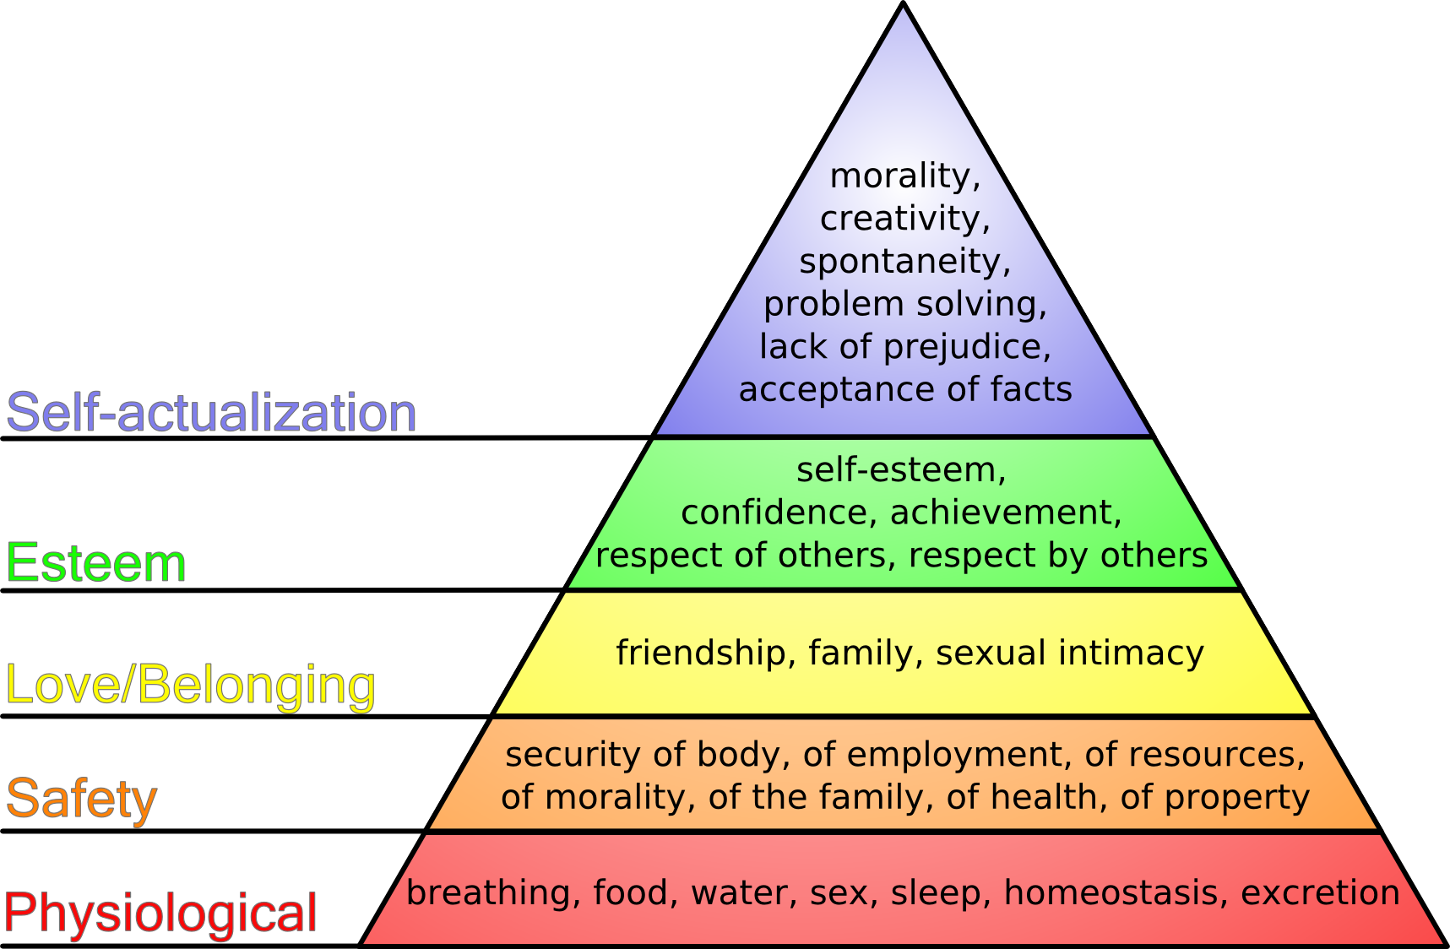
Source From Wikipedia, the free encyclopaedia.

Several studies have pointed out that satisfaction and motivation are not the same thing. According to Denhardt and Aristigueta (2008), satisfaction is focused on the past, whereas motivation is focused on the future. SDT directs these motivation types along a continuum of self-determination from controlled to autonomous or self – regulatory, of particular importance in the study sample of knowledge workers. Despite this predictable sequence, each is expected to affect employee outcomes differently (Deci & Ryan, 2000).
The current study explores the balance between extrinsic motivation and intrinsic motivation, aiming to promote a healthier, more sustainable approach to motivation and performance.
6.0 Performance, Engagement and Job Crafting/ Co-Production.
Srivastava and Pathak (2019) examined EPM through the lens of self-efficacy and job involvement (job crafting), linking motivation and job satisfaction through regression analysis. They found that banking employees with high self-efficacy and job involvement perform well with gender and qualifications barely impacting efficacy and involvement.
Srivastava and Pathak (2019) offer proportionate transferable insight into variables in the sample population of the current study through analysis of the data in chapter 4, using cross tabulations of the variables in discipline, experience, and which team they are a part of within ICT.
García et al. (2019) conducted research that is key to the theme of job crafting and co-production. Allowing employees to participate in job-related decisions is arguably one of the most popular strategies used by many organisations to increase employees’ level of job satisfaction (Harley et al.,2000; Pacheco and Webber,2016).
This concept is supported by Pratson, Stern, and Powell (2021) by linking the theme of motivation, job satisfaction and self-determination discussed above by adding that motivation is further positively impacted when employees feel they have the autonomy and competence to co-produce, and their work is relatable and meaningful. A fundamental psychological theory associated with knowledge workers (Turriago-Hoyos, Thoene, and Arjoon, 2016; Ferraro, et al. (2018), with further evidence review by CIPD (2022) recommending employees understand the organisations mission, vison and how the impact the wider goals.
Multiple schools of thought approach this with the same view, the challenge appears in how this is achieved in the NHS and at employee level. The Health Foundation (2021) supports the argument and aim of this study by considering sustained performance a concept that starts with a motivated and capable employee discussed earlier, suggesting co-production is critical to improving EPM and emphasised by Ferraro et al (2016).
It is clear that performance management must change to keep up with the changing workforce. Due to digital and workforce changes, traditional performance management methods may no longer work and must evolve (Chellappa , 2022). Toolkits such as NHS Employers (2023) offer interactive digital based tool for EPM is a career long conversation, supported by Armstrong (2022) must not be a one-off event, everyday work discussions essentially managing performance. The missing element from this is the role of feedback and KPIs and how variability is measured, a variable the current study will explore and analyse.
6.1 Performance, Key Performance Indicators and Variability.
Current analysis argues that a policy focus on possibilities without considering preparedness, capability, and readiness may hamper ICT's existing aims. Quality and progress must be measured to meet goals. With no infrastructure to improve performance and only enough performance possibilities, the current study argues that to accomplish investment targets, stated as an aspiration of 17 percent C&C (Brooks, 2024), performance must be measured in terms of quality and improvement measures as well as hard data. Critical service logic taken from the field of marketing could be considered in terms of value and co-production in public services, service dominant logic (Vargo and Lush, 2008; Grönroos and Voima, 2013) appear to accentuate the aim of the current study in understanding what matters to the employee and the mediating role of feedback on PM and variability.
WAST functions in a knowledge-based, service-focused economy where people are the capital to provide the care that is quantified by metrics (Harb et al., 2021; CIPD, 2022b). Given that knowledge workers make up more than half of the British workforce (Eurostat, 2023), it is critical that the current study aligns with strategic people management by utilising incentive theories to achieve long-term quality improvement. Knowledge workers' performance management has received little attention (Kianto et al., 2016; Razzaq et al., 2019), and suggested the relationship between knowledge management practises and performance is mediated by low organisational commitment, evident in high turnover rates and recruitment issues in the NHS overall (LinkedIn, 2023; Stats Wales, 2024).
The variables thought to mediate and propagate performance improvement will be rigorously examined in this study, which will also contribute to the limited but expanding body of research on performance management and sustainable healthcare practices. Argyee et al (2016) argue that much research focuses on frontline employees interaction with people, very little research focuses on the organisational processes that influence service delivery and the role of metrics, data and targets, an area this study will focus on and offer recommendations for change. Knowledge workers require a particular approach which managers need to consider when managing performance (CIPD, 2022b; CIPD, 2024;).
Razzaq et al (2019) classed knowledge workers in the public sector as ‘neglected’, offering that until knowledge worker management practices, infrastructure and understanding of what matters to these workers, such as a culture of learning, reward and collaboration/co-production is understood, contextual performance will not increase (Mohrman et al, 2002; Kianto et al, 2016).
This study aims to understand what matters to clinicians and if co-production can have the potential to improve contextual performance. It is the relationship of Maslow hierarchy and Vrooms (1964) theory of expectancy that aggregates human capital collectively with motivation grounds this study.
6.2 Unintended Consequences.
Contracts, targets, scorecards, rankings, rewards, and sanctions are being used more frequently by health systems to incentivise performance in healthcare organisations and networks (Li and Evans, 2022).
According to Li and Evans (2022) and earlier work by Powell et al (2014) identified that unintended consequences lead to unnecessary care, less focus on patient outcomes and dynamics of the clinical team tend to negatively reinforce each other. Powell et al (2014) suggest their findings were as a result of poor local implementation strategies as a result of national definitions and policies, the current study will consider whether the arbitrary set targets for C&C are a contributing factor to the current failings.
Measure fixation, tunnel vision, and misrepresentation or gaming were the most common unintended consequences of PM in the literature, while administrative burden, insensitivity, reduced morale, and systemic dysfunction were most common in qualitative data (Elaad, 2022; Li and Evans, 2022).
Li and Evans (2022) conclude unintended consequences were indicator fixation, tunnel vision, and misrepresentation or gaming, whereas the qualitative data showed workload, insensitivity, reduced morale, and systemic dysfunction. Powell et al (2014) add further insights to support the current study in concluding that PM impacts on clinical performance scores, ancillary benefits, and unintended consequences and must be considered. Most performance measurement system evaluations have focused on clinical performance, but considering all three categories of effects may improve patient care and provider satisfaction faster.
Both studies influenced the current study and anticipated outcomes to consider in chapter five, summarised by Chellappa (2022) that organisations must prioritise new methods for assessing and improving employee performance, particularly how that performance is managed.
6.3 Financial Implications of Employee Performance Management.
Literature across business, finance and accounting was also analysed to provide a link in the financial burden of the Welsh NHS and the recurrent funding already invested in ICT. It aims to analyse the potential reasons the current investment is not reaching the targets discussed in chapter one. Due to resource limitation, healthcare organisations face challenges in providing sufficient help to National Health Services (NHS) across the country (Lorenzo, Fanelli and Zangrandi, 2023).
Public services frequently struggle with a shortage of money. Multiple scholars have written in managerial and financial literature; sustainability is actually something more than a financial consideration (Higuchi, et al. 2013). This study will add a further lens, drawing on financial, professional, and public sector research to critically analyse and propose the overriding significance of well developed and implemented performance measures, the impacts of these on sustainability as well as recruitment and retention and judicious spending of public money.
6.4 Conclusion and Summary.
The initial literature evaluation highlights the significance of relationships between staff engagement and performance. Performance in the NHS is typically assessed quantitatively using quality indicators, which are activities or outcomes that are measured in line with quality improvement (Yildiz & Demirors, 2014). Several researchers have contested this, pointing out unexpected outcomes including giving targets precedence over employees and patients (Kontopantelis et al, 2015).
Within the NHS, performance is legally specified and enforced using performance metrics compared to the organization's standards (Pollard et al, 2020). CIPD (2023a) found that elements like training, manager experiences with employees, and performance reviews were positively correlated with performance, indicating wider effects on employees. Improvements are brought about by discussing performance and assessing it (CIPD, 2023a), with regular performance conversations a positive influence (Armstrong, 2022).
Current EASC's Quality Indicators are not explicitly matched with any distinct KPIs for the ICT to work towards and be clear on the expectation. The present Integrated Medium-Term Plan 2023/24 (WAST, 2022) contains percentage targets that define a target but do not provide a clear path to reaching it. The next chapter will discuss the philosophical approach to the study, methods, and sample frame before leading into the data analysis and findings chapter.

7.0 Chapter Three - Methodology
7.1 Introduction.
This chapter will start with an overview of the research purpose, moving onto its aims and objectives before analysing the philosophy and methods available to explain the research methodology and the crucial theory-method relationship (Kholeif, Abdel-Kader and Sherer, 2008). The methodology was designed around the research objective to critically analyse primary data to identify factors influencing performance within Integrated Care. Chapter one introduced the challenge of the promised improvements in productivity by successive governments, chapter two critically analysed secondary data producing themes that informed the methodology discussed in this chapter.
A research methodology is ‘a general approach to studying research topics' (Hussey and Hussey, 1997), whereas a method is the tool or approach (Bailey, 1996) used to gather data. Limitations of both the chosen philosophy, tool and sample and methods chosen will be explored to continue the thread of validity and relevance of the study and its findings.
To examine factors impacting performance a survey tool was designed to explore motivation, self-determination, performance indicators, feedback, and employee behaviour. Considering the work of economists Brynjolfsson, Rock, and Syverson (2017) who introduced the concept of productivity paradox, which is defined as when technology is introduced but does not immediately deliver the predicted productivity gains.
The survey questions were designed to explore key themes emerging and discussed in chapter two, in particular those pertaining to the role of feedback and the understanding of key performance indicators. In the sample population, telehealth software and PowerBI are used as tools to inform and perform the sample population's roles, the current study explored how these are being implemented and understood and if productivity paradox could be a concept influencing the sample.
Brynjolfsson, Rock, and Syverson (2017) cite two reasons for this: a lack of meaningful feedback and impediments such as processes, structure, and workplace culture. While this study does not investigate culture, the survey was designed to investigate the borders of culture while considering the limitations of the sample group and methodology, which will be explored later. The authors go on to say that the performance paradox always resolves, but they do not provide an explanation other than that it takes a period of years, implying that the technique leaves the change to chance rather than improvement.
7.2 Aims and Objectives.
The aim of this research is to explore and understand the factors that affect the performance of this team against set targets, to inform how performance management can be improved to deliver on the commissioning and strategic intent and aligned to A Healthier Wales: Our Workforce Strategy for Health And Social Care (2020).
Four primary objectives form part of a critical examination of performance to achieve the study aim. These objectives are defined within the target sample.
1. To critically analyse why current performance targets are not being met in a clearly defined team of clinicians with arbitrarily set targets.
2. Survey the team with the goal of figuring out what influence’s performance and exploring perceptions of current staff.
3. Critically analyse the data gathered to investigate the views of the present workforce on performance management.
4. Offer suggestions on how to enhance performance management and enhance organisational results.
7.3 Research Process – The Onion.
The purpose of this research project is to investigate employee perspectives on performance management in a team setting within integrated care by utilising epistemological influences. When conducting a research study to answer a question, it implies a framework of research philosophies (approaches), using validated, reliable methods and techniques; is unbiased and objective (Goundar, 2012).
While Saunders et al (2019) introduce five philosophical paradigms and the research onion—a pictorial representation of the fundamental components of research methodology (fig. 1), Burrell and Morgan (1979) present four paradigms of organisational analysis (Fig. 2).
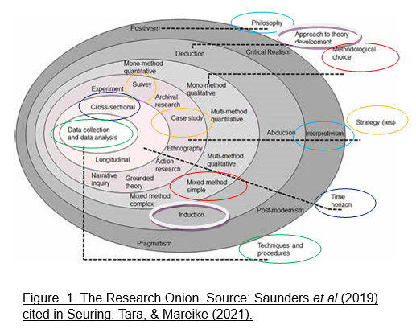

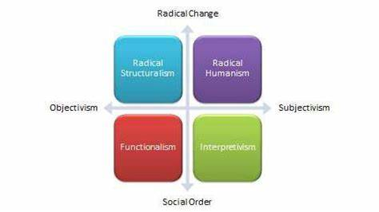
Figure. 2. Four paradigms of social science research (Source: Burrell and Morgan, 1979)

7.4 Brief Analysis of Research Methodology.
When considering the approach for this study it was clear that several approaches needed to be studied, it was a process of reflection through analysis of Epistemology, Ontology and Axiology (Realism) before deciding which suited this work. According to Tiitola et al, (2023) many management studies explain employee behaviour using pragmatic constructivism (PC). Contexts for studies include strategic and operational management, decision-making, and organisation (Mitchell et al., 2013; Laine et al., 2016; Saukkonen et al., 2018; Korhonen et al., 2020).
Whilst pragmatic constructivism emphasises employee reality construction (Mitchell et al, 2022) and showing PC as a method delivery for understanding service performance (Wilden et al, 2017), the current study aims to understand employee perceptions where an interpretivist approach suits the objectives. Interpretivism studies focus on meaning and may use multiple methods to address different themes and issues (Dudovskiy, 2024).
A method must be adopted at the start of empirical research in order to understand the way the researcher sees the world (Kholeif, Abdel-Kader and Sherer, 2008; Mbanaso, Abrahams and Okafor, 2023). This study will also add insight and information linked to an emerging area of healthcare and people management in the NHS. It draws upon mode two knowledge development, linked to the chosen approach of Epistemology discussed later and will enhance current understanding of how performance is managed in the NHS and linked to the second layer of the research onion (Saunders et al, 2019) considering the approach to theory development.
7.5 Knowledge Production Modes.
Knowledge production is a construct that refers to how knowledge is produced with three modes conceptualised to date (Hessels and van Lente, 2008). Gibbons (1994) conceptualised Mode 2 as a mid-20th-century knowledge production method (Martinez-Conesa, Soto-Acosta, and Carayannis, 2017). This is relevant to the current study in two significant points, mode 2 knowledge production is context-driven, problem-focused, and interdisciplinary, unlike Mode 1 which is summarised briefly as discipline-based and investigator-initiated research that seeks to develop and test theories. Mode 1 is context free, mode 2 is context driven involving multidisciplinary teams producing tailored, situational knowledge for practise (Gibbons, 2013). It is the belief of Hessels and van Lente (2008) that Mode 2 knowledge is not intended to take the place of Mode 1 knowledge but rather to supplement it.
Secondly, this study takes the theoretical approach of induction and aims to improve current understanding through analysis of newly created knowledge on why capital investment in a specific team has not returned the expected improvement in performance. It is through research and the study of knowledge that the critical analysis of perceptions will inform future understanding of performance measures and how these can be improved.

7.6 Research Philosophy.
Epistemology deals with the nature or theory of knowledge, concerned with how knowledge is acquired or how we know what we know (Killam, 2013). In fact, while ontology “is concerned with what exists and in what form,” epistemology “is concerned with how humans can come to know and understand those things” (Potter, 2017). In other words, ontology focuses on the what, while epistemology focuses on the how (Potter, 2017).
When considering the validity of knowledge, it is through sources such as perception, reason, and memory that scepticism is considered to be important (Long, 1992). Philosophers such as Klein (2010) defines scepticism as the belief that humans have limited knowledge of the world, the past, and other minds beyond their own, and may not know as much as they believe. A criticism of scepticism is that it is self-defeating (Long, 1992; Lemos, 2007). Chevarie-Cossette (2019) offers further challenge to this, and a more detailed analysis is outside the scope of this study. It is believed through deep reflection and analysis that Epistemology is the philosophical approach suited to this study with an interpretivist paradigm to understand how knowledge is created through subjective exploration (McChesney and Aldridge, 2019).
7.7 Understanding Epistemology.
A research philosophy is concerned with a system of beliefs and assumptions that will develop knowledge (Saunders et al, 2019).The challenge presented for the current study centred around what was being understood through the research, our own beliefs, and assumptions and how they affect everyday life as well as people and organisations. Edelheim (2014) explains the three main philosophies as ontology, axiology and epistemology that lay foundations of perception, truth and meaning.
The current study takes an epistemological approach, considered by Saunders et al (2019) as all types of knowledge, including numerical, textual, visual, factual, opinion, narrative, and stories. Sol and Heng (2022) adds that it is the theory of knowledge with different approaches such as positivism, interpretivism and pragmatism. The interpretive method with qualitative data best fits the rational, aim, and objectives of the current study, whereas quantitative methods generate knowledge by investigating measurable things (Mukhles, 2020).
Considering Interpretivism as a paradigm it lends itself well to the current study as it allowed subjective knowledge to answer the research question and objectives through lived experiences. Something that Kelly and Cordeiro (2020) challenges, suggesting pragmatism is as relevant for organisational research with application of interconnectedness between experience, knowing and acting, with emphasis on actionable knowledge and inquiry as the experiential process. Orlikowski (1993) summarise why the interpretive approach suits this study as it allows humans to build meanings when they interact with the reality they are interpreting. According to Greener (2008) cited in Rashid et al (2019), interpretivism allows researchers to have diverse perspectives on a research subject because it allows them to see the world through the eyes of the participants.
7.8 Research Sample Framework and Characteristics.
The sample population consists of 108 clinicians see table 1. below. The remaining sample presented are discussed further in chapters four and five respectively.
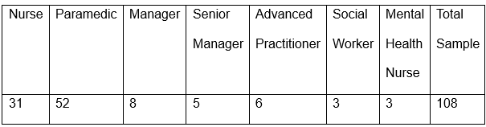
Table 1. Breakdown of characteristics of sample.

Probability sampling is considered better for quantitative data analysis that requires a sample that is statistically representative of the population and reflects its characteristics so findings can be generalised (Saunders, Lewis, and Thornhill, 2019). This Cross-sectional study will look at variables at a particular point in time with probability sampling ensuring that all population members have an equal chance of selection. The current study used probability (simple random sampling) and non-probability (convenience, quota, purposive, and judgmental) sampling methods. This is because the population characteristics are varied which permits the study to follow multi-methods. Non-probability sampling is used when demographics are unknown or cannot be identified individually; while this raises the likelihood of study bias, it is effective for exploring characteristics and accomplishing the research objectives in a specific directorate and group of employees.(Nikolopoulou, 2023).
This is explored in Chapter 4 when the data is analysed, and non-parametric tests applied to increase the reliability of the research outcome and recommendations. The geographical variations in characteristics of the participants, availability and numbers were included in the selection, excluding clinicians that are external partners of the organisation and therefore not direct employees.
Sample size in simple terms is the more information gathered, the more reliable it is (Kraemer and Blasey, 2016). The challenge for the current study is the relatively small sample frame to work with (108) and ensuring the tool (survey) fits the sampling formula that is applied. This sample size is inclusive of abstractions due to sickness and different types of leave. To avoid bias and encourage inclusion the survey was available to the complete establishment according to the electronic staff record (ESR) dated March 17th, 2024.
A small sample size study is considered an ‘underpowered study', meaning a study with a small sample size and questionable reliability (Sapra, 2022). Sample size is determined by the available basic information about the population parameters to be estimated or statistically tested (van de Schoot, 2020).
Examples of expected values include mean, proportion, strength of association, correlation and regression coefficients, sensitivity, specificity, accuracy, standard deviation, and effect size (Soukup, 2018; Bhandari, 2023).
7.9 Research Tool/ Design – Survey.
Abutabenjeh and Jaradat (2018) argue that identifying the appropriate research design is essential after defining the topic and questions, adding that literature on social science research design, methods, and methodology lacks clarity. Chapter two Literature review noted differences in scholar approaches in design, perspectives and methodology which led the current study to its final design (survey), approach (epistemology/interpretivism) as converging methods.
Several authors informed the design with debates on research methods in public administration and social sciences (Wright, Manigault and Black, 2004; Engbers, 2016; Gunn, 2017; Walt, 2020). Survey questions have been designed as mixed method approach, the current study refers to literature challenging the clarity of choice of paradigms in study design, in this case interpretivist and whether such approaches are classed as rigorous (Bergman 2010 cited in McChesney and Aldridge, 2019).
According to McChesney and Aldridge (2019) studies often use a mix of qualitative and quantitative research questions and inferences through this was questioned in earlier work by Morse (2010). Surveys have long since been considered a source of valuable information for public services (Wenemark et al, 2011; Anderson, Fontinha & Robson, 2023). Several papers on use of surveys argue that response rates impact the quality of the research (Luiten, Hox, & de Leeuw, 2020; Dillman et al. 2002; Ekholm et al. 2009). Schoonenboom, J. and Johnson (2017) argue that qualitative and quantitative methods, methodologies, and paradigms serve many purposes with a well-structured survey serving to meet rigour and validity as an instrument supported by earlier work by Morse (2010).
Rashid et al (2019) provided the author with caution in the ethical development of the survey, suggesting that researchers choose case study as a method without understanding the variety of circumstances that can affect the outcome of their research. Despite case studies being extensively discussed and used in literature (Yazan, 2015), Rashid et al (2019) suggests that little research considered how a case study is conducted effectively and offer a four phased approach; foundation phase which includes the philosophical considerations and inquiry techniques, aligned to the outer layers of the research onion. Pre field phase aligned to the middle layers of the research onion of case study survey. The third ‘field’ stage is the research stage and reporting phase which aligns with the inner two layers of the onion. The current study adopted both frameworks to understand, construct, research and analyse the data ethically and in line with the research aim.
A concurrent analysis of survey data with focus interviews have been considered with sequential design, time limits this as an approach and will introduce a recommendation for future work in this area (Morse, 2010; Schoonenboom, J. and Johnson, 2017). Banerjee Chatterjee (2019) and (Braun, V. et al. (2021) positively suggest that primary surveys allow the researcher to understand specific research questions where secondary sources have not or show little insight or are unreliable, see table 3 as an analysis.

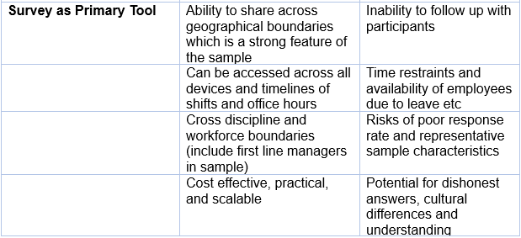
Table 3. Source – researchers own construct.

It will also offer voluntary participation through action consent and the right to withdraw as well as confidentiality and anonymity. The survey approach also fits the sample due to wide geographical location, hybrid working, and variable shift hours all support the choice of tool. There are limitations to using just surveys as primary tool without sequential or parallel use of semi structured interviews, summarised in the table 4 below.
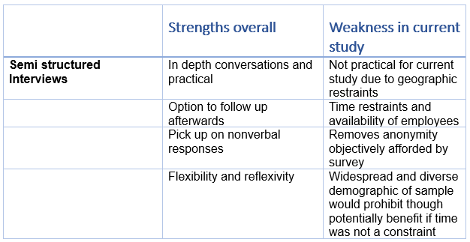
Table 4. Source – researchers own construct.

The survey design in this study also provides a comparative purpose, seeking to describe data and consider similarities with data from participants within the study with different disciplines and roles. This will introduce some limitations, the overall sample frame is an aggregate of different groups of clinical grades, some groups such as Advanced Practitioners (AP) have a small sample size. The final question offers the participant the opportunity to offer further narrative insights, this allows qualitative opinions to compliment the quantitative data and will be used to build overall themes and arguments during the analysis of findings, (see Appendix 1 for the primary survey). It was important to include this and the smaller groups when considering self-determination and statistical differences discussed in chapters four and five.
8.0 Pilot Study.
This study faced challenges in certainty of an accurate sample size to utilise the above calculations due to concerns of senior leaders on ethics and availability of public relatable knowledge of workforce analytics. This was a challenge met during the pilot phase which allowed the researcher to consider alterations to the wording of the survey and the inclusions and exclusions to the sample population. This was considered a significant risk to the study and its validity and expected values, mitigated by a short 2-day pilot study resulting in a change to the parameters of the sample.
According to Malmqvist et al (2109) pilot studies are frequently undertaken as feasibility studies or to examine the efficacy of research instrument. The survey was tested with five clinicians as discussed above. The opportunity to feedback user experience as well as suggestions on wording resulted in one small change in question 11, option five clear on the role of KPIs. The average time to complete was 5.12 minutes which was insightful to include in the survey invite.
8.1 Response Rates and Reliability.
Gill and Johnson (2010) propose that surveys can uncover patterns and frequencies that can be used to inform exploratory and inductive theories. Later research by Wenemark et al (2011) provides the current study with confidence in its methodologies and the impact of response rates. The findings and peripheral context suggest that it is possible to improve response rates while also promoting data quality and positive experiences for respondents. The impact of poorly understood/communicated performance measures provided an opportunity for the current study to investigate this with respondents' motivation based on employee experiences and perceptions.
The sample size offered challenges in terms of nonresponse bias (Dillman et al, 2002; Ekholm et al, 2009), the author acknowledges response rates are important indicators of quality and generalisability as well as the reputation of the organisation and reputation of surveys as a research tool (Biemer and Lyberg, 2003).
Calculating the sample size using an online tool revealed that a response rate of 85 is necessary to attain a confidence interval of 95%. The confidence level is a measure of certainty about how precisely a sample represents the population being investigated within a defined confidence interval, see fig 3.
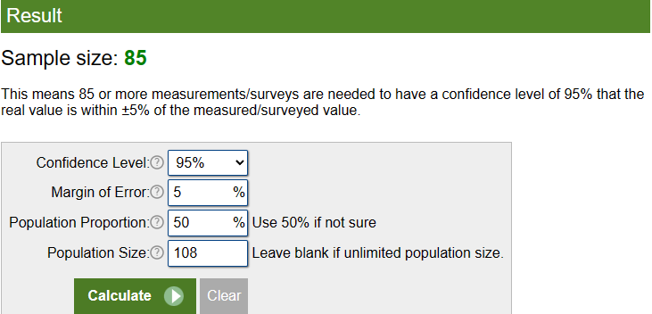
Fig. 3. Source Sample Size Calculator
The margin of error calculated on the sample and population size is 4.96%, see fig.4 below.
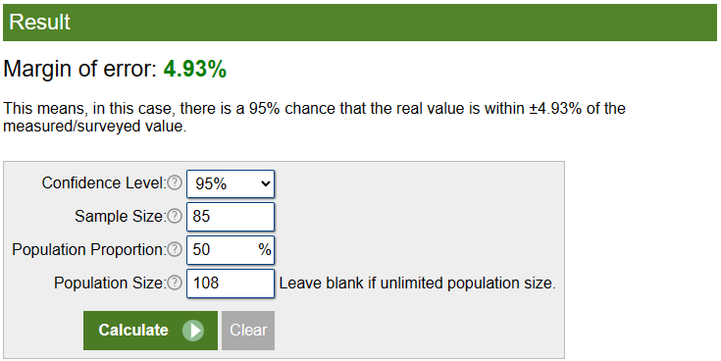
Fig. 4. Source Sample Size Calculator

Using the commonly used 95% confidence level means if the same population of employees was sampled numerous times and interval estimates were made on each occasion, about 95% of the time, the true population parameter would be included within the interval. The study's representativeness was precisely established to verify that it measured the demographic characteristics it promised to investigate (Bolarinwa, 2020), this was achieved through use of a recognised online tool, to calculate sample sizes. The aim of this study is to understand what factors impact performance in a small group of employees, the characteristics of the population and categorical variables is descriptive not requiring set power (1 – type error) estimation (Bolarinwa, 2020).
8.2 Data Collection and Analysis.
The survey was planned to launch January 17th, 2024 – February 16th inclusive. This period was chosen to avoid the post-Christmas challenges and pre-Easter annual leave. Unplanned, unexpected events outside of the researchers control impacted these dates, pushing back the start date to March 16th – 31st, 2024. The author acknowledges this as a limitation and whilst a smaller than anticipated sample response rate was achieved, the descriptive statistical analysis in chapter four provides quantitative analysis using SPSS for non-parametric tests and cross tabulations with visual summaries including qualitative observations from the sample and serve as primary data description of the survey findings discussed in chapter five.
Charan and Biswas (2013) support variance in sample size proposing that sample size calculation is different for different study designs, and one blanket formula for sample size calculation cannot be used for all. Sample size and poor response rate were among the top three research design issues, according to Green et al, (2016). The response rate was 47% with 51 responses from a total of 108 potential survey respondents. A response rate of 50% is considered a statistical acceptable response rate. For this survey to achieve validity a sample of more than 40 respondents were required as it is equal to the minimum sample size decided by the researcher using Cochran’ or Yamane’s formula (Holtom et al, 2022), 47% is considered statistically acceptable for this case study. The author accepts that this is an underpowered study but suggests it also provides a strong basis to include NHS111 and propose a much larger study in the future.
8.3 Validity and Limitations.
To ensure data validity, the researcher established at the start of the research that the goals and objectives were clearly specified, understood, and feasible for a consistent balance whilst working through the research onion outside to core where the data was collected and analysed. Throughout the dissertation, the researcher worked closely with a supervisor, following the university ethics and dissertation handbook, piloted the survey, highlighted limitations and ethical considerations as threads through the study.
The findings answer the research question empirically and reveal how EPM affects patient outcomes beyond the role of data analysis and performance metrics . It will be applicable beyond healthcare performance management to technology contexts and should be of interest to strategic people management, business, and public services governance scholars (Tiitola et al, 2023).
Operational issues, time pressures, preferences of participants including line managers involved in the study and the influence of culture within the directorate are limitations to the study. The directorate commenced a cultural review of CSD a week after the survey was launched, this added a potential of survey fatigue and concerns that the data was clouded by the external analysis of the culture with CSD.
The timeline to launch and close the survey originally preceded the internally commissioned external culture review. This external influence may have negatively impacted the response rates and the lower than anticipated return. A further limitation was the inability to use triangulation through sampling NHS111 as a second population to survey and cross comparison through regression analysis. This was due to time and the NHS 111-team undergoing significant changes to digital infrastructure not known at the start of the study.
The study maintained its focus and excluded any reference explicit to the culture review to validate the data relating to the current survey. Saunders (2019) explains this phenomenon as a variety of perspectives involved in organisational research, the current study which takes an exploratory approach and the external agency conducting the culture review taking a design science perspective to develop valid knowledge and solution-based approach to understand organisational problems (Van Aken 2005).
8.4 Ethical Considerations.
Applying an ethical framework such as Beauchamp and Childress (2019) and Seedhouse and Lovett (1993) help guide research to make decisions in an ethical manner. The Beauchamp and Childress framework was chosen as it reflects the ethical values of the researcher and the professional context of the organisation in which the sample population belongs to. Whilst the current study was not patient focused, it was important to use a framework embedded in medical ethics that has wider business and organisational relevance and lends itself the theme of quality and improvement.
The ethical framework required inclusion of the principles of beneficence and non-maleficence and included consideration to protect the researcher, participants and enhance validity and academic integrity of the study. It was important to balance the research objectives and using ethical methods and methodology which the current study has achieved. The challenge of data ethics discussed above was highlighted and overcome following the pilot study and the researcher providing better clarity in the sample frame and anonymity.

9.0 Chapter Four - Data Analysis.
9.1 Introduction.
This chapter explains the data analysis procedure and presents the study’s findings by interpreting survey trends and associations. Through extensive data analysis, the author is able to show what affects employee performance in this small case study and suggest ways to increase current performance to meet the 17% consult and close target.
Chapter one introduced the wider challenge of performance management in the NHS, including the external and internal influences on performance. Chapter two funnelled the focus to meet the aim of this study to explore and understand the factors that affect the performance of CSD clinicians against current targets to inform how performance management can be improved to deliver on the commissioning and strategic intent. Chapter three used the research Onion (Saunders et al, 2019) to structure the research question progressing from the research philosophy (Epistemology), through inductive simple mixed methods for a case study using a primary survey longitudinal case study to collect and analyse data to address the themes discussed in chapter two. Nonparametric statistics were used for further discussion in chapter five. The study objectives form part of a critical examination of performance, this chapter will present the data, an analysis of examined variables and how groups influence each other based on the four study objectives.
1. To critically analyse why current performance targets are not being met in a clearly defined team of clinicians with arbitrarily set targets.
2. Survey the team with the goal of figuring out what influence’s performance and exploring perceptions of current staff.
3. Critically analyse the data gathered to investigate the views of the present workforce on performance management.
4. Offer suggestions on how to enhance performance management and enhance organisational results.

Statistical analysis is the process of analysing data in order to identify patterns, trends, and other significant conclusions (Salcedo and McCormick, 2020; Bender, 2023; Gajendraker, Ali and Vaidya, 2024). Descriptive analysis used in the current study seeks to accurately describe the characteristics of the sample population, categories, frequencies, and trends to meet the research aim by examining what, where, when, and how questions (McCombes, 2023).
Generalisability must be challenged due to the sample size, though the author suggests the themes are relatable to the whole team. Validity in generalising the results would require further wider research without time limits, a higher response rate, and a complex mixed method approach.
9.2 Data Preparation.
The data was organised through MS Forms, then transposed into excel and cleansed before extracting the data into IBM SPSS Statistics Data Editor Version 29.0.1.0 (171). Data preparation, refining, coding, and analysis involved converting raw data into a clean, organised format in Excel before importing it into SPSS. This stage was critical since data quality has a direct impact on the accuracy and dependability of the insights obtained from it (Ribeiro, 2024). Errors, inconsistencies, or missing values in data can lead to incorrect results, requiring data cleansing and structuring before any analysis took place to maintain ethical research principles. The coding tables for each analysis will be presented together to ensure clarity of results.
9.3 Exploratory Data Analysis (EDA).
Next the data was explored to understand patterns, detect anomalies, test theories and provide the groundwork for the next stage of descriptive analysis. EDA began the data story, revealing insights through visualisation and statistical summaries that inform strategic decision-making (IBM, 2024). MS Forms provided raw data insights that informed how the data should be presented to SPSS before applying descriptive statistics of correlation analysis, cross tabulation and Spearman’s test.
9.4 Data Analysis.
9.4.1 Types of Variables in Sample.
The sample provided an opportunity to research the impact of current performance measures against variables of time in post, the role, the location of work, effect and timing of feedback and role of key performance indicators in improving individual and team performance.

10.0 Frequency Distribution.
10.1 Question One.
Was concerned with consent and offered no statistical analysis with 100% consent to proceed.
10.2 Question Two.
Provides the scale of response across all job roles with the highest response rates in the paramedic (39%) and nurse group (33%).
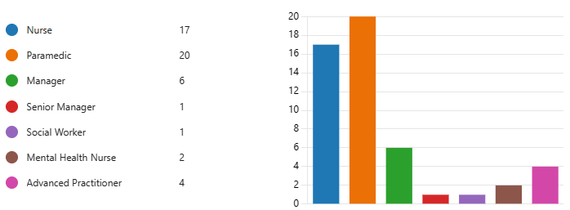
Fig. 5. Demographics of respondents by job title

10.3 Question Three.
Considered the range of experience in the sample with a variance of 35% with over 5 years’ experience and 9% with less than a year.
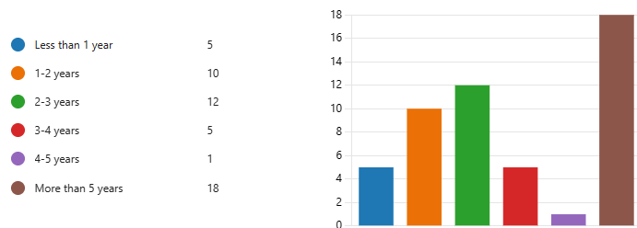
Fig. 6. Time in post

10.4 Question Four.
Builds on the job role demographic and found that 94% of the respondents work directly within the clinical support desk, 4% within the advanced practitioner role in health board hosted hubs. A cross tabulation, Spearman’s Test is performed later in the analysis between feedback, job role and team for a test of difference/association in satisfaction with feedback and job satisfaction and association with motivation/self-efficacy.
10.5 Question Five.
When asked where they worked, 16% worked home/remote, 59% at a site and 26% work agile/hybrid.
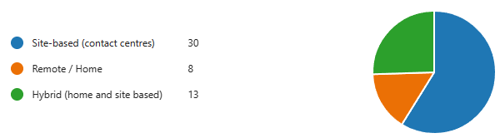
Fig. 7. Location of work

Of the home working/hybrid variable, 100% answered yes for receiving regular feedback, an interesting insight for exploring the positive impact of home working and feedback.

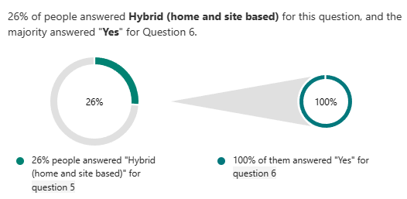
Fig. 8. Comparison of Q5 and Q6

10.6 Question Six.
Asked about regular feedback with 73% of the respondents reporting yes and 100% in both home workers and the advanced practitioner group reporting yes to regular feedback. Q8 showed some variance when asked about the quality of this feedback 63% of home workers being more satisfied with the quality of feedback, a theme appearing with the employee experience of home workers and an unexpected finding in this case study.
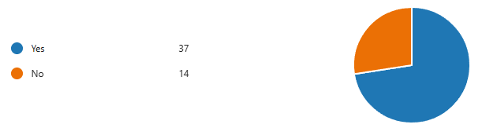
Fig. 9. Depicting if respondents receive feedback.

10.7 Question Seven.
When asked about the frequency of feedback, there were zero responses for daily feedback with 25% reporting they receive regular ‘touch points’, 38% were site based, 38% hybrid and 15% were home workers.
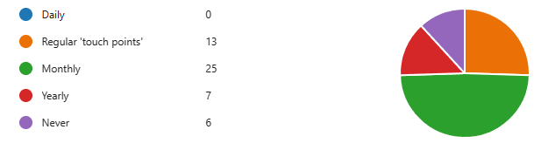
Fig. 10. Frequency of feedback

ID 9 provided additional impact in Q14 by offering insight into what guidance and support they feel is needed,
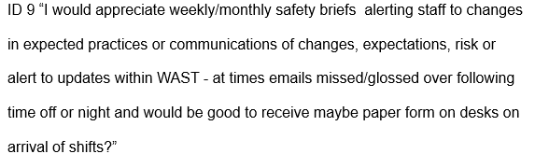
10.8 Question Eight.
Asked how satisfied they felt about feedback with 43% expressing being somewhat satisfied, 21% being very satisfied, 29% reporting neither satisfied or dissatisfied, of which 100% of the social worker group reported this.


Fig. 11. Satisfaction of feedback received.

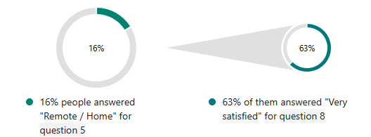
Fig. 12. Quality of feedback received.

Open text insight from Q14 provides further experiences on satisfaction with current feedback measures,
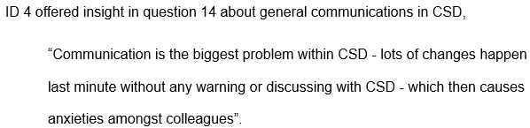

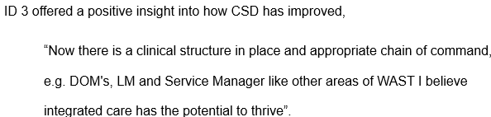
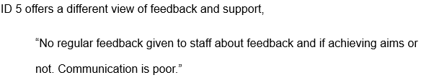
ID10 suggests,
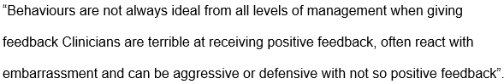
Themes around feedback extend through the survey findings and discussed in chapter five.
10.9 Question Nine.
Asked about satisfaction in support and resources, 33% answering somewhat satisfied and 24% somewhat dissatisfied with 100% of mental health nurses answer somewhat satisfied.
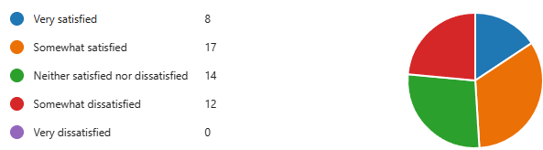
Fig. 13. Satisfaction of support and resources.

ID1 provided a response to Q14 around resources impacting performance,


ID5 expands on this,
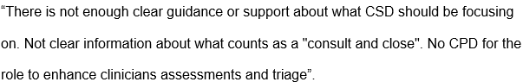

ID17 introduces the impact of self-efficacy and motivation,

11.0 Question Ten.
Asked about skills and abilities with 45% reporting extremely well, 41% somewhat well.
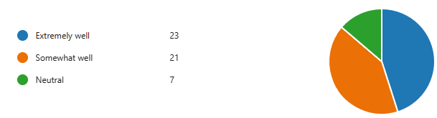
Fig. 14. Use of skills and abilities in job role.

Out of this 88% of homeworkers saying they are able to use their skills and abilities extremely well, further presenting a theme of homeworkers employee experience.
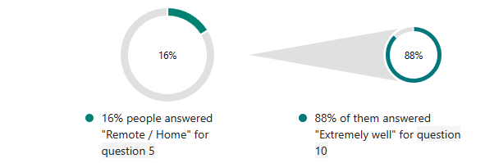
Fig. 15. Percentage of home workers saying they are able to use their skills and abilities.

ID2 offered insight into staff development,

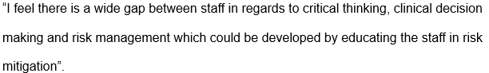

ID3 considers a wider cultural impact on performance,
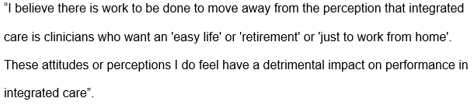

11.1 Question Eleven.
Provides five statements on key performance indicators, 48% agree there are clear performance indicators, 22% disagree with 18% strongly agreeing.
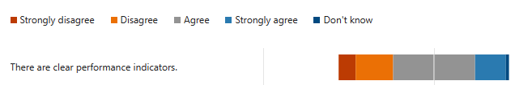
Fig. 16. Likert Scale of clarity of performance indicators.

When asked if they understand the current performance measures 40.8% agree and 34.7% disagree.
Fig. 17. Likert Scale of the understanding of performance indicators.

Understanding of the link between performance measure and wider organisational goals, 9.8% don’t know, 9.8% strongly disagree, 29.4% disagree and 39.2% agree.
Fig. 18. Likert Scale of the understanding of link with individual and organisational performance indicators.

ID11 suggests that there are increasing expectations,
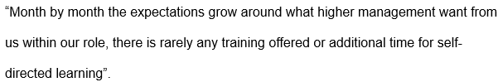

With ID7 suggesting,

ID16 suggests,
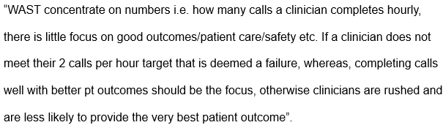
Adding that,
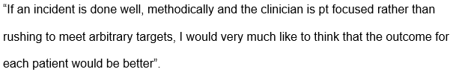

ID8 offers insight on the perception of performance management,

11.2 Question Twelve.
When asked how each respondent would rate their overall performance, 55% responded with ‘good’, 32% ‘very good’,

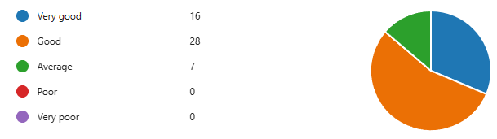
Fig. 19. Individual rating of own performance

with the majority also answering yes to Q6 asking about frequency of feedback.
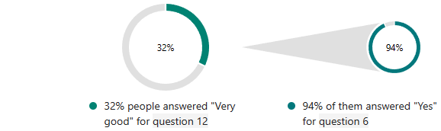
Fig. 20. Comparison percentage of own performance rating of ‘good’ and frequency of feedback.

11.3 Question Thirteen.
Used a Likert scale to ask statement around improving individual and team performance, with largely equal share between agree and disagree scales across the three statements,

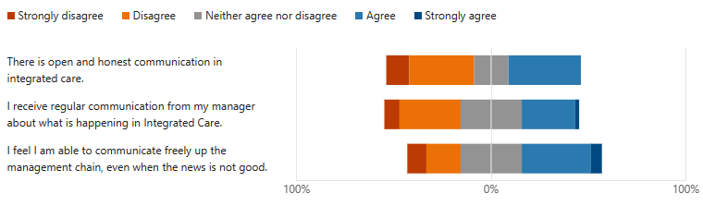
Fig. 21. Scales of improvement of individual and teams performance and communication.

ID1 answered Q14 with,
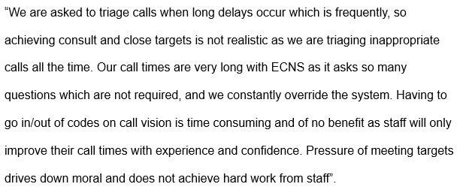

12.0 SPSS Statistical Data Analysis.
12.1 Non-Parametric Tests.
The author used descriptive statistics in SPSS to calculate correlation coefficient that synthesises sample data without allowing population judgements. This is important for validity of the small sample in this study, and an alternative to inferential statistics that would not be suitable as the data will not be generalisable.
A correlation coefficient is a number from -1 to 1 that indicates the degree and direction of a link between variables. In other words, it indicates how similar the measurements of two or more variables are across a dataset (Bhandari, 2023).
Gadermann, Guhn, and Zumbo (2012) argue that underestimating a test's reliability might lead to inaccurate conclusions, such as discarding it due to low dependability, if it is utilised in conditions that contradict its assumptions. This was considered when analysing data from survey questions using Likert scales, data arising from such items are not continuous, but ordinal that focus on the reliability of the unobserved continuous variables underlying the observed item responses. Based on the findings of Gadermann, Guhn, and Zumbo (2012) challenging the accuracy of Cronbach’s alpha, Spearman's rank correlation was considered as the most suitable non-parametric test (see fig 4.) and an alternative for Pearson's correlation (Bhandari, 2023).
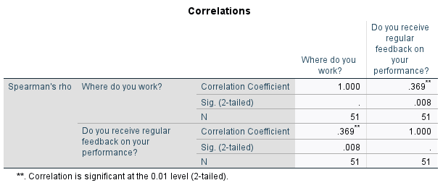

Fig. 22. Spearman’s Correlation showing correlation between remote/home working and frequency of feedback.

12.2 Frequencies.
Following the frequencies procedure on the dependant variable on regular performance feedback and location of work the coefficient is strong against the dependant variable of frequency of feedback, home workers report to receive more frequent feedback compared to site-based workers.
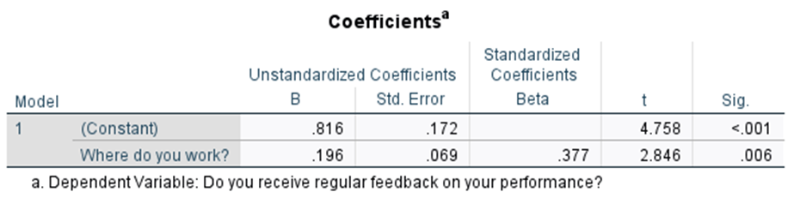
Fig. 23. Dependant variable frequency on regular performance feedback and location of work the coefficient.

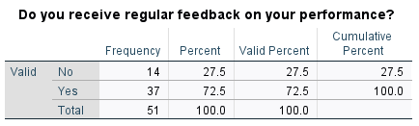
Fig. 24. Dependant variable on frequency of performance feedback.

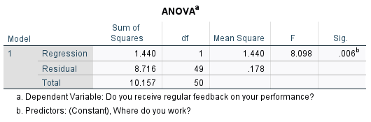
Fig. 25. ANOVA Test of dependant variable and predictor of frequency of feedback and location of work.

Graph. 1. Cross tabulation of motivational factors and understanding of key performance indicators
An analysis of motivation through use of skills and understanding of performance indicators, 45% reporting extremely well with 48% reporting there are clear key performance indicators.
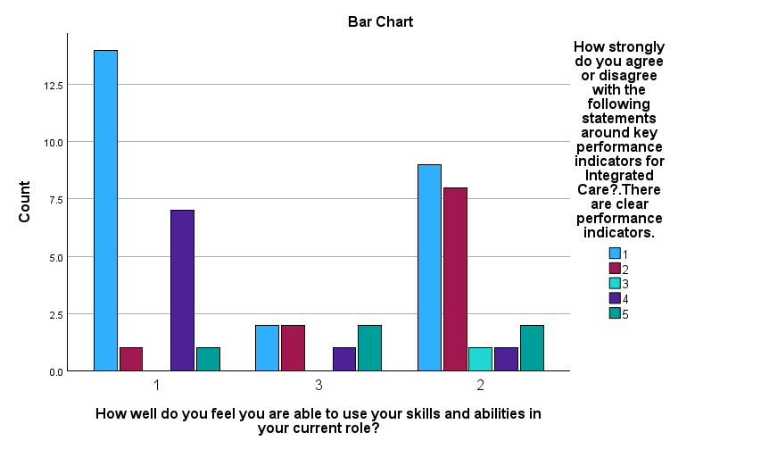
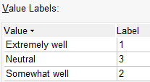
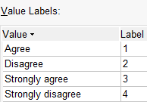

Graph. 2. Cross Tabulation of location and satisfaction score for support and resources.
Analysis of location of work and perception of support and resources to complete job role shows site-based clinicians report higher perception of support and resources comparted to home and hybrid workers with hybrid having higher rates than remote.
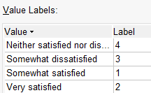
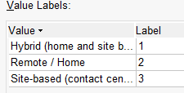

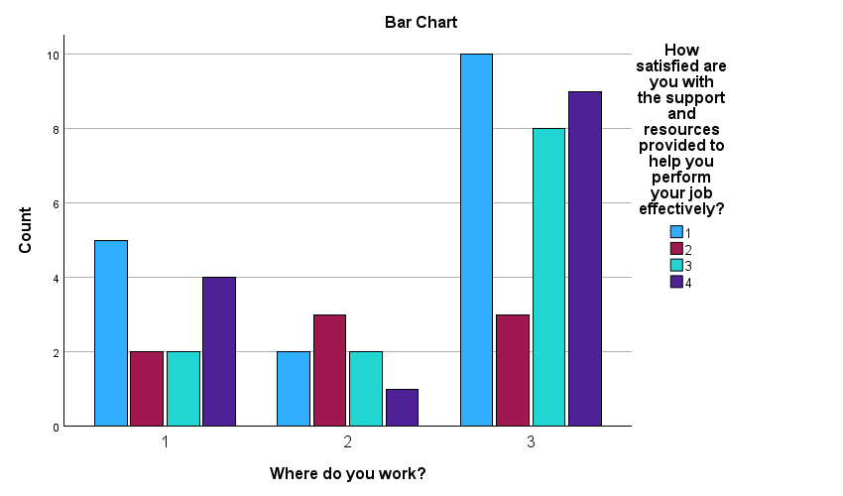
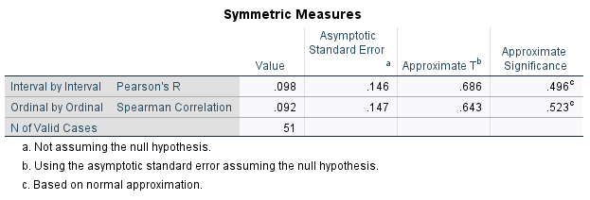
Fig. 26. Spearman’s Correlation showing correlation between support and resources and location of work.
Graph. 3. Cross tabulation of location and frequency of feedback.
A crosstabulation of location and frequency of feedback shows that remote workers received more frequent feedback.
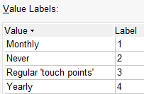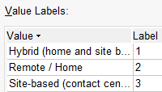
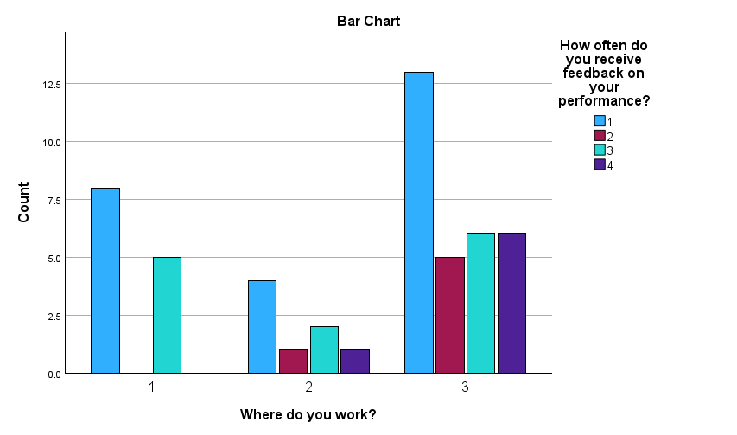
Graph. 3. Cross tabulation of location and frequency of feedback.

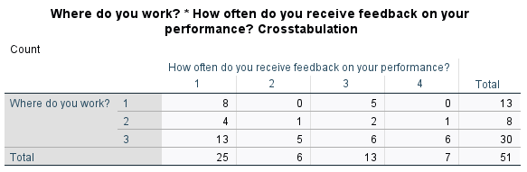
Fig. 27. Cross tabulation of location and frequency of feedback.
Graph. 4. Cross tabulation of frequency of feedback and ability to improve individual and team performance.
Analysis of statements in Q13 compared to Q6 frequency of feedback and ability to improve team and individual performance through communication, those who received monthly feedback report higher levels of open and honest communication in CSD. Those who receive feedback through regular touchpoints disagree with the statement with those only receiving annual appraisals and those who report to never receive feedback are more negative about the statement.
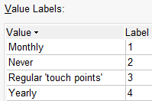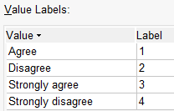
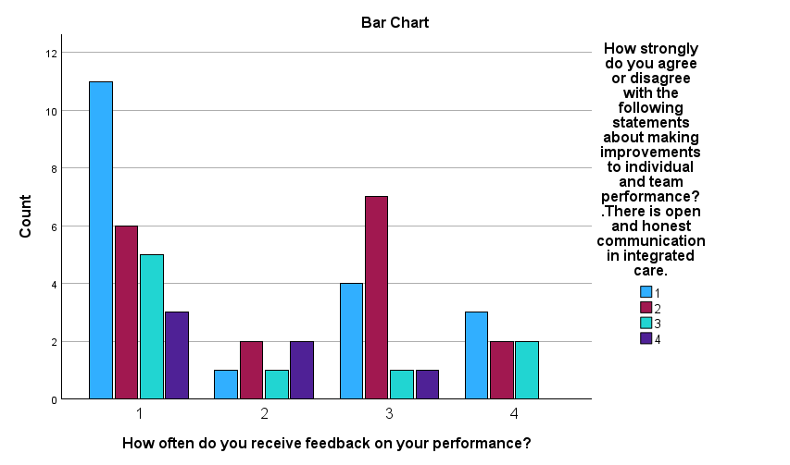
Graph. 4. Cross tabulation of frequency of feedback and ability to improve individual and team performance.

Graph. 5. Cross tabulation of personal performance ratings and achieving current key performance indicators.
Analysis of personal performance ratings against understanding of the current target of 17% consult and close, 12 respondents report their individual performance as good and agree to understanding the current performance measures. Those who report very good individual performance also report clear understanding of the current measures.
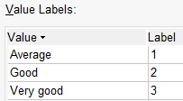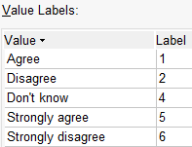
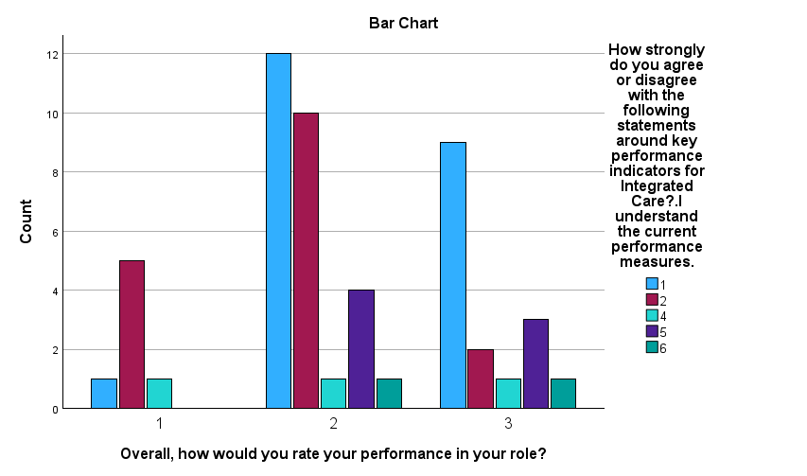
Graph.5. Cross tabulation of personal performance ratings and achieving current key performance indicators.

Graph.6. Graph.6. Cross tabulation of individual performance and understanding of the link between this and WASTs wider organisational goals.
Further analysis of individual performance and understanding of the link between this and WASTs wider strategic goals, similar spread of responses indicate positive perception of performance is linked to the understanding of the impact of individual performance has on organisational goals.

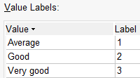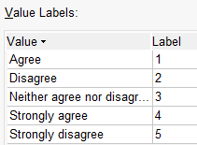

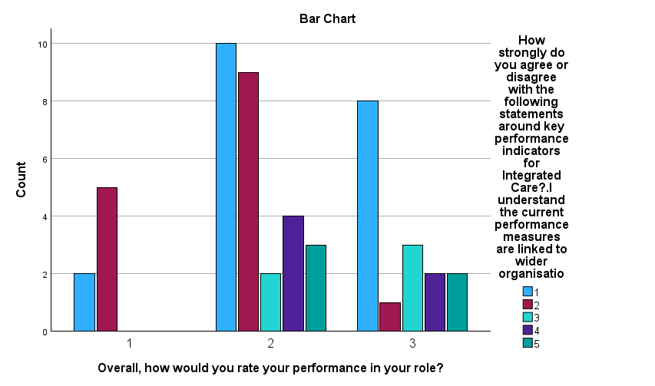
Graph.6. Cross tabulation of individual performance and understanding of the link between this and WASTs wider organisational goals.

Graph. 7. Cross tabulation analysis of frequency of feedback and ability to achieve monthly targets.
Analysis of frequency of feedback and ability to achieve monthly targets, of those who receive monthly feedback, six report that they achieve the targets, nine disagree indicating there is lack of clarity on current measures and a split in perceptions.

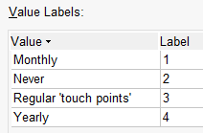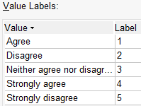
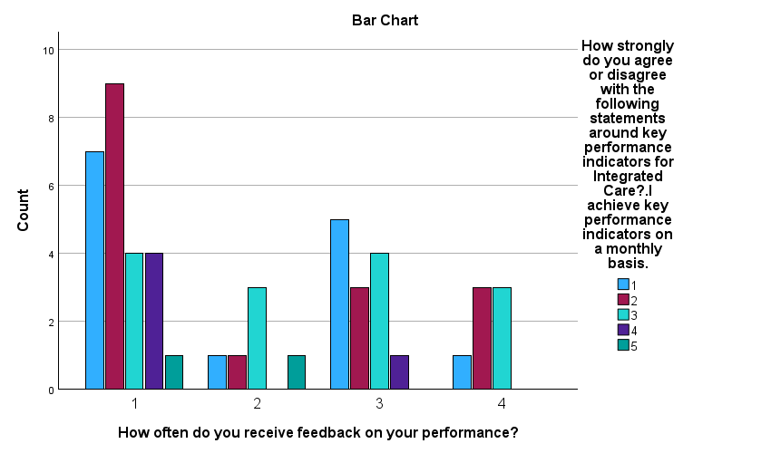

Graph.7. Cross tabulation analysis of frequency of feedback and ability to achieve monthly targets.

13.0 Chapter Five - Findings and Discussion.
13.1 Introduction.
This case study considers the impact of individual; employee level performance and its impact on the broader organisational performance based on government set targets and those aspired by the Welsh Ambulance Service University NHS Trust (WAST), looking at how performance at an individual level has a cross level influence on service quality and organisational performance. Very little research focuses on the organisational processes that influence service delivery and the role of metrics, data and targets, areas this study focused on through the perceptions of employees within the Integrated Care Team. This final chapter will discuss the findings from chapter four and connecting back to the research objectives, literature review and analysis of data from the survey, finally the author will offer two recommendations based on key findings from both secondary literature review and the primary survey analysis.
The study objectives formed part of a critical examination of performance, this chapter will present a discussion of the data analysis of examined variables and how groups influence each other to answer the four objectives set in chapter one.
1. To critically analyse why current performance targets are not being met in a clearly defined team of clinicians with arbitrarily set targets.
2. Survey the team with the goal of figuring out what influence’s performance and exploring perceptions of current staff.
3. Critically analyse the data gathered to investigate the views of the present workforce on performance management.
4. Offer suggestions on how to enhance performance management and enhance organisational results.
13.2 Findings Summary.
This case study used data to describe perceptions of the sample population, it is not a large volume representation and aims to challenge the assumptions of the arbitrarily set C&C targets (17%), add complexity by revealing more insight into employee level experiences and impacts of different variables presented below.
The study followed an ethical approach to collection and use of data in the public sector to innovate and produce data informed insights (Central Digital and Data Office , 2020) on performance management experiences of a specific group of employees. Through analysis of motivation, self-determination, performance indicators and feedback literature was explored in chapter two and data analysed to consider intrinsic and extrinsic motivators managers can use or may already use in improving performance.
Descriptive analysis used in the current study sought to accurately describe the characteristics of the sample population, categories, frequencies, and trends to meet the research aim by examining what, where, when, and how questions (McCombes, 2023). Findings have suggested that the current focus on compliance to poorly defined outputs and targets can constrain employees, a theme explored under motivation, feedback and KPIs. It became apparent during the exploratory data analysis that the lack of a clear performance framework, poor communication and feedback potentially contributes to the team not achieving the targets set. When considering this and the findings in existing literature on job crafting and co-production, García et al. (2019) found that engagement and co-designing of job-related decisions are used to increase employees level of job satisfaction supported by CIPD (2022) in recommending employees understand the organisations mission, vison and how the impact the wider goals.
The methodology of this case study was chosen as it allowed the researcher to follow interpretivism and focus on meaning and use of multiple methods to address different themes and issues that emerged from the data (Dudovskiy, 2024). Following an epistemological research philosophy that is concerned with a system of beliefs and assumptions, the study has critically analyzed factors affecting performance of clinical desk clinicians within Integrated Care.
The objective to survey the team to understand what influences performance and perceptions of employees has gained knowledge on current performance measures and met the aim of the study (Saunders et al, 2019), adding to the understanding of performance in this emerging field of remote clinical practice and people management.
Mode two knowledge production is context-driven, problem-focused allowing the study to explore if the productivity paradox (Brynjolfsson, Rock, and Syverson, 2017) could be a concept influencing the sample. Through the theoretical approach of induction, the aim to improve current understanding through analysis of newly created knowledge on why capital investment in a specific team has not returned the expected improvement in performance has been achieved.
This case study found the productivity paradox to be evident in this team with the explosion of technology and nature of this practice exposes clinicians to high technological input with apparent little direction on acceptable levels of performance. Recommendations from this case study will highlight areas for consideration and not to leave the current underperformance resolve over time as found by Brynjolfsson, Rock, and Syverson (2017) beginning with the impact knowledge workers have on understanding performance management.
13.2.1 Performance Management and Knowledge Workers.
When considering literature on knowledge workers, an evidence review by CIPD (2022) proposes that outcomes from knowledge work are less tangible, making them more challenging to define, quantify, and assess. This is a challenge for managers and leaders, who prioritise input for change and associated loss of trust in the NHS and employees who feel ‘monitored' (Kline, 2019; Jones, Horton, and Home, 2022). This case study found that clinician felt ‘monitored’ and ‘micromanaged’. This is supported by Thiel et al (2022) with the argument that monitored employees are more likely to break rules, more likely to take unapproved breaks, disregard instructions and deliberately work slower.
This in part is backed up by Binford (2023) with morale being negatively affected by this perception, shedding a negative light on the impact it can have on employees. CIPD (2022) recommend employees must understand how individual targets aggregate to organisational outcomes and how these are linked to their day-to-day work and responsibilities. Analysis of this understanding clearly demonstrates a lack of understanding and whilst communication is reported to have improved, it is clear that the ‘regular feedback’ may not align with the wider organisation goal of 17% consult and close.
One respondent reported communication is poor linking this with the significant change taken place without warning or consultation, another adding that weekly / monthly alerts of impending changes would help. Despite a small sample, the findings indicate a desire to improve from the responses and intrinsic motivation being prevalent amongst responses.
13.2.2 Employee Performance Improvement – Intrinsic and Extrinsic Motivation
Themes of motivation and the role of feedback have produced areas for discussion and implication as well as an unexpected influence of home working and performance. A full analysis of motivational factors and influences was outside the scope of this case study, the survey aimed to understand what motivators impact performance with communication, feedback and clarity of performance indicators being key and the autonomy to work within a skillset and location correlate with improved satisfaction scores. Several studies have pointed out that satisfaction and motivation are not the same thing. According to Denhardt and Aristigueta (2008), satisfaction is focused on the past, whereas motivation is focused on the future. Based on the findings of this case study, it is proposed that motivation will improve through better communication, trust and autonomy, clear performance metrics and a framework of measures that make it clear what is expected/needed from individuals.
Graph 5 illustrates the analysis of higher performance ratings and the correlation with understanding the current performance measures, with those who report very good individual performance also report clear understanding of the current measures. Further analysis of individual performance and understanding of the link between this and WASTs wider strategic goals found a similar spread of responses indicating positive perceptions of performance being linked to the understanding of the impact of individual performance has on organisational goals. This adds to the theme of communication, need for regular feedback and clear performance indicators that are explained and understood and improves job satisfaction an self-determination.
13.2.3 Motivation - Job satisfaction and Self- Determination.
This theme aimed to understand what matters to clinicians and if co-production can have the potential to improve contextual performance. With communication a theme emerging as well as clinicians stating that patient outcomes considered to be more important than the pressures of targets, this study found that a focus on compliance to defined outputs and targets can constrain employees. This impacts motivation and feelings of autonomy and self-determination with one respondent stating that micromanagement results in poor performance with the lack of trust from managers in individual clinician autonomy also negatively impacting performance management.
When asked about individual use of skills and abilities the findings were more positive with 45% reporting extremely well and 41% somewhat well, again the highest responses here were from home workers with 88% reporting they are able to use their skills extremely well. Overall, the positive findings relating to motivation and job satisfaction came from respondents in the home/hybrid working.
An interesting finding presented in graph 2 show site-based clinicians report higher support and resources to complete their job role compared to homeworker, with hybrid reporting higher satisfaction scores than remote workers. This is significant when considering the development of staff and an assumption from the data that remote workers feel slightly disadvantaged in this category, though report higher satisfaction in feedback, use of skills and performance categories.
The effect size, or magnitude of this association is presented in fig. 26 with a spearman’s value of .092. This high value (range from 0-1) indicates a strong correlation between support and resource and where clinicians work.
Relating this to knowledge workers, Persky and Robinson (2008) claim that professionals have large knowledge bases that influence what they notice and how they organise, portray, interpret information, and improving problem-solving. Adding that performance is supported by length of experience, reputation, and perceived knowledge and skill have traditionally determined professional expertise. Beard (2019) disputes the notion that professional experience always leads to good performance.
There was no correlation between time in post/ experience and satisfaction scores, one respondent with more than 5 years’ experience reported a concern on the variable of critical thinking, clinical decision making and risk stratification with a second respondent offering there is no clarity on what counts as consult and close and the need for more training/development, especially in extended roles.
When considering how to improve current performance to meet aspirational 17%, it is best understood by acknowledging people are motivated when they believe effort will produce acceptable performance (expectancy), the performance will be rewarded (force/instrumentality), and the rewards are highly positive (Vroom 1964) cited in Filipova (2022). This theme of communication and engagement was a common thread across the data.
13.2.4 Engagement and the Role of Feedback.
A spearman’s test showed that correlation was significant between remote/home working and frequency of feedback (see fig.22 and 23). Further analysis using ANOVA of the independent variable of work location and dependant variable of frequency of feedback produced F test value of 0.098. The small sample size increases confidence that the observed difference is genuine and not merely a result of coincidence.
Graph 4 shows a cross tabulation frequency of feedback and the ability to improve team and individual performance. Those who received monthly feedback report higher levels of open and honest communication in CSD. Those who receive feedback through regular touchpoints disagree with this statement, with those only receiving annual appraisals and those who report to never receive feedback are more negative about the statement.
The study found that those who worked hybrid/remotely received more feedback than site-based workers, one response highlighted the importance of regular feedback with a further response sharing the impact culture has on performance. Questions relating to feedback and current performance indicators suggest that less than half reported to be satisfied with only 21% being very satisfied.
3% of respondents; ID 7 (nurse), 31 and 42 (paramedics) reported to be very dissatisfied though did not opt to offer further insights into how this can be improved in Q14. Interestingly 63% of home workers reported being very satisfied with their feedback. Of the home working/hybrid variable, 100% answered yes for receiving regular feedback, an interesting insight for further research to explore the positive impact of home working and feedback.
This was an unexpected finding across the study in several variables, with communication identified as a theme within question 14 with Q11 asking the respondents if they know the current performance indicators and if they understood the link between individual performance and wide organisational performance. When considering improvement in performance, Ihensekien and Joel (2023) suggest that hard data cannot be measured in isolation if goals/targets are unknown.
ID 7 and 16 suggests that the obsession with targets is misplaced when the ‘gold standard’ should be patient outcomes, something secondary literature also suggest.
Dated research into comparative improvements in performance targets by Buchner (2007) found that strong performance management regimes appear to contribute to higher levels of performance. This wasn’t the findings in the current case study with ID11 suggesting the increasing workload burden is impacting performance combined with the lack of development and training. This case study also illustrates the lack of clear performance framework is impacting on achieving the 17% consult and close target.
13.2.5 Key Performance Indicators and Employee Development.
Current literature argues that the missing element of improvement in performance is the role of feedback and KPIs, how variability is measured and the underlying concept that performance is concerned with the "quality" of results, whereas productivity is concerned with the "quantity" of results (The Health Foundation, 2021). This case study found that the respondents were not clear on current performance indicators, and by linking understanding of what motivates employees is key to driving individual and organisational success (Ihensekien and Joel, 2023).
Graph 1 visualises the cross tabulation of use of skills and understanding of KPIs, with the majority reporting they use their skills and a strong correlation with their understanding of KPIs. Tallack (2024) suggests there is a huge amount of information and data that’s collected and proposes we are missing key bits of information based on the outcomes of care. This was a theme of the responses, with concerns that too much focus was placed on targets and not patient outcomes.
Cespedes (2022) presents employee performance management (EPM) as having two goals: first, an accountable performance evaluation; and second, staff development to attain role-specific skills and competencies. Employees must adjust their skills to meet the organisation's evolving needs and innovations because of the speed at which change is occurring (CIPD, 2021a; HBR, 2023). Q9 and 10 analysed perceptions of development and ability to use skills, linking the low satisfaction scores with the organisational need to improve adaptive performance in rapidly changing work conditions. There is a link between the pace of change experienced by clinicians and the need for such change for the organisation to position itself as world leaders in emergency and unscheduled care and innovate to improve patient outcomes. Whilst there is evidence that communication and engagement has improved, this case study data suggest a way to go, and employee engagement must be considered to create opportunities to share and learn and develop new skills and ways of working (CIPD, 2022). It is important to note that 88% of homeworkers reported they are able to use their skills and abilities extremely well, further presenting a theme of homeworkers employee experience.
14.0 Conclusion and Recommendations
This case study set out to critically analyse factors affecting performance in clinical desk clinicians, secondary literature suggested themes relating to motivation, the consideration of performance management knowledge workers, the negative impact/unintended consequences key performance indicators have on such a group supported by research by Ratwatte (2023) and Mahese (2022) suggesting performance improvements are mediated through work engagement. This case study found that there were higher rates of satisfaction amongst hybrid/home workers, engagement with managers increases with effective performance management when employees are comfortable in work. A theme of culture emerged in some responses but was not closely studied as it was outside the scope if this case study, however it is an area for future research with recognition of the current cultural review ongoing at the time of this case study and identified as a limitation.
This case study found that unintended consequences were linked to arbitrary key performance indicator fixation, tunnel vision, and variance in feedback type and frequency, whereas the qualitative data from Q14 showed workload, insensitivity, reduced morale, and systemic dysfunction impacts the performance of the study population, similar findings were reported by Li and Evans (2022).
Generalisability must be challenged due to the sample size, though the author suggests the themes are relatable to the whole team. Validity in generalising the results would require further wider research without time limits, a higher response rate, and a complex mixed method approach.
The author recommends setting investment targets for WAST's current year to focus on quality and improvement, highlighting the value of people in care. WAST operates in a knowledge-based, service-focused economy where people are the capital to give performance-measured care.

14.1 Recommendation 1.
Performance targets can be a proxy for system-wide performance, development of clear and specific KPIs and co-produced with the team to improve engagement and communication evidenced by the correlation of satisfaction with feedback and understanding of current indicators suggest co-production in this group of knowledge workers that aligns with patient outcomes is recommended. There needs to be an iterative approach to developing and monitoring targets, starting with key performance indicators and moving towards detailed national targets. Chellappa (2022) suggests that organisations must prioritise new methods for assessing and improving employee performance, particularly how that performance is managed.
Performance data must also be of high and relatable quality, the data produced is as important as the target thus reducing the misuse of performance data suggested by Ensslin, Welter, and Pedersini (2022) and responses related to outcome based metrics and not just productivity.
14.2 Recommendation 2
Further research is needed to compare the performance measures and culture of CSD with 111 as they integrate to form one team aligned with future goals of once for Wales. Chellappa (2022) suggests that organisations must prioritise new methods for assessing and improving employee performance, particularly how that performance is managed.
Any future research must focus more into the variation of satisfaction and experience of remote with hybrid/site workers and the role of managers in influencing improvements in performance and frequency of feedback.

References
A Healthier Wales: Our Workforce Strategy for Health And Social Care (2020).
Abutabenjeh, S. and Jaradat, R. (2018) “Clarification of research design, research methods, and research methodology: A guide for public administration researchers and practitioners,” Teaching public administration, 36(3), pp. 237–258. Available at: https://doi.org/10.1177/0144739418775787.
Anders Ericsson, K. (2008) “Deliberate Practice and Acquisition of Expert Performance: A General Overview,” Academic emergency medicine, 15(11), pp. 988–994. Available at: https://doi.org/10.1111/j.1553-2712.2008.00227.x.
Armstrong, M. (2022) Armstrong’s Handbook of Performance Management; An Evidenced Based Guide to Performance Leadership. 7th Edition. Kogan Page. London.
Aryee, S. (2016) “Developing and Leveraging Human Capital Resource to Promote Service Quality: Testing a Theory of Performance,” Journal of management., 42(2), pp. 480–499. https://doi-org.ezproxy.uwtsd.ac.uk/10.1177/0149206312471394.
Atkins, G., Davies, N., Wilkinson, F., Pope, T., Guerin, B., and Tetlow, G. (2019) Performance Tracker 2019: A data-driven analysis of the performance of public service. Available at; performance-tracker-2019_0.pdf (instituteforgovernment.org.uk). Accessed February 2nd, 2024.
Awan, S. H., Habib, N., Shoaib Akhtar, C., & Naveed, S. (2020). Effectiveness of Performance Management System for Employee Performance Through Engagement. SAGE Open, 10(4). https://doiorg.ezproxy.uwtsd.ac.uk/10.1177/2158244020969383.
Baard, P.P., Deci, E.L. and Ryan, R.M. (2004), Intrinsic Need Satisfaction: A Motivational Basis of Performance and Weil-Being in Two Work Settings. Journal of Applied Social Psychology, 34: 2045-2068. https://doi.org/10.1111/j.1559-1816.2004.tb02690.x
Bailey, K. D. (1996) Typologies and Taxonomies: An Introduction to Classification Techniques. Wiley Periodicals Inc. New York.
Banerjee Chatterjee, Tanmoyee. (2019). Designing primary survey-based research. Available at; https://www.researchgate.net/publication/336987020_Designing_a_primary_survey-based_research. Accessed February 22nd, 2024.
BBC. (2020) Coronavirus: How the world of work may change forever
Available at; Coronavirus: How the world of work may change forever - BBC Worklife. Accessed February 2nd, 2024.
Beard, A. (2019) Experience Doesn’t Predict a New Hire’s Success. Havard Business Review. Available at; Experience Doesn’t Predict a New Hire’s Success (hbr.org). Accessed February 14th, 2024.
Beauchamp, T. and Childress, J. (2019) “Principles of Biomedical Ethics: Marking Its Fortieth Anniversary,” American journal of bioethics, 19(11), pp. 9–12. Available at: https://doi.org/10.1080/15265161.2019.1665402.
Bender, J. (2023) What is Statistical Analysis? Business News Daily. Available at; What You Need to Know About Statistical Analysis (businessnewsdaily.com). Accessed March 21st, 2024.

Bhandari, P. (2023) Correlation Coefficient: Types, Formulas and Examples. Available at; Correlation Coefficient | Types, Formulas & Examples (scribbr.com). Accessed February 23rd, 2024.
Biemer, P.P. and Lyberg, L.E. (2003) “Introduction to Survey Quality,” Technometrics. Alexandria: Taylor & Francis, pp. 277–277. Available at: https://doi.org/10.1198/tech.2003.s786. Accessed March 19th, 2024.
Bolarinwa O. A. (2020). Sample size estimation for health and social science researchers: The principles and considerations for different study designs. The Nigerian postgraduate medical journal, 27(2), 67–75. https://doi.org/10.4103/npmj.npmj_19_20.
Braun, V. et al. (2021) “The online survey as a qualitative research tool,” International journal of social research methodology, 24(6), pp. 641–654. Available at: https://doi.org/10.1080/13645579.2020.1805550.
British Medical Journal. (2023). An NHS under Pressure. Available at; An NHS under pressure (bma.org.uk). Accessed February 2nd, 2024.
Brown, T. C., O’Kane, P., Mazumdar, B., & McCracken, M. (2019). Performance Management: A Scoping Review of the Literature and an Agenda for Future Research. Human Resource Development Review, 18(1), 47-82. https://doi-org.ezproxy.uwtsd.ac.uk/10.1177/1534484318798533.
Brynjolfsson, E., Rock, D. and Syverson, C. (2017) “Artificial Intelligence and the Modern Productivity Paradox: A Clash of Expectations and Statistics,” NBER Working Paper Series, pp. 24001-. Available at: https://doi.org/10.3386/w24001.

Buchner, T.W. (2007) Performance management theory: A look from the performer’s perspective with implications for HRD, Human resource development international, 10(1), pp. 59–73. Available at: https://doi.org/10.1080/13678860601170294.
Burrell, G., & Morgan, G. (1979). Sociological Paradigms and Organisational Analysis: Elements of the Sociology of Corporate Life (2nd ed.). Routledge. https://doi.org/10.4324/9781315609751.
Central Digital and Data Office (2020) Available at; Data Ethics Framework - GOV.UK (www.gov.uk). Accessed March 26th, 2024.
Cespedes, F.V. (2022) ‘How to Conduct a Great Performance Review’, Harvard Business Review. Available at: https://hbr.org/2022/07/how-to-conduct-a-great-performance-review. Accessed January 12th, 2024.
Chang, L. (2015) “Accountability, Rhetoric, and Political Interests: Twists and Turns of NHS Performance Measurements,” Financial accountability & management, 31(1), pp. 41–68. Available at: https://doi.org/10.1111/faam.12045.
Charan, J., & Biswas, T. (2013). How to calculate sample size for different study designs in medical research? Indian journal of psychological medicine, 35(2), 121–126. https://doi.org/10.4103/0253-7176.116232
Chellappa, S. (2022). Performance Management In The Future Of Work. Available at; Performance Management In The Future Of Work (forbes.com). Accessed February 25th, 2024.

Chevarie-Cossette, S.-P. (2019) “Self-Defeating Beliefs and Misleading Reasons,” International journal of philosophical studies : IJPS, 27(1), pp. 57–72. Available at: https://doi.org/10.1080/09672559.2018.1548636.
CIPD (2016) Performance Management: Could do Better? Available at; Performance management: Could do better? | CIPD. Accessed February 4th, 2024.
CIPD. (2020) People Profession 2030: A Collective View of Future Trends. Available at; 234people-profession-2030-report-compressed_tcm18-86095.pdf (cipd.org). Accessed February 13th, 2024.
CIPD (2021) Learning Methods. Available at; Learning Methods | Factsheets | CIPD. Accessed February 25th, 2024.
CIPD. (2022) Effective People Managers: An Evidence Review. Available at; 8424-effective-people-managers-practice-summary.pdf (cipd.org). January 12th, 2024.
CIPD (2022a) Performance Management: An Introduction Understand How to Build An Effective Approach To Performance Management, Including The Tools That Can Support It. Available at: Performance Management | Factsheets | CIPD. Accessed January 25th, 2024.
CIPD. (2022b) Knowledge Work Performance: An Evidence Review. Available at; 8296-knowledge-work-practice-summary.pdf (cipd.org). Accessed February 4th, 2024.
CIPD. (2023a) Strategic Human Resource Management. Available at; Strategic human resource management | Factsheets | CIPD. Accessed January 12th, 2024.
CIPD. (2023b) Change Management. Available at; Change Management | CIPD. Accessed February 13th, 2023.
CIPD. (2023c) Productivity and People Management. London: Chartered Institute of Personnel and Development. Available at; http://www.cipd.org/uk/knowledge/reports/people-management-productivity. Accessed October 27th, 2023.
CIPD. (2023d) Labour Market Outlook; View from Employers, Spring 2023. Available at; Labour Market Outlook: Spring 2023 (cipd.org). Accessed October 27th, 2023.
Cleary, S. M., Molyneux, S., & Gilson, L. (2013) Resources, attitudes and culture: an understanding of the factors that influence the functioning of accountability mechanisms in primary health care settings. BMC health services research, 13, 320. https://doi.org/10.1186/1472-6963-13-320
Coombes, S. (2023) Research Design: Step by Step Guide. Available at; Research Design | Step-by-Step Guide with Examples (scribbr.co.uk). Accessed January 22nd, 2024.
Deci, E.L. and Ryan, R.M. (2000) “The ‘What’ and ‘Why’ of Goal Pursuits: Human Needs and the Self-Determination of Behaviour,” Psychological inquiry, 11(4), pp. 227–268. Available at: https://doi.org/10.1207/S15327965PLI1104_01.
Denhardt, K.G., Aristigueta, M.P. (2008) Performance Management Systems: Providing Accountability and Challenging Collaboration. In: Van Dooren, W., Van de Walle, S. (eds) Performance Information in the Public Sector. Governance and Public Management Series. Palgrave Macmillan, London. https://doi.org/10.1007/978-1-137-10541-7_8
Dillman, D.A., Eltinge, J.L., Groves, R.M., and Little, R.J.A. (2002). Survey Nonresponse in Design, Data Collection, and Analysis. In Survey Nonresponse, R.M. Groves, D.A. Dillman, J.L. Eltinge, and R.J. Little (eds). New York: Wiley.
Dissanayake, E. V. A. (2023). Research Onion: A Systematic Approach for Designing Research Methodology. Part One. http://dx.doi.org/10.13140/RG.2.2.24466.
Dudovskiy, J. (2024) Interpretivism (interpretivist) Research Philosophy. Available at; Interpretivism (interpretivist) Research Philosophy - Research-Methodology. Accessed February 23rd, 2024.
EASC. (2028) Amber Review. Available at; easc.nhs.wales/publications/amber-review/. Accessed February 10th, 2024.
Edelheim, J. (2014). Ontological, epistemological and axiological issues. In D. Dredge, D. Airey, & M. J. Gross (Eds.), The Routledge handbook of tourism and hospitality education (pp. 30-42). Routledge. https://www.routledgehandbooks.com/doi/10.4324/9780203763308.ch3
Ekholm, O., Hesse, U., Davidsen, M., and Kjøller, M. (2009). The Study Design and Characteristics of the Danish National Health Interview Surveys. Scandinavian Journal of Public Health, 37, 758–765. Available at: https://doi.org/10.1177/1403494809341095. Accessed March 19th, 2024.
Elaad, E. (2022). Tunnel Vision and Confirmation Bias Among Police Investigators and Laypeople in Hypothetical Criminal Contexts. SAGE Open, 12(2). https://doi.org/10.1177/21582440221095022
Engbers, T.A. (2016) “Comparative research: An approach to teaching research methods in political science and public administration,” Teaching public administration, 34(3), pp. 270–283. Available at: https://doi.org/10.1177/0144739416640850.
Ensslin, S.R., Welter, L.M. and Pedersini, D.R. (2022) “Performance evaluation: a comparative study between public and private sectors,” International journal of productivity and performance management, 71(5), pp. 1761–1785. Available at: https://doi.org/10.1108/IJPPM-04-2020-0146.
Escrig-Tena, A.B., Segarra-Ciprés, M., García-Juan, B. and Beltrán-Martín, I. (2018) The impact of hard and soft quality management and proactive behaviour in determining innovation performance, International journal of production economics, 200, pp. 1–14. Available at: https://doi.org/10.1016/j.ijpe.2018.03.011.
Eurostat (2023) Data Browser. Available at: https://doi.org/10.2908/HTEC_EMP_NISCO2. Accessed February 4th, 2024.
Ferraro, T. et al. (2018) “Decent Work and Work Motivation in Knowledge Workers: the Mediating Role of Psychological Capital,” Applied Research in Quality of Life, 13(2), pp. 501–523. Available at: https://doi.org/10.1007/s11482-017-9539-2.
Filipova, A.A. (2022) Expectancy Theory in Organizations. In: Farazmand, A. (eds) Global Encyclopaedia of Public Administration, Public Policy, and Governance. Springer, Cham. https://doi.org/10.1007/978-3-030-66252-3_3002.
Gagné, M. et al. (2010) ‘The Motivation at Work Scale: Validation Evidence in Two Languages’, Educational and psychological measurement, 70(4), pp. 628–646. Available at: https://doi.org/10.1177/0013164409355698.
Gajendraker, P., Ali, R and Vaidya, D. (2024) What is Statistical Analysis? Available at; Statistical Analysis - Meaning, Methods, Types & Examples (wallstreetmojo.com). Accessed March 21st, 2024.
García, G.A. et al. (2019) ‘Employee involvement and job satisfaction: a tale of the millennial generation’, Employee relations, 41(3), pp. 374–388. Available at: https://doi.org/10.1108/ER-04-2018-0100.
Garrett, H. (2024) Professional Accountability: Taking Charge Of Your Career Destiny. Forbes. Available at; Professional Accountability: Taking Charge Of Your Career Destiny (forbes.com). Accessed February 14th, 2024.
Gibbons, M. (2013). Mode 1, Mode 2, and Innovation. In: Carayannis, E.G. (eds) Encyclopaedia of Creativity, Invention, Innovation and Entrepreneurship. Springer, New York, NY. https://doi.org/10.1007/978-1-4614-3858-8_451.
Gill, J and Johnson, P (2010) Research Methods for Managers, Sage, London.
Goddard, M., Mannion, R., & Smith, P. C. (1999) Assessing the performance of NHS hospital trusts: the role of 'hard' and 'soft' information. Health policy (Amsterdam, Netherlands), 48(2), 119–134. https://doi.org/10.1016/s0168-8510(99)00035-4.
Goundar, S. (2012). Chapter 3 - Research Methodology and Research Method. Available at; (PDF) Chapter 3 - Research Methodology and Research Method (researchgate.net). Accessed December 12th, 2023.
Greener S. (2008). Business research methods. Frederiksberg, Denmark: Ventus Publishing ApS.
Green, J.P., Tonidandel, S. and Cortina, J.M. (2016) “Getting Through the Gate: Statistical and Methodological Issues Raised in the Reviewing Process,” Organizational research methods, 19(3), pp. 402–432. Available at: https://doi.org/10.1177/1094428116631417.
Groen, B.A.C., Wouters, M.J.F. and Wilderom, C.P.M. (2012) ‘Why do employees take more initiatives to improve their performance after co-developing performance measures? A field study’, Management accounting research, 23(2), pp. 120–141. Available at: https://doi.org/10.1016/j.mar.2012.01.001.
Groen, B.A.C., Wilderom, C.P.M. and Wouters, M.J.F. (2017a), High Job Performance Through Co-Developing Performance Measures With Employees. Human Resource Management, 56: 111-132. https://doi-org.ezproxy.uwtsd.ac.uk/10.1002/hrm.21762
Groen, B.A.C., Wouters, M.J.F. and Wilderom, C.P.M. (2017b) ‘Employee participation, performance metrics, and job performance: A survey study based on self-determination theory’, Management accounting research, 36, pp. 51–66. Available at: https://doi.org/10.1016/j.mar.2016.10.001.
Grönroos, C. and Voima, P. (2013) “Critical service logic: making sense of value creation and co-creation,” Journal of the Academy of Marketing Science, 41(2), pp. 133–150. Available at: https://doi.org/10.1007/s11747-012-0308-3.
Gunn, A. (2017) “Critical debates in teaching research methods in the social sciences,” Teaching public administration, 35(3), pp. 241–259. Available at: https://doi.org/10.1177/0144739417708837.
Hackman, J. (1976) “Motivation through the design of work: test of a theory,” Organizational behaviour and human performance, 16(2), pp. 250–279. https://doi.org/10.1016/0030-5073(76)90016-7
Han, Y., & Hong, S. (2019). The Impact of Accountability on Organizational Performance in the U.S. Federal Government: The Moderating Role of Autonomy. Review of Public Personnel Administration, 39(1), 3-23. https://doi.org/10.1177/0734371X16682816.
Harb, Y., Zahrawi, A., & Shehabat, I. and Zhang, J. (2021). Managing knowledge workers in healthcare context: role of individual and knowledge characteristics in physicians' knowledge sharing. Industrial Management & Data Systems. ahead-of-print. http://dx.doi.org/10.1108/IMDS-02-2020-009710.
Harley, B., Ramsay, H. and Scholarios, D. (2000) ‘Employee Direct Participation in Britain and Australia: Evidence from AWIRS95 and WERS98’, Asia Pacific journal of human resources, 38(2), pp. 42–53. Available at: https://doi.org/10.1177/103841110003800204.
Hassan, M. (2024) Theoretical Framework: Types, Examples and Writing Guide. Available at; https://researchmethod.net/author/hassan/. Accessed February 2nd, 2024.
HBR (2021) Who are knowledge Workers and how do we enable them? Available at; Who Are Knowledge Workers And How Do We Enable Them? (forbes.com). Accessed February 4th, 2024.
HBR (2023) Rapidly Scale Learning Across the Enterprise. Available at: Learning Sprints | Leadership Development Program | Harvard Business Publishing. Accessed February 25th, 2024.
Heavisides, B. and Price, I. (2001) “Input versus output-based performance measurement in the NHS--the current situation,” Facilities (Bradford, West Yorkshire, England), 19(10), pp. 344-.
HEIW. (2019) Local Review of the Patient Management Arrangements within the Welsh Ambulance Service Trust. Available at; Local Review of the Patient Management Arrangements within the Welsh Ambulance Service Trust | Healthcare Inspectorate Wales (hiw.org.uk). Accessed February 10th, 2024.
Hesketh B., Neal A. (1999). Technology and performance. In Ilgen D. R., Pulakos E. D. (Eds.), The changing nature of performance: Implications for staffing, motivation, and development (pp. 21-55). San-Francisco, CA: Jossey-Bass.
Hessels, L.K. and van Lente, H. (2008) “Re-thinking new knowledge production: A literature review and a research agenda,” Research policy, 37(4), pp. 740–760. Available at: https://doi.org/10.1016/j.respol.2008.01.008.
Higuchi, K.S. et al. (2013) “Using the NHS sustainability framework to understand the activities and resource implications of Canadian nursing guideline early adopters,” Journal of clinical nursing, 22(11–12), pp. 1707–1716. Available at: https://doi.org/10.1111/j.1365-2702.2012.04193.x.
Holtom, B. et al. (2022) “Survey response rates: Trends and a validity assessment framework,” Human relations (New York), 75(8), pp. 1560–1584. Available at: https://doi.org/10.1177/00187267211070769.
Hussey, J., Hussey, R. and Tomkins, C. (1997) “Business research: a practical guide for undergraduate and postgraduate students,” Accounting and business research, pp. 259–259.
IBM. (2024). What is Exploratory Data Analysis (EDA)? Available at; What is Exploratory Data Analysis? | IBM. Accessed March 21st, 2024.
Ihensekien, O. A. and Joel, A, C. (2023) “Abraham Maslow’s Hierarchy of Needs and Frederick Herzberg’s Two-Factor Motivation Theories: Implications for Organizational Performance,” Jurnalul economic, XXVI(85), pp. 31–48. Available at: https://doi.org/10.24818/REJ/2023/85/04.
Jones, B., Horton, T. and Home, J. (2022) Strengthening NHS management and leadership Priorities for reform. Available at; https://www.health.org.uk/publications/long-reads/strengthening-nhs-management-and-leadership. Accessed February 27th, 2024.
Kanfer, R., Frese, M. and Johnson, R.E. (2017) “Motivation Related to Work: A Century of Progress,” Journal of applied psychology, 102(3), pp. 338–355. Available at: https://doi.org/10.1037/apl0000133.
Kelly, L. M., & Cordeiro, M. (2020). Three principles of pragmatism for research on organizational processes. Methodological Innovations, 13(2). https://doi.org/10.1177/2059799120937242
Kholeif, A.O., Abdel-Kader, M.G., Sherer, M.J. (2008). Research Methodology and Methods. In: Enterprise Resource Planning. Palgrave Macmillan, London. https://doi.org/10.1057/9780230584051_4.
Kianto, A., Shujahat, M., Rahim, S., Nawaz, F., and Ali, M. (2018). The impact of knowledge management on knowledge worker productivity. Baltic Journal of Management. 14. http://dx.doi.org/10.1108/BJM-12-2017-0404.
Killam, L. (2013). Research terminology simplified: Paradigms, axiology, ontology, epistemology and methodology. Kindle Edition.
Klein, P. D. (2010). Epistemology from A to Z [Scepticism]. In J. Dancy, E. Sosa, & M. Steup (Eds.), A companion to epistemology (2nd ed.) (pp. 714- 715). Blackwell Publishing.
Kline, R. (2019) “Leadership in the NHS,” BMJ leader, 3(4), pp. 129–132. Available at: https://doi.org/10.1136/leader-2019-000159.
Kluge, H., Azzopardi-Muscat, N., Figueras, J., McKee, M. (2023) Trust and transformation: an agenda for creating resilient and sustainable health systems. British Medical Journal. 380 :p651 https://doi.org/10.1136/bmj.p651.
Kontopantelis, E. et al. (2015) ‘Investigating the relationship between quality of primary care and premature mortality in England: a spatial whole-population study’, BMJ : British Medical Journal., 350(mar02 1), pp. h904–h904. Available at: https://doi.org/10.1136/bmj.h904.
Korhonen, T. et al. (2021) “Exploring the programmability of management accounting work for increasing automation: an interventionist case study,” Accounting, auditing, & accountability, 34(2), pp. 253–280. Available at: https://doi.org/10.1108/AAAJ-12-2016-2809.
Kraemer, H., & Blasey, C. (2016). How many subjects?. SAGE Publications, Ltd, https://doi.org/10.4135/9781483398761
Krijgsheld, M., Tummers, LG., Scheepers, FE. (2022) Job performance in healthcare: a systematic review. BMC Health Services Research. 4;22(1):149. Doi: 10.1186/s12913-021-07357-5
Lacobucci, G. (2019) New government is urged not to stoke “unrealistic expectations” about NHS performance. British Medical Journal. 367 :l6887. Doi: https://doi.org/10.1136/bmj.l6887
Laine, T. et al. (2016) “Boundary subjects and boundary objects in accounting fact construction and communication,” Qualitative research in accounting and management, 13(3), pp. 303–329. Available at: https://doi.org/10.1108/QRAM-09-2015-0085.
Lemos, N. (2007). An introduction to the theory of knowledge (1st ed.). Cambridge University Press. https://doi.org/10.1017/CBO9780511801525
Li, X. and Evans, J.M. (2022) “Incentivizing performance in health care: a rapid review, typology and qualitative study of unintended consequences,” BMC health services research, 22(1), pp. 690–690. Available at: https://doi.org/10.1186/s12913-022-08032-z.
LinkedIn. (2023). Facing the NHS Staffing Crisis: Unveiling Challenges and Solutions. Available at; (33) Facing the NHS Staffing Crisis: Unveiling Challenges and Solutions | LinkedIn. Accessed February 5th, 2024.
Long, D.C. (1992) “The Self-Defeating Character of Scepticism,” Philosophy and phenomenological research, 52(1), pp. 67–84. Available at: https://doi.org/10.2307/2107744.
Lopez – Garrido, G. (2023) Self Determination Theory: How it Explains Motivation. Available at; Self-Determination Theory Of Motivation (simplypsychology.org). Accessed February 25th, 2024.
Lorenzo, P., Fanelli, S. and Zangrandi, A. (2023) Not Only Funding: How Healthcare Organizations Can Contribute to National Health Service Sustainability, International Journal of Public Administration. DOI: 10.1080/01900692.2022.2050924
Luiten, A., Hox, J., & de Leeuw, E. (2020). Survey Nonresponse Trends and Fieldwork Effort in the 21st Century: Results of an International Study across Countries and Surveys. Journal of Official Statistics, 36(3), 469-487. https://doi.org/10.2478/jos-2020-0025
Madlabana, C.Z. and Petersen, I. (2020) Performance management in primary healthcare : nurses’ experiences, Curationis (Pretoria), 43(1), pp. 1–11. Available at: https://doi.org/10.4102/curationis.v43i1.2017.
Maguire, D. (2019) The NHS Needs to be More Productive – Or is it more Efficient? Available at; The NHS Needs To Be More Productive – Or Is It More Efficient? | The King's Fund (kingsfund.org.uk). Accessed January 31st, 2024.
Mahese E. (2022) New Legislation Places Duty On NHS To Tackle Climate Change. British medical journal; 378 doi: https://doi.org/10.1136/bmj.o1681
Malmqvist, J., Hellberg, K., Möllås, G., Rose, R., & Shevlin, M. (2019). Conducting the Pilot Study: A Neglected Part of the Research Process? Methodological Findings Supporting the Importance of Piloting in Qualitative Research Studies. International Journal of Qualitative Methods, 18. https://doi.org/10.1177/1609406919878341
Maniatopoulos, G., Hunter, D. J., Erskine, J., & Hudson, B. (2020). Large-scale health system transformation in the United Kingdom. Journal of health organization and management, ahead-of-print(ahead-of-print),325–344. https://doi.org/10.1108/JHOM-05-2019-0144.
Mannion, R. and Braithwaite, J. (2012) “Unintended consequences of performance measurement in healthcare: 20 salutary lessons from the English National Health Service,” Internal medicine journal, 42(5), pp. 569–574. Available at: https://doi.org/10.1111/j.1445-5994.2012.02766.x.
Martinez-Conesa, I., Soto-Acosta, P. and Carayannis, E.G. (2017) “On the path towards open innovation: assessing the role of knowledge management capability and environmental dynamism in SMEs,” Journal of knowledge management, 21(3), pp. 553–570. Available at: https://doi.org/10.1108/JKM-09-2016-0403.
Mbanaso, U.M., Abrahams, L., Okafor, K.C. (2023). Research Philosophy, Design and Methodology. In: Research Techniques for Computer Science, Information Systems and Cybersecurity. Springer, Cham. https://doi.org/10.1007/978-3-031-30031-8_6
McChesney, K. and Aldridge, J. (2019) Weaving an interpretivist stance throughout mixed methods research, International Journal of Research & Method in Education, 42:3, 225-238, DOI: 10.1080/1743727X.2019.1590811.
McClelland, S. (2013) Strategic Review of Welsh Ambulance Services. Available at; Written Statement - Progress against McClelland Review recommendations (23 February 2015) | GOV.WALES. Accessed February 4th, 2024.
McCombes, S. (2023) Descriptive Research | Definition, Types, Methods & Examples. Available at; Descriptive Research | Definition, Types, Methods & Examples (scribbr.com). Accessed March 21st, 2024.
McLean, D. (2024) Master the 3i’s of Employee Engagement.
Available at; Master the 3i’s of Employee Engagement | McLean & Company (mcleanco.com). Accessed February 25th, 2024.
Mesabbah, M. and Arisha, A. (2016) Performance management of the public healthcare services in Ireland: a review, International journal of health care quality assurance, 29(2), pp. 209–235. Available at: https://doi.org/10.1108/IJHCQA-07-2014-0079.
Miller, J. (2023) The Synergy of Hard and Soft Metrics in Decision Making. Forbes. Available at; The Synergy Of Hard And Soft Metrics In Decision-Making (forbes.com). Accessed February 5th, 2024.
Mitchell, F. et al. (2013) “Scoring strategic performance: a pragmatic constructivist approach to strategic performance measurement,” Journal of management and governance, 17(1), pp. 5–34. Available at: https://doi.org/10.1007/s10997-012-9216-7.
Mitchell, F. et al. (2021) “Evaluating performance management of COVID-19 reality in three European countries: a pragmatic constructivist study,” Accounting, auditing, & accountability, 34(6), pp. 1345–1361. Available at: https://doi.org/10.1108/AAAJ-08-2020-4778.
Mohrman, S.A., Finegold, D. and Klein, J.A. (2002) “Designing the Knowledge Enterprise: Beyond Programs and Tools,” Organizational dynamics, 31(2), pp. 134–150. Available at: https://doi.org/10.1016/S0090-2616(02)00097-9.
Morgan, B. (2022) NHS staffing shortages: Why do politicians struggle to give the NHS the staff it needs? Available at; NHS Staffing Shortages: Why Do Politicians Struggle To Give The NHS The Staff It Needs? | The King's Fund (kingsfund.org.uk).
Accessed February 2nd, 2024.
Morse, J.M. (2010) “Simultaneous and Sequential Qualitative Mixed Method Designs,” Qualitative inquiry, 16(6), pp. 483–491. Available at: https://doi.org/10.1177/1077800410364741.
Mukhles M. Al-Ababneh (2020) “Linking Ontology, Epistemology And Research Methodology,” Science & Philosophy, 8(1), pp. 75–91. Available at: https://doi.org/10.23756/sp.v8i1.500.
NHS Confederation. (2020). Transforming NHS Wales services through digital developments. Available at; Transforming NHS Wales services through digital developments | NHS Confederation. Accessed February 11th, 2024.
NHS Employers. (2023) People Performance Management Toolkit. Available at; People Performance Management Toolkit Dec 2023.pdf (nhsemployers.org). Accessed February 25th, 2024.
NHS England. (2018). Lord Carter’s review into unwarranted variation in NHS ambulance trusts: Operational productivity and performance in English NHS Ambulance Trusts: Unwarranted variations. Available at; Operational_productivity_and_performance_NHS_Ambulance_Trusts_final.pdf (england.nhs.uk). Accessed February 5th, 2024.
NHS England ( 2019. ), The NHS Long Term Plan , NHSE; , London.
NHS England. (2023) Major Plan to Recover Urgent and Emergency Care Services. Available at; NHS England » Major plan to recover urgent and emergency care services. Accessed January 31st, 2024.
NHS Wales. (2022) Six Goals for Urgent and Emergency Care. Available at; Six Goals for Urgent and Emergency Care - NHS Wales. Accessed January 31st, 2024.
Nikolopoulou, K. (2023) What Is Purposive Sampling? | Definition & Examples. Available at; What Is Purposive Sampling? | Definition & Examples (scribbr.com). Accessed March 26th, 2024.
ONS (2023) Census 2021. Public service productivity: total, UK, 2020: Updated measures of output, inputs and productivity for UK public services between 1997 and 2020: service area breakdown, quality adjustment, latest revisions. Available at: Public service productivity - Office for National Statistics (ons.gov.uk). Accessed November 10th 2023.
de Oliveira, C. et al. (2023) “The Role of Mental Health on Workplace Productivity: A Critical Review of the Literature,” Applied health economics and health policy, 21(2), pp. 167–193. Available at: https://doi.org/10.1007/s40258-022-00761-w.
Orlikowski, W. J. (1993). CASE Tools as Organizational Change: Investigating Incremental and Radical Changes in Systems Development. MIS Quarterly, 17(3), 309–340. https://doi.org/10.2307/249774.
Ourlinq. (2023). Productivity vs Performance, Differences, and Measuring. Available at; productivity. Accessed December 14th, 2023.
Pacheco, G. and Webber, D. (2016) ‘Job satisfaction: how crucial is participative decision making?’, Personnel review, 45(1), pp. 183–200. Available at: https://doi.org/10.1108/PR-04-2014-0088.
Park, S. and Park, S. (2019). Employee Adaptive Performance and Its Antecedents: Review and Synthesis. Human Resource Development Review, 18(3), 294-324. https://doi.org/10.1177/1534484319836315.
Paton, C. (2008). The NHS after 10 years of ‘New Labour’, in Martin Powell (ed.) (2012), Modernising the welfare state: The Blair Legacy. Policy Press Scholarship Online. https://doi.org/10.1332/policypress/9781847420404.003.0002.
Persky, A.M. and Robinson, J.D. (2017) “Moving from Novice to Expertise and Its Implications for Instruction,” American journal of pharmaceutical education, 81(9), pp. 6065–80. Available at: https://doi.org/10.5688/ajpe6065.
Potter, W. J. (2017). Epistemology. In J. Matthes, S. C. Davis, & R. F. Potter (Eds.), The international encyclopaedia of communication research methods (pp. 1-14). John Wiley & Sons. https://doi.org/10.1002/9781118901731.iecrm0084
Powell, A. A., White, K. M., Partin, M. R., Halek, K., Hysong, S. J., Zarling, E., Kirsh, S. R., & Bloomfield, H. E. (2014). More than a score: a qualitative study of ancillary benefits of performance measurement. BMJ quality & safety, 23(8), 651–658. https://doi.org/10.1136/bmjqs-2013-002149
Pratici, L., & Fanelli, S. and Zangrandi, A. (2023). Not Only Funding: How Healthcare Organizations Can Contribute to National Health Service Sustainability. International Journal of Public Administration. 46(13), pp 971-981. DOI: 10.1080/01900692.2022.2050924.
Pratson, D., Stern, M.J. and Powell, R.B. (2021) “What organizational factors motivate environmental educators to perform their best?,” The Journal of environmental education, 52(4), pp. 256–271. Available at: https://doi.org/10.1080/00958964.2021.1924104.
Rashid, Y., Rashid, A., Warraich, M. A., Sabir, S. S., & Waseem, A. (2019). Case Study Method: A Step-by-Step Guide for Business Researchers. International Journal of Qualitative Methods, 18. https://doi.org/10.1177/1609406919862424
Ratwatte . (2023) The NHS workforce crisis is a retention crisis. British Medical Journal; 380 doi: https://doi.org/10.1136/bmj.p602.
Razzaq, S. et al. (2019) “Knowledge management, organizational commitment and knowledge-worker performance: The neglected role of knowledge management in the public sector,” Business process management journal, 25(5), pp. 923–947. Available at: https://doi.org/10.1108/BPMJ-03-2018-0079.
Rees, G. and French, R. (2023). Strategic People Management and Development. 6th Edition. Kogan Page. London.
Ribeiro, D. (2024). A Comprehensive Guide to Data Preparation and Exploratory Data Analysis: A Practical Approach to Data Preparation and Exploratory Data Analysis. Available at; A Comprehensive Guide to Data Preparation and Exploratory Data Analysis | by Diogo Ribeiro | Feb, 2024 | Towards Dev. Accessed March 21st, 2024.
Ryan, R.M. and Deci, E.L. (2000) ‘Self-Determination Theory and the Facilitation of Intrinsic Motivation, Social Development, and Well-Being’, The American psychologist, 55(1), pp. 68–78. Available at: https://doi.org/10.1037/0003-066X.55.1.68.
Salcedo, J and McCormick, K. (2020) SPSS Statistics for Dummies. 4th Edition. John Wiley and Sons. New Jersey.
Sapra, R.L. (2022). How to Calculate an Adequate Sample Size? In: How to Practice Academic Medicine and Publish from Developing Countries? Springer, Singapore. https://doi.org/10.1007/978-981-16-5248-6_9
Saukkonen, N., Laine, T. and Suomala, P. (2018) “Utilizing management accounting information for decision-making: Limitations stemming from the process structure and the actors involved,” Qualitative research in accounting and management, 15(2), pp. 181–205. Available at: https://doi.org/10.1108/QRAM-01-2017-0007.
Saunders, M.N.K., Lewis, P. and Thornhill, A. (2019) Research methods for business students. Eighth edition. Harlow, England: Pearson.
Schoonenboom, J. and Johnson, R.B. (2017) “How to Construct a Mixed Methods Research Design,” Kölner Zeitschrift für Soziologie und Sozialpsychologie, 69(Suppl 2), pp. 107–131. Available at: https://doi.org/10.1007/s11577-017-0454-1.
van de Schoot, R. (2020) Small sample size solutions : a guide for applied researchers and practitioners. Edited by R. van de Schoot and M. Miočević. London: Taylor & Francis.
Seedhouse, D. and Lovett, L. (1992) Practical medical ethics. Chichester ; Wiley.
Sims, J. (2023) Is Wales outpacing England on NHS improvements—or vice versa? British Medical Journal; 381 doi: https://doi.org/10.1136/bmj.p1420
Sol, K. and Heng, K. (2022). Understanding epistemology and its key approaches in research. Cambodian Journal of Educational Research. 2. 80-99. Doi:10.62037/cjer.2022.02.02.05
Sorrentino, M., Sicilia, M. F., and Howlett, M. (2018) Understanding co-production as a new public governance tool, Policy and Society, 37:3, 277 293, DOI: 10.1080/14494035.2018.1521676
Soukup, P. (2018) “How many subjects? Statistical Power Analysis in Research,” Sociologicky Casopis. Prague: Institute of Sociology of the Academy of Sciences of the Czech Republic, pp. 656–658.
Spreitzer, G. and Porath, C. (2012). Creating Sustainable Performance. Havard Business Review. Available at; Creating Sustainable Performance (hbr.org). Accessed February 5th, 2024.
Srivastava, S. and Pathak, P. (2019) Employees' Job Performance through the Lens of Self-Efficacy and Job Involvement. Available at; (PDF) Employees' Job Performance through the Lens of Self-Efficacy and Job Involvement (researchgate.net). Accessed February 12th, 2024,
Stats Wales. (2024) NHS Staff. Available at; NHS staff (gov.wales). Accessed February 2nd, 2024.
Tallack, C. (2024) Making The Best Use Of Healthcare Information. Available at; How can healthcare best use past, present and future information to support transformation? | Health Service Journal Guides (hsj.co.uk). Accessed March 26th, 2024.
The Health Foundation. (2015) Evidence scan: The impact of performance targets within the NHS and internationally. Available at; TheImpactOfPerformanceTargetsWithinTheNHSAndInternationally_0.pdf (health.org.uk). Accessed February 12th, 2024.
The Health Foundation (2021) Agility: The Missing Ingredient for NHS Productivity. Available at; https://www.health.org.uk/publications/long-reads/agility-the-missing-ingredient-for-nhs-productivity. Accessed February 5th, 2024.
Thiel. C. ,Bonner, J.M., Bush. J. , Welsh. D., and Garud, N. (2022) Monitoring Employees Makes Them More Likely to Break Rules. HBR. Available at; Monitoring Employees Makes Them More Likely to Break Rules (hbr.org). Accessed February 11th, 2024.
Tiitola, V. et al. (2023) “Enabling value-in-use with digital healthcare technologies: combining service logic and pragmatic constructivism,” Journal of management and governance, 27(3), pp. 841–871. Available at: https://doi.org/10.1007/s10997-022-09631-y.
Tilley, C. and Knight, M. (2004) Raising the Standard of Performance Reporting in the NHS A Guide to Best Practice in Performance Reporting to NHS Boards. Available at; raising_the_standard_of_performance_reporting-pdf.pdf (hfma.org.uk). Accessed January 24th, 2024.
Turriago-Hoyos, A., Thoene, U., & Arjoon, S. (2016). Knowledge Workers and Virtues in Peter Drucker’s Management Theory. SAGE Open, 6(1). https://doi.org/10.1177/2158244016639631
UK Covid-19 Inquiry. (2022). Available at; 2023-01-18-The-Welsh-Ambulance-Service-NHS-Trust-Notice-of-Determination-Grant.pdf (covid19.public-inquiry.uk). Accessed February 12th, 2024.
Van den Broeck, A. et al. (2008) Self-determination theory: A theoretical and empirical overview in occupational health psychology. Vol. 3. Nottingham University Press; Nottingham.
Van den Broeck, A. et al. (2021) “Beyond intrinsic and extrinsic motivation: A meta-analysis on self-determination theory’s multidimensional conceptualization of work motivation,” Organizational psychology review, 11(3), pp. 240–273. Available at: https://doi.org/10.1177/20413866211006173.
van Aken, Joan. (2005). Management Research as a Design Science: Articulating the Research Products of Mode 2 Knowledge Production in Management. British Journal of Management. 16. 19 - 36. 10.1111/j.1467-8551.2005.00437.x.
Vargo, S.L. and Lusch, R.F. (2008) “Service-dominant logic: continuing the evolution,” Journal of the Academy of Marketing Science, 36(1), pp. 1–10. Available at: https://doi.org/10.1007/s11747-007-0069-6.
Vijayan, S. (2013). Performance Anxiety: The Nature of Performance Management in the NHS under New Labour. Available at; Performance Anxiety: The Nature of Performance Management in the NHS under New Labour (researchgate.net). Accessed January 12th, 2024.
Walt, J.V. (2020). Interpretivism-Constructivism as a Research Method in the Humanities and Social Sciences – More to It Than Meets the Eye. International Journal of Philosophy and Theology. 8, (1), pp. 59-68. DOI: 10.15640/ijpt.v8n1a5 URL: https://doi.org/10.15640/ijpt.v8n1a5.
Wenemark, M. et al. (2011) “Applying Motivation Theory to Achieve Increased Response Rates, Respondent Satisfaction and Data Quality,” Journal of official statistics, 27(2), pp. 393–414.
Welsh Government. (2021). A Heathier Wales: Our Plan for Health and Social Care. Available at; a-healthier-wales-our-plan-for-health-and-social-care.pdf (gov.wales). Accessed February 26th, 2024.
Welsh Government. (2022). Cabinet Statement: Written Statement: Transforming health and social care using digital and data services.
Available at; Written Statement: Transforming health and social care using digital and data services (17 June 2022) | GOV.WALES. Accessed February 12th, 2024.
Welsh Government. (2023a). Ambulance service triage team improving experience and reducing pressure on emergency departments. Available at; Ambulance service triage team improving experience and reducing pressure on emergency departments (gov.wales). Accessed February 11th, 2024.
Welsh Government. (2023b) Digital and data strategy for health and social care in Wales. To improve the way we deliver modern health and care services through technology and use of data. Available at; Digital and data strategy for health and social care in Wales [HTML] | GOV.WALES. Accessed February 11th, 2024.
Wilden, R. et al. (2017) “The Evolution and Prospects of Service-Dominant Logic: An Investigation of Past, Present, and Future Research,” Journal of service research : JSR, 20(4), pp. 345–361. Available at: https://doi.org/10.1177/1094670517715121.
Wright, B.E., Manigault, L.J. and Black, T.R. (2004) “Quantitative Research Measurement in Public Administration: An Assessment of Journal Publications,” Administration & society, 35(6), pp. 747–764. Available at: https://doi.org/10.1177/0095399703257266.
Yildiz, Ö. and Demirors, O. (2014) ‘Healthcare quality indicators – a systematic review’, International Journal of Health Care Quality Assurance., 27(3), pp. 209–222. Available at: https://doi.org/10.1108/IJHCQA-11-2012-0105.
Zeng, J., Anh Phan, C. and Matsui, Y. (2015) The impact of hard and soft quality management on quality and innovation performance: An empirical study, International journal of production economics, 162, pp. 216–226. Available at: https://doi.org/10.1016/j.ijpe.2014.07.006.
Zimlichman, E., Nicklin, W., Aggarwal, R and Bates, D. (2021). Health Care 2030: The Coming Transformation. Available at; Health Care 2030: The Coming Transformation | NEJM Catalyst. Accessed February 12th, 2024.

Appendix One
Link to Primary Survey

https://forms.office.com/Pages/ResponsePage.aspx?id=-REPTm4EBUWcuNshUjEeIfxWRmtOzVNCtOVhRGKN9KRUOTJGNVoxSFdJM0FDTFRJUVUwODAyOFNJUi4u

