

Presentation - Paper 1

STUDENT NAME: JOHNSON B. AKEJU

STUDENT ID: 1919481

MODULE CODE: BMHP6006

LECTURER: BIANCA SANFILIPPO

Content | Slide No.
INTRODUCTION TO THE BIPOLAR AFFECTIVE DISORDER. | 3
INTRODUCTION TO THE BIPOLAR AFFECTIVE DISORDER CONT. | 4
INTRODUCTION TO THE BIPOLAR AFFECTIVE DISORDER CONT. | 5
OVERVIEW AND EVALUATION OF THE HISTORIC, CONTEMPORARY SUPPORT, TREATMENT AND PROVISION | 6
OVERVIEW AND EVALUATION OF THE HISTORIC, CONTEMPORARY SUPPORT, TREATMENT AND PROVISION CONT. | 7
DISCUSSION OF THE PAST AND PRESENT SERVICES OFFERED | 8
STATISTICAL SUPPORT EVIDENCE ON BIPOLAR DISORDER | 9
ANALYSIS OF THE POSITIVE AND NEGATIVE TREATMENT AVAILABLE FOR BIPOLAR DISORDER | 10
POLICY FRAMEWORKS FOR MENTAL HEALTH CONDITION | 11
CONCLUSION | 12

- Introduction to the Bipolar Affective Disorder
Bipolar disorder is defined by the occurrence of many episodes of hypomania or mania
Subsyndromal symptoms, such as irritability and sleep disturbance, are widespread in the absence of significant mood episodes.
This illness is commonly linked to a wide range of major medical and psychological conditions.
Depressive episodes are also prevalent.
There must be at least one hypomanic episode and one severe depressive episode to be diagnosed with bipolar 2 disorder.
Extreme highs (mania) and lows (depression) characterize the bipolar disorder.

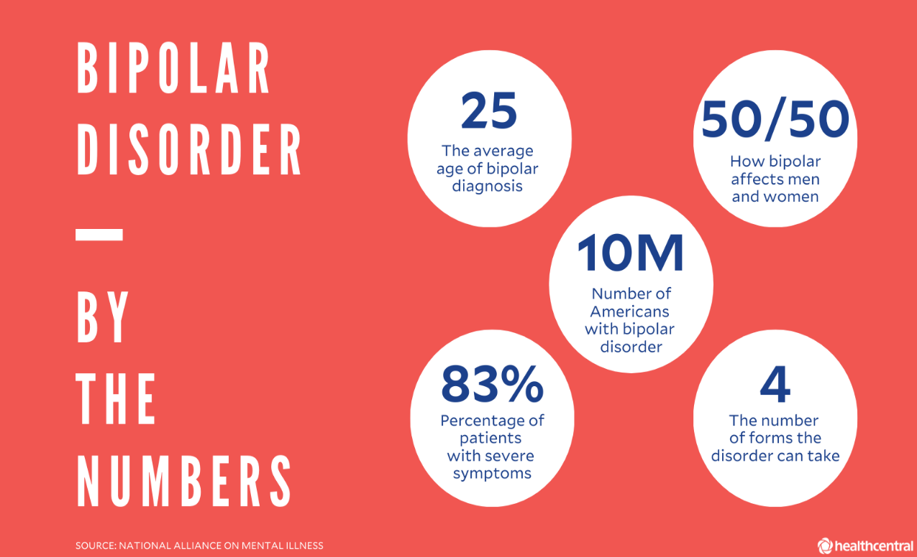

- Overview And Evaluation of The Historic, Contemporary Support, Treatment and Provision
This category of patients, as well as others in the area of mental illness, had limited access to effective pharmacological treatments until the discovery of lithium's antimanic action.
However, it wasn't until the early 20th century that the first standardized medications for the treatment of manic individuals were developed, including barbiturates.
Lithium salts' antimanic effectiveness was proven in the 1950s, and it was eventually proved in Europe in the late 1960s.
This medicine was approved for antimanic and maintenance/prophylactic therapy.
Twenty-eight years later, in 1995, the Food and Drug Administration authorized valproic acid, an anticonvulsant medication, for its antimanic use
Carbamazepine, another antiepileptic medicine, was created to treat people with bipolar illness at the same time as sodium valproate got relevance.
Psychiatrists all across the globe are supportive of this medication, which has received approval from several regulatory bodies in numerous nations.

Finally, the FDA has granted antimanic (olanzapine, risperidone, quetiapine, ziprasidone, aripiprazole, etc.) and antidepressant criteria to many atypical antipsychotic drugs (AADs) since 2000

The contemporary antiepileptic drug lamotrigine has been approved for the treatment of bipolar disorder's periods of depression.

Bipolar illness is now treated with a variety of drugs.

Medication dosages and type are determined by a patient's specific symptoms.

Medicines that help with depression and anxiety, such as antidepressants, antipsychotics,

- Discussion of the Past and Present Services Offered
The primary care physician may give families of individuals with bipolar illness great assistance.

For both the patient and the family, the physician may aid in predicting and planning for life changes.

Previously, primary care services were used to provide the initial guidance for the care and treatment.

Although after the integration of online medical support groups and services in the contemporary world, the management of bipolar disorder has become more convenient.

People may find it difficult to see a psychiatrist in a regular environment, where schedules may be hectic and mental health concerns can be awkward.
Telepsychiatry appointments with board-certified online bipolar disorder physicians and trained online bipolar disorder counsellors are both approachable and inexpensive.

- Statistical Support Evidence on Bipolar Disorder

The bipolar illness affects 46 million individuals worldwide, comprising 2.8 per cent of the United States population (Hafeman et al., 2020)

The prevalence rate of bipolar disorder was estimated to be 2.4 per cent in a study of 11 nations Uk among other countries.

Over 970 million individuals worldwide had a psychiatric condition in 2019, including anxiety and depressive disorders.

Approximately 40 million individuals have been suffering from bipolar illness since 2019

As many as 2 to 5% of the population may have bipolar disorder at some point in their lives

In the United Kingdom, bipolar disorder is one of the most frequent long-term diseases (Age Uk 2018)

Getting a proper diagnosis of bipolar disorder may take an average of nine years; misdiagnoses occur on average 3.5 times. (Van Rheenen et al., 2020)

- Analysis of the Positive and Negative Treatment Available for Bipolar Disorder
Positive Impact of Bipolar Treatment
Medications can help regulate mood shifts and lessen effects by stabilizing energy levels, concentration, and behaviour.
It is also possible to reduce the severity of current manic or depressed episodes with the use of medication.
An important aspect of treatments such as Interpersonal and Social Rhythm Therapy (IPSRT) is the stability of daily cycles.
CBT may help determine what sets off the manic or depressive episodes.

- Negative Impact of Bipolar Treatment
Increase of bodyweight
Tiredness
Dysregulation of the metabolism, such as excessive cholesterol, hypertension, and diabetes mellitus (hyperglycaemia
Stress and irritation with an overwhelming desire to move, rock or walk, known as akathisia

- Policy Frameworks for Mental Health Condition

Since the release of the last NICE guideline (CG38) in 2006, there have been significant breakthroughs in the understanding of the care route for bipolar illness
The treatment of bipolar illness in children, adolescents, and adults is addressed in this document
People with bipolar I, bipolar II, mixed affective, and fast cycling illnesses should follow these guidelines
The COVID-19 mental health and well-being recovery action plan was released by the Department of Health and Social Care on March 27, 2021
Mental health promotion and assistance for those with mental health issues is the focus of this strategy
The Office for Health Improvement and Disparities monitors the citizenry's mental health and well-being

- Conclusion/ Recommendation
it can be stated that the diagnosis of the disorder needs to be rapid

It is necessary to recognize the possibilities and gaps which exist in the existing strategic initiatives to ensure futuristic development

This paper has explored this aspect of Bipolar disorder and provided contemporary evidence of its relevance in the present scenario

References
Kato, T., 2019. Current understanding of bipolar disorder: Toward integration of biological basis and treatment strategies. Psychiatry and clinical neurosciences, 73(9), pp.526-540.
Liu, J., Obioha, T., Magpantay, J., Kanovsky, D., Niles, L. and Scholle, S.H., 2020. Inclusion of telemedicine in behavioral health quality measures. Psychiatric Services, 71(12), pp.1288-1291.
López-Muñoz, F., Shen, W.W., D’ocon, P., Romero, A. and Álamo, C., 2018. A history of the pharmacological treatment of bipolar disorderRhee, T.G., Olfson, M., Nierenberg, A.A. and Wilkinson, S.T., 2020. 20-year trends in the pharmacologic treatment of bipolar disorder by psychiatri. International journal of molecular sciences, 19(7), p.2143.
Perrotta, G., 2019. Bipolar disorder: definition, differential diagnosis, clinical contexts and therapeutic approaches. J Neuroscience and Neurological Surgery, 5.
sts in outpatient care settings. American Journal of Psychiatry, 177(8), pp.706-715.
Roe, J., Cresswell, A., Mittal, S., Al-Uzri, M., Tanner, J., Moore, M., Simpson, S., Guo, B. and Morriss, R., 2022. Service user experiences of care recommendations from the 2014 NICE guideline for bipolar disorder: a survey. Journal of Mental Health, pp.1-8.
Rowland, T.A. and Marwaha, S., 2018. Epidemiology and risk factors for bipolar disorder. Therapeutic advances in psychopharmacology, 8(9), pp.251-269.
Tonozzi, T.R., Braunstein, G.D., Kammesheidt, A., Curran, C., Golshan, S. and Kelsoe, J., 2018. Pharmacogenetic profile and major depressive and/or bipolar disorder treatment: a retrospective, cross-sectional study. Pharmacogenomics, 19(15), pp.1169-1179.
Van Rheenen, T.E., Lewandowski, K.E., Bauer, I.E., Kapczinski, F., Miskowiak, K., Burdick, K.E. and Balanzá‐Martínez, V., 2020. Current understandings of the trajectory and emerging correlates of cognitive impairment in bipolar disorder: An overview of evidence. Bipolar disorders, 22(1), pp.13-27.
Vieta, E., Salagre, E., Grande, I., Carvalho, A.F., Fernandes, B.S., Berk, M., Birmaher, B., Tohen, M. and Suppes, T., 2018. Early intervention in bipolar disorder. American Journal of Psychiatry, 175(5), pp.411-426.



SUPPORTING PAPPER

Assessment 1
Student name: JOHNSON B. AKEJU
Student ID: 1919481
Module name: Mental Disorders and Psychopathology
Module code: BMHP6006
Lecturer name: BIANCA SANFILIPPO
Date: 16/05/2023

BIPOLA DISORDER (BPD)
DEFINITON
Bipolar disorder is defined by the occurrence of many episodes of hypomania or mania.
Subsyndromal symptoms, such as irritability and sleep disturbance, are widespread in the absence of significant mood episodes.
A manic episode is characterized by an excessive sense of euphoria, productivity, and even invincibility.
SYMPTOMS
Maniac or hypomanic symptoms characterised by excessive energy.
Restlessness,
Felling irritable, angry, or easily agitated.
Difficulty in sleeping
Depression, changes in appetite.
As a result of this, they may avoid socializing (withdrawal)
Loss of inhibition or poor judgement.
More than a million individuals in the United States are affected by bipolar disorder.
Bipolar disorder is often identified in persons in their teens or early twenties.
Mental illness affected approximately 792 million individuals in 2017 in Uk
The highs and lows of bipolar illness are present in all forms of the condition.
The severity and duration of the mood swings vary greatly among the various types of the illness.
Bipolar II sufferers experience a range of emotions from euphoria to depression.

STATISTICS STATISTICAL SUPPORT EVIDENCE ON BIPOLAR DISORDER
Approximately 40 million individuals have been suffering from bipolar illness since 2019

As many as 2 to 5% of the population may have bipolar disorder at some point in their lives

In the United Kingdom, bipolar disorder is one of the most frequent long-term diseases (Age Uk 2018)

Getting a proper diagnosis of bipolar disorder may take an average of nine years; misdiagnoses occur on average 3.5 times. (Van Reenen et al., 2020)

CAUSES - BIPOLAR DISORDER
The causes of bipolar disorder is not unknown. Experts believe there are several factors that work together to make a person more likely to develop it.
These are thought to be a complex mix of physical, environmental, and social factors.
Genetics
Bipolar disorder is linked to genetics, as it seems to run in families.
The family members of a person with bipolar disorder have an increased risk of developing it themselves.

But no single gene is responsible for bipolar disorder. Instead, a number of genetic and environmental factors are thought to act as triggers.

Triggers
A stressful circumstance or situation often trigger bipolar
Examples are;
Breakdown of a relationship
physical, sexual, or emotional abuse
Death of a close family member or loved one
These types of life-altering events can cause episodes of depression at any time in a person's life.
Physical illness
Sleep disturbances
Chemical imbalance in the brain
Bipolar disorder may be associated with chemical imbalances in the brain.
The chemicals responsible for controlling the brain's functions are called neurotransmitters, and include noradrenaline, serotonin, and dopamine.

MANAGEMENT OF BIPOLAR
Anyone suffering from Bipolar must see a doctor.
Lithium salts' antimanic effectiveness was proven in the 1950s, and it was eventually proved in Europe in the late 1960s.
This medicine was approved for antimanic and maintenance/prophylactic therapy.
Twenty-eight years later, in 1995, the Food and Drug Administration authorized valproic acid, an anticonvulsant medication, for its antimanic use.
Carbamazepine, another antiepileptic medicine, was created to treat people with bipolar illness at the same time as sodium valproate got relevance.
Finally, the FDA has granted antimanic (olanzapine, risperidone, quetiapine, ziprasidone, aripiprazole, etc.) and antidepressant criteria to many atypical antipsychotic drugs (AADs) since 2000
The contemporary antiepileptic drug lamotrigine has been approved for the treatment of bipolar disorder's periods of depression.
This category of patients, as well as others in the area of mental illness, had limited access to effective pharmacological treatments until the discovery of lithium's antimanic action.
However, it wasn't until the early 20th century that the first standardized medications for the treatment of manic individuals were developed, including barbiturates.
Lithium salts' antimanic effectiveness was proven in the 1950s, and it was eventually proved in Europe in the late 1960s.

MEDICATIONS
Bipolar illness is now treated with a variety of drugs.
Medication dosages and type are determined by a patient's specific symptoms.
Medicines that help with depression and anxiety, such as antidepressants, antipsychotics

. Mood stabilizers: These medications help to regulate mood swings and prevent episodes of mania and depression. Mood stabilizers commonly prescribed include lithium, valproic acid, and carbamazepine.

2. Antipsychotics: Used to treat symptoms of mania or mixed episodes, antipsychotics can help calm racing thoughts, agitation, and other symptoms of mania

3. Antidepressants: Although antidepressants are not typically used alone to treat bipolar disorder, they may be prescribed alongside mood stabilizers or antipsychotics to treat depressive symptoms. Some commonly prescribed antidepressants for bipolar disorder include bupropion, fluoxetine, and sertraline.

4. Benzodiazepines: These medications are used to treat symptoms of anxiety and may be prescribed when someone with bipolar disorder is experiencing extreme anxiety or agitation. Examples of benzodiazepines commonly prescribed for bipolar disorder include clonazepam and lorazepam.
It is important to note that medication management for bipolar disorder is highly individualized and may involve a combination of different medications.

PROGNOSIS
The prognosis varies and this depend on various factors including severity of the illness.
Bipolar is a lifelong condition, and with appropriate treatment it is possible for people to live longer. Other factors that can influence bipolar are.
Lifestyle factors like sleep, diet exercises and stress.
Substances used also can affect bipolar disorder. So, it is better to avoid alcohol and drugs that can worsen the situations.
People with bipolar I, bipolar II, mixed affective, and fast cycling illnesses should follow these guidelines.

The COVID-19 mental health and well-being recovery action plan was released by the Department of Health and Social Care on March 27, 2021
Mental health promotion and assistance for those with mental health issues is the focus of this strategy.
it can be stated that the diagnosis of the disorder needs to be rapid It is necessary to recognize the possibilities and gaps which exist in the existing strategic initiatives to ensure futuristic development, this paper has explored this aspect of Bipolar disorder and provided contemporary evidence of its relevance in the present scenario.

