STUDENT NAME: SAMEENA HASSAN
STUDENT ID:2023264
LECTURES NAME: PATRICK
MODULE CODE: LCBB5010
COMPONENT 1 (TESLA)
2000 WORDS

Table of Contents

INTRODUCTION 3
Cost Analysis and Business Model 4
Budgeting and Financial Planning 5
Performance Measurement and Decision-Making 6
Sustainability and Ethical Considerations 9
Conclusion and Recommendations 10
References: 12

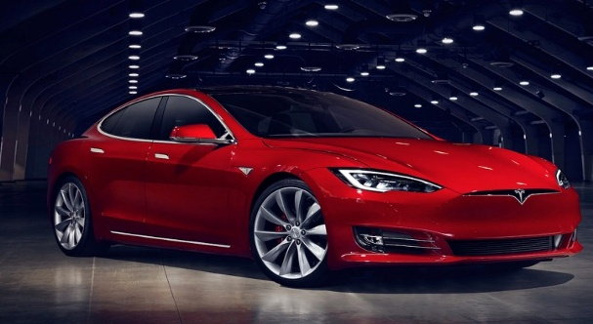
(Panmore ,2024)

INTRODUCTION

Tesla, Inc.is a global leader in the electric vehicle (EV) and clean energy industry, headquartered in Austin, Texas. Founded in 2003 by Martin Eberhard and Marc Tarpenning, and later propelled under the leadership of Elon Musk, the company has grown into one of the most valuable automakers in the world (Investopedia, 2015). Tesla operates across three major segments: automotive (EV design, manufacturing, software, and autonomous driving technologies), energy generation and storage (solar panels, solar roofs, Powerwall and Megapack), and services including its Supercharger infrastructure and vehicle maintenance (Tesla, 2024). Its key automotive products Model S, Model 3, Model X, and Model Y represent a disruptive shift in the traditional automotive sector, combining innovation with sustainability.
Telsa is "important beyond just the products they've developed." This statement, which outlines a vision “to accelerate the world’s transition to sustainable energy,” places it among those centrally involved in global sustainability debates (Panmore, 2024). Through its overarching hardware and software vertical integration strategy, the company is positioned to maintain its competitive edge with over-the-air updates, a proprietary battery ecosystem, as well as cutting-edge AI-enhanced autonomous driving technology (Britannica, 2025). But Tesla also has challenges to confront, such as variable margins and supply-chain risks information from Forbes (2022) indicated that regulatory pressures are growing, with increased global competition in the EV marketplace.
From an intellectual perspective, Tesla is frequently approached as a hybrid organization at the crossroads of the automotive and technology and energy sectors. Such a distinctive positioning makes that performance measurement should introduce simultaneously qualitative and quantitative measures, relating to both profitability, innovation capability as well as environmental damage (IJEFM, 2021). Management accounting is important in this context as it helps management to make decisions, performance evaluate and the proper allocation of resources (Kaplan & Norton, 1996). From a management accounting perspective, one can see what makes Tesla as a modern innovation-focused company continues to survive and compete in this global post-dynamic world.

Cost Analysis and Business Model
Tesla is based on unique business model that combines car production, energy applications and software-based offerings. Electric vehicle (EV) sales are its major revenue source, with the Model 3 and Model Y produced delivering most of them in 2023 (Tesla, 2023a). Outside of vehicles, Tesla makes money from energy generation and storage products, regulatory credits sales, servicing after the sale as well as software like its Full Self-Driving (FSD) package. This revenue mix allows Tesla to offset cyclicality in the automotive market with stable, high-margin software and energy businesses (Mangram, 2012).

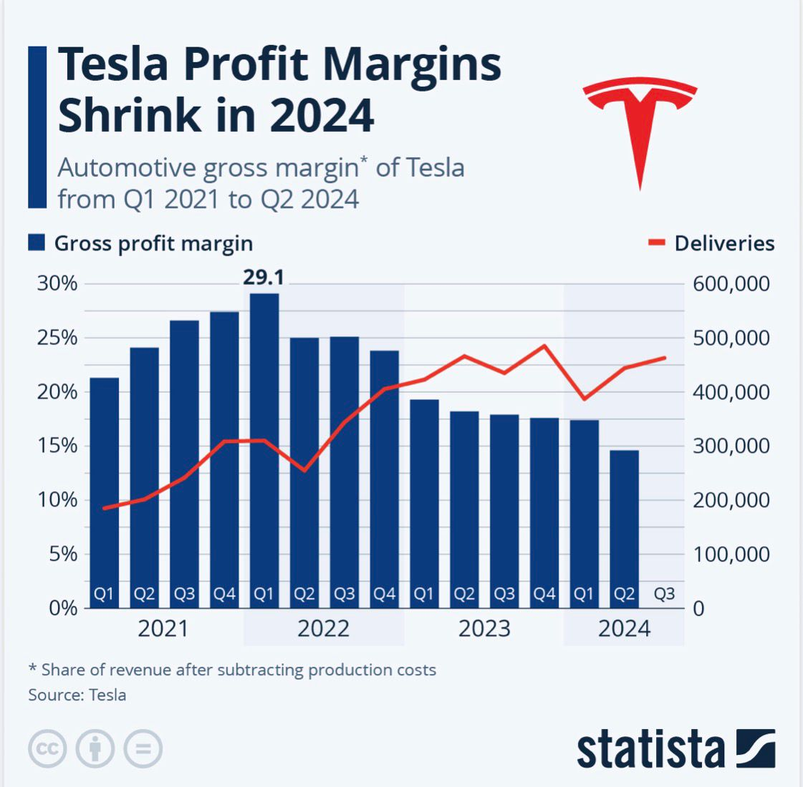

This chart shows the automotive gross margin of Tesla from Q1 2021 to q2 2024
The cost structure of Tesla reveals that it is a highly capital-intensive and technology driven entity. The company has a tank of fixed costs, thanks to expensive Gigafactory capital expenditures, robotic advances and ongoing R&D. In 2023, Tesla spent about USD 3.1 billion on R&D, which was just below 4% of its total revenue (Macrotrends, 2024). These fixed costs are essential to preserve Tesla’s technology lead in batteries, autonomous driving and manufacturing efficiency. This is further compounded by ever increasing overhead expenses such as those relating to global distribution networks and corporate infrastructure, which contributes to an increase in fixed costs (Statista, 2024).

Budgeting and Financial Planning
Budgetary and financial planning forms the crux of Tesla’s functioning, owing to its high capital intensity and innovation that must be relentless. Tesla's budgets create a plan to allocate resources towards its core business including R&D, manufacturing expansion, marketing and sustainability activities. Strategic budgeting for operational efficiency and managing cost, all while supporting Tesla’s long-term objective of speeding the world’s transition to sustainable energy Our mission at Tesla is “to accelerate the world's transition to sustainable energy” (Tesla, 2023a).

Financial Performance
In 2024, Tesla's revenue was $97.69 billion, an increase of 0.95% compared to the previous year's $96.77 billion. Earnings were $7.13 billion, a decrease of -52.46%.

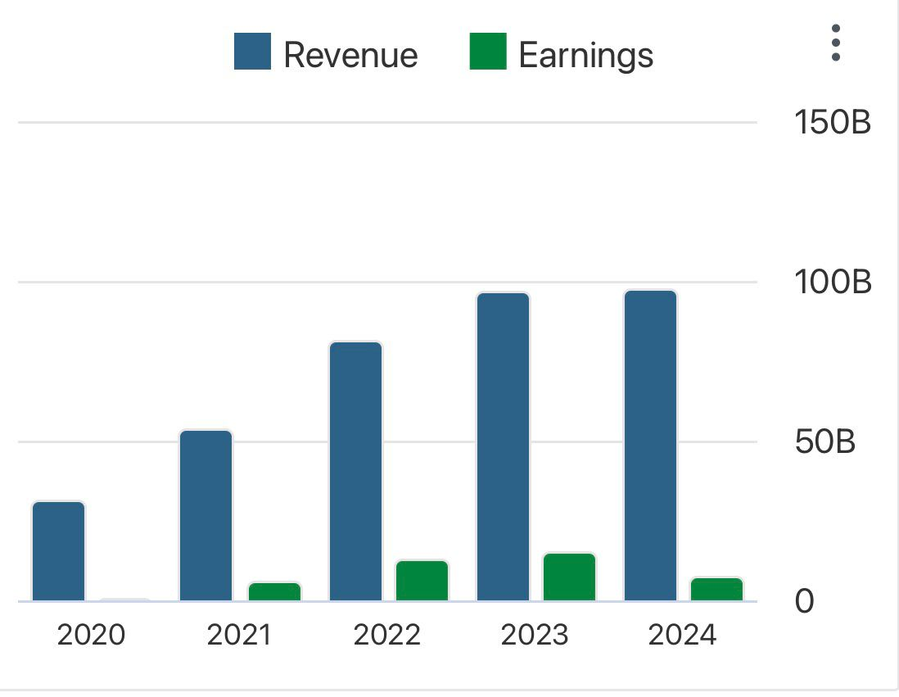

Budgeting's importance to operations is especially meaningful for Tesla because the company manufactures around the world. Texas, Berlin and Shanghai (Tesla, 2023b) but these require heavy upfront investment with Capex above USD 8.9 billion in 2023. Budgets ensure that the financing of these long-term projects does not impair liquidity or destroy shareholder value. Moreover, operating overhead budgets, and in particular R&D and SG&A ones, enable management to focus on which initiatives that will improve performance or technological innovation (Drury, 2018).
Tesla: A look at the financial statements financial statement analysis exposes significant YoY operating expense reductions for Tesla. Operating expenses in 2023 were about 13% higher than those in 2022, which amounted to USD 7.16 billion (Macrotrends, 2024). This growth was primarily driven by increased investment in R&D for artificial intelligence, autonomous driving, and robotics, as well as growing SG&A associated with business expansion. Internally, MGMT also views decision to expand R&D budgets as constituting a long-term growth strategy of (Technological leadership, albeit under short term pressure copyright Tesla, 2023b).
There are also big external macro drivers that heavily impact the notional budgeting process for Tesla. In addition, global inflation pressures and supply-chains constraints have pushed up the raw materials prices that are essential for battery production including lithium and nickel (Bloomberg NEF, 2023). In addition, market demand in key markets such as China and Europe is volatile, thus Tesla would need adaption for its pricing strategy to respond this volatility; could impact revenue forecast besides the flexible budget (IEA, 2022).
Overall, Tesla’s budgeting and financial planning techniques demonstrate a mix of strategic funding and flexibility. By combining internal managerial imperatives and external market conditions, Tesla makes sure that its budgets are dynamic instruments for guiding this decision-making process in an industry marked by rapid technological innovation and keen competition.

Performance Measurement and Decision-Making

Performance measures are an integral component of Tesla’s MAFS; they offer a basis for cost and performance comparisons and provide both qualitative and quantitative information that helps in decision making. KPIs provide management with the tools to assess operational performance, financial health and strategic progress in relation to organizational goals. Tesla combines both financial and non-financial measures for the company to make a well-rounded decision within the competitive and dynamic market (Kaplan and Norton, 1996).

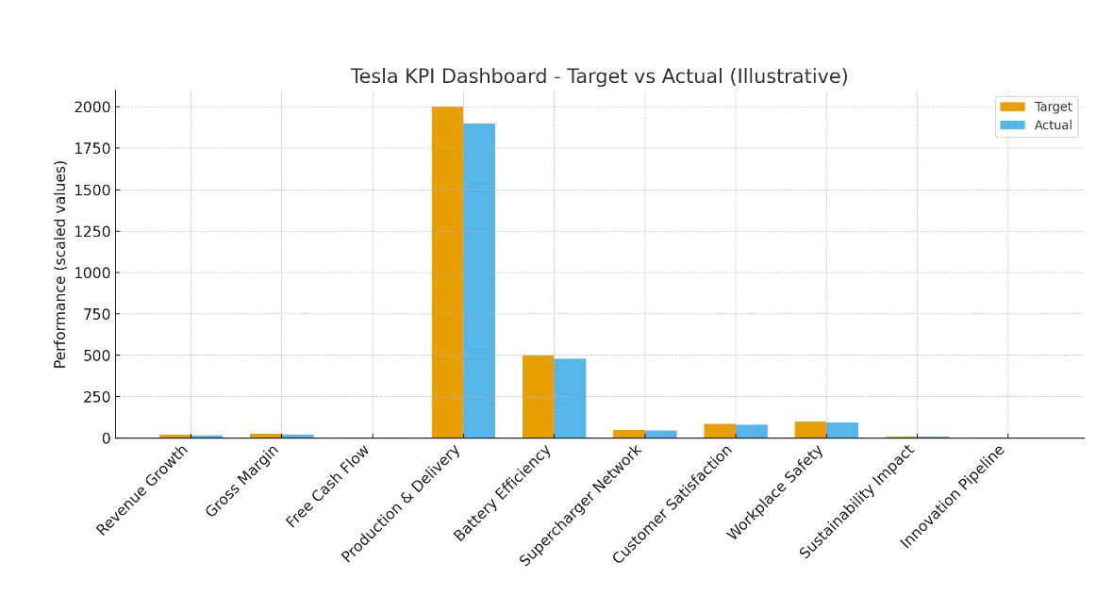

Financial KPIs in Tesla’s Performance Framework

Profitability: Gross Margin & Net Margin
Gross margin reflects how efficiently Tesla turns revenue into gross profit after accounting for cost of goods sold (COGS). In 2023, Tesla’s automotive gross margin declined notably (from ~28.5 % to ~19.4 %) compared to the prior year (as cited in Tesla’s 2023 10-K). This deterioration is commonly attributed to aggressive price reductions intended to sustain demand and competitive positioning in global markets. That strategy, while boosting volume, exerts downward pressure on margin sustainability. Net margin, which captures the bottom line inclusive of operating costs, taxes, and non-operating items, also exhibits volatility, e.g. Tesla reported a net profit margin of 13.7 % in 2023 (versus higher levels earlier). The divergence between gross and net margins underscores that cost control, operating efficiency, and tax/finance items remain critical in preserving profitability.

Liquidity: Current Ratio
The current ratio (current assets ÷ current liabilities) gauges short-term solvency. Tesla’s ability to meet obligations and simultaneously invest in R&D or capital expansion. Tesla’s current ratio has recently been 2.04 (quarterly) and 2.02 (annual) in most recent reports, indicating a comfortable short-term liquidity buffer. A ratio in the 1.5–2.0 range is often considered healthy for capital-intensive firms. If Tesla’s current ratio were to fall below 1.0, it would suggest tight cash management, increased reliance on external financing, and potential vulnerability to cyclical pressures.
Efficiency: Inventory Turnover
Although explicit public figures for Tesla’s inventory turnover are less frequently reported, this metric is critical given Tesla’s global vehicle distribution, parts inventories, and production scaling. A higher turnover rate signals robust demand and efficient inventory management, reducing warehousing costs and releasing tied-up capital. Conversely, a declining turnover would be an early warning of overproduction relative to demand, or misalignment in supply chain and forecasting. In Tesla’s context, supply chain constraints or mismatches in market demand (e.g. regional saturation) could depress this rate.
Valuation: EPS & P/E Ratio
Earnings per share (EPS) captures per-share profitability and is a central input into valuation. Tesla’s EPS has fluctuated over recent years, influenced by margin swings, one-time tax benefits (e.g. Tesla’s 2023 net income benefited from a non-cash tax release). and macroeconomic headwinds. Despite this volatility, Tesla consistently commands a high price-to-earnings (P/E) multiple relative to traditional automakers, reflecting investor expectations about its future growth trajectory in software, autonomous driving, energy, and AI integrations. The elevated P/E implies that investors are pricing in significant future value beyond current earnings.
Leverage: Debt-to-Equity Ratio
Debt-to-equity ratio measures how much debt Tesla uses relative to shareholder equity a crucial indication of financial risk and flexibility. Tesla has significantly reduced leverage over recent years. For instance, Tesla’s debt-to-equity ratio is reported at 0.11 for FY 2024 (ending December 31, 2024), and historical data show periods of very low leverage (e.g. 0.07). In recent quarters, the debt/equity ratio remains modest, such as ~0.17 reported in some datasets. The trend toward lower leverage enhances Tesla’s flexibility to absorb shocks, pursue aggressive capital investments (e.g. new gigafactories), and reduce financial risk. However, overly conservative capital structure might limit growth leverage in capital-intensive industries.

The financial KPIs provide a foundation for assessing Tesla’s financial health, operational discipline, and investor expectations. Together with non-financial metrics (e.g. production efficiency, innovation, customer satisfaction), they create a comprehensive performance measurement system suitable for academic analysis or strategic reporting.

Sustainability and Ethical Considerations

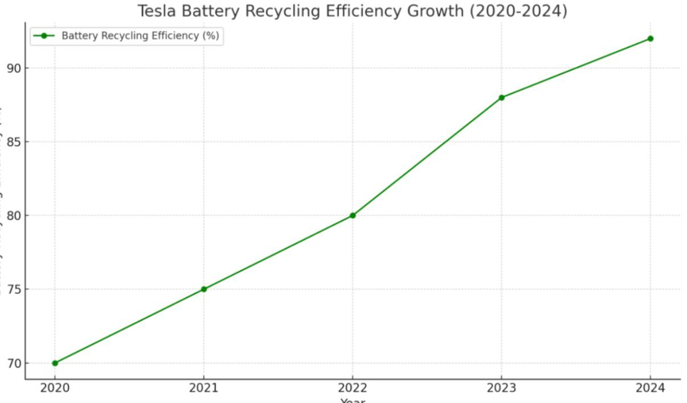

Sustainability is at the core of Tesla's mission and business strategy. The organization presents itself not only as a car maker, but also as technology company focused on sustainability. Its objective is to speed up the world's shift to renewable energy (Tesla, 2023a). As it seeks to shift investment patterns and research priorities from energy supply to low-cost, low pollution yet sustainable infrastructure, this viewpoint will impact decision-making in terms of product design, production and finance. For example, Tesla's Gigafactories are situated and designed fully with an eye on energy conservation: the Nevada facility is power hung partially by solar panels (IEA, 2022). In addition, Tesla is pouring big money into battery recycling projects to slash reliance on raw materials and reduce life-cycle emissions (Tesla, 2023b).
From an ethical perspective, Tesla's supply chain is under ongoing scrutiny. The extraction of cobalt, a critical battery material, has been linked to children working in perilous conditions and unjust working conditions in the Democratic Republic of Congo (Amnesty International, 2021). While Tesla has taken steps to minimize cobalt use and increase transparency through supplier audits, critics argue that ethical risks still lie in the supply chain (Bloomberg, 2023). Furthermore, Tesla's unions, and reports of poor working conditions at its U.S. factories, raise ethical concerns about workers' welfare (Reuters, 2022).
Nevertheless, Tesla's sustainability initiatives are a substantial source of competitive advantage for it. By aligning financial decisions with environmental ends, such as reducing the cost of renewable energy systems, Tesla is boosting its own market image and long-term viability (Mangram, 2012). But in the field of ethics, there remain areas needing attention to ensure that growth is in line with substantive social responsibility standards. By integrating sustainability and ethics into management accounting frameworks, Tesla can make decisions that balance profitability with stakeholder expectations.

Conclusion and Recommendations

Tesla’s application of management accounting frameworks enables it to balance the challenges of high fixed investments such as Gigafactories and R&D with volatile variable costs including lithium, nickel and labour (Drury, 2018). Through strategic budgeting and performance monitoring, the company sustains global expansion while pursuing innovation in EVs and clean energy.

Tesla’s competitive advantage is rooted in its key selling points: vertical integration in battery and software production, which reduces supplier dependence (Mangram, 2012); technological leadership in range, autonomous driving and over-the-air software (Tesla, 2023a); and sustainability branding that reinforces its mission of accelerating the shift to renewable energy (IEA, 2022). However, profit pressures are evident, with gross margin falling from 25.6% in 2022 to 18.2% in 2023 (Macrotrends, 2024), while competition from Chinese EV manufacturers intensifies (Bloomberg NEF, 2023).

To strengthen its long-term position, Tesla should consider five strategic recommendations:
Enhance Financial Health Monitoring: Regularly evaluate liquidity ratios such as the Current Ratio, targeting a healthy range of 1.5–2.0 to avoid short-term financial stress (Kaplan & Norton, 1996).
Differentiate Product Selling Points: Reinforce advantages in battery efficiency, global charging infrastructure and software innovation to maintain pricing power despite competitive price cuts (Hinterhuber & Liozu, 2014).
Improve Cost Forecasting Models: Deploy predictive analytics to anticipate commodity price swings, stabilising gross margins and informing Capex planning (IEA, 2022).
Strengthen Ethical Supply Chain Practices: Expand audits to address risks in cobalt sourcing and labour conditions, embedding ethical sourcing as a KPI (Amnesty International, 2021; Bloomberg, 2023).
Diversify Revenue Streams: Increase focus on software subscriptions and energy services to reduce reliance on car sales, supporting resilience and high-margin growth (Mangram, 2012).

In summary, by aligning financial discipline, innovation and ethical responsibility, Tesla can safeguard margins, sustain competitive advantage, and deliver on its mission of sustainable energy.

References:
1. Amnesty International (2021). This is What We Die For: Human Rights Abuses in the Cobalt Supply Chain.
2. Bloomberg NEF (2023). EV Battery Metals Outlook.
3. Drury, C. (2018). Management and Cost Accounting. 10th ed. Andover: Cengage Learning.
4. Hinterhuber, A. and Liozu, S. (2014). Innovation in Pricing: Contemporary Theories and Best Practices. New York: Routledge.
5. IEA (2022). Global EV Outlook 2022. Paris: International Energy Agency.
6. Kaplan, R.S. and Norton, D.P. (1996). The Balanced Scorecard: Translating Strategy into Action. Boston: Harvard Business School Press.
7. Macrotrends (2024). Tesla R&D Expenses 2010–2023.
8. Macrotrends (2024). Tesla Operating Expenses 2010–2023.
9. Mangram, M.E. (2012). The globalization of Tesla Motors: a strategic marketing plan analysis. Journal of Strategic Marketing, 20(4), pp.289–312.
10. Reuters (2022). Tesla faces renewed scrutiny over labour practices.
11. Statista (2024). Tesla’s revenue worldwide from FY 2008 to FY 2023.
12. Statista (2024). Tesla’s vehicle deliveries 2012–2023.
13. Tesla (2023a). Tesla Impact Report 2023.
14. Tesla (2023b). Q4 2023 Update. [online] Tesla Investor Relations.
15. World Economic Forum (2023). Global Supply Chains of EV Batteries.

