
Module Name: Academic Skills in the Digital Era
Module Code: BMSW4013
Assessment 1:
Student Name: Sadia Islam
Student Number:2531380
Lecturer: Chris Wilkin
Deadline: Friday 27th February

Wordcount: 2195
AI Acknowledgement
(This section is compulsory for all students.)
I acknowledge the use of [AI tool name] ([AI tool URL]) on [date] to support [state purpose – e.g. research / proofreading / none].
Prompt(s) used (if applicable):

I confirm that I have not presented any AI-generated text as my own work. I confirm that I have retained copies of drafts, notes, and resources used before and after the use of AI tools.
Contents
Component 1- Development of Academic skills (500 words) ………………………………. 4-6
Component 2 – Application of Academic Skills (1,000 words) ……………………………… 7-8
Component 3 – Academic Poster ……………………………………………………….……………. 11

.

Component 1 – Development of Academic Skills (500 words)
(Personal experience must NOT be included in this component)
Evaluating Academic Sources Using the CRAAP Test (250 words)
Choose TWO academic sources related to the use of digital skills in higher education.
Source 1
Author(s) and year: Grinberga-Zalite, G et al, 2019
Where you found the source (e.g. library database, Google Scholar): Library Database
Using the CRAAP Test, briefly evaluate:
With the CRAAP test, this source proves somewhat a strong currency as it was published in 2019. Relevancy is great as it mentions the “author’s intention was to research digital performance indicators in the European Union in the context of higher education”. Authority is strong due to the authors research method, processing “publicly available digital performances” from several Latvian universities, as-well as using “surveys to the LLU students, academic staff and managers responsible for the e-studies provision, marketing and communication processes” to source data from. Accuracy is based on research method, which is secondary data analysis. Purpose is to inform the importance of meeting the level of needs of digital skills in higher education which can strengthen the EU’s human capital in the digital economy.
Full reference (Harvard style): Grinberga-Zalite, G., Rivza, B., Zvirbule, A. And Tihankova, T., 2019. Promoting Digital Skills in Higher Education to strengthen the competitiveness of the EU Human Capital. Sofia: Surveying Geology & Mining Ecology Management (SGEM)
Source 2
Author(s) and year: Bastos, S, et al, 2019
Where you found the source (e.g. library database, Google Scholar): Library Database
Using the CRAAP Test, briefly evaluate:
Using the CRAAP test, the source could be seen as good currency considering it was published in 2019. Relevancy is strong as it mentions “the inclusions of soft-digital skills training in higher education”. Authority is great due to the author producing many articles as-well as being a “researcher/publisher in educational European Journals about the need to bring soft-digital skills into the curricula of courses.” Accuracy is extensive with a vast number of references used through out the source. The method is supported by questionnaires to students in higher education in different departments such as medicine, nursing, engineering, management, arts, and literature. Purpose of the source is to highlight that future education relies on blending both human and digital factors together within the evolving modern world.
Full reference (Harvard style): Bastos, S., De Oliveira, H., Silva, M.M. And Azevedo, L., 2019. Soft–Digital Skills in Higher Education Curricula. Kidmore End: Academic Conferences International Limited.
Synthesis of Academic Sources (150–180 words)
Both sources are adamant on the importance of digital skills in higher education for the evolving future as well as for student satisfaction. (Grinberga-Zalite et al, 2019) states “Universities must continue to evolve their curricula and study environments to meet labour market demands and student expectations”. Likewise, (Bastos et al, 2019) claims “use of digital environments…improves student performance and helps be more effective”.
(Grinberga-Zalite et al 2019) cites more about how digitalisation is advancing the EU’s competitiveness, while (Bastos et al, 2019) focuses more on developing digital and human skills together for a more balanced approach to learning.
Both sources emphasise that to meet the demands of the digital era, we must improve the way we learn and understand. (Grinberga-Zalite et al, 2019) highlights how “digitisation has a significant impact on higher education; thus universities should offer a study environment that meets the demand of students, using latest technologies”. Similarly, (Bastos et al, 2019) emphasises that “Higher Education Institutions (HEI) must reinvent themselves in order to maintain a major role in society: to graduate students prepared to a profession”.

(Write objectively and include in-text citations.)
Identifying a Key Challenge and Opportunity (100–120 words)
Using ONLY the two sources above:
A key challenge for students is offering a clear way that will indefinitely improve their learning. (Grinberga-Zalite et al, 2019) emphasises “Universities curriculum should be more based on the idea of training students’s skills demanded by labour market[s]” Similarly, (Bastos et al, 2019) claims “the curricula must undergo a huge transformation in order to promote the development in students”.
An opportunity for students is that they have an easy access to information needed whilst learning. (Grinberga-Zalite et al, 2019) states “generally all public universities… make their websites appropriate for students’ needs”. Likewise, (Bastos et al, 2019) survey results show that “100% of the HEI in study provides them a digital environment to support their studies”.
(Both must be supported by academic evidence.)
Academic Planning for Component 2 (80–100 words)
For component 2 I will prioritise the challenges and opportunities digital learning can bring to higher education. This is because it is important to understand exactly what difficulties and benefits digital learning can bring to us. Concepts I will develop into are digital literacy, critical thinking and academic integrity. The structure of component 2 will be as followed, introduction, challenges for the students in the digital era, opportunities in the digital era, how students can adapt to succeed and a conclusion.
Timeline
Task | Date/ Deadline
Finish research | 15/2/2026
Draft first section | 17/2/2026
Complete first draft
Final editing

Reference List – Component 1
(Harvard style, alphabetical order. Only sources used in Component 1.)
Bastos, S., De Oliveira, H., Silva, M.M. And Azevedo, L., 2019. Soft–Digital Skills in Higher Education Curricula. Kidmore End: Academic Conferences International Limited.
Grinberga-Zalite, G., Rivza, B., Zvirbule, A. And Tihankova, T., 2019. Promoting Digital Skills in Higher Education to strengthen the competitiveness of the EU Human Capital. Sofia: Surveying Geology & Mining Ecology Management (SGEM)

Component 2 – Application of Academic Skills (1,000 Word Report)
(Personal experiences must NOT be included in this component)
Introduction (100–150 words)
Digital learning has become one of the most key features in higher education, from being an easy access for students to engage with to assisting with teaching when needed, it has surely become an increasing factor that most higher education institutions have adapted to. Understanding both the challenges and opportunities of digital learning is essential for us as we can create a balanced and more effective way to learn that meet the demands in an increasingly digital world. I will develop into the key challenges and opportunities digital learning can offer in education, as well as strategies students can adapt to succeed with, concluding with a summary addressing the main topic.
Challenges for Students in the Digital Era (150–200 words)
A huge challenge students face in the digital era is the unwillingness to engage. “Some students are… less keen to participate… when it requires more effort form their side” (Xiang et al, 2019). This challenge impacts academic success as “no student[s] are equal as people learn in different ways” (Xiang et al, 2019). With the evolving wave of digital learning, it is almost forced upon students to adapt to the way of technology, even when traditional methods are preferred or wanted. “Teachers need to adapt to the students’ needs and thus in a style, which is suitable for for the students and the teachers themselves” (Xiang et al, 2019). This discussion indicates critical analysis; students are not just “less keen to participate” but perhaps have just not found a clear method that suits their needs.
Opportunities in the Digital Era (150–200 words)
A significant opportunity provided by digital tools is that “Digital technologies offer rich media for [the] teaching” (Kaushik et al, 2020). With the many ways students can learn from, digital learning technologies can provide easier access to educate students. “Virtual media for teaching and learning, for example, learning through simulation (i.e. animation and games), video lectures, live chat sessions, online discussions and forums” (Kaushik et al, 2020). Another opportunity offered by digital tools is that “Institutions are becoming more enthusiastic about the possibilities of online learning to give affordable and current education to people of all ages and socioeconomic levels” (Alenezi, 2023). The effectiveness of this opportunity is substantial as it allows flexibility to education for students from all locations and backgrounds to study the same. However, it is limited to the extent of internet access, as-well as digital literacy skills not being a universal trait. It is understood that using digital tools do not automatically improve learning but the way we incorporate it into our education. It may seem easier to introduce digital aspects into learning, yet we still must understand that it is used to interact with students in a way that positively strengthens engagement and learning.
How Students Can Adapt to Succeed (200–250 words)
Propose THREE strategies students can use to succeed
For EACH strategy:
A strategy students can use to succeed with is digital literacy. This is the “cognitive, social and emotional abilities users require to function in digital environments” (Kabakus et al, 2025). This allows students to “minimise the inequalities that may arise from the digital divide” (Kabakus et al, 2025). Digital literacy develops students research, writing, academic integrity and independent learning as “a higher digital literacy level would have a positive impact on users' productivity and… use of digital technology” (Kabakus et al, 2025). Digital literacy addresses challenges by reducing technology barriers and offers opportunities by allowing students to learn digitally confidently and effectively.
Another strategy students can use is critical thinking. “Critical thinking trains students to explain their reasoning, consider other possibilities… and question their answers” (Haston, 2020). This develops writing skills, as-well as researching and structuring arguments. Critical thinking is challenging as it requires personal awareness, however, it portrays opportunities by developing students analysing and academic performances. “These skills prepare students to handle a multitude of challenges they are likely to face” (Haston, 2020).
A third and final strategy students can use is academic integrity. This is “a commitment to the five fundamental values of honesty, trust, fairness, respect, and responsibility” (Davis, 2023). Academic integrity helps students reinforce their research, critical analysis referencing and in general writing skills. Challenges academic integrity address are academic misconduct and plagiarism whilst maintaining opportunities to allow fairness and strengthen personal development.
Conclusion (100–150 words)
The challenges and opportunities students face when digitally learning are significant. The challenges of having to adapt to digital technologies whilst also maintaining engagement and academic success may cause some issues for students as-well as teachers, however, the opportunities are great and offer students many different ways to suit their way of learning. Improving skills such as digital literacy, critical thinking and academic integrity will not only benefit students in higher education but also in all sorts of environments. These skills allow students to learn effectively as-well as developing personal independency. In conclusion digital learning is a beneficial tool that we will continuously have to adapt with in this evolving era, as for education, success will only come from how we incorporate digital learning to students. This will have to be done in an engaging and balanced way that suits all students in all ways.
Reference List – Component 2
(Harvard style, alphabetical order. Only sources used in Component 2.)
Alenezi, M., 2023. Digital Learning and Digital Institution in Higher Education. Education Sciences, 13(1), pp. 88.
Carter, B.A., 2008. Faculty beliefs, level of understanding and reported actions regarding academic integrity, The University of North Carolina at Greensboro.
Davis, A., 2023. Academic integrity in the time of contradictions. Cogent Education, 10(2).
Haston, A.L., 2020. Critical Thinking in Higher Education STEM: A Qualitative Faculty Perspective, Franklin University.
Kabakus, A.K., Ekrem, B. And Ahmet, A., 2025. The effect of digital literacy on technology acceptance: An evaluation on administrative staff in higher education. Journal of Information Science, 51(4), pp. 930-941.
Kaushik, M.K. And Verma, D., 2020. Determinants of digital learning acceptance behaviour: A systematic review applied theories and implications for higher education. Journal of Applied Research in Higher Education, 12(4), pp. 659-672.
Xiang, Y.M., Aas, E. And Medgard, M., 2019. Teachers’ use of digital learning tool for teaching in higher education: Exploring teaching practice and sharing culture. Journal of Applied Research in Higher Education, 11(3), pp. 522-537.

Component 3 – Academic Poster
Copy and paste your academic poster below.
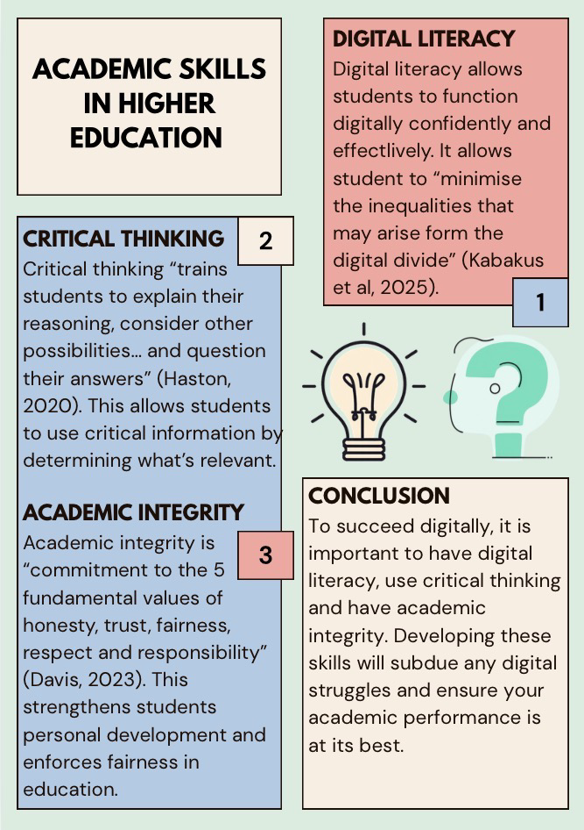
Your poster must include:

Reference List – Component 3
(Only sources cited on the poster.)
Davis, A., 2023. Academic integrity in the time of contradictions. Cogent Education, 10(2).
Haston, A.L., 2020. Critical Thinking in Higher Education STEM: A Qualitative Faculty Perspective, Franklin University.
Kabakus, A.K., Ekrem, B. And Ahmet, A., 2025. The effect of digital literacy on technology acceptance: An evaluation on administrative staff in higher education. Journal of Information Science, 51(4), pp. 930-941.

