Managing Projects in the Organisation

(BMSK5004_SWAN)

Student name; Musammot Sima

Student number; 1705525

Contents
Managing Projects in the Organisation 1
(BMSK5004_SWAN) 1
Student name; Musammot Sima 1
Student number; 1705525 1
Introduction 3
Work placement organisation; 3
Main body: 4
Project Scope; 4
Quad Chart; 5
Gantt chart; 6
Project Cycle; 7
Iron Triangle; 9
Risk assessment: 10
PESTLE; 11
SWOT; 12
WBS; 13
Stakeholder analysis; 14
Conclusion; 15
Reference List; 16

Introduction
The aim to this report is to critically assess project management tools that have been used within the wok placement given by the tutor. This will include brief description of the organisation and how the project was undertaken. It will show how the tools have led the project towards success and what the risks are. Finally the report will deliver how to improve the project for future development.
“Project management is the application of processes, methods, skills, knowledge and experience to achieve specific project objectives according to the project acceptance criteria within agreed parameters. Project management has final deliverables that are constrained to a finite timescale and budget.” (APM, 2019).
All projects have a mission which helps show the needs, solve problems and show the opportunities which leads success for projects. To attain the best result it is necessary to advertise accordingly, see what and where to hold the event, who the stakeholders are, finalise budgets and focus on the time to see what can be given towards the project itself. Some projects fail due to the lack of understanding of the project itself and the misunderstanding of the project tools. It can also fail due to communication problems within the team. (Maund, 2018)

Work placement organisation;
The organisation is Community for Work. The main goal was to promote information. To complete the project the team collaborated with the employees in CFW. It was established in 2016. It consists of various projects to help the public, for example; IT services, English, building CV and one to one support to build confidence. The program is an EU funded project based in the city and county of Swansea. The motto of the organisation is ‘Alone we can do so little, together we can do so much’. (Communities for work, 2019).
To complete the project the candidate needed to form a team where they took a Belbin test to see what type of role they can take for the project. To complete the project it was necessary to finalise who is taking what role to meet the requirements. In Belbin’s test individuals have a greater self-understanding of their strengths and weaknesses which gives more effective communication between staff and managers. (Belbin, 2019)
The following members were involved and their team role;
Hena- Project manager
Sima- IT Implementer
Jasminara- Coordinator
Jahanara- Team leader

Main body:

Project Scope;
Every manager needs to understand how to define the project scope and there are a few points to focus on, such as what the project is, how it can be completed and who is going to do what. To complete the project the team implemented the scope to gain success. The tool helps analyse which team member can do what role analysing who does well at what part. It focuses on what the best result can be taken from the project, who is involved, when it will take place and why it is important to run the project. (Connolly, 2019).
The main reason for the project is to make awareness about the services that CFW provide. To achieve the best result the team need to go out to Swansea city to distribute leaflets to the public. By providing this information, it will make people more involved and help them gain knowledge on how to get success towards gaining employment and many more facilities. Everyone is responsible for making the leaflet and to communicate well with the people. Brainstorming ideas is very important to get the best result. For the best result it is important to have a good-looking leaflet and a good location to get the public attracted towards the event.

Quad Chart;
Quad chart is a quick and easy technique to promote any organisations products, capabilities and services. It is a standard marketing tool. It is divided into four sections;
- Aims/objectives
- Stakeholders
- Critical success factors
- Key performance indicators. (business.gov.au, 2018).
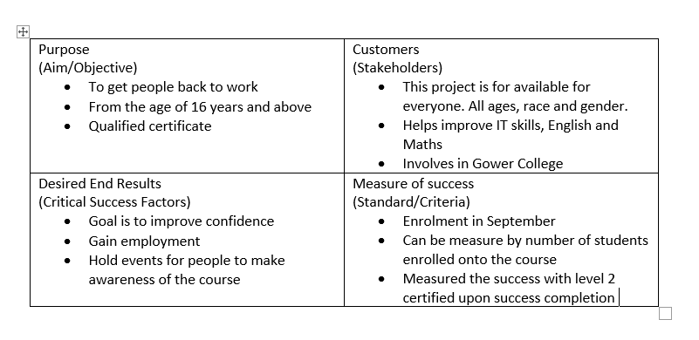
The main aim of the project is to get people back into work. People who have less confidence needs one to one support. CFW provide this help and try to get them into employment. By completing the quad chart, the team have acknowledged who the stakeholders are. The organisation Collab with Gower college. They provide each other information regarding what services they provide. Both companies promote each other’s facilities. The goal of CFW is to raise awareness of the courses that they hold. By providing classes they tend to help people are lacking these qualities and help them achieve employment. measure success have been analysed through the quad chart, which is their enrolment starts in September. They require several students to be enrolled to get the funding and run classes accordingly. To achieve this, the team have taken the role to promote their information through the project itself in the main event.

Gantt chart;
Gantt chart was introduced in 1910 by Henry Gantt. It is used for planning and monitoring projects. It includes activities, tasks and events which will be used for project planning. (Gantt Chart, 2019). The Gantt chart below consists of different tasks which needs to be completed to get to the result for the event.
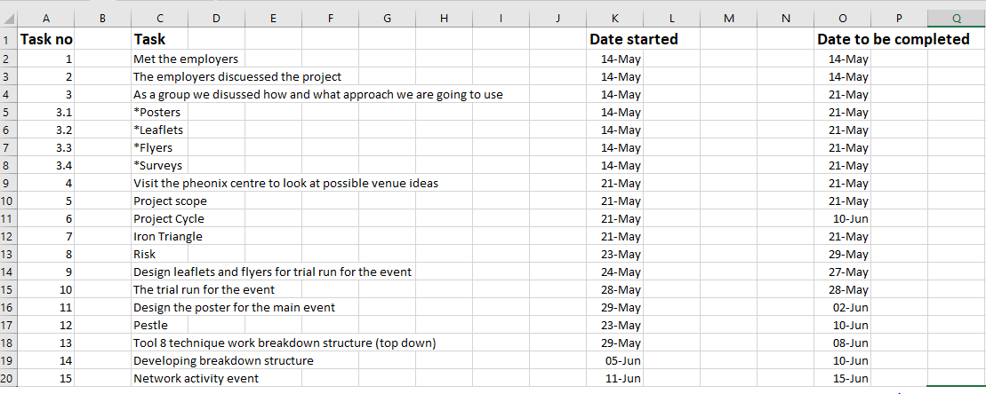
Through this tool, the team had planned several works that needs to be done in order to achieve the best result for the project. Unfortunately the team did not manage to complete all the required tasks mentioned. The mentors and the team planned to go door to door to give out flyers to show the public what the organisation provide. While undertaking the WBS in the planning phase we set time targets to give out the flyers before the main event takes place. This was cancelled due to other issues. Instead the team took extra time and made effort into the main event and went to another promotional event to give out more leaflets to the community.

Project Cycle;
Project cycle consists of three phases.
In the plan phase there is three more phases which consist of conception, definition and initiation phase. The do phase comes next and finally the review phase. (Usmani, 2019).
In the conception phase, the first meeting took place. At the meeting everyone brainstormed ideas to analyse the project and see how the best can be contributed. The project is to undertake an event where leaflets will be distributed to the community promoting what communities for work provide.
In the definition phase, the leaflet needs to be done. A risk assessment is required in this phase. The mentors discussed what the risks are one of them being how hard it might be to attract the public. It is necessary to understand what audience that needs to be targeted. This risk should be avoided as it will cause more time and cost which can lead the organisation to loss as this is a step to promote themselves.
In the initiation phase, the project will lead to success. The team and the mentors have decided to arrange the main event to distribute the leaflets on 11th June 2019. The event will run for two hours. The mentors have booked a place in the City for £40. A trail run has been arranged to see if the leaflets will work and how improvements can be made for the main event.
The implementation phase is where the planned things need to be done. In this stage not everything has been completed, such as; the trail run has been cancelled but the mentors have advised the team how to put more effort into the leaflets and how to boost up confidence for the main event.
The final stage is the evaluation phase. The main event is completed but unfortunately not much response was gained as expected due to the bad weather and most people in town were elderly. By the mentors, the team had their leaflets as well as a security service leaflet which was taken by some people as they are interested to have it as a side job.

Below is the leaflet;
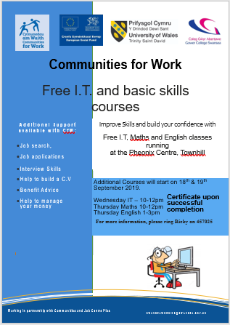

Iron Triangle;
In 1980, Dr Barnes formed the Iron triangle. It determines that quality, cost and time are interconnected. The triangle helps promote an event in ways which shows how important it is to focus on how to complete on the main event. In any project time is important and the project should be completed within the time given. A project must have a fixed budget in order to avoid any loss within the company. The quality is as important as the others. These effects the success of the project. (Stakeholdermap, 2019).
For the main event time and quality was important as this led the project towards success. Cost is necessary but for this specific project it does not effect as much as the others. The area in the city was hired for two hours for £40. It was necessary to complete the event within the time given. The quality for the leaflets were as important as time. The public would investigate how good information has been provided into the leaflets and what services can be given to them. The quality of the leaflet will attract the customers. This is a marketing strategy.

Risk assessment:
Risk assessment is a structured process that enables to identify how objectives can be affected and analyse the risk in term of their probabilities before deciding on what needs to be done. There are certain methods can prevent from risks taking place. Such as; Brainstorming ideas, checklists, hazard analysis etc. (Popov, Lyon & Hollcroft, 2016).
Below is the risk assessment for the project itself: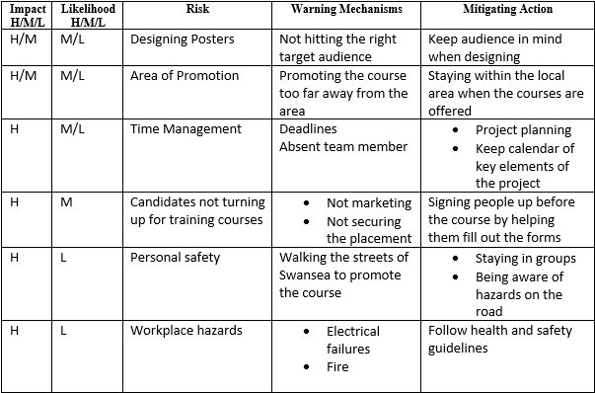
After completing the risk assessment, the team found there are many risks, one of them being time management. This relates to the iron triangle as time is very important for this project. For the project we needed to understand how to accomplish the project within the time given. If the project is not completed within the time it will cause high risk. Another high risk is personal safety. As the event is taking place outside, it is risky to walk outside as there might be road works or wet due to the weather. It can cause accidents like slips and cuts etc. To avoid this it is important to be dressed properly for the weather.

PESTLE;
PESTLE is a framework which is used for knowing what the external influences are on any organisation. Whatever the result, pestle is used to understand the threats and weaknesses in an organisation. (PESTLE, 2018). Below is the PESTLE completed for the project. Community for work plus is a Welsh funded organisation and CFW is funded by the EU government. For the organisation to keep on going it is important to get the right funding. If Brexit does take place, then unfortunately this will be a downfall as it won’t be getting the right funding which will cause the loss in their services. This is the political phase from the PESTLE.
Political | Economic | Social | Technological | Legal | Environmental
There might be a change of government. As CFW+ is funded by the Welsh government, funding may stop, and the project could end. Without this project, support to help people get into employment would end. | The economy in the area could suffer if there are less people in work. This project helps people gain the skills needed to get into employment, which then boosts the economy. | The event planned for the project is community based, in an accessible centre with a café, crèche, and a library, so it is helping people socially. | Posters and leaflets were designed using technology. Technology was also used when designing the planning toolkit to plan the event. | It was a legal requirement to translate the literature into Welsh. We also had to have permission from the council to hand out leaflets in Swansea. | Utilised social media for some of the advertising to reduce the amount of paper used.

SWOT;
Stella, C. (2015) mentioned, “A swot analysis is a useful way to record your situation. It is a simple way of recording the level of willingness for a new task. Swot stands for Strength, weakness, opportunity and threats.”
The strength is that they involve the community with everything, in regards providing them full services in IT and numeracy etc. They have all facilities the Phoenix centre.
The weakness is the leaflet might not be targeting the right people. The leaflet must be attractive or else the organisation will be missing out for customers. it is also necessary for the employees of the organisation and for the team to be able to encourage the people to get into employment.
One of the opportunities are if CFW collaborated with other organisations like UWTSD or Gower college they could increase the reputation of theirs. Another good outcome from this would be they can promote their services, and this will increase awareness to the public.
For an organisation to have success they must know what the threats are. One of them being if the funds are not received then the programs won’t be running. Another threat can be the competition around. The organisation must be aware what services are going on around in order to avoid the risks of losing projects.

WBS;
Work breakdown structure is used as the most common cost estimation approach for any project. (He, Wu, 2014).
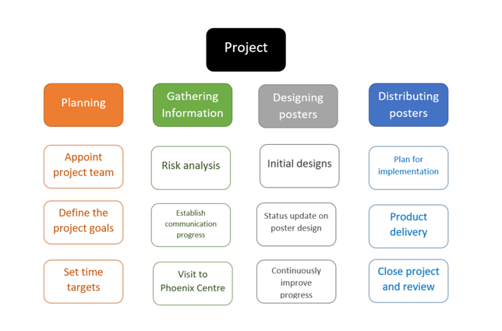

This tool was used to guide the event and provide the understanding to what has been done. Due to some issues, such as weather and personal circumstances many targets needed to be changed and to overcome these missing targets extra time needed to be invested and so as work to achieve the goal. Certain targets were not achieved for example; the door to door flyers which was mentioned in the Gantt chart. To achieve extra success the team participated with another organisation - working wales and distributing more leaflets out helped promote the services that community for work provide. This helped boost up confidence as the team interacted more with the public.

Stakeholder analysis;
Stakeholder analysis is a method to assessing a system. It is an important process that helps manage stakeholders of an organisation and helps ensure the projects leads to success. The tool helps get the project into scope, builds good understanding and gets the managers to analyse the best method to promote the project. (mindtools.com, 2019).
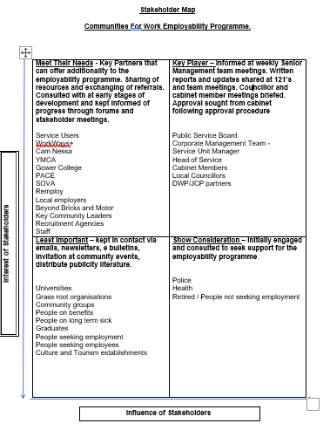
The stakeholder analysis helped the organisation and the team understand who is important. The key players for this project is the public. The main reason of choosing the public as the key players, is because the services provided from communities for work is for the public. All these effect on how the organisation can gain people into their projects. The public should be aware on how the company can give them the services. By doing the stakeholder analysis, the team have understood who and how each person is involved in the project and the roles they have within the organisation.

Conclusion;
After analysing the project, it has concluded that all tools are important. Some tools are important accordingly to the project. The tools used above were relevant to the project and this has given success. By doing the Gantt chart it helped keep the team on track to see what has been done and what needs to do. The project helped promote the services and the tools such as the quad chart helped us focus on what range and type of people to target. It provided to work in a structure and build the project to a high level. The iron triangle helped the team to manage time and complete the tasks within the time given. To conclude this report, the candidate would love to thank the lecturer and the team for all the help as the project given did give the team to boost up their confidence and give the organisation a technique to promote their services.

Reference List;
- APM (2019) What is Project Management, APM.org. [online] available at: https://www.apm.org.uk/resources/what-is-project-management/ [accessed: 17.06.19].
- Belbin (2019) Belbin Team Roles [online] available at: https://www.belbin.com/about/belbin-team-roles/ [accessed: 19.06.19].
- Business.gov.au (2018). Quad charts [online] available at: https://www.business.gov.au/Centre-for-Defence-Industry-Capability/International-support-and-exports/Quad-charts [accessed on 19.06.19].
- Connolly, B. (2019). ‘How to define the scope of a project’, CIO from IDG 5 (1), pp. 7,9.
- Cottrell, S. (2015) SKILLS FOR SUCCESS, Career planning, 3rd edn., Basingstoke, United Kingdom: Palgrave Macmillan. P (273, 339).
- Gantt Chart (2019) Gantt Chart for Project Plan, Available at: http://www.gantt-chart.co.uk/ (Accessed: 22nd June 2019).
- He, Wu, 2014. A Framework of Combining Case-Based Reasoning with a Work Breakdown Structure for Estimating the Cost of Online Course Production Projects. British Journal of Educational Technology, 45(4), pp.595–605.

- Maund, A. (2018). BA in Leadership and Management Skills for the Workplace Student Yearbook. Singapore. Sage.
- Mindtools (2019). Stakeholders analysis [online] available at: https://www.mindtools.com/pages/article/newPPM_07.htm [accessed on 29.06.19]

- Popov, G., Lyon, B.K. & Hollcroft, B., 2016. Risk assessment: a practical guide to assessing operational risks.
- (2018) Pestle, (2018). [online] available at: https://www.processpolicy.com/pestle-analysis.htm [accessed on 15.06.19).

- Stakeholdermap (2008) Project Management Triangle/Iron Triangle, Available at: â€¢ https://www.stakeholdermap.com/project-management/project-triangle.html (Accessed: 15th June 2019).
- The Phoenix on the Hill (2019) The Phoenix on the Hill, Communities for Work [online] available at: https://thephoenixonthehill.com/ [accessed: 10.06.19].
- Usmani, F. (2019) Project Life Cycle vs Product Life Cycle, Available at: https://pmstudycircle.com/2015/10/project-life-cycle-vs-product-life-cycle/ (Accessed: 19th June 2019).

