Malgorzata Szpila (1712241)
28 March 2020

Ethic, Sustainability and Quality and its impact on Customer Relationship Management -
ASDA

Executive Summary

Trading environment has change from the one which ASDA establish itself. Now, the partner company WALMART is facing a difficult time of change. One of the factors which should be reviewed inside the organization are ethical and sustainable trading which in this case have sometimes negative impact on the customer relationship. Also, the study of quality system has showed that ASDA shows lack of specify its target market. Which have affected on loss in customer numbers and profit.
Contents

Executive Summary 1
Introduction 3
Findings 4
Ethics 4
Sustainability 5
Customer Relationship Management / Quality 7
Conclusion 11
Recommendations 12
Appendices 13
Acknowledgements 14
Reference List 14

Introduction

Asda is a famous grocery and general merchandise retailer in United Kingdom. They offer wide range of products and conduct business through a variety of retailer channels like supermarkets, living stores, petrol filling stations. Asda was formed by small local business, but trading environment has change and now ASDA is facing a difficult time of change that they cannot always keep up with.
The report below has been requested by Marketing and Operations Director of ASDA and it shows the ideas how ASDA could improve their impact on customers relationship through ethical and sustainable trading as well as quality system.
In recent years being “green” cannot be ignore by any organizations who want to be competitive on the market. Relationships between ASDA and customers should be built on trust and commitment which should result from factors such as sustainability and ethics within the organization.
Over the year’s customers behaviour has change, and services provided by ASDA become less attractive that a few years ago. Beside the new alternative appear on the market such as Aldi and Lidl which are budget supermarkets widely accepted by British middle class.
The following report is based on benefits of engaging in ethical trading and building sustainable resources to the customer relationship. The author is also looking at the quality system which also have an impact on the customers relationship.

Findings

Ethics
The era of Milton Friedman has ended and the perception of “The primary and only responsibility of business is to make a profit” (Friedman, 1970) is no longer applicable. Predominance of ethics and values are crucial for future business success (Cory, 2005). In the modern business world people should treat others as they would want to be treated and it is a contemporary organizational standard (Duska, 2007).
Every time when consumers are doing shopping they are voting with they wallet. People become more conscious about the fact when they are choosing brands and products it might have positive or negative impact on people, the planet and animals (Ethical consumer, 2020). According to research done by WRAP (2020) only in UK there are 6.6 million tonnes of household food waste a year. There are many factors can influence household food waste, and even though the big supermarkets are not obligated by law to reduce that problem should take this into consideration. The food waste problem has a significant impact on the planet and consequently on people and future business success.
Marketing strategies cause people to over-spend, supermarkets do their best to develop an environment that encourage customers to buy more than they should and waste-food (Feedback, 2019). UK retailers are wasting around 200,00 tonnes of food every year (WRAP, 2020) and the least ethical British supermarket in 2016 was ASDA (Independent, 2016). Unlike their competitors they do not make changes that could affect on their food-waste score. For example, Tesco, has resigned from “Buy One, Get One Free” on fruit and veg in 2014, because they know that customers who feel promotions create more food waste. Instead they focus on price cut offering customers value all year around (Tesco, 2014).
Asda is not only the “worst” in the food-waste ranking but also have a problem in transparency data which is an unethical behaviour in business. On their website there is an information that “they have helped farmers to save over 300 tones carrot waste per year (…) we had no increase in complaints from customers. In 2017 we looked at this again and by relaxing our specifications on carrots even further allowed our farmers to save another 690 tonnes of carrots” (Asda, 2017). Unfortunately, looking at these numbers in most meaningful context, just one UK farmer is wasting 1,750 tonnes of his carrots per year, which is equal to 22 million portions (Bowman, 2018). Which means 2.5 times more carrots are wasting on one farm than ASDA has saved across the whole operation (Feedback, 2019).
Honest information drives long-term trust and loyalty, as the research shows 94% of customers are likely to be loyal to a brand that offers complete transparency (Label Insight Transparency, 2019). The same applies to employees, trust entails advocacy, loyalty, engagement and commitment (Forbes, 2019). For example, Tesco have decided to publish their food waste data. They become honest and open to public and even they ambitious to target zero in-store food waste has not been met (Tesco, 2018) that move led to a massive increase in donations. Building awareness of the level of waste is not only the moral obligation but also has an impact on business success (Cohen, 2016).

Sustainability
Over the years socially conscious consumers and ethical consumerism become even more important to organizations and researches. Relationship between business ethics and consumerism are crucial for the future business success (Sarkar & Kundu, 2017). The research shows about 1.7 billion people around the world belong to the “consumer class”, characterized by the group of people desire for bigger houses, more and bigger cars and lifestyles which leads to the acquire non-essential goods (Mayell, 2004). But in the age of globalism and free access to information the potential client is more conscious and easily noticed the connection between consumption and todays environmental issues. For this reason, customers have started to attach more attention to the sources of origin products, how ware they made and if they buy this product, will it have an impact on the environment (Cottdiener, 2000).
Sustainability is grounded in moral claims and has been called “one of the least meaningful and most overused word in English language” (Owen, 2011). However, this criticism does not mean that the term is not important but simply sustainable requires something more than understanding the definition. Traditionally described as three pillars of Society, Ecology and Economy (triple bottom line of People, Planet and Profit. If one of these goods fall, they all will fall together (Thiele, 2013).
According to Leslie Paul Thiele (2013) “Sustainability is an adaptive art wedded to science in service to ethical vision. In entails satisfying current needs without sacrificing future well-being through the balanced pursuit of ecological health, economic welfare, social empowerment and cultural creativity”.
Based on research done by the MIT Sloan Management Review 67% of managers (survey 4,000 managers in 113 countries) claimed that “sustainability is key to competitive success” (Economist, 2012, p. 76).
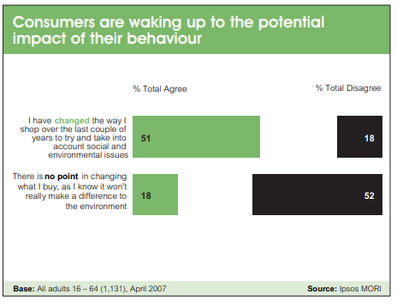
The Walmart-owned supermarket said they want to be “open and honest” with supply chain about the need of reducing plastic use and impact on environment (The Grocer, 2020). Thy also wants to help their suppliers make saving and in 2017 they launched Sustain and Save Exchange (SSE). The program is helping their suppliers to reduce environmental impact and making supply chain more efficient. For example, family-owned vegetable business is predicting to save about 3.5 million pound in 25 years after installing solar PV. Asda offers the web-based tool which give suppliers information and ideas how to increase resource in efficiency way (The Guardian, 2014).
Environmental manager of Monaghan Mushrooms, Leanne Wilson, said: “The SSE programme is aligned with our sustainability strategy and offers a practical and effective forum for learning and sharing best practice. We’ve made significant improvements and savings since signing up and would highly recommend it for local companies already working with Asda” (Pullman, 2017).
According to research done by Greenpeace, Asda is responsible for 58 billion plastic pieces and they are using 65.000 tons of plastic a year (Greenpeace Report, 2019). The company even had increased their overall plastic footprints and in 2019 have been almost the worst one out of seven supermarkets who increased their plastic footprints. In 2018 the company reduced 49 % of single -usage plastic and eliminated only 15% of non-recyclable plastic. Compare to their competitors like Iceland or Morisons, who reduced 58% of their single-use plastic the statistic does not encourage potential customers to make a shopping with Asda. Especially millennial, who grew up with practise of recycling and with knowledge about climate change are expecting business to do more to help the environment.
Customer satisfaction provides metric that can be used to manage and improve organization. In 2020 Asda was named the worst in-store grocery shopping for customer satisfaction through their negative impact on the environment. Customers were positive about the ranges on offer but were not satisfied about plastic use within the company. They also complain about low quality of Asda’s own-label product (Which, 2020). It shows that people are doing shopping in Asda because of their prices but are not commitment to the organization. They are not customers who are advocates who refer Asda’s products or services to their family and friends. The Customer Relationship Life Cycle can be described as declining because people are moving away from shopping at Asda because of their expectation about for example, plastic use or supporting local product/suppliers).

 | Reducing single-use plastic | Eliminating non-recyclable plastic | Influencing suppliers | Transparency
Iceland | 58% | 47% | 49% | 84%
Morrisons | 58% | 20% | 49% | 58%
M&S | 42% | 40% | 43% | 87%
Tesco | 45% | 20% | 38% | 82%
ASDA | 49% | 15% | 27% | 47%
Co-Op | 36% | 45% | 35% | 87%
Aldi | 40% | 40% | 20% | 84%
Lidl | 42% | 40% | 30% | 58%
Sainsbury’s | 31% | 15% | 36% | 61%
Table 1. Supermarket's plastic policies (Greenpeace, 2018).

Customer Relationship Management / Quality

Long-term Asda’s direction described by their mission statement claims: “to be Britain’s best-value retailer exceeding customer needs always” as well as “to make goods and services more affordable for everyone” which is helping stakeholders to understand why the business actually exist (Asda, 2018). Mission statement should help people to understand the organization relationship with customers. This relationship based on loyalty is essential because is driving an organization towards being successful (Smith, 2006). Loyal customers are more likely to repeat buying from the same organization, if they will receive consistent value (Hassan, 2012).
ASDA mission statement is primarily aimed at their prices, they want to be cheap and they are highlighting it in the first words, “to be Britain’s best-value retailer”. Oppositely to one of their competitor Lidl, who put their customers first: “To enhance the lives of our customers, by providing quality products at market leading value, whilst ensuring that customer satisfaction is at the heart of everything we do” (Lidl, 2020). Also Tesco makes clear that customers and stakeholders are part and parcel of their success: “We make what matters better, together” (Tesco, 2020).
Research done by Anitsal in Business Journal (2014) shows that the most important component of mission statement are people. Retailers should show how they are interacting with each stakeholder, primarily customers and associates. Unfortunately, ASDA is failing in the first part of interacting with potential customer.
Looking at Asda’s campaigns and focus on being the cheapest on the market (Porter’s Generic Strategy – Cost Leadership) shows that they are mostly focus on families of lower incomes but also, they are concern on young mothers in age between 25-35 (The Finance Business Partner, 2016). They are offering standard products with little differentiation which are widely accepted by their clients. However, Asda offers wide range of products and services (Pharmacy, Opticians, Café, Travel Money Bureau, Fuel Station and many more) which gives them a chance to reach beyond their typical market segmentation than do discount retailer (Gregory, 2017). But at the same time, they strategy is mostly focus on being the lowest-cost operator at any stage of their business. This business model impedes quality of the products and services and gives the entrance for competitors like Lidl or Aldi who are offering low prices to consumers and focus on “prime-match” (Write Pass journal, 2017).
Grown of digital technologies have made consumers expectations higher, it is not only about satisfying them but also listen to them (Kotler, 1999). Social media become vital tool which is helping to build closer relationship between the organization and customers. In recent years all the big retailers like Tesco, Sainsbury, Aldi, Asda, Lidl etc. are existing in the World Wide Web. In 2019 e-commerce market was worth £476.65 billion in UK (Fisher, 2019) and this statistic cannot be ignoring by any retailer. Asda starts to use social media in 2011 and their late appearance on the web explains by “lack of consumer demand”. Another reason was their organization structure, many of the store managers feared that e-commerce would affect their in-store sales (Berg and Roberts, 2012). However, now Asda become the pioneer in this field. They are monitoring real-time customer input from social media like Facebook, Twitter and YouTube. For example, the social media users discussed the Asda’s biscuits tasted different and they are not happy with that change, then Asda confirmed that the retailer had recently changed suppliers. Because of that feedback from customers, Asda changed to its original biscuit supplier preventing the loss of customers (Berg and Roberts, 2012).
In 2019 Asda jumped a step further and has established a partnership with Jaywing’s team. That collaboration is helping organization to better understand customer journey across touchpoints. The retailer is also using technologies like Scan and Go and Click and Collect, process which enables cusomers to give their feedback. However, all these methods are very general and already used by most of the competitors. Compare to another retailers Asda is not collecting many information about their customers who could leave their fingerprints on many different touchpoints. One of the greatest examples of way to gather that information is Tesco, who applies loyalty programs called Tesco Clubcard. They can collect all sort of information from types of products which people are happy to buy to their shopping routines. Tesco like Amazon is also using advanced recommendation engines for more personal transaction (Westenberg, 2010). If Asda could apply this idea in their business, they could better match the type of their offers rather than having to many products on their shelfs. It drives them in paradox of choice when it is generally common that too many choices leave people dissatisfied and disappointed (Schwartz, 2004). In 2015 Dave Lewis, Tesco chief executive decided to scrap 30.000 of 90.000 products from Tesco’s shelves. It was a response to the growing market of smaller discounter like Lidl and Aldi where people can do their shopping faster and easier. In Asda people can feel confuse and overwhelmed with variety of products, for example they offer more than 22 types of ketchups while in Lidl there only one in one size.
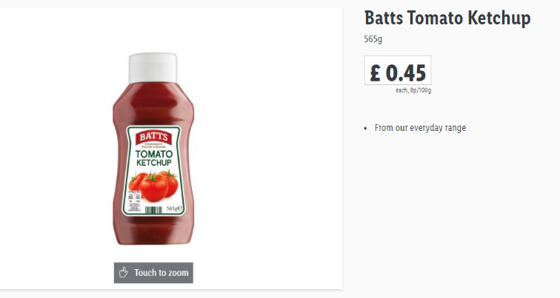
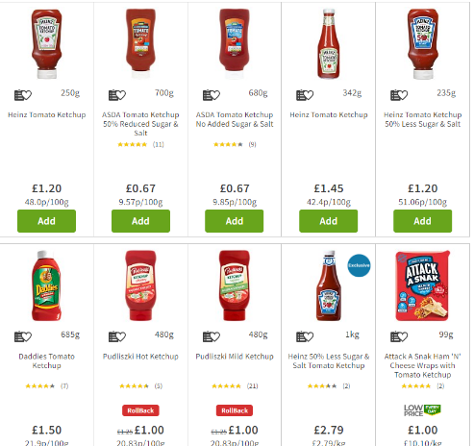
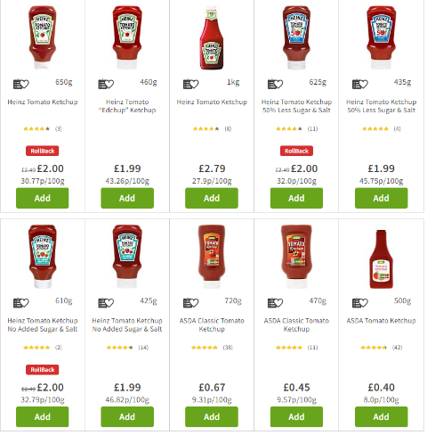
Figure 1. ASDA
Figure 2. Lidl
If Asda would measure customers preference, they could choose products that are fully tailored to the needs of their consumers. That step would help them to get more transparency and thus increase sales and customer satisfaction.
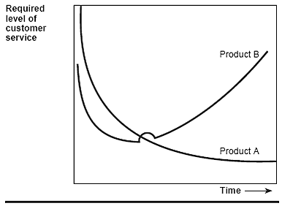
The quantity of products affects their quality and to be effective in customer relationship management Asda needs a quality model. Company must understand the timing and pattern of their product and services. In 2016 Asda has launched a new QmS which was developed by Solution 4 Retail Brands. New system enables them to the monitoring of performance and product quality, shows how product or range is performing in the market. Paddy, senior director at Asda explained; “QmS allows us to hold all of our quality data in one place, whether it is from our internal checks across Asda house or our depots, or from our external providers. It allows us to be able to report more effectively so we can take any required actions to ensure that we are delivering a consistent quality experience for our customers.” (Lemmon, 2016).
Figure 3. Postpurchase service demands for two products.
The quality of services is mainly applied to their employees who are hosting customers and managing multiple checkout sites. Asda has launched a three-year programme, allowing them to gain a qualification in distribution, operation or retailer. The study for example helps employees to deal with complains. Unfortunately, the situations showed that Asda has a problem while they are dealing with issues. In 2019 the company has been accused for the poor hygiene standards during their home delivery service. They rejected all the allegations even if all the evidence indicated their fault (Majid, 2019). They did not treat this case with PECA standards, and it could have an impact on customers relationship because the case was reported in all the most popular newspapers.

Conclusion

Asda is still one of the most famous supermarkets in UK but by looking at the grow of their competitors can be easily noticed that their actions which works years ago, are no longer relevant today. One of the biggest concerns about Asda is that they should become more relevant to customers’ need. A large selection of products which is not tailored to their target group, makes people confused and lost. They should first define the people who are doing shopping with them, then measure their preference by introducing for example loyalty car, club card. That step allows the organization in reducing unnecessary products and takes more care about those which are “important”. It is applying both products and services. If on their shelves people will find the products which they can trust it will transfer to organization trust. They also should improve shopping experience, make it simpler and more transparent.
Asda should support local communities, engage with local suppliers. Local suppliers will provide higher quality of service because those are passionate and care about customers satisfaction. Unlike the mass production, who are focus mostly on sales. Having products from for example small farm in Wales can build communities and community identify.
And one of the biggest concerns is that they should be more responsibilities to the planet because sustainability has a growing role in inspiring trust in a retailer. The consumers want retailers to make sustainable choices for them – provided the retailer is a brand that they can trust.

Recommendations
Ethics:
Develop the website with information about their suppliers, transparency and food waste. Customers want to have information on the sustainability of the products they buy.
Sustainability:
Reduce plastic use, improve the way of packing fruits and vegetables.
Quality:
Reduce some unnecessary (low sale) products and be more focus on the high selling one. Improve its quality and advertising.

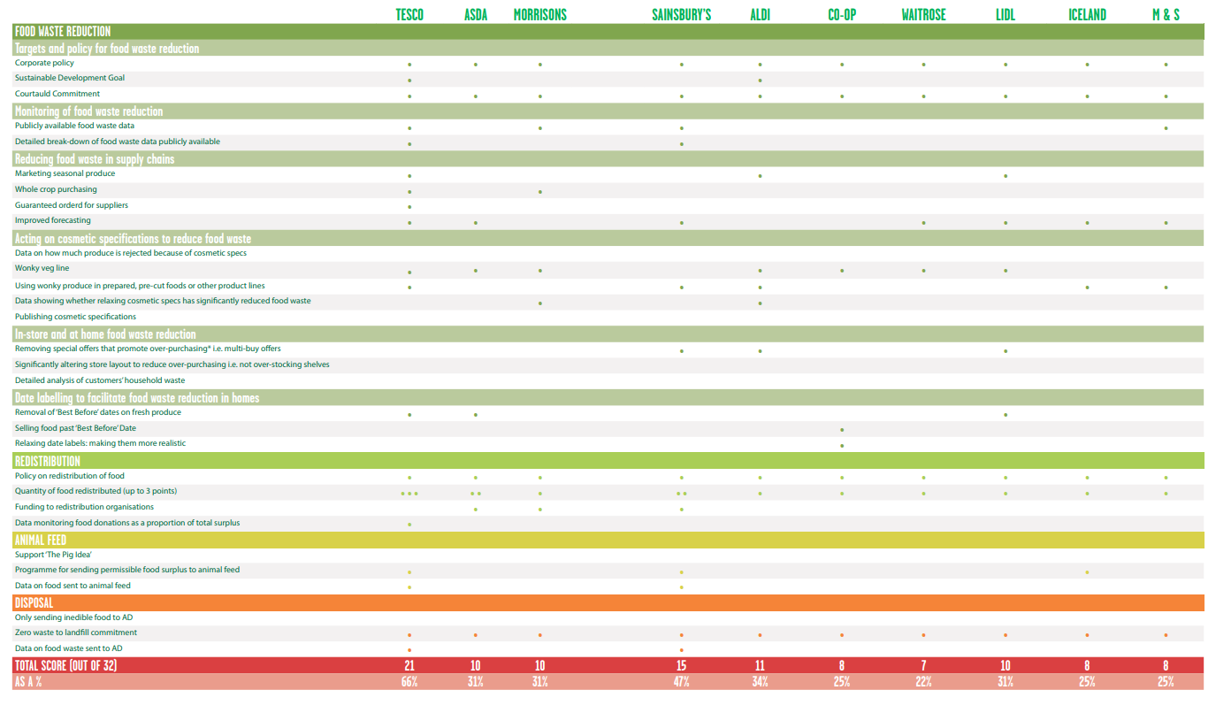
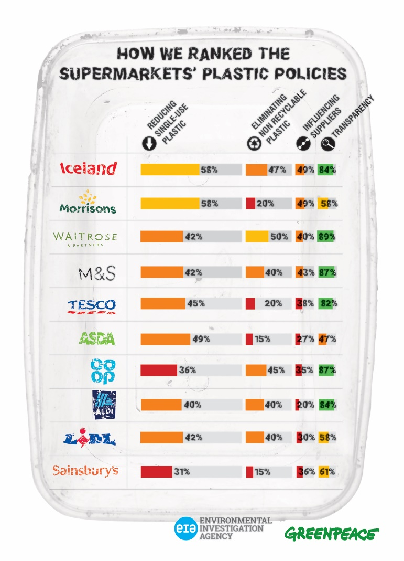
Appendices

Acknowledgements

Reference List

- Anitsal, M. (2014) “The core of retail mission statements” Business Journal, 13(6), p. 5.
- ASDA (2018) Ethical. Available at: www.sustainability.asda.com [Accessed 11 March 2020].
- Berg, N. and Roberts, B. (2012) Key insights and practical lessons from the world’s largest retailer. London: Kogan Page.
- Berkes, F., Colding, J. and Folke, C. (2013) Rediscovery of traditional ecological knowledge as adaptive management. Ecol. Appl. 2013, 10, 1251-1262.
- Bowman, M. (2018) Farmers talk food waste: supermarkets’ role in crop waste on UK farms. London: Feedback. Available at: www.feedbackglobal.org [Accessed 11 March 2020].
- Brown, D. L (2009) ‘Sustainability reporting and perceptions of corporate reputation: An analysis using Fortune most admired scores’, Advances in Environmental Accounting and Management, 4, 83-104.
- Cohen, D. (2016) Food for London: Supermarkets donate 2% of surplus to south-east London charity. Available at: www.standard.co.uk [Accessed 11 March 2020].
- Cory, J. (2005) Activist Business Ethic, Israel: Springer.
- Cottdiener, M. (2000) New Forms of Consumption. Unites Stated of America: Rowman & Littlefield Publisher, INC.
- Duska, R. F. (2007) Contemporary Reflection on Business Ethics, The Netherlands: Springer.
- Ethical Consumer (2020) Why shop ethically? Available at: www.ethicalconsumer.org [Accessed 11 March 2020].
- Feedback (2019) The Food Waste Scorecard. Available at: www.feedbackglobal.org [Accessed 11 March 2020].
- Fisher, B. (2019) UK Ecommerce 2019. Available at: www.emarket.com [Accessed 25 March 2020].
- Forbes (2019) Transparency In Business: 5 Ways To Build Trust. Available at: www.forbes.com [Accessed 11 March 2020].
- Friedman, M. (1970) The Social Responsibility of Business is to Increase its Profits. New York: Times Magazine
- Greenpeace Report (2019) Checking Out on Plastic. Breakthroughs and backtracking from supermarkets. Available at: https://eia-international.org/wp-content/uploads/Checking-Out-on-Plastics-2-report.pdf [Accessed 11 March 2020].
- Gregory, G. (2017) “Porter's (1980) Generic Strategies as Determinants of Strategic Group Membership and Organizational Performance”, Academy of Management Journal, 27(3), doi.org/10.5465/256040
- Hassan, A. (2012) “The Value Proposition Concept in Marketing: How Customers Perceive the Value Delivered by Firms – A Study of Customer Perspectives on Supermarkets in Southampton in the United Kingdom”, International Journal of Marketing Studies, 4(3), pp. 4-8.
- Independent (2016) 'Least ethical' British supermarkets named following French ban on stores throwing food away. Available at: www.independent.co.uk [Accessed 11 March 2020].
- KPMG (2011) Corporate sustainability. A progress reports. Available at: www.kpmg.com [Accessed 11 March 2020].
- Label Inside Transparency (2019) Drive Long-Term Trust & Loyalty Through Transparency. Available at: www.labelinsight.com [Accessed 11 March 2020].
- Lemon, Ch. (2016) Asda rolls out quality management system. Available at: www.retail-systems.com [Accessed 26 March 2020].
- Lidl (2020) Mission Statement. Available at: www.mission-statement.com [Accessed 25 March 2020].
- Majid, A. (2019) Dirty crates and vans used to deliver food by Asda. Available at: www.bbc.co.uk [Accessed 26 March 2020].
- Mayell, H. (2004) As Consumerism Spreads, Earth Suffers. London: National Geographic.
- Mihăiloaie, C. (2013) From vision, mission and values to KPIs at Tesco. Available at: www.performancemagazine.org [Accessed 25 March 2020].
- Owen, D. (2011) How Scientific Innovation, Increased Efficiency and Good Intentions Can Make Our Energy and Climate Problems Worse, New York: Riverhead Books, p. 246.
- Pullman, N. (2017) Asda helps suppliers make savings. Available at: www.fruitnet.com [Accessed 11 March 2020].
- Sarkar, D. and Kundu, K. (2017) Developing a “Theoretical Toolbox” for the concept of Consumerism. aWEshkar Vol. XXIII Issue 2 September 2017 WeSchoo.
- Schwartz, B. (2004) The paradox of choice. Why more is less. United States: Harper Perennial.
- Smith, D. (2006) Exploring Innovation. Berkshire: McGraw Hill Education.
- The Finance Business Partner (2016) Who is your target customer why do you care. Available at: www.thefinancebusinesspartner.com [Accessed 25 March 2020].
- Thiele, L. P. (2013) Sustainability. Cambridge: Polity Press.
- Westenberg, E. (2010) The Future of Retail Touchpoints Extending Your Reach in the Consumer Shopping Journey. London: Cisco System.
- Which (2020) Best supermarket. Available at: www.which.co.uk [Accessed 25 March 2020].
- WRAP (2020) Food surplus and waste in the UK – key facts. Available at www.wrap.org.uk [Accessed 11 March 2020].
- WRAP (2020) UK progress against Courtauld 2025 targets and UN Sustainable Development Goal 12.3. Available at: www.wrap.org.uk [Accessed 11 March 2020].
- Write Pass Journal (2017) Asda Marketing Plan. Available at: www.writepass.com [Accessed 25 March 2020].

