Feasibility Plan for an International Meeting
Module: International Meetings Management for the Hotel Industry
Module code: BMIH6007
Student Name: Marina Georgiana Hogea
Student ID: 2131351
Lecturer: Kathryn Flynn

Introduction
TechHospitality Summit – 18th May 2024- ExCeL London Convention Center.
Feasibility is a term that refers to the practicality or possibility of accomplishing a proposed project, plan, or course of action.
This presentation will consider a feasibility study of an event named TechHospitality Summit.
Several skills those event teams need to have will also be depicted here along with analysing key resources required in the event.
The summit aims – encourage discussions for future days of business

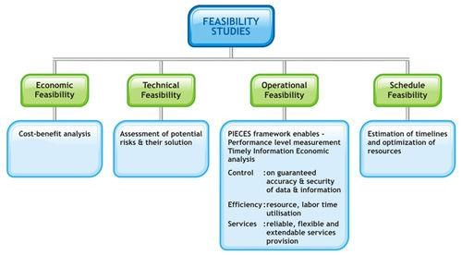

Market factors

Target market
The target market of the TechHospitality Summit comprises several different stakeholders, with a specific focus on tech startup companies and hospitality businesses.

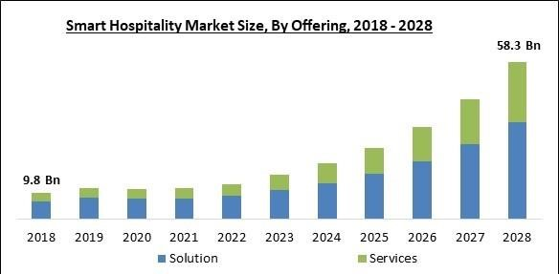

Demand for such events
(
polarismarketresearch,
2021)
The potential demand for the TechHospitality Summit and similar events is extremely high and continues to grow.
Hospitality executives are planning an increased investment in technologies over the next couple of years, with 95% of hotel executives reporting increasing their technology spend.


Contd….
(
ITB,
2024)

Presence of competitions
There is a demand for such technology-focused hospitality events, though it also needs to recognise the competitive environment.
The two key competitors for the TechHospitality Summit are existing industry conferences, HITEC and ITB Hospitality Technology Forum.
Both conferences target a similar audience that comprises technology providers, hospitality professionals, investors in the industry, and some experts.

Operational factors

Overview of the venue
The TechHospitality Summit will be held at the esteemed ExCeL London Convention Centre, conveniently located in the heart of London.

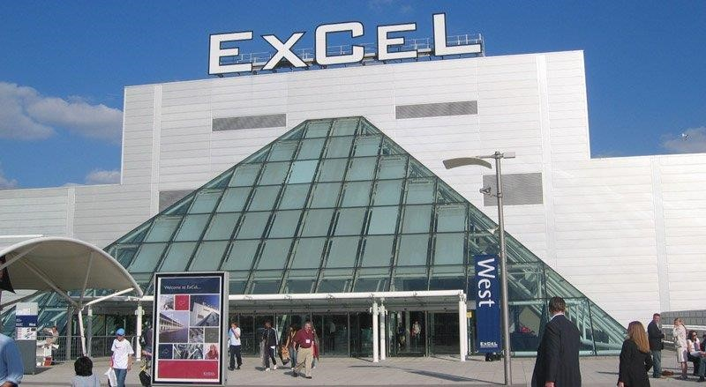
ExCeL London is known for its world-class convention centre facilities and large in-built exhibition space, making it an ideal place to host the biggest industry summits.
(
ExCeL London,
2024)
The organisational team of this event will work hand in hand with the venue management to book the venue on 18th May 2024.
Contd….

Skills needed for event staff
The employees require strong organisational abilities to plan for the venue, manage suppliers, and maintain that attendees register in advance.

Required resources for the event
- Catering,
- Lighting installations,
- Parking or transportation,
- Seat provision for different types of sessions.
The success of the TechHospitality Summit depends on several resources that collectively develop the space for networking, learning, and collaboration.

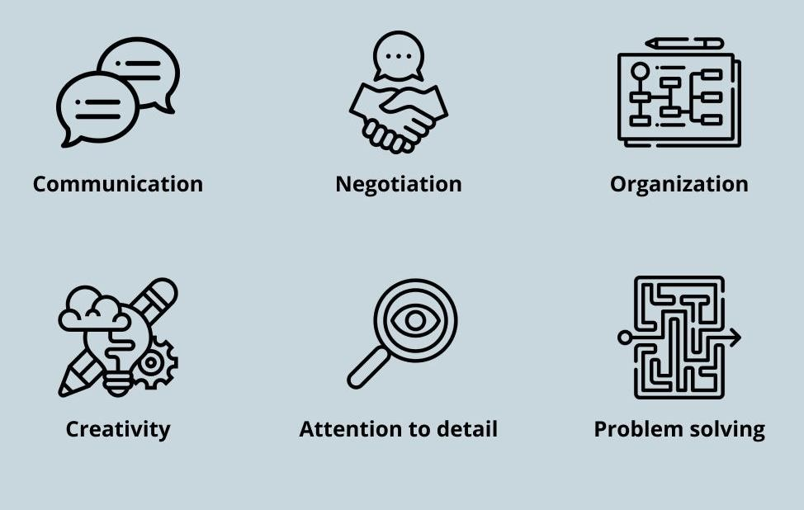
Appropriate lighting installations guarantee sufficient clearance and the ability
_{(Bladen et al., 2022)} to create ambience during sessions and while networking.

Financial factors

Sources of income and expenditures
Sources of Income |  | Sources of Expenses
TicketSales | £10,000 | Bookingof the event venue | £5,000
Sponsorship packages | £15,000 | Hiring event assistantsandcoordinators | £2,000
Total | £25,000 | Software andtools | £500
Total | £25,000 | Marketingmaterials | £500
Total | £25,000 | Total | £8,000
Event revenue growth as well as monetisation is one of the essential tactics of event planners that they utilise to enhance revenue margin and eliminate the chances of loss.
The expense sources of this event include booking the event venue, hiring event assistants and coordinators, using software, marketing tools and others.
Apart from that, the revenue of this event will be coming from specific sources, such as ticket sales and sponsorship packages
Contd….
Sponsorship packages and ticket selling are two of the most important funding sources of the event and they will help the event planners of this TechHospitality Summit to reduce the chances of loss.
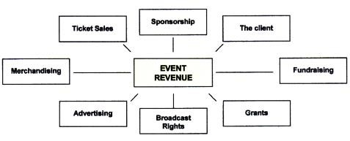
Selling Sponsorship: It is one of the most renowned techniques event planners depend on to foster successful revenue growth. (O’Toole, 2011)
Ticket Selling: Through ticket sales and registration, event planners can easily generate revenue depending on the perceived value of the event.
Swot
Strengths  - Technological integration  - Personalisation | Weaknesses  - Cost issues  - Security
Opportunities  - Data-Driven insights  - Partenerships and collaborations | Threats  - Regulatory compliance  - Economic uncertainly

Pestel
- Political factors – Brexit
- Economic factors – 2018 £60 billion
–2032 expected to reach £112 billion
- Social factors – may get a vast audience as innovators ans stakeholders
- Technological factors – reach of investment in this category
- Legal factors – are obliged to be aware of some particular legal permissions • Environmental factors – sustainability

Conclusion
The aforementioned context has focused on conducting a feasibility study of a hospitality event, named TechHospitality Summit.
The context has first provided information regarding the target audience of the event and the impact of competition on the event.
Furthermore, some important sources of income and expenses in the context of the event have been portrayed.

References
- Allen, J., Harris, R. and Jago, L., (2022) Festival & special event management. John Wiley & Sons.
- asana, (2024) 7 event planning tools every event manager needs. [Online] Available at: https://asana.com/resources/event-planning-tools [Accessed 16 April 2024].
- Bladen, C., Kennell, J., Abson, E. and Wilde, N., (2022) Events management: An introduction. Routledge.
- ExCel London, (2024) About ExCeL London.[Online] Available at: https://www.excel.london/about-us [Accessed 16 April 2024].
- ExCel London, (2024) Venue services-Organiser home. [Online] Available at:https://www.excel.london/organiser/venue-servicesoverview [Accessed 5 May 2024]
- Fox,D. et al. (2014) Doing events research: from theory to practice. Routledge: Oxford.
- HITEC, (2024). About HITEC. [Online] Available at: https://www.hitec.org/about-hitec [Accessed 16 April 2024].
- insightaceanalytic, (2024). https://www.insightaceanalytic.com/report/global-ai-in-hospitalitymarket/1322#:~:text=The%20AI%20in%20Hospitality%20Testing,forecast%20period%20for%202024%2D2031.. [Online] Available at: https://www.insightaceanalytic.com/report/global-ai-in-hospitalitymarket/1322#:~:text=The%20AI%20in%20Hospitality%20Testing,forecast%20period%20for%202024%2D2031. [Accessed 15 April 2024].
- ITB, (2024). TRAVEL TECHNOLOGY INCL. ETRAVEL WORLD & TTA. [Online] Available at: https://www.itb.com/en/trade-showbrands/segments/travel-technology/ [Accessed 16 April 2024].
- Khatri, I., (2019) Information technology in tourism & hospitality industry: Areview of ten years’ publications. Journal of Tourism and Hospitality Education,9, pp.74-87.
- Londontechweek(2024) Why attend London Tech Weeck 2024. [Online] Available at: https://londontechweek.com/whyattend#Headline%20Keynotes [Accessed 5 May 2024]
- O’Connor, P. and Murphy, J., (2004) Research on information technology in the hospitality industry. International
Journal of Hospitality Management,23(5), pp.473-484.
- O’Toole, W. (2011) Events feasibility and development: fromstrategy to operations. Elsevier: Oxford.
- Peng, X., et al, (2024) Digital transformation in the hospitality industry: A bibliometric review from 2000 to 2023. International Journal of Hospitality Management,120, p.103761.
- polarismarketresearch, (2021). Smart Hospitality Market Share, Size, Trends, Industry Analysis Report, By Offering; By Deployment Mode (Cloud and On-premises); By End-Use (Hotels, Cruise, Luxury Yachts and Others); By Region; Segment Forecast, 2022 - 2030. [Online] Available at: https://www.polarismarketresearch.com/industry-analysis/smart-hospitality-market [Accessed 15 April 2024].
- Starkov, M., (2021). Hospitality Digital Technology: Challenges, Priorities and Buzzwords. [Online] Available at: https://hoteltechnologynews.com/2021/03/hospitality-digital-technology-challenges-priorities-and-buzzwords/ [Accessed 15 April 2024].
- Steemit, (2018). what is Feasibility Study? how to use it in a clinic And explain it.
[Online] Available at: https://steemit.com/feasibility/@mamunjm/what-is-feasibility-study-how-to-use-it-in-a-clinic-and-explain-it [Accessed 5 May 2024]
- TechSummit (2024) TechSummit London.[Online] Available at: https://techsummit.tech/london/ [Accessed5 May 2024]

