
Module Name: Managing Hotel Administration
Module Code: BMIH6004

Student Name: Shahjahan Ali
Student ID:2118400
Lecturer Name:Jessica Newport
AI Acknowledgement
I confirm that I have not used any AI tools in the research and creation of this assignment. I confirm that I have not presented any AI-generated materials as my own work. I confirm I have copies of my drafts, notes, and other resources I used, which I may be asked to provide in evidence.

Table of Contents
Introduction 3
Section 1: Role Reflection 4
Section 2: Hotel Administration Issue – Training 6
Section 3: Future Trends in Hotel Administration 7
Conclusion 8
Reference List 9
AI Declaration 11

Introduction
During my hotel placement, I worked at Holiday Inn Sunderland - City Centre. I spent most of my time in the Front Office. This is the first place where guests come, so it is very important. The staff greet people, check them in and out, and help with questions. I also helped with bookings and payments. I had my first job in a hotel which was a valuable experience for me. I wanted to improve my ways of interacting with guests, use the system in the hotel and cooperate well with my colleagues. I also wished to become stronger and better at work by handling actual assignments. This placement gave me a chance to see how a hotel works from the inside. It allowed me to get an overall knowledge of the hotel environment. I was excited and nervous, but I was ready to learn as much as I could.

Section 1: Role Reflection
In my placement at Holiday Inn Sunderland, I worked in the front office. I welcomed guests, checked them in and out, gave them keys, and answered questions. I also booked tables for breakfast and dinner, helped with car parking, and made sure extra items like pillows were sent to rooms. Sometimes, I worked in the back office to update guest records and reply to guest emails. I used the Opera system to do most of the work.
To reflect on my experience, I used Gibbs’ Reflective Cycle (Gibbs, 2020). One time, a guest said their room was too noisy because of the road works. I stayed calm and listened carefully. I checked availability and found a quieter room. I asked housekeeping to check it, then helped the guest move. The guest was very thankful and smiled. This made me feel proud. It also showed me that listening with patience helps solve problems. Wood (2018) says soft communication skills like tone and patience improve guest happiness.
Another time, a guest needed breakfast very early to catch a train. I spoke to the kitchen staff and explained the request clearly. I wrote it in the logbook and told the morning staff. The guest was happy that we helped. I felt proud again. This showed me that teamwork and sharing tasks make work better. According to Armstrong and Taylor (2020), communication and coordination are key parts of good service.
My strength is staying calm and polite under pressure. However, I need to be faster at doing tasks when the desk is busy. I want to practice more with the system and ask my supervisor for tips. I also plan to do a short course online to improve my front office speed and confidence in busy times.
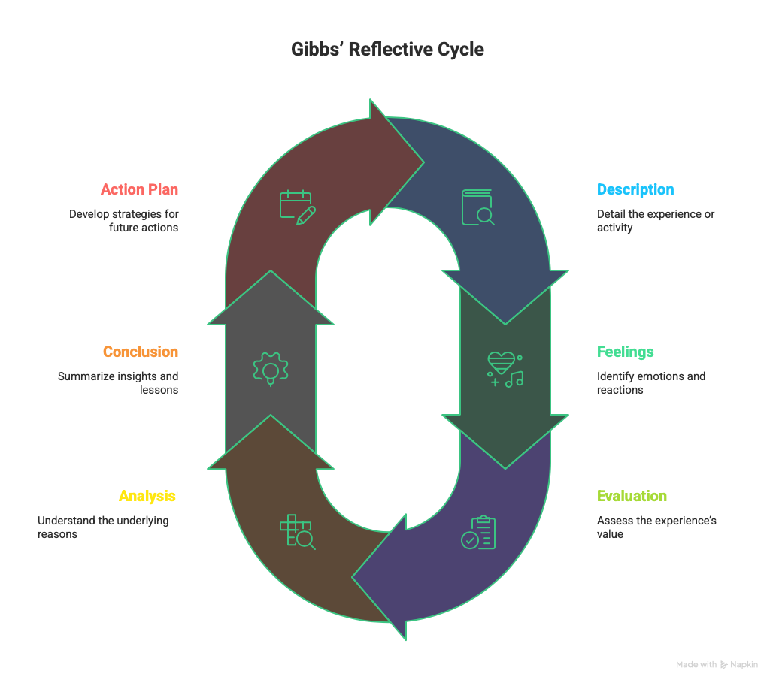
Figure: Gibbs’ Reflective Cycle
Source: Self-made

Section 2: Hotel Administration Issue – Training
In my placement at Holiday Inn Sunderland, I noticed that training was not always given the same way to everyone. When I started, I had online training and my supervisor showed me how to use the Opera system and talk to guests. However one of the new staff members did not get the same support. He was not shown how to do check-ins or take card payments. He got nervous and made some mistakes. Once, he booked a room under the wrong name, and the guest got upset. The supervisor fixed the issue, but it slowed everything down.
This showed me that training is very important. If staff don’t know what to do, it affects service. Armstrong and Taylor (2020) say that good training makes staff more confident and helps guests get better service. In our Level 5 module Personnel Resourcing & Development, we learned that proper induction helps new staff feel ready. I saw this myself. I felt more confident because I had support from the start. The new staff who didn’t get support found it harder.
I also noticed that the hotel has a cleaning checklist, but not a front office training checklist. I think every new staff member should follow the same steps. This would make the team stronger. Johnston et al. (2017) say training must continue, not just at the start. Opera also gets updates, so staff need refreshers to stay up to date.
A clear plan for training would help avoid mistakes and make staff feel supported. When staff feel ready, they work better and smile more with guests. I think good training helps the whole team, and it helps guests have a better experience too.

Section 3: Future Trends in Hotel Administration
During my placement at Holiday Inn Sunderland, I saw that technology is changing how hotels work. At the front desk, the hotel started using QR codes for express check-in. Some guests used their phones to fill in details before arrival. This helped to make check-in faster. But some older guests did not understand it and still came to the desk. I had to explain it or do the check-in myself.
This showed me that even with new tools, we still need people at the front desk. Wood (2018) says that guests still expect a warm welcome and friendly service, even when technology is used. I agree because many guests still smiled and thanked me for helping them face-to-face.
The Opera system also had small updates during my placement. If staff didn’t learn these updates, they got confused. Buhalis and Leung (2018) say hotels need to train staff quickly when new tech is added. This helps avoid mistakes and keeps the service fast. It also shows the need for ongoing training, not just once.
I believe that in the future, front office staff must learn more digital skills. We may use mobile apps, online payments, and maybe even talk to AI chatbots. But we also need to stay polite and helpful. Armstrong and Taylor (2020) explain that human communication is still crucial in hospitality.
I want to keep up with these changes. I plan to learn more about hotel technology and take a course if possible. I also want to improve my guest communication. I think both tech and people are important. Using both in the right way will help hotels give better service. My placement helped me see how fast the industry is changing and how I can grow with it.

Conclusion
During my hotel placement at Holiday Inn Sunderland, I learnt a lot about how the front office works. I started with three main goals: to improve my customer service, understand front desk systems, and build better communication with team members. I feel I have made good progress in all of these. I now know how to check guests in and out, book rooms and breakfast, and use the computer systems. I also learnt how to stay calm with guests and always speak politely and helpfully. Working with supervisors showed me how they lead the team and keep everything running smoothly. I faced some small problems at first, but over time I became more confident. I believe I now have a stronger understanding of hotel operations. This experience has helped me grow, and I will take these lessons with me into my future career in hospitality.

Reference List
Armstrong, M. and Taylor, S. (2020) Armstrong’s Handbook of Human Resource Management Practice. London: Kogan Page.
ASET (2017) Good Practice Guide for Work-Based and Placement Learning in Higher Education. Sheffield: ASET.
Bardi, J.A. (2017) Hotel Front Office Management. 6th ed. Hoboken: Wiley.
Buhalis, D. and Leung, R. (2018) ‘Smart hospitality – Interconnectivity and innovation’, International Journal of Hospitality Management, 71, pp. 10–21. Available at: https://www.sciencedirect.com (Accessed: 4 June 2025).
Fallon, M. and Rutherford, D. (2017) Hotel Management and Operations. London: Wiley.
Gibbs, G. (2020) Learning by Doing: A Guide to Teaching and Learning Methods. Oxford: Oxford Polytechnic.
Hagg, E. (2018) Internship Guide: Work Placements Step by Step. 6th ed. The Hague: Eleven International Publishing.
HotelOwner (2024) ‘Is AI replacing receptionists?’. Available at: https://www.hotelowner.co.uk (Accessed: 3 June 2025).
Johnston, R., Clark, G. and Shulver, M. (2017) Service Operations Management: Improving Service Delivery. 5th ed. London: Pearson.
QAA (2018) UK Quality Code for Higher Education: Work-based Learning. London: Quality Assurance Agency. Available at: https://www.qaa.ac.uk (Accessed: 3 June 2025).
Reneilwe, A. (2025). Hotel Management Short Course | Hotel Management Short Course. [online] Elearningcollege.com. Available at: https://www.elearningcollege.com/learn/hotel-management-short-course [Accessed 5 Jun. 2025].
The Caterer (2024) ‘Digital transformation in UK hotels’. Available at: https://www.thecaterer.com (Accessed: 4 June 2025).
Wood, R.C. (2018) Key Concepts in Hospitality Management. London: SAGE Publications Ltd.

AI Declaration
I wrote this assignment myself. I only used AI tools to help with checking spelling, grammar, and structure. All the ideas, reflections, and examples are from my own hotel placement experience. I followed the university rules.

