Lesson Plan Phase 1

Lesson Plan – Step 1 Cynllun Gwers – Cam 1

Student-teacher | Nyree Walters | Class: | NA
AoLE or Subject | Welsh | Date: | 25 / 02 / 2020
Lesson Focus: | Welsh Assessment (10 min video assessment)
Meaningful links to Curriculum | NA
Meaningful links to:  Cross Curricular Responsibilities | NA
Personal Targets (Linked to QTS and identifed in weekly review)
NA

Learning Objectives (focus on Learning- use accessible vocabulary):
The pupils will learn to:

Dysgu lliwiau a siapiau.

Success Criteria (clearly linked to each Learning Objective and related to the process and/or product of learning) | Assessment of Pupils’ Learning  Evidence  (What have the learners to say/write/do/produce – to demonstrate learning)
Byddwch chi’n dysgu lliwiau a siapiau ac didoli siap. | Dylech chi siarad am lliwiau a siap.

Time | Activities/Methodology/Key Concepts  (Teacher’s Role – including key teaching points, differentiation strategies and key questions) | Pupil Tasks  (Pupils’ role –including differentiation, engagement in formative assessment and homework) | Resources  (Including Health and Safety requirement)
Opening phase (with links to prior learning) | Question and answer starter  Pa lliw ydy eich hoff? Dwylo i fyny!  Pa lliw ydy du hoff di?  Siarad gyda partner. | Question and answer starter  Ateb fy cwestiwnnau.
Teaching & Core Learning | Dwedwch ar fy ol i.....  Oren, porffor, glas, melyn. | Gyda dy partner, trenwch y siap. Trefnwch y lliwiau.  Mae dau munud gyda chi! | Printed coloured shapes
Plenary | Recap colours –  Pa lliw ydy hwn? (hold up coloured shape, all say colour yn gymraeg)  Pa siap ydy hwn? (hope up shape, all say shape yn gymraeg)

Lesson Plan Phase 1

Lesson Plan – Step 1 Cynllun Gwers – Cam 1

Student-teacher | Nyree Walters | Class: | Dosbarth 4
AoLE or Subject | Physical Education / Health and Wellbeing | Date: | 23/01/2020
Lesson Focus: | Gymnastics
Meaningful links to Curriculum | PESS approach to teaching Gymnastic Activities
Meaningful links to:  Cross Curricular Responsibilities | Numeracy- sequencing
Personal Targets (Linked to QTS and identifed in weekly review)

Incidental Welsh - ensure welsh incidental phrases and commands are used throughout the lesson.

Learning Objectives (focus on Learning- use accessible vocabulary):
The pupils will learn to:
Consolidate a performace of simple body actions: still and moving.

Success Criteria (clearly linked to each Learning Objective and related to the process and/or product of learning) | Assessment of Pupils’ Learning  Evidence  (What have the learners to say/write/do/produce – to demonstrate learning)
- Demonstrate 3(tri) still and 2 (dau) moving actions which flow together  - Be in sync with a partner  - Demonstrate changes in direction.  - Peer assess others’ routines – use welsh praise when assessing. | Construct a performance of body actions with a partner.

Time | Activities/Methodology/Key Concepts  (Teacher’s Role – including key teaching points, differentiation strategies and key questions) | Pupil Tasks  (Pupils’ role –including differentiation, engagement in formative assessment and homework) | Resources  (Including Health and Safety requirement)
Opening phase (with links to prior learning) | Model stretches  Model BSAs | Play stuck in the mud  Stretch  Practice BSA movements | N/A
Teaching & Core Learning | Direct activity | With a partner, construct a routine of BSA movements : still, moving, still, moving, still: while changing direction.  Stopiwch  Rhedeg | N/A
Plenary | Direct peer assessment | Perform and peer assess eachother’s routines : WWW/EBI  Welsh phrases for praise:  Gwaith da  Dda iawn  Fastastig  Bendigedig | N/A

Lesson Plan – Phase 1
Evaluation of the Learning Experience
(include references to QTS)

Evaluation of Pupil Learning

Evidence of Learning (including attitude to learning over time)) | All children remembered their BSAs from last lesson. Most children worked well with a partner and included a range of moving and still movements. The communication between partners was good but needs improving in the next session to ensure their routines are in sync.
Next Steps for Progress | Therefore in the next lesson, to progress, the children need to make sure the children communicate thoroughly with their partners and

Reflective Analysis of Teaching and Strategies For Development – including justification/rationale for pedagogical choices

Evidence of my Effective Practice | The students simply followed instructions a lot better. Thus I believe the simplicity in my intruction is getting a lot better. The children improved their movements after my modelling, thus modelling the BSAs was effective in practice.
Areas for my Development  Personal Targets for Progress | Despite the students following instructions better, I need to ensure i don’t spend too much time on a warm up so there is more time available for instruction and questions before starting an activity.  Therefore, a personal target for progression would be time management during the lesson.

Lesson Plan Phase 1

Lesson Plan – Step 1 Cynllun Gwers – Cam 1

Student-teacher | Nyree Walters | Class: | Dosbarth 4
AoLE or Subject | Topic – Mathematics | Date: | 23/01/2020
Lesson Focus: | Presenting Data
Meaningful links to Curriculum
Meaningful links to:  Cross Curricular Responsibilities | Numeracy – collect information by voting or sorting and represent it in pictures, objects or drawings.  DCF – PS 2- record data collected in a suitable format.
Personal Targets (Linked to QTS and identifed in weekly review)

Incidental Welsh: Use of incidental phrases is important in this lesson – counting, recognising colours, question and answers - ‘Ble rwyt ti’n byw?’ ‘Dw I'n byw yng Gaerdydd’

Learning Objectives (focus on Learning- use accessible vocabulary):
The pupils will learn to:

To gather and present data.

Success Criteria (clearly linked to each Learning Objective and related to the process and/or product of learning) | Assessment of Pupils’ Learning  Evidence  (What have the learners to say/write/do/produce – to demonstrate learning)
- Discuss our favourite places in Cardiff.  - Vote and gather data on our faces places in Cardiff.  - Understand tally charts.  - Log into hwb (in partners)  - Represent the data using pictograms through J2 Launch.  - Screenshot pictogram and upload to seesaw. | Learners must vote on their favourite area of Cardiff. Then read the class data and represent the data in a pictogram.

Time | Activities/Methodology/Key Concepts  (Teacher’s Role – including key teaching points, differentiation strategies and key questions) | Pupil Tasks  (Pupils’ role –including differentiation, engagement in formative assessment and homework) | Resources  (Including Health and Safety requirement)
Opening phase (with links to prior learning) | Lean how to say Wales in Welsh – Cymru  Dwedwch ar fy ôl i – Cymru, Cymru, Cymru.  Show lots of pictures of places in Cardiff. Choose 5 within the class and ensure the whole class votes upon their favourite.  Explain how tally charts work  Which was our favourite place? How can we tell? | Teacher led introduction  Engage in discusssion surrounding our favouite places in Cardiff.  Welsh = “Fy hoff i ydy...” Pam? - Partner work to find out what is their favourite and why in Welsh.  Vote upon favouite place. | Powerpoint presentation  Whiteboard
Teaching & Core Learning | Ensure understanding of tally charts.  Support children who struggle when logging into hwb.  Model the use of a pictogram. | WORKING IN PAIRS- 1 iPad PER PAIR  All children log into hwb on laptops  - Interpret the tally chart data and input onto pictogram.  - Upload to seesaw  Commands done in welsh throughout the lesson -  Bore / Prynhawn da.  Beth wyt ti’n eisau am cinio?  Coch, oren, gwyrdd. (traffic light)  Gwrandwch!  Eisteddwch!  Counting in Welsh.  Dwedwch ar fy ôl i..... | iPads (J2 Launch- JiT - Pictogram)  Whiteboard
Plenary | What have we learnt today? – lollypop sticks  Recap intro - how do we say Wales in Welsh? – Cymru. | Engage in discussion: WWW/EBI. | Lollypop sticks.

Lesson Plan – Phase 1
Evaluation of the Learning Experience
(include references to QTS)

Evaluation of Pupil Learning

Evidence of Learning (including attitude to learning over time)) | The children are progressing in their speed of typing. The children were more able than an anticipated when it came to the production of the pictogram. The end product was evidenced via seesaw and all children trafflic lighted with green. This made me question whether the task was challenging enough for the learners.
Next Steps for Progress | If i was to do the lesson again, I would ensure the children peer assess eachother’s work by posting a comment on seesaw and then acting upon these comments on their work.  The children also need to work upon their need to work upon their typing skills as much time was consumed by logging into hwb.

Reflective Analysis of Teaching and Strategies For Development – including justification/rationale for pedagogical choices

Evidence of my Effective Practice | All learners grasped the lesson quickly and were able to interpret tally charts after some explanation. As well as this, MAT students completed the task without teacher input, making which made me feel as though the task was clear and simply explained.
Areas for my Development  Personal Targets for Progress | However, to develop further, i will ensure that there is an extension task in place to challenge the MAT students further (as i underestimated how qyuickly they’d work through the set task.  Thus, my target for next session is to ensure there is a challenging ET in place for MATs.

Mid Term Review Welsh Evidence:
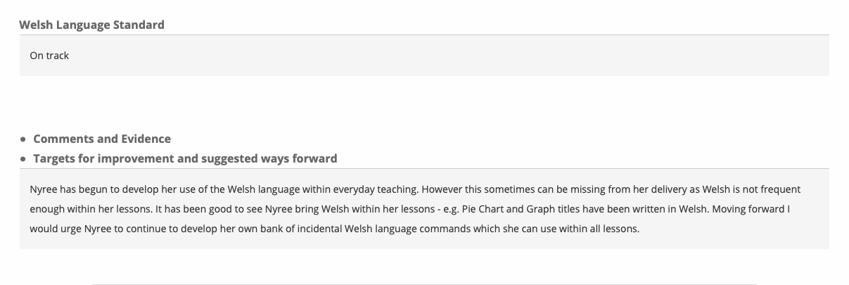

Lesson Observation Welsh Evidence: 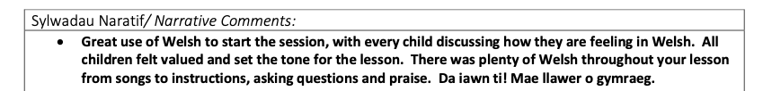

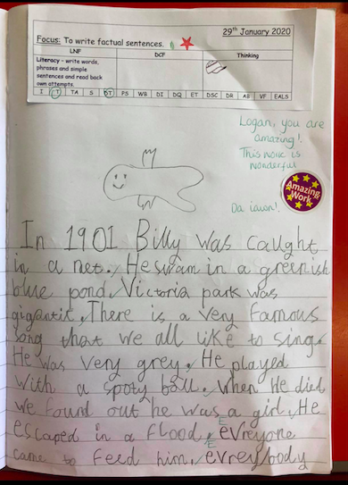
Examples of simple Welsh praise in marking:
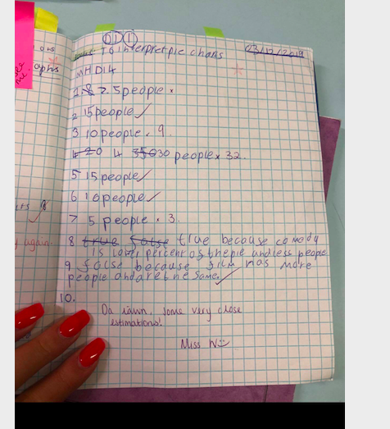

Reflecting upon my use of Welsh in the classroom.

Prior to beginning professional teaching experience one, I felt reasonably confident in my Welsh language speaking, reading and skills. This confidence came from having obtained good grades in both GCSE and A Level Welsh. However, Welsh is not my first language and when going to attend an English university to complete my undergraduate degree, my ability to converse fluently in the Welsh language gradually declined. Nevertheless, after a number of Cymraeg I Pawb lessons at UWTSD, my confidence grew in my level of incidental Welsh going into the classroom.

When delivering lessons, it was apparent that my lessons lacked incidental Welsh and my use of Welsh around the school was low. This was due to the level of concentration on other aspects of teaching which I was nervous about. Therefore, Welsh soon became a weekly target of mine to work upon. As a step towards meeting my target, I firstly decided to concentrate on the use of Welsh commands in the classroom, these include:

Stopiwch
Gwrandwch
Eisteddwch
Cerddwch
Sefwch
Tachluswch
Ewch
Ysgrifennwch
Rhedwch
Peidiwch

And many more.

I set myself a target of introducing two Welsh commands every day. This worked well and quickly received improved feedback on my use of Welsh. I ensured I felt confident enough to use an extensive range of commands inside the classroom and around the school before using full sentences in the Welsh language. Despite quickly growing confidence in the use of commands in my lessons, I decided to keep the use of incidental Welsh as an ongoing weekly target to improve further. In the weeks following this, my confidence grew and after conversing my mentor, I slowly introduced welsh language in marking and feedback. Mostly through praise, using words such as:

Bendigedig
Gwaith da
Dda iawn
Gwych.

During my time in my first professional teaching experience I attended a questioning workshop and this included techniques on embedding the use of the Welsh language into questioning. This was a brilliant workshop where I was able to converse with the other teaching staff in the school about Welsh language in questioning gathered many resources and ideas from this, in order to work upon adding extra Welsh into my lessons, particularly in questioning. These resources were (and still are) being used in order to improve upon and revise my Welsh abilities and forming new ways of embedding the language into every lesson.

I quickly noticed that the pupils within the classroom were more likely to use the Welsh language when there was some level of competition. I regularly directed Welsh games during ‘helpwr heddiw’ sessions where points were awarded for the best questions and most detailed answers. This challenged and encouraged the pupils to improve their Welsh. Upon reflection, I would use competitive point scoring games in future practice as it definitely encouraged and stretched the pupils to use more Welsh. They were also very much enjoyed.

My experience with the use of Welsh in this school allowed for my confidence to grow when using the Welsh language in my lessons and provided training and resources for furture practice. Despite having much room for further improvement and much more progress to make before my Welsh is considered brilliant, I now feel as though I am able to deliver a lesson with sufficient levels of Welsh language embedded in it, through commands, questions, praise and incidental phrases.

