

Assignment 1: Blog Posts 1-7

REFLECTIONS ON QUANTITATIVE RESEARCH
Liya An 2005347∣Applied Quantitative Business Research∣27th November 2020

Word count:2896
Contents
Blog 1: The Journey of Creative Destruction─ “Breaking the Circle” 1
Blog 2: I'm Right There to Undertake Data Analysis 3
Blog 3: Sampling ─The Foundation of Positivism 5
Blog 4: Netflix or “Data Tranny” vs. the World? 7
Blog 5: Data Dictator or Data Detect? 9
Blog 6: Titanic─The Miracle of Human Nature or MCF Norm? 11
Blog 7: The Struggling from Novice of Econometric Statistics 14

List of Figures
Figure 1: Schumpeter's Creative Destruction Theory (Source: amazon.com) 1
Figure 2: Todd Haynes' Biopic of Bob Dylan I'm not there (Source: Metacritic) 3
Figure 3: Nobel laureates of economics in 2019(source: Wikipedia 2020) 5
Figure 4: The movie poster of Netflix vs. the World (Source: Metacritic) 7
Figure 5: R.A. Fisher (Source: Wikipedia, 2020) 9
Figure 6: The Titanic (Source: Wikipedia, 2020) 11
Figure 7: Determinants of survival in maritime disasters (Source: the article “Gender, social norms, and survival in maritime disasters”) 12
Figure 8: Susan Athey (Source: Baidu search engine) 14

The image in the cover is cited from a website: www.unsplash.com, an internet source of freely-usable images.
Blog 1: The Journey of Creative Destruction─ “Breaking the Circle”
(word count 436)

Joseph A. Schumpeter, a prestigious Austrian economist, has a famous theory called “Creative Destruction”, which tries to elaborate one of the features of capitalism, “…that incessantly revolutionizes the economic structure from within, incessantly destroying the old one, incessantly creating a new one. This process of Creative Destruction is the essential fact about capitalism. It is what capitalism consists in and what every capitalist concern has got to live in”.

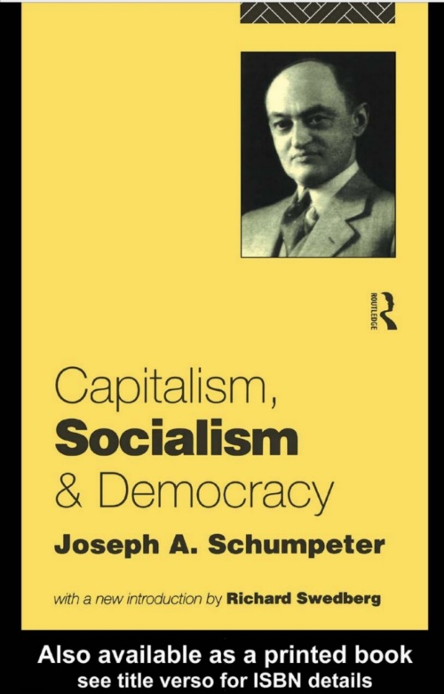
Figure 1: Schumpeter's Creative Desruction (Source: amazon.com)

Although this theory targets capitalism, the importance of originality has been universally applicable. As it were, the motivation that has transferred me from my familiar ground to this brand-new world is the impetus of desiring for creativity, which will be expected to produce unexpected results. In China, a buzzword called “Breaking the Circle” goes viral on the internet to date. It originally refers to “being accepted by broader population through breaking technical barriers and boundaries”, it can be interpreted and envisaged as “stepping out of ‘comfort zone’” as well.For me, novelty comes out from breaking the existing knowledge background, introducing different perspectives, and thereafter trying to seek for the combination of those disparate disciplinaries.

This module, called “Applied Quantitative Business Research”, entails that it is a paradigm of positivism. And it is never an easy job, but quite a big challenge to me since the related professional techniques of data collection and analysis is, if not always, absent in my previous practices and experiences of study. But, for all this, that research instrument is significantly meaningful for me to strike another possibility in my future exploring.

Dr. Guy E. White reminds me that output changes even as the same study, but it changes depending on what paradigm or theoretical lens has been picked. Thomas Kuhn, the term “paradigm” inventor, highlights that the facts that the paradigm defines and explains are not the same as those defined and explained by other competing paradigms. Even there are great gap between different research fields and the related instrument and methodologies, it’s dubious there is incommensurability among those different paradigms. After all, cross-disciplinary study and mixed methods research is my ultimate goal and the “Quantitative” module will become one of the sharp weapons in my academic career.

Blog 2: I'm Right There to Undertake Data Analysis
(word count 352)

I have just finished a thesis titled “The Truth Description of Semiotics on Anti-biopic: A Semiotic Observation of Bob Dylan’s Biopic I’m not there”, where a thought-provoking comment from “Anthology Film Archives” has been cited, “Biopic is one of the most ubiquitous and perennial of cinematic genres, but it has developed conventions that are spectacularly ill-suited to conveying the messiness, the complexity, and the essential, ultimately impenetrable mystery of a real human life". I am convinced that the empirical world is composed of "the multiple, layered truth of life" and have been informed and trained as believing in “multiple complex realities”. This context bounded knowledge cries out aloud in my ear that this world is far more complex than just being determined by a large or small group of data, which derives from the closed system----laboratory.

Figure 2: Todd Haynes' Biopic of Bob Dylan I'm not there

Positivists uphold the belief that both natural and social disciplines are suitable for using the same method or logic of explanation. This statement is strongly criticized for its "reductionist position” that propositions of the social sciences could ultimately be analyzed down to those of physics.

Absolutely, data is not omnipotent, but it can explain and predicate within a certain range. Bearing strong characteristics of positivism, the quantitative research aims at reflecting the causal relationship between variables and results should be dependable, consistent, and replicable. The punch of data analysis lies in the design of the survey, which includes sampling and questionnaire and manipulating SPSS. Every step of this procedure is a brand-new attempt for me. I have to break my context knowledge framework of metaphysical speculation and integrate a fresh paradigm to enhance the persuasion of my future research and polish it as a well-grounded construction.
Blog 3: Sampling─The Foundation of Positivism
(word count 434)

Quantitative research believes the knowledge or the meaningful results of the research generated from nowhere than from the laboratory or the field in the real world, because the test in it could be verified to be deemed as true. In the words of Bracht and Glass, one of the quality criteria for research is to aim at external validity, referring to “the extent and manner in which the results of an experiment can be generalized to different subjects, settings, experiments and tests”, which can be increased by the way of sampling. While a sample is defined as “a smaller (but hopefully representative) collection of units from a population used to determines truths about that population”, and sampling is "a practical way of studying people and their activities, thoughts, attitudes, abilities, and relationships".

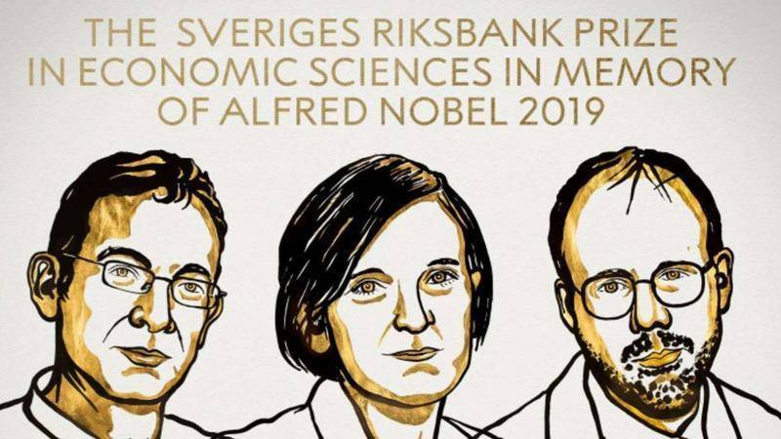
Figure 3: Nobel laureates of economics in 2019(source: Wikipeda 2020)

Thus, according to Lynch, those questions of sampling can be of fundamental importance to the quality and significance of our research. For example, the Nobel Prize of 2019 in economics was awarded to three American economists in recognition of their application of field experiments to poverty alleviation research and practice. Those researchers specialize in an economic branch, named “development” and their studies were almost wholly observational sampling and deep data collections. The quantitative method adopted by this group of economists is called "randomized control trial" (RCT), which is exactly conducted based on probability sampling. The two of those laureates, Abhijit Banerjee and Esther Duflo, are very concerned about the problems of the poor in Africa and India, and therefore made a painstaking on-the-ground work, in which the Multi-stage cluster sampling is inevitable.
Sampling is one of the key steps of hypothesis testing. If there was no sampling, p-value could not be significantly tested and significant test could not be carried out. In a word, quantitative methods like tests and questionnaires have to be conducted on the premise of sampling, because it is the basis of exactitude and objectiveness of the research results. Without sampling, the data source can be questionable as well as the reliability and validity of the research can be dubious. It is an indispensable step of quantitative study and an intensifier of convincing explanation of the research.

Blog 4: Netflix or “Data Tranny” vs. the World?
(word count 480)

Netflix has 27 million users around the world and knows better than anyone about what kind of movies and TV programs people like to watch. Every day, its subscribers will generate 30 million behaviors and give 4 million ratings by which its online movie recommendation capabilities will be improved. As Mayer-Schönberger says, “Knowing what, however, drives clicks. This insight has the power to reshape many industries, not just e-commerce”. Since Netflix established a profit model at the beginning of its establishment─ to obtain income from users’ paid rental, it is quite different from Hulu, another online audio-visual platform in the US, which mainly relied on advertising to generate revenue. In this sense, Netflix’s business intentions of spare no effort to promote machine learning can be expected and reasonable.


Figure 4: The movie poster of Netflix vs. the World (Source: Metacritic)

However, Pat Heiland, one of the prominent database designers, predicted that with big data “we can no longer pretend to live in a clean world”. Data privacy advocates believe that the big data concept is no different from “dictatorship of data”,(worries about the private space of people in the data-driven era), even though its applications, characterized with personalized service, has a huge attraction. Evgeny Morozov, an Internet philosopher, has sharply criticized the ideology behind many "big data" applications. He suggested that big data application should be regularly reviewed by independent auditors to prevent abuse of power. This is a warning for “an algorithm that engineers and encroaches into viewing habits and preferences”.

Television can cater to the tastes of the audience, but in a world where everything is calculated, where are the ideas, inspirations, and even the private space? In modern society, a more urgent question is: do people want to accept a world of the digital-driven economy in which data analysis can predict everything of their life?!
Blog 5: Data Dictator or Data Detect?
(word count 400)

The above quotation is about the role and limitation of benchmarks of the significance test, as well as how far the data analysts can go in the virtual empirical world.

In the disputes between Neyman, Pearson and A.R. Fisher, Fisher insisted that “a hard and fast rule” did not mean everything. He believed that “no scientific worker has a fixed level of significance at which from year to year, and in all circumstances, he rejects hypotheses; he rather gives his mind to each particular case in the light of his evidence and his ideas”. Fisherman’s insight includes two implications: a significance result has been obtained for only once is insufficient to come to a conclusion, instead, the repeatability of the level of significance has to be emphasized; P-value should not be taken as the only touchstone of hypotheses, instead, the specific problems have to be analyzed according to the specific situation.

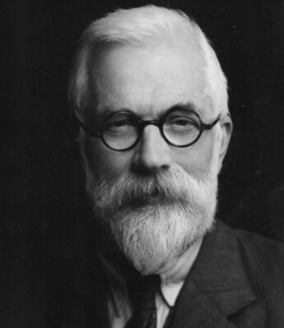
Figure 5：R.A. Fisher, one of the founders of modern statistics
（Source: Wikipedia, 2020）

Fisher strongly suspected the “pure mathematical formalism”. He did not believe in solving the problems only by the mathematical models and benchmarks, but asserted that hypotheses had to be tested integrating circumstances. This similar idea has been confirmed by other scholars. Tom Redman, author of Data-Driven: Profiting from Your Most Important Business Asset, advocates to use the data to guide more experiments, not to only make conclusions about cause and effect. Milton Friedman refers to the importance of observing real circumstances, either. Hume emphasized, "the necessity for repeated observation as the only route ─via the observation of ‘constant associations’ ─to our understanding of any matters of fact”. In a word, compared with the complicated real world, data and the level of significance is not so much a determinator than a reminder. To put it another way, a qualified researcher cannot be bound by anything, including benchmarks of data analysis, but tries to examine the results closely under specific conditions and in the light of the evidence of significance test. After all, a data analyst works as no more a dictator than a detect.

Blog 6: Titanic─The Miracle of Human Nature or MCF Norm?
（word count 426）

In 1932, Lionel Robbins, England economist, proposed the definition of economics as "the science which studies human behavior as a relationship between ends and scarce means which have alternative uses". This definition implies that as long as the problems are related to human behaviors, they belong to the categories of economics. In modern decades, Gary Becker, a famous Chicago economist, has done the most to a research method that expands the boundaries of economics into the other social sciences, particularly sociology. It seems that the tool of economics, i.e. quantitative research tools, can be used to study all of the social phenomena. Then, how do economists view the value of life─ a classical philosophical proposition?

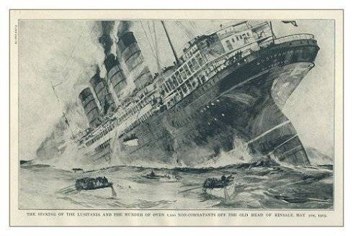
Figure 6: The Titanic (Source: Wikipedia, 2020)

In 2012, two Sweden economists, Mikael Elinder and Oscar Erixson, published a paper to study the problems of life and death by using the list of Titanic survivors we obtained afterward. Notably, they made great efforts to expand samples, involving 18 maritime disasters from 1852 to 2011. They put their research on eight hypotheses as to the following chart:

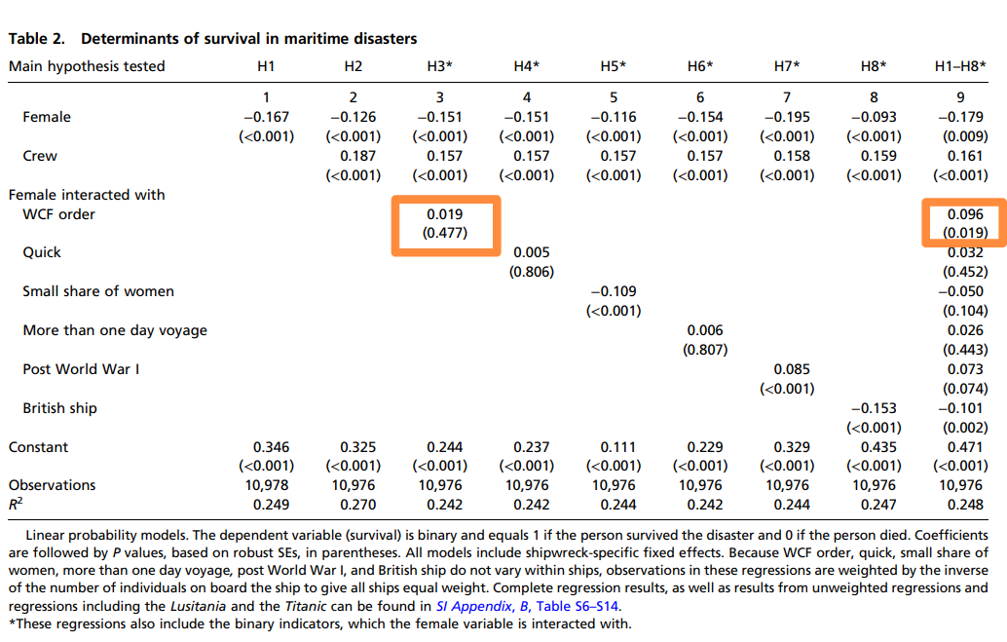

Figure 7: This graph is cited from the article “Gender, social norms, and survival in maritime disasters”

(The red squares are added by the author of this blog)

These hypotheses are estimated employing linear probability models and regression analysis is used to study determinants of survival in maritime disasters. And the researchers have made some startling discovering, in which what the most astonished is that it is the captain’s leadership and his command of WCF that decides the survival rate of women. According to the above table, the last column (column 9:H1-H8) represents a joint test (the rest columns focus primarily on the other 16 shipwrecks), including the data of Titanic. Although the samples of the other 16 shipwrecks are not good enough to test H3 because the WCF order was given on only five ships (p-value>0.05), the 9th column displays that the survival of women is increased by 9.6% (p-value<0.05) partly owing to Edward Smith, the captain of Titanic, orders WCF! One of the surviving crew members recalled clearly that Captain Smith ordered to shot the mature male who tried to scramble the lifeboats in the first place. But in most other cases, the miracle of human nature did not happen when the passengers on these ships followed the law of the jungle to escape.

Economists perceive the choice of human nature and conclude the universality of characteristics of "every man for himself". The captain’s choice of protecting women and children is just a coincidental glory of human nature！

(This story will be reported and discussed in details in another assignment!)

Blog 7: The Struggling from Novice of Econometric Statistics
(word count 368)

In this module, I have acquired some basic knowledge of quantitative methods, including parametric and non-parametric analysis, for which I have been informed how to distinguish the differences between these two types of strategies in the data research. And I have learned to observe the histograms plots, skewness and kurtosis as well as carry out significance test in deciding the normality distribution of data set. What the most impressed me are correlation analysis and regression analysis, which will be bound to be used in composing my future dissertation of DBA study. Reviewing the resources uploaded in the online module has reinforced my understanding of Regression and correlation analysis——They are actually fundamentally the same statistical procedure. The difference is essentially in what your purpose is. In correlation we are generally looking at the strength of a relationship between two variables, X and Y, where in regression we are specifically concerned with how well we can predict Y from X.

In addition, the punch of data analysis also lies in the design of the survey, which includes sampling, questionnaire and manipulating SPSS. Thanks for Dr. Promise, I have experienced the preliminary operation of SPSS, and tried to finish data description on my won.

Figure 8: Susan Athey (Source: Baidu search engine)

Recently, I have been enlightened by an article written by Susan Athey, a former Microsoft chief economists and Sandford University Professor. In this article, she discussed the role of machine learning in causal inference and policy evaluation. She pointed out that in the past, machine learning was mainly used for prediction; in the future, machine learning will certainly be used for prediction, but at the same time, it can also provide us with more help in the field of causal inference. Future economists should combine machine learning technology with existing econometric theory more.

Although I am a novice of quantitative research, and I cannot handle an advanced study in econometric statistics, I will endeavor to read extensively, understand the latest cutting-edge economic knowledge and research methods, broaden my horizon and finally produce a fruitful graduation thesis.

Schumpeter, J.A.(1994) Capitalism, Socialism and Democracy. 5th ed. London: Routledge. (p.83)
People’s Daily (2019) Expecting more “Breaking the Circle” Effect. Available at: https://baijiahao.baidu.com/s?id=1649589921003887147&wfr=spider&for=pc (Accessed: 20 October 2020).
White, Guy E. (2014) How to choose a Theoretical Framework for My Dissertation [video]. Available at: https://www.youtube.com/watch?v=MdXVq_9aoms (Accessed: 17 October 2020).
Kuhn, T.S.(1996) The Structure of Scientific Revolutions. (3rd ed). London: University of Chicago Press.
Rademacher, V.N. (2020) ‘Contrarians at the Gate: Biofiction, the Anti-Biopic and I, Tonya: Biofiction in Context’ , in Biofiction and Writers’ Afterlives, Layne, B. (ed) Cambridge Scholars Publisher. (p.143)
Ibid.
Elshafie, Marwa (2013) ‘Research Paradigms: The Novice Researcher’s Nightmare’, International Peer Reviewed Journal, 4(2), pp.4-13. (p.7)
Elshafie, Marwa (2013) ‘Research Paradigms: The Novice Researcher’s Nightmare’, International Peer Reviewed Journal, 4(2), pp.4-13. (p.5)
Blaikie, N (2004) ‘Positivism’, in Encyclopedia of Social Science Research Methods, M. Lewis-Beck, A. Bryman and T. Liao (eds.) CA: Sage Publications, Inc. (p.837)
Ibid.
Bracht, G.H. and Glass, G.V. (1968) ‘The External Validity of Experiments’, American Educational Research Journal, 9(4), pp.437-474. (p.438)
Field, A. (2005) Discovering Statistics Using SPSS for Windows. London: Sage.
Greener, S. (2008) Business Research Methods. Available at: http://digilib.stiem.ac.id:8080/jspui/bitstream/123456789/66/1/13.%20introduction-to-research-methods.pdf (Accessed: 11 November 2020). (p.342)
Lynch, Gordon. Sampling. Available at: https://www.kent.ac.uk/religionmethods/documents/Sampling.pdf (Accessed: 11 November 2020). (p.1)
Kendall, J. M. (2003) ‘Designing a Research Project: Randomized Controlled Trials and their Principles’, Emergency Medicine Journal, 20(2), pp. 164-168.
屠玥 (2020) ‘基于SCP 视角的中美流媒体平台比较——以网飞与爱奇艺为例’,当代电影, 5, pp.118-126. (p.118) [Yue, Tu (2020)‘A Comparative Study on Sino-American Online Video Platforms Based on the Angle of SCP─Taking Netflix and IQIYI as Examples', Contemporary Movies, 5, pp.118-126. (p.118)]
Mayer-Schönberger, V. and Cukier, K. (2013) Big Data: A Revolution That Will Transform How We Live, Work, and Think, Boston, MA: Houghton Mifflin Harcourt. (p.70)
Heiland, R (2011) Communications of the ACM, 54(6), pp. 40-47. (p.45) Available at: http://m.cacm.acm.org/ magazines/2011/6/108666-if-you-havetoo-much-data-then-good-enough-isgood-enough/fulltext (Accessed: 13 November 2020)
Walker, S. J. (2014) ‘Big Data: A Revolution That Will Transform How We Live, Work, and Think’, Review of Big Data: A Revolution That Will Transform How We Live, Work, and Think, by Viktor Mayer-Schönberger and Kenneth Cukier. International Journal of Advertising, 33(1), pp.181–183. (p.182)
Morozov, Evgeny (2013) To Save Everything, Click Here: The Folly of Technological Solutionism, Public Affairs. (p.18)
Frey, Mattias (2016) ‘Netflix Crit in the Twenty-First Century’, Film Criticism, 40(1), pp.1–4. (p.1) Available at: https://quod.lib.umich.edu/f/fc/13761232.0040.111?view=text;rgn=main (Accessed: 14 November 2020).
Ellenberg, Jordan (2014) How not to Be Wrong: The Power of Mathematical Thinking. Now York: The Penguin Press. (p.157)
Ibid.
Gallo, A. (2015) A Refresher on Regression Analysis. Available at: https://hbr.org/2015/11/a-refresher-on-regression-analysis (Accessed: 12 November 2020).
Hume, D. et al. (1978) A Treatise of Human Nature. 2nd ed. Oxford: Clarendon Press.
Rotwein, E. (1959) ‘The Methodology of Positive Economics’, Quarterly Journal of Economics,73(4), pp.554-575. (p.563)
Robbins, L. (1932) An Essay on the Nature and Significance of Economic Science. London: Macmillan.
Lazear, E.P. (2000) ‘Economic Imperialism’, The Quarterly Journal O Economics, 115(1), pp. 99-146.
Elinder, M. and Erixson, O. (2012) ‘Gender, Social Norms, and Survival in Maritime Disaster’, Proceedings of the National Academy of Science, 109(33), pp. 13220-13224. (p.13223)
National Center for Research Methods(2011) Simple Linear Regression. Available at: https://www.restore.ac.uk/srme/www/fac/soc/wie/research-new/srme/modules/mod2/5/index.html (Accessed: 16 November 2020).
Athey, S. (2017) ‘Beyond prediction: Using big data for policy problems’, Science, 355(6324), pp. 483-485.

