  Group Project Portfolio  Work Based Group Project ACDA 5022 | Rachel McColm  2223157

AI Declaration
I confirm that I have not used any AI tools in the research and creation of this assignment. I confirm that I have not presented any AI generated materials as my own work. I confirm I have copies of my drafts, notes, and other resources I used, which I may be asked to provide in evidence.

Abstract
This report will discuss a Work-Based Group Project (WBGP) that was completed in tandem with the Systems Engineering Module. It will cover the team of people brought together to design a munition from a given design brief, their roles and how they worked together to create the final solution. It will also include an analysis and reflection on the group dynamic.
Contents
List of Figures 4
List of Tables 5
1. Introduction 6
1.1 Task Description 6
1.2 Design Team 6
1.3 Process Safety Role 7
2. Design Project Management 8
3. My Role in the Team 9
3.1 Legislation and Regulation 9
3.2 Safety Requirements 9
3.3 Gemba Visit and Risk Assessment 10
3.3.1 Gemba Visit 10
3.3.2 Risk Assessment 11
4. Process Controls 12
4.1 Mitigations 12
4.2 Post-Mitigation Risk Classification 12
5. My Presentation Slides 13
6. Feedback from Presentation and Comments 17
6.1 Group Feedback 17
6.1.1 Comments 18
6.2 Individual Feedback and Reflection 18
7. Reflection 20
7.1 Group Work Reflection 20
7.2 Personal Reflection 20
8. Conclusion / Lessons Learned 21
References 22

List of Figures

Figure 1 - Slide 1 - Regulation and Legislation 13
Figure 2 - Slide 2 - Safety Requirements 13
Figure 3 - Slide 3 - Processing Hazards and Deficiencies 14
Figure 4 - Slide 4 - Initial Risk Classification Matrix 14
Figure 5 - Slide 5 - Mitigations 15
Figure 6 - Slide 6 - Post Mitigation Risk Classification Matrix 15
Figure 7 - Slide 7 - ALARP Carrot Diagram 16
Figure 8 - Group Feedback 17
Figure 9 - Individual Feedback 19

List of Tables

Table 1 - Design Team 6

Introduction

Task Description

The design team will engage in solving a designated design task (the same as Systems Engineering ACDA 5021). The design team will work unsupervised on providing a solution to a particular OME design brief. Systems tools are to be used to advise the design as well as interaction with different stakeholders. The design team is required to provide a presentation of the design solution as well as a 2500-word report outlining the progress as the project developed.
Each member should include:
- How each role interacted
- How the team communicated
- How decisions were made
- How communication and teamwork are essential for the success of a project
- A reflection section to incorporate feedback from the presentation portion of the project.

Design Team

The design team consisted of 6 individuals and 5 different roles. As there were only 5 roles and 6 team members, the Safety role was divided into Design Safety and Process Safety. The roles can be seen in Table 1 below.

Table 1 - Design Team
Design Team
Team Member | Role
Gareth James | Research and Development
Libby Jones | Design Safety / Team Lead
Charles Hadley | Test & Trials
Daniel Garton | Manufacture
Rachel McColm | Process Safety
Lewis Gray | Disposal

Process Safety Role

The team member responsible for process safety must:
- Understand the safety requirements for processing
- Understand the legal safety deliverables
- Identify the key hazards in the area of operation selected
- Critically analyse the key hazards
- Describe the mitigations required in processing
- Develop the basis of safety

Design Project Management

Together, the team appointed a Team Leader who managed the tasks and made sure the team stayed on track and weren’t getting too caught up in aspects that were out of scope for the project. This was important as the team had a limited amount of time to work together on developing a weapon system, so every minute had to be utilised effectively.
In terms of dividing the workload, the team did all of the systems engineering work together. This meant that every person had an input in every part of the design process up until the point where the team split into their individual roles.
The team had a shared folder with shared documents that every member had access to. This allowed the team to track progress and make sure that every individual was contributing. There was also the use of an open forum where the team could communicate and ask questions of people who had more experience in certain areas.
At the beginning of each day, the team would go over what tasks had to be completed and what ones were to be undertaken on which days. As well as this, the team would reconvene at the end of the day and go over what tasks had been completed and how they compared to the tasks that were to be done for the day. This gave the team an overview of productivity and helped with planning the following days.

My Role in the Team

My role within the design team for this project was Process Safety. This refers to the safety mechanism required for the manufacture and processing of explosives.

Legislation and Regulation

Before I was able to assess the Safety Requirements needed for the manufacturing process, I had to find out the relevant legislation and regulations that had to be complied with. From the research conducted, it was clear there were numerous regulations and pieces of legislation that were applicable. Given the time constraints for the presentation, I chose to focus on three very important pieces of legislation and regulation. These were:

- The Health and Safety at Work Act (HASAWA) 1974 [1]
- The Explosives Regulations 2014 (ER 14) [2]
- Defence Safety Authority (DSA) 02 Ordnance, Munitions and Explosives (OME) [3]

The key parts of the HASAWA that were focused on were:
- The duty of the employer to “ensure, so far as reasonably practicable, the health, safety and welfare at work of all employees.”
- The requirement of the employer to conduct risk assessments and have safe practices.
- Control of the keeping and use of explosive/highly flammable or otherwise dangerous substances, as well as the prevention of unlawful acquisition, possession and use of these substances.
ER 14 and DSA 02 OME cover the licensing and authorisations required to manufacture and store explosives. They also detail the safety and security of explosives.

Safety Requirements

In order to create a list of safety requirements, I had to liaise with the team member in charge of manufacturing and consult existing regulations and legislation, as aforementioned. Through this process, I was able to derive the following safety requirements: ​
- All personnel must be adequately trained on the manufacturing process and associated hazards before they are permitted to work.​
- All operators must don the correct PPE when in the manufacturing area.​
- Equipment must be regularly inspected and maintained according to the maintenance schedule.​
- Operators must take regular breaks.​
- Explosive and hazardous materials must be properly labelled, handled, stored and disposed of according to regulations.​
- Work areas must be kept clean and free of debris to reduce contamination risks and tripping hazards.​
- The manufacturing facility must have environmental controls (temp and humidity) to prevent condensation, corrosion, or electrostatic discharge (ESD) risks.

Gemba Visit and Risk Assessment

Once the safety requirements had been established, the next step was to conduct a Gemba Visit and risk assessment of the processing facility.

Gemba Visit

During the Gemba Visit, the safety team documented several issues and identified two key hazards within the manufacturing process. The two key hazards identified were the weighing and decanting of the explosive and the pressing of the explosive into pellets. The safety team documented that the weighing and decanting of explosives was conducted manually by an operator. As expected, this was highlighted as a high-risk activity as it could cause harm to the operator. In addition, ​the pressing of the PETN was flagged as hazardous due to the simple fact that you are putting a high explosive under a large amount of pressure, which in some cases could cause an ignition.

Risk Assessment

The audit of the processing facility highlighted several deficiencies within the facility that had to be addressed in order to ensure compliance with regulations. The three key issues that were highlighted were:
- There were no humidity or temperature controls. The team noted that when the facility was too hot, the operators would open the door. If the facility was not humid enough, they would mop the floor and come back to check humidity levels later.
- The facility had a shadow board for tools, but were lacking in other tooling controls​
- The pressing of the PETN into pellets was being manually timed by an operator, introducing potential variability in each pellet due to human inconsistency. One operator may start the timer early, another late. Human factors such as fatigue, stress, personal distractions, and others could further impact the reliability of the process.

Following on from the identification of the key hazards and the processing deficiencies, a risk assessment was carried out, and a risk classification was assigned to the process. From the risk classification matrix (refer to Figure 4, Section 5), it can be observed that the risk classification was identified to be ‘D’, which is intolerable [4]. HSE guidance states that for the risk to be considered As Low As Reasonably Practicable (ALARP), the risk classification should be in the A or B region ideally. Undoubtedly, some mitigations must be put in place to lower the overall risk class.

Process Controls

Mitigations

In order to bring the risk level down to ALARP, the safety team recommended that some mitigations be put in place. These were:
- The implementation of a tooling sign-in/out sheet and approved tooling list with a bill of materials. This would provide oversight and control over stock management so that the facility has everything required for a given procedure. It would also ensure that no unapproved tooling is being used that could affect the effectiveness or reliability of the explosives​.
- The implementation of Environmental Controls. As identified by the Gemba Visit, the steps the operators take to manage the temperature and humidity in the facility are not sufficient or safe for an explosives manufacturing facility. It is essential to reduce and manage Electrostatic Discharge (ESD) risk as much as possible, and ensure the reliability of the explosive for the operators and the end user​.
- The automation of the weighing and decanting process. A good example of this would be the use of a dosing machine so that the operator isn’t being exposed to the hazards of handling explosives​.
- The automation of the timing of the press. This could be done by installing pressure sensors and monitoring the process via a computer system. As identified in the previous recommendation, the automation of certain aspects of the process reduces the likelihood of human error as the human interaction has been reduced.

Post-Mitigation Risk Classification

Following the mitigation recommendations, the safety team re-evaluated the risk classification, taking these into account.
The risk classification, post-mitigation, was identified to be ‘B’, which is broadly acceptable [4] (See Figure 6, Section 5).
Assuming the manufacturing facility addressed these recommendations and the mitigations were put in place, the safety team were confident that the risk had been reduced to ALARP.

My Presentation Slides

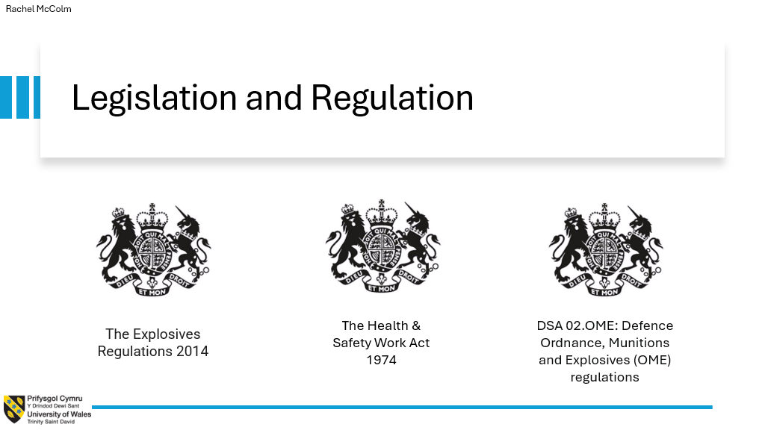
Figure 1 - Slide 1 - Regulation and Legislation
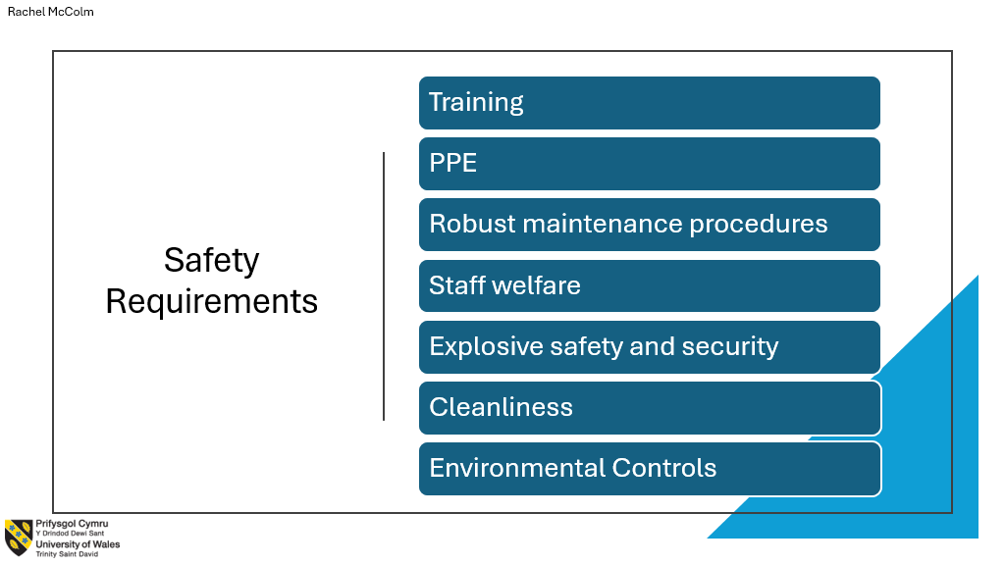
Figure 2 - Slide 2 - Safety Requirements

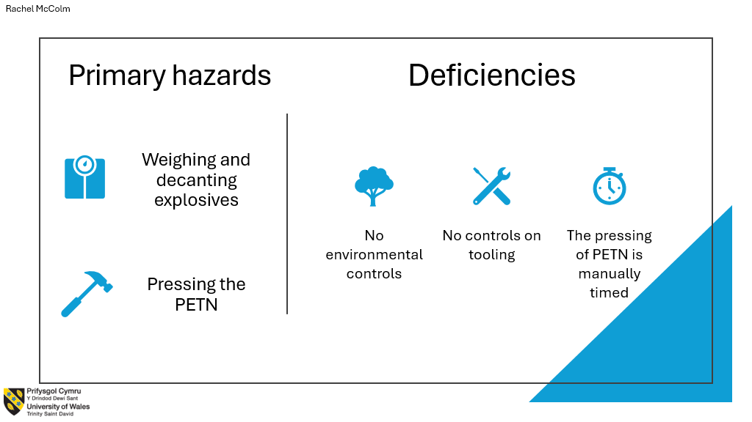
Figure 3 - Slide 3 - Processing Hazards and Deficiencies

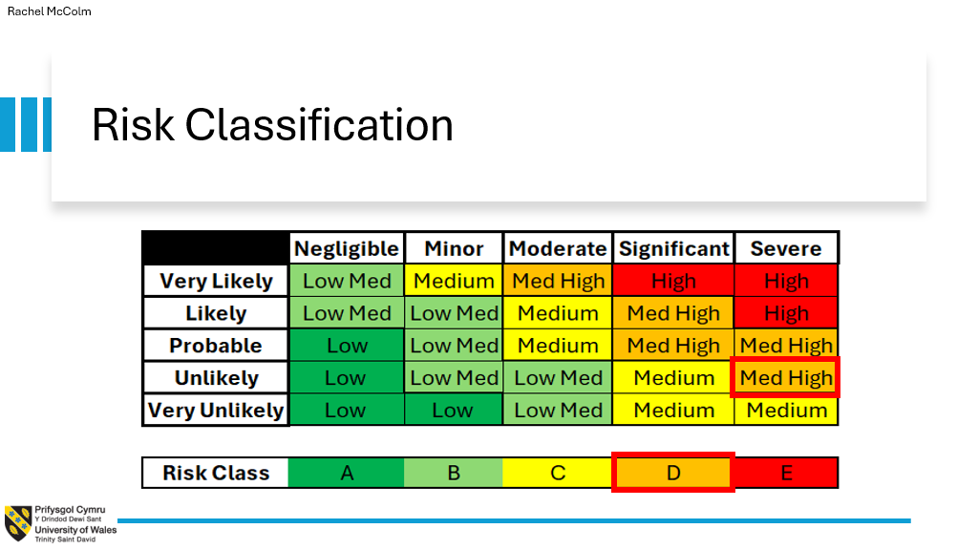
Figure 4 - Slide 4 - Initial Risk Classification Matrix

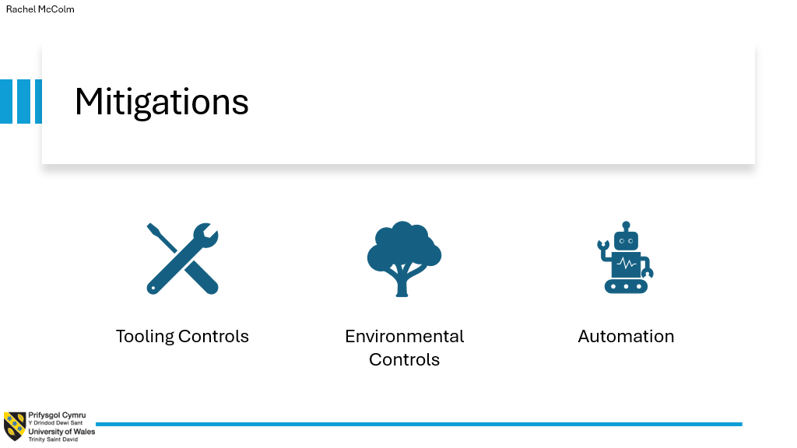
Figure 5 - Slide 5 - Mitigations

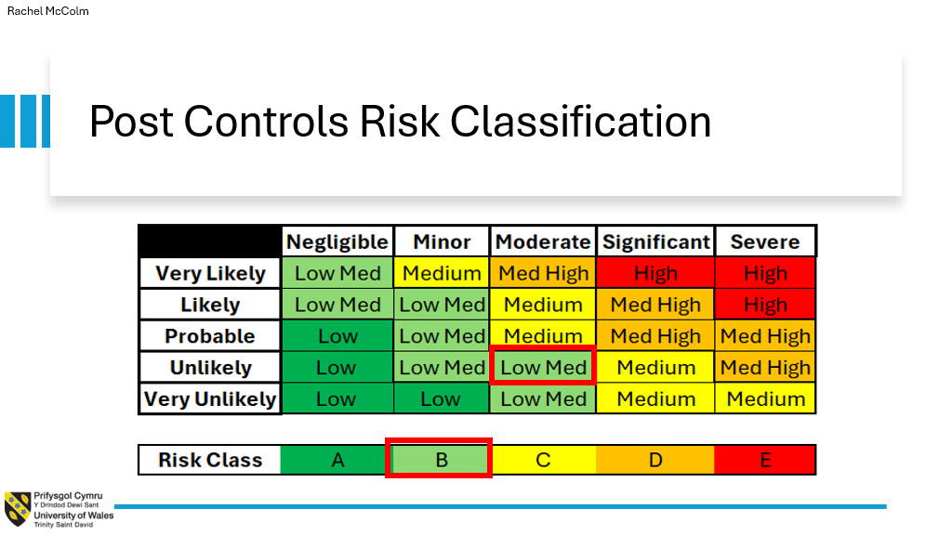
Figure 6 - Slide 6 - Post Mitigation Risk Classification Matrix

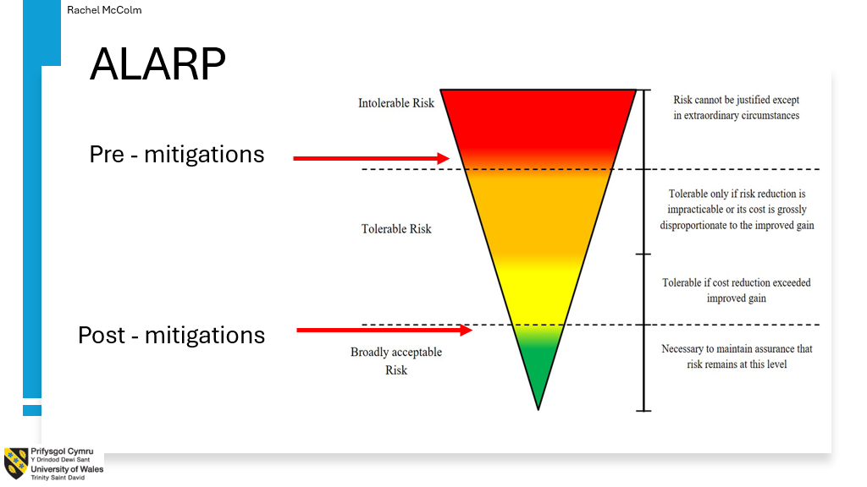
Figure 7 - Slide 7 - ALARP Carrot Diagram

Feedback from Presentation and Comments

Once the presentation was complete, the team received feedback on a group and individual basis (see figures 8 & 9, respectively). The feedback has been divided into positives and negatives to provide a better evaluation.

Group Feedback

From a group point of view, the feedback stated that the presentation is aesthetically well presented and consistent throughout. There was evidence of good collaboration, and a clear introduction was given.
The feedback also stated that there was no distinct conclusion and no inclusion of references. It also stated that there may have been some misinterpretation or miscommunication between team members in certain aspects.
The team were also asked if there was a consideration toward alternatives for the Exploding Bridge Wire.

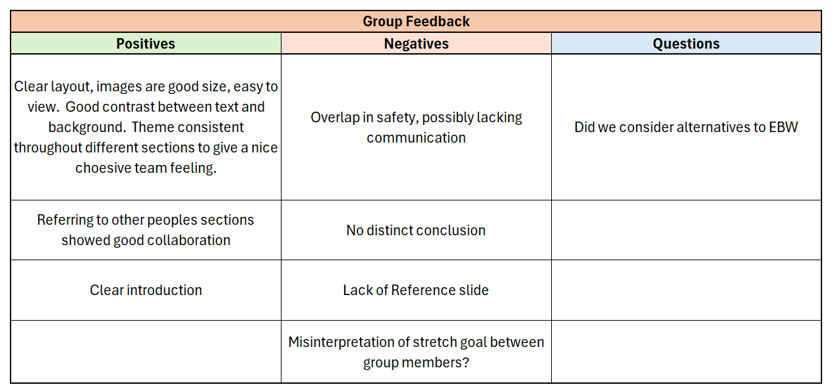
Figure 8 - Group Feedback

Comments

In terms of creating the presentation and collating all of the team members' work, everyone worked quite well together. A template was made so that there was a standard theme throughout the whole presentation. The team also had multiple checkpoints throughout the creation of the presentation to ensure that no one was covering the same information. Certain aspects of the presentation were linked to others (e.g., manufacturing and safety), so it was essential to reference where these connections were made to illustrate the communication between the two.
There were several aspects of the project that were misinterpreted between team members. The lack of conclusion was due to some miscommunication between team members and some confusion in the final design. The exclusion of the reference slide was also due to some disagreements in the team about whether this should be included or not. Some of the team had been taught to include references in presentations, and others had not. As well as this, not everyone had been keeping track of references used throughout the duration of the project, so this made it difficult when collating everything for the presentation.
In terms of the overlap in safety, there was very good communication between both safety roles. However, when the presentation was complete and the team were completing all their run-throughs, changes were being made and not necessarily kept track of. This was probably due to being nervous for the presentation and having tunnel vision for our individual sections.
Finally, the team was asked if we considered an alternative to the EBW. The team arrived at the decision of an EBW after considering what type of Safety and Arming Unit (SAU) would be used in the munition. A Pugh Diagram told us that an Electrical SAU was the best option for the requirements. This then led the team to decide an EBW was the best fit.

Individual Feedback and Reflection

I was very familiar with safety and the safety of munitions due to projects I have contributed to in my workplace. This meant that my knowledge and experience helped with my confidence in talking about the subject. I tried to utilise the systems tools I had available to me, as well as safety tools that I have used in my workplace. Myself and the team did multiple practice run-throughs of the whole presentation, which solidified our knowledge and helped us come across more confidently.
As with any presentation, there is a period of discomfort in the beginning. In this instance, some people being presented to were not familiar to the team and there were more people than we had originally thought. Once I was a bit further into my presentation and was comfortable with the subject matter, I came across more confidently.
The feedback asked which part of the processing is the highest at risk of an accident. This would be the actual pressing of the explosive into pellets. This was found through the utilisation of a Process Flow Diagram, Design Failure Modes and Effects Analysis (DFMEA) and other safety tools. These highlighted that the pressing of the explosive was the highest risk and highest consequence activity in the processing operations.

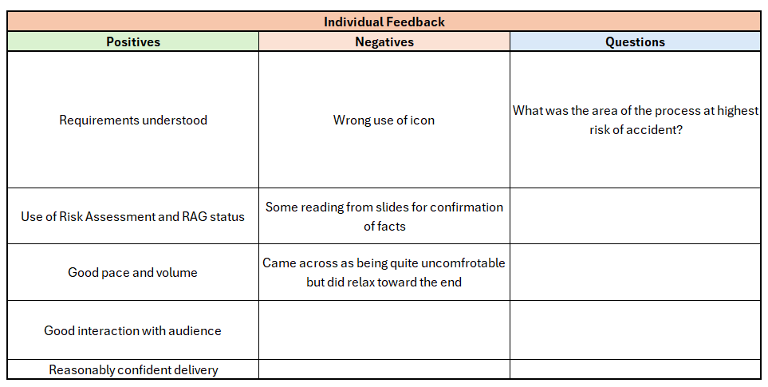
Figure 9 - Individual Feedback

Reflection

Group Work Reflection

I think that the team worked well to the time constraints and managed time around different working schedules well when away from university. As well as this, each team member was from a different working background which helped us when it came to designing the munition as each member could add a different perspective.
One major drawback with this project was the differences in personalities within the design team. As a result of this, communication and relationships between team members could become strained at times.
There was an attempt to manage the strained communication/relationships. Some team members asked university staff for advice and how to best proceed. This helped and provided the team with a plan and some reassurance that even if it could not be managed, it would not affect our individual marks.
This project was also impacted by the team members' differences in motivations. Most team members wanted to utilise the time that the team had together at university and get as much work done in that time as possible. However, some individuals did not share the same motivations. This made it particularly difficult when it came to creating the presentation portion of the project, as some individuals had not done as much work by comparison. This was a difficult situation to handle as it could have potentially impacted the rest of the group.

Personal Reflection

Personally, I feel I was well prepared for the presentation as I knew the subject well and tried to practice as much as possible. I had experience in writing Risk Assessments and have contributed to a Safety Case in my workplace, so I felt this put me in a good position for this project.
An area I feel that I should improve on, which was highlighted through working on this project, was communication. In hindsight, I recognise that I allowed more dominant personalities to overshadow my contributions when I should have been more assertive in advocating for my ideas and expressing my perspective.

Conclusion / Lessons Learned

Working on this project demonstrated the value and importance of effective time management and prioritisation of tasks. As well as this, it highlighted the fact that having a team with diverse working backgrounds will enhance the design process by bringing in different perspectives and avoiding any potential bias.
The project also illustrated the challenges that can arise from poor communication among team members. Personality clashes and different dynamics can make collaboration very difficult and, in turn, affect the team's output. In future, it would be recommended to have defined roles in the team, manage relationships appropriately from the beginning and ensure every team member has a platform to express their ideas.

References

[1] | UK Government, “The Health and Safety at Work Act 1974,” [Online]. Available: https://www.legislation.gov.uk/ukpga/1974/37/section/2. [Accessed May 2025].
[2] | UK Government, “The Explosives Regulations 2014,” June 2014. [Online]. Available: https://www.legislation.gov.uk/uksi/2014/1638/made. [Accessed May 2025].
[3] | UK Government, “DSA 02 OME,” June 2020. [Online]. Available: https://www.gov.uk/government/publications/dsa-02ome-defence-ordnance-munitions-and-explosives-ome-regulations. [Accessed May 2025].
[4] | HSE, “Guidance on ALARP decisions in COMAH,” [Online]. Available: https://www.hse.gov.uk/foi/internalops/hid_circs/permissioning/spc_perm_37/. [Accessed May 2025].

