BMSW4001
Academic and Employability Skills
Tutor: Peter Allen
Student Name: Noemi Navas
Student ID: 1921194

Table of Contents
Introduction 3
Term 1 4
Article 1 4
Employability Skills: The Skills You Need to Get a Job? 4
Article 2 6
What Are the Top 10 Skills That’ll Get You a Job When You Graduate? 6
Article 3 8
What are the transferable skills? 8
Article 4 10
“Soft" Is an Understatement: The Importance of Transferable Skills’ 10
Analysis of own employability skills 12
Conclusion 14
References 15

Introduction
Academic skills are made up of fundamental skills e.g. presentation skills and writing skills which are the most important for the inspiring student to become good learners. Besides, the employability skills are leadership skill, communication skill, team working skill and motivation skill which are important for getting along with. Besides, the employability skills also support an individual to works well with others. Here, the context will discuss 4 different articles where articles 1 will describe employability skills. In article 2 will describe the top 10 skills, and in article 3 & 4 will describe the transferable skills and its importance (Cottrell, 2017).

Term 1

Article 1

Employability Skills: The Skills You Need to Get a Job?
According to SkillsYouNeed (2020), employability skill refers to all the mandatory and supportive knowledge and learning which assists to perform the assigned roles and responsibilities properly. The article shows that to get a job properly an employee needs to know about CV writing, applying for a job, interview skills, using LinkedIn, writing cover letter etc. The article also focuses on the three core employability skills which are recommended to be well enough in employment segments namely working with other people (Teamwork), being reliable and dependable as well as a willingness to learn such as…
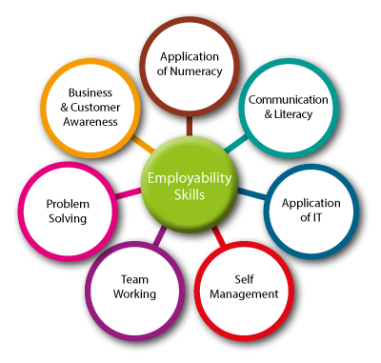
Figure: Employability Skills (Cottrell, 2017).

Working With Other People (Teamwork)
Team working is mandatory to work with other peoples where each employee is dedicated to accomplishing the business objectives properly. For example, an employee needs to be cooperative and supportive for the other employees where each employee is depended with one another. If teamwork is not at the optimum level then it will influence in all the involved areas (Keevy et al, 2018).
Being Reliable and Dependable
To accomplish the shared vision, being reliable and dependable is a must because it supports to encounter each job roles and responsibilities flexibly and properly. For example, an employer needs to have the optimum level output and that’s why, if the employee is involved the sequential flow chain then it will be easier and supportive for all the employees to have shared working platform (Skillsyouneed, 2020).
Willingness to Learn
The willingness to learn new things is essential because new learning is supportive to avail with new knowledge which is more powerful and supportive for employment segments. For example, if an employee is limited with the knowledge which is required for his assigned areas then he will be effective for this section only. But if the employee has enough dedication and approaches to learn new issues then it will be supportive of him with a broad area of knowledge and skills (Boissy et al, 2016).

Article 2

What Are the Top 10 Skills That’ll Get You a Job When You Graduate?
As a graduate, every student needs to have a better understanding and preparation for the job skills and knowledge about where he prefers to work such as…
1. Commercial awareness
Commercial awareness skills help to be well-known about the business perspectives which are assistive to perform the business actions strategically. For example, a graduate student must be familiar with the commercial aspects when he is about to enter into employment sectors (Keevy et al, 2018).
2. Communication
Communication helps to make interconnection with other parties to accomplish the shared vision and even also, communication is widely necessary to attain the individual goals and purposes. For example, an employee needs to engage in effective communication with the other employees
3. Teamwork
Team working is required for shared business goals and objectives as team working is mandatory to work with other peoples where each employee is dedicated to accomplishing the business objectives properly. For example, a group of employees engaged to attain one single goal.
4. Negotiation and persuasion
Negotiation skills are mandatory to reduce the negative impact of conflict and even also this skill is required for convincing the other parties. For example, if an employee has negotiation skill then it will be effective for him to convince others (Boissy et al, 2016).
5. Problem-solving
Problem-solving skill is the capability to handle any hard or critical problems which is the most important for an employee. For example, if any employee has this skill, he can handle any situation and make the work easier (Targetjobs, 2020).
6. Leadership
The desires of achievement of the leaders or managers are not as strong as an entrepreneur because their achievements are only restricted in the organization. For example, employees need to leadership skill as it provides how to give support and inspire to others (Mumford et al, 2017).
7. Organisation
The organisation is the process of regulating and operating regular activities. As this process support an employee to identify the strength and weakness of his works. So, this skill helps an employee to eradicate his weakness and increase his performance (Keevy et al, 2018).
8. Perseverance and motivation
Self-motivation is very crucial in the business sector because it always pushes the entrepreneur to think about new business with a new concept. For example, when an employee works, he or she will face many critical tasks, if he has practised this skill, he can support others and also improve himself (Boissy et al, 2016).
9. Ability to work under pressure
This skill is highly required for an employee to accomplish his goal. If the employee has the power to works within the pressure, he cans development his career properly. For example, in the workplace, there have sometimes included pressure works, if the employee wants to cope with the pressure, he must need to practice this skill (Dawson et al, 2018).
10. Confidence
Confidence is highly required for an employee at the time to do any works in the workplace. For example, if an employee has enough confidence in his works, he can complete his works and the authority can also believe him so much which is more important for career development (Mumford et al, 2017).

Article 3

What are the transferable skills?
Transferable skills refer to those skills which can be used to any field of practices wherever and whenever they are required. As an employer needs to have the optimum level output then it needs to be feasible to have the transferrable skills in the employment sectors properly. Besides, transferable skills are effective to deal with present and upcoming knowledge sectors as If the employee has enough dedication and approaches to learn new issues then it will be supportive for him with the broad area of knowledge and skills (Reed, 2020).
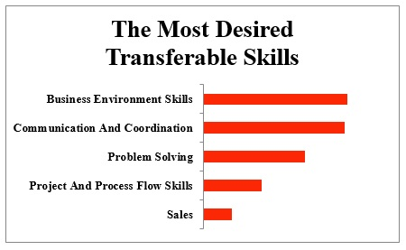
Figure: Transferable skills (Boissy et al, 2016).
Leadership
Every aspects or character of the business wants to be successful and create achievements in their professional career. The desires of achievement of the leaders or managers are not as strong as an entrepreneur because their achievements are only restricted in the organization. On the other hand, an entrepreneur desires a high need for achievement and this he always tries to include different things in his business (Dawson et al, 2018).

Time management
Time management is the thing which also indicates an entrepreneur from others. This skill of an entrepreneur shows and explains the right time to do any important task. This ability of an entrepreneur also showed his intelligence of scheduling important tasks and decision-making meetings. It also helps to satisfy the workers of the business (Dawson et al, 2018).
Prioritisation
Prioritisation is mandatory to complete one task according to its deadline and importance. Academic skills are made up of fundamental skills e.g. presentation skills and writing skills which are the most important for the inspiring student to become a good learner.
Communication
Communication is essential to meet the anticipated outcomes by communicating with others. Besides, the employability skills are leadership skill, communication skill, team working skill and motivation skill which are important for getting along with (Boissy et al, 2016).

Article 4

“Soft" Is an Understatement: The Importance of Transferable Skills’
Soft-skills fundamentally denotes to that type of skills which are the combination of all the associated skills in the sectors of social skills, people skills, communication skills etc. Transferable is good enough to deal with soft skills where the core importance of soft skills is it effective for all the required sections. The key issues of soft skills are communication skills, time management skills, team working skills such as (Forbes, 2020).
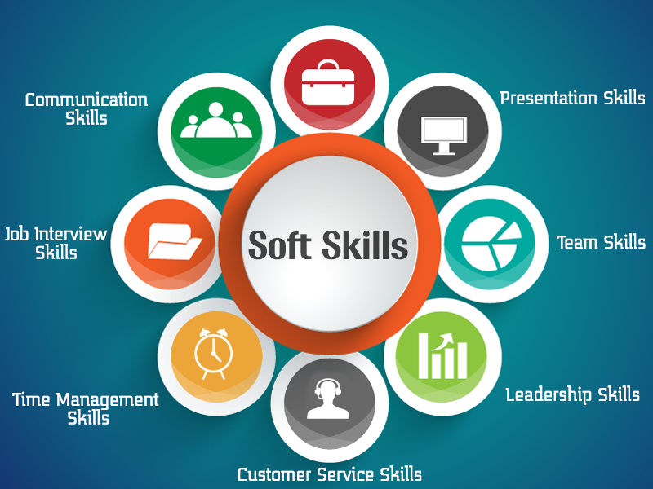
Figure: Soft Skills (Arnold et al, 2019).
The importance relies on the key practices as to accomplish the shared vision, being reliable and dependable is a must because it supports to encounter each job roles and responsibilities flexibly and properly. For example, team working is mandatory to work with other peoples where each employee is dedicated to accomplishing the business objectives properly. The key skills which are required for doing best in the employment segments vary from one job to another job and also the dependency also considers the purposes of the specific business outcomes (Dawson et al, 2018).

Moreover, the importance of transferable skills is that it will make things easier for capturing new knowledge. For example, the willingness to learn new things is essential because new learning is supportive to avail with new knowledge which is more powerful and supportive for employment segments. Besides, the employability skills also support an individual to works well with others (Boissy et al, 2016).
Furthermore, transferable skills are required to have self-motivated approaches. Self-motivation makes a direct impact on the mind-set of an entrepreneur and because of this; he can easily complete any hard task very easily. Besides this, it can provoke the entrepreneur to add new ideas in the business (Ute et al, 2017).

Analysis of own employability skills
My employability skills need to be measured to identify the strength and weakness of the assigned roles and responsibilities. As we know that all the mandatory and supportive knowledge and learning which assists to perform the assigned roles and responsibilities that can be recognized as employability skills. Moreover, I need to satisfy my employer as every employer wants the key skills which are supportive to accomplish the business objectives and that are why each employee needs to learn and available with all the mandatory skills what are essential for the desired job position (Arnold et al, 2019).
I need to be dedicated and available to cover all the required skills along with the new knowledge as the willingness to learn new things is essential because new learning is supportive to avail with new knowledge which is more powerful and supportive for employment segments (Boissy et al, 2016).
Furthermore, I need to cope with the employment requirements as core employability skills which are recommended to be well enough in employment segments. That’s why; I need to know about CV writing, applying for a job, interview skills, using LinkedIn, writing cover letter etc. The following SWOT analysis will be effective to measure my employability skills such as (Dawson et al, 2018).
Personal SWOT Analysis
Strength  - I have enough writing and personal skills.  - I have known well how to motivate people.  - I have technical knowledge in a different field. | Weakness  - I have no experience with HR.  - I am no idea how to cope with any changes.  - I have no idea about how to communicate with different culture people.
Opportunities  - To enter the new market is an opportunity for me.  - Increasing the number of a start-up business which is the opportunity for me.  - Modern technology has supported me a lot to find a good job (Cottrell, 2017). | Threats  - Lack of advance education and training.  - Companies are not hiring  - Tough competition from the young (Boissy et al, 2016).

Conclusion
Thus, it can be said that the report is enough good to deal with Academic and Employability Skills. As an employer needs to have the optimum level output then a graduate student must be familiar with about the commercial aspects when he is about to enter into employment sectors. So, employees should have leadership skill as it provides how to give support and inspire to others effectively and efficiently (Arnold et al, 2019).

References
Arnold, E.C. and Boggs, K.U., 2019. Interpersonal Relationships E-Book: Professional Communication Skills for Nurses. Elsevier Health Sciences.
Boissy, A., Windover, A.K., Bokar, D., Karafa, M., Neuendorf, K., Frankel, R.M., Merlino, J. and Rothberg, M.B., 2016. Communication skills training for physicians improves patient satisfaction. Journal of general internal medicine, 31(7), pp.755-761.
Cottrell, S., 2017. Critical thinking skills: Effective analysis, argument and reflection. Macmillan International Higher Education.
Dawson, P. and Guare, R., 2018. Executive skills in children and adolescents: A practical guide to assessment and intervention. Guilford Publications.
Forbes, 2020. ‘"Soft" Is An Understatement: The Importance Of Transferable Skills’ Available at << https://www.forbes.com/sites/forbeshumanresourcescouncil/2019/04/26/soft-is-an-understatement-the-importance-of-transferable-skills/#5ae396c15ea9>>
Keevy, M. and Mare, D.J., 2018. Pervasive skills development for aspirant chartered accountants: Academic versus training programmes. Journal of Economic and Financial Sciences, 11(1), pp.1-9.
Reed, 2020. ‘What are transferable skills? Available at<<’https://www.reed.co.uk/career-advice/what-are-transferable-skills/>>
Skillsyouneed, 2020. ‘Employability Skills: The Skills You Need to Get a Job. Available at<<https://www.skillsyouneed.com/general/employability-skills.html>>
Targetjobs, 2020. What Are The Top 10 Skills That'll Get You A Job When You Graduate?’ Available at <<https://targetjobs.co.uk/careers-advice/career-planning/273051-the-top-10-skills-thatll-get-you-a-job-when-you-graduate>>

