

LCMB7020

Impact of Macroeconomic factors on the foreign exchange rate

: Case analysis of Indian Economy

Student Id: 2239855
Student Name : Aditya Pratap Gurjar
Supervised by : Jia Miao
Word count:

Abstract
Purpose: The study will aim to investigate the impact of macroeconomic factors on the foreign exchange rates concerning the case of India.
Methodology: The study has been conducted through the usage of authentic research tactics and means in order to enhance the quality of the research. The positivism research philosophy has been used in the following study. In order to support the quantitative research method adopted in the study, the deductive research approach is applied to meet the requirements of the study. A secondary data collection method is used over the primary data collection method to save the time and get the readily relevant available data. The descriptive statistical method is used in the research, correlation and regression statistical tools played crucial roles. The case study analysis is applied to derive real-time insights into foreign exchange rates and meet the research aim.
Findings: It has been identified through the research that the inflation rate, unemployment rate, GDP, per capita income, and national income are a few essential macroeconomic factors. It has been found that foreign exchange rates serve as a critical link point between domestic and international economic activities. GDP and foreign exchange rates are found to be sharing a direct relationship, increasing the GDP growth rate helps strengthen the currency of a nation. Moreover, it is found that unemployment has an inverse relationship with the foreign exchange rate. Indian corporations are facing the challenge of performing business tasks as they have to change their policies because of fluctuating foreign exchange reserves.
Recommendations: The government of India is recommended to amend the changes in the foreign trade strategies because this will help it to align its goals with the fluctuating macroeconomic factors. The government is suggested to analyse the foreign trade policies of distinct countries to derive effective strategies and implement the same to tackle the challenges of dynamic foreign exchange rates.
Keywords: GDP, inflation, correlation, regression, macroeconomic factors, foreign exchange

Table of Contents
Abstract 2
1. Introduction 6
1.1 Research Background 6
1.2 Problem Statement and Rationale 8
1.3 Research Aim and Objective 9
1.4 Research Significance 10
1.5 Research Question 10
1.6 Research Hypothesis 10
1.7 Research structure 10
2. Literature Review 12
2.1 Introduction 12
2.2 The concept and trend of the foreign exchange rate in the Indian Economy 12
2.3 To determine the macroeconomic factors impacting the economy and foreign exchange. 15
2.3.1 Inflation rate and its impact on FX rates 15
2.3.2 GDP growth and its impact on FX rates 16
2.3.3 Unemployment and its impact on FX rates 16
2.4 Relationship between macroeconomic factors and the foreign exchange rate of India. 18
2.5 Reasons of foreign exchange rate fluctuations and its impact on the Indian Economy 19
2.6 Challenges faced by Indian companies due to foreign exchange rate fluctuations and strategies undertaken to deal with them. 20
2.7 Research Gap 22
2.8 Research Summary 22
3. Research Methodology 24
3.1 Introduction 24
3.2 Research Design 24
3.3 Data and Data Collection Method 26
3.4 Research Method and Strategy 27
3.5 Research Philosophy 27
3.6 Research Approach 28
3.7 Data Analysis 29
3.8 Ethical Considerations 29
3.9 Research Limitations 30
4. Data Analysis 31
4.1 Introduction 31
4.2 Case Analysis 31
4.2.1. Existing trend of different macroeconomic aspects in the Indian economy 31
4.2.2 Understanding the relationship between the foreign exchange and macroeconomic aspects in the Indian economy 36
4.2.3 Key trend and reason for fluctuation in the exchange rate in the Indian economy 38
4.2.4. Key challenges and possible solutions used by Indian companies to reduce the impact of macroeconomic trend on foreign exchange 40
4.3 Descriptive Statistics 41
4.4 Correlation and Regression Analysis 42
4.5 Discussion 43
5. Conclusion and Recommendations 48
5.1 Introduction 48
5.2 Conclusion 48
5.3 Recommendations to the Government of India 51
5.4 Recommendations for Future Research 52
References 53

Introduction

1.1 Research Background
Foreign exchange, with the name itself, depicts the exchange or conversion of one currency into another at a pre-determined rate called foreign exchange rates (Fanelli and Straub, 2021). The conversion rate (foreign exchange rate) mostly keeps on fluctuating due to the impacts of dynamic factors such as recession, inflation, speculations, stock markets, and political stability on an economy (Ibrahim and Basah, 2022). Macroeconomic factors can be understood through a thorough understanding of the macroeconomics. Macroeconomics is a subject matter, study, and branch of economics that studies the behaviour and working of an economy as a whole. Inflation, fiscal policy, gross domestic product (GDP), national income, employment, and per capita income are some of the crucial macroeconomic factors (Garg and Kalra, 2018) countries and their rulers across the globe proactively show their concern toward these macroeconomic factors in order to ensure the regular growth and development of the nation in economic terms.
India currently is the fastest growing and developing nation on the planet as the World Bank projected that the Indian economy will wind up a growth of 7.5% for the fiscal year of 2023-24. Moreover, the nation stands with a GDP of USD 3.732 trillion, growing at a rate of 8.4% in the third quarter of the financial year 2024 (India Today, 2024). These numbers depict that the country has been successfully mitigating the challenges of poverty and poor economic conditions over the years. According to Gu, et al., (2021), India has seen significant growth in the past two years considering the poverty, economic condition, education, health, and infrastructure. Being a democratic country, India has seen a continuous hike under several ruling parties and rulers. Democracy is also a major macroeconomic factor that impacts the growth and development of the economy of a nation.
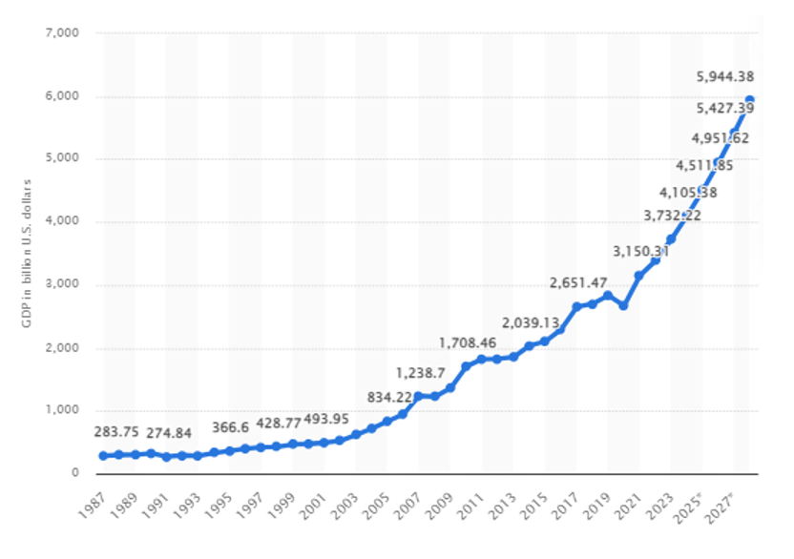
Figure 1: India: Gross domestic product (GDP) in current prices from 1987 to 2028
(Source: O’Neill, 2023)
The above diagram presents the information regarding the regular GDP growth of India from the year 1987 to 2028. It can be derived from the presented graph that the country has grown by approximately 25 times today compared to the 80s times.
Inflation refers to the rate of increase in the price over a given period of time, it is one of the major macroeconomic factors that consider the increase and decrease in the prices of all the goods and services available to the population of the nation (Carstens, 2022). The inflation rate in India is not a specific value, it is distinct from the rate in the rural areas and the inflation rate in the urban areas. Currently, the nation’s inflation rate in the rural areas stands at 5.34%, higher than that of the urban areas at 4.78% (Forbes, 2024). It has been shown in the below diagram that as of February 2024, consumer price index (CPI) inflation in India downed to 5.09% from that of 5.1% in January.
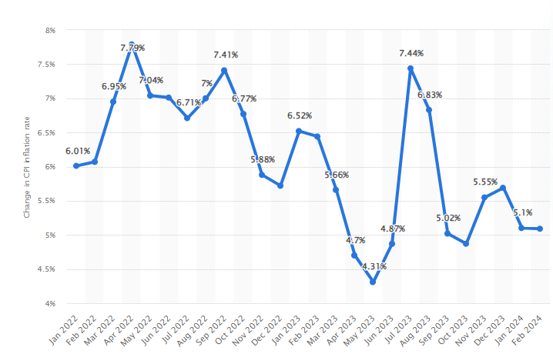
Figure 2: Consumer price inflation rate across India during from 2022-2024
(Source: Statista, 2024)
Foreign exchange opens the door for India to let its domestic industry and corporations enter the international market to enjoy the benefits of the increased number of consumers, enhanced revenue and profitability, increased visibility, and brand popularity. Allowing the domestic company to operate their business activities across the globe helps India foster its foreign reserves as well. As per Drehmann and Sushko, (2022), increased foreign reserves help the nation ease the foreign exchange rates to exchange the currency and ease the cross-border trades. The foreign exchange rates have a trait of fluctuating through the influence of changing times and distinct macroeconomic factors. Therefore, the major agenda of conducting this particular study is to analyse and evaluate the impacts of macroeconomic factors on foreign exchange rates.

1.2 Problem Statement and Rationale
Macroeconomic factors such as GDP, inflation rates, interest rates and other uncertain events have a significant relationship with the international trade aspects of multinational companies concerning the changes in the foreign exchange rate. It has been analysed that the foreign exchange rate of India has been fluctuating due to the macroeconomic factors which brought challenges to the trading activities of the companies (Morina, et al., 2020). Further, it is also analysed that Indian companies are concerned with foreign exchange fluctuations while making international imports and exports as it influences their profitability to a certain extent. The study by Jyoti, (2021), reflected that foreign exchange volatility has a negative influence on the exports which affects the competitive advantage of the companies and also affects the GDP of the nation creating complexities in economic development. Further, the transaction of India with the other countries for the imports and exports face issues due to the volatile foreign exchange rate which leads to the capital losses of the country which is one of the big concerns as foreign exchange rates have been driven by macroeconomic factors.
However, it can be stated that conducting this research is highly important to present the macroeconomic factors impacting the foreign exchange rates of India along with the key relationship of GDP, inflation rates, interest rates and others on the exchange prices to spread awareness. This is also required to analyse as defining the key reasons behind the fluctuating exchange rates is the high concern of the companies as facing various complexities due to this. The growth of the Indian economy has been facing issues as this is identified as an obstacle to economic growth and development which is required to be investigated for further actions taking ensure gaining a competitive advantage and make the country stand in the international market with effective positioning.

1.3 Research Aim and Objective
The study will aim to investigate the impact of macroeconomic factors on the foreign
exchange rates concerning the case of India.
- To evaluate the concept and trend of the foreign exchange rate in the Indian Economy
- To determine the macroeconomic factors impacting the economy and foreign exchange.
- To analyse the relationship between macroeconomic factors and the foreign exchange rate of India.
- To explore the reasons of foreign exchange rate fluctuations and its impact on the Indian Economy
- To understand the challenges faced by Indian companies due to foreign exchange rate
fluctuations and strategies undertaken to deal with them.

1.4 Research Significance
Conducting this research is beneficial for several companies as well as the government in the different areas. The study provides in depth analysis of macroeconomic factors driving the foreign exchange rate of India and relationship between the two. This helps companies make strategies in order to protect against foreign exchange rate volatility and effectively trade in the international market concerning the relationship and impact of macroeconomic factors on the exchange rates in India. Inflation rate, interest rates, government debt, terms of debt and recession are some factors influencing the exchanges prices (Fexco, 2023). Understanding the factors driving macroeconomic factors assist the government make policies and other strategies to reduce the impact of macroeconomic factors on the exchange prices including the imports and exports of multinational companies and hence, restricting growth of Indian economy. The long-term planning and future decision making of the companies and government of India could get an additional edge by understanding the reasons behind foreign exchange rate fluctuations and macroeconomic factors impacting economy. Further, the students seeking for the concept of foreign exchange rate in India and macroeconomic drivers of the same can get a help with the study reflecting in depth analysis of the factors as well as exchange rates.

1.5 Research Question
What is the influence of macroeconomic factors on the foreign exchange rate of India and its economy?

1.6 Research Hypothesis
H0- Macroeconomic factors significantly impact foreign exchange rates in India
H1- There is a non-significant impact of macroeconomic factors on Indian foreign exchange rates.

1.7 Research structure
- Introduction: This particular study is initiated by iterating on the research topic in the first chapter of the introduction. Research background, problem statement, aim and objectives, research question, and research hypothesis are included in the introduction.
- Literature review: This chapter has been addressed by taking the crucial reviews and viewpoints of distinct authors who support the arguments related to the research topic.
- Research methodology: This chapter includes the research philosophy, approach, and method used to meet the requirements of the research question. The data collection and data analysis method used in research is also discussed.
- Data analysis: This chapter addressed the evidence of the information used in the study, considering the higher reliability of the sources to help achieve the desired outcome that matches the requirement of the research question.
- Conclusion: A brief summary of the viewpoints of distinct authors is presented in this chapter that stands as significant to meet the needs of the study.

Literature Review

2.1 Introduction
This chapter highlights the viewpoints of distinct authors, distinct perspectives gathered from the study, and research conducted by several authors to support the aim of the study. Supportive viewpoints that support the research topic and its aims and objectives have been presented thoroughly. Moreover, the contradictory statements stated by distinct authors are critically evaluated and used to make the research more authentic and accurate. The significance of foreign exchange rates in the development of the Indian economy is analyses by taking into consideration distinct thoughts of the authors. Macroeconomic factors and their impacts on a growing nation like India have been elaborated in this chapter.

2.2 The concept and trend of the foreign exchange rate in the Indian Economy
According to the perspective of Drehmann and Sushko, (2022), foreign exchange is a broader concept that includes the impact of the conversion of one country’s currency into another by considering the factor of the law of demand and supply. Economies decide their foreign exchange and the value of currency according to the ongoing fluctuation rate. The foreign exchange rates are the relative value between a pair of currencies and often show a fluctuating attribute. As per the views of Camanho, et al., (2022), foreign exchange rates serve as a critical link point between domestic and international economic activities. Therefore, these rates play a vital role in determining the effectiveness of international trading activities that are going on in a nation. These exchange rates directly impact the monetary and financial benefits that a domestic company derives by entering into the international markets. A slight decline in the value of the domestic currency due to the fluctuations in foreign exchange rate impacts the profitability generation and growth of domestic industry that eventually becomes a hurdle ahead of the economy’s growth.
According to Bhat and Bhat, (2021), foreign exchange rates and international trading have helped the Indian economy to continuously grow at a significant and increasing rate. The nation has signed several foreign trade agreements such as India-Mauritius CECPA, India-Japan CEPA, India-Australia ECTA, and a framework agreement with Thailand (Department of Commerce, 2024). In order to derive a significant outcome and remarkable benefits out of these foreign trade agreements, fluctuations in foreign exchange rates play crucial roles. Contrarily, Raj, et al., (2020) stated that being a developing country, India’s currency value is less valued as compared to its international trade alliance developed countries like Japan. This stands as an obstacle ahead of the country in deriving maximum benefits from the signed foreign trade agreements. Partnering with the developed countries in the international trade has enhanced India’s competency of performing well in export and import terms, which helped the nation build significant foreign reserves.
As per the viewpoints of Cespa, et al., (2022), the fluctuations in the foreign exchange rates occur due to the influence of some macroeconomic factors like inflation, GDP, national income, per capita income, and the unemployment factor of the nation. Indian economy being a developing nation has been majorly affected by these fluctuations in these factors that influenced the foreign exchange rates. Similarly, Liu and Lee, (2021) elaborated that a rising inflation in a country forces the value of the currency of the concerned country to decline. India’s trade relations with the UK have been affected due to the global increment in the inflation factor along with India’s. Increased inflation impacted the foreign exchange rate and made the Indian currency Rupee weak ahead of the United Kingdom’s Pound. This disruption impacts the profitability and benefits that could be generated through these trade agreements and contributes to disruptions in the growth of the nation.
As per the views of Egilsson, (2020), the potential reasons behind the low currency value of a nation when compared with that of the other country with which it has signed a trade agreement are poor literacy and employment of the nation. India is a backward nation in terms of literacy rates and employment rates. The Country’s most population hovers around a young age group of 20-40 which significantly indicates the need for excessive employment opportunities in the nation. Unemployment being a macroeconomic factor affects the norms and benefits of the foreign trade agreements signed by India. Similarly, Feng, et al., (2024) specified that unemployment plays a vital role in fluctuating the foreign exchange rates for the concerned nation.
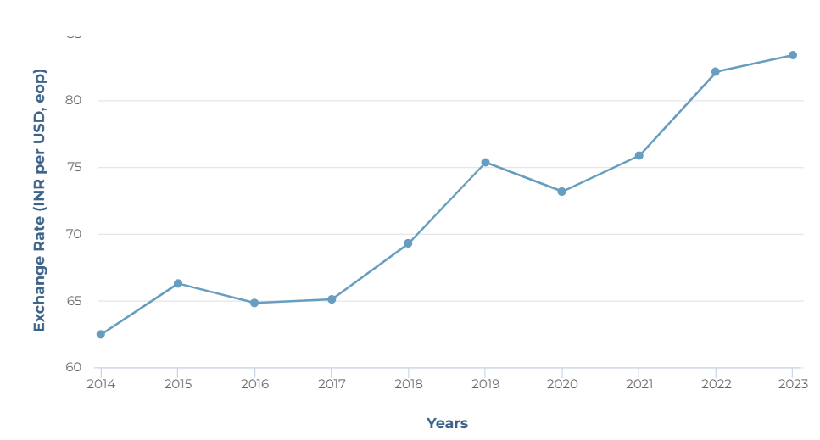
Figure 3: The exchange rate of India with the United States
(Source: Focus Economics, 2024)
Based on the report provided by Focus Economics, (2024), it has been seen that the Indian Rupee in terms of US dollar has been depreciated from 2013 to 2022. This trend is in consideration with India’s global geopolitical uncertainty, large trade deficits, as well as federal reserve monetary tightening with the help of RBI “Reserve Bank of India”, and the government. The exchange rate in the year-end 2022 was INR 82.14 per USD as compared to 2021 at INR 75.86 USD, which was INR 59.95 per USD a decade earlier, as represented in the above graph (Focus Economics, 2024). However, it has been seen that the exchange rate has been in an increasing trend from the past decade (2014 to 2023) depicting effective results.
It can be stated from the whole chapter that foreign exchange is the broader concept that affects international trade agreements. Foreign trade agreements and cross-border business by domestic industries helped India develop at a significant rate. Fluctuations in foreign exchange rates arise due to the influence of macroeconomic factors like Inflation and employment. Rising inflation results in making the currency of a particular currency decline. It has been seen that the trade relations of India with the UK are affected by the forex rate and hence resulted in making the Indian currency weaker than the UK pound sterling. Furthermore, based on the trend analysis, it has been ascertained that the exchange rate between the India and US is in the increasing trend from the past 10 years (2014 to 2023), and is in consideration with the trade deficits, geopolitical uncertainty, as well as federal reserve monetary tightening policy.

To determine the macroeconomic factors impacting the economy and foreign exchange.

2.3.1 Inflation rate and its impact on FX rates
According to Hussain, et al., (2021), macroeconomic factors are those concerning and influencing factors that determine and influence the functioning of an economy in economic and numeral terms. There are several macroeconomic factors such as inflation, unemployment rate, gross domestic product, recession, and national income that influence the strategy-making by the rulers of nations. Similarly, Musarat, et al., (2021) stated that fluctuations in the Inflation rate impact the growth and stability of the nation’s economy in both the trends positively and negatively. In terms of statistical fact the consumer price index impact due to inflation in India was increased from 5.13% in 2021 to 6.7% in 2022, leading to an annual change of 1.57% (Behera and Patra, 2022). Inflation refers to the rate of increase in prices of goods and services available to the consumers of a nation over a given period of time. The study conducted by Padder and Mathavan, (2021) highlighted the usage of regression statistical tool suggesting that inflation has an inverse relation with the growth of the economy as an increasing trend of inflation diminishes the growth of the economy and a declining trend in the inflation supports the growth of the nation. Recently, increased inflation has impacted the growth of the Indian economy severely, as increased inflation reduced the purchasing power and led to lower real earnings.
As per the views of Musarat, et al., (2021), fluctuations in the inflation rates either domestically or globally lead to the fluctuations in the foreign exchange rates. Nations derive foreign exchange reserves through international trading and signed foreign exchange rates. These fluctuations in the inflation rates affect the collected number of foreign reserves with the government reserves. An increase in the inflation rate reduces the number of foreign reserves collected by the government of distinct nations. Contrarily, Ridwan, (2022), stated that fluctuations in the inflation rate do not affect the foreign exchange rates considering the country and its rulers have already planned strategies to mitigate the impacts of increased inflation. India lost its foreign exchange severely due to the recent increase in inflation domestically and internationally. Being a macroeconomic factor increased inflation disrupted business development, employment opportunities, international trade relations, and the growth of the GDP and national income of India.

2.3.2 GDP growth and its impact on FX rates
As per the views of Williams, (2021), the current trend of the nation’s GDP growth also determines the fluctuations in the currency exchange rate for a country. The GDP growth rate signifies the efficiency of the strategies adopted by the rulers of a nation to foster economic development. A significant GDP of a nation is required in order to foster and enhance the foreign trade activities within the nation. A stable and growing GDP over the years helped India take full benefits of entering the international trade such as increased popularity of domestic brands. Similarly, Dahliah and Nur, (2021), iterated the same that the stable GDP helps the rulers attract more foreign reserves to the nations in order to utilise them in times of need such as wars and recession. Stoica, et al., (2020), suggesting the relation between the GDP statistical factor and per capita income through the usage of correlation statistical tool. Being the fastest-growing economy, India has seen a potential growth in its foreign exchange reserves, derived from the positive movements in the foreign exchange rates for the country.

2.3.3 Unemployment and its impact on FX rates
As per Chakraborty, et al., (2021), it has been observed that the unemployment rate in the country also determines the foreign exchange rate and economy at a concerning rate. A constantly declining rate of unemployment in the country depicts that the country is growing in the right direction and adopted strategies are significant and accurately implemented. A high unemployment rate impacts the growth of an economy severely as it directly impacts the GDP, national income, and per capita income of the nation. similarly, Feng, et al., (2024), evaluated that a high unemployment rate affects the nation’s growth negatively through the economic slowdown, lower income levels, increased poverty, and reduction of foreign exchange reserves.
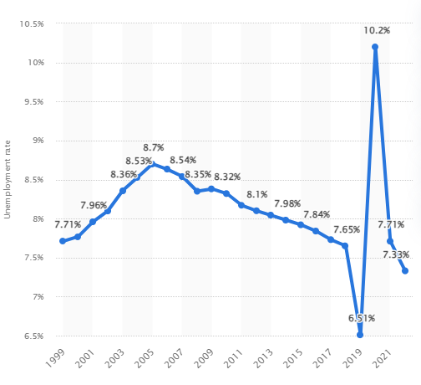
Figure 4: India: Unemployment rate from 1999 to 2022
(Source: Statista, 2024)
The above diagram shows the trend of the unemployment rate in India over the period of 1999 to 2022. In 2022, the unemployment rate being a macroeconomic factor in India was 7.33% and the impact of the COVID-19 pandemic on the economic slowdown in the nation is clearly visible from the high 10.2% of unemployment rate in 2020. Furthermore, in consideration of the perspectives of Guzman, et al., (2018), foreign exchange traders track the rates in association with the broader economic analysis. It has been seen that a high unemployment rate adversely affects the market of foreign exchange as it results in instability, economic distress, as well as minimised consumer spending. It results in making the currency weaker, and vice versa. On the other hand, currency appreciation results in making the imports cheaper, and the exports to be less competitive. This results in making the domestic demand falls, reduced costs, might cut jobs, and hence resulting in making unemployment rise.
Through the evaluation conducted in this head, it can be summarised that the inflation rate, unemployment rate, GDP, and national income are the major macroeconomic terms. Current GDP and inflation rate impact the foreign exchange rates. It has been determined that there is an inverse relation between the inflation macroeconomic factor and the economy of the nation. Moreover, it has been seen that the inflation rate results in minimising the number of foreign reserves that are collected by various nations. The GDP growth also affects the currency exchange rate in terms of fostering economic development by enhancing foreign trade activities.

2.4 Relationship between macroeconomic factors and the foreign exchange rate of India.
As per the views of Hussain, et al., (2021), macroeconomic factors such as inflation and GDP have an influential relationship with the foreign exchanges of an economy, either they help it grow or decline, based on the impact of some deriving factors. The relationship these macroeconomic factors share with that of the foreign exchange rate influences the working of the country and the decision-making by the policy-makers. Garg and Kalra, (2018), reflected that the macroeconomic factors after being influenced by the dynamic nature of economic conditions all over the world directly impact the outcome derived from the dynamic nature of the country. This influences the foreign exchange decisions and foreign trade decisions by the country's rulers.
As per the views of Meda, et al., (2022), the increase in the GDP macroeconomic factor indicates that the country is doing well in terms of achieving desired financial goals and strengthening the foreign exchange position, moreover, a decline in the GDP leads to a poor foreign exchange position of the economy. this indicates that the country should prioritise in strengthening its GDP in order to have a better foreign exchange position to perform exceptionally in terms of foreign trade. Aligning with this, Hussain, et al., (2021), have identified that the GDP and foreign exchange rate share a direct relationship. In India, the growing GDP has started showing its impact on strengthening the INR value against other currencies.
According to Hussain et al., (2021), a higher inflation rate in an economy makes the currency of that particular country weak and negatively impact the foreign exchange rate. However, such a relationship between inflation and foreign exchange can be stated as an inverse relationship between the countries. In India, the increasing inflation has declined the performance of the country in terms of generating higher revenue through foreign trade. In addition, Kumari, et al., (2023), suggests the relationship between inflation and foreign exchange rate as an inverse relationship. In India, the increase in inflation has reduced the purchasing power of the country's people which diminishes the import and export activities leading to a decline in the foreign exchange rate and foreign reserves in the economy.
Islam, et al., (2020), suggested that unemployment has an inverse relationship with the foreign exchange rate which suggests that high unemployment indicates economic distress, leading to the weak currency of the nation. In India, the unemployment rate is high which affects the country’s INR value in front of the other economies. This weakening of the country’s currency value disrupts the international business operations by the domestic industry and firms, affecting the overall GDP and national income of the country.
It can be concluded that there are various macroeconomic factors like GDP and inflation play an influential relationship with foreign exchanges and have an impact on the country’s working, as well as decision making of policy makers. It has been seen that increased GDP helps in attaining financial goals, and hence strengthen the foreign exchange position, and thus have a positive relationship. Whereas, a higher inflation results in negatively affecting the foreign exchange rate in terms of minimising the revenue generation of the companies, and hence have an inverse relationship. Similarly, unemployment is concerned with an inverse relationship with foreign exchange fluctuations as high unemployment result in economic distress, and hence weak nation’s currency.

2.5 Reasons of foreign exchange rate fluctuations and its impact on the Indian Economy
As per Wen and Wang, (2020), the fluctuations in the norms and policies of distinct countries by the policymakers of these countries are the reasons behind the fluctuations in the foreign exchange rate. Undoubtedly, the changing strategies and plans for the future functioning of the economy influence the foreign exchange rate to show its dynamic nature. The changing norms related to foreign direct investment have influenced the foreign exchange rates and so impacted the currency value of India. Additionally, Bernoth and Herwartz, (2021), highlighted that the government’s rules and regulations on foreign trade, import-export, and foreign direct investments affect the fluctuations in the foreign exchange rate. The norms developed and introduced by the government authorities that favor the international trade influence the foreign exchange rate to become strengthened leading to a high currency value of the country. However, a decision that does not support foreign trade influences the foreign exchange rate negatively leading to a weak currency value of the Indian economy.
As per the views of Islam, et al., (2020), the stock index plays a crucial and significant role in determining the fluctuations in the foreign exchange rate of the country. It has been observed that When a country's stock market is performing well, it can attract foreign investment, which increases demand for that country's currency. Similarly, the Indian economy is enjoying a better and growing position in the stock market because of the highest development rate among all growing countries. Similarly, Calderón and Kubota, (2018), evaluated that, Both the stock market and foreign exchange are the most financially traded markets on the globe. It has been observed that the Indian economy has been majorly affected by the stock market performance of domestic companies and industries. The increased and better performance of the domestic industry influenced the country’s stock market position to be strengthened that ultimately attracting the foreign investors.
Ha, et al., (2020), have suggested that the speculations are the forces that affect the currency value of an economy letting the investors attract or influence them not to invest in the country’s economy. Investors across the globe invest in the country’s currency and in its domestic industries in order to earn more through beneficial investing. India being a developing country, nowadays attracts investors and foreign direct investments by distinct investing companies across the globe. Supporting this Pearce, (2019), has evaluated that if a country’s currency value is going to rise keeping in mind the efficiency of developed strategies, investors show interest in its currency to generate significant profits.
It has been derived through this part of the literature review that the fluctuations in the norms and strategies developed by the policy-makers and government authorities majorly influence the foreign exchange rate.

2.6 Challenges faced by Indian companies due to foreign exchange rate fluctuations and strategies undertaken to deal with them.
As per Charumathi and Ramesh, (2020), the fluctuations in the foreign exchange rate affects the business strategies and future plans developed by the executives and top management of the Indian companies. The change in the foreign exchange rate affects the currency value of India which is INR, leading to disruptions in the cost and profit generation strategies in the companies of India. Moreover, it has been observed that governmental fluctuations affected businesses by influencing the supply chain of the economy. similarly, Morina, et al., (2020), evaluated that the decision of the Indian government regarding foreign trade has significantly restricted some domestic industries from going international. This has restricted the growth of the economy and the concerned business in developing revenue and profitability. This disrupted the business expansion of the domestic companies which as a result affected the overall economic development.
As per Ahmed, et al., (2021), the fluctuations in the foreign exchange rate disrupted the business growth of the Indian companies because of impacts on the revenue and profitability generation. The fluctuations in the foreign exchange rate affect the currency value of the economy and that leads to considerable impacts on the cost and profitability. The unfavorable impact of foreign exchange rates significantly affects business development due to the declining value of the INR. Pearce, (2019), suggested that the changes in foreign exchange rates led to the lowering and fluctuations in the funds which led to the difficulty in compensating the employees. The companies facing issues in providing employees with better satisfaction by not giving them the desired compensations. Moreover, this prevents the company from retaining the goodwill and reputation among employees and other stakeholders.
According to Kharbanda and Singh, (2018), the Indian companies are focusing on the development of the business in the domestic industry so that profitability and revenue generation can be maintained. It has been observed that the companies of India fostering the investment in the domestic manufacturing units so that the influence of foreign exchange fluctuations can be mitigated. Being an Indian-based company these corporations understand the fluctuations in the Indian domestic industry and make effective strategies and plans accordingly for further development. As per Cespa, et al., (2022), the Indian corporations have adopted data analytics and trend forecasting technologies so that they can track the changes in the foreign exchange rates. These technologies undoubtedly help predict the future changes in the foreign exchange rate so that the company executives can make strategies and plans accordingly. It has been further observed that the Indian corporations are evaluating the strategies of competitors regarding adaptation to the change that occurred due to the influence of foreign exchange rates. The executives and top management of Indian corporations are fostering their ability to adapt to change to bear the impact of foreign exchange rates.
It has been derived in this head that the Indian companies are facing issues in the development and frequent amendments in the developed business strategies and plans. The fluctuation in the foreign exchange rate has hindered the business growth of Indian companies in international trade. The Indian executives are enhancing their ability to adapt to the changes to mitigate the challenges faced.
It can be concluded that Indian firms due to the fluctuations in the foreign exchange rate face various challenges such as disruptions in profit generation considering the business strategies as well as future plans developed by the top management, and executives. Along with this, other challenges involve the impact on the decision-making by the government for international trade, difficulty in compensating employees, and difficulty in frequent amendments in business plans and strategies. However, the companies have undertaken various strategies for overcoming such challenges like the adoption of trend forecasting technologies, data analytics tools, and others.

2.7 Research Gap
There have been various researches conducted by Hussain, et al., (2021), Musarat, et al., (2021), Dahliah and Nur, (2021), Meda, et al., (2022), and Islam, et al., (2020), that determine the impact, relationship, and reasons of macroeconomic factors on the foreign exchange rate. However, these studies have not completely focused on each and every macroeconomic factor that affects the forex rate in a particular country like India. Thus, there is a significant gap with regard to the analysis of various macroeconomic factors that lead to an impact on the foreign exchange rate of the nation. Therefore, in association with the same, the particular research focuses on the evaluation of the impact of various macroeconomic factors like the unemployment rate, inflation rate, and Gross Domestic Product on the foreign exchange rate of India in order to bridge the concerned gap.

2.8 Research Summary
It can be summarised that foreign exchange rates are considered as the relative value between the currencies pair, and consider as a fluctuating attribute. Thus, it creates a critical link point between international as well as domestic economic activities. The exchange rate influences directly the fiscal and monetary benefits for domestic companies by entering the international markets. There are various macroeconomic factors that influence the overall economy, as well as the foreign exchange such as unemployment rate, inflation, recession, national income, GDP, and others. It has been seen that GDP and inflation have an influential relationship with the foreign exchange rate. Based on the analysis, the GDP and foreign exchange rate as a positive and direct relationship; whereas, the inflation rate and unemployment have an inverse relationship.
The reasons behind the forex fluctuations involve import and export, government rules and regulations, as well as FDIs. A good performance of the stock index helps in attracting foreign investment leading to enhancing the demand for the domestic currency. On the other hand, Indian companies due to the forex fluctuations face various challenges such as disruption in the profit and cost generation strategies, restrictions on domestic industries, and difficulty in compensating employees. However, various strategies have been adopted by business organisations to overcome the challenges and involve fostering investment, and adoption of data analytics, as well as trend forecasting technologies.

3. Research Methodology

3.1 Introduction
The third chapter of the study is the research methodology chapter that shows all key practices, procedures and methods used for the purpose of gathering, assessing, evaluating and interpreting of information and data associated with the analysis of key macroeconomic factors that affect the foreign exchange rate. It presents an analysis of the impact of independent variables such as the inflation rate, GDP and unemployment rate of India on the dependent variable that is the foreign exchange rate of USA/India for the last 10 years from 2013 to 2022.

3.2 Research Design
The research design mainly defines the framework comprising of research techniques, as well as method for conducting research for addressing the identified research problem in relation to examining the impact of various macroeconomic factors on the foreign exchange rate considering the case of the Indian economy. It mainly indicates the procedures and practices for conducting research that is applied in the study indicating the sequential steps by using Saunder's research onion framework that incorporate various methods, techniques and procedures (Tantia, 2020). It is used for addressing the research problem associated with the impact of macroeconomic factors on foreign exchange rate in India economy that affect the international trade relations along with influence the flow of imports and exports in the country.
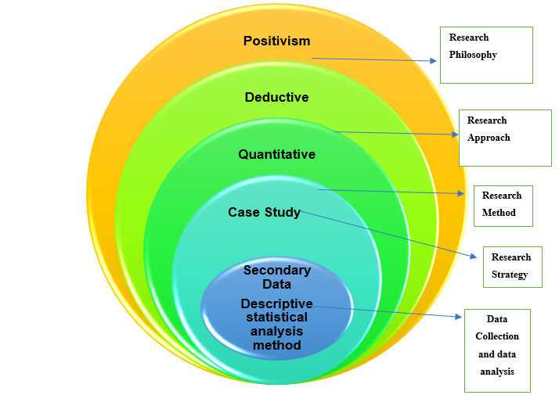
Figure 5: Saunder's Research Onion
The above-mentioned figure depicted Saunder's research onion framework that showed in-depth insights regarding the understanding of the methodological process, as well as decisions that are considered significant for solving the identified problem for which research has been conducted. It mainly indicates the important research philosophy, method, approach, data collection method and analysis of data method indicated through different layers presented in the research onion. The research focuses on analysing the impact of macroeconomic factors that affect the foreign exchange rate prevailing in India for which positivism research philosophy is considered as appropriate as it helps in proper manipulation, as well as controlling of associated variables namely, macroeconomic factors and foreign exchange rate prevailing in India for understanding the key impact of the independent variable on the dependent variable. Further, the deductive research approach is applied in the research study as it provides support in developing and proving of hypothesis made relative to the research topic along with the application of the quantitative research method.
For the purpose of gathering of data for solving the identified research problem, a secondary data collection method is applied that helps in understanding the key macroeconomic factors that directly affect the movement of currency value in India and also impact the international trade relations of the country. The data is collected from authentic websites, government reports, industry reports and newspaper articles. Further, the data is analysed by application of descriptive statistical method along with the application of case study analysis that resolves the predetermined research problem by understanding the relationship between the dependent and independent variables.

3.3 Data and Data Collection Method
Research is mainly based on the type and method of data used for the purpose of gathering of data as it directly affects the research findings. In the research study, a secondary data collection method has been applied where numeric, as well as non-numeric information and data are collected for the purpose of analysis to derive suitable findings (Tarrant and Hughes, 2019). It helps in the understanding of the impact of various macroeconomic factors namely, the unemployment rate, inflation rate and GDP of India for the last 10 years from 2013 to 2022 and considering the foreign exchange rate of India in selected 10 years. The data is mainly collected by using authentic websites such as Statista and Macro Trends that provide information for selected period along with considering published government reports and newspaper articles. It is an appropriate method as it is considered as cost-effective strategy and also helps in the proper elimination of data collected by using manual techniques and are easily accessible without taking permission. It is also easily variable on online sources that make the collection process faster and easy to access; thus, considered suitable for the research study (Rose, et al., 2019).
The independent variables taken for the research study are the unemployment rate, GDP and inflation rate of India for the last 10 years while the dependent variable is the foreign exchange rate of India for the last 10 years. It helps in understanding the relationship between the dependent and independent variables along with considering the cause and effect relation.

3.4 Research Method and Strategy
The research method mainly indicated the perspective in respect to the selected research problem along with getting suitable information. In the current research, the quantitative research method is appropriate as it helps in the proper examination of key macroeconomic factors that directly impact the foreign exchange rate considering the case of the Indian economy for which numerical data and information are requisite for resolving the research problem. It provides support in understanding the relationship between both variables, especially understanding and interpreting cause and effect relationship by using numeric data. A wide range of values are properly examined, as well as compared that help in proper implementation of quantitative research method (Williams, et al., 2022). The quantitative research method is opted for the conducted research study as it provides support in understanding, as well as examining of macroeconomic factors such as inflation rate, unemployment rate and GDP on the foreign exchange rate prevailing in India.
It has been also presented that research is conducted by using various activities and undertaking different actions that help in the attainment of research goals. In the present research study, a suitable research strategy selected is a case study strategy that helps in a proper understanding of key macroeconomic factors and foreign exchange rates. Case study of India is taken into consideration for understanding the impact of various macroeconomic factors on the foreign exchange rate prevailing in India that also affect the volume and value of exports and imports. It is an effective strategy that provides support in conducting study with a higher level of accuracy along with maintaining research quality (Baron and McNeal, 2019).

3.5 Research Philosophy
Research Philosophy is considered as a key belief with respect of the manner a data set has been gathered and interpreted in respect to the selected research topic (Brinkmann, 2018). In the current study, positivism research philosophy is suitable for the study as it helps in proper understanding of numeric information along with proper consideration of cause and effect relationship between variables that is understanding the impact of macroeconomic variables on the foreign exchange rate in India affecting the revenue generated through imports and exports with overseas nations. It is a suitable philosophy as it provides support in the development of theories, as well as hypothesis that contribute towards proper examination and interpretation of numeric and objective data relative to the selected research topic. It has been presented that experience within the positivism philosophy through getting reliable information helps in getting reliable results used for addressing the research problem. It is also appropriate for hypothesis testing that provides support in deriving of suitable findings in respect of the macroeconomic factors impact on the foreign exchange rate of India affecting its international trade operations.
It is also suitable for the study as it considers a wide exploration of data relative to the research study that helps in deriving of significant insights that help in understanding the relation between different macroeconomic factors such as inflation rate, unemployment rate and GDP with foreign exchange rate in India. It contributes towards answering of identified research questions that provide support in proper evaluating, as well as measuring of statistical and numerical information associated with the research topic (Edson, et al., 2016).

3.6 Research Approach
The research approach is an important phase within the research onion as it indicates the processes that are applied for the purpose of collection, as well as the analysis of key information relative to the selected research topic. In the current study, the deductive research approach is considered as appropriate as it helps in proper development, as well as testing of associated hypothesis and theories (Kumar, 2018). It helps in understanding and interpretation of the causal relationship between the independent variable (Macroeconomic factors such as inflation rate, unemployment rate and GDP of India) and dependent variable (Foreign exchange rate prevailing in India).
It is appropriate for the study as it mainly focuses on the proper interpretation of theory, as well as hypothesis along with testing that help in moving towards specific context in research from the generalised context. It is a helpful approach that contributes towards the exploration of unique and new perspectives, as well as ideas relative to examining the impact of macroeconomic factors on the foreign exchange rate prevailing in India. It is also appropriate as it provides support in the proper evaluation of a wide variety of information and also provides help in precise understanding, as well as interpretation of the manner and extent to which macroeconomic factors affect the foreign exchange rate prevailing in India. Further, it is also suitable for conducting research study as it helps in providing objective results at a faster pace; thus, considered better than the inductive approach (Pajo, 2017).

3.7 Data Analysis
In order to gather appropriate research findings to resolve the identified research problem along with proving of hypothesis a suitable analysis method is requisite for the gathered data for getting suitable findings. It has been presented that descriptive statistical data analysis method has been applied in the study that help in proper analysis and interpretation of numeric data gathered in relation to GDP, inflation rate and unemployment rate of India along with considering of foreign exchange rate. It shows the relationship between the dependent and independent variables along with understanding the impact of independent variables on dependent variables. It is an important analysis method that mainly summarises the dataset using various statistical methods such as standard deviation, mean, mode and median. For the purpose of fulfilling the research requirements, various key aspects are analysed for deriving suitable results that also align with the developed research aim and objectives (Bergin, 2018).
It also helps in understanding casual relationship and patterns between the movement of dependent and independent variables that provide help in proving the developed hypothesis. Additionally, regression and correlation analysis has been conducted by application of SPSS through taking GDP, unemployment rate and inflation rate as independent variables that are taken into consideration as it affects the foreign exchange rate through fluctuating the value of the currency taken as dependent variable; thus, resulting in change in the level of imports and exports in India. It shows relationship of GDP, unemployment rate and inflation rate with foreign exchange rate with the help of correlation analysis while impact of GDP, unemployment rate and inflation rate on foreign exchange rate is shown through conducting regression analysis. It provides help in better interpretation and evaluation of data collected for deriving suitable findings and addressing the problem for which research has been conducted.

3.8 Ethical Considerations
At the time of conducting the research study, ethical considerations are considered to be significant that ensure the study is conducted in an ethical manner. It helps in the maintenance of proper validity, as well as the reliability of the study. In the current study, the university guidelines are strictly complied that helps in enhancing the validity and feasibility of the research study. In research study, secondary data collected from different sources are taken into consideration that ensuring proper reference is provided to authors and researchers whose data is used in the research. Additionally, the names of authors are properly cited in the study that ensures the validity of information along with limiting the risk of copyright infringement (Buntis, et al., 2019).

3.9 Research Limitations
The research is conducted by using quantitative data that provide objective and factual information and have a lower level of detailed information indicating a key limitation of the research study. It has been also determined that data collected in respect of a single country which is India indicated a restricted scope of research as the findings provided are based in narrower terms affecting the results. Therefore, the research study can be conducted by taking a comparative analysis between the developing and developed nations.

4. Data Analysis

4.1 Introduction
The chapter on data analysis comprises of critical analysis of data gathered in respect to macroeconomic aspects namely GDP, unemployment rate and inflation rate. The findings derived with respect to the impact of macroeconomic aspects namely the unemployment rate, GDP and inflation rate of India on exchange rate of India for last 10 years that help in addressing the identified research problem. The data gathered is analysed by using the case study analysis method along with the application of the descriptive and statistical method for analysing the quantitative data in respect to macroeconomic aspects and the foreign exchange rate of India. The chapter also incorporates discussion on findings derived from the data gathered and is critically analysed with the information derived from existing literature that helps in understanding cause and effect relationship between the independent variables (Macroeconomic aspects namely, GDP, unemployment rate and inflation rate of India) on the dependent variable (foreign exchange rate of India).

4.2 Case Analysis

4.2.1. Existing trend of different macroeconomic aspects in the Indian economy
India is one of the emerging nations that has showed a significant growth in terms of growth in GDP (Gross Domestic Product) of the country. It is considered as one of the leading economies in terms of GDP and its economic growth on an annual basis has been around 7% on annual basis in recent years. It has been also presented that the Indian economy is showing higher growth as compared to China in recent years especially after the outbreak of the Covid-19 pandemic as the majority of MNCs moved out of their factories from China and considered India to be appropriate that helped in increasing revenue in the economy. It has been examined that rapid economic growth was observed in recent years in the Indian economy indicated through a rise in GDP and per capita income in India (Adam, 2023). One of the key aspect is GDP that is mainly considered as a quantitative measure that shows the market value in respect of finished products and services over a particular time period (CFI, 2024).
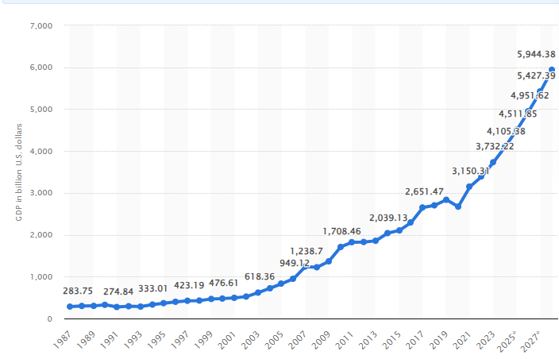
Figure 6: GDP of the Indian Economy
(Source: O’Neill, 2024)
The above-mentioned figure showed that the GDP of the Indian economy that indicated an increasing trend as it was $ 476.61 billion in 2000 that reached to $ 1708.46 billion in 2010 and $ 2671.6 billion in 2020. In 2023, the GDP of the Indian Economy was $ 3732.22 billion and is expected to reach to $ 5944.38 billion by the end of 2028 (O’Neill, 2024). Growth in the GDP of India was observed that amounts to 7.6% in actual that was forecasted to be 7.3%. The key reason for the higher growth in the GDP of India in 2023 was the shifting of focus of the Indian government towards conducting higher capital expenditure for the growth and development of the economy. It has been presented that the Indian economy got the benefit of proper exploitation of global trade, as well as investment opportunities that mainly developed due to the MNCs that focused on diversification along with not considering China for conducting business operations. The interim budget in respect of conducting capital expenditure increased by 11.1% and is expected to reach to $ 133.9 billion at the end of 2025 (Sanyal, 2024). It has been also presented that the growth rate for real GDP was 7% in the fiscal year 2022-23 that increased to 8% in 2023-24. Further, increasing GDP growth was also indicated through improvement in asset quality along with the availability of a sufficient level of loan-loss reserves (The Hindu, 2024).
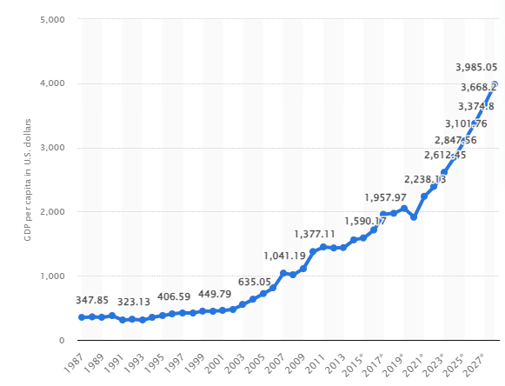
Figure 7: Per capita income in different years in the Indian Economy
(Source: O’Neill, 2024)
The GDP of the Indian economy is mainly affected due to the three key sectors namely the agriculture sector, industrial sector and service sector that make significant contribution towards generating revenue for the economy and also boost its growth level. In 2023, it has been presented that around 60% of the total GDP is contributed through the service sector that mainly incorporates transportation, communication, business service, real estate service, insurance and financing services. It has been also presented that around 12% of the GDP is generated from forestry, fishing and agriculture sector while 15% is generated through the manufacturing sector (UA, 2024). Further, per capita income is also a key macroeconomic factor that mainly shows the amount of money that is earned by every person on an average in a particular economy. In regards to India, the per capita income was reduced in 2020 to $1913.22 from $ 2050.16 in 2019. However, it showed an increasing trend as it was 2391.87 and 2612.45 in 2022 and 2023 showing growth and is also expected to rise to $ 3985.05 by the end of 2028 as shown in the above-mentioned figure (O'Neill, 2024).
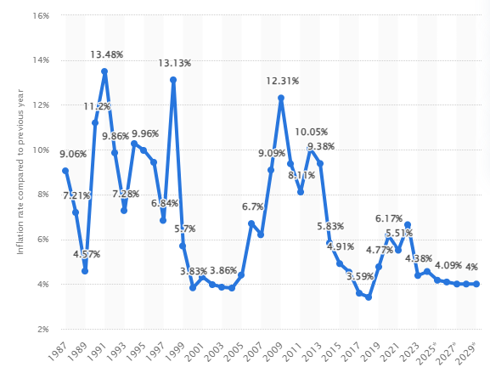
Figure 8: Inflation Rate in India
(Source: O’Neill, 2024)
The inflation rate is an important macroeconomic measure that mainly shows a rise in the level of price in an economy over a particular time period. It is considered a broad measure that indicates the overall rise in the cost of living or a rise in price in a particular nation in a given period of time. It directly affects the prices of products at which it is offered in the market along with affecting the purchasing power of individuals and flow of money in the economy (Oner, 2024). In respect of the inflation rate of India, it shows a fluctuating trend in the inflation rate of the country as it was 10.05% in 2012 that reached to 3.41% in 2018. However, it increased in 2020 to 6.17% and reduced in 2023 to 4.38% as shown in the above-mentioned figure (O'Neill, 2024). It has been analysed that the inflation rate of the Indian economy has decreased from 2010 along with the rise in GDP as a result of the fall in the national debt of the country. The key reason for the fall in the inflation rate of India during the fiscal year 2018-19 was due to a lower level of food inflation that was between the range of -2.6% and 3.1%. A fall in food inflation to 1.8% from 4.2% in 2016-17 resulted in a decrease in overall inflation due to deflation in fruits, vegetables, eggs and pulses by 13.1%. The Indian government is highly focused on reducing inflation through a short supply that helps in minimising the issue of black marketing and hoarding (India Budget, 2020).
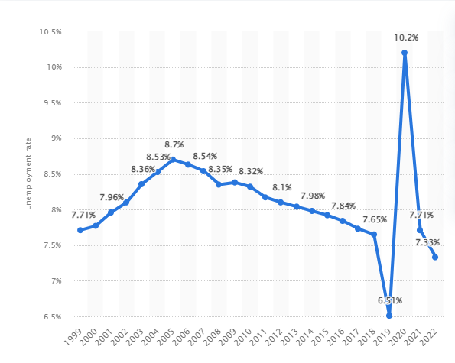
Figure 9: Unemployment Rate in India over different years
(Source: O’Neill, 2024)

The Central Bank of India "Reserve Bank of India" focused on maintaining the inflation rate/ Consumer Price Index (CPI) upto 4%. It has been presented that deflation in some agricultural products and the fluctuating wholesale price index to 4.64% in 2018 affected the inflation rate. Further, changes in fuel prices also affect the overall inflation rate of the nation as it leads to a rise in food prices (Economic Times, 2018). On the other hand, the unemployment rate is one of the key macroeconomic measures that indicate the number of individuals in an economy without jobs or employment. It is a key indicator that shows a fall or rise in the economic growth of the country instead of anticipating them. In regards to the Indian economy, the unemployment rate in 2018 was 7.65% that dropped to 6.51% in 2019; however, it increased to 10.2% in 2020 due to the advent of the Covid-19 pandemic. A huge volume of layoffs and shutting down of businesses resulted in an increase in unemployment during the COVID-19 pandemic period. Contrary, the unemployment rate reduced to 7.71% and 7.33% in 2021 and 2022 due to the recovery of the Indian economy from the pandemic as shown in the above-mentioned figure (O'Neill, 2024).
It has been analysed that the unemployment rate in India remained low in the pre-pandemic period and post-pandemic period due to structural changes and transformations in the labour market of the country. It has been presented labour population has shifted their mindset towards self-employment that helps in minimising the risk of being layoff by companies during uncertain shocks in the economy. It has been also evaluated that the Indian working class is focusing on shifting towards a dynamic, as well as a self-sustaining model for conducting business instead of using a traditional employment approach. It has been also indicated that LFPR (Female Labour Force Participation Rate) increased to 27.8% in 2023 from 17.5% in 2018 especially between the age group of 15 years to 29 years. Additionally, the unemployment rate especially among the literate population decreased in India due to a higher focus on self-employment and entrepreneurial aspect (Bazaz, 2023).

4.2.2 Understanding the relationship between the foreign exchange and macroeconomic aspects in the Indian economy
Exchange rate fluctuation in India has a direct impact on foreign direct investment, import value and export value. Change in the exchange rate In India results in the rise or fall in the value of investment that is mainly converted into home currency. It also affects the competitiveness, as well as profitability of Indian companies that are engaged in international trade; thus, impacting dividends and stock prices. RBI supervises the foreign exchange rate and is also influenced by different macroeconomic factors such as inflation rate, global market sentiments, interest rates and trade balances. It has been presented that fluctuation in foreign exchange rate results in change in the prices of goods and services. In case of depreciation of currency due to foreign exchange fluctuation, the prices of products from foreign countries become expensive and local people prefer to purchase domestic goods over foreign goods. Thus, it leads to a rise in demand for domestic products thus, showing the expansionary impact on income, output and employment investment (Anirvinna, 2024).
It has been presented that a flexible exchange rate system is used in the Indian Economy and the government makes policies for devaluation that lead to a lowering of the value of the currency of the home country as compared to other foreign countries. It has been presented that the Indian Government had a deficit balance of trade of a huge amount in 1951 that led to a rise in the inflation rate in the Indian economy. It has been presented that the exchange rate in India was highly volatile due to higher exposure to external or macroeconomic aspects. For instance, a sharp fall in the price of crude oil amounting to $ 72.48 per barrel in the month of November 2018 resulted in a change in exchange rate. Further, the occurrence of uncertain events such as demonetisation, hike in oil prices and bank rates have a direct impact on exchange rates and the economic performance of the Indian Economy (Shaik and Gona, 2020).
It has been presented that the GDP of a nation has a robust relationship with exchange rate of the nation that is considered as a key indicator showing its economic development. Indian economy has an increasing trend in terms of GDP that is a key macroeconomic factors that indicate a larger volume of production along with higher demand for the product manufactured in the country. Further, an increase in exports resulted in a rise in the supply of foreign currency in the nation indicating an increase in the value of domestic currency results in a rise in exports and foreign exchange flow in the country. It contributes towards reducing the deficit in balance of trade and showing a positive relationship between the two variables (Bazaz, 2023).
Contrarily, it has been presented that the unemployment rate in India has a negative relationship with the exchange rate. It showed that change in value of the domestic currency in India affect the unemployment rate as appreciation in currency value leads to making imports cheaper, as well as exports less competitive leading to a decrease in domestic demand. It has a significant impact on demand in labour market as it affects demand for the workforce (Guha, et al., 2020). Therefore, it results in a decrease in cost by domestic companies through the layoff of employees leading towards a rise in unemployment. Moreover, it has been indicated that foreign exchange reserve In India observed a significant fall to $ 583.5 billion indicating a fall of $ 2.36 billion. It showed that the decrease in the value of Indian Rupee against the dollar in 2020 resulted in a fall in the value of foreign currency assets to $ 515.2 billion indicating a fall of $ 4.14 billion during the period (Economic Times, 2023).
The inflation rate in India has a significant and inverse relationship with the exchange rate prevailing in the nation as it affects international trade, imports and exports in a particular period of time. It has been presented that a rise in inflation leads to a decrease in the currency value and suppresses investment; therefore, have a negative effect on exchange rate. On the other hand, an economy that has a lower exchange rate leads to an increase in the value of the currency and also improves the exchange rate. It has been also indicated that fluctuation in the stock market (BSE and NSE) is observed due to foreign exchange fluctuation as a result of an increase in the inflation rate (Economic Times, 2023).

4.2.3 Key trend and reason for fluctuation in the exchange rate in the Indian economy
In India, fluctuation in the exchange rate is observed due to changes in the volume of demand and supply for products and services. It has been presented that an increase in inflation in India economy is a key reason resulting in fluctuation in currency value. Recently the Indian rupee showed a downfall where it reached to 83 per US $ that cannot be considered to be abnormal. It has been presented that a fall in the Indian Rupee value resulted in making the imports expensive for the country. It has been indicated that the Indian economy is highly dependent on foreign countries for the import of oil, fertilisers and electronics to meet their demand and a rise in inflationary pressure directly affects the exchange rate of the country. It has been presented that the exchange rate movement resulted in a change in the value of the Indian Rupee amounting to 82.6 per dollar in 2022 that was depreciated in 2023 to 83.10 per dollar. It showed that exchange rate fluctuation was observed due to higher exposure in emerging markets as a result of higher level of interest rate indicating higher volatility (Economic Times, 2023).
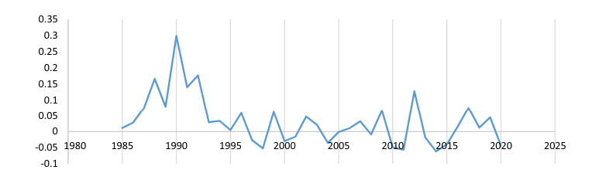
Figure 10: Volatility in Indian Exchange Rate
(Source: Iqbal, et al., 2023)
It has been presented that higher volatility was observed in foreign exchange that have a significant impact on exports and imports. It has been analysed that India became a significant trading partner with the US especially during the recovery period from the Covid-19 pandemic in 2021-22. It showed that around goods amounting to $157 billion of products and services were bilaterally exchanged between India and the US in 2021. The above-mentioned figure showed exchange rate volatility in respect of the Indian Rupee that was higher in the 1900s and also in the 2010s. It showed that the exchange rate increased in 2012 and 2013 where the value of the Indian Rupee increased; however, it reduced in 2020 due to the pandemic that had a significant impact on imports and exports (Iqbal, et al., 2023). On the other hand, it has been indicated that changes in the exchange rate have a direct effect on the competitiveness, as well as the profitability of a company as a rise in the inflation rate have a negative impact on dividends and stock prices of Indian companies operating in overseas markets. Exchange rate volatility also affects the FDI (Foreign direct investment) along with exposure towards the overseas market. It has been presented that a higher level of exchange fluctuation observed due to the movement of macroeconomic aspects in an uncertain manner results in increasing volatility that leads to reduce the estimated investment value and also leads to a decrease in the FDI accordingly. Fluctuations in foreign exchange result in the depreciation of the value of Indian currency that negatively influence the Indian economy depicted through a fall in GDP and an increase in the unemployment level in the country (Guha, et al., 2020).

4.2.4. Key challenges and possible solutions used by Indian companies to reduce the impact of macroeconomic trend on foreign exchange
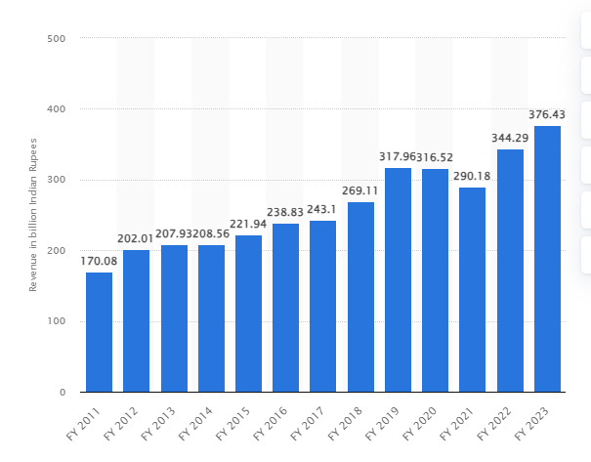
Figure 11: Revenue of Bajaj Auto in different years
(Source: Sun, 2023)
It has been analysed that Indian companies involved in conducting international trade face the issue of foreign exchange fluctuation that significantly affects its profits and financial performance. It has been presented that the rise in inflation creates challenges for Indian companies in conducting imports and exports in an effective and efficient manner. For instance, the revenue of Bajaj Auto which is one of the well-known Indian MNCs observed a downfall in revenue due to fluctuation in foreign exchange during the period of the Covid-19 pandemic. It resulted in a fall in revenue of the company to 290.19 billion Indian Rupees in 2021 from 316.52 billion in 2020 as shown in the above-mentioned figure (Sun, 2023). The company has a total foreign exchange cash flow of 113.868 million Indian Rupee in 2023 that was 90.208 million Indian Rupee in 2022. The company focused on minimizing the risk by entering into hedging transactions that help in mitigate the risk associated with foreign exchange (Bajaj Auto Annual Report, 2023).
It has been also presented that companies involved in import and export face problems due to changes in government regulations for foreign companies that affect the supply chain and also negatively affect the operating expenses. It has been presented that the Indian Government provide relaxation for domestic companies to introduce their products in the international market that can help in bringing foreign exchange in the country and reduce the foreign trade deficit. However, it was observed that domestic companies face challenges in survival in highly competitive market in overseas nations. Therefore, the Indian government provide financial support along with making policies that are in the interest of Indian companies that help in expansion and growth in foreign markets (Iqbal, et al., 2023).

4.3 Descriptive Statistics
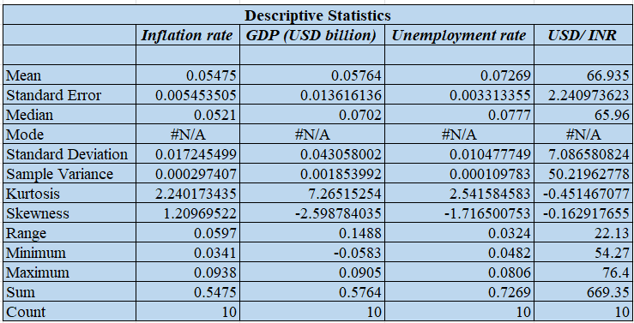
Figure 12: Descriptive Statistics
Based on the above figure, it has been analysed that the independent variables like inflation rate, GDP, and unemployment rate of India have a positive kurtosis of 2.24, 7.26, and 2.54 indicating heavier tails, as well as an effective and more peaked distribution. Whereas, the dependent variable (USD/ INR exchange rate) has a negative kurtosis of -0.45 indicating lighter tails, as well as a flatter distribution. Furthermore, the mean value (0.054) of the inflation rate is higher than the median value (0.0521) resulting in a positive skewness of 1.209. However, the mean value of others is lower than the median value resulting in the negative skewness of -2.598 (GDP), -1.716 (unemployment rate), and -0.162 (USD/ INR exchange rate) respectively. Moreover, it has been seen that in the past 10 years, the inflation rate ranges from 3.4% to 9.3%, the unemployment rate from 4.82% to 8.06%, and the USD/ INR exchange rate from 54.27 to 76.4 respectively. However, the GDP ranges from -5.83% to 9.05%; the negative value shows the pandemic period which resulted in a declined GDP.

4.4 Correlation and Regression Analysis
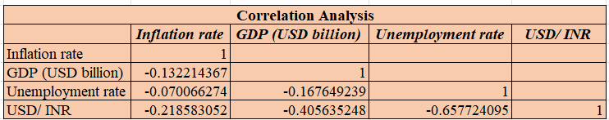
Figure 13: Correlation Analysis
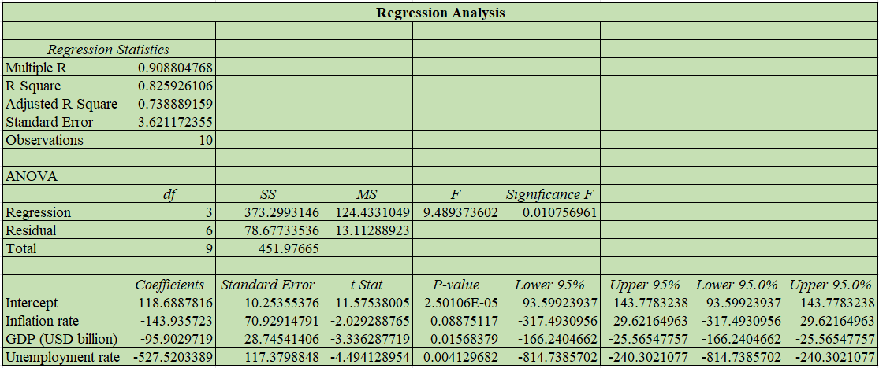
Figure 14: Regression Analysis
Correlation for the dependent and independent variables is represented through the r value. the r value for the inflation rate, unemployment rate, and GDP with USD/ INR exchange rate is negative of -0.218, -0.657, and -0.405 respectively. This means that there is an inverse relationship between the exchange rate, and the macroeconomic variables. A high inflation rate results in making the currency weaker, and suppresses investment leading to an adverse effect on the exchange rate, and vice versa concerning the past 10 years' data for India. Moreover, higher unemployment rates result in signalling economic distress, as well as minimise consumer spending leading to a weaker currency, and hence have a 65.7% impact on each other. Furthermore, the GDP and exchange rate have a positive impact but due to the COVID-19 pandemic, the GDP become negative at -5.83%, and hence it creates a negatively correlated representing a 40.5% R-value.
Moreover, in consideration with the regression analysis, it has been seen that the r-squared value for analysing the impact of the macroeconomic variables on the exchange rate of India and the USA is 0.825. This means that a change of 1% in the macroeconomic variables leads to a change of 82.5% in the foreign exchange rate (USD/ INR). The same has been analysed with regard to the significant value of 0.010 which is lower than 0.05, and the p-value intercept is also negative leading to generating effective results. This means that an increase in the unemployment rate, and inflation rate results in diminishing the currency value; whereas, an increase in GDP leads to enhancing the currency value, but they have a major impact on the foreign exchange rate. Thus, the regression analysis shows a positive, and effective impact of the independent variable on the dependent variable.

4.5 Discussion
Drehmann and Sushko, (2022), provided a brief understanding of the topic of foreign exchange and iterated it as a broader concept and that influences the currency prices by taking into consideration the law of demand and supply. It has been observed that distinct nations across the globe are deriving the foreign exchange and the value of currency based on the trends in the fluctuation rates. The reasons for the fluctuations in the foreign exchange rates are a result of multiple factors either at the micro or macro level. Cespa, et al., (2022), concluded that the macroeconomic factors like FDP, inflation, national income, per capita income, and the unemployment rate are some potential reasons that influence the fluctuation rates. The macroeconomic factors are those influential factors that directly impact the functioning of an economy. The minor changes in these factors influence the economic condition of the whole country including international trade.
Through the previously done analysis of the relationship between the Indian currency and the US currency from the above findings, it has been identified that the Indian rupee has been depreciating in front of the US dollar. This trend of the Indian currency depicts the inefficiency of the government in aligning with the need to become a developed country and taking advantage of international trade by strengthening the currency value. The exchange rate in the year-end 2022 was INR 82.14 per USD as compared to 2021 at INR 75.86 USD, which was INR 59.95 per USD a decade earlier, as represented in the above graph (Focus Economics, 2024). The constant rise in the inflation in the current scenario of business and the global political world might be an influential reason for the weak currency value of the nation. The lower value of the currency leads to the low power of initiating negotiations in international trade, undoubtedly this all influences the trade deficits, geopolitical uncertainty, as well as the Federal Reserve monetary tightening policy of the nation.
From the findings it is discussed that the macroeconomic factors are the most influential factors that derive significant influence on the economy and foreign exchange. The dynamic nature of these macroeconomic factors such as national income, GDP, and inflation are the reasons for derived fluctuations in the foreign exchange. Inflation has been studied as an influential factor in an economy that considers fluctuations in the prices of basic consumer products and services. Behera and Patra, (2022), researched that the consumer price index impact due to inflation in India was increased from 5.13% in 2021 to 6.7% in 2022 deriving an annual change of 1.57%. As per the views of Musarat, et al., (2021), it has been observed that any fluctuations in the inflation rates are the reasons behind the fluctuating foreign exchanges. This impacts the foreign reserves collected by the country's rulers through international trade and effective geopolitical relations. However, Ridwan, (2022), stated that countries can reduce the impact of changes in the inflation rates on foreign exchanges by covering the impact in advance by adopting risk mitigation tactics and strategies.
From the correlation and regression it is depicted that inflation directly affects the prices of products at which it is offered in the market along with affecting the purchasing power of individuals and the flow of money in the nation. It has been seen and analysed with the Indian economy as well because increasing inflation globally and domestically developed such market circumstances that the nation’s consumers face massive hikes in the basic consumer goods, especially food and dairy products. O'Neill, (2024), provided a fluctuating trend in the inflation rate of India as it increased in 2020 to 6.17% and reduced in 2023 to 4.38%.
The findings provided light on the usage of regression statistical tools suggesting that inflation has an inverse relation with the growth of the economy as an increasing trend of inflation results in the declining growth of the economy and a declining trend in the inflation fosters the growth of the nation. The usage of statistical tools like correlation and regression helped in determining the trend more specifically. Undoubtedly, it has been seen that these statistical tools are crucial in order to derive the relationship between macroeconomic factors and the relationship of these macroeconomic factors with the foreign exchange rates. Through the implication of the correlation statistical tool in the data analysis chapter of this particular study, it has been identified that there is an inverse relationship between the exchange rate and the macroeconomic variables.
Williams, (2021), suggested that the growth rate and economic development rate of the countries also depicts an impact on the foreign exchange rates. A strong GDP depicts the strong position of the currency value of the country which is required to enhance geopolitical relations and derive maximum returns for the international trading practices. In the context of India, the country is approaching towards growth and development with a stable GDP growth rate. It has been analysed that India has seen potential growth in its foreign exchange reserves, derived from the positive movements in the foreign exchange rates for the country. The findings stated that the usage of a correlation statistical tool for the purpose of relating GDP growth and the per capita income of the nation. As previously discussed, correlation and regression are significantly used by the statistical officers to find out the reasons for fluctuations in the foreign exchange by taking into consideration some essential and relevant macroeconomic factors.
Through the analysis of the GDP trend of the economy of India, it has been identified that the Indian economy indicated an increasing trend as it was $ 476.61 billion in 2000 reached to $ 1708.46 billion in 2010, and $ 2671.6 billion in 2020. The growth of the GDP of India showed a positive fluctuation of 1% from 7% in the fiscal year 2022-23 that increased to 8% in 2023-24 (O’Neill, 2024). The growing GDP of the economy of India will help the economy strengthen the currency value and derive such foreign exchange that will benefit the economy in monetary terms and help it generate excessive foreign reserves, required to further enhance geopolitical relations and attract foreign direct investments. This increased and positive GDP will help the country foster the involvement of domestic brands and industry to enter international trade that will result in the attraction of excessive foreign currency, increasing foreign exchange reserves, and controllable investment opportunities.
Charumathi and Ramesh, (2020), highlighted some challenges of the fluctuations in the foreign exchange rate and suggested that the fluctuations in the foreign exchange rate affect the business strategies and future plans developed by the executives and top management of the Indian companies. Undoubtedly, the corporations that are operating in the international market and belonging to the India-based industries are facing challenges of altering the policies and regulations multiple times. Aligning with the same Ahmed, et al., (2021), iterated that the fluctuations in the foreign exchange rate disrupted the business growth of the Indian companies because of impacts on the revenue and profitability generation. In the data analysis chapter, the same issues were identified with Bajaj that the company observed a downfall in revenue due to fluctuation in foreign exchange during the period of the COVID-19 pandemic. There was a loss of revenue from INR 316.52 billion in 2020 to INR 290.19 billion.
Hussain, et al., (2021), suggested that macroeconomic factors such as GDP, inflation, per capita income, and employment share an interrelated relationship with each other. The relationship among these factors varies according to their respective individual nature and attributes, generating either a direct or an inverse relationship. Islam, et al., (2020), in a study, identified that unemployment has an inverse relationship with the foreign exchange rate which suggests that high unemployment indicates economic distress, leading to the weak currency of the nation. The application of correlation statistical tools helped in deriving that there is an inverse relationship between the exchange rate, and the macroeconomic variables. Further, it has been analysed in the data analysis section that A high inflation rate results in making the currency weaker, and suppresses investment leading to an adverse effect on the exchange rate.
By implementing the regression analysis it has been identified that a change of 1% in the macroeconomic variables leads to a change of 82.5% in the foreign exchange rate (USD/ INR). It suggests that the unemployment rate and inflation rate both share an inverse relationship with the currency value. an increase in the unemployment rate, and inflation rate results in diminishing the currency value. Iqbal, et al., (2023), provided insight into the volatility of the Indian Exchange Rate, suggesting a direct relationship between the exchange rate and the value of the currency. With the COVID-19 pandemic, the imports and export activities declined leading to a lower exchange rate and lower currency value of India, depicting a direct relationship. The impact of the COVID-19 pandemic was identified through a correlation between the GDP and the exchange rate of India. the GDP and exchange rate shared a positive impact but due to the COVID-19 pandemic, the GDP became negative at -5.83%, representing a 40.5% R-value this represented the negative correlation.

5. Conclusion and Recommendations

5.1 Introduction
This is the last chapter of the study that incorporates the concluded aspects, as well as includes recommendations for enhancing the effectiveness of the macroeconomic variable impact on the foreign exchange rate. Thus, the summarised findings of the study to attain effective and possible results can be analysed. The summary is provided using the literature review section, as well as the data analysis findings. The recommendations are provided to the government of India to improve the fluctuations in the macroeconomic variables, and hence the foreign exchange rate of India to enhance international trade and finances. These aspects can result in attaining the outcomes of the study effectively.

5.2 Conclusion
Based on objective 1, it can be concluded that the foreign exchange rate aligns with the concept of foreign exchange and plays a vital role in fluctuating the foreign exchanges in a company. A foreign exchange rate is a conversion rate through which one currency can be exchanged for another across borders. Fluctuations in the foreign exchange rates are primarily impacting the growth of Indian domestic business. The foreign exchange rate impacts the business operations of the domestic countries of India derived through the impact on import and export activities. The fluctuating trend of the foreign exchange rates due to the influence of distinct factors affects the business by declining the performance of the corporations in international trade. Thus, it can be summarised that fluctuating trends in the foreign exchange rate are a key factor in influencing the foreign exchange reserves and the performance of the domestic industry of India. The strong foreign exchange rate indicates the strong value of the currency which leads to a decline in the exports of the country.
Furthermore, it has been assessed that the Indian Rupee has depreciated from 2013 to 2022 in terms of USD (United States Dollars), and is in association with the trade deficits, geopolitical uncertainty, and the Federal Reserve monetary tightening. On the other hand, based on the data analysis section, it has been analysed that the Indian economy is concerned with a higher growth rate in comparison with China especially after the pandemic because various firms of China have moved to India to enhance the revenue generation. Furthermore, it has been seen that GDP is considered as a most important quantitative measure representing the market value of the finished goods, and services over a particular period. The same has been assessed considering an increased GDP from $476.61 billion in the year 2000 to GDP 2,671.6 billion in the year 2020 respectively.
Based on objective 2, it can be concluded that a macroeconomic factor is a geopolitical, environmental, or economic event that affects the whole economy’s financial well-being. There are distinct macroeconomic factors such as GDP, inflation rate, and unemployment rate that positively or negatively impact the economy and foreign exchange. It has been ascertained that a higher GDP of an economy leads to the currency of the economy becoming stronger and a lower GDP affects the currency value negatively. GDP affects the collection of foreign exchange in the country. The good GDP position in terms of value significantly fosters the foreign currency in the Indian domestic market. On the other hand, based on the data analysis section it has been ascertained that the correlation between the GDP, and the foreign exchange rate between USD and INR is negative of -0.405 depicting an inverse relationship with each other in the past 10 years. This is because there is a decline in the GDP during the period of the pandemic leading to a negative growth rate, and hence negatively influences the GDP. Thus, GDP, in general impacts positively the foreign exchange rate; but due to some uncertain events, it can adversely impact the forex rate.
Furthermore, inflation is another factor impacting the foreign exchange. The high inflation makes a currency weaker and leads to a poor impact on the investors regarding their decisions to further invest in the country’s future. India being a developing country is growing at the highest rate as compared to other nations in the world. Additionally, the unemployment rate also plays an important role in impacting the foreign exchange rate concerning the macroeconomic variable. It has been seen that a declining unemployment rate in a country helps in attaining the growth of a nation. However, a high unemployment rate results in severely affecting the country in terms of a direct impact on the GDP leading to an economic slowdown, increased poverty, lower income levels, and hence a reduction in the foreign exchange reserves. Thus, it can be summarised that the foremost macroeconomic factors that influence the functioning of the economy and foreign exchanges are the GDP, inflation rate, and unemployment rate. It has been identified that high inflation leads to a weakening in the currency value of the economy.
From the objective 3, it can be summarised that the macroeconomic factors share a significant relationship with each other and that relationship either direct or inverse contributes to the fluctuations in the foreign exchange rates. It has been further evaluated that these factors influenced by the dynamic nature of economic conditions all over the world directly impact the outcome derived from the dynamic nature of the country. It has been found that a higher inflation rate in a country or globally makes the currency of that particular country weak and negatively impacts the foreign exchange rate, resulting in low foreign exchange reserves. There is an inverse relationship between the foreign exchange rate and the employment factor of the nation indicating economic distress, leading to the weak currency of the nation. It has been evaluated that the increasing GDP benefits the country in improving the foreign exchange rate and attempting to better the financial position of the nation during geopolitical relationships. The GDP macroeconomic factor seems to be sharing a positive or direct relationship with the currency exchange rate of the country.
From objective 4, it can be concluded that there are various reasons for the fluctuations in the foreign exchange rate that are deriving from the internal and external business and political environment of the particular country. In the context of India, it has been observed that the influence of the changing norms related to foreign direct investment has influenced the foreign exchange rates and so impacted the currency value of India. It has been derived that the stock index has to play a crucial role in order to determine the changes and the extent of the changes in the foreign exchange rate of the country. Both the stock market and foreign exchange market are found to be the most influential markets on the planet, and the most used market in order to invest in savings by the general public. The influence on the economy of India is very high on the stock and foreign exchange market, and the increasing awareness of education in India enhanced the traffic of people engaged in trading activities. India seems to be the leading developing country on the planet as it is attracting investors from across the globe in order to further enhance the GDP and per capita income being aligned with reducing the reducing the unemployment of the country.
From objective 5, it can be summarised that with the fluctuations in the foreign exchange rates corporations around the world especially those that are engaged in foreign trade have to change their set goals and adopted strategies. the companies of India facing disruptions in the cost and profit generation due to the change in the foreign exchange rate that ultimately affects the currency value of the nation. The decision by the Indian government regarding the foreign trade restricted the growth of the domestic industries. The fluctuations in the foreign exchange rate have resulted in the declining growth of the revenue and profitability generation of the nation. Indian companies are facing issues in providing desired compensation, remuneration, salaries, and bonuses due to the lower availability of funds that caused by unfavuourable changes in the foreign exchange rate. The companies are hindering themselves from growth and development opportunities for the expansion of business operations in the foreign market. There is a decline in the functioning of the manufacturing units of the Indian corporations due to the lower availability of funds deriving through negative implications of the currency. Indian corporations are further facing issues in adopting the technological changes because of the unwanted foreign exchange fluctuations, moreover, they hinder themselves from making competitive advantage.

5.3 Recommendations to the Government of India
Fanelli and Straub, (2021), in a study suggested that the governements should strengthen the foreign exchange policies in order to derive maximum benefit of the international trade. The government of India is recommended to make amendments in the foreign exchange policies developed by the government officials. Those amendments will benefit the country in aliginnig the adopted morms and policies regarding the foreign exchange reserves and international trade with the current trend of the macroeconomic factors. Regular amendments in the norms, policies, and strategies help the nation in deriving effective means of insights regarding the trade (Choi and Limnios, 2022). Undoubtedly, the government of India should analyse the policies and strategies adopted by the developed countries like USA and China in order to derive insights regarding the face off with fluctuating foreign exchange rates.
The government of India is suggested to foster the analysis of distinct macroeconomic factors like inflation rate, employment rate, literacy rate, GDP, per capita income, and national income that will help derive future decisions regarding strategisiing the gowth. According to Oblath, (2019), keeping the track of the trend for distinct macroeconomic factors help derive essential insights and helpful in deriving the current relationship between a particular macroeconomic factor and foreign exchange. As it has been earlier found that the fluctuations in the foreign exchange is hindering the growth of the companies in India, leading to an interruption in further expansion. Easing the foreign trade policies and trading norms stands as a crucial step in order to foster the development of effective strategies and helping the domestic businesses go international (Bose, et al., 2020). Governement of inda should concentrates on fostering the implementation of effective foreign trade policies that will support the domestic corporations go international and generate excessive revenue and profitability.
Smith Stegen, (2018), in a study specified that fostering the geopolitical relationships with the government of distinct countries is crucial in order to strengthen the currency value of the nation. It is recommended to the government of India that it should establish a healthy relationship with the distinct countries that will help address the risks of fluctuating macroeconomic trends. The government can align the unemployment challenge faced by the nation through partnering with distinct countries and enabling healthy foreign direct investment. Allowiing the foreign companies to commence their businesses and company branches in the country will generate the employment opportunities. Significance of the same will be delivered through enhanced per capita income and strengthen currency value of the nation.

5.4 Recommendations for Future Research
For the future recommendations to conduct the study, the qualitative research method can be used in place of quantitative research mehod. The qualitative research method is fruitful in order to consider the real-time beliefs and expeiences of the people regarding the concerned topic of the research (Busetto, et al., 2020). The usage of the qualitative research method may stand more fruitful and may meet the expectations of the research question and aim more effectively, making the research more authentic. Moreover, the primary data collection method can be used in place of secondary data collection. The primary data collection method is a means of fresh data collection method that is collected for the sole purpose of meeting the research requirements (Mazhar, et al., 2021). Undoubtedly, the primary data collection will be more time consuming but it will deliver the effective and accurate insights refarding the research topic.

References
Adam, A. (2023) India's economy: development, growth and prospects. [Online]. Available at: https://www.leverist.de/en/insights/indias-economy-development-growth-and-prospects#:~:text=Although%20India%20is%20considered%20an,per%20cent%20in%20recent%20years. [Accessed on: 16.05.2024].
Ahmed, R., Aizenman, J. and Jinjarak, Y. (2021) Inflation and exchange rate targeting challenges under fiscal dominance. Journal of Macroeconomics, 67, p.103281.
Anirvinna, C. (2024) EXCHANGE RATE & ITS ECONOMIC EFFECTS. [Online]. Available at: https://live.icai.org/bos/vcc/pdf/20052022_Dr__Chivukula_Annirvinna_Chapter_4_Unit_IV_Exchange_Rate___its_Economic_Effect_1653049513.pdf [Accessed on: 16.05.2024].
Bajaj Auto Annual Report. (2023) Annual Report. [Online]. Available at: https://investors.bajajauto.com/wp-content/uploads/2023/06/BAL_AR_2023_for-Web_IndiDesign.pdf [Accessed on: 16.05.2024].
Baron, A. and McNeal, K. (2019) Case Study Methodology in Higher Education. IGI Global.
Bazaz, S. (2023) India’s unemployment rate hits a record low but remains steep among educated youth. [Online]. Available at: https://www.cnbctv18.com/education/india-unemployment-rate-hits-record-low-but-remains-steep-among-educated-youth-18322091.htm [Accessed on: 16.05.2024].
Behera, H.K. and Patra, M.D. (2022) Measuring trend inflation in India. Journal of Asian Economics, 80, p.101474.
Bergin, T. (2018) An Introduction to Data Analysis: Quantitative, Qualitative and Mixed Methods. SAGE Publications.
Bernoth, K. and Herwartz, H. (2021) Exchange rates, foreign currency exposure and sovereign risk. Journal of International Money and Finance, 117, p.102454.
Bhat, S.A. and Bhat, J.A. (2021) Impact of exchange rate changes on the trade balance of India: An asymmetric nonlinear cointegration approach. Foreign Trade Review, 56(1), pp.71-88.
Bose, U., Mallick, S. and Tsoukas, S. (2020) Does easing access to foreign financing matter for firm performance?. Journal of Corporate Finance, 64, p.101639.
Brinkmann, S. (2018) Philosophies of Qualitative Research. Oxford University Press.
Buntis, K., Bond, M., Kerres, M., Zawacki-Richter, O. and Bedenlier, S. (2019) Systematic Reviews in Educational Research: Methodology, Perspectives and Application. Springer Fachmedien Wiesbaden.
Busetto, L., Wick, W. and Gumbinger, C. (2020) How to use and assess qualitative research methods. Neurological Research and practice, 2(1), p.14.
Camanho, N., Hau, H. and Rey, H. (2022) Global portfolio rebalancing and exchange rates. The Review of Financial Studies, 35(11), pp.5228-5274.
Carstens, A. (2022) The return of inflation. speech at the International Center for Monetary and Banking Studies, Geneva, 5.
Cespa, G., Gargano, A., Riddiough, S.J. and Sarno, L. (2022) Foreign exchange volume. The Review of Financial Studies, 35(5), pp.2386-2427.
CFI. (2024) Macroeconomic Factor. [Online]. Available at: https://corporatefinanceinstitute.com/resources/economics/macroeconomic-factor/#:~:text=A%20macroeconomic%20factor%20is%20a%20phenomenon%2C%20pattern%2C%20or%20condition%20that,are%20examples%20of%20macroeconomic%20factors. [Accessed on: 16.05.2024].
Chakraborty, T., Chakraborty, A.K., Biswas, M., Banerjee, S. and Bhattacharya, S. (2021) Unemployment rate forecasting: A hybrid approach. Computational Economics, 57(1), pp.183-201.
Charumathi, B. and Ramesh, L. (2020) Impact of voluntary disclosure on valuation of firms: Evidence from Indian companies. Vision, 24(2), pp.194-203.
Choi, J.H. and Limnios, C. (2022) Choice of foreign exchange intervention and inflation targeting commitment. Finance Research Letters, 46, p.102402.
Dahliah, D. and Nur, A.N. (2021) The influence of unemployment, human development index and gross domestic product on poverty level. Golden Ratio of Social Science and Education, 1(2), pp.95-108.
Department of Commerce. (2024) International Trade. [Online]. Available at: https://commerce.gov.in/international-trade/trade-agreements/ [Accessed on: 10.04.2024].
Drehmann, M. and Sushko, V. (2022) The global foreign exchange market in a higher-volatility environment. BIS Quarterly Review, 12, pp.33-48.
Economic Times. (2018) Inflation in 2018: Data shows price rise within comfort zone, but farmers hit. [Online]. Available at: https://economictimes.indiatimes.com/news/economy/indicators/inflation-in-2018-data-shows-price-rise-within-comfort-zone-but-farmers-hit/articleshow/67308342.cms?from=mdr [Accessed on: 16.05.2024].
Economic Times. (2023) India's forex reserves fall $2.36 bn to $583.5 bn. [Online]. Available at: https://economictimes.indiatimes.com/news/economy/indicators/indias-forex-reserves-fall-2-36-bn-to-583-5-bn/articleshow/104756589.cms?from=mdr [Accessed on: 16.05.2024].
Economic Times. (2023) Rupee below 83 not abnormal; currency fluctuation not exclusive to India: Finance Ministry official. [Online]. Available at: https://economictimes.indiatimes.com/news/economy/policy/rupee-below-83-not-abnormal-currency-fluctuation-not-exclusive-to-india-finance-ministry-official/articleshow/102838006.cms?from=mdr [Accessed on: 16.05.2024].
Edson, M.C., Henning, P.B. and Sankaran, S. (2016) A Guide to Systems Research: Philosophy, Processes and Practice. Springer Nature Singapore.
Egilsson, J.H. (2020) How raising interest rates can cause inflation and currency depreciation. Journal of Applied Economics, 23(1), pp.450-468.
Fanelli, S. and Straub, L. (2021) A theory of foreign exchange interventions. The Review of Economic Studies, 88(6), pp.2857-2885.
Fanelli, S. and Straub, L. (2021) A theory of foreign exchange interventions. The Review of Economic Studies, 88(6), pp.2857-2885.
Feng, Y., Lagakos, D. and Rauch, J.E. (2024) Unemployment and development. The Economic Journal, 134(658), pp.614-647.
Fexco. (2023) 10 factors that influence exchange rates. [Online]. Available at: https://internationalpayments.fexco.com/news-insights/factors-that-influence-exchange-rates/ [Accessed on: 10.04.2024].
Focus Economics. (2024) India Exchange Rate. [Online]. Available at: https://www.focus-economics.com/country-indicator/india/exchange-rate/#:~:text=Exchange%20Rate%20in%20India&text=The%20exchange%20rate%20ended%202022,of%20INR%2059.95%20per%20USD. [Accessed on: 16.05.2024].
Forbes. (2024) Inflation Rate in India 2024: A closer look at economic trends. [Online]. Available at: https://www.forbesindia.com/article/explainers/inflation-rate-india/85983/1#:~:text=India's%20current%20inflation%20rate&text=The%20inflation%20rate%20in%20the,at%204.34%20percent%20in%20December. [Accessed on: 10.04.2024].
Garg, K. and Kalra, R. (2018) Impact of macroeconomic factors on Indian stock market. Parikalpana: KIIT Journal of Management, 14(1), pp.134-145.
Gu, D., Andreev, K. and Dupre, M.E. (2021) Major trends in population growth around the world. China CDC weekly, 3(28), p.604.
Guha, P., Islam, B. and Hussain, M.A. (2020) COVID‐19 lockdown and penalty of joblessness on income and remittances: A study of inter‐state migrant labourers from Assam, India. Journal of Public Affairs, 21(4), pp.e2470.
Guzman, M., Ocampo, J.A. and Stiglitz, J.E. (2018) Real exchange rate policies for economic development. World development, 110, pp.51-62.
Hussain, S., Nguyen, V.C., Nguyen, Q.M., Nguyen, H.T. and Nguyen, T.T. (2021) Macroeconomic factors, working capital management, and firm performance—A static and dynamic panel analysis. Humanities and Social Sciences Communications, 8(1), pp.1-14.
Ibrahim, J. and Basah, M.Y.A. (2022) A study on relationship between crypto currency, commodity and foreign exchange rate. The Journal of Muamalat and Islamic Finance Research, pp.1-12.
India Budget. (2020) Prices and Inflation. [Online]. Available at: https://www.indiabudget.gov.in/budget2019-20/economicsurvey/doc/vol2chapter/echap04_vol2.pdf [Accessed on: 16.05.2024].
India Today. (2024) The Latest GDP numbers mystifying, they don't add up. [Online]. Available at: https://www.indiatoday.in/business/story/india-today-conclave-2024-arvind-subramanian-economy-gdp-growth-shamika-ravi-2515120-2024-03-15 [Accessed on: 10.04.2024]
Iqbal, J., Nosheen, M. and Wohar, M. (2023) Exchange rate volatility and India–US commodity trade: evidence of the third country effect. Indian Economic Review, 58, ppS359-S398.
Islam, M.S., Hossain, E., Rahman, A., Hossain, M.S. and Andersson, K. (2020) A review on recent advancements in forex currency prediction. Algorithms, 13(8), p.186.
Jyoti (2021) Impact of Exchange Rate Fluctuations on India’s Manufacturing Exports: An Empirical Investigation on Long-Run Relation. Journal of Asian Economic Integration, 3(1), pp.61-73.
Kharbanda, V. and Singh, A. (2018) Futures market efficiency and effectiveness of hedge in Indian currency market. International Journal of Emerging Markets, 13(6), pp.2001-2027.
Kumar, R. (2018) Research Methodology: A Step-by-Step Guide for Beginners. SAGE Publications.
Kumari, R., Shabbir, M.S., Saleem, S., Yahya Khan, G., Abbasi, B.A. and Lopez, L.B. (2023) An empirical analysis among foreign direct investment, trade openness and economic growth: evidence from the Indian economy. South Asian Journal of Business Studies, 12(1), pp.127-149.
Liu, T.Y. and Lee, C.C. (2021) Global convergence of inflation rates. The North American Journal of Economics and Finance, 58, p.101501.
Mazhar, S.A., Anjum, R., Anwar, A.I. and Khan, A.A. (2021) Methods of data collection: A fundamental tool of research. Journal of Integrated Community Health (ISSN 2319-9113), 10(1), pp.6-10.
Meda, N., Miola, A., Slongo, I., Zordan, M.A. and Sambataro, F. (2022) The impact of macroeconomic factors on suicide in 175 countries over 27 years. Suicide and Life‐Threatening Behavior, 52(1), pp.49-58.
Morina, F., Hysa, E., Ergün, U., Panait, M. and Voica, M.C. (2020) The effect of exchange rate volatility on economic growth: Case of the CEE countries. Journal of Risk and Financial Management, 13(8), p.177.
Musarat, M.A., Alaloul, W.S. and Liew, M.S. (2021) Impact of inflation rate on construction projects budget: A review. Ain Shams Engineering Journal, 12(1), pp.407-414.
O’Neill, A. (2023) India: Gross domestic product (GDP) in current prices from 1987 to 2028. [Online]. Available at: https://www.statista.com/statistics/263771/gross-domestic-product-gdp-in-india/ [Accessed on: 10.04.2024].
O’Neill, A. (2024) Gross domestic product (GDP) in India 2028. [Online]. Available at: https://www.statista.com/statistics/263771/gross-domestic-product-gdp-in-india/ [Accessed on: 16.05.2024].
O’Neill, A. (2024) Gross domestic product (GDP) per capita in India 2028. [Online]. Available at: https://www.statista.com/statistics/263776/gross-domestic-product-gdp-per-capita-in-india/#:~:text=The%20statistic%20shows%20the%20gross,on%20India's%20economic%20growth%20here. [Accessed on: 16.05.2024].
O’Neill, A. (2024) Inflation rate in India 2029. [Online]. Available at: https://www.statista.com/statistics/271322/inflation-rate-in-india/ [Accessed on: 16.05.2024].
O’Neill, A. (2024) Unemployment rate in India 2022. [Online]. Available at: https://www.statista.com/statistics/271330/unemployment-rate-in-india/ [Accessed on: 16.05.2024].
Oblath, G. (2019) Trade policy recommendations. In Foreign Economic Liberalization (pp. 207-218). Routledge.
Oner, C. (2024) Inflation: Prices on the Rise. [Online]. Available at: https://www.imf.org/en/Publications/fandd/issues/Series/Back-to-Basics/Inflation [Accessed on: 16.05.2024].
Padder, A.H. and Mathavan, B. (2021) The relationship between unemployment and economic growth in India: Granger causality approach. NVEO-Natural Volatiles & Essential Oils Journal| NVEO, pp.1265-1271.
Pajo, B. (2017) Introduction to Research Methods: A Hands-On Approach. SAGE Publications.
Pearce, D.K. (2019) Information, Expectations, and Foreign Exchange Market Efficiency 1. In International financial markets and agricultural trade (pp. 214-270). CRC Press.
Raj, J., Bhattacharyya, I., Behera, S.R., John, J. and Talwar, B.A. (2020) Modelling and forecasting currency demand in India: A heterodox approach. Reserve Bank of India Occasional Papers, 41(1), pp.1-45.
Ridwan, M. (2022) Determinants of Inflation: Monetary and Macroeconomic Perspectives. KINERJA: Jurnal Manajemen Organisasi dan Industri, 1(1), pp.1-10.
Rose, H., McKinley, J. and Briggs Baffoe-Djan, J. (2019) Data Collection Research Methods in Applied Linguistics. Bloomsbury Publishing.
Sanyal, S. (2024) India ‘easily’ the fastest growing economy, IMF executive director says, as GDP growth blows past estimates. [Online]. Available at: https://www.cnbc.com/2024/03/01/india-easily-fastest-growing-economy-imf-director-says-as-gdp-growth-soars.html#:~:text=The%20Indian%20government%20also%20raised,over%20the%20last%20few%20years. [Accessed on: 16.05.2024].
Shaik, K. and Gona, B.R. (2020) Exchange rate and the economic growth in India: An empirical analysis. Journal of Public Affairs, pp.1-9.
Smith Stegen, K. (2018) Redrawing the geopolitical map: international relations and renewable energies. The geopolitics of renewables, pp.75-95.
Statista. (2024) Consumer price inflation rate across India during 2022-2024. [Online]. Available at: https://www.statista.com/statistics/1361583/india-change-in-cpi-inflation-rate/ [Accessed on: 10.04.2024].
Statista. (2024) India: Unemployment rate from 1999 to 2022. [Online]. Available at: https://www.statista.com/statistics/271330/unemployment-rate-in-india/#:~:text=In%202022%2C%20the%20unemployment%20rate,estimated%20to%20be%207.33%20percent.&text=India%20possesses%20one%20of%20the,up%20of%20rapidly%20growing%20economies. [Accessed on: 10.04.2024].
Stoica, O., Roman, A. and Rusu, V.D. (2020) The nexus between entrepreneurship and economic growth: A comparative analysis on groups of countries. Sustainability, 12(3), p.1186.
Sun, S. (2023) Bajaj Auto total revenue FY 2011-2023. [Online]. Available at: https://www.statista.com/statistics/252199/bajaj-autos-total-revenue/ [Accessed on: 16.05.2024].
Tantia, J.F. (2020) The Art and Science of Embodied Research Design: Concepts, Methods and Cases. Routledge.
Tarrant, A. and Hughes, K. (2019) Qualitative Secondary Analysis. SAGE Publications.
The Hindu. (2024) Moody’s pegs this year’s growth at 8%; higher than the official 7.6% projection. [Online]. Available at: https://www.thehindu.com/business/Economy/indias-robust-economic-growth-will-continue-real-gdp-growth-will-accelerate-moodys/article67925053.ece [Accessed on: 16.05.2024].
UA. (2024) GDP of India. [Online]. Available at: https://unacademy.com/content/railway-exam/study-material/economics/gdp-of-india/ [Accessed on: 16.05.2024].
Wen, T. and Wang, G.J. (2020) Volatility connectedness in global foreign exchange markets. Journal of Multinational Financial Management, 54, p.100617.
Williams, K. (2021) Does national income mediate the relationship between trade and government size?. Empirical Economics, 61(6), pp.3029-3057.
Williams, M., Wiggins, R.D., Vogt, W.P. and Vogt, W. (2022) Beginning Quantitative Research. SAGE Publications.

