Student name: Lauren Fry
Student Number: 231570
Programme of Study: Illustration (BA)
Module: ADAD5004 Research in Practice
Word count: 2410
Tutor’s Name: Delyth Lloyd-Evans
Three Keywords: Disability, Dark Humour and Narrative

Introduction
This proposal will examine three key concepts: Disability, Dark Humour, and Narrative. I will explore the significance of art in the lives of disabled individuals, how dark humour can be used to broach sensitive subjects, and how visual storytelling fosters a connection between the artist and the audience. Through research and writing, this exploration will help shape a central question for my independent project, guiding further inquiry.
Disability

Disabled people are often marginalised, excluded, and rendered invisible. We’re left out of conversations that directly impact us, conversations about social programs and policies, support plans and accommodations.

(Bones, 2022)

What is a disability? According to Gov.uk,

You’re disabled under the Equality Act 2010 if you have a physical or mental impairment that has a ‘substantial’ and ‘long-term’ negative effect on your ability to do normal daily activities.

(Gov.uk, n.d)

Further to the above statements, the book Redefining Disability (Bones, 2022)will be accessed as it covers the stigmatisation of disabled people. People view the word ‘disabilities’ as a sensitive topic that should not be discussed. Non-disabled people (neurotypical, mentally healthy, and able-bodied) tend to feel as though they should ‘walk on eggshells’ around disabled people or choose to ignore the existence of disabilities altogether. This can fall under ableism, which ‘Redefining Disability’ writes in depth about. According to Ashley Eisenmenger from AccessLiving.org, 2019, “Ableism is the discrimination of and social prejudice against people with disabilities based on the belief that typical abilities are superior. At its heart, ableism is rooted in the assumption that disabled people require ‘fixing’ and defines people by their disability. Like racism and sexism, ableism classifies entire groups of people as ‘less than’ and includes harmful stereotypes, misconceptions, and generalisations of people with disabilities.” Eisenmenger continues to discuss what ableist behaviour and micro-aggressions can look like in everyday life. Moreover, she states that these can include using someone’s mobility device as a hand or foot rest, choosing inaccessible venues and thus excluding some participants, framing disability as either ‘tragic’ or ‘inspirational’, speaking to a disabled person as though they are a child, and questioning how severe someone’s disability is, among many other examples. Eisenmenger (2019) also states, “Micro-aggressions are everyday verbal or behavioural expressions that communicate a negative slight or insult in relation to someone’s gender identity, race, sex, disability, etc.” Some of the examples of ableist micro-aggressions she lists include statements such as “You’re so retarded; my words fell on deaf ears; it’s like the blind leading the blind; I don’t think of you as disabled; can I pray for you? and are you off your meds?”, to list a few.
Marginalised people in our society, almost by definition, frequently have their voices silenced. But gradually, as we see representation from such communities grow within the creative sector, artists are breaking through who can share their thoughts, feelings and experience, being the voices we don’t listen to often enough.
(May, 2021)

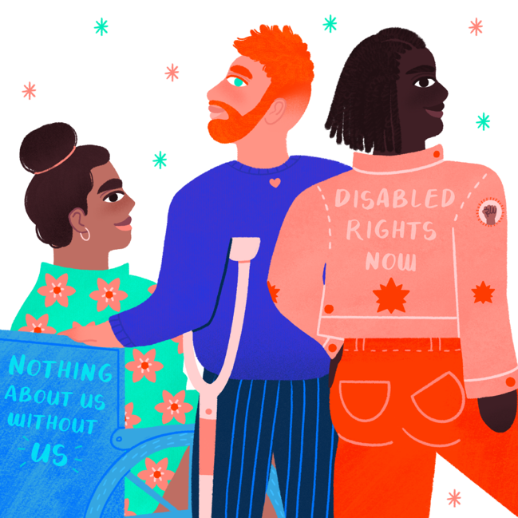
Anya Rao-Middleton is a disabled woman whose brain injury diagnosis was the direct catalyst for her becoming an illustrator. As someone who lives with a brain injury and multiple sclerosis, she uses her work to express herself and includes themes of disability.

Figure.1 Illustration for Schuh, Rao-Middleton

According to Rao-Middleton in her interview with Tom May, creating her artworks felt very healing for her and had become a healthy coping mechanism. In addition, becoming a freelance illustrator was an escape from a job that had a negative impact on her health. Rao-Middleton stated,
My day job was making me unwell and exacerbating my chronic inflammation because I wasn’t able to centre my days on my energy levels or routines that help me […] When I quit my job as Marketing Director to pursue illustration full-time, it wasn’t just a move to pursue my passion. It was a way for me to create a life for myself that centres my energy levels and needs as a disabled person. In that sense, illustration has given me the space and energy to heal from my demanding day job and cultivate a routine around my needs.

(May, 2021)

Dark Humour

Dark humour is a genre of comedy that targets more sensitive subjects. Violence, inequality, death, sex and politics, among many other topics, are not out of bounds for this type of comedy. While it may seem insensitive to some, the goal is to make light out of harsh realities, and dark humour can and often is used as a coping mechanism, or as a form of spreading awareness. (BBC , 2023)

According to the BBC Maestro in an article about dark comedy, Billy Connolly, a well-known comic, shares his experience with the use of dark humour.
“I now suffer from Parkinson’s disease and comedy has helped me deal with it. It’s given me a very light look at it.” (BBC , 2023)

Bo Burnham is a 34-year-old American comedian who uses dark humour in his sets. In 2021, Burnham released Inside, a comedy special that he created throughout 2020 during the outburst of the COVID pandemic. In this special, Burnham references mental illness and suicide, which he has openly discussed experiencing in his previous shows. A great example of dark humour used in Inside is the song How The World Works. (Inside , 2021). This song has a childlike tune with Bo playing the piano, using a tone of voice that is reminiscent of songs from children’s television. During the song, Bo introduces Socko, a sock puppet who, after a fun introduction, starts to discuss topics such as paedophilia, genocide, assassination, and politics. The song ends with Socko exclaiming that Burnham is unhelpful to those suffering since he will not put in the effort to educate himself on the state of the world, and in turn, Burnham threatens Socko into silence. This was a reference to how marginalised people have no voice. The overall message is incredibly sour, yet the execution is done in a way that makes it difficult not to find it humorous. Overall, Burnham’s How The World Works forces the listener to think about the criticisms he has for our modern society, and he makes it easier to do so by being playful and witty. (Dawson, 2021)

Alex Gamsu Jenkins is a South London-based illustrator whose work centres around the dark and grotesque. In an interview with House of Vans, Jenkins was asked why he feels humour is an effective artistic tool when creating illustrations that focus on more critical subjects, and he stated,
Humour is effective as it can act as a valve and help to balance an image. If the imaginary is 100% violent or macabre, humour can help to dissolve the mood and cast a different light on it or make it more acceptable. Also you can probably get away with a load more if it’s under the bracket of comedy.
(Anon., 2017)

Jenkins’ work consists of bright, positive colours that directly contradict the blood, gore and ‘ugly’ aspects of his pieces. Sometimes, his work depicts random scenarios, while others depict real-world issues. Since he is a modern illustrator, he touches on topics that are relevant to today which can make his art more influential. His art is known for confronting the viewer with themes of discomfort, the grotesque, and the surreal, often in ways that are humorous or unexpected. This juxtaposition of dark or unsettling subjects with humour can create a sense of unease, inviting the viewer to laugh while also confronting deeper, sometimes more uncomfortable ideas.
A lot of the humour in his work comes from exaggeration, absurd situations, and a playful, almost childlike approach to serious themes. His characters might be grotesque or warped, yet they are presented in ways that allow the viewer to find humour or irony in the visuals. This enables Jenkins to explore complex topics like identity, alienation, and mortality, using humour as a way to keep the viewer engaged without trivializing the underlying messages. Dark humour in Jenkins' art serves as both a way to draw attention to uncomfortable subjects and a method of disarming the viewer, encouraging them to think critically while also being entertained.
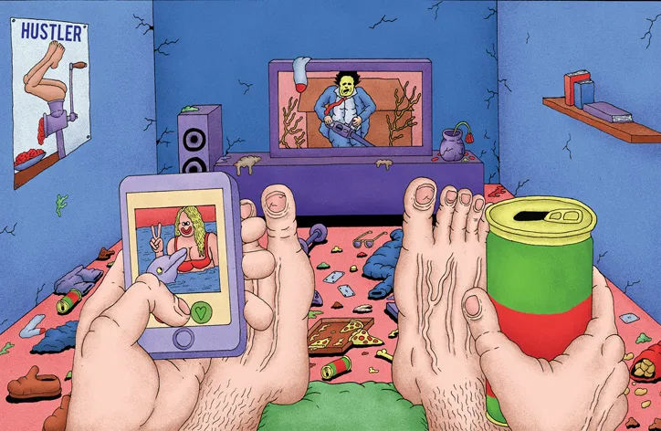

Fig.2 Untitled Illustration, Gamsu Jenkins

Narrative
A narrative is essentially a story, and narrative art refers to art that tells a story. For much of Western art history, up until the twentieth century, art was largely narrative, often illustrating stories drawn from religion, mythology, history, and literature.
Starting around the seventeenth century, genre painting emerged, showcasing scenes and narratives from everyday life. During the Victorian era, narrative painting of common life gained immense popularity. In modern art, formalist approaches have led to a decline in overt narrative. However, works still often contain subtle references to political or social issues, or to personal experiences of the artist ( The Board of Trustees of the Tate Gallery, n.d).
Peter Grundy is an infographics designer who uses narrative within his pieces. While his works are singular, they still have a story behind them that speaks to the audience. Each month, Grundy creates new infographics for Men’s Health magazine, dealing with health issues ranging from hay fever to diet to addiction. Each of his works is a mixture of the usual vector style you’d find in a lot of graphic design and illustration. There’s a lot of visual information, all coated with bright colours allowing the viewer to engage with the artwork and spend time deciphering the meaning. As icons, they are small and simple, however, they manage to tell more stories than the typical iconography (Heller & Anderson, 2018).
Grundy also produces the more typical symbolic shorthand that is the essence of effective iconography. But his challenge is to make icons that are not simply signs (or exclamations) but which actually tell a complete story in a minute amount of space, and attempt to explain life imaginatively and individually.
(Heller & Anderson, 2018)

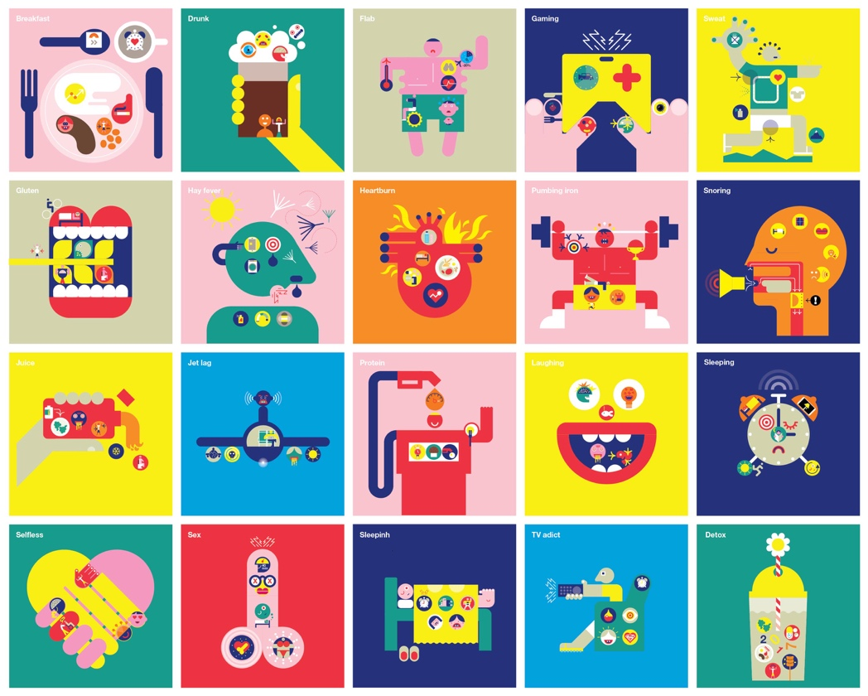

Fig.3, “Body Science”, Peter Grundy

In Chapter 7 of Children’s Picture Books: The Art of Storytelling by Martin Salisbury and Morag Styles, the authors explore the impact of narrative in non-fiction picture books. While their focus is on children as the intended audience, this concept could easily apply to readers of all ages. Salisbury and Styles suggest that, with the rise of multi-platform media, particularly screen-based content, educational books that incorporate storytelling and humour can effectively capture and hold the reader’s attention (Salisbury & Styles, 2020).
A wonderful example that Salisbury and Styles highlight is the picture book series Little People, BIG DREAMS, written by Lisbeth Kaiser and illustrated by Ana Sanfelippo. This picture book series aims to tell the stories of strong and inspirational women in art, science and literature throughout history, such as Emmeline Pankhurst and Coco Chanel.
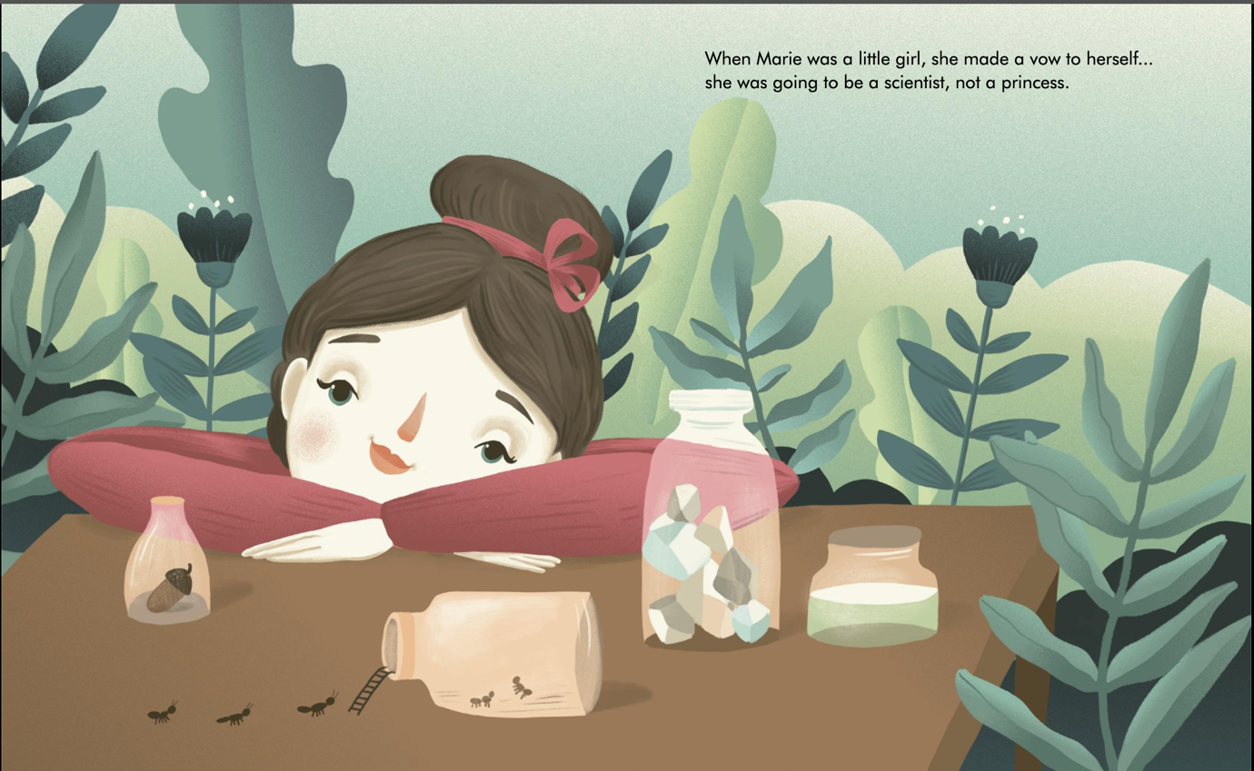

Fig.4, Little People, BIG DREAMS: Marie Curie, Ana Sanfelipp

Although this book series is biographical and factual, it incorporates a strong narrative element. While this series is aimed at children, biographical storytelling offers creatives a powerful way to share and reflect on life stories, serving as a tool for self-discovery, understanding personal growth, and developing connections with others, no matter their age. By weaving together real-life experiences with compelling narrative techniques, these stories not only inform but also inspire readers to reflect on their own lives and journeys. They provide a lens through which readers can empathise with diverse perspectives, understand different cultures, and appreciate the complexity of human experiences.
In 2023, BMC Geriatrics published an article on how biographical narrative can benefit older adults after conducting a study. The article states,
It is a particularly useful research methodology to explore human experiences and needs in the unique context of ageing. This methodological development thus provides an insightful analytical lens to explore how older people’s earlier life experiences may be carried forward and confronted to shape their emotional stability in the present and future stages of their ageing lives.
(Fang, et al., 2023)
Although non-fictional narratives are prevalent in the creative industry, fictional narratives also play a significant role. Fiction allows for the exploration of real human experiences, emotions, and situations in ways that provide greater creative freedom. These stories may be entirely fictional or inspired by real events, yet they are reimagined to serve various purposes, whether for entertainment, education, or the exploration of themes and ideas. The creator has the liberty to craft a world that resonates with the audience. Through fictional narratives, individuals with diverse experiences can gain insight into the perspectives of those who have lived through similar situations, fostering empathy and offering a chance to emotionally experience these scenarios vicariously. (Santi, 2023)
Researching the terms disability, dark humour, and narrative has been instrumental in shaping ideas for my upcoming independent project. My findings highlight how marginalised groups, like those with disabilities, often find empowerment through art. Additionally, dark humour emerges as a powerful tool for addressing topics that might be too uncomfortable or intimidating for the general public. Crafting narratives not only gives a voice to those often overlooked but also serves to educate audiences who may be unaware of the daily challenges faced by marginalised communities. Dark humour, in particular, offers those who are considered less fortunate a way to find humour and resilience in their situations, and combining this with narrative can further enhance awareness and understanding. From my research, I have come to believe that creating narratives about dark topics using humour can be a really impactful way of spreading awareness, or just making others feel included and seen. I want my practice-based project to use storytelling in order to educate audiences about some of the unseen sides of disabilities, while also making them comedic enough not to be upsetting.
The main question I have come to is: How can narrative be used to educate people bout disability? I will be extending my research to answer sub-questions such as how effective is dark humour? Do people respond better to difficult subjects if they’re portrayed with humour? Is there a place for dark humour when discussing disability?
Currently, my proposed practice-based project will consist of zines and prints, all highlighting disability and using humour to outline symptoms or characteristics of said disabilities.
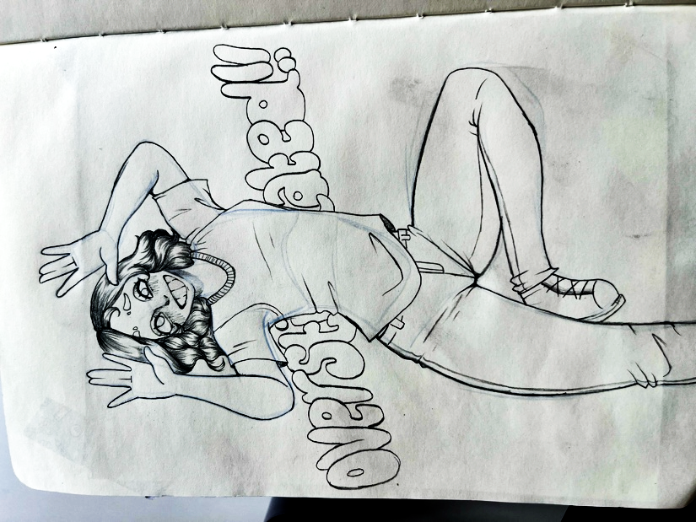
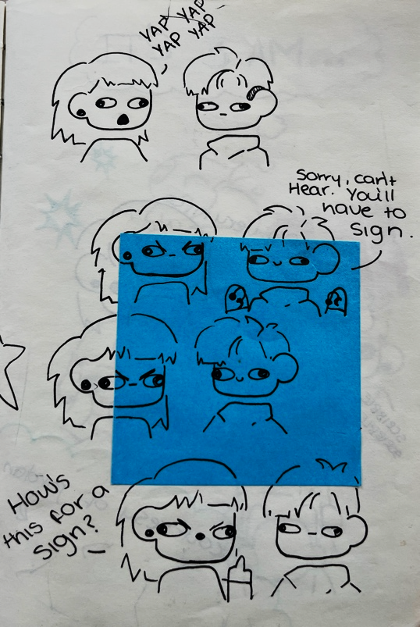

Fig.5 Fig.6

Figures 5 and 6 are examples of previous ideas I have had where I used humorous imagery or commentary to tell a short and simple story about disabilities (in the examples used, the disabilities presented are Deafness and Autism). I aim to do more work like this for my practice, but in small zines and in digital prints.

Bibliography

The Board of Trustees of the Tate Gallery, n.d. Narrative. [online] Available at: https://www.tate.org.uk/art/art-terms/n/narrative [Accessed 9 April 2025].
Anon., 2017. House of Vans. [online] Available at: https://houseofvans.tumblr.com/post/168757066514/art-school-qa-w-alex-gamsu-jenkins-uk-with [Accessed 1 April 2025].
BBC, 2023. BBC Maestro. [online] Available at: https://www.bbcmaestro.com/blog/what-is-dark-comedy [Accessed 25 March 2025].
Bones, E. A., 2022. Redefining Disability. Volume 12 ed. n.c.: Koninklijke Brill NV.
Dawson, D., 2021. Bo Burnham's 'INSIDE' - Dark Comedy and Music Combine. [online] Available at: https://www.mindful-melody.com/the-articles/category/bo-burnhams-inside-dark-comedy-and-music-combine [Accessed 30 March 2025].
Eisenmenger, A., 2019. Access Living. [online] Available at: https://www.accessliving.org/newsroom/blog/ableism-101/ [Accessed 19 March 2025].
Fang, C., Comery, A. & Carr, S., 2023. “‘They want you to know who they really are inside of the old visage”—biographical storytelling as a methodological tool to explore emotional challenges in old age. BMC Geriatrics. [online] Available at: https://bmcgeriatr.biomedcentral.com/articles/10.1186/s12877-023-04094-8#citeas [Accessed 18 April 2025].
Gov.uk, n.d. Definition of disability under the Equality Act 2010. [online] Available at: https://www.gov.uk/definition-of-disability-under-equality-act-2010 [Accessed 17 March 2025].
Green, M. B., 2021. Studio Binder. [online] Available at: https://www.studiobinder.com/blog/what-is-a-narrative-definition/ [Accessed 25 March 2025].
Heller, S. & Anderson, G., 2018. The Illustration Idea Book. London: Laurence King Student & Professional.
Burnham, B., 2021. Inside. [Film] Directed by Bo Burnham. s.l.: Netflix.
May, T., 2021. Creative Boom: Ananya Rao-Middleton on making the industry more accessible to disabled artists. [online] Available at: https://www.creativeboom.com/insight/ananya-rao-middleton/ [Accessed 9 March 2025].
Salisbury, M. & Styles, M., 2020. Children's Picturebooks Second Edition: The Art of Visual Storytelling. 2nd ed. s.l.: Laurence King Publishing.
Santi, E., 2023. Reading and narrative fiction: Understanding ourselves and others. [online] Available at: https://www.bera.ac.uk/blog/reading-and-narrative-fiction-understanding-ourselves-and-others [Accessed 18 April 2025].

