Task A
Centrifugal clutches were first used in the 19th century and have slowly developed over the past years to be used in smaller machinery such as chainsaws and lawn mowers, they need to have the required engine power before having to take the load of cutting grass or trees. The clutch is based on operation for the principle of centrifugal force generation, the clutch is considered to be the smoothest type of clutch because it engages gradually allowing the engine to reach the required torque range to undertake the load or force.
The clutch has a shaft that is connected to the crankshaft of the engine and is placed into the in the centre of the clutch, the outer housing is concentrical to the crankshaft and is connected to the driven shaft. The speed of the shaft increases as the engines RPM increases which forces the shoes to reach out to the inner wall of the drum. The clutches can have a various number of shoes from to up to six that symmetrical positioning on the driving shaft. To allow them to move and expand in a controlled way and in relation to the engines RPM the manufactures had to use the expansion springs to achieve the symmetrical outward and inward movement. (Toulas, 2018)
They were used in the railway locomotives before 1858 and referred to in a patent of 1899,
There was a patent issued in the United States for an automotive centrifugal clutch on an electrical vehicle in 1898. The Armstrong Siddeley was a British engineering group that operated during the first half of the 20th century, and their cars featured automatic centrifugal clutches starting in 1936. (Wikimili, 2020)
The applications of a centrifugal clutch are for a range of engine drive equipment with a high starting inertia, they are more commonly found on equipment with rotating parts are fuelled by petrol or diesel engines.
They are used on:
- Compact road cleaners
- Mobile water pumps
- Go karts
- Woodchippers
- Milling cutters
- Rammers
- Vibratory plate compactors and rollers
- Ground care equipment
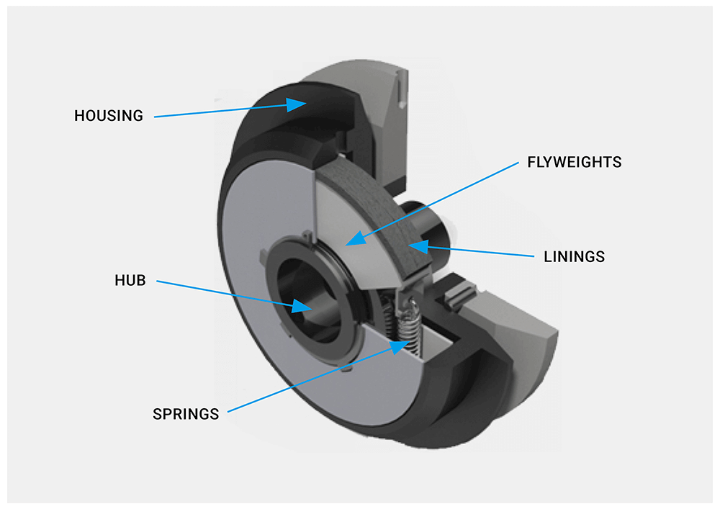 (Lancereal, 2019)

Advantages to a centrifugal clutch
Compared to the other clutches the centrifugal clutch the cost of the clutch is much lower; this is due to the fewer parts that are involved in the design. There is no extra component or battery needed to assist the centrifugal clutch to perform and function properly. The cost would very if the clutch design has more shoes in the design as there would be more parts to account for.
The centrifugal clutch can control the speed of the engine which enables the clutch to have a greater progressive engagement to help increase the torque load from the engine. The centrifugal clutch having this feature of greater engagement and speed control enhances the longer lifespan and excess energy accumulation on the start-up.
The overloading and abrupt starting can create the burden on the engine which can cause damage to engine, whereas in the case of the centrifugal clutch safer and better than the others with load and progressive engagement. The clutch is mainly designed to specialize in shock less and smooth acceleration.
The maintenance and servicing cost of the centrifugal clutch is low due to the construction and design is sustainable therefore there is little chance of breaking down and wearing away in the system. This is also due to the less parts used in the design hence there is less cost to repair more parts.
The centrifugal clutch automatically does the work of engaging and disengaging, this then does not require a mechanical part to control the peak speed of the engine. The clutch is designed for the working principle mainly based on the law of physics.

The disadvantages of the centrifugal clutch
The transmission power of the centrifugal clutch has many limitations due to its slippage, the case of an engine with a low RPM the centrifugal clutch is not suitable because of the overheating problem. More heat can be produced due to the friction between the shoes and the outer drum therefore resulting in the clutch being damaged from the slippage and loss of power.
The various number of sizes of the clutch can create different peak speed, the clutch is smaller in size and produces faster speed because of the centrifugal force that is needed to be engaged.
When the clutch reaches a certain speed, it is then activated, if the engine wants to attain a certain speed the clutch does not perform properly and if a loading capacity goes beyond the capability of the clutch, it loses its performance which then again leads to slippage. This problem then means the engine cannot perform properly because of the damage its cause; hence the clutch is suitable for an engine having a high speed but not for having a lower speed.
The centrifugal clutch cannot reach a high torque and there is a great deal of power loss during the slipping and friction. (Baksiin, 2021)
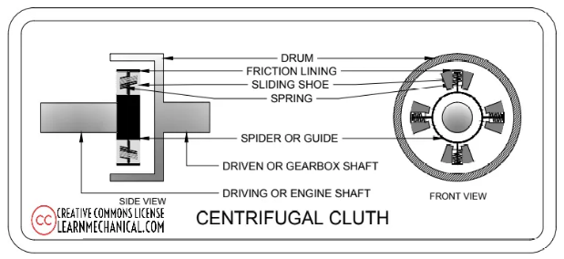 (Baksiin, 2021)
Electromagnetic clutches
An electromagnetic clutch is a clutch that is engaged and disengaged by an electromagnetic actuator. The clutch works electrically but it transmits torque mechanically, in the electromagnetic clutch the flywheel consists of winding and the current is supplied to the winding from battery or dynamo.
When the clutch is disengaged there will be an air gap between the hub and rotor, then when the engine start again the rotor start to rotate to cause the engine shaft to rotate in sync with it as it is connected. A current is supplied into the clutch winding with the help of the battery and then the current converts the winding into an electromagnet to attract armature towards it. The armature forces a friction plate towards the rotor and make rotor to make the hub rotate therefore the rotor transmits 100% torque during the engaged position. Once the clutch is pressed the battery stops the power supply which then removes the electromagnetic force t the clutch for it to disengage. (Kalyani, 2021)
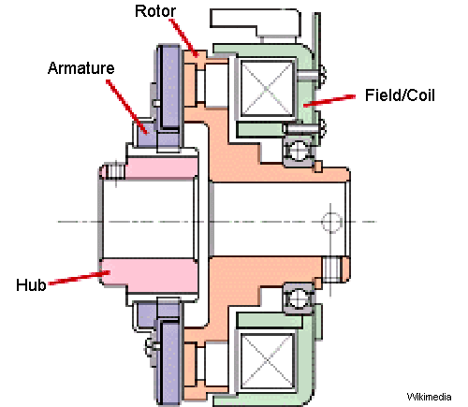 (Mecholic, 2021)

The applications of electromagnetic clutches are used in:
- In automobiles – it replaces the clutch pedal via way of means of an easy transfer button
- Printing machinery – conveyor drives manufacturing facility automation and copier machines.
- The smaller electromagnetic clutches is used in the compressor or an air conditioning system to control the pressure.
- They are also used in the food packaging industry for the food processing machines, printing machines and factory automation. (Kalyani, 2021)

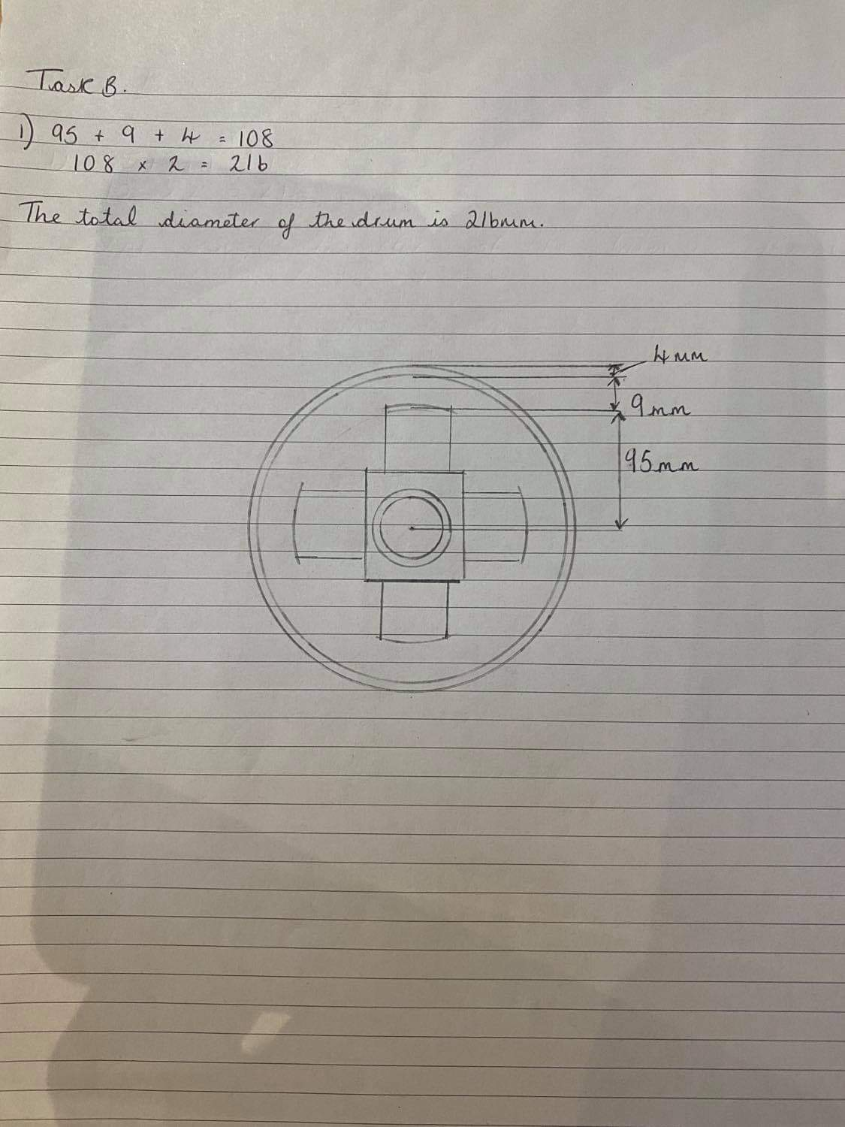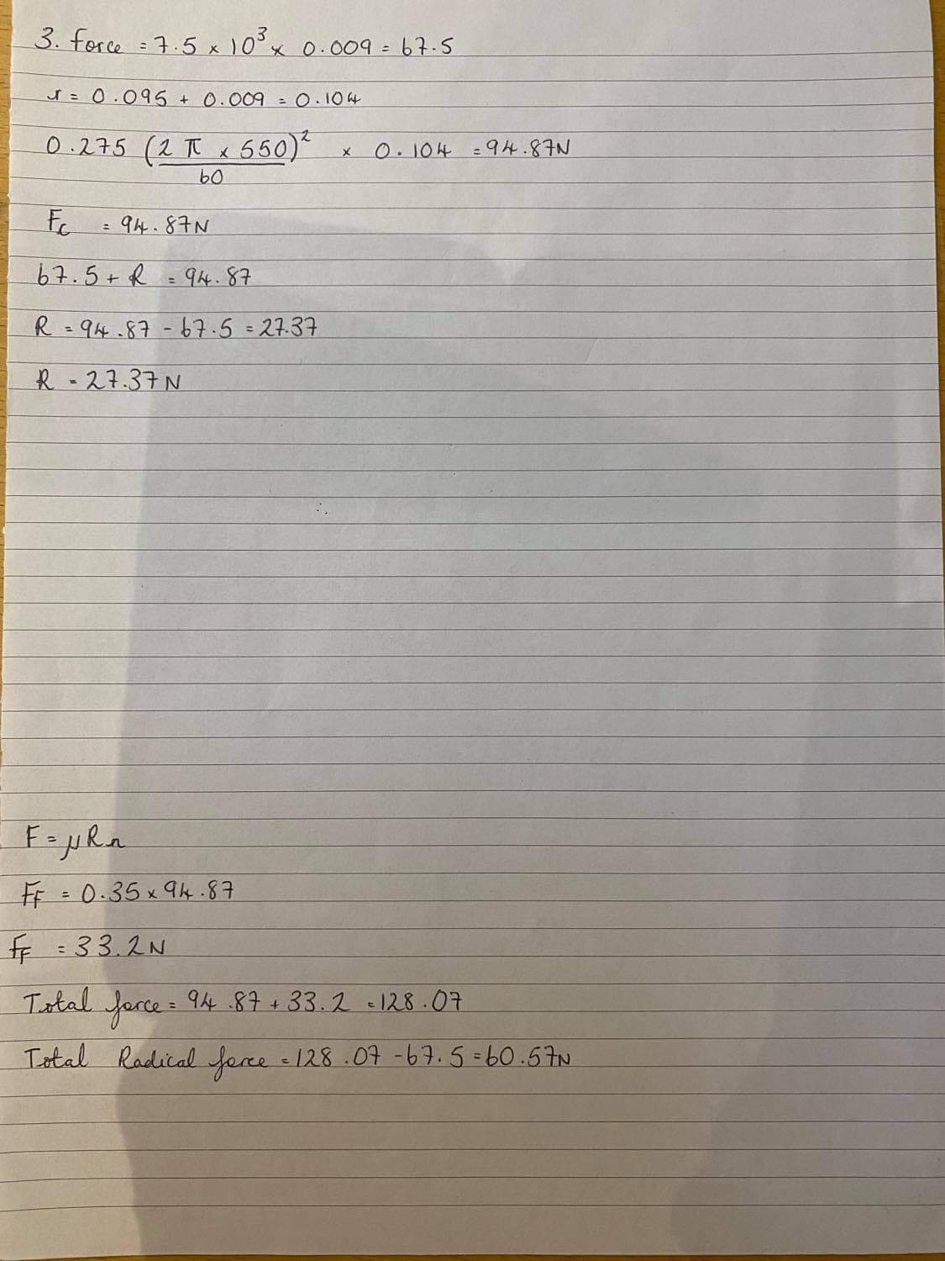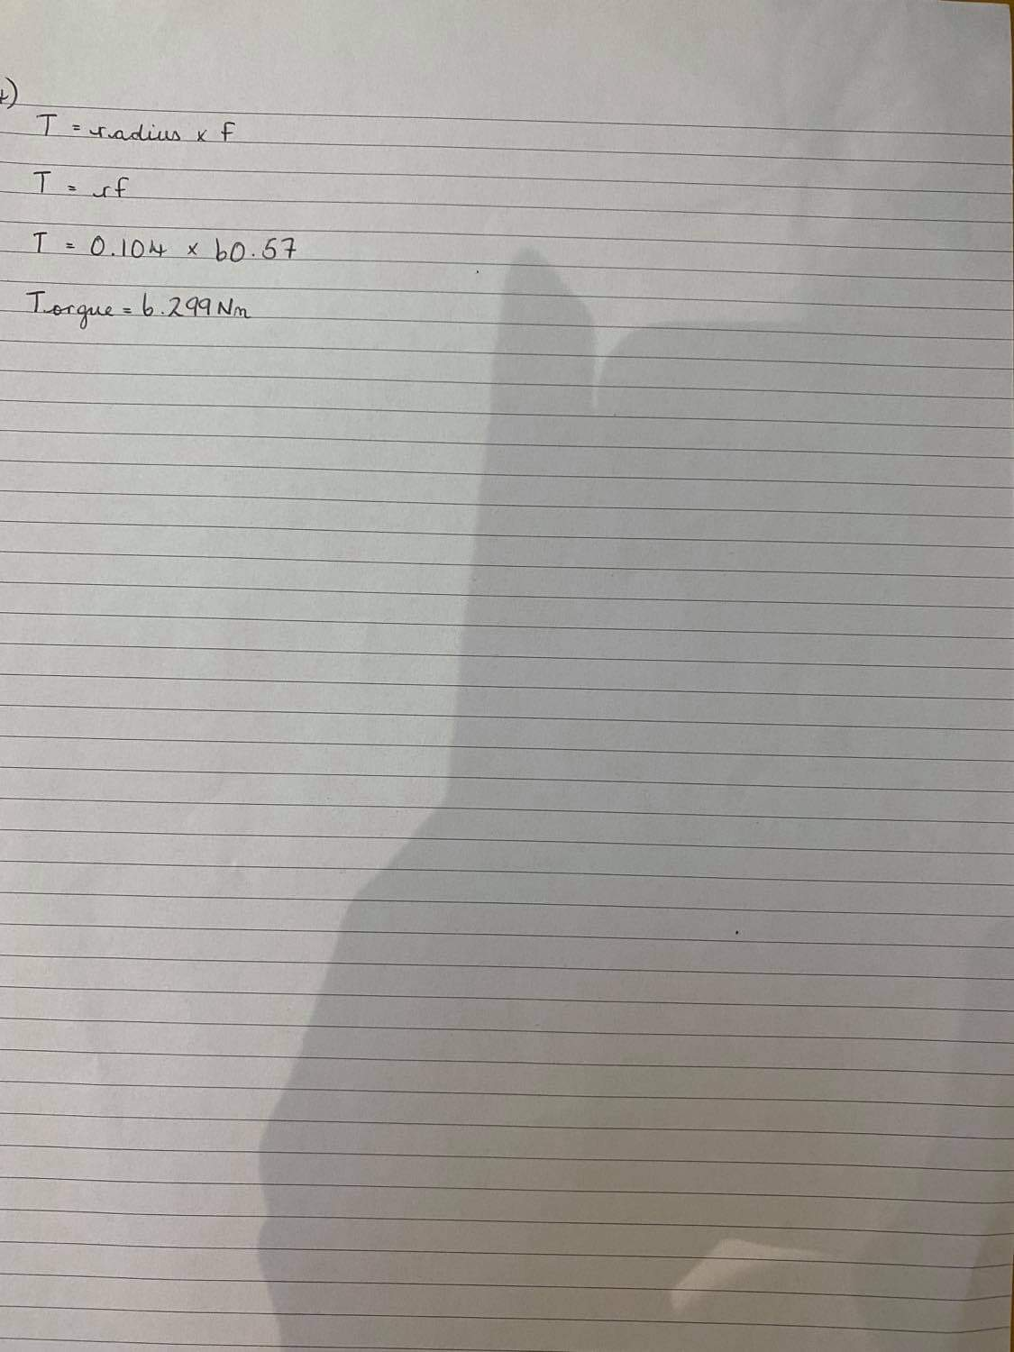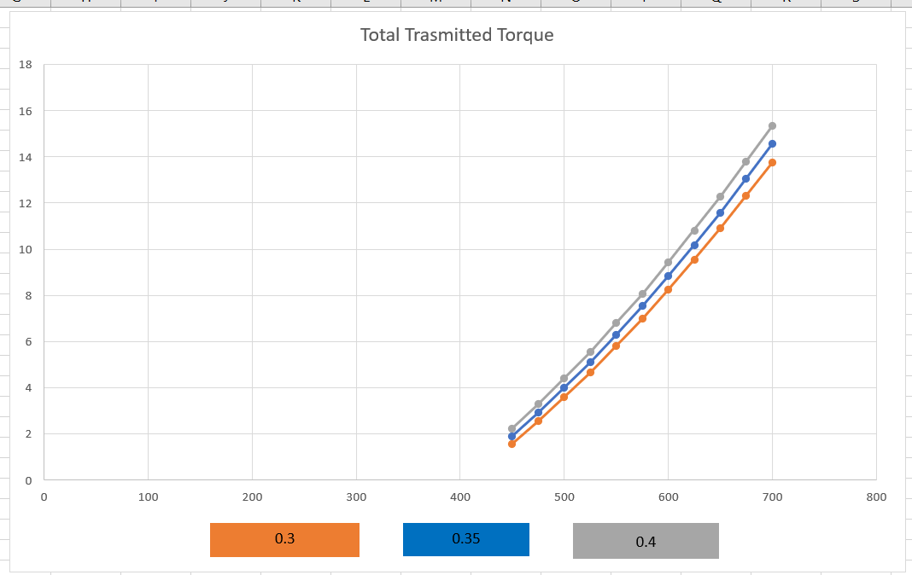

The effect on torque due to the coefficient of friction is shown in the graph above, as shown in the graph with the higher coefficient of friction of 0.4 the torque value is much higher with the value at 450RPM it is 2.22Nm, then at 700RPM the value is at 15.35Nm.
Compared to the values with the coefficient of friction 0.3 the torque values are lower with the value at 450RPM it is 1.56Nm, then at 700RPM the value is at 13.75Nm

Bibliography
Baksiin, S., 2021. Centrifugal Clutch: Definition, Parts, Working Principle, Advantages, Disadvantages, and Applications. [Online]
Available at: https://learnmechanical.com/centrifugal-clutch/
Kalyani, U., 2021. Electromagnetic Clutch Applications. [Online]
Available at: https://www.autoprotips.com/electromagnetic-clutch-applications/#:~:text=%20Applications%20Of%20Electromagnetic%20Clutch%20%201%20Electromagnetic,clutch%20pedal%20via%20way%20of%20means...%20More%20
Lancereal, 2019. Lancereal. [Online]
Available at: https://www.lancereal.com/centrifugal-clutch-explained/#:~:text=What%20Is%20A%20Centrifugal%20Clutch%3F%20A%20centrifugal%20clutch,giving%20a%20%E2%80%9Csoft%20start%E2%80%9D%20with%20no%20load%20engagement.
Mecholic, 2021. [Online]
Available at: https://www.mecholic.com/2016/01/electromagnetic-clutch-working-application-advantages.html
Toulas, B., 2018. enginneringclicks. [Online]
Available at: https://www.engineeringclicks.com/centrifugal-clutc
Wikimili, 2020. wikimili. [Online]
Available at: https://wikimili.com/en/Centrifugal_clutch

