Aida Lamer
1706552
Computer Networks and Cyber Security
Project Management and Research Methods-ACDA5004
Sue Maw
Project Management

The following section will be discussing the project initiation.
The objectives of E-ceipts is to turn paper receipts into digital receipts. This would reduce the amount of paper, plastic and harmful chemicals being used every year to create paper receipts. This would also introduce a more convenient way of keeping track and dealing with receipts. The digital receipts would be stored up to 7 years. “Statistics show that approximately 90 percent of paper receipts end up in the trash can.” (1) This problem could be simply managed by the digital receipts as they are stored up to 7 years and regulated by the banking sector.
The project would have multiple scopes to deliver a successful project. The long-term goal of the project is to change the way banks and shopping is connected. One of the scopes is to complete the project before Christmas 2019. This is a very short timescale to work with and all members of the project will have to strictly stick to the timeline. To make sure that all members of the team are up to date with their work, as a group we regularly organise dates to meet and present our work in progress. This will also allow a chance for any alterations if needed to be done.
During the project it is expected that there will be multiple constraints that will affect the outcome. One of these constraints could be time management. During the time of working on the project, all team members will have their own personal commitments as well as completing their given role in the project. Working within a short deadline and wanting to create work up to their own standards was proven to be difficult. Many team members are expected to struggle with the short timescale, and this could affect the quality of their work and outcome. Another factor is costs and finance. The budget for the project is £100. This is to be used for Amazon web services to create the hosting platform to simulate the system. The budget is enough to create the basics of the project, however it is not enough to pay members of the project for their work or to expand and take on more employees. Additional funding would be required to make changes in these aspects. During the project, another constraint would be disagreements on the design and logo. The role of the design and logo will be given to a team member with access to Photoshop and background in design. Due to other team members having a different visualization of the logo and design, it is expected that disagreements will make the working progress longer.
The following section will be discussing the authority and the potential stakeholders related issues. Below is the stake holder register for the project.
Name | Position | Internal/External | Project Role | Contact Information
Aida | Business & Design | Internal | Team Member | 1706552@student.uwtsd.ac.uk
James | Project Leader | Internal | Project Leader | 1800349@student.uwtsd.ac.uk
Connor | Planning & Production | Internal | Team Member | 1800742@student.uwtsd.ac.uk
Harry | Market | Internal | Team Member | P133366@student.uwtsd.ac.uk
Becca | Team-working & management | Internal | Team Member | 1705433@student.uwtsd.ac.uk
This table shows basic information and contact details of the stakeholders of the project.
The project could encounter many issues due to the stakeholder’s diverse characteristics and personal preferences. The project members come from different backgrounds in computing which could suggest that in the future the project would encounter disagreements during the production stages. An example would be what programs to use for the project as multiple team members could be put to work on programming, but they might not be able to use their preferred programming language. Another example would be that what the project leader envisioned might turn out different to how the analyst designed it and the programmer wrote it.
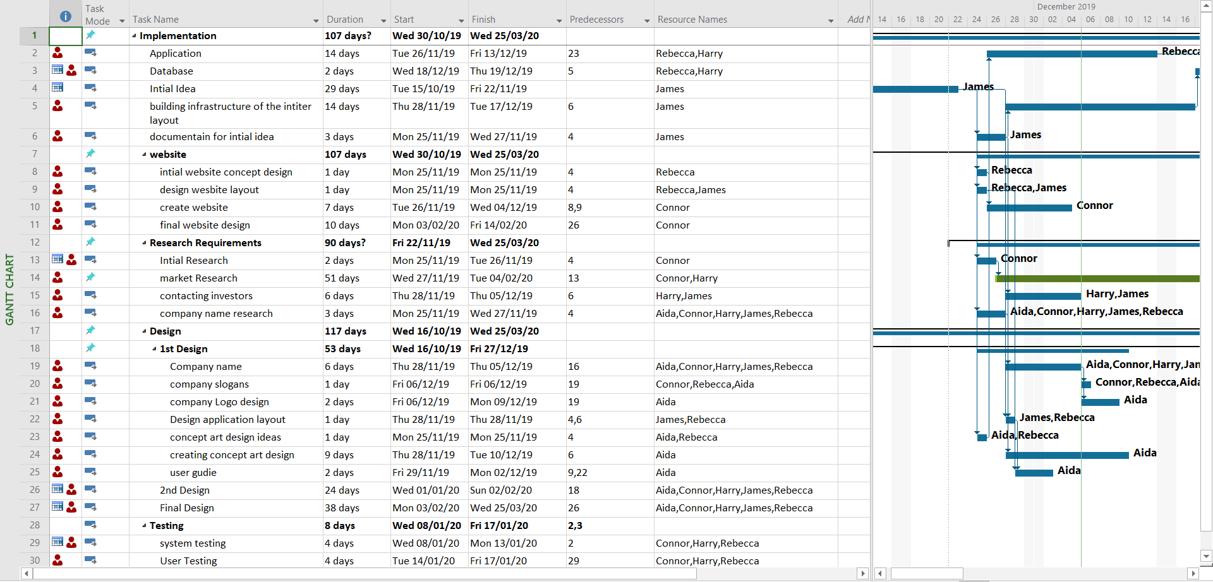
Gantt Timetable
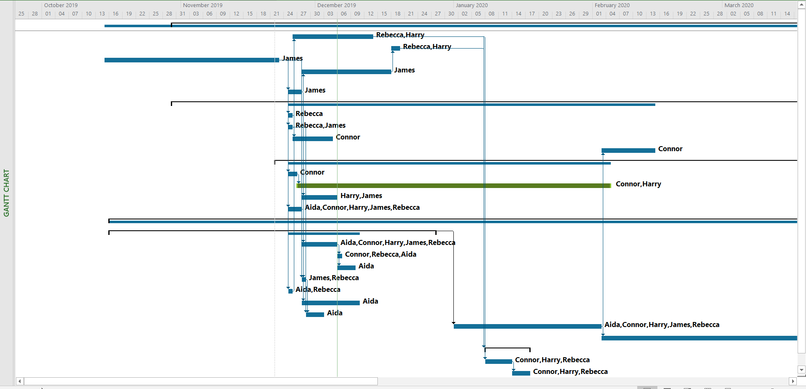
Above is an example of the project Gantt Chart
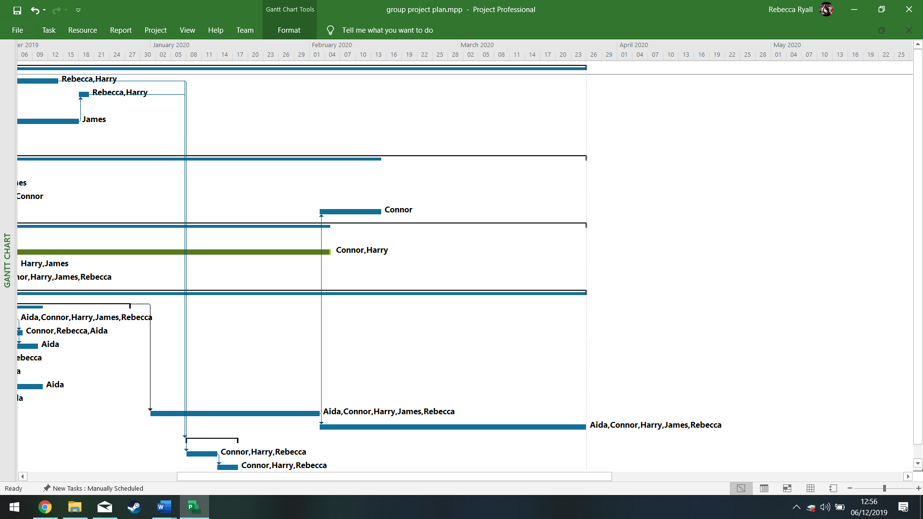
Gantt Chart
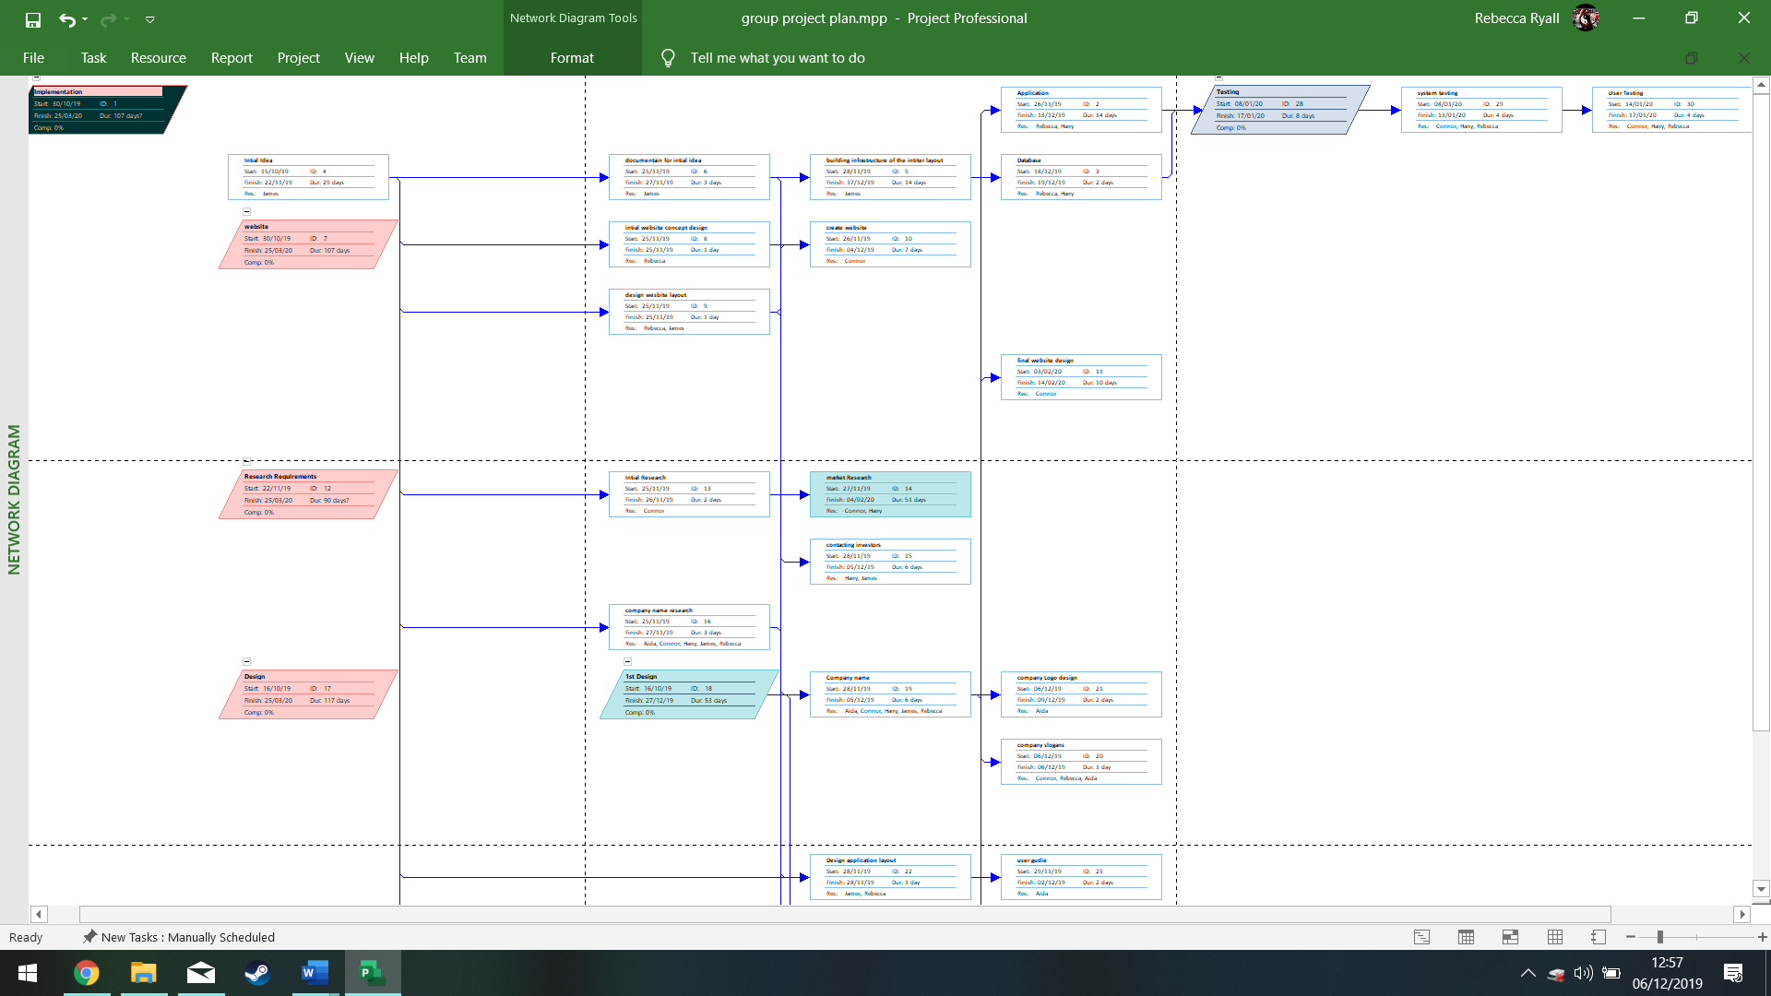
Above is the networking diagram.
For the project there is £100 allocated to be used on Amazon web services to create the hosting platform to simulate the system. This budget in the future would be expanded to make improvements on the project. Additional employees would be required once the project started to expand. This would be to keep the maintenance up to date and standards. Hardware and software would be easily accessible through the university, however in the future if the project required additional resources that the university could not provide, additional funding would be needed. In the long term, legal fees would be considered to have accountants and lawyers working on the project. Another potential resource would be commission fee to who the project will partner with in the future such as Tesco or Barclays. By having more funding, it “enables investments in innovation and development, which contributes to job opportunities and growth.” (2) These resources could be available through crowd funding.

References
[1]"Everyone wants Digital Receipts, So Why Is the Retail Industry Not Adopting It?", Hackernoon.com, 2019. [Online]. Available: https://hackernoon.com/digital-receipts-in-retail-b415fbdfde3f. [Accessed: 06- Dec- 2019].
[2]"Home", Swedish Investment Fund Association, 2019. [Online]. Available: http://fondbolagen.se/en/About-us/The-importance-of-funds-for-individuals-companies-and-society1/. [Accessed: 06- Dec- 2019].

