Learning in the Digital Era
ACCA4025
L4 UCM Assignment 1

Student Kristian Crawford

Student No. 1919795

Course Title Digital Degree Apprenticeship in
Networking and Cybersecurity
Table of Contents
Title Page p1

Table of Contents p2

E-portfolio p3
Link and Screenshot
Unit 1 p3
Links and Screenshot
Unit 2 p4
Links and Screenshot
Unit 3 p4
Links and Screenshot
Unit 4 p5
Links and Screenshot

E- Portfolio
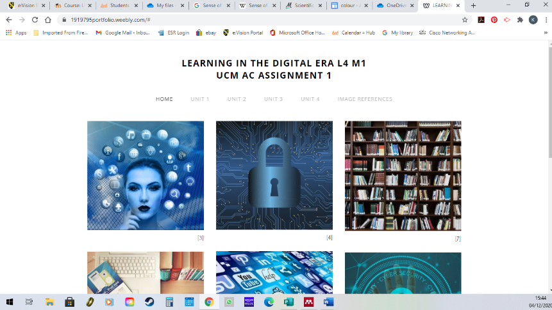
Website link https://1919795portfolio.weebly.com
Screenshot

Unit 1 – Written Summary
Portfolio link https://1919795portfolio.weebly.com
Link to answer
https://uowtsd-my.sharepoint.com/:w:/g/personal/1919795_student_uwtsd_ac_uk/EVr_p_DE9bxEiN-VQfzbhWEBLQ1JPUg_IhvO8AYZWK7umw?e=XhHGEl
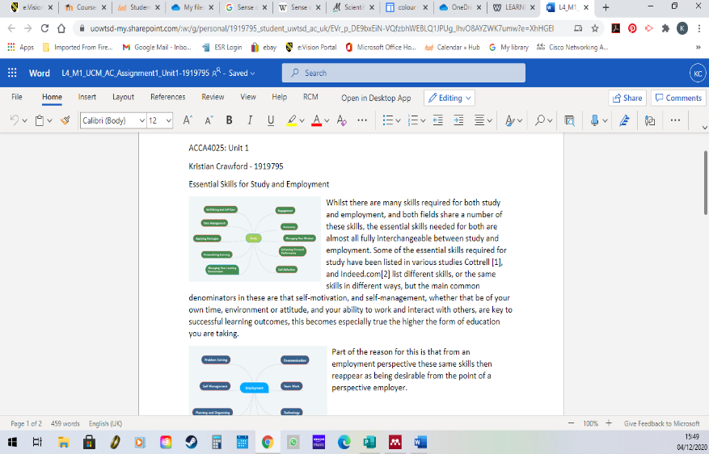
Screenshot

Unit 2 – Mind Map
Portfolio link https://1919795portfolio.weebly.com
Link to answer
https://embed.coggle.it/diagram/X5b9q6pAglVv4qnF/t/networking-and-cybersecurity-29723649810_8cb4a06489_b-5/24c5f9687de1322eea1bd889415a4f25667d546a3bffa80a7474e8c28b6d498c
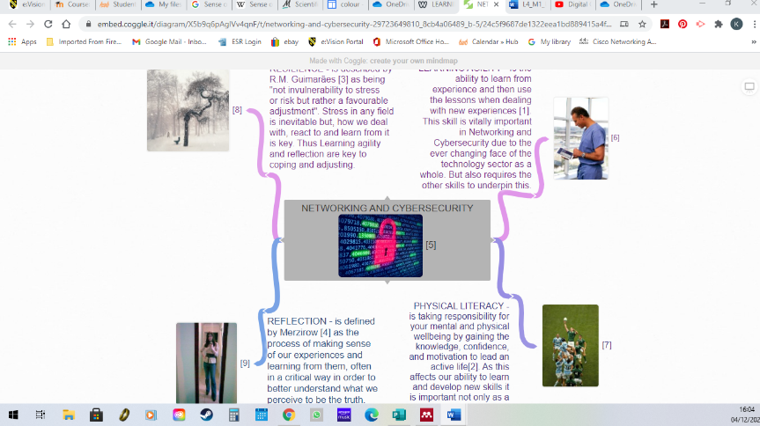
Screenshot

Unit 3 – Video Presentation
Portfolio link https://1919795portfolio.weebly.com
Link to answer
https://www.youtube.com/watch?v=75d5ogn8BvU&feature=youtu.be
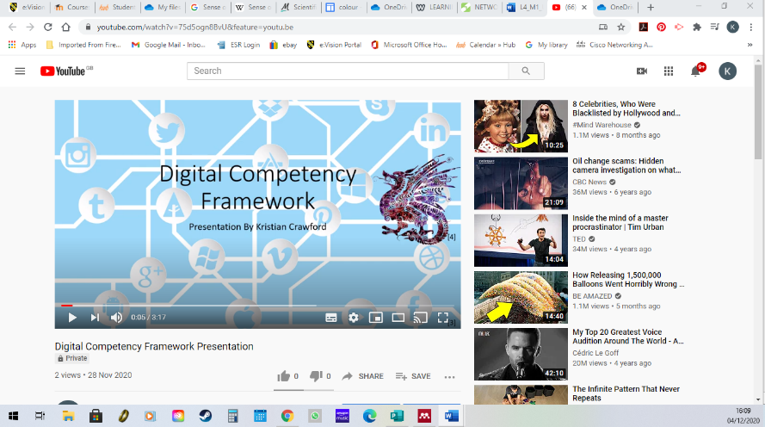
Screenshot

Unit 4 – Academic Poster
Portfolio Link https://1919795portfolio.weebly.com
Link to Answer
https://uowtsd-my.sharepoint.com/personal/1919795_student_uwtsd_ac_uk/_layouts/15/onedrive.aspx?id=%2Fpersonal%2F1919795%5Fstudent%5Fuwtsd%5Fac%5Fuk%2FDocuments%2FUnit4%5F1919795%2Epub&parent=%2Fpersonal%2F1919795%5Fstudent%5Fuwtsd%5Fac%5Fuk%2FDocuments&originalPath=aHR0cHM6Ly91b3d0c2QtbXkuc2hhcmVwb2ludC5jb20vOnU6L2cvcGVyc29uYWwvMTkxOTc5NV9zdHVkZW50X3V3dHNkX2FjX3VrL0VVRENOMzdmMk54UHZyUGlfM2ZZT2JVQlBKZTA4X01VeUxJVnZQV0JteG5BSkE_cnRpbWU9Q3p4YzVHMlkyRWc
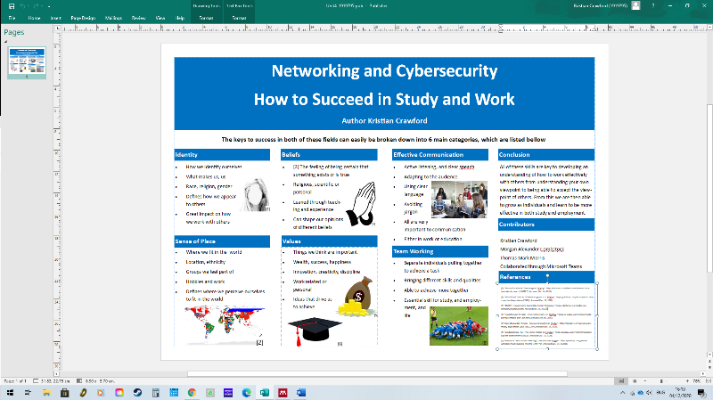
Screenshot

