Skills for the workplace
Name: Nazmila Ghanti
Student id: 1817894
Moodle: Academic and employability skills

In this report I will be writing about the skills I have gained on employability skills. In term one I learnt about time management skill which is something you need and use whether it is for studying, day to day life or even for work.
Time management has helped me in my day to day life as before I use to struggle to complete tasks, I learnt you should complete the most important tasks first. If I ever have a day I’m struggling I watch the videos that were shown to me in class.
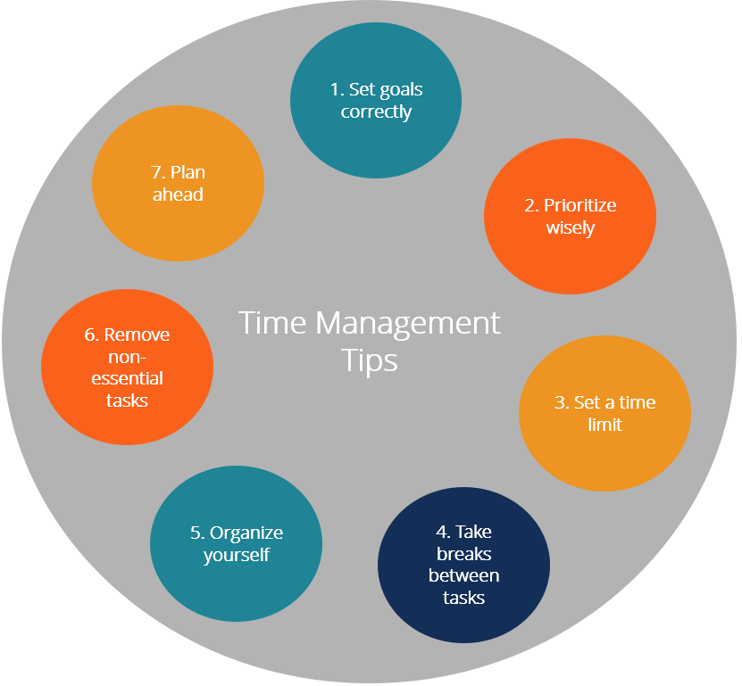
I have this picture printed out in my room as I now write down tasks in the morning and be very organised which will help me later when I am working and have less time to complete my task.

In term two we focused on employability skills which helped us write CV, cover letter and also how to prepare for interviews. We watched various videos in class on how to write cover letter, I learnt not all videos was the same for example some said it is ok to say ‘hi’ and some said you should say ‘dear’ I personally think ‘dear’ is more formal and I would only address someone ‘hi’ only if I have them before. Some cover letters can make you sound over confident so you need to be careful how you word your cover letter. We looked at different cover letters and we also did an in class cover letter was given feedback; this has helped me apply for jobs and write my own cover letter.

We had to do a reflective writing and do a mini presentation. We also learnt about Analytical and critical thinking skills: analytical thinking and critical thinking is analytical thinking involves breaking down complex information into smaller parts while critical thinking involves taking outside knowledge into account while evaluating information.
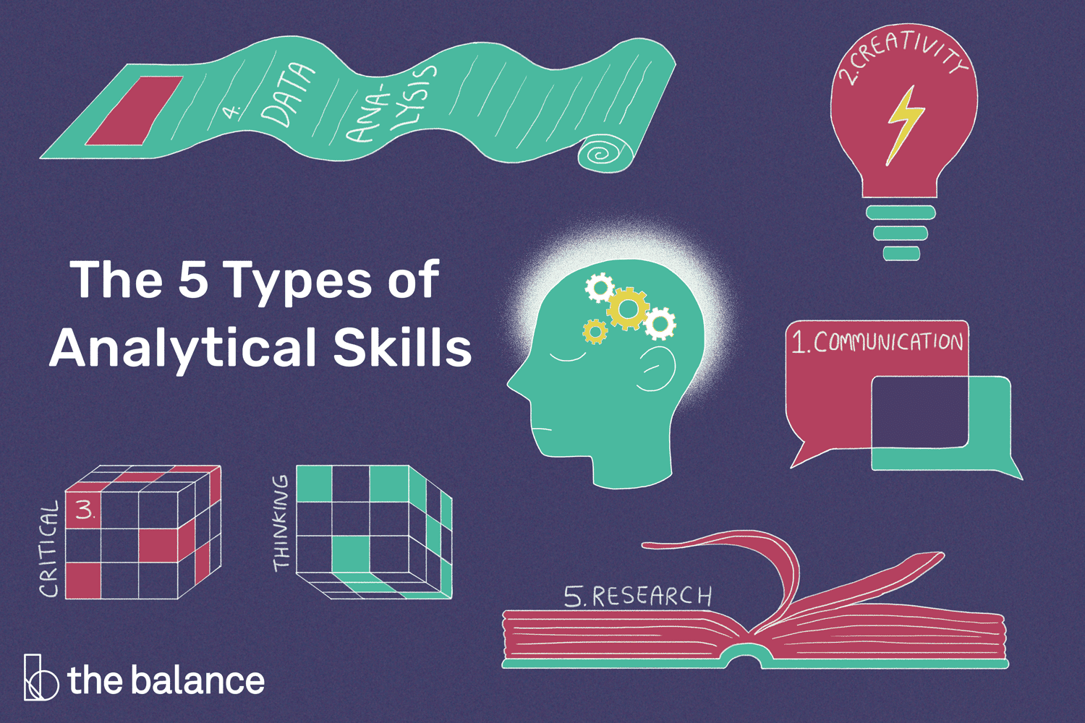
I have always been a person to rush to say something and not think or analyse but critical thinking is very good skill to have especially as a manager role, it helps you to make clear decision this is something I’m trying to work on and have watched few videos regarding this.
In term one we studied a lot on summarising and paraphrasing, we did few in class exercise which helped me. Paraphrasing is writing the text in your own words by rearranging similar text but making sure you have included the important points. Summarising is making sure it is shorter than the actual and you use your own words and you have mentioned the main points.
We did a recap on this on term 2 this has helped me remember and refresh my brain on it this will help me for when I get a job and if my role involves meetings and any other role.
Im not very confident person and being on the spot can make me freeze, in class we did few activites when we had had to speak in front of people this will help me when I go for an interview and meet new people.
We learnt about when applying for a certain job you should do some background check on the company as the interviewer may ask you questions to see if you have done your research and even for yourself to understand the company better and confirmation if it’s something you want to apply for.
I have gained a lot of skills during term1 and 2 and I am very confident this will help me in the future when I write my cv and cover letter and be prepared for an interview.

