

Entrepreneurship

BMIH5001

A Comprehensive Business Model Canvas Analysis for a Cozy Coffee Shop

Student Name: Svetla Dinkova
Student ID: 2209101
Lecturer: Chris Wilkin
Word Count: 2185
Submission Date: 31.05.2024

Part 1 - Essay
Hospitality industry is all about value creation through ideas that would appeal to the customers. This paper aims to provide a detailed evaluation of a business idea of a coffee shop using BMC tool. The BMC is useful in that it offers an umbrella under which one can plot the business model and covers the areas such as customer segments, value proposition, channels, customer relationships, revenue streams, key resources, key activities, key partnerships, and cost structure (Indrawan, Nasuton and Rossanty, 2016).
* * *
One of the most important steps in any business is to define and analyze the customers’ segments base. In the case of this coffee shop, the target consumers are the working young adults, students, freelance workers, and occasional coffee consumers. The customer segments are interested in a comfort zone for work and communication. According to Chen, Raab, and Tanford, (2017), it is important to differentiate the customers according to activity level and their need and this is beneficial in delivering services. In this regard, by focusing its attention to these specific groups, the coffee shop will be in a position to offer the groups with services they would like to be offered, hence gaining their loyalty (Karunia and Arifin, 2019).
It is critical to understand that there is always competition in the market, and thus it is crucial to identify how the coffee shop will be unique in the market, in other words, what is the value proposition. This particular coffee shop offers great coffee and a broad range of healthy foods and delicious pastries as well as the proper environment. This includes comfortable furniture, fast internet connection, and friendly personnel to attend to the customers (Brunner and Wolfartsberger, 2020).
In particular, the following communication channels are employed: social networks – Instagram, Facebook, Twitter (X); cooperation with local businesses. Social networks are the most effective tool when it comes to communicating with young professionals and students. In the context of the current consumer experience, Galingga Wira Shenta (2023) asserted that the establishment of digital media is pivotal to mending the customer touchpoint for the SMEs.
The management of the coffee shop should therefore aim at establishing and sustaining good business customer relationships. The measures are individual approach, loyalty programs, and constant communication with the clients. Customer relations involve individual approaches to customers to make them feel special while on the other hand, loyalty inducement serves to get the customers to come back for more. In the paper by Putri, Astuti, and Safitri (2023), the authors elaborate on the significance of customer relationship management for coffee shops.
Another important factor of the business model is the generation of revenues through different sources revenue streams. The coffee shop earns its revenues from the sales of coffee and snacks, merchandise products, and the subscription service. Free refilling of coffee for a fixed amount of money within a month can also entice more customers, thus providing more cash flow. Fathin Mahdi & Baga, (2018) also emphasized on the need for companies to look for other sources of revenue in order to sustain the business.
Key resources are essential for the functioning of the coffee shop business. These are quality coffee beans, qualified barista, quality furniture and quality coffee making equipment and members card for special offers. According to Endratno, Rusman, and Hidayah (2021), key resources are critical in the effective use of the business model canvas. The quality of resources used in the establishment guarantees that the coffee shop meets the customer experience expectations (Yulian and Soegoto, 2020).
The major business tasks of the coffee shop are buying high-quality coffee beans, staff training, supervising routine activities, and performing the proposed marketing actions. This leads to proper training so that the baristas can be able to offer the needed quality services and operations management to make sure that there is a consistent quality of the results. Marsono et al. (2023) stress the importance of key activities in maintaining business processes.
Key partnerships are of significant importance for the context of a coffee shop. These partners are the local bakers for fresh snacks, suppliers of quality coffee beans, and digital marketing companies for promotions. Such factors are crucial in ascertaining the company’s ability to maintain a healthy product portfolio and product differentiation. In the study by Endratno and Santoso (2020), analysing various aspects of strategic partnership it has been claimed that this is a vital factor in enhancing the results of the business. The strong links engaged in a coffee shop create an easier way of sourcing for external help in a bid to improve the coffee shop’s products and market (Yulian and Soegoto, 2020).
Cost structure and control management is one of the crucial factors that determine the sustainability of the coffee shop business. The major costs of running a business include rent, employees’ wages, stock, and advertising expenses. According to Ladd (2018), the business model canvas is used in the identification of costs and their optimisation. Thus, controlling the costs and seeking for ways to minimise them, the coffee shop will be financially stable and provide the customers with the highest level of service (Yulian and Soegoto, 2020).
All the choices made while developing the business model for the coffee shop stem from the project’s analysis of market demands, competition, and the organisation’s viability. The strategic choices in each of the BMC elements are made with the purpose of achieving the ultimate vision of opening a new kind of coffee shop that caters to the customers’ needs.
The decision to target the youth, working and studying individuals, freelancers, and occasional coffee consumers as the key customers is based on the understanding of their requirements for an appropriate work and leisure space. Unlike other demographics, these groups spend considerable amount of time in coffee shops, for work as well as leisure. In the research paper by Chen, Raab, and Tanford (2017), it is noted that adopting the customer activity level is the basis for segmentation with the aim of enhancing services’ delivery and customers’ satisfaction.
The value proposition is based on such factors as quality service, quality product, quality environment. This decision is made because of the high competitiveness of the coffee shop industry where offering merely standard products will not be enough. Brunner and Wolfartsberger (2020) also point out that in order to keep customers organizations need to have a distinct value proposition. Thus, by providing options other than coffee, like comfort, fast Internet, and a friendly barista, the coffee shop outperforms its competitors and becomes a memorable experience (Yulian and Soegoto, 2020).
Main communication channels, which are social media and local businesses, are chosen because of their efficiency in reaching the target audience. From the study done by Galingga Wira Shenta (2023) it was established that the best way to market to young professionals as well as students is through online platforms such as social media. These are direct channels of communicating with the customers, timely information delivery, and affordable marketing strategies, which makes them better than traditional marketing techniques (Yulian and Soegoto, 2020).
Instead of providing standard services, customer service that is tailored to fit each customer and loyalty programs are selected. High-quality customer relation management plays a crucial role in sustainability of coffee shops business (Putri, Astuti, and Safitri, 2023). Customised service makes the customers feel special while rewards and incentives to frequent the business make the customers loyal and recommend the business to others (Yulian and Soegoto, 2020).
The management of organisations should diversify their sources of income to avoid relying on a single revenue stream. The coffee shop will sell merchandise, and this includes caps, mugs and other items that are branded with the coffee shop symbols, whereas the monthly subscription service offered is to members of the coffee shop’s club and diversifies further the revenue streams. To enhance the sustainability of any business, there is the need to diversify the sources of income (Fathin Mahdi and Baga, 2018).
Providing the right key resources like quality coffee beans, well-trained human resource in form of baristas and quality equipment is very crucial in ensuring quality service delivery. Endratno, Rusman, and Hidayah (2021) emphasize that the key resources are crucial to create and deliver the value. This investment is useful in making certain that the coffee shop is in a good position to meet the needs of the customers most of the time, which is very important in establishing a regular clientele (Lestari and Fathurrohman, 2021).
Focusing on such strategic activities as purchasing high-quality coffee beans, staff development, and proper advertising is selected to preserve operational efficiency and deliver excellent service. Marsono et al. (2023) stress on the importance of key activities in maintaining the business operations. Thus, the specified activities help the coffee shop achieve efficient operations and high customer satisfaction (Lestari and Fathurrohman, 2021).
It is more advantageous to form close relationships with local bakers and suppliers of coffee beans as well as digital marketing companies instead of undertaking these functions internally because of the potential of the outputs to be of higher quality and to have better access to the market. Consequently, to the knowledge of Endratno and Santoso (2020), they implicitly argue that establishing strategic partnership is useful in improving the performance of a business. Such collaborations help to purchase goods of good quality and get professional advice on how to promote them which all contribute to the success of the coffee shop (Yulian and Soegoto, 2020).
Operating decisions relate to cost management and control, which include rent, salaries and marketing expenses. As mentioned by Ladd (2018), the BMC has the role of identification and cost control. Proper cost control as a concept ensures that a company does not spend beyond its means while at the same time delivering quality services.
* * *
In conclusion, all the decisions made in each of the components in the BMC are informed by strategic market considerations, differentiation and sustainable business needs. With all of these points in mind, the coffee shop is in good stead to provide for the needs of its target consumers and sustain itself in the long run in the highly saturated hospitality market.

Part 2 – Reflection using Gibbs Reflective Cycle
A reflection of one’s entrepreneurial personality is crucial when it comes to identifying strengths and drivers. In order to analyze the presence and characteristics of my entrepreneurial traits, I will utilise the Gibbs Reflective Cycle.
Description
In a similar exercise carried out, I filled several questionnaires that tested my entrepreneurial predispositions, the roles in a group, and leadership qualities. The outcomes revealed high creativity and willingness to take risks together with leadership skills; as negatives – low time organisation and low financial literacy.
Feelings
In the first place I had some confidence and at the same time I was somewhat worried. Confidence emerged from the assessment of one’s abilities, major skills I have in this case being creative and I realised that being an entrepreneur, one needs to have leadership skills. Nevertheless, I still had certain disquiet regarding some aspects of my personality as a student – it was still difficult for me to manage the time effectively and plan my finances.
Evaluation
The strengths shall be specific in creativity and risk taking since they lead to the innovation, identification and exploitation of business opportunities. Thus, creativity, which was noted by Surya and Rosliana (2020) as one of the key factors for innovations that allows to meet the market needs and develop new solutions. However, my weakness is the areas of time management and financial management may affect efficient implementation of strategies and funds management.
Analysis
As measured by the Entrepreneurial Motivation Theory (EMT), the main motivation with respect to the above traits is intrinsic motivation in my entrepreneurship. The inspiration of being able to develop something more out of the ordinary and meaningful to other fuels this more than acceptable incentives. This intrinsic motivation is in accordance with Ramelan (2021) that noted, successful business owners are intrinsically motivated. But that has its drawbacks so, to compensate my weak points, I have to get more organised. Improved time management and financial planning will be critical; thus, pursuing relevant courses and acquiring practical experiences.
Conclusion
This reflection has helped to reveal promising developments and suggested the presence of some weaknesses regarding the essential aspects of the entrepreneurial personality. These characteristics need to be understood since organisational risk taking along with inspiration and creativity needs to be complemented with good management skills. Because of this, improving on my weaknesses will need commitment and a passion for learning although this will in the long run improve on my abilities as an entrepreneur.
Action Plan
To strengthen my time and financial management, I will take courses in these areas and possibly get tutored by well experienced entrepreneurs. Furthermore, I will always look for opportunities which will put these areas under pressure so that I develop the skills under these areas in practice. Another important aspect to be incorporated into this process of development would, therefore, be the regularity of self- assessments as well as feedback from tutors and peers.

References
Brunner, M. and Wolfartsberger, J., (2020) Virtual Reality enriched Business Model Canvas Building Blocks for enhancing Customer Retention. Procedia Manufacturing, 42, pp.154-157.
Chen, S.C., Raab, C. and Tanford, S., (2017) Segmenting customers by participation: An innovative path to service excellence. International Journal of Contemporary Hospitality Management, 29, pp.1468-1485.
Endratno, H. and Santoso, S., (2020) Canvas Business Model Marketer Village, Tunjungmuli Purbalingga. Proceedings of the 2nd International Conference of Business, Accounting and Economics, ICBAE 2020, 5 - 6 August 2020, Purwokerto, Indonesia.
Endratno, H., Rusman, A. and Hidayah, A., (2021) Model Bisnis Canvas Hutan Pinus Limpakuwus Purwokerto. Journal of Management, 15, pp.29-42.
Fathin Mahdi, A. and Baga, L.M., (2018) Business Model Canvas Perusahaan Pengolah Rumput Laut. Forum Agribisnis, 8(1), pp.1-16.
Galingga Wira Shenta, H., (2023) Optimizing Customer Segments of SMEs by Transforming Business Model Canvas. Journal of Entrepreneurship & Business.
Indrawan, M.I., Nasution, M., Adil, E. and Rossanty, Y., (2016) A Business Model Canvas: Traditional Restaurant “Melayu” in North Sumatra, Indonesia. Business Management and Strategy, 7, pp.102-120.
Karunia, A. and Arifin, B., (2019) Business Development Using Business Model Canvas in Lucky Star Digital Printing. Journal of Management, 5, pp.378.
Ladd, T., (2018). Does the business model canvas drive venture success? Journal of Research in Marketing and Entrepreneurship.
Lestari, R. and Fathurrohman, Y.E., (2021) Analysis Business Model Canvas (BMC) Mie Tjap Tiga Anak Desa Wlahar Kulon Kecamatan Patikraja Kabupaten Banyumas. Proceedings Series on Physical & Formal Sciences.
Marsono, A.D. et al., (2023) Home Baking Business Analysis Using the Canvas Business Model for Mekaar Customers at PT Permodalan Nasional Madani, Bandung Branch. Formosa Journal of Sustainable Research.
Putri, E., Astuti, S. and Safitri, C., (2023) Analysis of Elements Business Model in Coffee Shop. Economic Education Analysis Journal, 12(3).
Ramelan, M., (2021). Evaluation Business Strategy Neira Coffee Shop Using Business Model Canvas Approach. Journal of Management, 7, pp.128-138.
Surya, R. and Rosliana, R., (2020). Brainstorming Business Model Canvas pada Formulasi Strategi “Rabuk Diyang” sebagai Produk Khas Kabupaten Indragiri Hilir. Journal of Business and Management, 6(1), pp.8-14.
Yulian, A.A. and Soegoto, H., (2020). Coffee Shop Business Planning for Creative Actors using Business Model Canvas. Proceeding of International Conference on Business, Economics, Social Sciences, and Humanities.
Appendix 1
Coffee Shop’s Business Model Canvas (BMC)
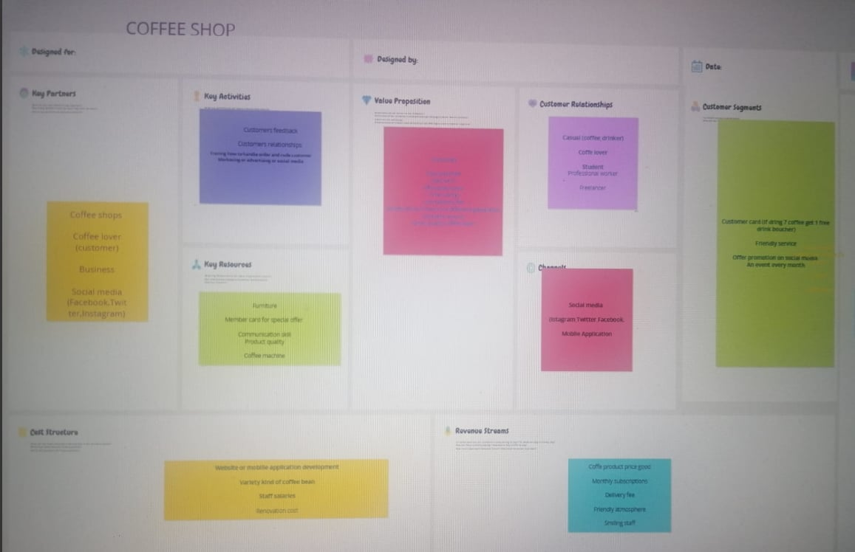
Appendix 2
Coffee Shop’s Mind Map


