
People management
BMSW5010 - PEOPLE MANAGEMENT

November 11, 2022
University of Wales Trinity Saint David
Mihaela Fodor - 1905830

Executive Summary
This report was compiled by Mihaela Fodor, student at University of Wales, as part of the assignment for the module BMSW5010 - People management Lecturer Marie Pitson. In the creation of this report multiple sources have been used such as scientific journal articles, academic journals, conference proceedings and academic books.
The purpose of this report is to critically analyse why Human Resources Management appeared at the end of 19th century and how it evolved, what is the definition, role and importance of Human Resources Management and what is the role of the manager in people management.

Table of Contents
Executive Summary 1
I. Introduction 3
II. Main Findings 3
1. Human Resources Management – definition and role in the organisational structure 3
• Taylor’s principles of Scientific Management 3
2. Effective People Management Theories 4
Content theories 4
Process Theories 5
3. The role of the manager in people management 6
Conclusion (average of 10% of word count) 8
References 9
UPDATE TABLE FREQUENTLY – CHECK IT HAS BEEN UPDATED PRIOR TO SUBMISSION

Introduction
Today, Human resource management is a very common term describing the totality of relations between an organisation and his workforce. However this was not the case in the 19th century, when industrialisation was expanding and “handling personnel” task was performed without planning, training and aggressive mode. In 1870, this led to an acute Labour Problem, marked by strikes and social unrest caused by unemployment, unfair work practices and conditions, lack of safety for the workers, insufficient pay. This marked the start of exploring the “personnel management and industrial relations” (Kaufman, 2008, p. 1). In the beginning period the duties of a personnel manager were the responsibility of the general management. However, very soon, forced by evolution of industry and the growing number of employees, creation of a new field to handle hiring compensation, training and all work relations. The People management field will soon evolve in Human Resources gaining more importance to the present day when it has the role of managing people’s relations in organisation. Human Resources draws

Main Findings
At the beginning of the 20th century, the acute social turmoil caused by worsening work conditions and the World War I, had forced the governments to seek solutions, creating national authorities to control and regulate the work relations between the workforce and employers. This created the premises for the apparition of workforce unions to defend the rights and demands of the labourers. (Kaufman, 2008).
This led to a revolution called “scientific management”, launched by F.W. Taylor in 1912, regarding on the study of the organisational workflow and increasing the speed of production. Taylor based his approach on four principles derived from his practices (Taylor, 1947). His study changed how employees were seen by the employers and how the employment can use the division of the process in basic tasks, each performed by one worker which possessed the specific skills at maximum speed and efficiency. Most important this system introduced an incentive aspect based on differential pay rates for the workers, but also the notion of groups engaged in different activities as parts of a greater production process, groups led by a person whose task was to oversee the fulfilment of each task as part of the process (Guillén, 2006).
In 1929, George Elton Mayo, studied the impact of the skills set of the workers, working conditions and social environment at the workplace on the motivation and the productivity of the workers. (Kyle, 2013). Through his studies started at the Hawthorne Electric Plant, Mayo showed that the work environment is a “social system” where the motivation of the individuals to perform or not, is related to the how efficient is the group in achieving the common goal.

Human Resources Management – definition and role in the organisational structure

Taylor’s principles of Scientific Management
By trying to experimenting with the work process, Taylor begun the draw some ideas on how to make more effective. These ideas turned into the four principles of the Scientific Management. (Conti, 2013)
The first principle was to analyse the work process by dismantling it into basic tasks and timing them. This created a standardized workflow based on the production process and order of tasks in this process. This system was successfully implemented by Henry Ford in 1914 by creating assembly lines and optimizing the production process of each part of a car from start to the final assembly of the vehicle. Based on the first principle, Taylor analysed the requirements of each task in terms of the person hired to do it and concluded that, for each task there are specific skills and traits needed, to reach maximum potential of production the process a scientific selection of workers based on their skills and abilities, but also these traits must be trained and developed with the aid of the employers. However, the division of the work tasks resulted in separating the planning and coordination process from the execution processes, creating the need for new management roles designed to plan and oversee the production (Taylor, 1911).
This provided the basis for the creation of the concept of Human Resources Management in the 1980’s, a science focused on the management activities and decisions that govern the relations between the workforce and organisations and how the assets and resources are spent in order to increase the productivity (Beer, et al., 1984). All these strategies involve all the decisions taken regarding the use of all the available assets like workforce, organizational structure, acquirement and development of human resources through recruitment and training, etc. (Armstrong, 2011). Therefore we can see the management of human resources as the planning and implementing of strategies designed to increase the motivation of the workforce by fulfilling their needs and expectations with the purpose of increasing the productivity and efficiency in reaching the common goal of the organisation.

Effective People Management Theories
One aspect identified by Taylor through his second principle, was that workers need an incentive to train to perform better, to develop the skills and abilities required for completing the tasks qualitative and in speed. His studies showed that the basic workman had little motivation to perform better and improve due to work environment and conditions, in reality trying to work less (Taylor, 1947).
His studies and researches had as the main purpose ways of increasing performance of the workforce by analysing the factors that influenced the behaviour of the employees and how this behaviour can be directed towards the desired outcome (Torrington, et al., 2020, pp. 7-10). However, this led to the need of identifying how to motivate employees’ behaviour, driving them to be more involved and out more effort into achieving the organisation’s goals. Motivation of the people became one important aspect in the strategic management of human force, being the reason that drives them to do something. Finding this reason and apply it to reach a certain goal has sparked multiple studies. Analysing motivation, it has been determined that there are three aspects for motivation – direction (what is the goal), the effort (how hard is the person trying) and persistence (how long the effort is sustained) all these having an important effect on performance (Blau, 1993). However, while the motivation is an important aspect in work performance it is not the only factor that has an impact on it (Arnold, et al., 2005).

Content theories
There are numerous theories that appeared through these studies, establishing different models and frameworks on how motivation can be used to increase performance. These theories can be split in two main categories by their focus. The first category includes content theories with a focus in what drives human, most notable being Maslow’s “Hierarchy of needs” and Herzberg’s “dual factor theory”. These two theories identified and categorised these factors which influenced the actions of each individuals toward reaching a goal.
  - Maslow’s Theory of Needs
Abraham Maslow proposed a theory that there are factors which motivate the human behaviour. In his essay published in 1943, he called these factors “needs” and created a hierarchy (Fig 1) based on importance, with five levels of needs, starting with the most basic needs for survival and ending with the higher need of exploring ones’ full potential. The hierarchy has been shapes as a pyramid by McGregor in 1960 in
This model has been developed and applied further by other researchers like Clayton Alderfer with a more concise hierarchy named the ERG (Adrefer, 1969), model Henderson in medicine (Henderson, 1991). Main criticism refers to lack of supportive research (Wahba & Bridwell, 1976), ambiguous terms describing the needs, different hierarchy based on the socio-cultural environment (Tay & Diener, 2011).
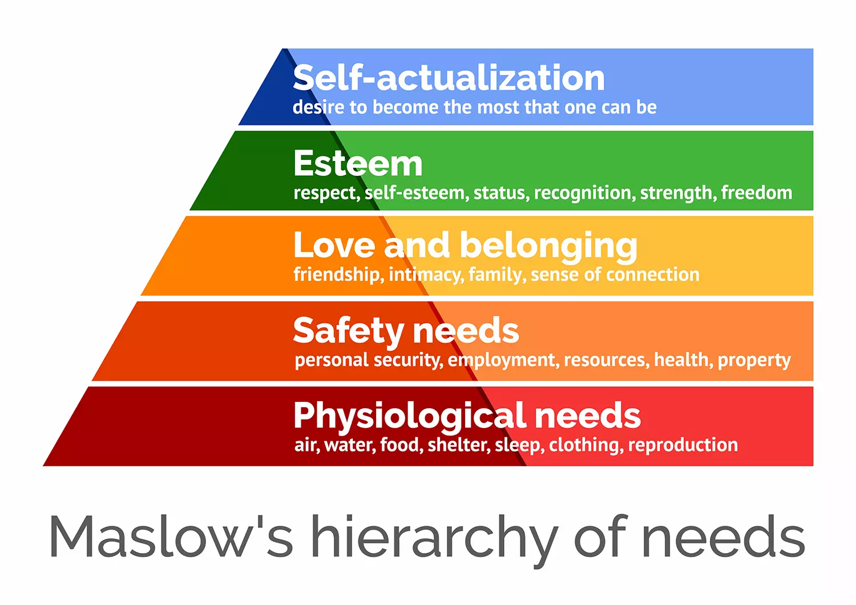
Figure 1 Maslow's Hierarchy of Needs (source - https://www.simplypsychology.org/maslow.html)

Maslow’s theory provides a good evaluation of motivation at work and brings in attention of the management methods of devising plans to increasing the performance by addressing the needs of the workforce. (Argyris, 1999) However, it has been proved that, since each person has different values systems, goals and needs, the strategies designed to improve the motivation of the workforce cannot be standardized and must take in consideration the differences between individuals (age, sex, beliefs, education, personal priorities and desires, etc). (Stoyanov, 2017)
  - Herzberg’s Dual Factor Theory
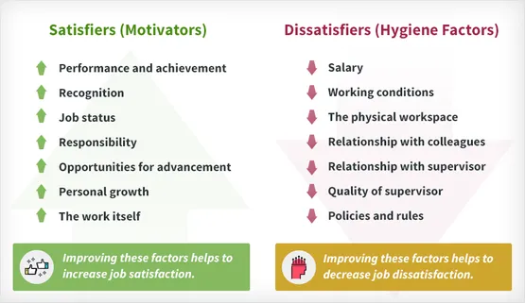
Another research studying what influences the performance of a worker was done by Herzberg which launched the dual factor theory. He concluded that while the main motivators for the individuals are the ones related to their activity, the main dissatisfaction is related to the factors related to the organisational environment. (Herzberg, et al., 1959).
Figure 2 Dual factor Theory (source- https://www.simplypsychology.org/herzbergs-two-factor-theory.html
However the main flaw of the theory is the defensive and deflective factor of biased subjective opinion of each individual as well as influence of the mental status of the respondents at the moment of the interview. (Vroom, 1964)

Process Theories
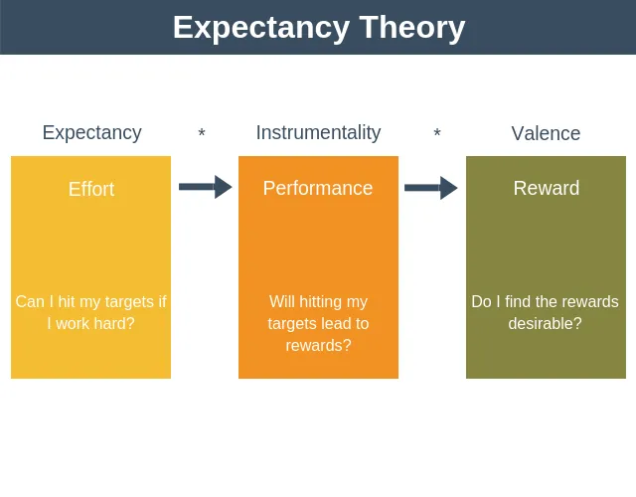
Another type of theory that emerged from the studies was treating the ways to improve the motivation by analysing the process. One of these is Vroom’s Expectancy theory which states that people make conscious decisions based on the reward expected (Vroom, 1964). The principle idea is that the more valuable the reward for a person, bigger is the effort deposed by that person to fulfil the conditions required to reach it. (Channell, 2021).
Figure 3 Expectancy theory of motivation (EPM, 2018))

The role of the manager in people management
To define the role of a manager we must consider what the management process is and what its purpose is in the organisational structure. Management in the organisation refers to all the activities and strategies used to plan, organize, control and coordinate how the available assets and resources of an organisation are spent with maximum effect (Fayol, 1949). It has the role to decrease the waste of resources, to speed up the process and to keep the focus on the main goal of the organisation. These assets and resources include finances, work systems and technology, knowledge, time and, one of the most important, the human resource including them as staff (Armstrong, 2011; Fayol, 1949). By considering this definition of the management, we can define the role of the manager as the person assigned to supervise a business or a part of it by following the management process and take measures to increase the effectiveness and productivity and reach the main goal of the organisation. They are given authority over different structures of the organisation with the main function of ensure the smooth operation and are responsible of the performance in fulfilling the assigned part of the work process by those working in that structure (Armstrong, 2011).
In 1960, Douglas McGregor came with a new people management theory called “Theory X / Theory Y” that provided two approaches towards how people should be managed. In his work ,The Human Side of Enterprise” (1960), McGregor explained that Theory X refers to the conventional way of managing people, as defined by Taylor and Fayol, by putting all the control in the hands of the management and removing the human factor. In McGregor’s view, while this management view can have some results in certain circumstances, on long term creates tensions and dissatisfaction which lower the performance. McGregor also presented another view of people management, based on Maslow’s Hierarchy of needs, and reintroducing the hierarchy as a pyramid with basic needs at the base and at the top the self-actualisation needs (McGregor, 1960). A third approach, based on social interactions in the work environment, was provided by Edgar Schein in 1988 in his book, Organisational psychology. Schein stated that social interactions influence behaviour of a person at work. He also defined leadership as a “partly a cultural phenomenon” (Schein, 1988, p. 110).
In 1973, Mintzberg defined 10 roles that a manager must fill when performing his duties by the behaviour shown when performing an activity (Mintzberg, 1973). There are three categories of behaviour identified:
- Interpersonal – leader, liaison and figurehead
- information –processing – monitor, disseminator and spoke person
- decision making – entrepreneur, disturbance handler, resource allocator and negotiator
Dr Meredith Belbin identified the team as a mix of people with different skills and abilities required to perform tasks to reach a common goal and collective work results.
The leader role of a manager is expressed by performing duties related to its team, like recruiting, hiring, supervising, motivating and guiding, promoting and rewarding his team members. In this role most often a manager had to guide its’ workforce towards reaching a common goal, by fulfilling different sets of tasks, to ensure a productive work environment and motivate the members of the team. Certain groups of skills have been identified as essential to define a leader (Nen, 2015):
- organisational skills – to plan, coordinate, control,
- solution finding based on knowledge and experience in the field
- social and interpersonal skills – creating relations with the members of the group and identify their needs
- communication skills – listening and relaying correctly a message inside his team, developing trust
- motivational and development skills – the ability to influence and guide the team members towards certain paths of personal training and development beneficial to both the individuals and organisation
- conflict management – the ability to solve conflicts in an efficient way and create a relaxed productive work environment for his subordinates
- self-confidence, perseverance, creativity
- team management and responsibility
The ability to influence and contribute to each member’s development but also to be influenced by his team members is also contributing to becoming an effective manager (Adair, 1979). Constant training and development provides high skilled individuals as assets for the organisation, with a high flexibility in assigning them to different tasks in different projects, providing a high organisational adaptability in the business environment (Easterby-Smith. M. & Araujo, (1999)) It also can provide a good impact on the employees’ motivation by satisfying a number of personal needs for the workers like better employment pay, personal security, self-esteem and social status and in some degree self-actualisation (Arnold, et al., 2005).

Conclusion (average of 10% of word count)
As Peter Drucker stated, management is a practice which requires “hard” and “soft” skills. (Drucker, 1998). While the hard skills involve the knowledge about the field of activity, market, technology, customer, the soft skills are required to identify the means through which his team can achieve maximum efficiency and become performant, how to motivate and reward his team by providing methods to satisfy the team members’ needs from the basic primary needs to the highest level as described by McGregor in his pyramid of needs.
The theories discussed show that meeting the personal needs and expectation of the worker can be beneficial to the organisation by increasing the motivation and determination of its subordinates. Ignoring these needs can be destructive and create a crisis due to the loss of an essential asset for the organisation – his employees.

References
Adair, J., 1979. Action Center Leadership. s.l.:Gower Publishing.
Adrefer, C., 1969. An empirical test of a new theory of human needs. Organizational Behavior and Human Performance, 4(2), pp. 142-175.
Argyris, C., 1999. On Organizational Learning. 2nd ed. s.l.:Wiley-Blackwell.
Armstrong, M., 2011. Armstrong's handbook of strategic human resource management. Fifth Edition ed. s.l.:Kogan Page.
Arnold, J. et al., 2005. Work Psychology Understanding Human Behaviour in the Workplace. 4th ed. Essex: Pearson Eduction LTD.
Beer, M., Spector, B., Lawrence, P. & Mills, D., 1984. Managing Human Assets. New York: Free Press.
Belbin, M., 2010. Teams at work. 2nd ed. s.l.:Routledge.
Blau, G., 1993. Operationalizing direction and level of effort, and testing their relationships to individual job performance. Organizational Behavior and Human Decision Processes, 55(1), pp. 152-170.
Channell, M., 2021. Maslow's Hierarchy of needs. [Online]
Available at: https://www.tsw.co.uk/blog/leadership-and-management/maslows-hierarchy-of-needs/#table-of-content-5
[Accessed 2022].
Channell, M., 2021. Vroom’s Expectancy Theory: How To Motivate Staff And Increase Performance. [Online]
Available at: https://www.tsw.co.uk/blog/leadership-and-management/vrooms-expectancy-theory/
[Accessed 2022].
Conti, R. F., 2013. 'Frederick Winslow Taylor',. In: M. W. a. M. Warner, ed. The Oxford Handbook of Management Theorists. s.l.:Oxford Academic, pp. 11-31.
Cook, S., 2009. The Effective Manager: Management skills for high performance. s.l.:IT Governance Publishing.
Easterby-Smith. M., B. & Araujo, L., (1999). Organizational Learning and the Learning Organization: developments in theory and practice. s.l.:SAGE Publications Ltd.
Fayol, H., 1949. General and Industrial Management. Translated by C. Storrs ed. London: Sir Isaac Pitman & Sons.
Guillén, M., 2006. The Taylorized Beauty of the Mechanical; Scientific Management and the Rise of Modernist Architecture. s.l.:Princeton University Press.
Henderson, V., 1991. Nature of Nursing. 2nd ed. s.l.:National League for Nursing Pr.
Herzberg, F., Mausner, B. & Snyderman, B., 1959. The motivation to work. (2nd ed) ed. New York: Wiley.
Kaufman, B. E., 2008. Managing the Human Factor: The Early Years of Human Resource Management in American Industry. s.l.:ILR Press/Cornell University Press.
Kyle, B., 2013. George Elton Mayo. In: a. M. W. Morgen Witzel, ed. The Oxford Handbook of Management Theorists. s.l.:Oxford Academic, pp. 94-112.
McGregor, D., 1960. The Human Side of Enterprise. New York: McGraw-Hill.
Mintzberg, H., 1973. The Nature of Managerial Work. s.l.:Harper & Row.
Nen, M., 2015. Leader vs Manager - influences and contributions to team development. SEA - Practical Application of Science, 3(2).
Schein, E., 1988. Organisational pshycology. 3rd ed. s.l.:Prentice-Hall.
Stoyanov, S., 2017. An Analysis of Abraham H. Maslow's a Theory of Human Motivation. 1 ed. Bucharest: Macat International Limited.
Tay, L. & Diener, E., 2011. Needs and Subjective Well-Being Around the World. Journal of Personality and Social Psychology, 101(2), p. 364.
Taylor, F., 1911. The Principles of Scientific Management. New York: Harper & Brothers.
Taylor, F., 1947. Scientific Management: Comprising Shop Management, The Principles of Scientific Management, Testimony before the Special House Committee. New York: Harper.
Torrington, D., Hall, L., Taylor, S. & Atkinson, C., 2020. Chapter 1 - The nature of human resource management. In: Human Resource Management. s.l.:Pearson Education, Limited, pp. 7-10.
Vroom, V., 1964. Work and Motivation. 1st ed. New York: John Wiley.
Wahba, M. & Bridwell, L., 1976. Maslow Reconsidered: A Review of Research on the Need Hierarchy. Organizational Behavior and Human Performance, 15(2), pp. 212-240.

