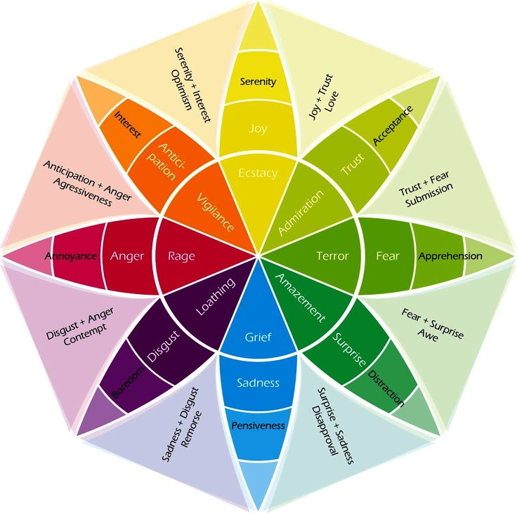
Plutchik Wheel of Emotions (Karimova, 2019)

Karimova, H. (2019) The Emotion Wheel: What It Is and How to Use It. Available at: https://positivepsychology.com/emotion-wheel/ (Accessed: March 07, 2020).

