DS 1 – Samanta Glowacka - 2534691

My Screenshots/Photos

Screenshot/Photo 1
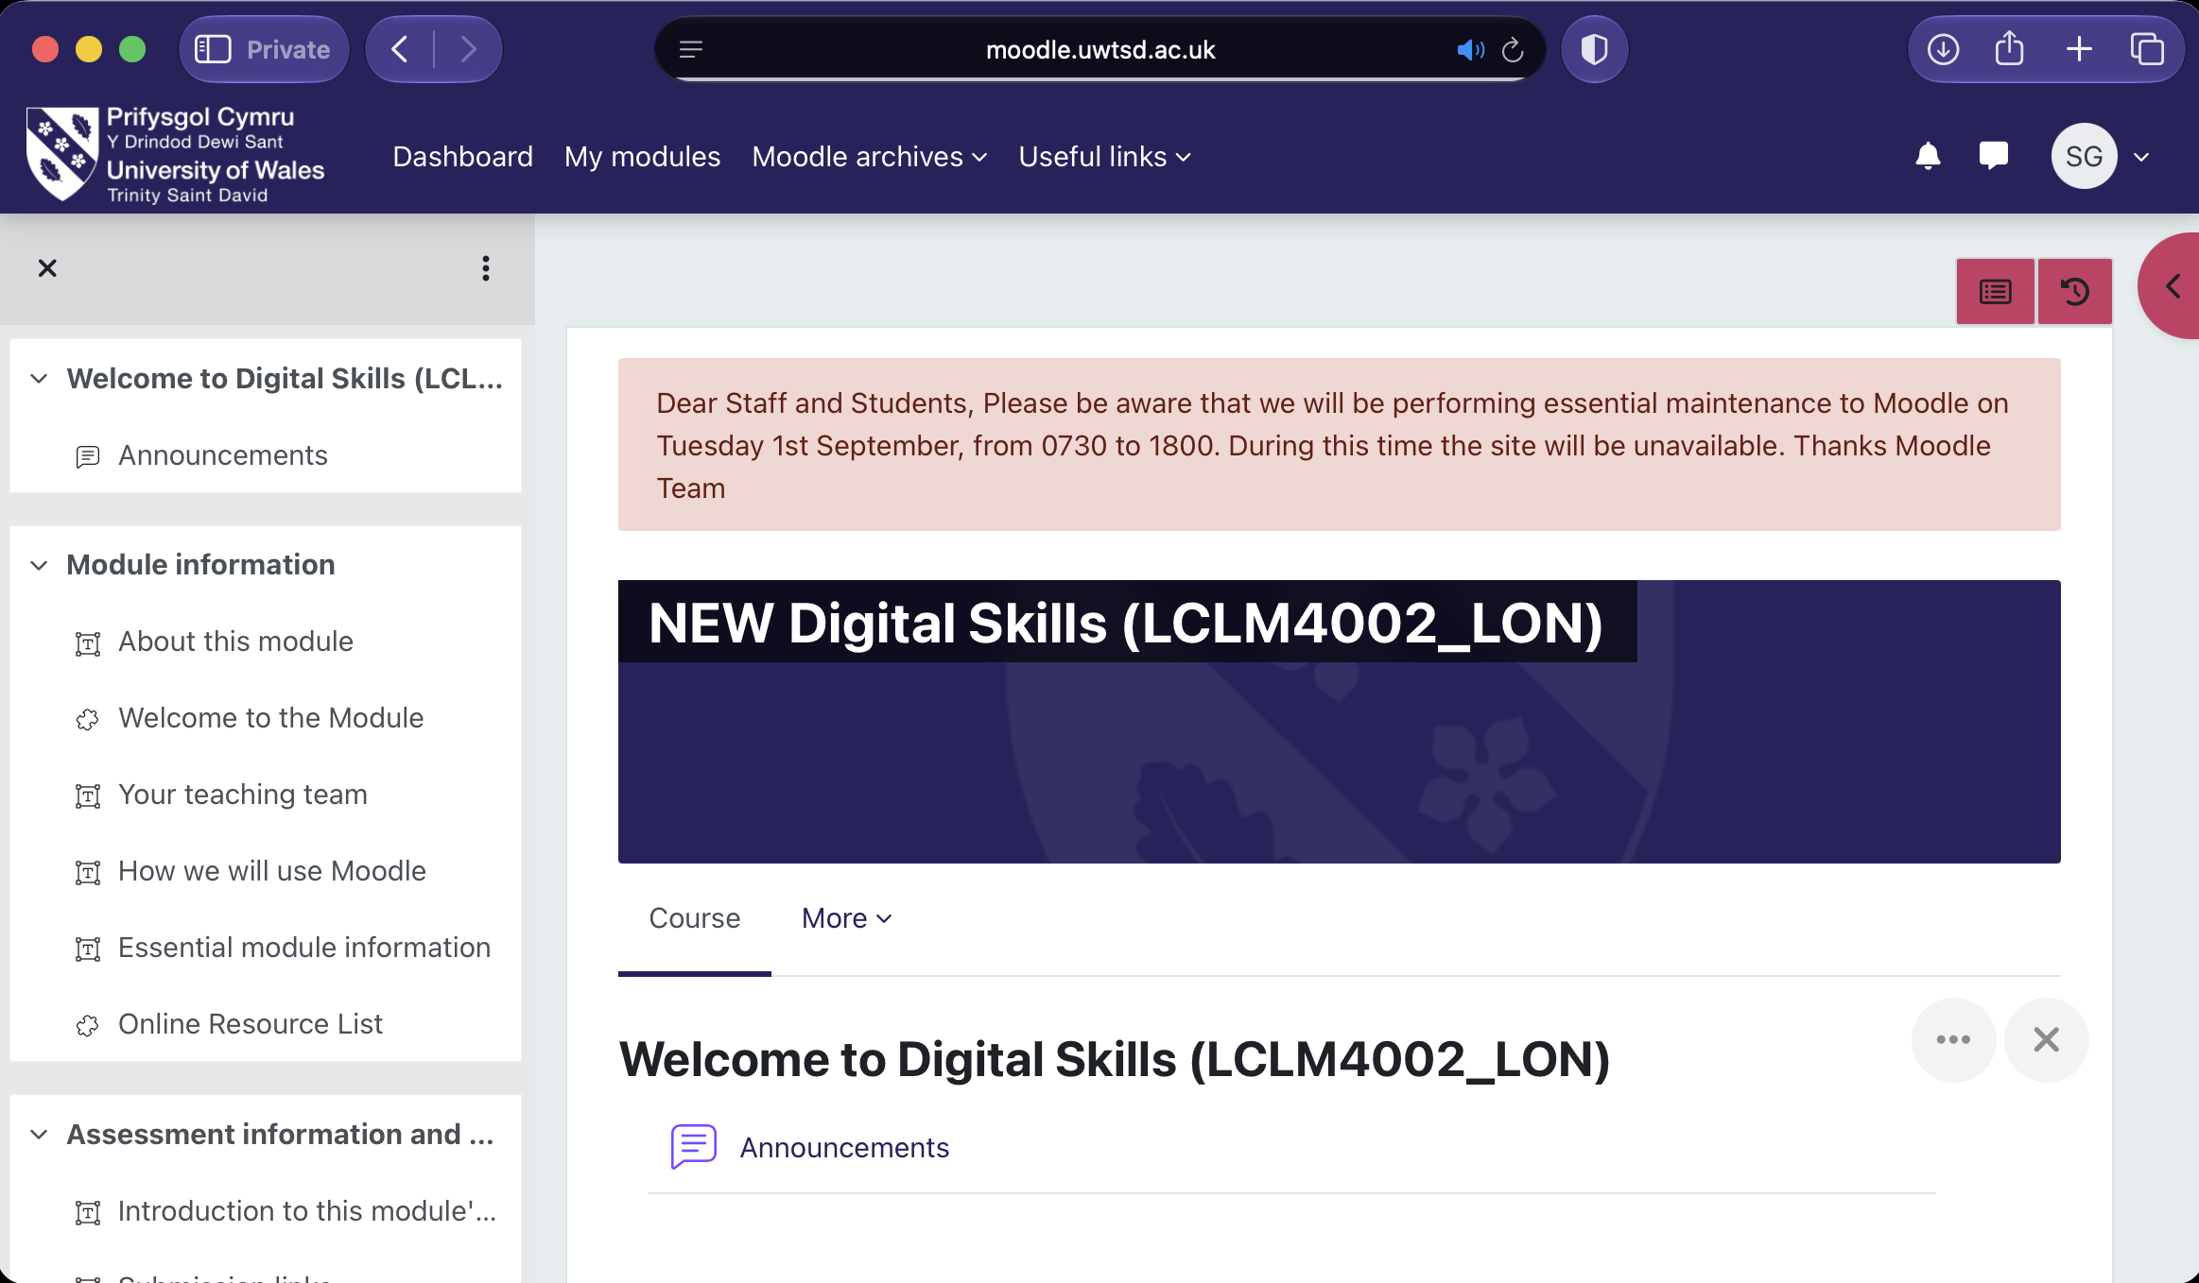
This screenshot shows my Digital Skills module on Moodle. I use this page to access module information, learning resources and assessment details throughout the course.

Screenshot/Photo 2
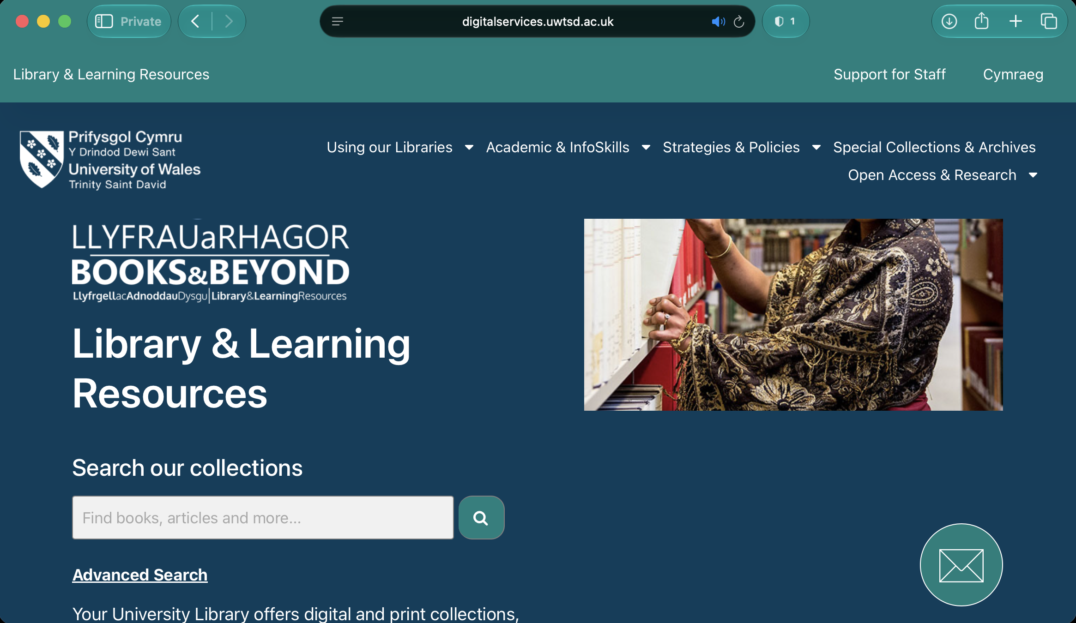
This screenshot shows the UWTSD online library. I use it to search for books, journal articles and other learning resources that help me with my assignments and research.

Screenshot/Photo 3
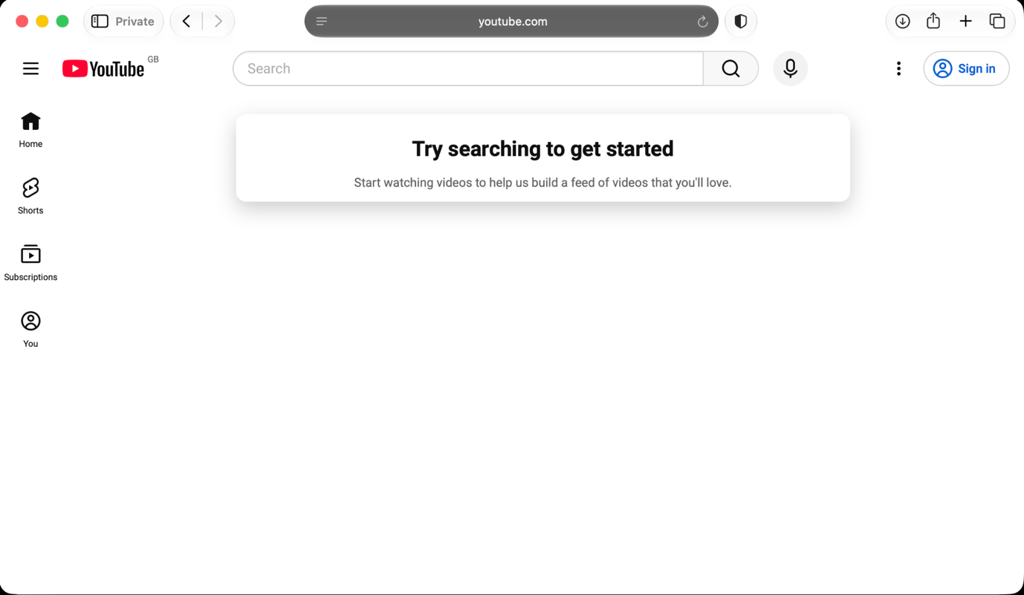 This screenshot shows YouTube. I use it to watch educational videos and tutorials that help me understand topics I am studying. It gives me another way to learn when I need extra support.

Screenshot/Photo 4
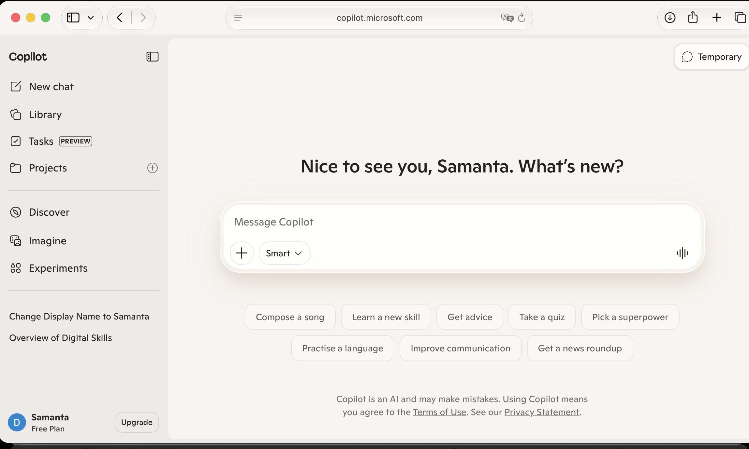
This screenshot shows Microsoft Copilot, an AI tool that I use to help explain topics. It helps me understand information more clearly when studying.

Screenshot/Photo 5
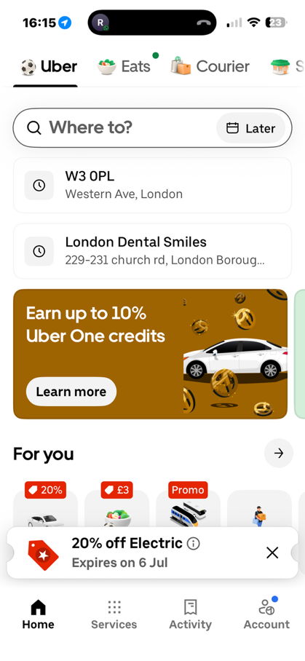
This screenshot shows the Uber app. I use it to book transport and plan journeys when I need to travel.

Screenshot/Photo 6
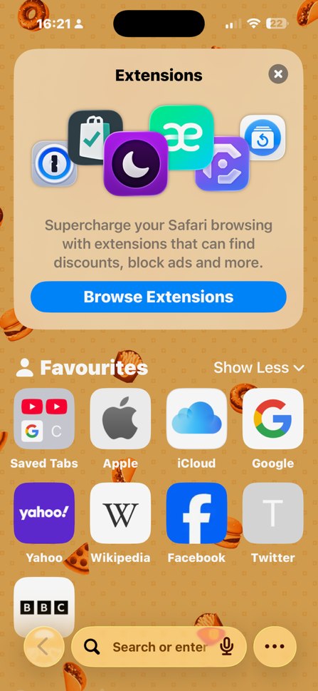
This screenshot shows the Safari web browser on my phone. I use it to search for information. Access websites and browse the internet for both university work and everyday use.

My Short Reflection
I use digital tools to help me with my university work and everyday tasks. I feel confident when I use Moodle and the online library because they help me find the relevant information I need for my studies. I want to improve my confidence when using new digital tools and learn how to use them more effectively. I often use these tools: Moodle, Online University library, YouTube, Microsoft Copilot, Uber and Safari. I sometimes feel nervous about using new technology because it can take time to learn how everything works. I hope this module will teach me new digital skills that I can use during my studies and in the future. Digital skills are important for me because they help me study more effectively and prepare for future employment.

