Effectiveness of Environmental Solutions in the US Energy Industry
Author: William Crews
Economics of Sustainability
Module: BMSP6007
Lecturer: Anthony Burns
Date: 10 April 2020

Introduction: The US Energy Industry
The Energy Industry in the United States is comprised of companies operating power plants that produce electricity in a variety of ways. Most electricity in the US is generated from power plants using turbines to drive generators. These turbines are turned by a fluid, such as water (hydroelectric), steam, air (wind) or combustion gases. Steam turbines use steam generated by burning a fuel such as natural gas, coal, nuclear energy or, to lesser extent biomass or heat from solar or geothermal energy. The majority of large power plants in the US use steam turbines to drive the electricity generators. Solar photovoltaic cells convert sunlight directly into electricity, whilst fuel cells convert fuels, such as hydrogen, into electricity through a chemical process (Eia.gov, 2020).
According to the US Energy Information Administration (EIA), in 2019, 4.2 trillion kilowatt hours were generated by 9,719 major power plants producing at least one megawatt that supply the national grid. 38% of that electricity was generated from burning natural gas, 23% from burning coal, 20% from nuclear generation, 17% from renewables and 1% from petroleum, as illustrated in the figure below:
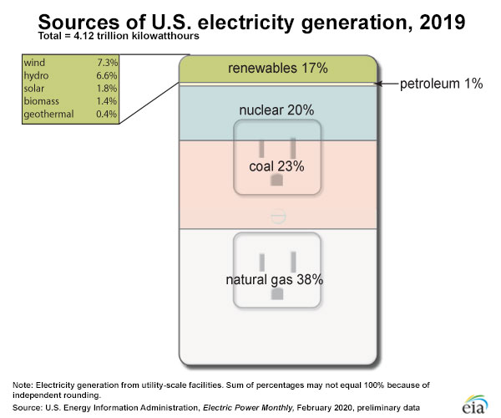
(eia.gov, 2020).
US power plants produced 1,763 million metric tons (MMmt) of carbon dioxide emissions in 2018 (EIA.gov, 2020). Whilst coal only amounts to 23% of electricity generation in the US, it contributed 65% of the CO₂ emissions for the industry. Natural gas generation contributed 33% of the CO₂ emissions for 38% of the electricity produced by the industry (eia.gov, 2020). CO₂ emissions directly contribute to climate change (climate.nasa.gov, 2020).
In addition to CO₂, power plants are major contributors of other harmful pollutants. The graphic below illustrates the level of pollution that is emitted from power plants in the US:
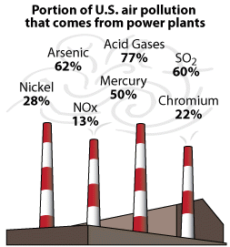 Image: (epa.gov, 2019)
Negative Externalities in the Energy Market: Market Failure
These pollutants and harmful emissions are negative externalities in the market. These externalities can be expressed as social costs. If the social costs or externalities are not factored into the market, there will be market failure. Markets determine the best price and quantity for a good or service, in this case electricity. This is known as the equilibrium price. At equilibrium the quantity supplied, or produced, is equal to the quantity demanded, or consumed. This is also called market clearing because there is no surplus production (waste) or shortage of supply. Everything produced will be consumed. (economicsonline.co.uk, 2020).
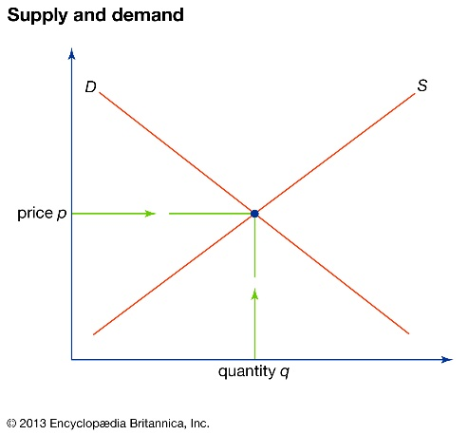
The equilibrium price in this market illustration is at the point where price p intersects with quantity q.
This would illustrate the energy market with no externalities taken into account.

Image: (britannica.com, 2013)
The Intergovernmental Panel on Climate Change at the UN (IPCC), describes market failure as the situation where there is a difference between market price and what the price should be when externalities are considered. In the energy market, failure occurs when the negative externalities (environmental harm) of producing electricity are not taken into account (energyeducation.ca, 2016).
A public good is defined as something that an individual can consume without reducing its availability to others and of which no one is excluded (Kenton, W, 2019). The air we breathe is a public good and, as such, it is hard to put a price on clean air. Free-ridership is a term to describe the consumption of a public good without paying for its use. Free ridership is considered an example of a market failure because it causes an inefficient distribution, in this case of clean air (Chepellow, J, 2019). Who should pay to have clean air when air is freely available for all to use? Should consumers voluntarily pay more for electricity from renewable resources to safeguard the environment? Or should companies choose to use more expensive power generation sources such as renewables or nuclear or invest in the latest technological solutions for pollution aversion?
In a market such as this, neither the public nor the power companies may be relied upon to voluntarily increase their costs for the betterment of the public good. In this case, it may be that governments must apply regulations or impose taxes to manipulate the market in order to address the failure in the market and artificially set the equilibrium price as shown in the figure below:
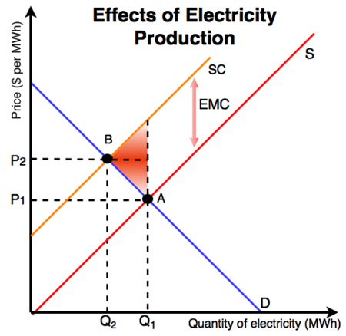
In this figure, at point A, the producer is generating electricity using fossil fuels which release pollutants, adversely affecting the public good and equilibrium is at the intersection of P₁ and Q₁. With government intervention, such as a tax on polluters, the supply curve shifts to the right. The new equilibrium price is point B, at the intersection of P₂ and Q₂. The higher price and lower quantity reflect the cost to society as a whole, the social marginal cost.

Image: (energyeducation.ca, 2018)
The government in this illustration is attempting to prevent inefficiencies in the market by affecting the price or quantity creating the negative externalities (pollution), thus minimising the effects (Christiansen, V., and Smith, S. 2012).
There are various ways a government can influence the market. They may choose “command and control” regulations that require the use of specific production or abatement technologies or setting limits on emissions. They may choose to use “market mechanisms” such as emissions taxes or tradable pollution permits. Economists mostly favour the efficiency advantages of market mechanisms over the traditional command and control approach (Christiansen, V. and Smith, S., 2012).

Emissions Trading Schemes
Instead of outlawing pollution, tradable emissions permits legalise emissions of pollutants up to a set limit or cap. These permits give producers flexibility. If a producer has a plant which operates under the cap, such as a wind farm or nuclear power station, that producer can trade emissions permits from the low-producing facility to a facility that produces more emissions or purchase additional permits on an emissions trading market.
The OECD says that a broader use of emission trading systems would be one of the most efficient and effective ways of reducing toxic emissions. These systems contribute to economic efficiency by encouraging emission reductions where it is cheapest to achieve them. In a perfect market, the costs of reducing emissions would be equal across the industry and the total cost to companies to reach given targets would be minimised. However, because the market is not perfect, these trading schemes allow power companies that have higher emission reduction costs to be able to buy more permits from those that can abate emissions at a lower cost (OECD.org, 2020).
The two main types of trading systems are “cap-and-trade” and “baseline-and-credit” systems. In cap-and-trade, an upper limit of emissions is set, either across an industry or across a geographic region. The permits are either auctioned or distributed free. Baseline-and-credit systems do not set a fixed upper limit on emissions, but offer credits to producers that produce under the set baseline. The credits in both systems can be sold to other producers who need them in order to comply with regulations (OECD, 2020). In both of these “polluter pays” systems, the cost of the externality is determined by the market for permits when the price for each is reached between the traders (LSE, 2018).
Emissions Trading Market Illustrated
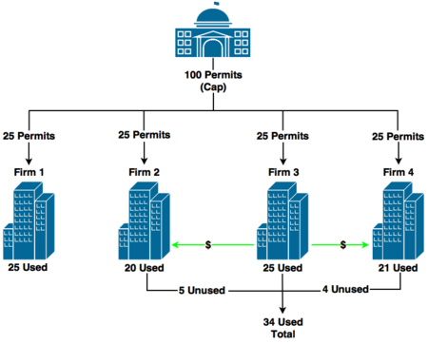
Image: (energyeducation.ca, 2020)
In the above illustration, Firm 3 purchased 9 unused permits from Firms 2 and 4, allowing them to use 34 total permits, but the market has only used the 100 permits issued in total.
An emissions trading system limits the total amount of emissions produced from power generation. In theory, this could mean that there is a limit to the total production of electricity (except that renewable sources would allow for production of electricity that does not produce emissions). If renewable sources are not included in the supply curve, this would result in the diagram below:

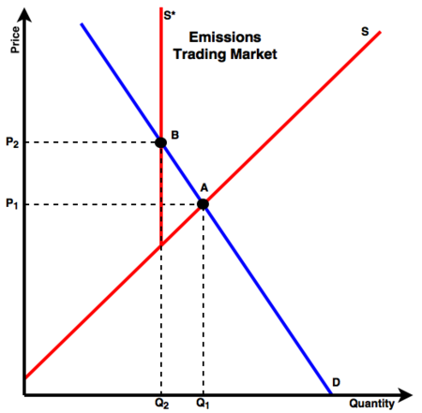
With a cap on the amount of emissions, thus limiting the total supply that can be produced, the supply curve becomes completely inelastic. The supply curve shifts from S to S*, quantity supplied shifts from Q₁ to Q₂ and price rises from P₁ to P_{2.} So, no matter the price, the quantity produced would remain at Q₂.

Image: (energyeducation.ca, 2020)

Pollution Regulation in the US: Clean Air Act (CAA)
In 1970, the US government passed the Clean Air Act (42 U.S.C. §7401 et seq. (1970)). The Act regulates air emissions from stationary and mobile sources and authorises the EPA (Environmental Protection Agency) to establish National Ambient Air Quality Standards (NAAQS) to protect public health and welfare and to regulate emissions of air pollutants (epa.gov, 2019). NAAQS consist of standards for six air pollutants: sulfur dioxide, nitrogen dioxide, carbon monoxide, ozone, lead and particulate matter (epa.gov, 2019).
It is the individual state’s responsibility to achieve these standards. States were directed to develop Site Implementation Plans (SIPs) to meet these national standards. SIPs include permitting programs which outline specific emission requirements and reductions, as well as recordkeeping, inspections, monitoring, and entry requirements. States are allowed to further devolve this authority to local agencies.
The Act was amended in 1977 and 1990. These amendments set new goal dates for the NAAQS due to the lack of achievement by many areas of the country and introduced Maximum Achievable Control Technology Standards (MACTS) which set technology-based standards for major sources, which include power plants. All new facilities and those undergoing modifications must meet New Source Performance Standards (NSPS). The standards include both equipment specifications and operation and monitoring requirements. (epa.gov, 2019).
The Acid Rain Program (ARP), included in the amendments to the Act, requires major reductions in the emission of sulfur dioxide and nitrogen dioxide (primary contributors to acid rain) from power plants. In 2010, SO₂ levels were capped at one-half that emitted by power plants in 1980. Reductions in these emissions are achieved through a market-based emission trading system.
In 2011, the EPA finalised national standards called Mercury and Air Toxic Standards (MATS) to reduce mercury and other toxic air pollution including dioxins and acid gases from power plants. Approximately 600 coal and oil-fired power plants are covered by these standards (epa.gov, 2019).
The goal of the MATS is to reduce mercury release in the atmosphere by 90%, acid gas emissions by 88% and sulfur dioxide by 40%. To reach these goals, power plants are encouraged to use widely-available technologies such as: Selective Catalytic Reduction (SCR) with Flue-gas Desulfurization (FGD), Activated Carbon Injection (ACI), ACI with Fabric Filter (FF) or Electrostatic Precipitators (ESP) (EPA.gov, 2019).
To monitor emissions, each source (power plant) is fitted with an EPA-certified monitoring system. This system continuously monitors and records emissions of SO₂. Sources use one allowance they have been issued for every tone of SO₂. Those plants that do not have enough allowances to cover their emissions are automatically fined and are deducted allowances from the next year to cover any shortfall.

Actions to Reduce Emissions
Power plants use many mechanisms to reduce emissions. Some coal-fired plants use low-sulfur-content coal, some burn wood chips with the coal to reduce SO₂ emissions. Wet and dry scrubbers reduce SO₂ emissions using lime. Pretreatment and processing of coal can also help to reduce emissions. NO_{x} emissions are controlled using combustion phase or selective catalytic and non-catalytic converters. Particulate matter is reduced through the use of filters, electrostatic precipitators and wet scrubbers (EIA.gov, 2020). Remaining coal-fired plants have increased efficiency by using a combined-cycle mode which uses coal gasification. This can improve efficiency from 35% to 50% (brighthubengineering.com, 2020).

In Conclusion: Have Government Regulations Worked?
The number of coal-fired power plants have declined in the US in recent years. This has led to a 28% reduction of greenhouse gasses from 2005 to 2017. This reduction in the number of coal plants is partly due to environmental regulation, but also from the lower cost of natural gas and renewables.
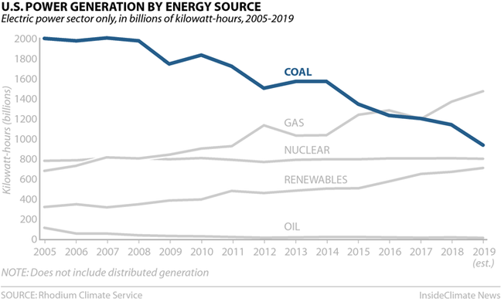
Image: (insideclimatenews.org, 2020)
The Acid Rain Program of the CAA reduced SO₂ emissions from 1980 to 2001 by 6.5 million tons per year and by 2010 levels were set at 50% of 1980 levels. The cap and trade system encourages the industry to pursue the most cost-effective methods. The limit on the allowances creates scarcity in the market, ensuring the value of the allowances and providing an incentive to reduce emissions. By allowing companies to save unused allowances for future use, the system encourages early adoption of the most efficient pollution reduction technologies, this results in earlier benefits for society and the public good.
The reductions in toxic emissions have been significant. The EPA estimates thousands of premature deaths will have been prevented and the societal benefit for 2010 was estimated to have been $50 billion (Epa.gov, 2016).
Under the Trump Administration, however, the EPA was ordered to relax limits on greenhouse emissions from power plants. Rolling-back an Obama era directive which was to take effect, the Affordable Clean Energy rule allows states to set their own emissions-reduction levels. It focusses on encouraging individual power plants to introduce energy efficient technologies rather than requiring carbon capture and storage as the Obama rules would have required (Tollefson, J, 2019).
That notwithstanding, EPA Administrator, Andrew Wheeler, said that “Under President Trump, our economy continues to grow, and we are enjoying ever-improving air quality.” With state and federal adherence to the CAA along with advances in technology has had a significant effect on reductions of key pollutants. In 2018, both SO₂ emissions reduced by 23% and NO_{x} emissions reduced by 14% and both were under 1 million tons for the first time since the introduction of the Acid Rain Program. From 1990-2019, a 94% decrease (-14.8 million tons) in annual emissions of SO2 from power plants and an 85% (-5.5 million tons) reduction of NO_{x} (epa.gov, 2020).
The data supports longer-term trends in air quality progress. From 1990 to 2017 emissions regulated under the NAAQS dropped by 52%, whilst the US economy and population continued to grow. SO₂ levels declined by 93% from the observation period 1989-1991 to 2016-2018 period. The EPA’s latest report found greenhouse gas emissions from power plants dropped 20% since 2011 (epa.gov, 2020).

References:
Brighthubengineering.com, 2020, Retrieved from: https://www.brighthubengineering.com/power-plants/31486-how-to-reduce-carbon-dioxide-emissions-from-power-plants/
Britannica, (2013), Supply and Demand, Retrieved from: https://www.britannica.com/topic/supply-and-demand
Chappelow, J, (2019), Free Rider Problem, Retrieved from: https://www.investopedia.com/terms/f/free_rider_problem.asp
Christiansen, V. and Smith, S. "Externality-Correcting Taxes and Regulation". The Scandinavian Journal of Economics, 114(2), pp. 1, 2012
Climate.nasa.gov, 2020, The Causes of Climate Change, Retrieved from: https://climate.nasa.gov/causes/
Eia.gov, 2020, Electricity Explained, Retrieved from: https://www.eia.gov/energyexplained/electricity/electricity-in-the-us-generation-capacity-and-sales.php
Epa.gov, 2020, EPA’s 2019 Power Plant Emissions Data Demonstrate Significant Progress, Retrieved from: https://www.epa.gov/newsreleases/epas-2019-power-plant-emissions-data-demonstrate-significant-progress
Epa.gov, 2019, Summary of the Clean Air Act, Retrieved from: https://www.epa.gov/laws-regulations/summary-clean-air-act
Epa.gov, 2019, Cleaner Power Plants, Retrieved from: https://www.epa.gov/mats/cleaner-power-plants
Economicsonline.co.uk, 2020, Equilibrium, Retrieved from: https://www.economicsonline.co.uk/Competitive_markets/Market_equilibrium.html
Energyeducation.ca, 2016, Market Failure, Retrieved from: https://energyeducation.ca/encyclopedia/Market_failure
Insideclimatenews.org, 2020, Retrieved from: https://insideclimatenews.org/news/07012020/infographic-united-states-emissions-2019-climate-change-greenhouse-gas-coal-transportation
Kenton, W, 2019, Public Good, Retrieved from: https://www.investopedia.com/terms/p/public-good.asp
LSE, 2018, What is the polluter pays principle?, Retrieved from: http://www.lse.ac.uk/GranthamInstitute/faqs/what-is-the-polluter-pays-principle/
OECD.org, 2020, Emission Trading Systems, Retrieved from: https://www.oecd.org/environment/tools-evaluation/emissiontradingsystems.htm
Tollefson, J, (2019), Retrieved from: https://www.nature.com/articles/d41586-019-01944-7

