

Programme: Master of Business Administration
Module: Strategic Management
Module code: LCMB7003
Individual report
Student’s Name: Md Mehedi Hasan
Student ID: 2506709
Word Count: 4896

Table of Contents
Section 1 4
Organisational Context and Overview 4
External and Internal Environment Analysis 5
External Environment Analysis (PESTEL) 5
Critical Success Factors and Strategic Challenges 9
Internal Environment Analysis 10
VRIO Analysis 12
Contribution of Internal Strengths to Competitive Advantage 14
CSR and Sustainability Objectives 14
Comprehensive and Holistic View: Balanced Scorecard 15
Financial Perspective 16
Customer Perspective 16
Internal Business Processes Perspective 17
Learning and Growth Perspective 17
Strategic Choices and Implementation (Trade-Off Analysis) 17
Business-Level Strategy: Cost Leadership vs Differentiation 17
Corporate-Level Strategy: Diversification and International Expansion 18
Recommended Strategic Choices 18
Strategic Implementation and Change Management 19
Strategic Evaluation and Recommendations 19
SWOT Analysis 19
Ansoff’s Matrix Analysis 20
Recommendations 21
Section 2: Reflective Account 23
Description 23
Feelings 24
Evaluation 24
Analysis 25
Conclusion 25
Action Plan 26
References 27

Section 1

Organisational Context and Overview
Amazon has become one of the largest multinational technology companies in the world since Jeff Bezos founded it in 1994 as an online bookstore. The company has also grown tremendously over time, and today it operates in various fields, among them being E-commerce, cloud computing, digital streaming and artificial intelligence (Baylis, Wirtz and Johnson, 2022). This change is a manifestation of Amazon's strategic vision of constant innovation and long-term market growth. The company's mission statement is: "The most customer-centric company on Earth," which shows that it is very customer-oriented, focused on its customers' satisfaction, convenience, and value creation. It has a vision that focuses on being innovative, operationally excellent and a global leader in digital services.
The Amazon business model is extremely diversified and has been established on a platform-based ecosystem. Its main income figures consist of retail sales via the web, third-party vendor solutions, subscription income (Amazon Prime), and cloud computing (Amazon Web Services (AWS). Of all importance is AWS, as it generates a significant percentage of the operating profits of Amazon, showing that Amazon has employed an effective diversification strategy (Bryson and George, 2020). Moreover, Amazon spends significant investment in logistics and technology infrastructure in order to provide the clients with rapid delivery and effective functioning, which helps to increase its competitive advantage.
The company functions in the global e-commerce and technology sector, which is typified by the accelerated technological change, stiff competition and the changing consumer preferences. Other major rivals are Walmart and Alibaba in the e-business business, Microsoft and Google in cloud service providers. Amazon commands a dominant market position, having a wide product range, a good brand name and a well-developed logistics network (Enholm et al., 2022).
Other factors that can be employed to popularise Amazon as a leader in the market are the strategic investments in innovation and customer loyalty. The availability of such services as Amazon Prime is an additional benefit to this, and they make a second purchase and use the service in the long run. Other problems that the firm is grappling with are the pressures on regulation, labour issues and increasing competition in the retail and cloud industries (Ferlie and Ongaro, 2022). Altogether, the effective strategic positioning, diversification of the business model, and the focus on innovation have helped Amazon to retain its dominant role in the international market.

External and Internal Environment Analysis

External Environment Analysis (PESTEL)
The PESTEL model offers a comprehensive insight into the macro-environmental forces that affect Amazon. But more importantly, in addition to description, it is imperative to critically analyse the role that such factors play in shaping strategic decisions and long-term competitiveness (Goni et al., 2021).

Table 1: PESTEL Analysis of Amazon
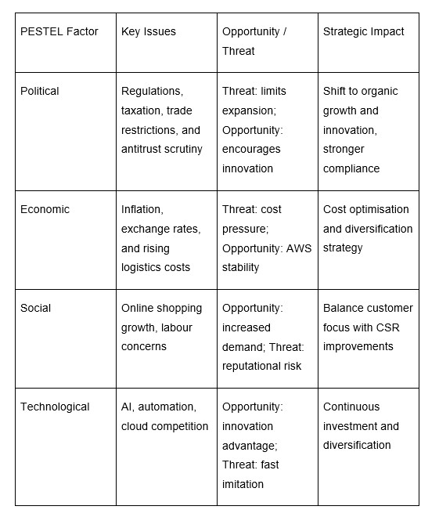

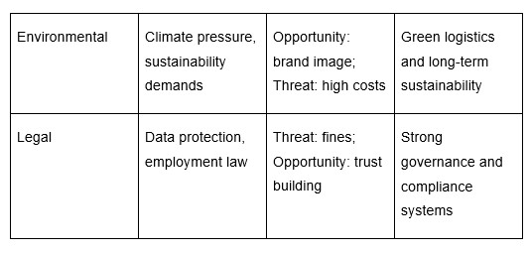
Political Factors
Amazon is faced with growing regulatory pressure, especially in the United States and the European Union, where antitrust regulations and taxation are becoming stricter. This implies that the future of Amazon in terms of acquisition or monopoly of a market may be limited. The strategic implication is that Amazon should embrace organic growth and innovation as opposed to using market consolidation (Grant, 2021).
Comparatively, Microsoft has the same regulatory issues, but it is less vulnerable since it has an enterprise-based model. This means that the retail dominance of Amazon turns it into a more susceptible target of political interference, which can raise the cost of compliance and reduce strategic flexibility.
Economic Factors
Economic factors like inflation, fluctuation of the exchange rates and global recessions directly influence the operating costs and the consumer demand of Amazon. The escalating fuel and logistics prices are increasing the cost of delivery, and this is a threat to the cost leadership strategy at Amazon. This brings out an important strategic conflict between low pricing and profitability.
The diversification of Amazon, especially with the help of AWS, offers financial stability. In comparison with Alibaba, which is heavily dependent on platform-based retail, Amazon has several revenue streams that minimise economic vulnerability. This implies that the diversification plays a very important role as a buffer to the macroeconomic uncertainty (Grant, 2024).
Social Factors
The evolving consumer behaviour, especially the increasing popularity of online shopping and convenience, has also brought many benefits to Amazon. This strengthens the customer-centric approach of Amazon and supports its significant investments in logistical solutions and rapid delivery (Henry, 2021). There are growing threats to reputation due to rising concerns about labour conditions and employee welfare. This can affect customer loyalty and brand value due to a negative public view. This indicates that social factors do not just drive growth, but also cause strategic risk, and Amazon has to manage efficiencies and ethical responsibility.
Technological Factors
Technology is a fundamental source of competitive advantage at Amazon, as the investments in artificial intelligence, automation, and cloud computing have improved the efficiency of operations and customer experience. This shows that the differentiation strategy at Amazon is focused on its technological ability (Lynch, 2021). Nonetheless, the overuse of AWS forms a strategic dependency. Although AWS makes substantial profits, the threat of losing its dominance is due to the growing competition with Microsoft Azure. This may imply that excessive dependence on one segment may subject Amazon to future market risks, and hence the necessity to continue innovating and diversifying (McKinsey, 2023).
Environmental Factors
Corporate strategies are also being influenced by environmental pressures such as climate change and sustainability demands. The Amazon Climate Pledge shows that Amazon is dedicated to carbon emission reduction. This helps in building brand reputation and meets the expectations of the stakeholders, which develops a long-term strategic value (Rose, 2020). Sustainability initiatives are expensive and long-term investments. It poses a trade-off between environmental responsibility and short-term profitability, implying that Amazon should strike a balance between the two conflicting priorities.
Legal Factors
The laws, especially the data protection laws like GDPR, give Amazon high standards of compliance. Lack of compliance may lead to financial fines and loss of reputation. The significance of effective governance and risk management systems is emphasised (Shakeel et al., 2020). Meanwhile, legal restrictions may restrict operational flexibility. It means that the legal considerations serve as a control tool and a strategic obstacle, and Amazon has to constantly adjust its policies and practices.

Critical Success Factors and Strategic Challenges
Critical Success Factors
The success of Amazon is determined by several relevant factors that help the company to compete successfully in the global market:
- Customer-centric strategy: Amazon cares about customer satisfaction; these factors include low prices, the speed of delivery, and a very large selection of products.
- Technological Innovation: The constant investment in AI, cloud computing and automation is used to ensure efficiency and expansion (Zohuri and Moghaddam, 2020).
- Effective logistics chain: a well-developed supply network is a guarantee of fast and dependable delivery.
- Strength of the brand: The reputation of Amazon in the world brings trust and customer loyalty.
These circumstances enable Amazon to stay at a high competitive level.
Strategic Challenges
Amazon has several strategic challenges, notwithstanding its strength:
- Regulatory pressures: an intensification of the scrutiny of the government can restrict the possibility of growth.
- Strong competition: Amazon has to deal with targeted competitors, including Walmart, Alibaba, and Microsoft.
- Expensive operation: Investments in operation, technology and sustainability are costly (Baylis, Wirtz and Johnson, 2022).
- Reputation risk: The issues of labour and environmental problems impact the societal attitude.
These are the issues that keep Amazon in the process of changing its strategies to stay competitive.

Internal Environment Analysis
The internal environment of Amazon is composed of resources, capabilities, and core competencies needed to attain a competitive advantage.
Key Resources
Amazon possesses numerous strong resources:
- Technological infrastructure (AWS): A forefront cloud computing platform that is making high incomes (Goni et al., 2021).
- International logistics network: Modern distribution centre and delivery networks.
- brand value: excellent international recognition, and is respected by the customers.
- Monetary power: Good income and investments.
Capabilities
The competencies of Amazon allow it to apply its resources to the best of its abilities:
- Information-based decision making: Customer information used to make personalised services.
- Efficiency in the supply chain: Rapid and dependable delivery services (Henry, 2021).
- Innovation capability: ongoing production of new products and services.
- Customer relationship management: Customer satisfaction and loyalty.
Core Competencies
The core competencies of Amazon are:
- Innovative cloud computing (AWS).
- Good logistics and delivery network.
- Customer-centric innovation
The competencies make Amazon stand out in the market and assist in its success in the long run.

McKinsey 7S Framework
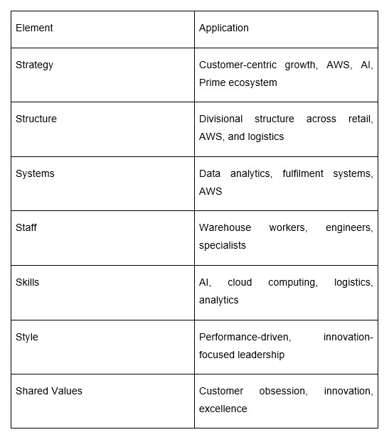
Although, Amazon has an excellent fit throughout the McKinsey 7S framework, the firm has a stronger strategic, systems, and skill-fit than a staff management fit. Its customer-focused approach and high-level AI, cloud computing, and logistics operating capabilities have maintained a competitive edge. But work dissatisfaction, excessive performance pressure and staff turnover expose flaws in work congruency. This produces reputational risks which can impact brand trust meaning that efforts should be made to enhance workforce wellbeing to make organisations effective and sustainable in the long run.

VRIO Analysis
The VRIO analysis will determine the sustainability of the competitive advantage posed by Amazon's resources.
Table 2: VRIO Analysis of Amazon
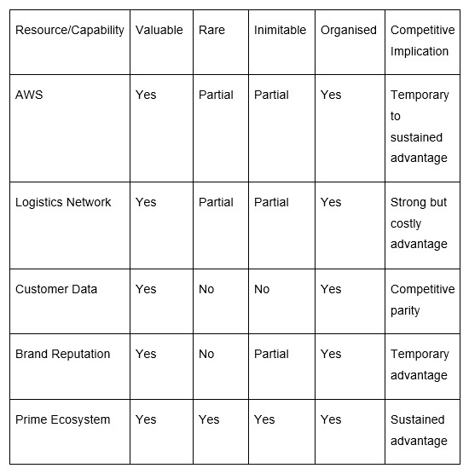
VRIO Discussion
The VRIO analysis shows that Amazon's competitive advantage is not grounded in the individual resources, but rather, in the combination of capabilities, particularly, the Prime ecosystem. Although the provision of resources like AWS and logistics is strong, competition and cost pressures are proving to be increasingly challenging to sustain. This implies that the success of Amazon in the long term lies in innovation and effective integration of its strategic resources instead of depending on a certain resource (Lynch, 2021).

Contribution of Internal Strengths to Competitive Advantage
The internal strengths of Amazon are of great importance in maintaining its competitive advantage in the global market. Its high level of technological ability, especially Amazon Web Services (AWS), leads to the creation of high profitability, and the ability to invest in innovation over the long run is one of its most significant of its strengths. This enables Amazon to stay at the top in e-commerce as well as in cloud computing. The delivery is very quick and confident, providing high consumer satisfaction and increasing the customers' loyalty, due to the highly efficient logistics network of the company.
The data-based strategy of Amazon is an important strategic competitive edge. The company can use the data collected about its customers in large amounts and personalise customer recommendations, streamline operations, and enhance decision-making. This will form an excellent value proposition that is hard to copy by the rivals. According to Whittington et al. (2020), organisations that manage to engage their resources and capabilities to a certain degree have higher chances of attaining sustainable competitive advantage.
This benefit needs to be supported by continuous innovation and strategic investment. Other competitors are also starting to apply such technologies, so that Amazon will not be different over time. Amazon should not stop building new competencies and improving on its competitive advantages to stay at the top of the market.

CSR and Sustainability Objectives
The Corporate Social Responsibility (CSR) strategy of Amazon is closely related to its long-term business goals, specifically, sustainability, innovation, and brand reputation. This firm has already done a lot to ensure environmental sustainability, including The Climate Pledge, which has set out to have net-zero carbon emissions by 2040 (Amazon, 2023). This incorporates renewable energy investment, electric delivery vehicles and sustainable packaging (Hong and Shore, 2023). Such measures show that Amazon is working towards minimising its environmental footprint as it attempts to face growing stakeholder demands of conducting business in an environmentally responsible manner.
Strategically, CSR activities of Amazon go hand in hand with their business goals in the following ways. Sustainability improves the brand image of the company and customer trust, and that assists the company in its customer-focused strategy (Yuan et al., 2020). The environmental problems are becoming a major concern of consumers, and Amazon's green activities contribute to the acquisition and maintenance of eco-friendly clients. Long-term cost savings can be achieved because of investments in energy efficiency and renewable resources, and an increase in operational performance. CSR assists Amazon in adhering to legal requirements and minimising risks of legal issues, as well as facilitating profitable operations worldwide.
The performance of Amazon in the area of CSR also has its critics. The company still has issues with its carbon footprint, high packaging waste and labour practices (Zhou, Wang and Zhao, 2020). The critics state that Amazon encourages sustainability, but its massive businesses remain part of the problem of environmental degradation. The CSR strategy of Amazon contributes to the business goals, as it helps the company build a positive reputation, provides compliance, and becomes more efficient. To realise a more sustainable competitive advantage, the company should more effectively take care of prevailing environmental and social issues (Orlando, 2022).

Comprehensive and Holistic View: Balanced Scorecard
Vision and Strategy
To be the most customer-centric business, through innovation, operational excellence, and worldwide growth.
One of the strategic performance management tools developed by Kaplan and Norton (1992) is known as the Balanced Scorecard, which helps organisations to assess performance on both financial and non-financial platforms. In the case of Amazon, the Balanced Scorecard is especially applicable as the business approach is quite diverse, with high rates of attention paid to customer harmony, innovation, and performance. Through the review of four major lenses, Financial, Customer, Internal Business Processes, and Learning and Growth, Amazon has the potential to streamline its operations towards the achievement of its mission of being the most customer-centric company in the world (Grant, 2016).
Table 3: Amazon’s Balanced Scorecard
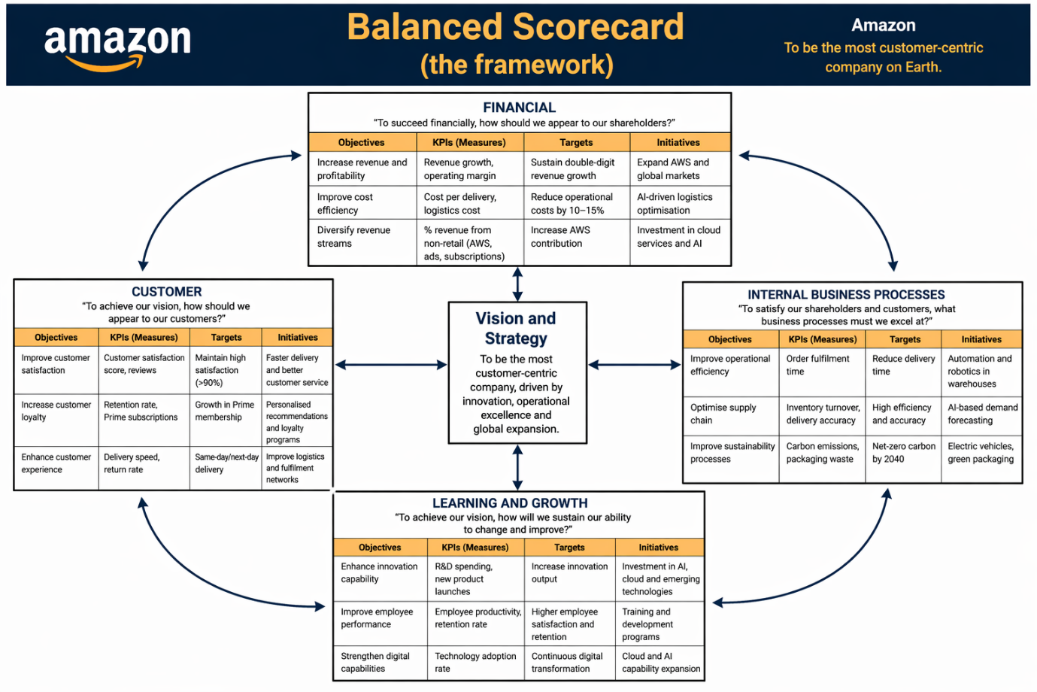

Financial Perspective
The financial aspect is concerned with the company in the capacity of Amazon to make money and be profitable. Sustainability of the financial growth based on diversification and expansion in the worldwide market is the main goal of Amazon. The major key performance indicators (KPIs) are revenue growth, operating margins, and return on investment (Hanson et al., 2016). AWS is decisive and essential in enhancing profitability because it leads to better margins than the retail operations. Strategic plans, including the expansion of cloud service and penetration into new markets, are factors which help Amazon to be financially stable in the long run.

Customer Perspective
The customer perspective of Amazon is the core part of the overall strategy. The company is also focused on the satisfaction of the customers with the provision of low prices, quick delivery and a broad product assortment. Performance is measured by such KPIs as the speed of delivery, customer retention rates, and scores associated with user satisfaction (Park, 2020). One of the significant programs that makes customers more loyal is Amazon Prime, which includes free delivery options and a streaming service. Customer experience is also enhanced further through personalisation using data analytics. There is a persistent challenge of ensuring good quality of the service, but at a low cost.

Internal Business Processes Perspective
The internal processes view is based on the enhancement of operational efficiency and effectiveness. The aim of Amazon is to streamline its chain of supply and delivery systems to provide efficient and quick service. Such KPIs are the order fulfilment speed, delivery accuracy, and cost per delivery (Deepak and Jeyakumar, 2019). The company is investing massively in automation, robotics and sophisticated logistics systems in order to enhance efficiency. The intricacy of a supply chain management endeavour in the global scope presents risks, especially when it comes to interference in times of crisis like pandemics and economic recessions.

Learning and Growth Perspective
The learning and growth point of view focuses on the innovation, employee growth and organisational capacity. Amazon seeks to retain its competitive edge by ensuring that it keeps innovating and enhancing its technology. KPIs entail research and development (R&D) expenditure, employee performance and innovation. Amazon spends a lot on artificial intelligence, cloud computing and employee training. These projects favour long-term development and flexibility (Grant, 2016). Employee satisfaction and workplace concerns can also have an influence on productivity and need to be approached with a strategy.

Strategic Choices and Implementation (Trade-Off Analysis)

Business-Level Strategy: Cost Leadership vs Differentiation
Amazon is both a cost leadership and a differentiation at the business level. It manages to secure economies of scale, advanced logistics and supply chain efficiency to help it offer competitive prices due to its cost leadership strategy. Meanwhile, Amazon also distinguishes itself by rapid delivery, a broad product offering and value-added services like Amazon Prime.
Porter believed that companies would be caught in the middle when they tried to do both at the same time. The quest for faster delivery and a high level of customer satisfaction in the case of Amazon makes the operations, especially those of warehousing and last-mile logistics, considerably more expensive (Ali and Anwar, 2021). This decreases the profit margins of retailing and questions the sustainability of cost leadership.
In comparison, Alibaba uses an asset-light platform model, which has minimum infrastructure costs but provides less flexibility of control over delivery speed. This analogy implies that Amazon cares more about customer experience than profitability in the short-term, and the firm is long-term, strategically oriented, but it is subject to cost pressures (Bogers et al., 2019).

Corporate-Level Strategy: Diversification and International Expansion
On the corporate level, Amazon has managed to pursue a diversification strategy, leaving the e-commerce and entering cloud computing (AWS), digital streaming, and artificial intelligence. Specifically, AWS is a significant source of profitability and proves how related diversification can be effective.
This plan is risky as well. The growing dependence of Amazon on AWS poses a threat of concentration whereby any slowdown in the growth of cloud computing will highly affect the overall performance (Abdulwase et al., 2020). Comparatively, Microsoft has created a more unified ecosystem that combines cloud computing with enterprise software that is not reliant on the use of one revenue stream. This implies that Amazon has been successful in its diversification, but it is not balanced across segments.
The international expansion strategy of Amazon has its chances and threats as well. Although venturing into emerging markets provides the opportunity to grow, it makes the company vulnerable to regulatory, cultural and competitive risks. It means that global expansion has to be selective and locally oriented, but not standardised.

Recommended Strategic Choices
According to this analysis, Amazon has to focus on differentiation rather than on pure cost leadership. Further investment in artificial intelligence, automation, and personalised customer experience will enhance its unique value proposition (Farida and Setiawan, 2022). The effort to be strictly cost-leader might not be sustainable in the face of increasing logistics and labour expenses.
On the corporate level, Amazon ought to engage in balanced diversification by venturing into the high-growth sectors like AI-driven services and enterprise solutions. This would lessen the over-dependence on AWS without technological lag. Also, the internationalisation should target the high-potential emerging markets (e.g., India and Southeast Asia) through localisation strategies.

Strategic Implementation and Change Management
Amazon has clearly shown its ability to cope with strategic change, especially in its efforts to transform into a technology-based organisation rather than an e-commerce one. Constant investment in innovation, automation, and digital infrastructure is a demonstration of being proactive to change (Oskooee, 2016).
The fact that it has grown rapidly has posed implementation challenges. Employee dissatisfaction, high operational cost and organisational complexity are issues that show a lack of alignment between strategy and implementation. This implies that Amazon is a very effective, strategic, innovative company, but it has problems that lead to failure in balancing its internal operations with its strategic goals.
Moreover, the rate of change can result in diminishing returns because continuous innovation can be costly. Thus, successful change management in Amazon should not be based on innovation only, but operational stability and workforce management as well (AlManei, Salonitis and Tsinopoulos, 2018).

Strategic Evaluation and Recommendations
Such tools as SWOT analysis and the Matrix provided by Ansoff can be used to critique the current strategy implemented by Amazon. Such tools can be used to evaluate the strategic position of the company and pinpoint some areas of improvement.

SWOT Analysis
Table 4: SWOT Analysis
Strengths  - Strong global brand  - Advanced logistics network  - Market leader in e-commerce and AWS | Weaknesses  - High operational costs  - Labour and ethical issues  - Low retail profit margins
Opportunities  - Growth in AI and cloud computing  - Expansion in emerging markets  - Sustainability innovation | Threats  - Intense competition (Walmart, Alibaba)  - Increasing regulations  - Economic uncertainty
Based on this analysis, strengths (e.g., AWS and logistics) enable Amazon to gain a competitive advantage, whereas weaknesses (e.g., high operational costs) restrain profitability. Moreover, the threats posed by outside forces, including regulation and competition, show that Amazon has to keep changing its strategy so that it can maintain its position in the market.

Ansoff’s Matrix Analysis
The growth strategy of Amazon fits well with the Matrix in the Ansoff:
- Market Penetration: Building customer loyalty with Amazon Prime and low prices.
- Product Development: Adding new services, i.e., AI tools and cloud solutions.
- Market Development: International expansion.
- Diversification: Social media and smart devices: Accessing digital streaming and entering new markets.
Amazon has been able to implement diversification, especially with AWS, which is now a significant source of profit (Zugay and Zakaria, 2023). The growing complexity and risk that are caused by diversification need effective control.
The approach pursued by Amazon is very successful in sustaining the market leadership by innovation and customer orientation. It has a problem of balancing cost leadership and differentiation. An increase in logistics/labour costs can decrease profitability, and the regulatory forces might curtail growth. The high growth rate in the company has enhanced the complexity of its operations, and this could have an impact on efficiency.

Recommendations
AI-Driven Logistics Optimisation:
Amazon should introduce an improved system of AI-powered demand prediction and route optimisation across the entire logistics network, particularly in the regions that are expensive to operate in, such as North America and Europe (Bryson and George, 2020). This would allow the placement of inventory more accurately and also allow efficient delivery routing. This enables the minimisation of the cost of operations without deterring the velocity of delivery, which directly responds to the trade-off of strategy between the cost leadership and differentiation.
Reduce AWS Dependency Risk:
The approach used by Amazon is very efficient in attaining market leadership, but it has its shortcomings. The logistics and innovation investment are heavy, which makes the company less profitable within a short period, as it makes the financial sustainability questionable. Also, reliance on AWS poses a strategic threat, especially when the competition with Microsoft deepens.
Although the customer-focused strategy of Amazon can be used to achieve loyalty, it can also result in diminishing margins as the constant enhancement of the service level becomes more and more expensive. The success of Amazon in the long-term is determined by its capacity to be able to balance between its growth, cost efficiency, and strategic diversification (Baylis, Wirtz and Johnson, 2022).
Targeted Emerging Market Expansion:
Rather than expanding globally on the board, Amazon should look at localisation approaches in local high-growth markets such as India and Southeast Asia by making partnerships with local firms and adapting to local price models. It is a particular strategy that minimises regulatory as well as cultural risks and maximises market penetration and long-term growth potential.
Improve Employee Strategy:
At Amazon, the company can increase the welfare of its employees through performance-based pay and enhancing the working conditions within the warehouses. This would reduce reputational risk, increase productivity, and lead to sustainable organisational performance since it is consistent with the concepts of the stakeholder theory.

Section 2: Reflective Account
This reflection report assesses my learning experience during researching, analysing, and preparing a strategic management report on Amazon. The framework of critical reflection on my experience is Gibbs (1988) Reflective Cycle. The cycle encompasses six steps: description, feelings, evaluation, analysis, conclusion, and action plan. This reflection will assist in realising the actual strengths, weaknesses, and gaps in my academic and analytical skills to succeed.

Figure: Gibbs Reflective Cycle (Gibbs, 1988)

Description
The assignment required a critical study of Amazon's strategic management practices, its internal and external environments, CSR strategy, and performance across the entire organisation. To accomplish this task, I used some important strategic frameworks that I learned during classes, such as PESTEL, VRIO, SWOT analysis, and the Balanced Scorecard. These models allowed us to organise the analysis and assess Amazon's position as a competitor systematically (Aaron et al., 2021). I performed thorough academic research utilising academic journals, books and sound internet sources, including reporting of companies of interest and other statistical databases to support my work.
It started with the choice of Amazon as the case study due to its great worldwide presence and its association with the digital transformation and innovation (Chang, 2019). I then collected data on its history, business model, and the environment in which the organisation operates, as I created a concise picture of the organisation. I followed this step by using applicable theoretical frameworks to examine the strategic position of Amazon and determine its weaknesses and strengths. Lastly, I compiled my results into a report that was well structured and formulated recommendations on the basis of the analysis.

Feelings
Throughout the initial stages of the assignment, I was faced with a daunting task because I had to implement several strategic frameworks and be able to be critical in my examinations. I did not know how to associate theory and practical examples effectively. Nevertheless, further on, I felt increasingly firm in my knowledge of the concepts of strategic management.
The case study of working with Amazon was both intriguing and inspiring due to its innovative method of doing business and its influence on the whole world (Bailey, 2016). I was excited when I analysed its strategies and more so when I was using models like VRIO and PESTEL. By the completion of the assignment, I had a feeling of accomplishment since I could critically assess a real-life organisation through the academic theory.

Evaluation
There was a good and a bad side to the overall process of completing the assignment. The possibility of using the theoretical knowledge in the context of a real-life organisation was one of the critical strengths. This assisted me in gaining a greater insight into the concept of strategic management and its application in the field (Schaffer and Rodolfa, 2020). Besides, the appearance of various frameworks enabled me to compare Amazon in various ways, which resulted in a more thorough report.
The amount of information about Amazon that is available is a challenge that one of them encountered. Sometimes, this proved to be difficult because of establishing the most pertinent and credible sources. The other problem was the need to have an analysis that is critical but not descriptive (Bogers et al., 2019). Sometimes, I would be explaining the strategies of the company, rather than analysing them.

Analysis
This task has elucidated the role of combining theory and practice in strategic management. The PESTEL and VRIO models helped to utilise a systematic method and analyse the environment and capabilities of Amazon. Whittington et al. (2019) assert that strategic frameworks assist organisations to comprehend their competitiveness and make well-informed decisions.
It is through this process that I realised that critical thinking is critical in strategic analysis. That is not the reason to explain what a company does, but I would like to estimate why it does it and how successfully these strategies work. To analyse the diversification strategy of Amazon, it was important to comprehend the advantages to Amazon (i.e., the revenue boost by taking an interest in AWS) and the disadvantages (i.e., the complexity) (Abdulwase et al., 2020).
Another aspect was time management. To accomplish a huge task, one had to plan and organise. The division of the task into small parts allowed me to cope with the workload better. Another way in which the academic sources enhanced the quality of the analysis was that the arguments were backed by evidence.

Conclusion
This assignment proved to be a great learning process that helped me improve my knowledge of strategic management. I learned how to do research, analyse, and write academic papers. Another useful practical insight that I gained was how strategic frameworks can be translated into real organisations.
Although I had some issues managing the information and keeping a critical approach, I could handle them by practising and planning. The assignment has helped me become more confident in terms of problem-solving, business solutions and providing knowledge-based recommendations.

Action Plan
Based on this reflection, it is possible to mention several areas of improvement in the future. I will develop my critical thinking techniques through writing more analytically and also focusing more on evaluation, as opposed to description. Secondly, I will learn to better my research skills by employing a broader academic base and improve my ability to recognise the informational pertinence.
Thirdly, I will strive to join the field of time management by ensuring that I complete my tasks earlier and develop a strategy. This will assist in eliminating stress and enhancing the quality of my work. Lastly, my goal will be to become a better academic writer by being more careful about the structure, clarity, and referencing.
With such enhancements in place, I shall be more ready to handle any future tasks and career-related issues. The given reflective process has allowed me to see my strong and weak points, and it will assist me in my further evolution as a student and a future employee.

References
Aaron, L., Hicks, J., McKnight, A., and Andary, J. (2021). Reflection as a Tool for Personal and Professional Development. Radiologic technology, 93(2). https://openurl.ebsco.com/openurl?sid=ebsco:plink:scholar&id=ebsco:gcd:153269502&crl=c
Abdulwase, R., Ahmed, F., Nasr, F., Abdulwase, A., Alyousofi, A., and Yan, S. (2020). The role of business strategy is to create a competitive advantage in the organisation. Open Access J Sci, 4(4), 135-138. https://www.researchgate.net/profile/Faroq-Ahmed/publication/344944641_The_role_of_business_strategy_to_create_a_competitive_advantage_in_the_organization/links/5f9a2af5299bf1b53e4edc60/The-role-of-business-strategy-to-create-a-competitive-advantage-in-the-organization.pdf
Ali, B. J., and Anwar, G. (2021). Business strategy: The influence of Strategic Competitiveness on competitive advantage. International Journal of Electrical, Electronics and Computers, 6(2). https://papers.ssrn.com/sol3/papers.cfm?abstract_id=3835696
AlManei, M., Salonitis, K., and Tsinopoulos, C. (2018). A conceptual lean implementation framework based on change management theory. Procedia cirp, 72, 1160-1165. https://www.sciencedirect.com/science/article/pii/S2212827118302981
Amazon.com Inc. (2023) Annual Report 2023. Available at: https://s2.q4cdn.com/299287126/files/doc_financials/2024/ar/Amazon-com-Inc-2023-Annual-Report.pdf
Bailey, B. (2016). Turning experience into learning. Journal of Health Visiting, 4(11), 586-586. https://www.magonlinelibrary.com/doi/abs/10.12968/johv.2016.4.11.586
Baylis, J., Wirtz, J. J., and Johnson, J. L. (Eds.). (2022). Strategy in the contemporary world. Oxford University Press. https://books.google.com.bd/books?hl=en&lr=&id=sfhgEAAAQBAJ&oi=fnd&pg=PP1&dq=Contemporary+strategy+analysis&ots=ynmx_NbdTv&sig=TSY8-SOfsqvA3KgKygE2Wnht0Wo&redir_esc=y#v=onepage&q=Contemporary%20strategy%20analysis&f=false
Bogers, M., Chesbrough, H., Heaton, S., and Teece, D. J. (2019). Strategic management of open innovation: A dynamic capabilities perspective. California Management Review, 62(1), 77-94. https://journals.sagepub.com/doi/abs/10.1177/0008125619885150
Bryson, J., and George, B. (2020). Strategic management in public administration. In the Oxford research encyclopedia of politics. https://oxfordre.com/politics/display/10.1093/acrefore/9780190228637.001.0001/acrefore-9780190228637-e-1396
Chang, B. (2019). Reflection in learning. Online learning, 23(1), 95-110. https://eric.ed.gov/?id=ej1210944
Deepak, R. K. A., and Jeyakumar, S. (2019). Marketing management. Educreation Publishing. https://books.google.com.bd/books?hl=en&lr=&id=_DmvDwAAQBAJ&oi=fnd&pg=PA1&dq=Marketing+Management.&ots=u57Zgnar-j&sig=-QvPyQ_77VvW2WbQEBq_6giwBYI&redir_esc=y#v=onepage&q=Marketing%20Management.&f=false
Enholm, I. M., Papagiannidis, E., Mikalef, P., and Krogstie, J. (2022). Artificial intelligence and business value: A literature review. Information systems frontiers, 24(5), 1709-1734. https://link.springer.com/article/10.1007/s10796-021-10186-w?trk=public_post_comment-text
Farida, I., and Setiawan, D. (2022). Business strategies and competitive advantage: the role of performance and innovation. Journal of open innovation: Technology, market, and complexity, 8(3), 163. https://www.sciencedirect.com/science/article/pii/S2199853122007648
Ferlie, E., and Ongaro, E. (2022). Strategic management in public services organisations: Concepts, schools and contemporary issues. Routledge. https://www.routledge.com/Strategic-Management-in-Public-Services-Organizations-Concepts-Schools-and-Contemporary-Issues/Ferlie-Ongaro/p/book/9780367517151
Gibbs, G. (1988) Learning by Doing: A Guide to Teaching and Learning Methods. Oxford: Oxford Polytechnic. https://www.scirp.org/reference/referencespapers?referenceid=478921
Goni, F. A., Gholamzadeh Chofreh, A., Estaki Orakani, Z., Klemeš, J. J., Davoudi, M., and Mardani, A. (2021). Sustainable business model: A review and framework development. Clean Technologies and Environmental Policy, 23(3), 889-897. https://link.springer.com/article/10.1007/s10098-020-01886-z
Grant, R. M. (2016). Contemporary strategy analysis: Text and cases edition. John Wiley & Sons. https://books.google.com.bd/books?hl=en&lr=&id=DTDvCQAAQBAJ&oi=fnd&pg=PP15&dq=Contemporary+Strategy+Analysis&ots=eoPMbJd41H&sig=pXDhNkQozDQedrUQrizY9noU5po&redir_esc=y#v=onepage&q=Contemporary%20Strategy%20Analysis&f=false
Grant, R. M. (2021). Contemporary strategy analysis. John Wiley & Sons. https://books.google.com.bd/books?hl=en&lr=&id=TadJEAAAQBAJ&oi=fnd&pg=PR5&dq=Contemporary+strategy+analysis&ots=oSZ6TLooM4&sig=KrUVwtDGumyyFReuTg2LwToLYbc&redir_esc=y#v=onepage&q=Contemporary%20strategy%20analysis&f=false
Grant, R. M. (2024). Contemporary Strategy Analysis, with eBook Access Code. John Wiley & Sons. https://books.google.com.bd/books?hl=en&lr=&id=kkAoEQAAQBAJ&oi=fnd&pg=PR5&dq=Contemporary+strategy+analysis&ots=fGhdR0gqGF&sig=pBGoyGDbDqDHWRiqSbMNlB8K7uY&redir_esc=y#v=onepage&q=Contemporary%20strategy%20analysis&f=false
Hanson, D., Hitt, M. A., Ireland, R. D., and Hoskisson, R. E. (2016). Strategic management: Competitiveness and globalisation. Cengage Au. https://books.google.com.bd/books?hl=en&lr=&id=gVtnDwAAQBAJ&oi=fnd&pg=PR18&dq=Strategic+Management:+Competitiveness+and+Globalization.&ots=4Kbr977GxE&sig=I8WWA36x-m-uUExk6suUs7F0Y3k&redir_esc=y#v=onepage&q=Strategic%20Management%3A%20Competitiveness%20and%20Globalization.&f=false
Henry, A. (2021). Understanding strategic management. Oxford University Press. https://books.google.com.bd/books?hl=en&lr=&id=M7wyEAAAQBAJ&oi=fnd&pg=PP1&dq=Strategic+Management&ots=Z4z2qhiEyr&sig=m0wwjiZWYK874xrZ4GLrQ1ybMdo&redir_esc=y#v=onepage&q=Strategic%20Management&f=false
Hong, H., and Shore, E. (2023). Corporate social responsibility. Annual Review of Financial Economics, 15(1), 327-350. https://www.annualreviews.org/content/journals/10.1146/annurev-financial-111021-094347
Lynch, R. (2021). Strategic management. Sage. https://books.google.com.bd/books?hl=en&lr=&id=MyAMEAAAQBAJ&oi=fnd&pg=PP1&dq=Strategic+Management&ots=lzhxmQMpqU&sig=OX9fcnIP2ldMo0_CS5MR6BXX-lA&redir_esc=y#v=onepage&q=Strategic%20Management&f=false
McKinsey and Company (2023). The State of AI in 2023. Available at: https://www.mckinsey.com
Orlando, B. (Ed.). (2022). Corporate social responsibility. BoD–Books on Demand. https://books.google.com.bd/books?hl=en&lr=&id=Q55lEAAAQBAJ&oi=fnd&pg=PR13&dq=Corporate+Social+Responsibility&ots=pmzbvs8dJt&sig=XgL1wKZ_ARhoE3NdEBmrJ6b9ic8&redir_esc=y#v=onepage&q=Corporate%20Social%20Responsibility&f=false
Oskooee, H. A. (2017, December). Key factors in strategy implementation. In Proceedings of the International Conference on Intellectual Capital, Knowledge Management & Organisational Learning (pp. 355-364). https://books.google.com.bd/books?hl=en&lr=&id=5blDDwAAQBAJ&oi=fnd&pg=PA355&dq=Strategic+Implementation+and+Change+Management&ots=Zp-WIjY0M1&sig=IM99X2xCsZIOcjaRlJHuZKDbQ-8&redir_esc=y#v=onepage&q=Strategic%20Implementation%20and%20Change%20Management&f=false
Park, S. (2020). Marketing management (Vol. 3). Seohee Academy. https://books.google.com.bd/books?hl=en&lr=&id=p6v7DwAAQBAJ&oi=fnd&pg=PA1993&dq=Marketing+Management.&ots=XzXsbpbUbb&sig=Z9N8FXn3e6ChWERzC_N-x0vPwuI&redir_esc=y#v=onepage&q=Marketing%20Management.&f=false
Rose, D. (2020). Artificial intelligence for business. FT Press. https://books.google.com.bd/books?hl=en&lr=&id=DNrPEAAAQBAJ&oi=fnd&pg=PT15&dq=The+business+of+artificial+intelligence.&ots=He0txEob3O&sig=j9dgBk2RKyu0s7q7X_Lojb4petE&redir_esc=y#v=onepage&q=The%20business%20of%20artificial%20intelligence.&f=false
Schaffer, J. B., and Rodolfa, E. R. (2020). Reflecting on reflective practice. https://psycnet.apa.org/fulltext/2021-22460-001.html
Shakeel, J., Mardani, A., Chofreh, A. G., Goni, F. A., and Klemeš, J. J. (2020). Anatomy of sustainable business model innovation. Journal of Cleaner Production, 261, 121201. https://www.sciencedirect.com/science/article/abs/pii/S0959652620312488
Whittington, R., Regnér, P., Johnson, G., Angwin, D., and Scholes, K. (2019). Exploring strategy. Pearson UK. https://books.google.com.bd/books?hl=en&lr=&id=ieksEAAAQBAJ&oi=fnd&pg=PT26&dq=Exploring+Strategy&ots=XEH7WnLgc9&sig=TL_B5hpDVP2u4dj1MDCs6BDnZnI&redir_esc=y#v=onepage&q=Exploring%20Strategy&f=false
Yuan, Y., Lu, L. Y., Tian, G. y Yu, Y. (2020). Business strategy and corporate social responsibility. Journal of Business Ethics, 162(2), 359-377. https://link.springer.com/article/10.1007/s10551-018-3952-9
Zhou, H., Wang, Q., and Zhao, X. (2020). Corporate social responsibility and innovation: a comparative study. Industrial Management & Data Systems, 120(5), 863-882. https://www.emerald.com/imds/article-abstract/120/5/863/445857/Corporate-social-responsibility-and-innovation-a?redirectedFrom=fulltext
Zohuri, B., and Moghaddam, M. (2020). From business intelligence to artificial intelligence. Journal of Material Sciences & Manufacturing Research, 1(1), 1-10. https://www.researchgate.net/profile/Bahman-Zohuri/publication/338924495_From_Business_Intelligence_to_Artificial_Intelligence/links/5e332d76458515072d70f517/From-Business-Intelligence-to-Artificial-Intelligence.pdf
Zugay, B., and Zakaria, R. (2023). Ansoff matrix. SAGE Publications, Inc.. https://sk.sagepub.com/foundations/ansoff-matrix?tab=Theory+In+Practice#_

