
School of Hospitality & Tourism Management BA International Hotel Management
BMIH5007: Financial Management for the
Hotel Industry
LEVEL 5

Module Lecturer:

Christopher wilkin
c.wilkin@uwtsd.ac.uk
Student name: Md Shahidul Islam
Student Id:2026286

Executive Summary

A budget is a financial plan of income and expenses for a given timeframe that is often constructed and reviewed regularly. Budgeting helps a company to regulate its costs and income for a sustainable outcome in the market. In short, it can be said that budgeting is one of the key ways to success for a business as it balances the expenses with the income to adjust its financial stability, meet the financial goals, gives control over the money, provides protection in the event of unusual occurrences, prevents from acquiring new or additional debt, and lastly, improves overall financial well-being.

Table of Contents
Executive Summary
1. Introduction
2. 500 words Analysis of Grand hotel budget planner
3. Task 2
3.1 Importance of budgeting
3.2 Understanding of incremental budgeting
3.3 Activity based
3.4 Value proposition based
3.5 Zero based budgeting
3.6 How budgeting control can support sustainability
4. Conclusion
5. Reference List
6. Appendix with Excel Budget planner

1. Introduction
Budgeting is the process of developing a spending plan that balances a person's or a firm’s income and expenses. This spending plan is called a budget. Perhaps, one may decide in advance if they will have enough money to do the things they want to do or would like to do by creating this spending plan. Therefore, it is simply balancing the expenses with the income. A budget is a strategy for making financial decisions over a specific time frame, typically a month or a year [1] However, a budget may also include anticipated assets, liabilities, sales volumes, revenues, and resource quantities, such as time, costs, and expenses. Predicted environmental and other effects could also be included in budgeting [2]. It might indicate a surplus of resources for later use or a deficit where expenses exceed income or other available resources. Indeed, all types of businesses require a budget [3]. Moreover, to expand the business and reach its financial goals budgeting is important. A company's management can ensure that they have the cash flowing in to cover costs when budgeting is done correctly. In a nutshell, a sound budget can undoubtedly help a company function more efficiently by establishing goals, communicating priorities, and producing reports for possible investors.

2. 500-words analysis of Grand hotel budget planner
Grand Hotel Budget Planner is very good example of how a company should maintain their financial budget. Grand Hotel tried to follow action-based budget planner. As here, the are trying to find out each financial activities and track it down in the budget planner. They have made this budget for the financial year between April ‘22 to March ‘23.They have divided the planner into three part mainly - revenue section, expense section and bank transaction section. On the revenue part, they have wrote down all probable source of revenue generation sector. Here, one sector is interest rate sector which depends on the bank balance at the end of each month. If the bank balance remains positive at the end of a particular month, the hotel will get the interest from the bank. Otherwise, bank will charge overdraft fee and it will go to the expense sector. In our calculation, all the month ended with positive bank balance, so they got interest after every month.
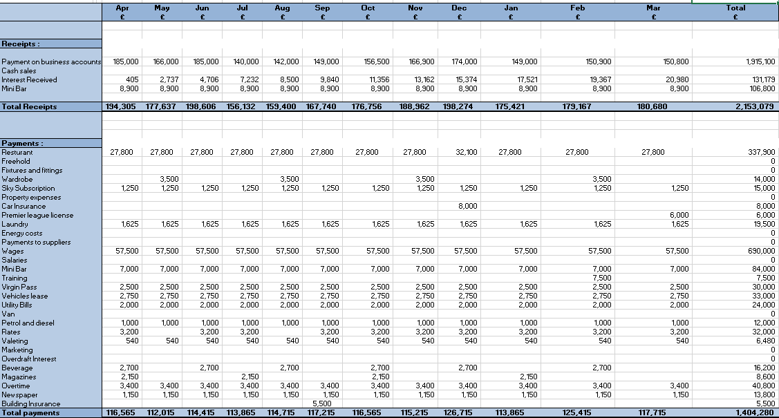
Source: Budget Planner Calculation
In the expense section, all the probable expense sectors were written down very carefully. In some sectors, the expense is given monthly. Though there are some other sectors which didn’t charge at certain months. Other that, some sectors was charged bimonthly though the fee was given on the monthly basis. Another interesting sector is paying the instalment fee of wardrobe. Though it was stated that the first instalment should be started from May and there are total four instalments needed to pay but was not mentioned what will be the time lapse between these instalments. So, on the basis of this difference there might come difference in the cashflow and bank interest rate as well. After each month, the difference between total revenue and total expense is stated as cashflow. There was a credit deposited at the beginning month of April, which we have taken as B/f or brought forward money. If we add B/f and cashflow, we’ll get C/f or carried forward money of that month. C/f of one month will be directed as next months B/f. At the end, we’ll see that total cashflow of the whole year is the difference between the c/f of the last month of the financial year and b/f of the first of the financial year.

3. Task 2

3.1 Importance of budgeting
Budgeting is an essential component of controlling expenditure. However, as previously covered, we are clear that the procedure of creating and managing a financial record that forecasts revenue and spending for a period of time is known as budgeting. The effectiveness of budgeting cannot be underestimated. Therefore, a budget is essential for devising a financial plan that forecasts predicted future cash inflows and outflows for the business and works as a benchmark for evaluating the success or failure of managers [4]. Budgets put a company's finances under effective control by stopping it from spending more than it brings in. Additionally, taking part in the budgeting process gives employees control over their financial results, which empowers them [5]. Likewise, the budgeting process stimulates the management department to engage and communicate, which helps to increase understanding of the needs of other departments. Without a budget, one might not know how his firm is doing. One may easily grasp how much money they have, how much they have spent, and how much money they will need in the future for their company by making a budget. Alternatively, this budget can shape significant managerial decisions like reducing excessive expenditure, hiring more people, or investing in new equipment [6]. If a business runs out of money, the budget can help it change its plan or decide which spending to prioritise.

There are four different budgeting methods used by businesses. They are incremental budgeting, activity based budgeting, value proposition, and zero based budgeting. Each of these four budgeting methods has advantages and drawbacks, which will be covered in more detail later.

3.2 Understanding of incremental budgeting
The traditional method of budgeting, known as incremental budgeting, is prepared with the current period's budget as a base which is then adjusted by the incremental amounts. This is normally done by using the budget from the previous year and making adjustments for some increase in costs [7]. Furthermore, one of the simplest budgeting techniques is incremental budgeting. Since the incremental budget analyses the future budget using the budget for the current period, it does not need complicated calculations. Even if it is simple and consistent, incremental budgeting is commonly criticised for having a number of fundamental problems that encourage overspending, inhibit innovation, fail to take changes and outside influences into account, and ultimately lack motivation for a comprehensive examination [8].

3.3 Activity based
Activity-based budgeting is a much more in-depth approach to cost analysis than traditional budgeting methods, which only make adjustments for inflation or changes in business activity. The activity-based budgeting (ABB) system monitors, researches, and assesses the activities that result in expenditures for a business. When constructing a budget, ABB does not consider previous costs [9]. In addition, the activity-based budgeting system links expenses to activities, and then budgets expenditures based on the anticipated level of activity. Moreover, this budgeting system focuses on the volume and types of activities taking place within an organisation and provides for a high degree of cost planning refinement. A possible result of adopting this strategy is management planning to lower the activity levels required to generate revenue, which will drive profits [10]. Additionally, if managers wish to improve a company's cost structure, they must possess a thorough understanding of all corporate operations which will lead the company to an advantage. On the contrary, the downside of activity-based budgeting is the added workload involved in tracking activities for which conventional tracking methods may not exist. And expenditures must be linked to activities, for which there might not even be any controls in place. As a result, setting up such a system can be challenging.

3.4 Value proposition based
Value proposition budgeting, also known as priority-based budgeting, focuses on evaluating and disputing the worth of every item on a list of costs for a given fiscal period [12]. In the end, the goal is to determine where a company should invest its funds to generate a profit. Revenue and expenditure estimations based on past outcomes are a part of value-based budgeting [13]. Afterward, you can utilize this data to guide profitable ideas shortly. As a result, value proposition budgeting is essential to validate a business idea, whether the company is just starting or growing.

3.5 Zero based budgeting
ZBB is short for zero-based budgeting, and it's a form of budget planning where each new budget period's costs must be justified and approved. Beginning with a "zero base," every function inside an organisation is evaluated for its needs and expenditures as part of the zero-based budgeting process [14]. Hence flexible budgets, targeted operations, cheaper expenses, and more methodical execution are the key strengths of zero based budgeting. Whereas the limitations include the potential for resource-intensiveness, vulnerability to manipulation by sophisticated managers, and inclination toward short-term planning [15].

3.6 How budgeting control can support sustainability
A key component of financial management for sustainable development is budgeting. The effectiveness of the company's capital investments and resources is also maintained using budgeting [16]. Though a business might survive without a budget due to the great demand from customers and the lack of strong competition, but a proper budgeting can control unwanted expenditures, identify the edges in operating the company, recognise inefficient investment and can drive a company effectively towards its goal [18]. However, a company's income must equal or exceed their expenses in order for a budget to be considered sustainable. Based on expected or actual costs and income, it is possible . Lastly a sustainable budget can drive it’s client's workforce, help the companies’ management department to identify the need of their firm, and constraints the expenditures and enhance profitability in a firm at a whole [19].

4. Conclusion
To give an abstract of the discussed topic it is clear that budgeting is essential for any firm to run effectively. Setting a budget enhances financial stability. Without a budget it is challenging to operate a company in this competitive market [20]. Overall, the significance of budgeting is undeniable and having a budget helps a person's financial situation, both now and in the future.

5. Reference List
- Tan, S.K., 2011. Intelligent budget planner (Doctoral dissertation, UTAR).
- Melnichuk, N., 2015. Budget planning in financial management. Baltic Journal of Economic Studies, 1(2), pp.95-100.
- Oktari, Y., Sari, R.N. and Rasuli, M., 2020. The Effect of Budget Planning, Budget Implementation, the Competency of Human Resources and Understanding of Regulation on Village Financial Budget Absorption with Organizational Commitment as Moderating Variable. International Journal of Economics, Business and Applications, 5(1), pp.17-32.
- Mirgorodskaya, E.O., Andreeva, L.Y., Sugarova, I.V. and Sichev, R.A., 2017. Balanced budget system: organizational and financial tools.
- Wildavsky, A., 1981. A budget for all seasons: Why the traditional budget lasts. In State Audit (pp. 253-268). Palgrave Macmillan, London.
- Emerling, I. and Wojcik-Jurkiewicz, M., 2018. The risk associated with the replacement of traditional budget with performance budgeting in the public finance sector management. Ekonomicko-manazerske spektrum, 12(1), pp.55-63.
- Bleeker, R., 2001. Key features of activity-based budgeting. Journal of Cost Management, 15(4), pp.5-20.
- Huynh, T., Gong, G. and Huynh, H., 2013. Integration of activity-based budgeting and activity-based management. International Journal of Economics, Finance and Management Sciences, 1(4), pp.181-187.
- Huynh, T., Gong, G. and Huynh, H., 2013. Integration of activity-based budgeting and activity-based management. International Journal of Economics, Finance and Management Sciences, 1(4), pp.181-187.
- Bengü, H., 2010. THE ROLE OF ACTIVITY BASED BUDGETING ON TARGET COSTING PRACTICES. Suleyman Demirel University Journal of Faculty of Economics & Administrative Sciences, 15(1).
- Pyhrr, P.A., 2012. Zero‐Based Budgeting. Handbook of budgeting, pp.677-696.
- Al-attara, H.A., Mashkourb, S.C. and Hassanc, M.G., 2020. Zero-based budget system and its active role in choosing the best alternative to rationalise government spending. International Journal of Innovation, Creativity and Change, 13(9), pp.244-265.
- Otten, G., 1978. Zero-based budgeting: implications for social services?. Administration in Social Work, 1(4), pp.369-378.
- Al Ahbabi, A.R. and Nobanee, H., 2019. Conceptual building of sustainable financial management & sustainable financial growth. Available at SSRN 3472313.
- Dudin, M., Kucuri, G., Fedorova, I., Dzusova, S. and Namitulina, A., 2015. The innovative business model canvas in the system of effective budgeting. Asian Social Science, 11(7), pp.290-296.
- Antić, L. and Novićević, B., 2011. Zero-Based Budgeting and Activity-Based Budgeting as Alternative Systems of Budgeting. ECONOMIC, p.363.
- Jin, S.H., Jeong, S.J. and Kim, K.S., 2017. A linkage model of supply chain operation and financial performance for economic sustainability of firm. Sustainability, 9(1), p.139.
- Al Breiki, M. and Nobanee, H., 2019. The role of financial management in promoting sustainable business practices and development. Available at SSRN 3472404.
- Ekpo, N.B., Etukafia, N. and Udofot, P.O., 2017. Finance manager and the finance function in business sustainability. International Journal of Business, Marketing and Management, 2(1), pp.31-38.
- Meyer, K.S. and Kiymaz, H., 2015. Sustainability considerations in capital budgeting decisions: A survey of financial executives. Accounting and Finance Research, 4(2), pp.1-13.

6.Appendix Budget Calculations

