Targed/Target 1 | Try to broaden the range of your reading.  I have done this by using a wider range of reading, including books, articles, journals and government documents.
Targed/Target 2 | Develop criticality in your writing, rather than being too descriptive.  I have done this by trying to be critical of some of the learning theories.
Targed/Target 3 | Proofread your work for accuracy in expression and for sentencing.  I have done this by proofreading my work, ensuring the punctuation and sentencing is correct.
Targed/ Target 4 | To make the assignment flow and not seem disjointed.  I have done this by not including subtitles and trying to paragraph my work, so it flows better.

Choose an intervention that supports the learning and development of a pupil/ group of pupils. Reflect critically on its potential for ensuring pupil progression and the possible challenges that may arise.

The aims of this assignment are to aid progression through a chosen intervention for a pupil and to face the possible challenges that may arise throughout. This assignment will also deepen the writers understanding of theorist and research that underpin child development. The theme chosen within this assignment is wellbeing, focusing on social and emotional development. The chosen intervention will support the learning and development of a pupil in Key Stage 2. Interventions are put in place for children who have difficulty with some aspects of learning. Such difficulties need to be identified early and addressed before they become entrenched. With this in mind, early intervention is therefore an integral part of good teaching and learning (Donaldson, 2015). Interventions can impact children’s development and improve academic attainment. Furthermore, they can also impact on children’s health and wellbeing. The pupil chosen is called Josh. Josh is a made-up pupil who was created for this assignment, he is eight years old and is a year four pupil who is in mixed class of 20 learners. Josh is a vulnerable pupil as he struggles aspects of his social and emotional development.
In terms of Josh’s development (See Appendix 1) there are a few areas which are of cause for concern for his teacher. Regarding Josh’s behaviour in the classroom, he lacks motivation when completing tasks. The teacher believes that Josh’s lack of motivation is influencing his performance. Pintrich (2003) and Schunk (1995) state: “motivation influences learning and performance and what students do and learn influences their motivation.”
Josh’s cognitive development is another cause for concern as he is not confident with problem solving when working independently and often gives up if he fails the first time. This is cause for concern as Piaget (1936) states that the concrete operational stage (age seven to eleven) is a major turning point in a child’s cognitive development because it marks the beginning of logical operational thought (McLeod, 2018). What’s more Josh’s social skills need to be developed as he lacks these skills when playing or working in a group. This may be because Josh finds it hard to sustain friendships. Parten’s stages of play suggest that from age six and above children should play together with shared aims. Parten suggest that this is the beginning of teamwork (Johnson, 2020; Parten 1929). Finally, regarding Josh’s emotional development, he struggles with skills such as expressing his feelings. Brookes (2014) state: “Emotions can support or impede pupils’ learning, their academic engagement, work ethic, commitment, and ultimate school success.” Josh’s teacher sees this area as a cause for concern as poor emotional wellbeing can impact mental health, social skills, participation and achievement.
The intervention that was chosen to focus on in this assignment was SEAL, which stands for social and emotional aspect of learning. SEAL is based on international research into children’s emotional and social development. That said, “improving the emotional and mental health of children and young people is a key priority for the Welsh Government” (Welsh Government, 2016). SEAL is an intervention which aims to support children aged three to sixteen to develop their personal and social skills of self-awareness, managing feelings, empathy and motivation. This intervention promotes social and emotional literacy in children and equips them with skills they need to lead a healthy, happy life. SEAL is embedded throughout the curriculum and in everyday school life rather than as a subject (TheSchoolRun, 2020). SEAL is delivered in three waves of intervention, the first is a whole school approach where social and emotional skills can be promoted (See appendix 2). In order to teach SEAL as a whole school approach the materials are organised into six themes for each half term (See appendix 3). Each theme is designed for a whole-school approach and includes a whole-school assembly and suggested follow-up activities in all areas of the curriculum (Department for Education, 2005). Wave two of the intervention involves a small group of children who require additional support when developing their social and emotional skills (Humphrey et al, 2008). The final wave is a one to one intervention for children who have not benefitted from the whole school approach or group intervention (Humphrey et al, 2008). Significantly, 70% of schools are involved with SEAL at some level, this intervention also engages staff and families. Estyn (2020) state that schools that best support vulnerable pupils place the wellbeing of pupils at their heart.
This intervention was chosen to develop Josh’s social and emotional skills. In order to support Josh’s development, he will be involved with wave one of this intervention as the teacher believes his social and emotional skills can be effectively promoted throughout this approach. The benefits of this intervention include managing feelings, solving problems, increasing independence and sustaining friendships. In addition to this, this intervention should develop Josh’s motivation when completing a task, improve his attainment and increase academic progress. “Better emotional wellbeing at age seven is a significant predictor of higher academic progression” (Gutman and Vorhaus, 2012).

Children learn and develop in a range of ways and many theorists have different views on this topic. For instance, Piaget (1936) believed children learn in four stages. As Josh is eights years old, he would be in the concrete optional stage, during this stage children begin to develop the ability to think logically. Piaget argued that this stage would allow children to look at things more in depth and release things are not always as they may seem. However, Coste (2019) states children should be reaching certain milestones at certain ages. She believed children at age eight will have a curious mind, which may distract them from a task, but children at this age should enjoy activities that include thinking. This however is a limitation to Coste’s theory as Josh should be reaching this milestone but does not enjoy activities where he must think, or problem solve.
Having said that, Vygotsky (1978) did not agree with Piaget as he argued that social interaction is crucial for cognitive development (UKessays, 2018). His theory empathises on social contributions and states that a child’s learning always occurs in a social context (McLeod, 2018). Vygotsky believed children learn and make progress from listening or receiving guidance from someone with more knowledge on the subject than themselves, this could be a teacher or peer and is called the more knowledgeable other (UKessays, 2018).This theory could support Josh with his social and emotional development by learning from his teacher or peers who have more knowledge on the subject than himself, this could be used to develop Josh’s social and emotional skills such as learning how to sustain friendships and manage feelings. Within a classroom, children will be at different stages so there will be a range of opportunities for coaching from their peers. In comparison, John Dewey believed that education is the fundamental method of social progress and reform (Pegg, 2019). Dewey (1880) believed in progressive education, which is the need to learn from hands on experiences and interacting with the environment in order to learn (Jordan, 2014). Furthermore, Dewey’s approach was child centred, he argued that students should play an active part in their learning and should learn from reflecting on an experience. Dewey also believed that learning by doing enabled students to develop their problem -solving skills, which they would then clarify and apply it to their everyday life (Pegg, 2019).This theory suggests that Josh could learn social and emotional skills from the environment around him, where he would learn from reflecting on the experience.
Coste (2019) states that social and emotional development for children at this stage will need a lot of support and encouragement. Children may be hard on themselves if they make mistakes and patience will not be their strongest virtue at this age. This suggests that the teacher could use encouragement and support to help Josh with his social and emotional development, this may increase Josh’s motivation when completing a task. Having said that, Erikson (1956) believed that personality develops in a predetermined order. Erikson’s theory suggests there are eight stages to social emotional development. Each stage is regarded as a psychosocial crisis which arises and demands resolution before the next stage (Child development, 2019). Erikson believed that age five to thirteen was the industry verses inferiority stage, as Josh is eight years old, he would be in this stage of development. Within this stage the child learns to master formal skills such as working in a team, progressing from free play to structured play and mastering social studies such as arithmetic and reading (Child development, 2019). This therefore is a limitation to Erikson’s theory as Josh lacks team working skills and has not progressed to structured play. By developing Josh’s emotional skills this will improve his stage of development and allow him to master these skills.
Children also develop their behaviour at this stage, Skinner’s (1948) theory states that behaviour which is reinforced tends to be repeated. Skinner believed positive reinforcement shaped behaviour; he demonstrated this theory by carrying out an experiment with a hungry rat and the ‘Skinner box’. Skinner states positive reinforcement strengthens a behaviour by providing a consequence the individual finds rewarding (McLeod, 2018). In addition to this Skinner argued a simple way to shape behaviour is to provide feedback on learner’s performance such as compliments and encouragement. Skinner agreed with Dewey as he believed the major influence on human behaviour is learning from our environment (McLeod, 2018). Skinner’s theory could support Josh’s motivation when completing a task as the teacher could provide him with positive feedback and a consequence which Josh finds rewarding.

That said, children also develop emotionally, and the development of emotions occurs in conjunction with neural, cognitive, and behavioural development and emerges within a particular social and cultural context. Trentacosta and Izard (2016) believe emotions have influence on children’s self-concept. Significantly, the benefits of laying foundations for lifelong emotional and physical health and wellbeing have been proven from a range of studies – Mellhuish (2014, quoted in Rose, Gilbert and Richards) these include “neuroscience, development psychology and educational and economics”. These benefits extend into cognitive, educational and social development (Rose, Gilberts and Richards, 2016). That said, developing Josh emotional skills will allow him to develop cognitively and socially.
Progression is a significant part of learning as it is the basis for developing an accurate picture of the child’s knowledge, skills and competence across the area of learning experience. For academic progression, better emotional wellbeing is a key factor in primary schools (Gutman and Vorhaus, 2012). In addition to this Gutman and Vorhaus (2012) state Children with better emotional wellbeing make more progress in primary school. For Josh to make good academic progress the school must support his emotional wellbeing. Within the Curriculum for Wales learner progression along a continuum of learning from ages three to sixteen is central (Welsh Government, 2020). Donaldson (2015) states that having areas of learning experience should promote and underpin continuity and progression and help to make the structure easier. Furthermore, the Curriculum for Wales recognises children will progress at different rates. Donaldson (2015) argued that key stages and phases should be removed to promote progression and as a result of this, progression will now be monitored through progression steps rather than levels. The idea behind this is that progression steps will provide a road map for every child’s progress in their learning (Donaldson, 2015).
Progression within the Curriculum for Wales Health and Wellbeing Area of Learning and Experience is non-linear and follows different pathways within and between progression steps. However personal concerns, interest and circumstances may have an impact on this, particularly feelings and emotion (Welsh Government, 2020). Within the health and wellbeing area of learning experience Josh’s progression would be tracked using the progression steps, Josh will be working towards progression step two within each statement. As Josh is developing the five main areas of SEAL, he will be working towards all five matter statements within this area of learning experience. This will be an effective way to monitor Josh progress as he will be developing his SEAL skills throughout the what matters statement. For example, within the what matters statement ‘How we process and respond to our experiences effects our mental health and emotional wellbeing’ (Welsh Government, 2020) Josh will learn how to have awareness of his own feelings and emotions, he will be working towards the progressions steps of noticing and communicating his feeling and reflecting on his experience, this is supported by Dewey’s theory when he suggests children need to reflect on experiences to learn. Josh will also be working towards the progression step of paying attention to other feelings, this will develop Josh’s empathy. Also, within this statement Josh will be working towards focusing his attention on his perceptions and thoughts, this will develop Josh self- awareness. Above all, supporting Josh with these strategies this will develop his emotional wellbeing and many of the key skills from SEAL.
Within the SEAL intervention progression can be tracked as each theme has an overview where there are descriptions for each age group of what children will know. Within KS2, they will contribute to judgements teachers make about children’s progress, within PSHE and Citizenship this happens using the end of key stage summative statements (Department for education and skills, 2005). Therefore, the assessment and monitoring of children’s learning is continuous and formative. In this way children know they are making progress and developing important skills (Department for education and skills, 2005). Progression in SEAL can also be tracked each lesson by reviewing if the learning objective has been met. Schools may want to use quantitative and qualitative tools to evaluate the impact of SEAL, for example, tools that could be used to monitored change in Josh’s behaviour could be higher academic attainment in core subjects. (Department for education and skills, 2005). At the end of each half-term a staff meeting review also takes place to review progress (Hall, 2017).
Given that, the SEAL curriculum was designed as an explicit Spiral Curriculum. The Spiral Curriculum was developed by Bruner in 1960 and was predicted on cognitive theory. What’s more the Spiral Curriculum allows logical progression from simplistic ideas to complicated ideas (Howard, 2012). Bruner argued that if the material was structured and presented in the right way any child would understand it at any stage of their development. He believed that the student revisits a topic, theme or subject several times throughout their school career, then the complexity of the topic or theme increases within each revisit. Then new learning has a relationship with old learning and is put in context with the old information (Howard, 2012). To that end, the SEAL information is reinforced and solidified each time.

SEAL will be implemented as a whole school approach during PSHE lessons. What’s more SEAL will also be taught within core subjects such as Literacy and Numeracy. For example, in Literacy Josh will be asked to make inferences about characters feelings in a book (TheSchoolRun, 2020), this will help Josh to understand his emotions and feelings and learn why others may feel the way they do. Whereas in a Numeracy, Josh will be challenged to review a problem he had previously got wrong and have another go at getting the answer, this will help Josh to develop his problem-solving skills independently. Josh will be encouraged to pick a problem of his choice to work on, this will increase motivation as Josh is being given free choice. In order to support Josh, the teacher will give him praise for trying each time. This is supported by Skinners theory of positive feedback and will develop Josh intrinsic motivation as he will want to overcome the problem and get it correct. The teacher will also support Josh by rewarding him with a values tokens when he solves the problem for consistent effort. Values tokens are a reward which are treasured by every pupil in KS2 including Josh. This will develop Josh extrinsic motivation as he will be motivated from the environment by having a reward, this is supported by Skinner’s theory of positive reinforcement. In addition to this SEAL skills will also be fostered through circle time, assemblies, anti- bullying week, mindfulness sessions and many more school bases opportunities.
When implementing this intervention throughout the school the rights of the child must be considered. In 1991, the United Kingdom, signed an agreement that all policies and programmes, including those promoting or relating to children’s health and wellbeing must ensure that children’s rights are upheld. (Rose, Gilberts and Richards, 2016). This states that while the school is promoting children’s health and wellbeing the rights of the child must be supported. In addition to this:
Section 25 of the Children Act 2004 places a duty on each children’s service authority to plan to promote co-operation between itself and partner agencies to improve the wellbeing of children in relation to: physical and mental health, and emotional wellbeing (National Assembly for Wales 2006).

Within the school the headteacher will be responsible for SEAL. They must ensure there is an ongoing whole school approach and effective delivery of the sessions. In addition to this, the headteacher must also ensure there is time for the class teacher to weekly reflect and plan the sessions, there is appropriate staff, resources and facilities for each session and to monitor the effectiveness of the sessions (Department for Education and Skills, 2005). The class teacher will have a responsibility of SEAL, they must plan the intervention in line with the whole class making sure they meet the specific needs of individuals in the class, hold weekly meetings to reflect on each session, follow up targets of individual children and communicate with parents or carers (Department for Education and Skills, 2005).
The resources for this intervention include detailed ideas and materials for assemblies and class activities for Foundation Phase and KS2. There are also resources relating to staff development, management and leadership, school organisation, school ethos and family and community relations (Dr Banerjee, 2010). SEAL is an intervention which works alongside parents and families. Some schools run Family SEAL workshops, this is where a child’s parent or family member can come into school and attend a session where they will learn about the social and emotional skills that are taught in school and can take part in activities with their child. These workshops are free and take place over six weeks the aim is to ensure parents can gain new strategies to support their children with SEAL at home. However, other schools involve parents and carers in school life by inviting them in for a whole school assembly to celebrate children’s achievements. (TheSchoolRun, 2020). Looking at Estyn’s thematic report (2020) Ysgol Golwg Y cym very much recognise that in order to have an impact on the social, emotional and academic progress of pupils, they need to work alongside parents, carers and families. The school’s community manager organises a range of engagement activities designed to support families to enable them to become actively involved in their child’s educational journey. As a result of this, most pupils feel the school has enabled them to be ambitious for the future and despite the number of vulnerable pupils at the school with social and emotional difficulties, the behaviour of nearly all pupils is exemplary (Estyn, 2020).
This intervention was chosen to support Josh as it improves social and emotional aspects of learning. The benefits of implementing SEAL would be improving Josh’s wellbeing and equipping him with many useful skills he may need throughout his life. SEAL would benefit Josh by improving his attainment. “Research has shown that focusing on SEAL improves academic attainment” (TheSchoolRun, 2020). In addition to this it would help Josh to solve problems independently and enhance motivation when completing classwork. Furthermore, this intervention would benefit Josh socially as it would help him sustain friendships and teach him how to work and play alongside with his peers. SEAL would also teach Josh how to manage his feelings and overall improve his emotional wellbeing. Regarding children’s outcomes from this intervention, teacher assessments indicated that children displayed less emotional problems and more pro-social behaviour over the course of this intervention (Humphrey et all, 2008). As a result of this, children in KS2 indicated positive changes in their perception of their own emotions and their social skills (Humphrey et al, 2008). In terms of the costing, SEAL is paid annually and is £75 for schools/settings and £100 for local authorities or other multi-school organisations. This cost covers the SEAL curriculum, resources, training materials and guidance.

However, there are also challenges that may arise when implementing this intervention. One of the possible challenges is the profile that SEAL is given within the school, this may arise from the head teacher’s perspective of SEAL and if it is something they want to prioritise in their school (Humphrey et al, 2008). This implies that SEAL may have a different approach in different schools as it depends on the head teachers view of the intervention. In addition to this, another challenge that may arise would be the time to fit in the intervention, as SEAL is embedded in everyday lessons some schools may not have enough time to fit this intervention in on top of following the national curriculum. This is supported by Humphrey et al (2008) when an LA states: “One or two staff have voiced concerns about fitting it in and we have got a curriculum that is very full already - how do we fit that in?”
Finally, another issue that many arise with SEAL is identifying the children to support when involving them in wave two or three of the intervention. Some schools have misconceptions about who it is for, and many schools believed SEAL was designed for ‘naughty’ children with no benefits for other children (Humphrey et al, 2008). This implies that some schools are identifying the wrong children for the waves of this intervention and not focusing on the benefits it would give the children who need the support.
The implication of SEAL for teachers would be beneficial because as Hallam (2009) states the teachers now listen to the children more and the environment seems calmer. What’s more, Hallam (2009) states that it brought teachers and pupils together as they are working on the same issues. Another benefit for teachers would be that pupils work will improve, because the pupils are calmer and their learning has enhanced (Hallam, 2009). In addition to this, teachers could also spend more time with the pupils who need the extra support, as they were not having to deal with so many behaviour issues. Some teachers state there was better team and independent work in their classrooms and that there was greater improvement with speaking and listening skills, motivation and attitudes towards work (Hallam, 2009). Significantly, ninety-two per cent of headteachers agreed that the programme had improved the skills of staff in promoting positive behaviour and improved their confidence (Hallam, 2009). This was supported by eighty five percent of teachers where they agreed that their skills had improved and nighty one percentage their confidence (Hallam, 2009). This implements that SEAL has not only taught the children skills but also the staff and worked effectively as a whole school approach. Moreover, fifty-seven percentage of teachers stated the level of anxiety in their classrooms had been reduced (Hallam, 2009). Overall, implementing SEAL in the classrooms allowed teachers to understand their pupils better, by becoming more aware of their needs and impacted the way teachers behaved as they were role models for the children (Hallam, 2009).
On the other hand, the implication for learning would be that pupils who are involved with SEAL will improve academically this is evidenced in Brookes (2014) briefing when he states, “Pupils with better health and wellbeing are likely to achieve better academically”. Furthermore, attitudes towards school will improve (Hallam, 2009). Humphrey (2008) states working on SEAL has benefits including greater work success and improved learning. Moreover, SEAL teaches children how to be effective successful learners and develops children motivation (TheSchoolRun, 2020).

To conclude, the SEAL intervention would support Josh’s learning and development by developing his social and emotional skills. In terms of moving this intervention forward the next steps for staff would be to ensure that before this intervention takes place, staff understand the importance of SEAL and what pupils it intends to support. For instance, some members of staff believed this intervention was for ‘naughty’ children and did not recognise the benefits it would give the children who needed the support. That is to say, further training is needed before the intervention is launched. This could happen through staff meetings where the members of staff go through the staff training booklet together and identify the pupils that need the support throughout the intervention.
The next step for Josh would be for school to implement Family SEAL. This could happen by sending resources home or parents attending the SEAL workshops. This would support Josh’s development as it ensures he is developing his skills not only at school but also at home and will reinforce a closer relationship with his parents. In fact, SEAL has given parents access to a whole new area of their child’s personal, social and emotional life (TheSchoolRun, 2020). For the school to ensure parents and careers are developing their skills to support their child and reinforcing closer relationships they need to promote SEAL workshops. This will give parents the chance to meet other parents are careers, to share ideas and to give them extra support.
There is a body of evidence, developed over the past thirty years, that demonstrates the significant and ongoing impact parental engagement has on the social and emotional wellbeing of children (Welsh Government, 2016).
This could be encouraged by sending parents a letter home (See appendix 4) explaining what the workshops consists of and inviting them into the school to attend. This would ensue that the pupil’s skills are being developed outside of the classroom and the parents understand the importance of SEAL.
All things considered, the SEAL intervention would support Josh immensely with his development throughout his time in KS2 and would aid progression and learning. This intervention will also equip Josh with skills he needs in everyday life.
Wordcount – 4382.
References
Bhoje, G. (2015) The importance of motivation in an educational environment. First edition. Solapur: Pintrich & Schunk.
Brooks, F. (2014). The link between pupil health and wellbeing and attainment: a briefing for head teachers, governors and staff in education settings: London. Crown Copyright. Available at https://assets.publishing.service.gov.uk/government/uploads/system/uploads/attachment_data/file/370686/HT_briefing_layoutvFINALvii.pdf. (Accessed 30 March 2020).
Child Development (2019) Erik Erikson’s Stages of Social-Emotional Development. Available at https://childdevelopmentinfo.com/child-development/erickson/#gs.1bi1nv. (Accessed 2 April 2020).
Coste, B. (2019) Stages of Child Development and Milestones from 7-12 Years. Available at https://www.positive-parenting-ally.com/stages-of-child-development.html#Age-8. (Accessed 14 April 2020).
Department for Education and Skills (2005) Excellence and enjoyment: social and emotional aspects of learning Key Stage 2 Small group activities: guidance. Available at https://dera.ioe.ac.uk/8431/1/85654a535a91ec8d49c90f892e30adea.pdf. (Accessed 7 April).
Department for Education and Skills (2005) Excellence and Enjoyment: social and emotional aspects of learning. Guidance. Available at https://webarchive.nationalarchives.gov.uk/20130323075217/https://www.education.gov.uk/publications/eOrderingDownload/SEAL%20Guidance%202005.pdf (Accessed 7 April).
Donaldson, G. (2015) Successful Futures. Independent Review of Curriculum and Assessment Arrangements in Wales. Crown Copyright. Cardiff. Available at: file:///C:/Users/User/Downloads/Donaldson%20Report%20-%20Successful%20Futures%20-%20Independent%20Review%20of%20Curriculum%20and%20Assessment%20Arrangements%20in%20Wales%20(10).pdf. Accessed 7 April).
Dr Banerjee, R. (2010) Social and emotional aspects of learning in schools: Contributions to improving attainment, behaviour, and attendance. Available at http://users.sussex.ac.uk/~robinb/SEALtracker.pdf. (Accessed 31 March 2020).
Estyn (2020) Effective school support for disadvantaged and vulnerable pupils – case studies of good practice. Available at https://www.estyn.gov.wales/sites/www.estyn.gov.wales/files/documents/Effective%20school%20support%20for%20disadvantaged%20and%20vulnerable%20pupils%20en_0.pdf. (Accessed 8 April 2020)
Gutman, L, M. and Vorhaus, J. (2012) The impact of pupil behaviour and wellbeing on educational outcomes. Institute of Education, University of London. Available at https://www.basw.co.uk/system/files/resources/basw_22531-3_0.pdf. (Accessed 6 April 2020)
Hall. G. (2017) Social and Emotional Aspects of Learning. Gary Hill [blog]. 28 August. Available at https://garyhall.org.uk/Social-and-Emotional-Aspects-of-Learning-SEAL.html. (Accessed 7 April 2020).
Hallam, S. (2009) ‘An evaluation of the Social and Emotional Aspects of Learning (SEAL) programme: promoting positive behaviour, effective learning and well‐being in primary school children’. Oxford Review of Education. Issue 3. P313 – P330. (Accessed 9 April 2020). https://www.tandfonline.com/doi/full/10.1080/03054980902934597?scroll=top&needAccess=true.
Howard, J. (2012) The spiral curriculum, research into practice. ERIC. Education Partnerships, Inc.. Available at https://eric.ed.gov/?id=ED538282. (Accessed 8 April 2020).
Humphrey, U., Kalambouka, N., Bolton, A., Lendrum, J., Wigelsworth, A., Lennie, M., & Farrell, C. (2008). Primary Social and Emotional Aspects of Learning (SEAL): Evaluation of Small Group Work. London: Department for Children, Schools and Families.
Johnson, A, J. (2020) Parten’s stages of play. Available at https://playvolutionhq.com/forms/handout-partens-stages-of-play/. (Accessed 20 March 2020).
Jordan, A. (2014) John Dewey on Education: Impact & Theory. Available at https://study.com/academy/lesson/john-dewey-on-education-impact-theory.html. (Accessed 14 April 2020).
McLeod, S. A. (2018) Skinner - operant conditioning. Simply psychology. Available at https://www.simplypsychology.org/operant-conditioning.html. (Accessed 2 April 2020).
McLeod, S. A. (2018). Jean Piaget's theory of cognitive development. Simply psychology: Available at https://www.simplypsychology.org/piaget.html. (Accessed 30 March 2020).
McLeod, S. A. (2018,). Lev Vygotsky. Simply psychology. Available at https://www.simplypsychology.org/vygotsky.html. (Accessed 2 April 2020).
National Assembly for Wales (2006) Safeguarding Children: Working Together under the Children Act 2004. Cardiff: NAW.
Pegg, M. (2019) ‘J is for John Dewey, his approach to education’. The positive encourager. Whole article. (Accessed 10 April 2020). URL: https://www.thepositiveencourager.global/john-deweys-approach-to-doing-positive-work/.
Rose, J., Gilbert, L. & Richards, L.V. (2015) Health and Well-being in Early Childhood. London: SAGE.
TheSchoolRun (2020) What is primary SEAL? Available at https://www.theschoolrun.com/what-primary-seal. (Accessed 27 March 2020).
Trentacosta, C and Izard, C. (2016) ‘Emotional development’. Encyclopaedia Britannica. Middle and late childhood.(Accessed 3 April 2020). URL: https://www.britannica.com/science/emotional-development.
UKEssays (2018). Constructivism 2: Vygotsky and the Zone of Proximal Development. [online]. Available at https://www.ukessays.com/courses/education/approaches/constructivism-2/lecture.php#citethis. (Accessed 10 April 2020).
Welsh Government (2016) Inclusion and pupil support. Available at https://gov.wales/sites/default/files/publications/2018-05/guidance-inclusion-and-pupil-support_0.pdf. (Accessed 12 April).
Welsh Government (2020) Draft Curriculum for Wales: Area of learning experience – Health and Wellbeing. Available at https://hwb.gov.wales/curriculum-for-wales/health-and-well-being/descriptions-of-learning/. (Accessed 6 April 2020).
Welsh Government (2020) Draft Curriculum for Wales: Supporting learner progression, assessment guidance. Available at https://hwb.gov.wales/curriculum-for-wales/supporting-learner-progression-assessment-guidance/ .(Accessed 6 April 2020).
Appendix
This is Josh, Josh is 8 years old and is a year four pupil.
Josh doesn’t enjoy maths lessons especially when he must solve problems. Josh enjoys working independently most of the time rather than in a group. He enjoys reading and reads in his spare time. However, his teacher has noticed Josh is lacking motivation when being set tasks and often will give up if he fails first time. Josh also struggles to manage his feelings as he sometimes gets very emotional. Josh also prefers to play alone the teacher believes this is because he lacks social skills and cannot sustain friendships with his peers.
When reflecting on how she can support Josh to develop further his teacher considers some of his main characteristics which are:

.
1.Pupil Profile


Physical Development
- He enjoys physical activity.
- He can dress himself after swimming lessons.
Cognitive Development
- Not confident with problem solving.
- Gives up if he fails.
- Enjoys reading books.
- Lacks motivation when completing a task.
Emotional Development
- Struggles with managing his feelings.
Language Development
- Enjoys literacy
- Has a wide spoken vocabulary.
- Begins to understand humour.

Social Development
- Lacks social skills when working or playing in a group
- Struggles to sustain friendships.

2.Waves of the intervention
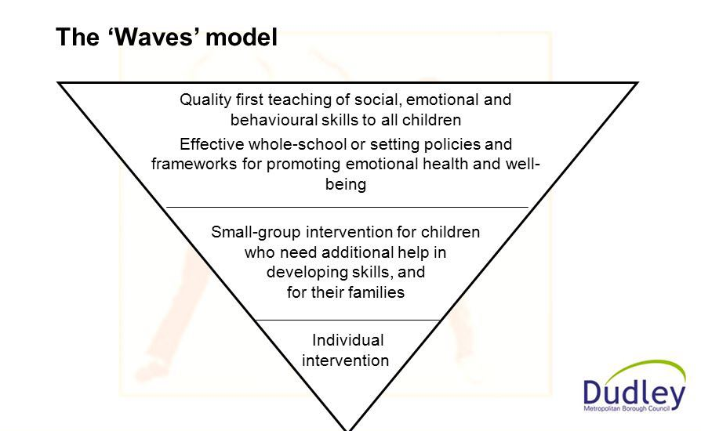

3.Overview of themes

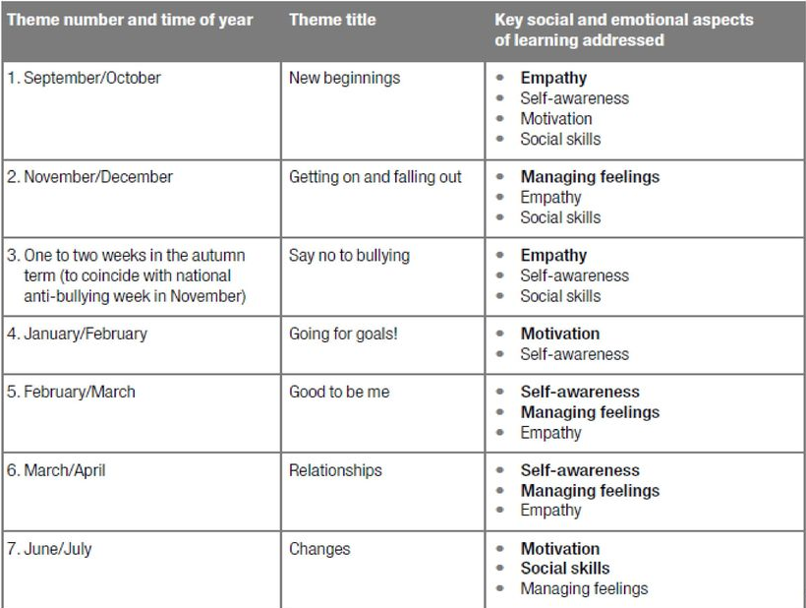

4. Letter home about SEAL workshop



