The Cyclical Failure Mode (HNC Mechanical Engineering)
This Report was conducted by
Samuel Edward Knight
Beginning on the 7th of march 2020

In materials science, fatigue is the weakening of a material caused by cyclic loading that results in progressive and localized structural damage and the growth of cracks. Once a fatigue crack has initiated, each loading cycle will grow the crack a small amount, The crack will continue to grow until it reaches a critical size, producing rapid propagation and typically complete fracture of the structure.

Contents

Page 1………………….………………………………………………………………,,………….Title Page
Page 2 ………………………………………………………………………………………………..Contents
Page 3………………………….…………..Introduction/Background overview of the case
Page 4…………………………..…. The theoretical perspective of Comet fatigue failure
Page 5/6/7……………………….………………………………………….….……..Material selection
Page 8………………………………………………………..…………………..Properties of Material
Page 9…………….……………………………….. Fracture mechanics and Design geometry
Page 10 ……………………….…………………………………………… Manufacturing methods
Page 11……………………………………………………………….………………..……. Bibliography

Introduction
Material and metal properties are regarded as one of the crucial factors for the integrity and safety of structures. While fractures are visible, the cause of cracks emanates from undetectable activities occurring at the micro-structural level affecting the lattice network of the product. Such events take place over time, sometimes cyclically and periodically, until failure of a structural member occurs. Some of the historical accidents that have happened previously are attributed to the influence of metallurgical properties besides human or technical errors. It is on this platform that a comprehensive discussion on factors influencing structural failure is provided. Concisely, the review investigates and provides an understanding of the dynamics of microstructure mechanisms and properties of cyclical fatigue failure. Based on that, mitigations measures that can address such a challenge have been recommended. The first section provides a background overview of the Comet Airplane case, followed by a brief theoretical review of the concept of cyclical fatigue failure in structural members. Part three entails an in-depth analysis of various sub-themes related to cyclical fatigue failure with reference to the said case. Lastly, preventive measures that would have been undertaken to mitigate such a failure are also summarized.

Background overview of the case
After the Second World War, the de Havilland Aircraft Company, located in England, modeled, and built the first jet aircraft for commercial purposes known as the Comet. It made its first flight in the late 1940s, and its structure consisted of four engines that were integrated, big square windows, and a pressurized cabin. Its design was aerodynamically ideal though one year after the start of its operation, the airline began to experience problems with its airplanes. In a span of one year, three Comet aircraft were involved in accidents after suffering break-ups while in operation. An analysis of the three accidents showed that two of them were as a result of structural failure ascribed to fatigue failure of the plane's metallic airframe. Unfortunately, this was not yet clear at the time of the accident. There was also a concern that severe weather led to overstressing the airframe while the aircraft was in-flight. After these events and withdrawal of services, the company scientists and engineers delved into extensive testing to determine the source of the problem. Findings showed that the construction and design of Comet were flawed, including incorrect riveting and hazardous stress concentrations adjacent to some area around the square windows. Consequently, the aircraft had to undergo extensive redesigning, such as oval-shaped windows and provision of structural supports. At the same time, other aircraft manufacturers like Boeing learned a lesson from the Comet episodes while designing and manufacturing their planes.

The theoretical perspective of Comet fatigue failure
According to scientists and engineers' findings of Comet's failure, the failure was a result of fatigue caused by the growth of a subcritical crack. Notably, the jet engine(s) used to propel the aircraft were not adequately tested during the design stage. Since the rate of fuel consumption of this engine was twice that of a piston type, the plane had to travel two times faster, and this means that Comet had to fly in a sophisticated atmosphere, that is, about 40, 000ft high. The altitude was double the one flown by the vintage aircraft during WWII. At such a high altitude (lower stratosphere), the outside temperature is significantly low (-56˚c) besides the clouds being bright with a little thunderstorm, which allows the aircraft to cruise. Also, the temperature difference between the intake (cold air) temperature and combustion temperature is quite high, enhancing the jet engines' efficiency.
High altitude flights require that the cabin design takes into consideration the pressure differentials close to the ground and the rarefied environment ideal for cruising. Adjacent to the ground level, the pressure difference between the interior and exterior of the plane's fuselage is marginal. On the other hand, there is a massive difference between the inner passenger cabin and the outer environment at a higher altitude. Recall that the fuselage is subjected to two types of environment whence the airplane's fuselage is repeatedly subjected to stresses from zero pressure differences to a very high-pressure difference. In such a scenario, the fuselage ought to be apt to withstand the resulting stresses caused by cabin pressurization at the high altitude. Regrettably, the stress cycles experienced by Comet led to fatigue of the Comet fuselage's metal skin leading to catastrophic fractures of many Comet aircraft.
After the first crash, which happened immediately after take-off, the officials investigating the incident stated that the accident was attributed to some structural fracture
due to higher forces pounding on the airframe because of the severe storm. All this time, the structure of the aircraft was not found as a significant cause of concern. But after three crashes, engineers from the Royal Air Establishment decided to conduct a pressurization test on the cabin of a retired Comet aircraft. In alternating sequences, the cabin was pressurized and depressurized to around 57 kPa within an atmospheric pressure range. After three thousand cycles of pressurization, a fatigue crack was found to initiate from the corner of the cabin window. The progression of the crack created a hole on the metal skin (see fig. 1 below).
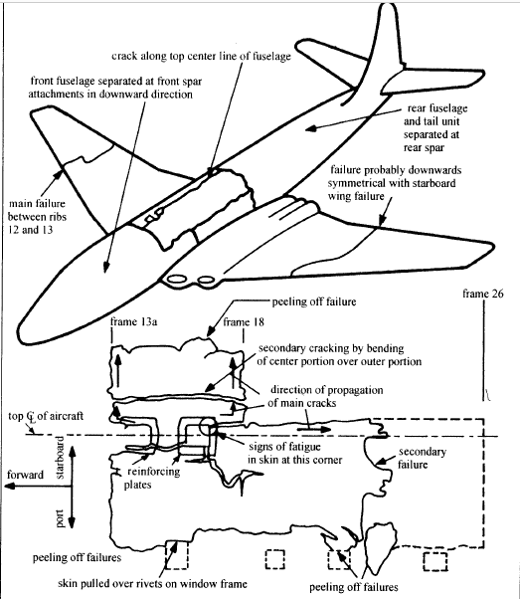
Fig. 1: Schematic diagram of Comet's fatigue failure

Sub-components of cyclical fatigue failure
Material selection
Aluminum and its alloys (evolutionary)
Aircraft are designed and built by materials that have unique properties. Historically, Aluminium and Aluminium alloys have been deemed reliable and durable in the aviation industry, dating back to the early 20th century (Yillikci and Findik, 2013). After the Second World War, commercial jets were built using materials exhibiting high fracture toughness and corrosion resistance properties. A series of aluminum materials have been developed over time, including 7178-T6, 7475, and 7150 have been incorporated to achieve such special features. Nevertheless, material scientists and structural engineers are increasingly coming up with special alloys comprising of Aluminium, Magnesium, and Scandium (Al-Mg-Sc alloy). This alloy, in particular, has been found to have "better corrosion resistance, lower density, and good welding characteristics" (Yillikci and Findik, 2013, p.10). Currently, a new generation Aluminium-Lithium alloy (series 2097) is under development, and it has been found to offer high resistance to growth of fatigue cracks. High-performance airplane's bulkheads are being developed using the alloy series. The new Al-Li alloys generated by the recent developments have an array of benefits, including savings on density weight, superior resistance to corrosion, and excellent toughness and strength combination. Also, the performance of the fatigue crack growth of the new alloys is observed to have an excellent spectrum. As per Giummarra et al. (2007), the Al-Li alloys being developed are well-balanced and are compatible with the standard manufacturing methods. Nonetheless, these Al-Li alloys provide considerable competition to composites in terms of performance as pertains to several applications in the aerospace industry. The new Al-Li alloys are being integrated into the manufacture of stringers, fuselage skins, floor beams, and frames (Burns, 2010). The figure below shows the difference between the conventional alloys (without Lithium) and the third generation Al-Li alloys in regard to their resistance to corrosion.
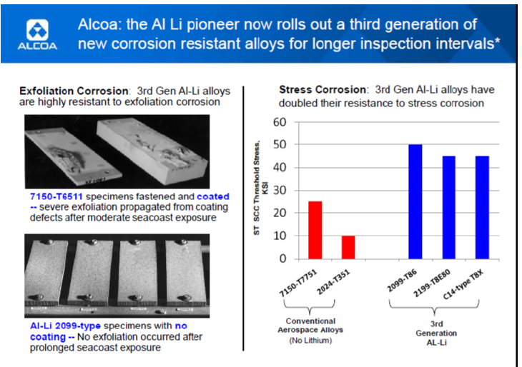
Fig. 2: Aluminium versus Aluminium-Lithium alloys in regards to exfoliation and stress corrosion (Yillikci and Findik, 2013)
Use of composites (Revolutionary materials)
The inclusion of composites in the manufacturing processes of aircraft has brought about a contest with metal construction. Yillikci and Findik (2013) opine that aircraft designers and manufacturers continue to invest billions of dollars in the application of composite materials instead of Al to achieve fuel economy, long-distance haulage, excellent cabin environment, and quietness. For example, Boeing is increasingly using composites in its primary structure(s); thus, setting the standard. In 1987, the military aircraft rarely used composites; for instance, the F-15 was built using 32 percent titanium, 49 percent aluminum, and 2 percent composites. Fast forward, and things changed in the early 21st century, where F-22 was constructed using 39 percent titanium, 16 percent aluminum, and 24 percent composites. Though the quantity of material and the construction cost utilizing composites is high, the operating costs are found to be lower during the plane's life-cycle. Titanium (Ti) has turned out to be a natural partner of composites since it provides necessary strength for stressed components. The same case applies for short-haul, lean body commuter airplanes, specially, the metal airframes since the material costs and development risks are lower. From 1990s, the composite materials have been fiber reinforced with the Airbus 350 (A350 XWB) and the 787 Dreamliner series utilizing large quantities of carbon fiber-epoxy composites. For A350 XWB, the composites were applied in several components including tail and wings, the fuselage, engine pylons, the landing gear, and structural beams; the overall airframe comprised of 53 percent of composites. Some of the advantages attributed to the extensive application of fiber-reinforced composite materials were "lower overall aircraft weight, along with proven in-service durability, reduced corrosion, and fatigue, as well as lower maintenance costs" (Yillikci and Findik, 2013, p.10).
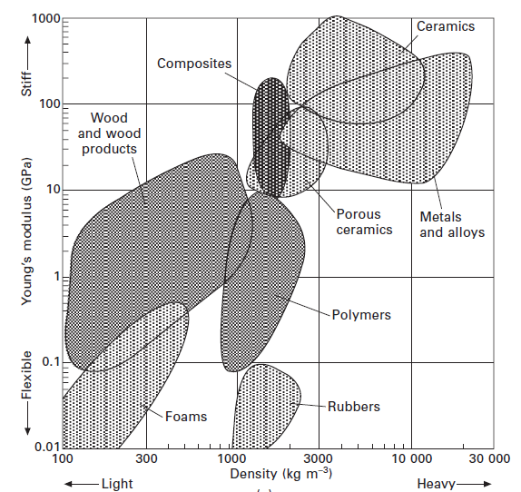
Fig. 3: Density, Strength, and Toughness of various materials (Mouritz, 2012)

Properties of material
The selection of materials for the design and development of aircraft structures is dependent on unique properties to meet design requirements (Mouritz, 2012). These distinct characteristics are primary and essential, while other variables like cost, mechanical/structural performance, and ease of manufacturing are listed as secondary. While it may be costly to build an aircraft structure with a capability to withstand thermal shock, resistance to cracking and spalling due fast heating ought to be considered as the primary element rather than the cost element. The aircraft's skin should have proper electrical conductivity to transmit electrical charges in the case of a lightning strike. Thermal conductivity properties are essential for applications in high-temperature conditions such as engine parts and heat shields. Low-thermal conductivity is necessary to guard the airframe components against excess heat, for example, heat shields. Thermal expansion is a critical factor for materials subject to high temperatures. A low value of thermal expansion coefficient is suitable because extreme contraction and expansion during cooling and heating are prevented (Gere and Timoshenko, 1996). Aircraft engines and cabins have a high fire risk; thus, flammability characteristics of materials in these sections ought to be considered. Examples of these properties are the spread rate of smoke and flame and the ignition temperature.

Table 1: Factors guiding the selection of aircraft materials
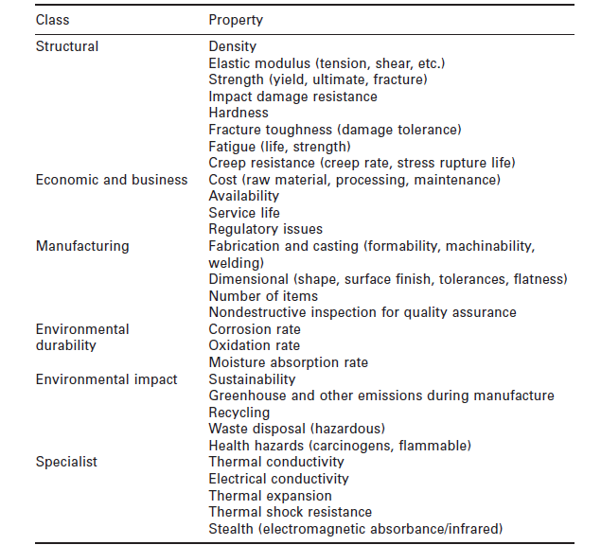
Fracture mechanics and Design geometry
As indicated in the case above, the concern for a minimum weight and minimum strength overrode the desire to have an aircraft that was fracture-resistant. Fort this reason, the aircraft materials experienced an unprecedented failure that led to the fracture. The subject of fatigue failure to crack propagation was not comprehended well by Comet's designers and engineers. Fracture mechanics provides an understanding of how fatigue occurs characterized by the weakening of structures due to cyclic loading that causes localized and progressive microstructural damages (Budynas et al., 2011). With each loading cycle, the fatigue crack continues to grow, albeit in small measures. Crack propagation continues until the critical size is reached, and this followed by rapid spread until a fracture occurs (Budynas, R. et al., 2011). Fatigue is categorized in various forms, namely creep, mechanical, corrosion, fretting fatigue, thermo-mechanical, just to mention a few. Fatigues can also be classified as high-cycle or low-cycle. It is worth noting that fatigue cracks propagate in three ways, but this depends on the load orientation relative to the crack, as indicated in the figure below.
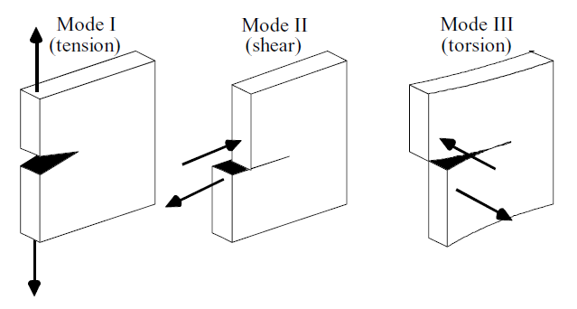
Fig. 4: Modes of crack propagation (Hendrickson, n. d.)
Structural details that are complex such as Comet's cabin window, may have regions that change geometrically, and these regions are referred to as stress concentrators. Markedly the local stress fields adjacent the concentrators have stresses that are greater than nominal stresses in locations far away from the stress concentrators. It is near the stress concentrators that fatigue cracks begin to appear. And so, stress concentrators leading to the presence of fatigue cracks are sometimes referred to as crack initiators, which may be in form of notches, holes, holes, or areas where the structure of the material changes. This may have been the local areas around the square windows and rivets. Similarly, a fatigue crack is considered a stress concentrator since the local area near the crack tip is characterized by a highly intensive stress field. Another important issue to consider is the residual stresses introduced by the fabrication processes. The residual stresses impact the stress field surrounding the stress concentrators (Hendrickson, n. d.). Referring to Comet's case, the pressure cabin apertures were imperiled by higher stresses located adjacent sharp-cornered cut-outs, in this case, square windows.
Manufacturing methods
The metal skin for Comet was thin, and consisted of advanced new alloys implying that evolutionary materials were selected (Mouritz, 2012). The manufacturers used rivets and a chemical bond to manufacture the fuselage with a view to saving weight and mitigating the risk of fatigue propagation from the rivets (stress concentrators). A new adhesive known as Redux was used for chemical bonding of the fuselage and the wings of Comet. The factor of safety (SF) applied in designing the aircraft's pressure cabin exceeded that recommended by the British Civil Airworthiness Requirements (BCAR). According to BCAR statutory regulations, a safety factor of 1.33 times the cabin's proof pressure (P) was recommended besides an ultimate load twice the value of P. Surprisingly, the safety factor used in the design of Comet was 2.5P; after the crashes, the values of safe loading strength had to be revised.
Manufacturing methods play an essential role in material selection and eventual manufacturing into engine and airframe components (Mouritz, 2012). Typical manufacturing processes include primary forming, heat treatment, material removal, finishing, joining, and non-destructive testing methods. Examples of primary forming processes include forging and casting of metals, and composites curing while annealing and thermal ageing are samples of processes falling under heat treatment. Anodising and surface coatings are some of the finishing methods whereas some of the joining processes used in aircraft manufacturing consist fastening, elding, and adhesive bonding. Manufacturing methods and materials are inseparable hence it is not possible to pick a material, and not consider a manufacturing process suitable for that particular material. As Mouritz (2012) asserts, "properties affect the choice of the process: ductile materials can be forged and rolled, whereas brittle materials such as composites must be processed in other ways. Conversely, the choice of the process affects the material properties" (p.590).
Mitigation methods to prevent cyclical fatigue failure
Following the findings of the core cause of numerous Comets' crashes, engineers and scientists decided to work on various areas to reduce accidents. First, the geometry of the windows was redesigned to take an oval shape rather than a square shape. By doing this, the effect of stress concentration around the sharp corners was eliminated significantly. As mentioned above, contemporary research is increasingly concerned with the use of Al-Li alloys and composite materials in manufacturing basic aircraft structures. Application of composite materials and the said alloys have several intrinsic and extrinsic benefits ranging from high stiffness-density ratio to fuel-economy advantages. Third, aerospace engineers have to consider inspection as part of the design criteria as espoused by Hosford (2010), who states that two methods are applied to alleviate fatigue failure; designing taking into account periodic inspection and designing for an infinite period where inspection is not required (p.297).
Conclusion
This discussion provides an important insight into the effects of cyclical load applications and cyclical fatigue failure. Interestingly, this type of loading may cause failure at stress levels that are sometimes marginally lower than the yield stress. Severe environments like repeated cycles of high loading, a surge in mean stresses corrosion, stress concentrators due to geometry, and surface roughness predisposed a structure to fatigue failure. Fatigue cracks growth and propagation eventually result in an unstable crack size at the critical point; subsequently, sudden failure is bound to occur. Material properties are critical for the selection of proper materials and manufacturing processes and eventual applications in different sections of the aircraft.

References
Budynas, R., Nisbett, J. & Shigley, J. (2011). Shigley's mechanical engineering design. New York: McGraw-Hill.
Burns, S. (2010). Trends in Aviation, Available at: http://agmetalminer.com/2010/09/14/trends-in-aviation-part-one/
Gere, J. M. and Timoshenko, S. P. (1996). Mechanics of Materials: Forth edition, Nelson Engineering, ISBN 0534934293
Giummarra, C., Thomas, R. and Rioja, R. J. (2007). In: New Aluminum Lithium Alloys for Aerospace Applications, Proceedings of the Light Metals Technology Conference http://alcoa.com/global/en/innovation/papers_patents/pdf/LMT2007_110.pdf
Hendrickson, D. (n. d.). Fatigue failure due to variable loading. University of Michigan, 1-13.
Hosford, W. (2010). Mechanical behaviour of materials (2nd ed.). New York: Cambridge University Press.
Mouritz, A. P. (2012). Introduction to aerospace materials. Reston, VA: Woodhead Publishing Limited.

