Professional Skills and Health & Safety in Construction- Assignment 1

Presented by: J. Albrighton

Presented for: J. Dauda

Word Count: 1845 (1444- Report,
401- Personal Development Table

Contents
- Introduction- Page 3
- Professional bodies- Page 3
- Institution of Civil Engineers- Page 3
- The Importance of Joining a Professional Body- Page 4
- How to Join a Professional body- Page 6
- Personal Development Plan- Page 7
- References- Page 9

- Introduction
In this report I will attempt to explain what a professional body is and why, as a member of this team, it is important for me to join one in order to improve the health and safety records of the workplace as well as protecting the interests of the company by helping them grown not only financially but also in terms of status and respect from peers.

- Professional bodies
A professional body is an organisation that holds a collection of members that are all associated with a specific profession (www.theweldinginstitute.com, n.d.). These professional bodies act as a network for professionals in the same occupation to connect with each other for advice, specific knowledge on a subject, career opportunities and much more. (www.theweldinginstitute.com, n.d.)
Membership with one of these professional bodies would give one access to things such as: events including talks on relevant topics, networking events, opportunities to volunteer with projects, specialist training on the latest advancements in engineering, access to the latest publications in the field and many more perks (www.theweldinginstitute.com, n.d.)
There are many professional bodies around the UK in the construction industry. The welding institute is a professional body that deals with welders, the Chartered Institution of Building Services Engineers deals with chartered engineers by guiding engineers through career paths to help them get chartered, approving courses and helping chartered engineers maintain a high level of work in their careers (www.theconstructionjob.com, n.d.). The Landscape Institute deals with landscape architects and aims to protect the natural environment and create a high standard for architecture in the UK by educating and inspiring professional and aspiring architects (www.theconstructionjob.com, n.d.). The Royal Institution of Chartered Surveyors provides many standards for training and education within the surveying profession including the APC which helps increase status in the construction industry (Project-resource.co.uk, 2019).

- Institution of Civil Engineers
The professional body which I am considering joining is the Institute of Civil Engineers (ICE). This professional body works with many different sectors of the civil engineering industry in order to promote the next generation of engineers and offer many services to engineers in the industry (Institution of Civil Engineers (ICE), 2019).
The Institute of Civil Engineers work hand in hand with many sectors of engineering such as geospacial engineering, municipal engineering and management. ICE also work with many communities of practice which are a collective of people who are passionate about a subject or concern and aim to work together to create new knowledge for the practice (Community of Practice, n.d.). some communities of practice that ICE work with include the energy community of practice, the transport community of practice, the resource management community of practice and the health, safety and wellbeing community of practice which could help us develop our health and safety records considerably.
ICE aims to be the leading source in information regarding health and safety for experts by providing expert advice, academic research and studies, training (which could be beneficial for our entire company), legal compliance and general guidance for all health and safety concerns.
ICE is built up of a council of engineers as well as trustees who promote quality work, honesty in the trade, ethical behaviour and professionalism. Their goal is to promote civil engineers for all their worth and show the public why civil engineers are so important to the world we live in today. (Institution of Civil Engineers (ICE), 2019)

- The Importance of Joining a Professional Body
Why is it so important for me to join a professional body? I believe that joining a professional body will help me to vastly improve my craft as it will give me the chance to socialise with other experts at the top of their sectors and this will give me a chance to get the best advice I can that can help me propel our company forward by using the latest studies and technologies to put our company at the forefront of engineering.
Joining a professional body is also important to me personally because it gives me an opportunity to be a part of something larger than this company. Being part of a professional body gives me the opportunity to talk to everyone I can about the subjects I am passionate about and get answers from other like-minded professionals. This will increase productivity in this workplace as other members of staff in this company will see me get more passionate and I can inspire better working from our employees and this will also encourage them to join a professional body which will further advertise this company as being an honest and positive company whose staff are passionate about their careers in engineering.
I appreciate the idea that most professional bodies support which is to “promote professionalism” (www.ciob.org, n.d.). This idea amongst other professional bodies to support professionalism would benefit this company massively as we can get promotion of the company through the ICE websites news feed which will not only draw in client but also new members of staff who are willing to work in a professional manner. This could save the company massive amounts of money as they will need to do less advertising due to the “word-of-mouth" effect that happens to companies involved in professional bodies e.g., high quality work will be respected and talked about by other members of the professional body and this will get talked about, making more people hear about the high standards of the company and will want to be involved. (www.ciob.org, n.d.)
I think it is very important to promote the “ethical and honest work” standpoint that most professional bodies embody as this will promote a better work environment as well as happier clients and better productivity among the workforce as no one will feel undermined or undercut by our work as everything is honest and laid out in front of our employees and clients so that everyone knows the plan before anything happens.
Another reason I would like to become a part of a professional body is the specialist training I would receive on the latest advancements and technology. This could also save the company a lot of money as I could teach the rest of the work force about the newest advancements and these new advancements will increase productivity meaning the lead time in projects would be shorter, creating more profit.
Joining a professional body could also improve our health and safety records as I could be trained in the latest and best ways to keep and update these records, meaning I could help with the inspections, speeding up the process, saving the company money. One of the Institute of Civil Engineering’s specialist knowledge society is the Hazard forum, and they specialise in looking at errors by engineers that may have caused disaster and look at what caused the hazard in particular. According to (Anon, n.d.), hazard forum encourages “open and active” debate about these disasters and hazards for the public to get a better understanding. If I had a better understanding for hazards, then I would be able to better identify them in our workplace and how to correct these hazards or minimise the risk of the hazards.
If we can teach the entire workforce about the hazard perception in the way that the hazard forum openly talks about it then it would be beneficial for our company as all employees would be able to identify risks more effectively and it wouldn’t require a training day as these are things that can be discussed on the job.
As a part of ICE, you can join a health and safety reading list and newsletters on health and safety so being signed up for all these newsletters, webinars, lectures and forums will make me more competent when it comes to health and safety aspects around the site.

- How to Join a Professional body
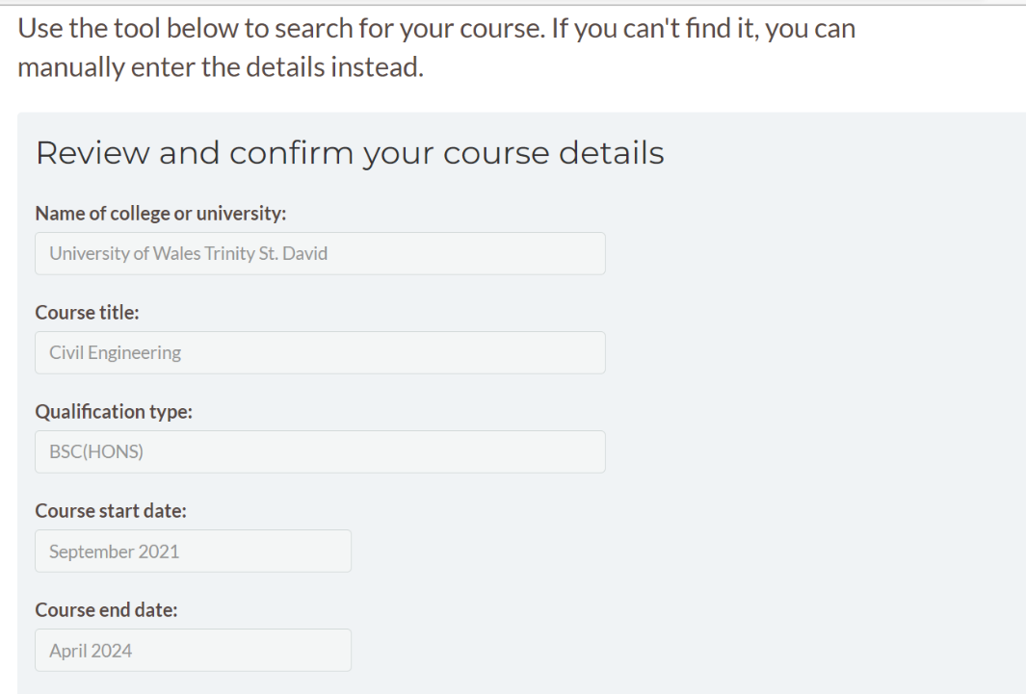
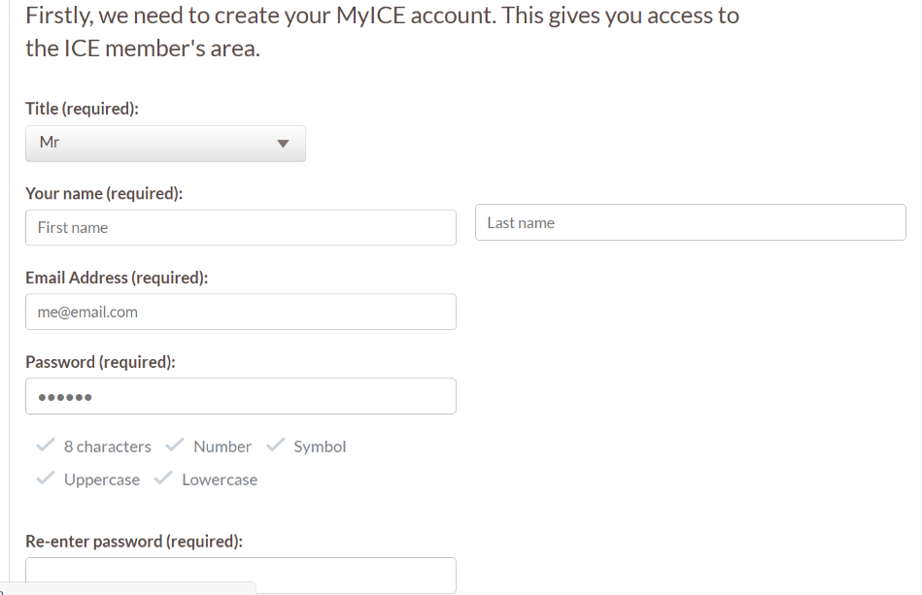
Most professional bodies will accept online membership forms but there are some such as The Chartered Institution of Building Service Engineers that require proof of identifications for things such as proving chartership. Most will only require the online submission which consists of a few simple questions such as name, address, email and number for marketing purposes mainly.

This is an example I have found of a student application on ICE website, and it shows how simple it is to apply for a membership online. They ask about details of the course and a few details about you personally and that is all. It is a very simple process which can be done in just a few minutes.
- Personal Development Plan
Name: | Joshua Albrighton
Job Role & Responsibilities: | Student Civil Engineer
 | Review of Learning Needs |  |  | Development Plan
Reference | In what area do I need to improve my performance? | What do I need to learn in order to Achieve this? | What will I do to achieve this? | What are the likely resources and support that I will need? | How will I evaluate a successful outcome?
To become a graduate member, you need to have an approved or accredited academic qualification (Institution of Civil Engineers (ICE), 2015). | Finish university | learn about all subjects in university my course has to offer me including CAD, law in construction, Fundamentals of construction, health and safety and maths. | Attend lectures regularly as well as doing personal study outside of lectures using the library and online resources. | Understanding the course in general will require support from lecturers and online resources such as YouTube videos and websites. | Achieve good grades on these topics as well as having a better understanding of them and finishing university with a good grade that accurately demonstrates the level of work I have done.
 | Improve on fundamentals of construction knowledge | Learn more about superstructures from lecturer Gavin and continue to learn about sub structures. | Regularly attend fundamentals of construction lectures and go to the university library to read study list given by lecturers as well as using online study list. | Will get books from the library to investigate topics such as substructures and ground works, support from Gavin will likely be needed for the superstructures topic. | Achieve a good grade on the superstructures assignment and get a better understanding of substructures including ground composition.
 | Improve CAD work and knowledge of CAD software such as AutoCAD and Revit. | Learn about techniques that will help me use CAD quicker in order to complete drawings faster and use the software more proficiently. | Mostly research online as well as guidance in lectures. Tutorials on YouTube are very helpful for tips on CAD skills as well as books on the reading list such as AutoCAD for dummies. | Support in lectures on tools in CAD will be needed as I will likely not find all my answers online. Gavin my lecturer for CAD will also be able to guide me where to look for tips online as well. | Achieve good grades in CAD assessment as well as becoming proficient in using software such as AutoCAD and Revit.

- References
www.theweldinginstitute.com. (n.d.). What is Professional Membership of Professional Bodies/Institutions? – Meaning and Definition. [online] Available at: https://www.theweldinginstitute.com/What-is-Professional-Membership-of-Professional-Bodies/Institutions-FAQ#:~:text=What%20is%20a%20Professional%20Body%3F%20A%20professional%20body [Accessed 11 Jan. 2022].
‌ www.theconstructionjob.com. (n.d.). Construction Bodies / Organisations | Construction Jobs. [online] Available at: http://www.theconstructionjob.com/displaycontent/sectionid/87/contentid/691_-construction%255fbodies%255forganisations [Accessed 11 Jan. 2022].
‌ Institution of Civil Engineers (ICE). (2019). What we do. [online] Available at: https://www.ice.org.uk/about-ice/what-we-do.
Community of Practice. (n.d.). What is a community of practice? [online] Available at: https://www.communityofpractice.ca/background/what-is-a-community-of-practice/.
Institution of Civil Engineers (ICE). (2015). Safety, Health and Wellbeing Community of Practice. [online] Available at: https://www.ice.org.uk/about-ice/what-we-do/safety-health-and-wellbeing-community-of-practice [Accessed 11 Jan. 2022].
‌ www.ciob.org. (n.d.). Search Results | CIOB. [online] Available at: https://www.ciob.org/sites/default/files/CIOB%20research%20-%20Professions%20Report.pdf#:~:text=Professional%20bodies%20have%20a%20crucial%20role%20to%20play [Accessed 12 Jan. 2022].
‌ Anon, (n.d.). Who we are - hazardsforum.org. [online] Available at: https://hazardsforum.org/who-we-are/ [Accessed 12 Jan. 2022].
‌Project-resource.co.uk. (2019). Professional Bodies and Chartered Institutes. [online] Available at: https://www.project-resource.co.uk/graduate-hub/professional-bodies-and-chartered-institutes.

‌Institution of Civil Engineers (ICE). (2019). Our mission and work. [online] Available at: https://www.ice.org.uk/about-ice/governance/our-mission-and-work.

Institution of Civil Engineers (ICE). (2015). Graduate membership (GMICE). [online] Available at: https://www.ice.org.uk/membership/grades-of-ice-membership/graduate-membership
[Accessed 12 Jan. 2022].
‌

Institution of Civil Engineers (ICE). (2014). Login | Institution of Civil Engineers. [online] Available at: https://www.ice.org.uk/student-application/course-information [Accessed 12 Jan. 2022]. ‌

