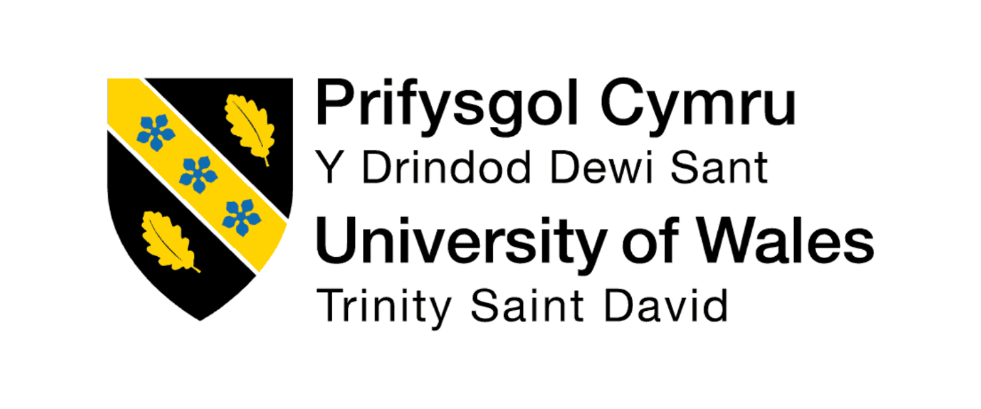
University of Wales Trinity Saint David (UWTSD)

Module Name: Employability and career development
Module code: LCLM 4005
Assessment title: Component 1
CV, Cover letter and Job description

CertHE Business skills for the workplace
Submitted by: Leena Khan
Student ID: 2528599
Lecturer: Zakia Jabeen
Submission date: 16/10/26
Word count: 13881

CURRICULUM VITEA
Name: Leena Khan
Dob: 12/10/06
Wolverhampton, UK
Contact: 07700 900123 | leena.khan@outlook.com

Personal Profile
I am an organised and motivated Business student with experience in office administration. I am now looking to progress into a Human Resources role where I can develop my skills and gain further experience. I have good communication, organisation and time management skills and enjoy working with others. I am keen to learn more about recruitment, employee records and HR procedures.

Key Skills
- Good written and verbal communication
- Administration and record keeping
- Organisation and time management
- Microsoft Word, Excel and Outlook
- Teamwork and problem solving
- Attention to detail
- Handling confidential information responsibly
- Willingness to learn new systems and procedures

Employment History
Administrative Assistant — Ez financial consultants, Birmingham
September 2025 – Present
- Maintain and update spreadsheets and company records.
- Organise documents and ensure information is accurate.
- Respond to routine telephone calls and email enquiries.
- Arrange appointments and assist with daily office tasks.
- Support colleagues with administrative duties.
- Handle company information responsibly and professionally.

Education
University of Wales Trinity Saint David, Birmingham
Business — Level 4 Undergraduate Student
2025 – Present
Relevant skills developed through my studies include communication, teamwork, problem solving and time management.

Additional Information
- Interested in developing a long-term career in Human Resources.
- Available for full-time employment.
- References available on request.

COVER LETTER
Leena Khan
Wolverhampton, UK
07700 900123
leena.khan@outlook.com
16 October 2026
Hiring Manager
Uxbridge Employment Agency
Harrow, London
Dear Hiring Manager,
Application for the HR Assistant position
I am writing to apply for the HR Assistant position advertised by Uxbridge Employment Agency. I am interested in this opportunity because I would like to build on my administrative experience and progress into a career in Human Resources.
In my current role as an Administrative Assistant at Ez financial consultants, I help maintain records, update spreadsheets, organise documents and respond to routine enquiries. This experience has helped me develop my communication, organisation and attention to detail skills. It has also taught me the importance of completing tasks accurately and handling information responsibly.
I am currently studying Business at university, which has increased my interest in how organisations manage and support their employees. I would welcome the opportunity to develop my knowledge of recruitment, onboarding, employee records and HR procedures. I am comfortable learning new systems, working as part of a team and managing different tasks to meet deadlines.
I believe my administration experience, my positive attitude and my willingness to learn would make me a suitable candidate for this position. I am keen to take the next step in my career and develop the skills needed to succeed in Human Resources.
Thank you for considering my application. I would love the opportunity to discuss my experience and suitability for the role in an interview.
Yours faithfully,
Leena Khan

JOB DESCRIPTION: HR ASSISTANT

Recruitment agency: Uxbridge Employment Agency
Location: Harrow, London
Salary: £26,000–£28,000 per year
Contract: Permanent, full-time
Working hours: 37.5 hours per week

Job Purpose
The purpose of the HR Assistant role is to support the Human Resources team with daily administrative tasks and help ensure employee information and documentation are maintained accurately. The role provides an opportunity for someone with administration experience to develop their knowledge of recruitment, employee relations and HR procedures.

Main Duties and Responsibilities
- Maintain and update employee records and HR databases.
- Prepare, organise and file HR documents and correspondence.
- Support recruitment activities, including arranging interviews and communicating with candidates.
- Assist with onboarding new employees and preparing relevant documentation.
- Help maintain accurate and up-to-date employee information.
- Respond to routine HR enquiries and direct more complex questions to the appropriate team member.
- Provide administrative support for employee starters and leavers.
- Assist with payroll-related information and other HR processes.
- Handle confidential employee information carefully.
- Follow company policies, procedures and data protection requirements.

Skills and Qualifications Required
- Previous experience in an administrative role.
- Good written and verbal communication skills.
- Strong organisation and time-management skills.
- Attention to detail and accuracy.
- Confidence using Microsoft Office and computer systems.
- Ability to work independently and as part of a team.
- A professional and responsible attitude when handling confidential information.
- An interest in developing a career in Human Resources.

Personal Qualities
The successful candidate should be reliable, organised, approachable and willing to learn. They should be able to manage different responsibilities, communicate professionally and maintain confidentiality when dealing with employee information.

Career Development
This role can provide experience in recruitment, employee administration and HR procedures. With further training and experience, an HR Assistant may progress into roles such as HR Adviser, HR Officer or HR Manager.

