Presented to Maria Heffernan &Brynach Heffernan
Submission date:08/12/2017
Students Name: Driss/Danielle/Tom/Emma/Ashely

Contents
Introduction 1
Tragedies 1
Safety 2
Conclusion 2
Bibliography 3
Appendix 3
a. Safety of the football Stadia in England 3
b. Football Safety Officers Association 3
c. Fans Safety regulation 3

Introduction Tom
This assignment is about the tragedies that have happened throughout the years within football off the field. We have prepared an assignment on how these tragedies took place and how changes have been made to prevent these tragedies from being repeated. Also we take a look at how people have been affected from these tragedies.

Tragedies Driss Mrabti)
There have been five football disasters here in the United Kingdom over the years,
Ibrox stadium 1902, Burnden Park 1946, Ibrox Stadium 1971, Valley Parade 1985, Hillsborough 1989. But due to time restrictions and limitations on assignment word count. The Hillsborough disaster in 1989 is the worst, so therefore the focus of investigation.
On the 15th of April 1989 at Hillsborough football ground the game was under way between Liverpool and Nottingham forest Clubs. Five minutes after kick off a crush barrier collapsed causing fans to fall on top of each other and mayhem occurred. Before the game commenced approximately 3,000 fans had been admitted to the central pen almost double what was considered safe! This occurred after police had opened gate c to avoid a crush outside of the ground. Fans began climbing over side fences to escape. This caused the crush barrier to collapse, some people were saved by fans on the upper pulling them to safety. Overall 96 people died with only 14 of these being admitted to hospital and a further 766 people were injured. This is the worst British sporting disaster. In an interim report on 4th of august 1989 wrote that the key element of police control at fault was the failure to close off the tunnel leading to pens 3and 4 once gate c had opened.Invalid source specified.
Two of the major sporting calamities happened here in the United Kingdom, During the 1980s. In 1985 at Valley Parade, the grounds of Bradford City. The stands of the stadium caught fire killing 56 fans and injuring 295. Ninety-six Liverpool fans were killed as a crush developed, that was triggered by over-crowding in the Leaping Lane side in the terraces on the grounds. Also 766 fans got badly hurt. This has been the greatest stadium disaster so far here in the United Kingdom.
Please refer to Appendix for safety measures before and after (see pictures)

Safety
Health and safety is a big thing in the world, and since new regulations have been put in place in the last twenty years it has improved and built the confidence in the world. The safety at football grounds have changed tremendously since the Hillsborough game in 1989, to prevent these incidents for happening again they have made changed so that health and safety is first. To begin with they have changed the stands so that the fans are sitting down and not standing up which you can see in picture two and three of the appendix. As you can see from the before and after pictures in the appendix the massive improvement in the stadium, from going standing, small and crowded areas to sitting, big and spacious areas for the fans.
The FIFA safety regulations make sure that everything is in check but not just on the inside but also outside the stadium as well. They get everything checked including equipment, evacuation routes, NOP's and EOP's, security and many more areas. But due to the accident in Hillsborough this has changed the way stadiums are made and designed to help put people and their safety first and not just that but the teams and staff as well. (Anon., n.d.)

Conclusion

Things needed to be changed and people saw this affect the accident that happened at Hillsborough in 1989 but to say that was not the only accident that has happened in football history with other fatalities in stadiums and fires, accidents and angry rages causing injuries as well. But they all contributed to the stadiums being more sustainable and safety for the supporting fans. For the future ahead, the safety is only going to improve while the fans increase in number. Anger rages you cannot prevent but step in to bring the rage down to a calm. Since the FIFA regulations came in the chance of these accident happening again is low.

Bibliography
Anon., n.d. http://www.fifa.com. [Online].
Anon., n.d. http://www.fifa.com/mm/document/tournament/competition/51/53/98/fifa_safety_regulations_en.pdf. [Online].
Anon., n.d. http://www.telegraph.co.uk/sport/football/teams/liverpool/5156627/Liverpool-to-mark-Hillsborough-disaster.html. [Online].
Arshad, S., January 23rd, 2014. Worst Football Stadium Disasters In History.
Conn, D., 20 October 2017 . Wheelchair access at Premier League grounds improved after campaigning. The guardian.
January 23rd, 2., January 23rd, 2014. Worst Football Stadium Disasters In History. Tsm plug.
KEEGAN, M., 21 June 2017. Premier League gauges interest in safe standing by sending a questionnaire to all 20 clubs including Liverpool. Daily Mail.
Officer, J. M. N. Q. P. R. S., n.d. http://achilleus.co.uk/. [Online]
Available at: http://achilleus.co.uk/achilleus-security-about-us/
website, n.d. http://achilleus.co.uk/.

Appendix (Driss Mrabti)

Before and after pictures of the stadium.

Safety of the football Stadia in England

Football Safety Officers Association

Fans Safety regulation

Before and after pictures of the stadium

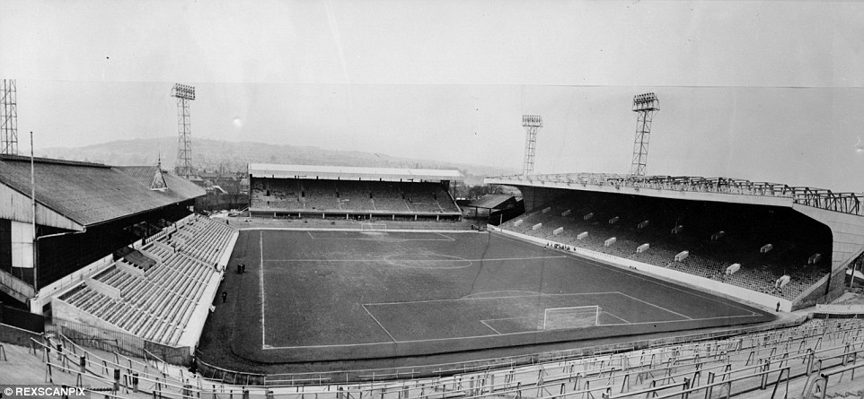
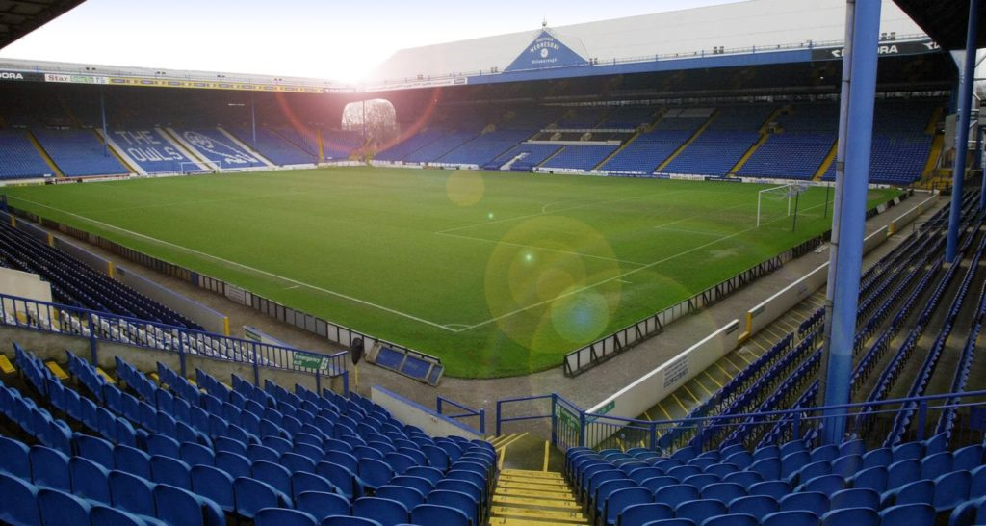
Safety of football Stadia in England
1990: Justice Lord Taylor publishes the Taylor Report into the causes of Hillsborough. The report concludes that the blame should mostly lie with the police control of spectators on the day. It suggests a number of recommendations to improve football stadia in England to avoid such a tragedy happening againInvalid source specified. These included all grounds in English football to be all-seater.Invalid source specified.1991 British Government starts Football Licensing Authority to ensure public welfare and safeguard that fans at games were not at risk.
1992 The arrangements to impose all on football clubs in England are all-seater stadiums and numbers reduced so that only teams from the top two divisions have to conform. Chester F.C Deva Stadium become in 1992 the first ground to work within the restrictions that were put in place after the Taylor Report. Over 30 new and purpose built stadia have been built in this country as well as over 200 new stands.
(Picture one)
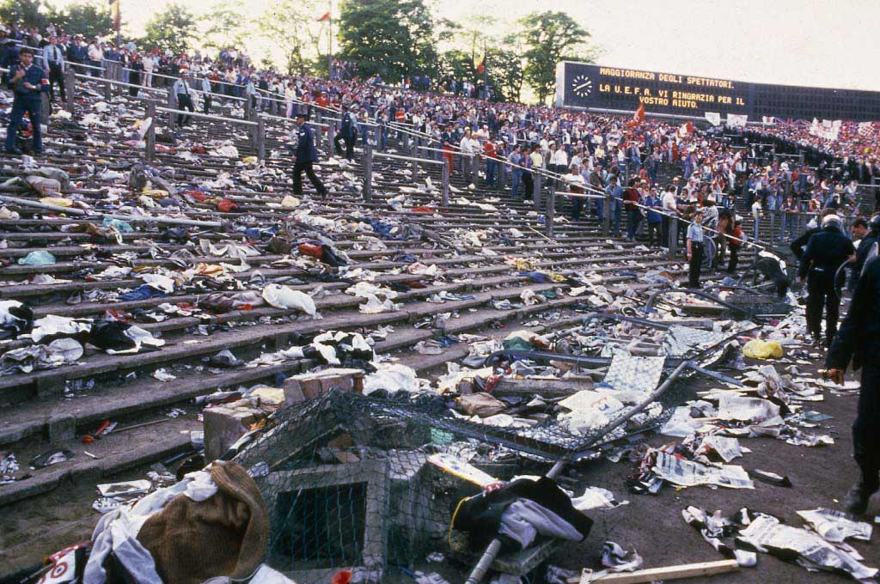
Hillsborough: April 15, 1989 (telegraph Newspaper)
(Picture two)
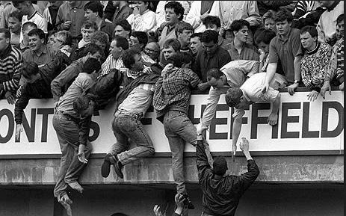
(Arshad, January 23rd, 2014) TSM plug journal
(Picture three)

Celtic's safe standing section (KEEGAN, 21 June 2017) Daily Mail
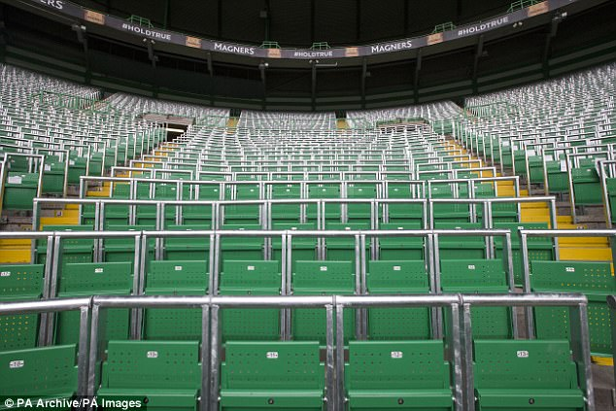
Football Safety Officers Association
1996 The Football Association arranges its own training set, to work alongside the Premier League and the Football League.2008: The 5th publication of the Green Guide is issued by the government, providing regulation on ensuring fans safety at sporting facilities and it is followed by all football clubs here in the U.K. Particularly concentrated the teaching procedure for stewards.2010 A fresh approach in training bundle is announced called ‘On the Ball’ to work together with the National Vocational Qualification (NVQ) course for football stewards. is arra2011: The Sports Grounds Safety Authority (SGSA) arranged to prosper the Football Licensing Authority.
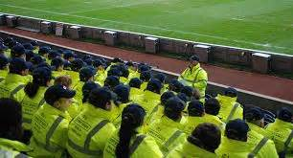
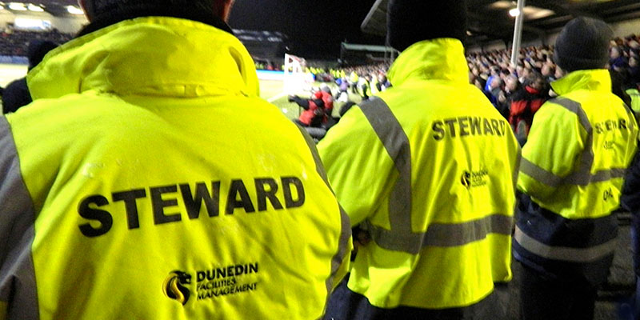
(Officer, n.d.) website, n.d. http://achilleus.co.uk/.

Fan Safety regulation (Stewards)
2012 The Hillsborough Independent Panel publishes its report on the Hillsborough disaster and exempts the Liverpool fans from any blame for the tragedy. Course 2012-13: A total of events took place in the of the year, 2 different physical attacks on goalkeepers by fans. This timeline shows that football safety and football stewarding have come a long way since the tragic events of the 1980s. But in the years to come even more improvements may need to be made to ensure that no negative incidents occur at games have led to many safety changes being made down the years.

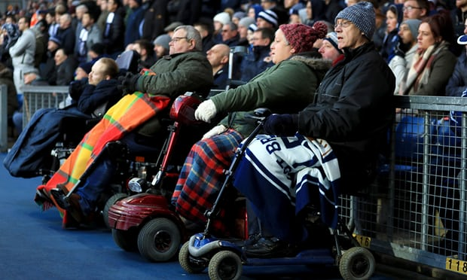

(Conn, 20 October 2017 ) Wheelchair access at Premier League grounds improved after campaigning

wheelchair spaces have been built to meet official guidelines to fourteen out of 20 Premier league clubs as the result of disabled supporter’s complaints. Fourteen of 20 stadiums now meet the terms, aims met after legal action was threatened by fans

What needs to be done | Who has done it
Introduction | Tom
Review literature | Driss, Dani
Conclusion | Dani
Appendix | Driss, Dani
Organiser /Bibliography | Driss, Dani

