Luke Redmore
2219318@student.uwtsd.ac.uk
Abstract
Research into key aspects of networking as well as practical deployment of a hypervisor-based network.
Network os coursework one
Research and practical work

Contents
Task1: Research 1
Hypervisors 1
Diagrams outlining key features of hypervisors. 2
Native device (Non virtualised) 2
With type 1 hypervisor installed 3
With type 2 hypervisor installed 3
Ip addressing 4
Group work summary 5
Routing 5
Network services 7
Configure outbound and inbound firewall traffic to allow icmpv4 requests 13
Allow icmpv4 echoes for ping etc through firewalls this is repeated for client 15
Linux side 17
Troubleshooting: disabling cdrom mount to force online packages for install 18
Ping failure (Issue with network adapters, switched to vmnet1) 23
Use vi to add deb apt repos to install needed packages 23
Verify sudo group 25
Pinged sdc windows server from linux server 25
Ping linux host with client 26
HOST to client (linux) 26
Verify linux configurations 27
References 27

Task1: Research

Hypervisors
A hypervisor can be thought of as an abstraction layer that segregates a host machine from guest machines where the hypervisor or virtual machine manager is in control of active virtual machines. Regarding architecture hypervisors often consist of a control domain or domain 0, and a guest domain. These have distinct but unrelated functions, domain 0 or DOM0 directly manages the hypervisor and any machines it hosts enjoying privileged access to hardware this domain is tasked with resource allocation and lifecycle management of the virtual machines. [1]
In contrast guest domains or DomUs are the virtual machines themselves running atop the hypervisor. These domains run isolated where applications and services are executed independently of another often via context switching, where Dom0 provides the necessary kernel-level facilities to these guest domains allowing a degree of abstraction that provides security and stability. [2] This is as each VM installed has a security zone or ring that is not accessible by any other VM [3] [4]
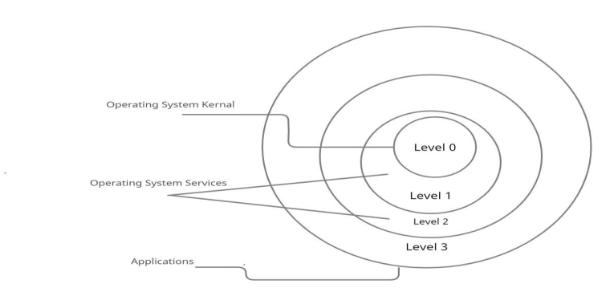Figure 0-1(Taken from A review paper on hypervisor and virtual machine security)
[3]

Regarding some outlying features virtualisation has become a standard practice in the computing industry as hypervisors allow the facilitation of multiple virtual machines off the same physical hardware, i.e. one may consider producing a windows server on one machine and perhaps a Linux based host on another. Without a whim both machines may run off the same hardware providing un-paralleled optimisation of hardware resources at the cost of some overall performance.
Similarly virtual machines may be deployed and decommissioned near instantaneously, allowing businesses to adapt rapidly to changing landscapes leading to phenomenal scalability.
Type 1 and type 2 hypervisors, while fundamentally their purpose is identical the mechanism to which they achieve this goal is totally different. Put simply, both the physical or native machines and virtual machines will communicate with the hypervisor via an application programming interface. In a type 1 hypervisor “bare metal” this host operating system is absent, instead the hypervisor sits directly on the physical hardware making it native, these are faster and more scalable than the equivalent type 2 hypervisor. In contrast a type 2 hypervisor or “embedded” relies on a host operating system to delegate resources to the hypervisor where needed as such they don’t have access directly to the hardware. Seldom seen in server environments type 2 hypervisors are used by engineers to access features that may not be available on the host operating system. [5] [6]
The above summary is informed via an IBM think blog however it correlates with Oracle documentation and shows no clear favour towards own software line.

Diagrams outlining key features of hypervisors.

Native device (Non virtualised)
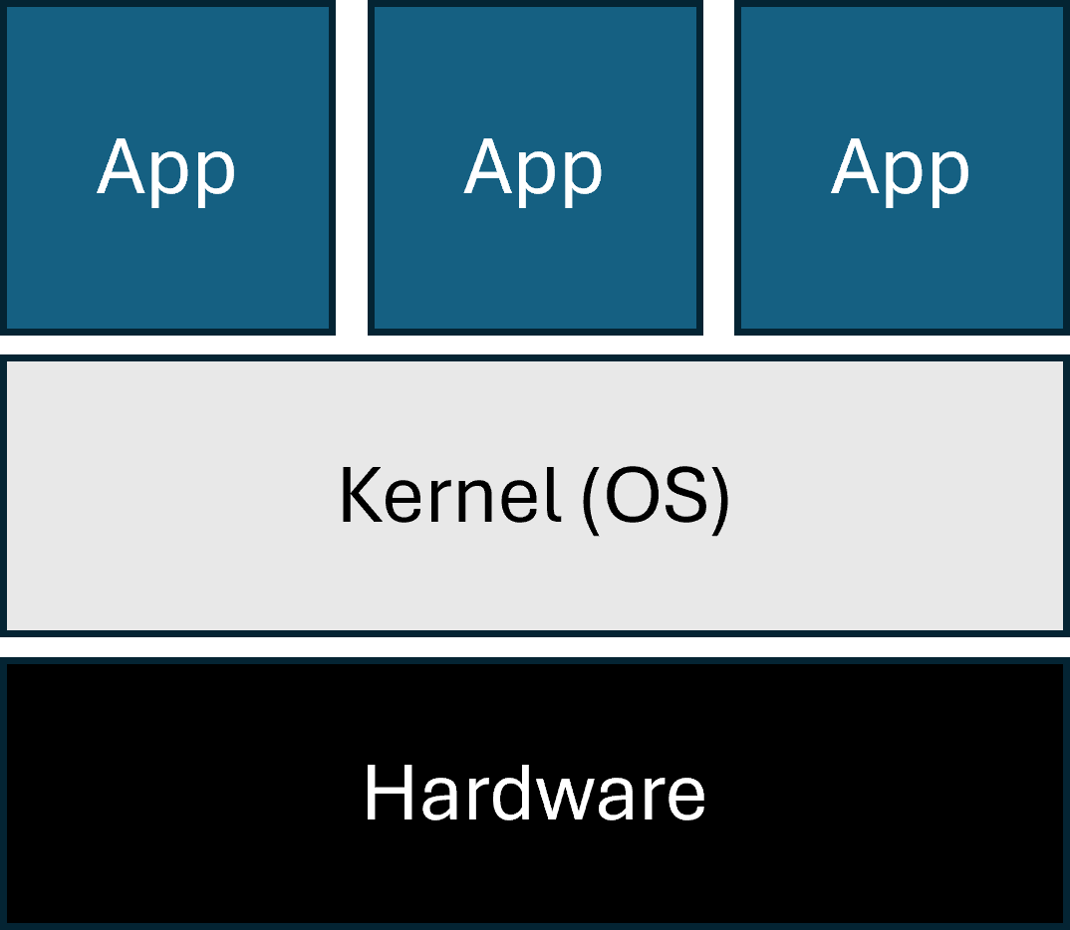
Figure 0-2(Native no hyper v)

With type 1 hypervisor installed
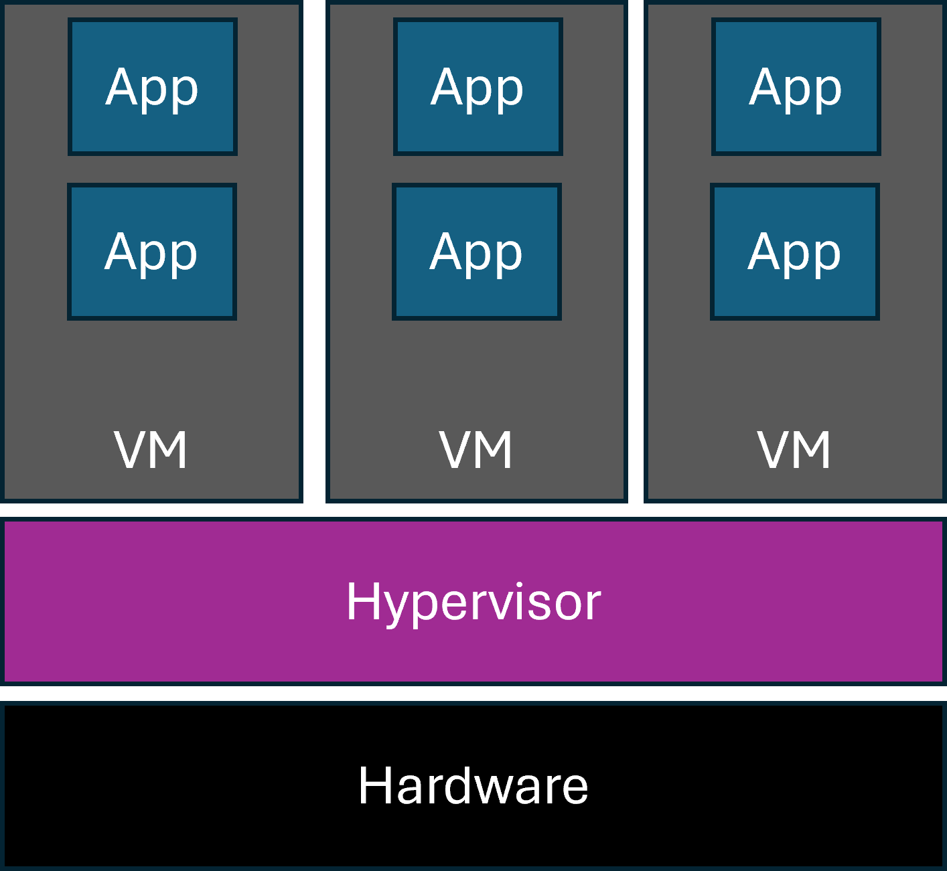
Figure 0-3(type 1 hyper v)

With type 2 hypervisor installed
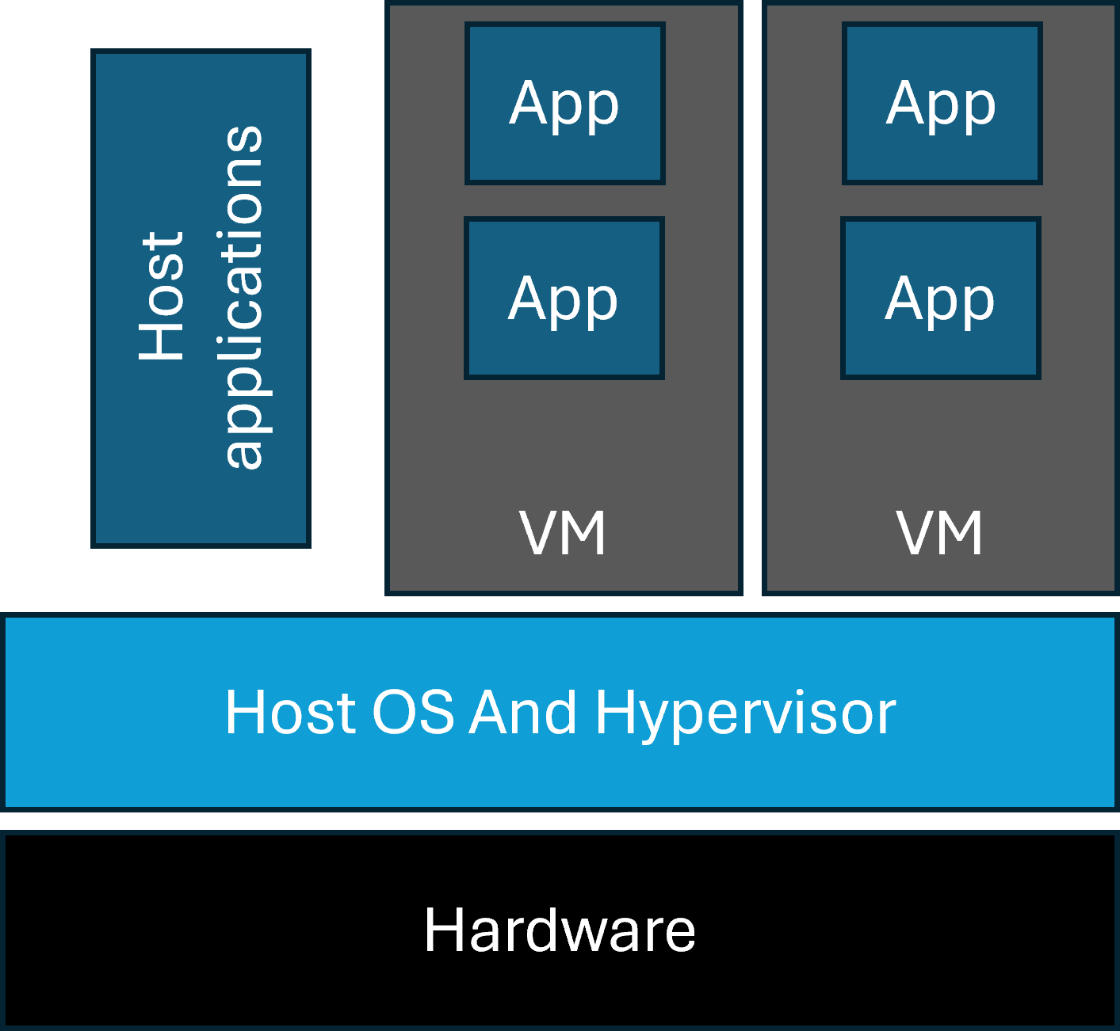
Figure 0-4(Type 2 hyper v)
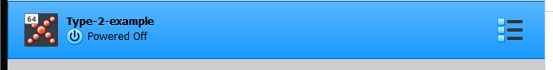
Figure 0-5(Snapshot of a virtual machine hosted within oracle vm virtual box a hypervisor that sits atop a host OS)
Figure 0-1(Taken from A review paper on hypervisor and virtual machine security) 1
Figure 0-2(Native no hyper v) 2
Figure 0-3(type 1 hyper v) 3
Figure 0-4(Type 2 hyper v) 3
Figure 0-5(Snapshot of a virtual machine hosted within oracle vm virtual box a hypervisor that sits atop a host OS) 4

Ip addressing
*Internet protocol
Network connectivity is impossible without a properly configured network interface which is often considered to be on most devices the network interface card (NIC) which despite its name often exists as a software suite, when an *IP address is assigned to a host is now assigned to the network interface. [7] [8] The above summary is via oracle JavaDocs, while providing a simple outline to address how an IP address bares access to a network the older nature of the documentation leaves some room for error.
As a TCP/IP network grows administration becomes difficult, In an ethernet switched network layer two devices will often handle full duplex data transmission (send and receive simultaneously) with the option to use VLAN (Virtual local area network) that act to logically segment a network at the switch level not requiring additional switches, needing a layer 3 router to communicate between VLANs reducing unnecessary broadcast traffic affecting non related nodes. [9]
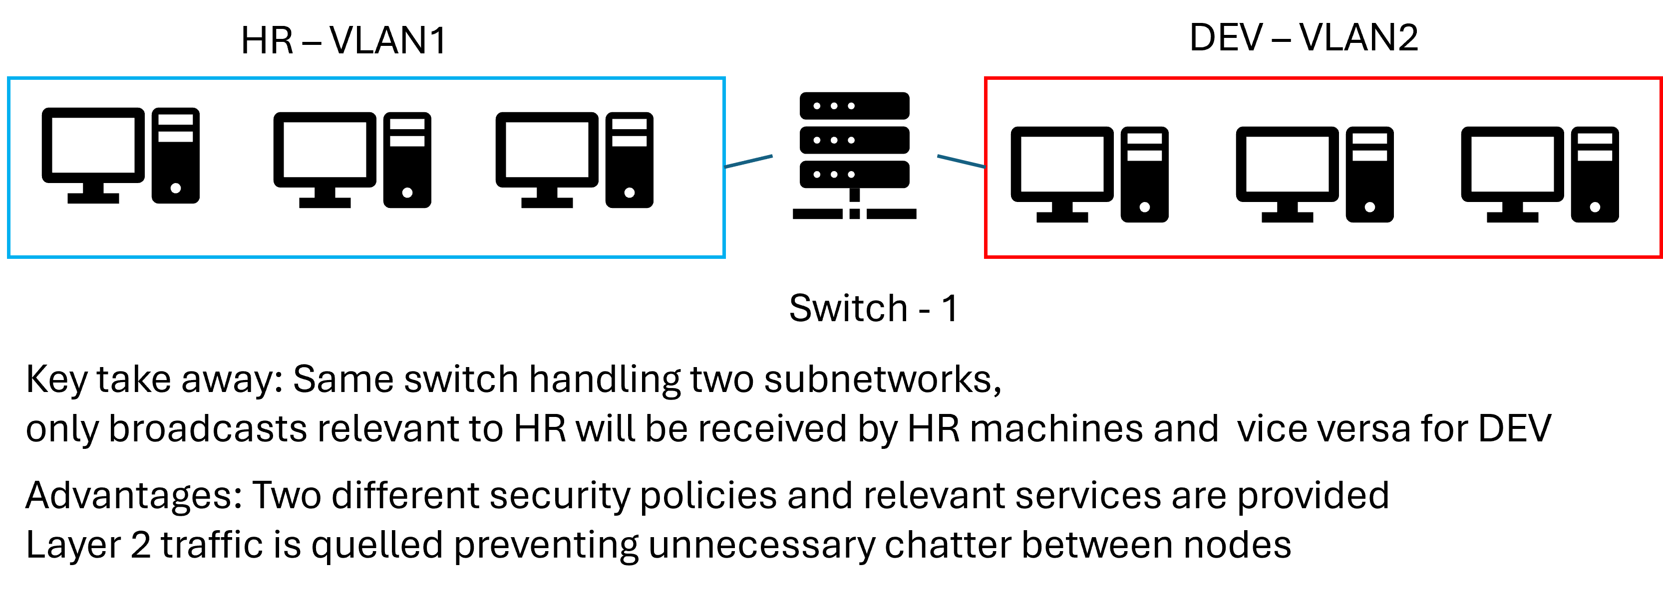
Despite switching, subnetting is still a crucial practice to manage broadcast traffic further such as address resolution protocol requests subnetting reduces the size of the broadcast domain, also allowing separate access control and security policies to be applied to each subnet. This works by reserving bits from the host and allocating them to the network portion of the IP addressing scheme. i.e. a class B IP address In IPv4 format existing on a private network may look like. 2.96.51.89 with a subnet mask of 255.255.0.0 / 16 (16 bits or 2 octets reserved for network). This comes at a trade-off less hosts for more subnets. [10]

Group work summary
Upon participation and completion of this activity understanding was gained and as such a more informed concept of Ip addressing schemes was produced. For example, how Ip addresses demonstrate a hierarchical structure within a network.
Other concepts such as how a network employs packet switching to transmit data over a network, this is a technique that depends on breaking data into smaller more efficiently transmitted packets where at a given instance a packet will have a source and destination address, this address will often be of an Ipv4 format this being a decimal base 10 system with a maximum given octet size of two to the eighth power or 255 with a total of four octets. Typically, the protocol associated with transmitting a packet will be the TCP/IP suite “transfer control protocol” this operates at the transport layer or layer 4 of the OSI model. Tasked with guaranteeing reliable delivery of packets by utilizing error detection, retransmission of non-received packets and flow control to manage rate of re transmission to prevent bottlenecking of network resources. [11] [12]

Routing
Fundamentally routing is the process of determining the optimal paths for data packets to travel from a source and destination typically across networks or subnetworks. Routing is associated mainly with layer three of the TCP/IP model.
Facilitated by hardware devices called routers the key functionality is to connect hosts to the wider network. This process is handled by a variety of protocols that vary depending on IP version or network architecture the theory behind effective routing is to build a routing table which can be thought of as a logical mapping of the quickest paths between nodes on the network. [13] [14]
A routing table may be updated in range of different ways, the most basic way is static routing where a network administrator manually configures the table entries, this results in lower CPU overhead on networked resources and no bandwidth usage as unlike dynamic routing static routing requires less resource in information exchange as the routing has been pre-configured. [15]

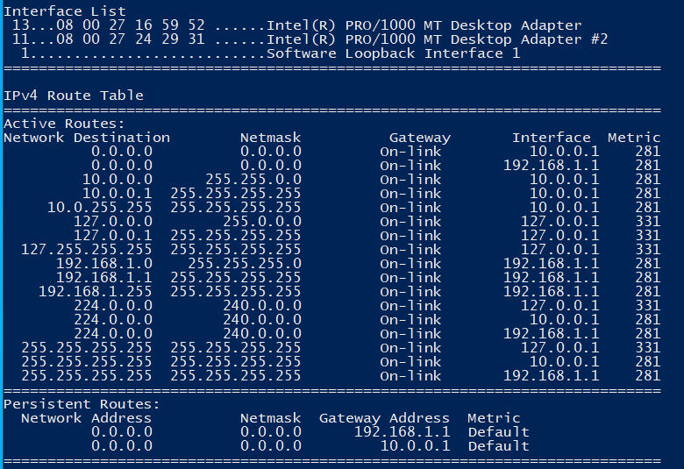
Figure 0-1 (Taken from sdc vm)
Unlike static routing adaptive routing depends on the router to determine the optimal path for a packet to take. This path is determined by a plethora of protocols of which all associated routers must have configured where the initial routing table is started statically and propagated via protocols, i.e. router information protocol which is a distance vector protocol that supports the exchange of routing information among networked routers using each routers routing table, the “hop count” is used as a metric to measure against where a hop is given as a router that must be accessed by a packet, the maximum hop count allocated in RIP is 15. This limits the size of network it can effectively manage. [16]
A significant challenge in the use of RIP is slow convergence time this being the time taken for routing tables in affected routers to stabilise particularly as link cost or bandwidth requirements increase. This can lead to infinite loops and ‘count to infinity’, where the bellman-Ford algorithm cannot prevent loops from occurring where routing tables never reach a stable state. To address this issue CF-RIP or convergence free RIP has been developed, this eliminates convergence periods by enabling failure carrying packets and multiple next hops per destination enhancing overall network availability. [17]

Network services
Networking services are applications that run on the network application layer designed fundamentally to secure connections or provide additional functionality to the network. [13]
A fundamental service now accepted as mainstream in corporate application is a virtual private network (VPN) tasked with establishing a secure connection over an unsecure network such as the internet VPNs funnel accessed resources through a private network ensuring that data is encrypted through the entirety of transmission. This is the act of VPN tunnelling. [14]
Another key service more so in network management is dynamic host configuration protocol (DHCP) which automates the process of assigning IP addresses and parameters that would otherwise be set manually which alleviates the burden on network administrators. A device discovers a dhcp server via a dhcp discover message where the server then provides the device with a default gateway an IP address and a subnet mask. This allows the device to communicate with others on the TCP/IP network. [15]
Active Directory domain services (ADDs) is a supremely powerful network management service utilised by windows machines, providing the methods for storing user credentials such as phone numbers, names and passwords enabling authorized users to access this information. Focused on centralizing network management and simplifying access control [16], ensuring all devices are configured with the correct parameters within their domain. Securing an ADDS is vital as attackers can gain control of critical assets and user privileges. [17] [18] [19]
Also vital for network security, certificate authorities ensure secure communications over the internet by verifying the identities of participants involved in a digital transaction. This is achieved through offering digital certificates that facilitate encryption allowing for secure communication channels almost guaranteeing secure exchange of information. A common use case is PKI (public key infrastructure) as seen on cloud services. [25] [26]

Setup configuration and troubleshooting: (Windows host and client)

Host – Win server 2022 (EVAL)
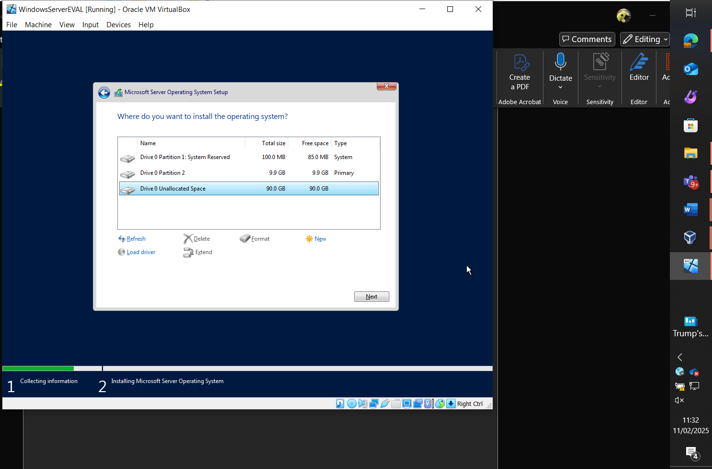
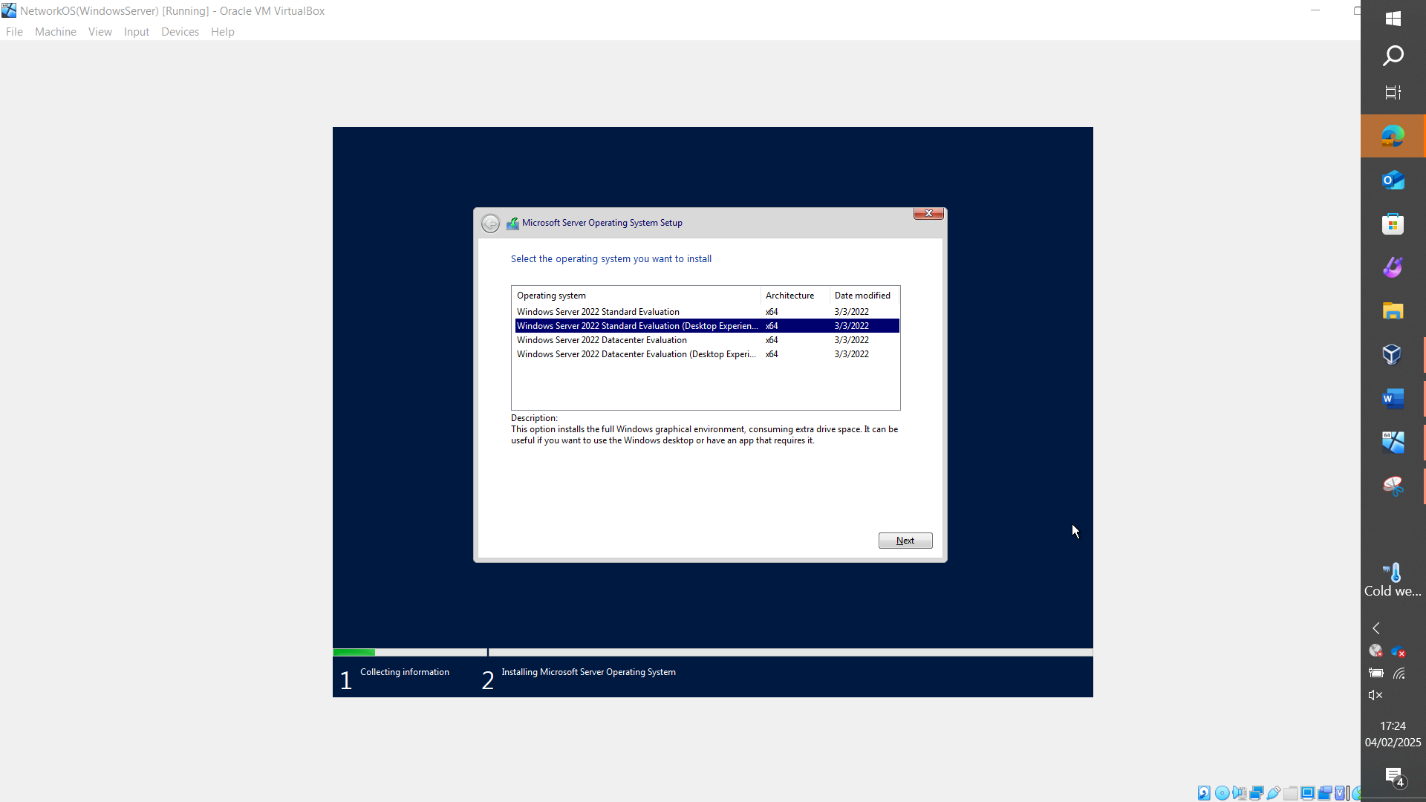

Client (Win 10 eval edition)
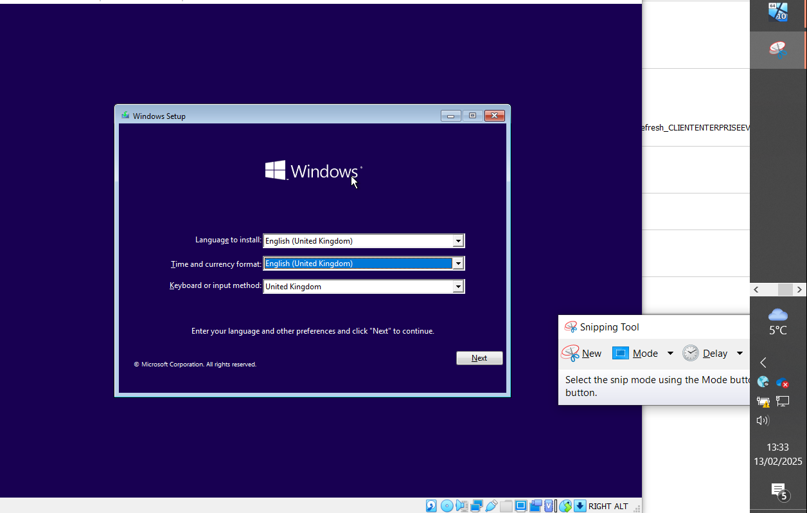
Disabling firewalls:
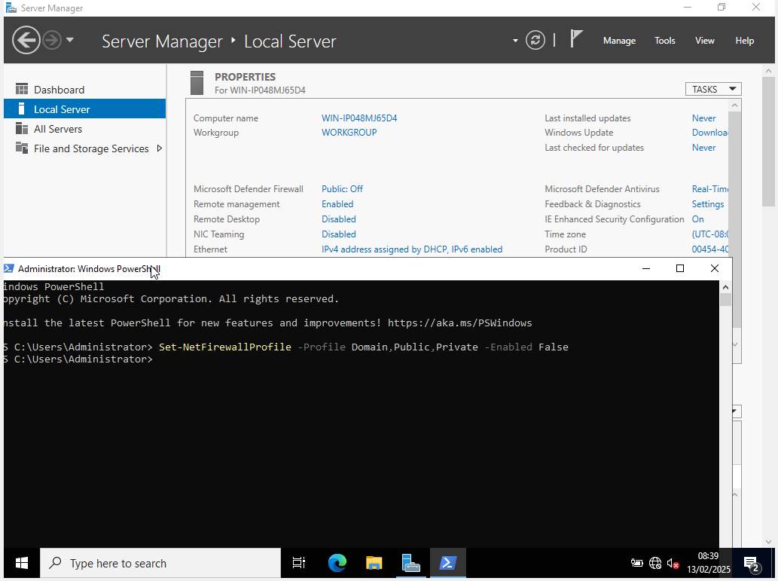
Connectivity testing
Ping (from host to client)
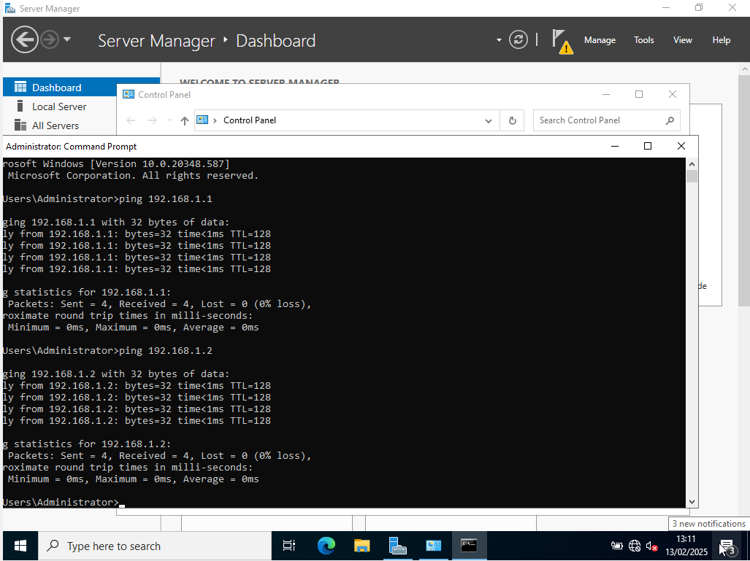
Ping (from client to host)
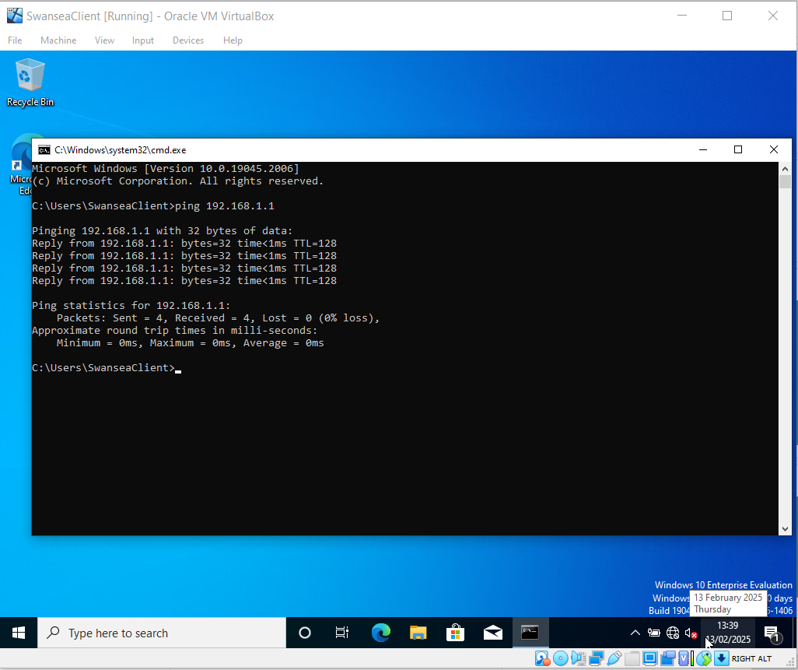
Problems encountered and remedied
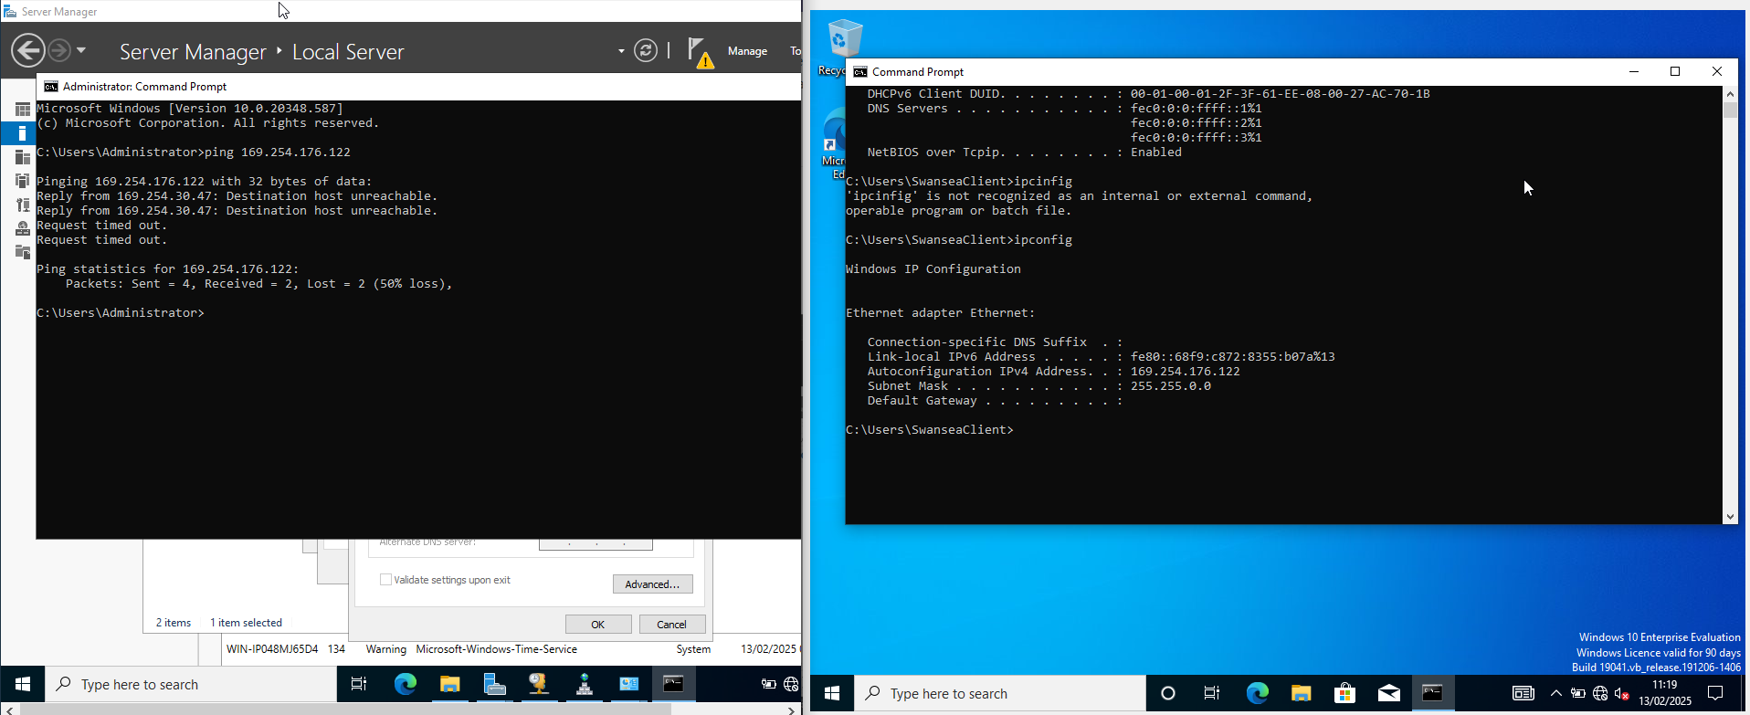
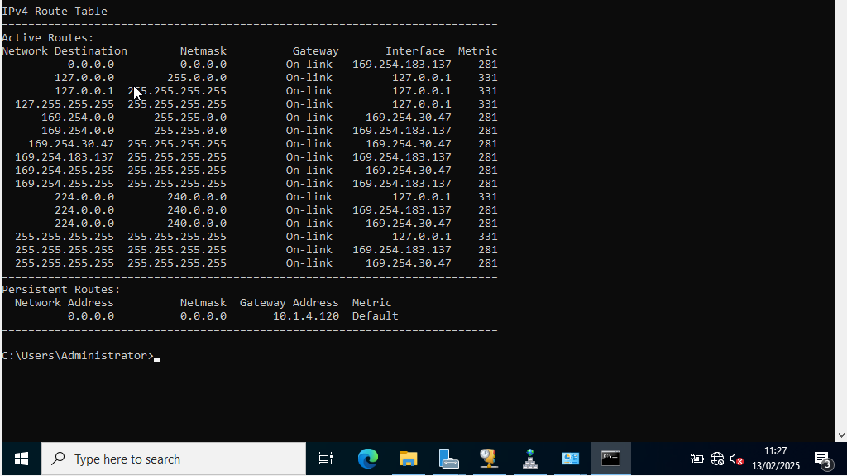
Connection was failing due to improperly configured adapters, fixed by assigning vmnet2 to both adapters associated with intranet connectivity.
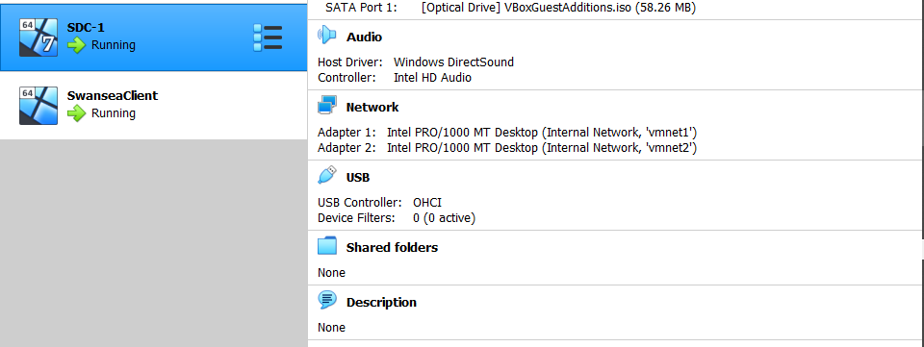
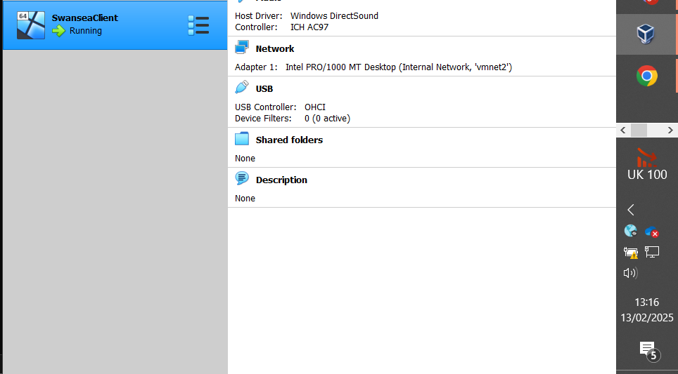

Configure outbound and inbound firewall traffic to allow icmpv4 requests
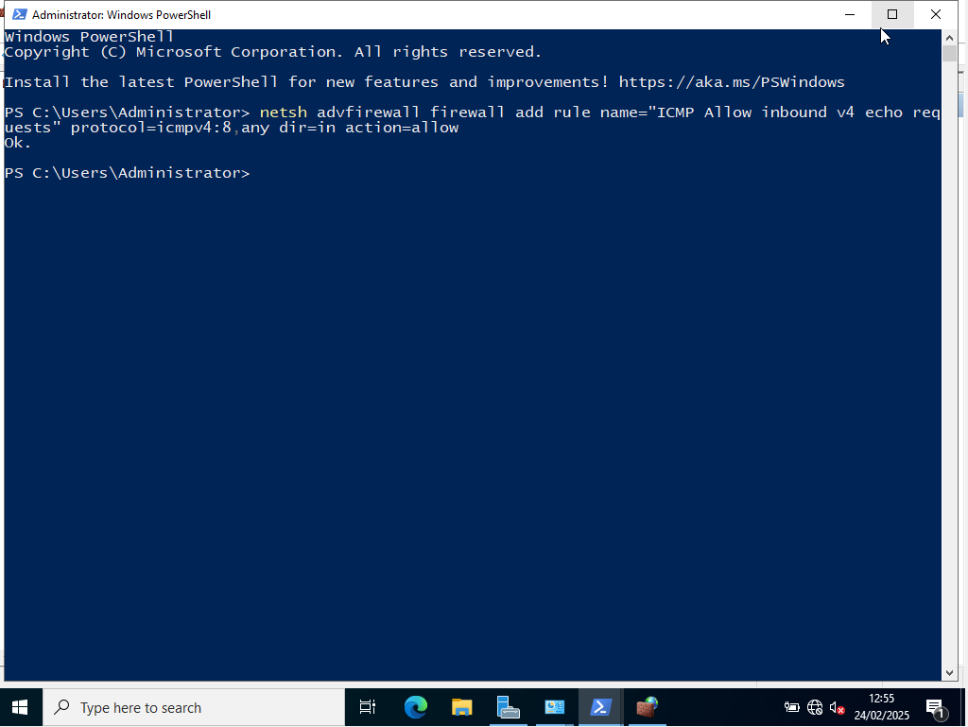
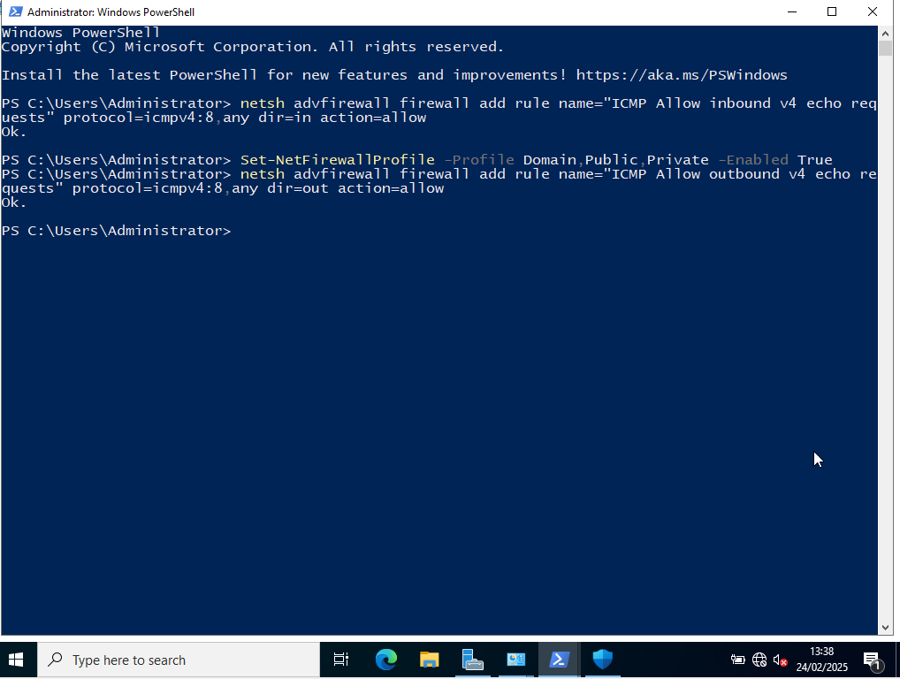

Allow icmpv4 echoes for ping etc through firewalls this is repeated for client
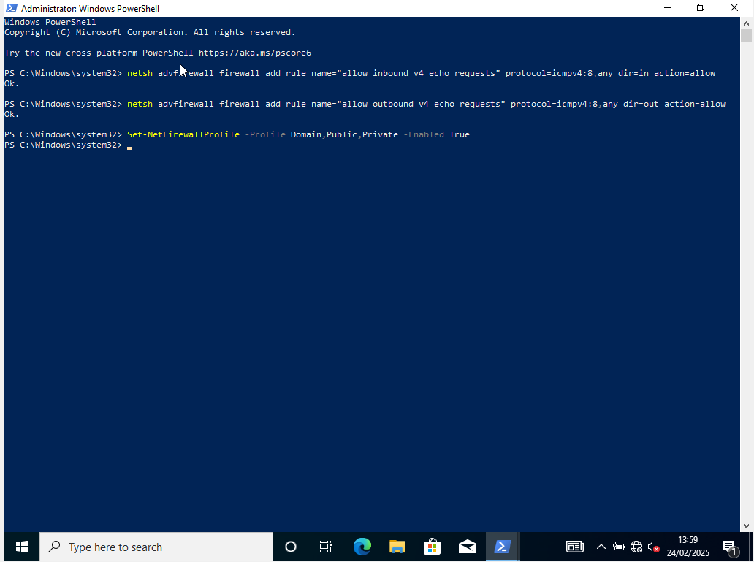
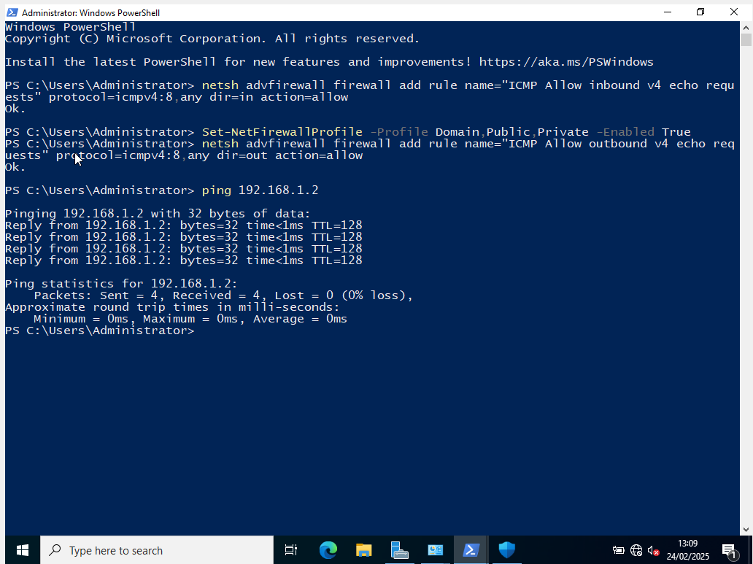
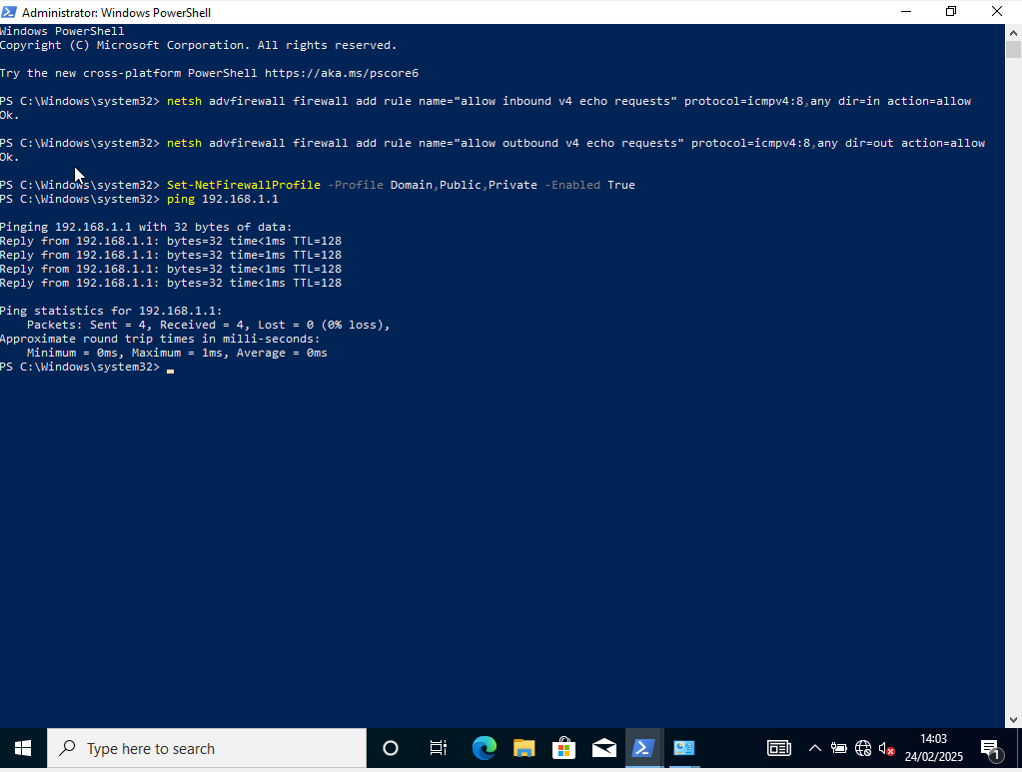

Linux side
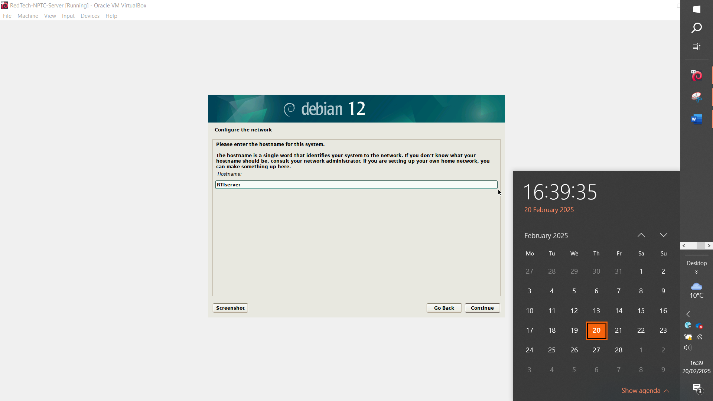
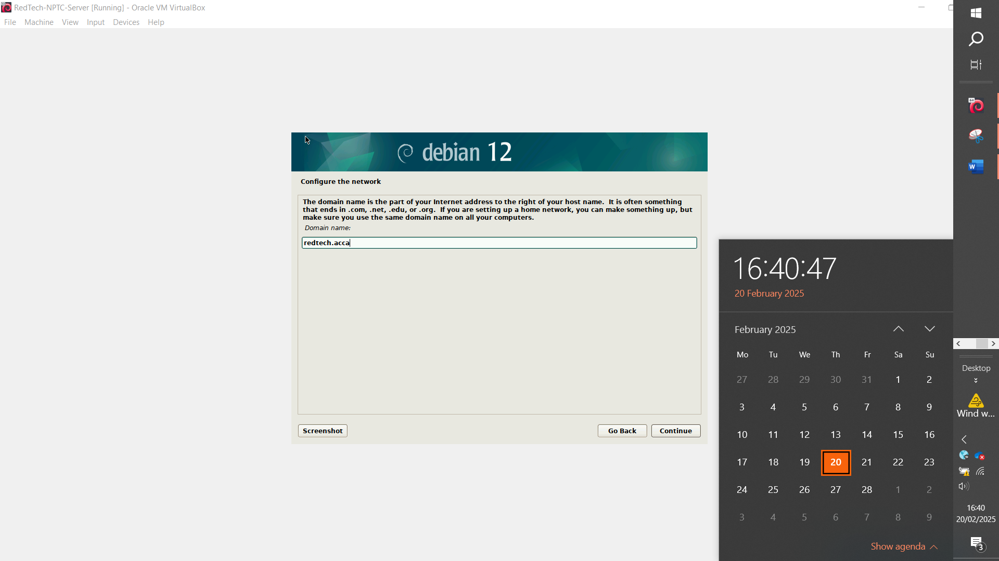
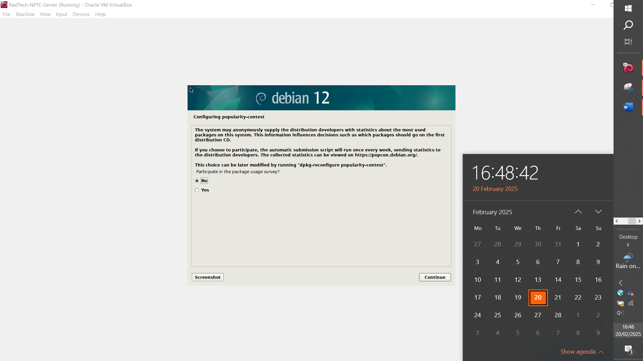

Troubleshooting: disabling cdrom mount to force online packages for install

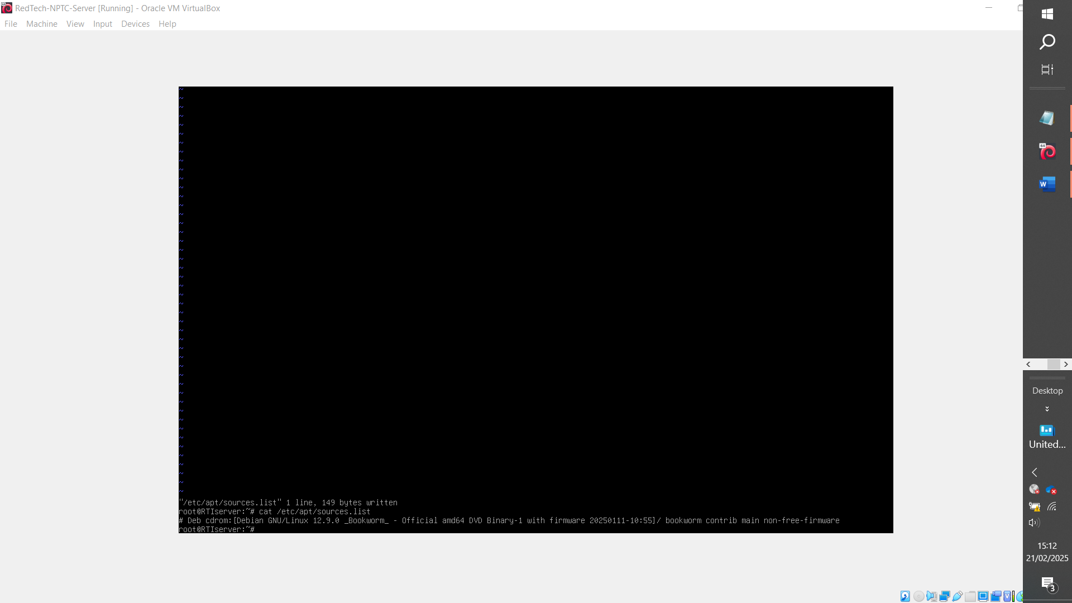
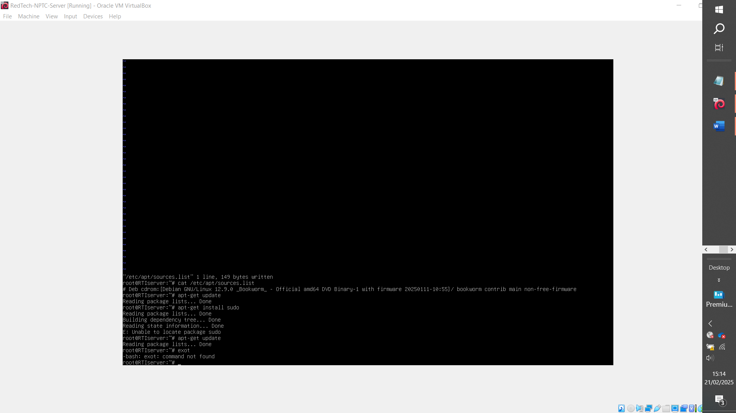
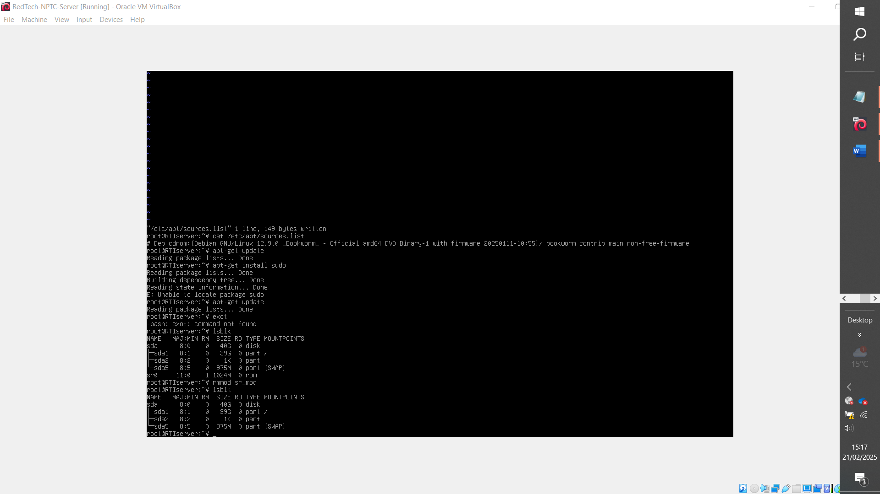
Ensure cdrom sr0 is disabled
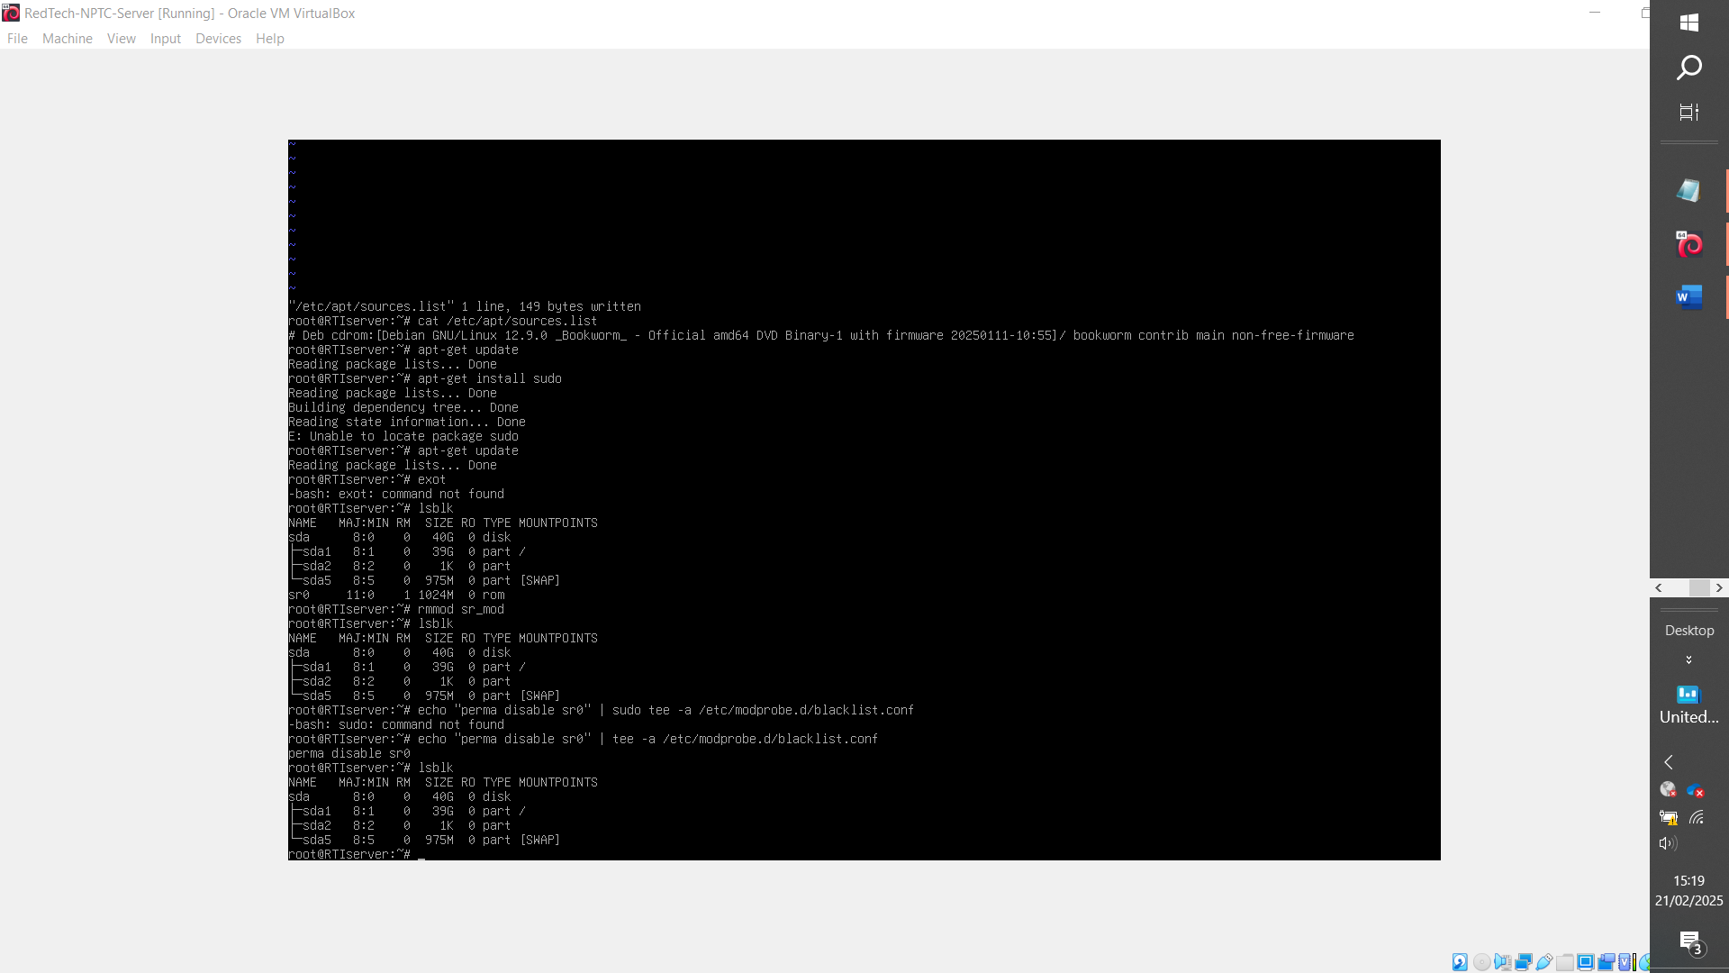
Disable unless needed

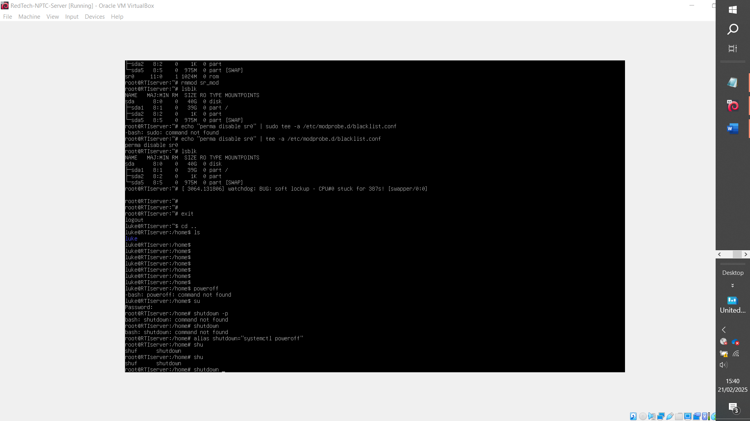
Added following apt-repos into /etc/apt/sources.list
deb http://deb.debian.org/debian bookworm main

deb http://security.debian.org/debian-security bookworm-security main
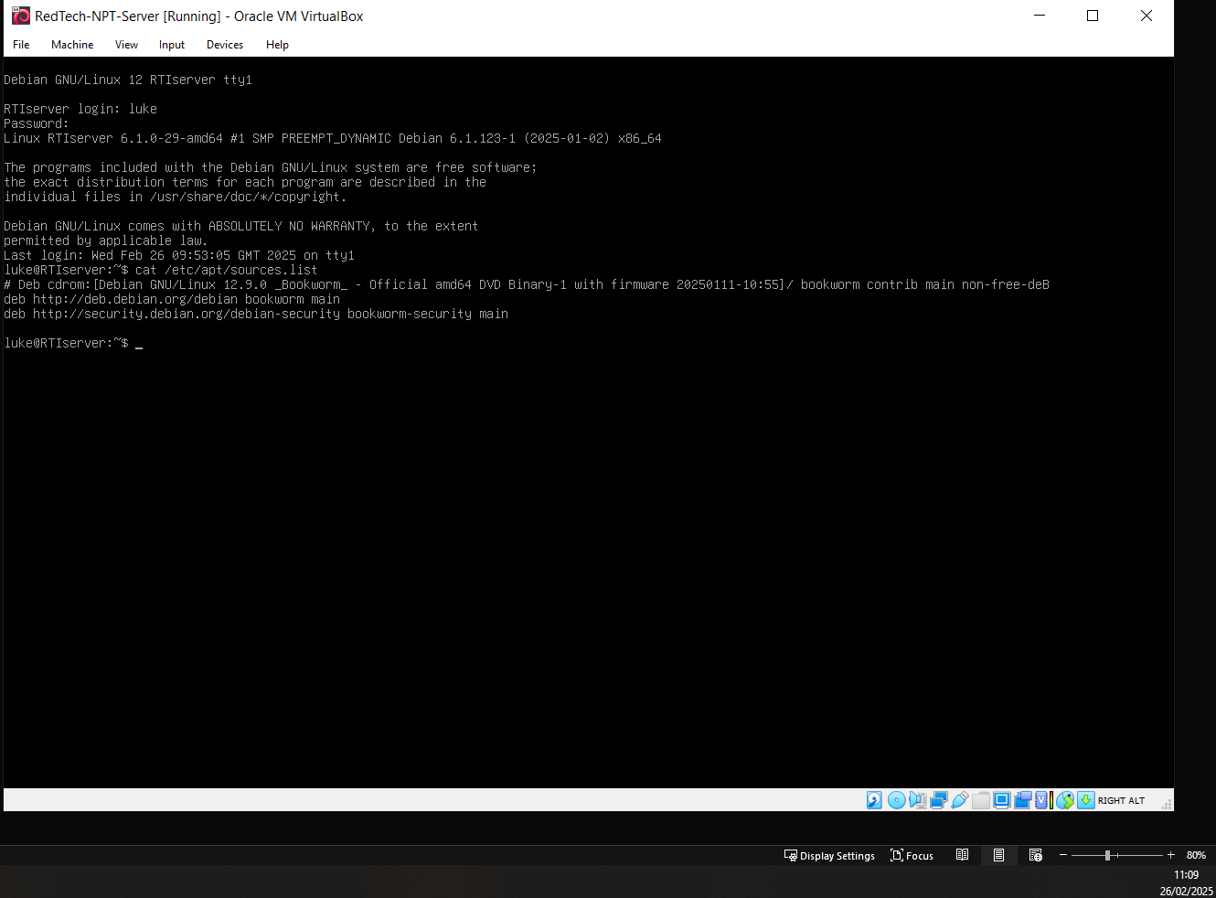

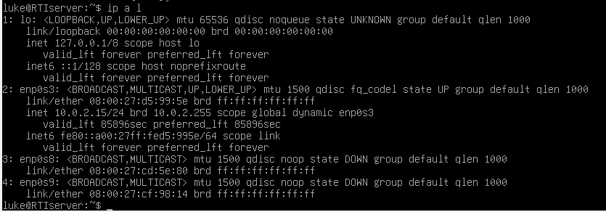
Marked in red: NAT adapter
Marked in purple:’ vmnet0’ (Linking servers) and
‘vmnet3’ (Linux host to client)

3 = vmnet1(config to ping windows set as 10.0.0.2 / 30 (255.255.255.252)
4 = vmnet3 (int)

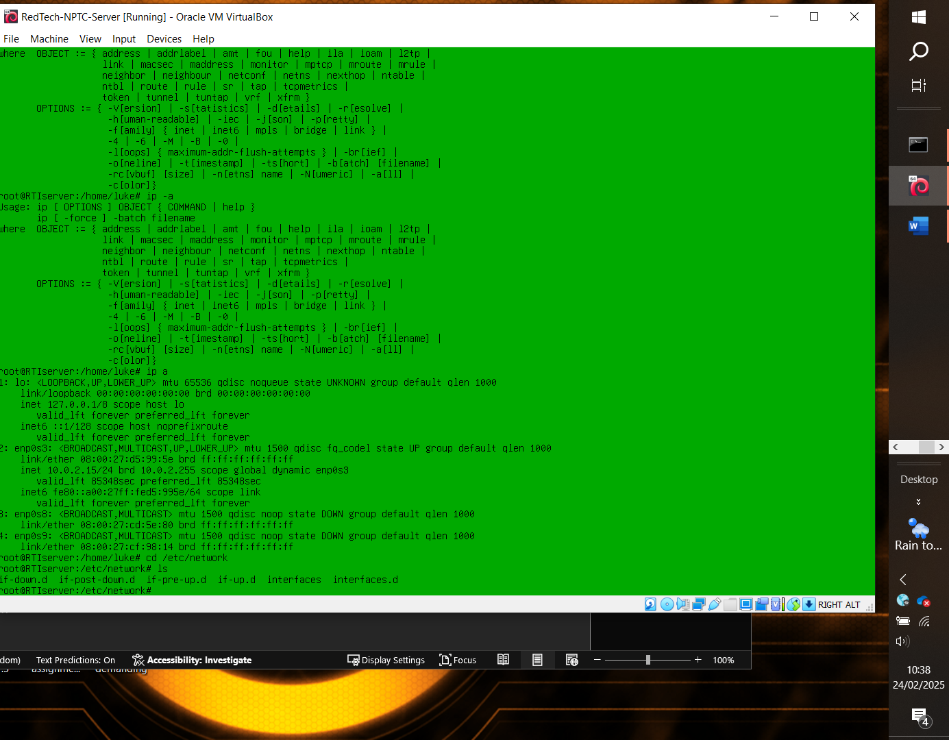
Adapter config
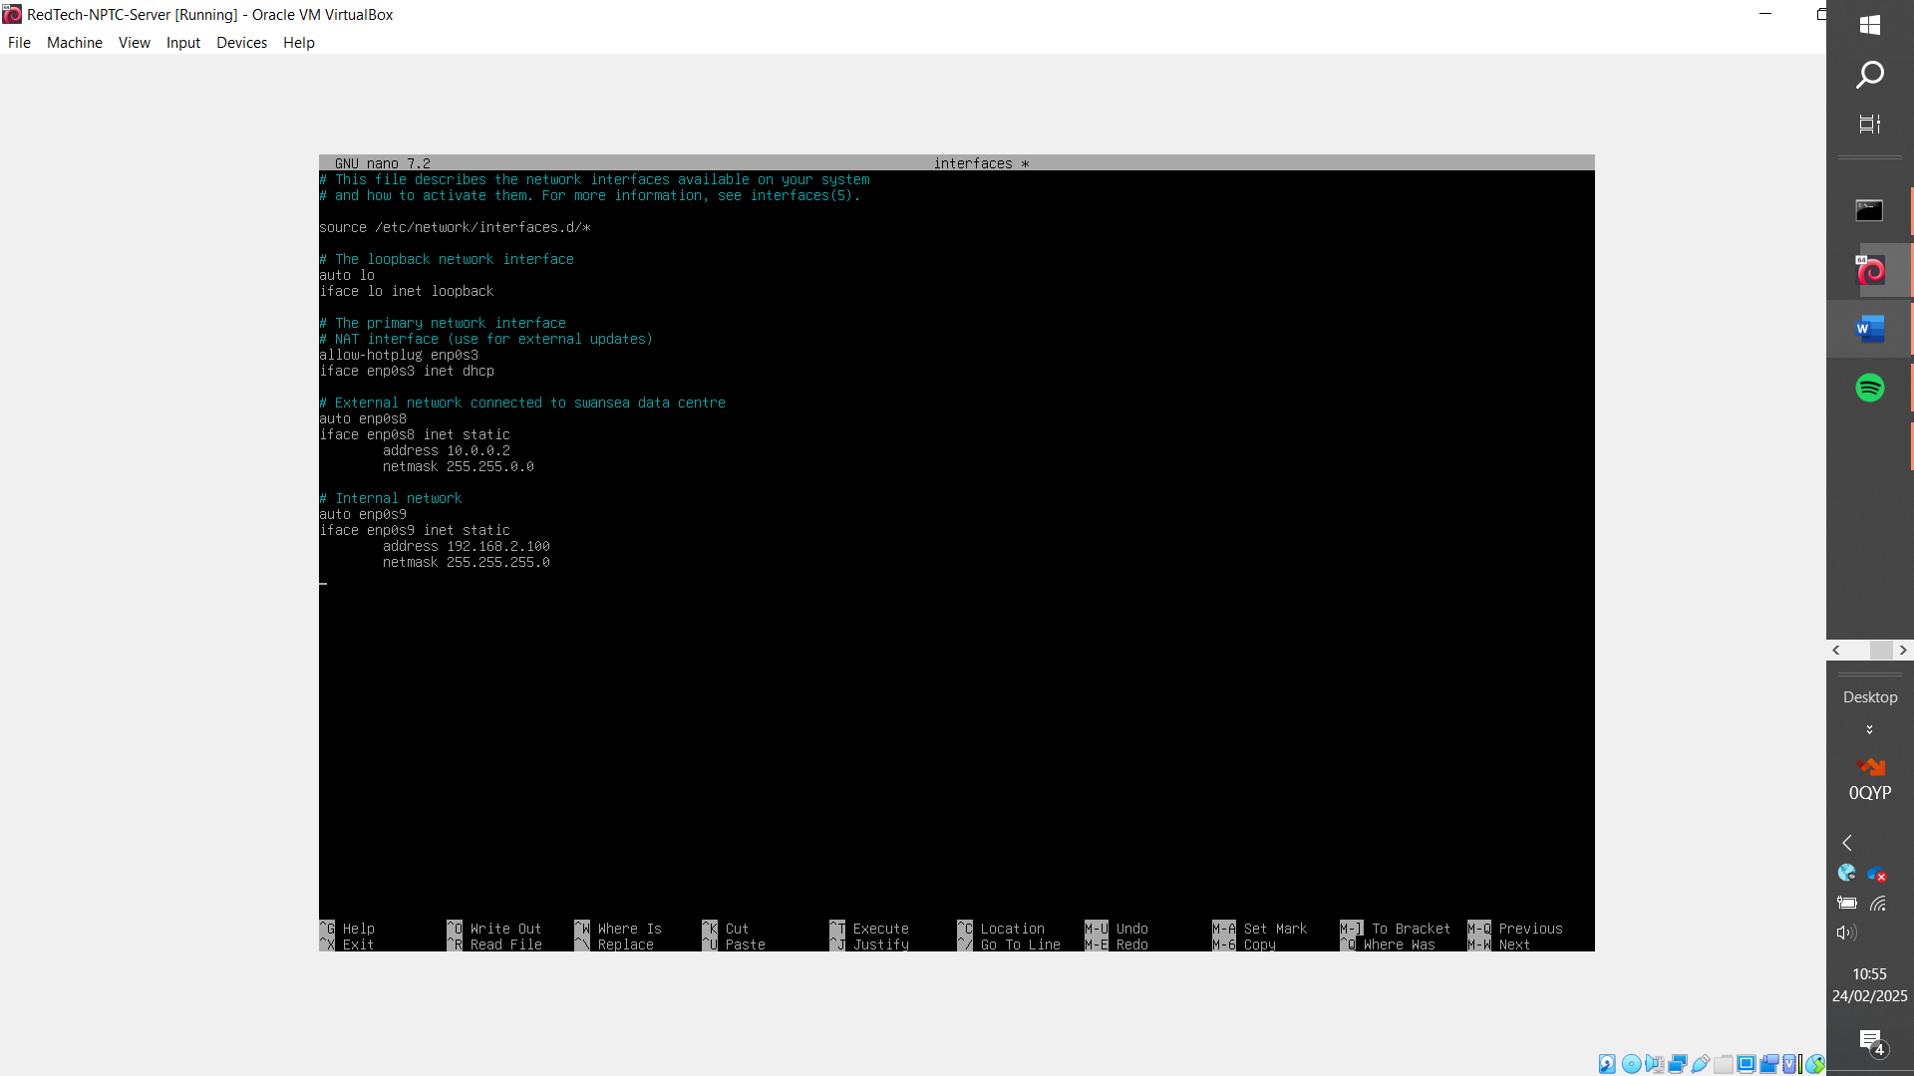
Used auto, this means instead of hotplug the interface is configured by the os at bootup [20]

Ping failure (Issue with network adapters, switched to vmnet1)
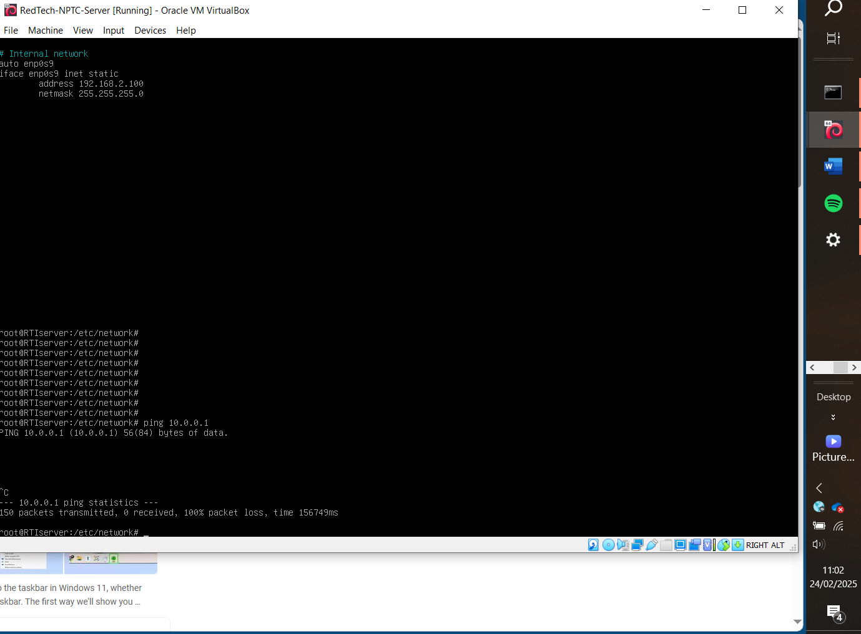

Use vi to add deb apt repos to install needed packages
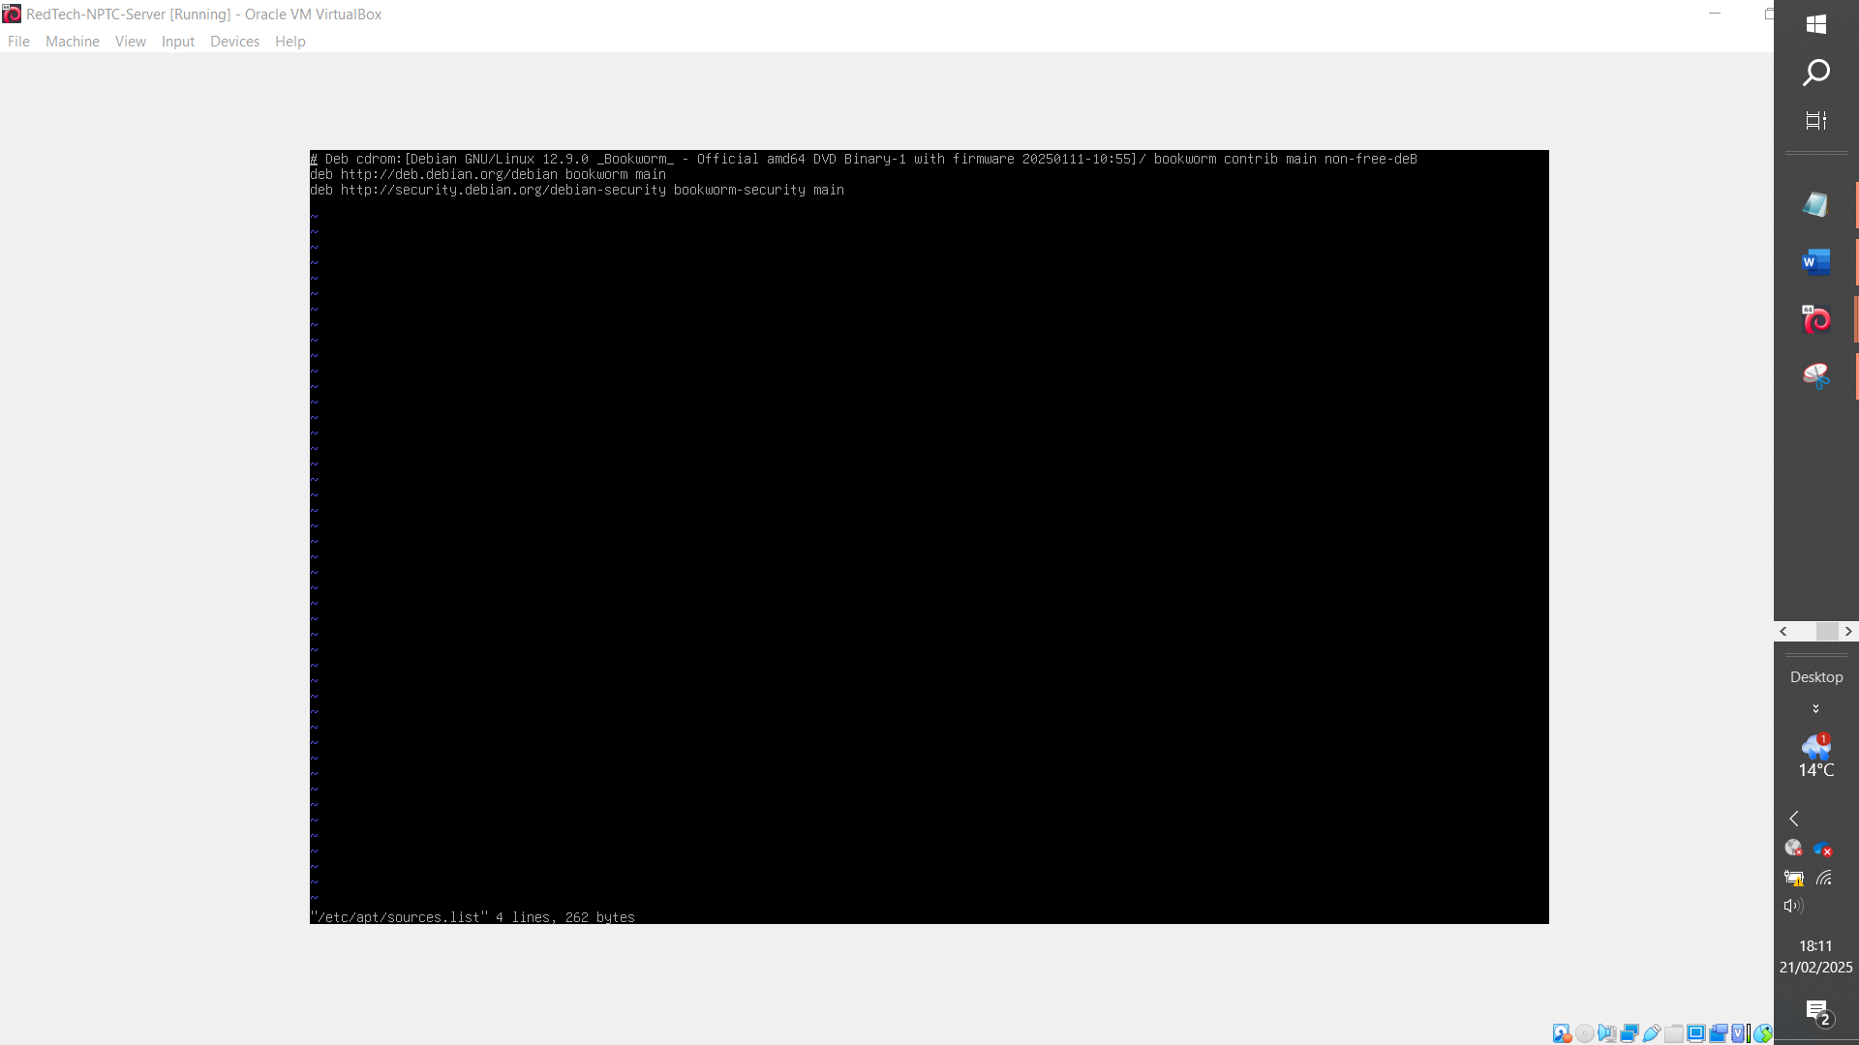

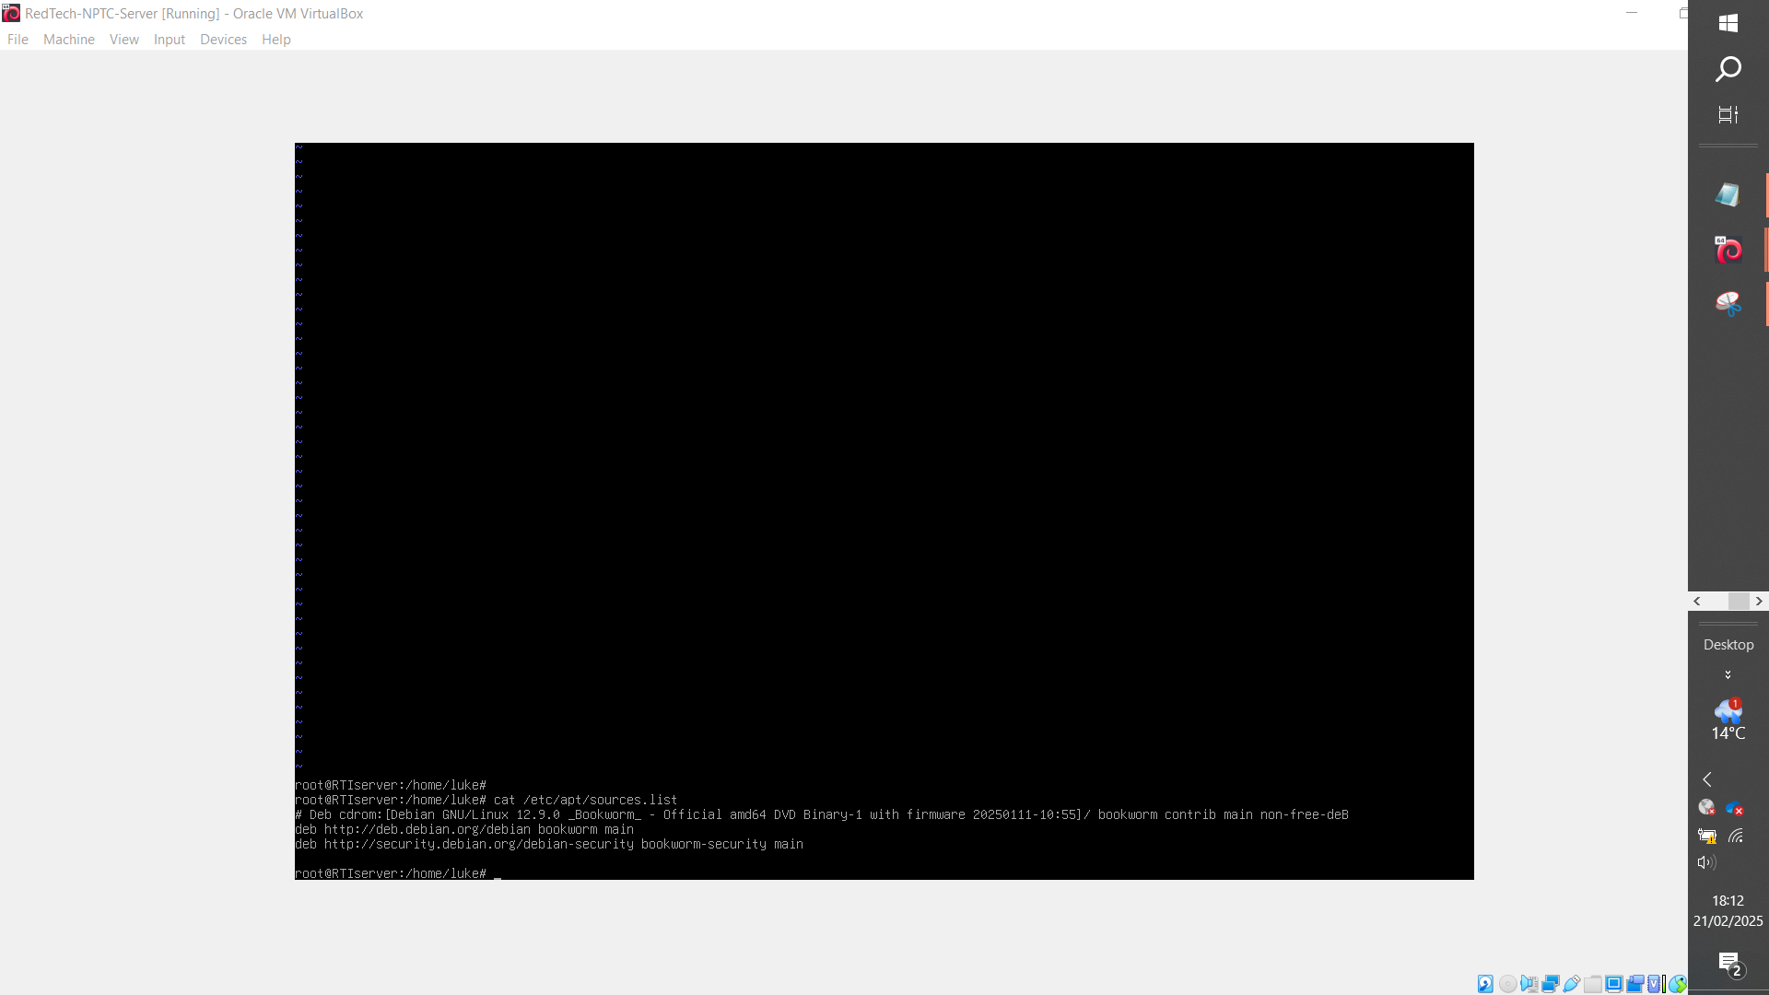
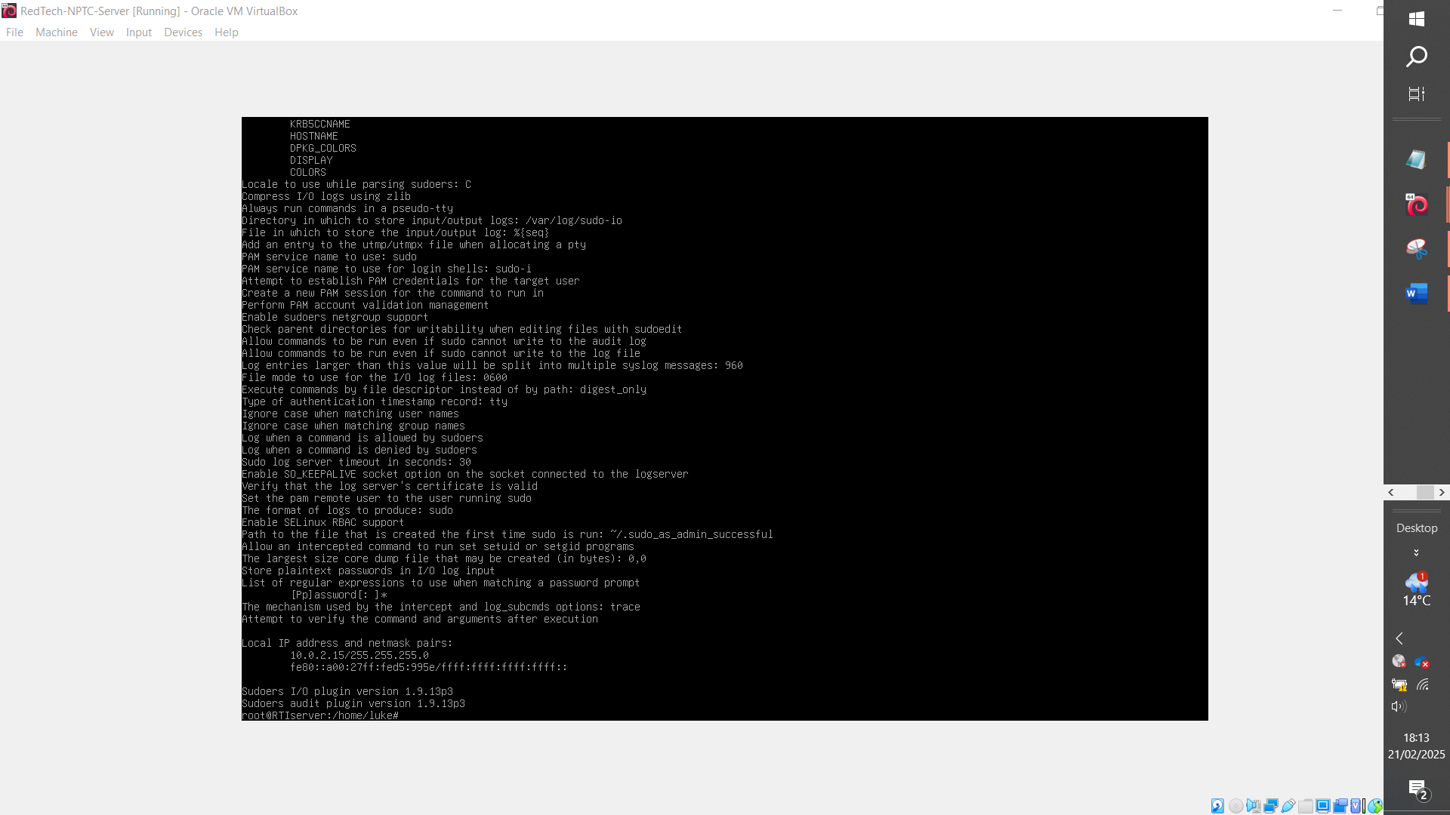

Verify sudo group
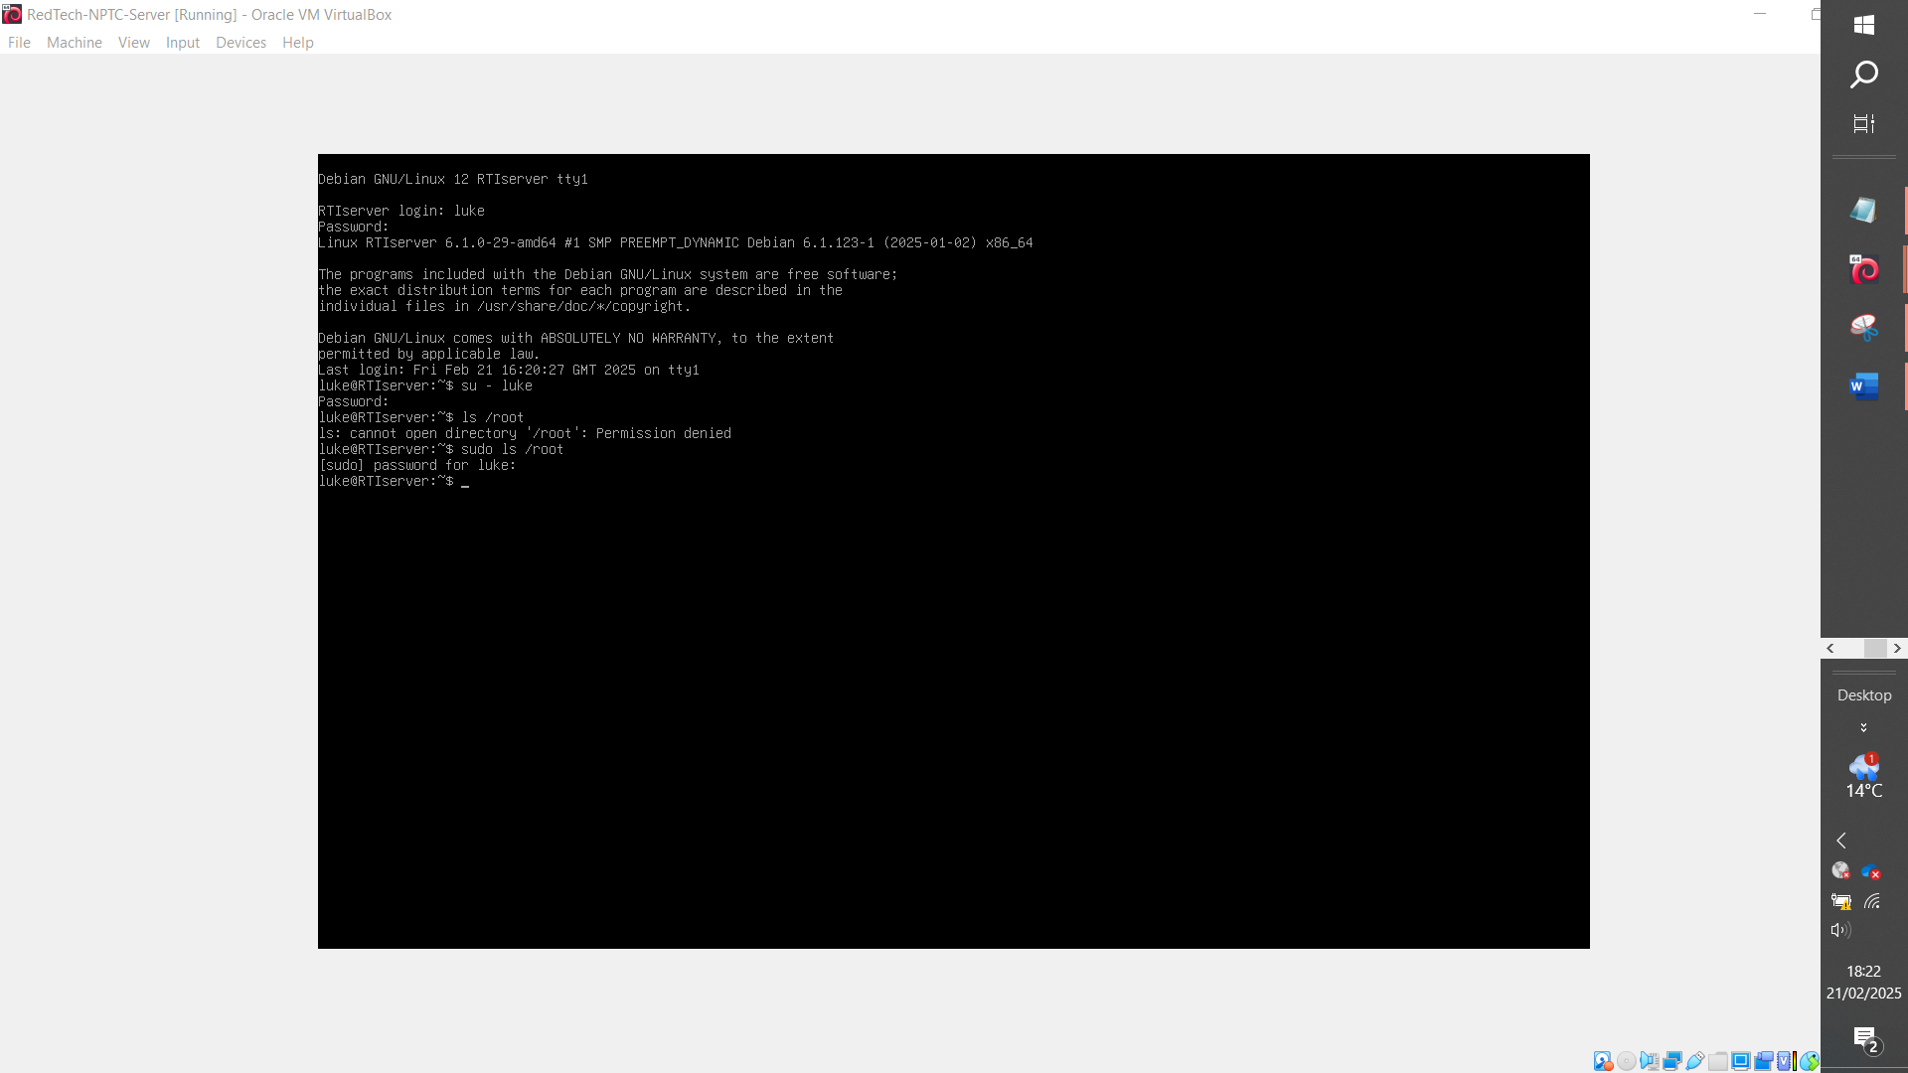
Issues pinging server groups
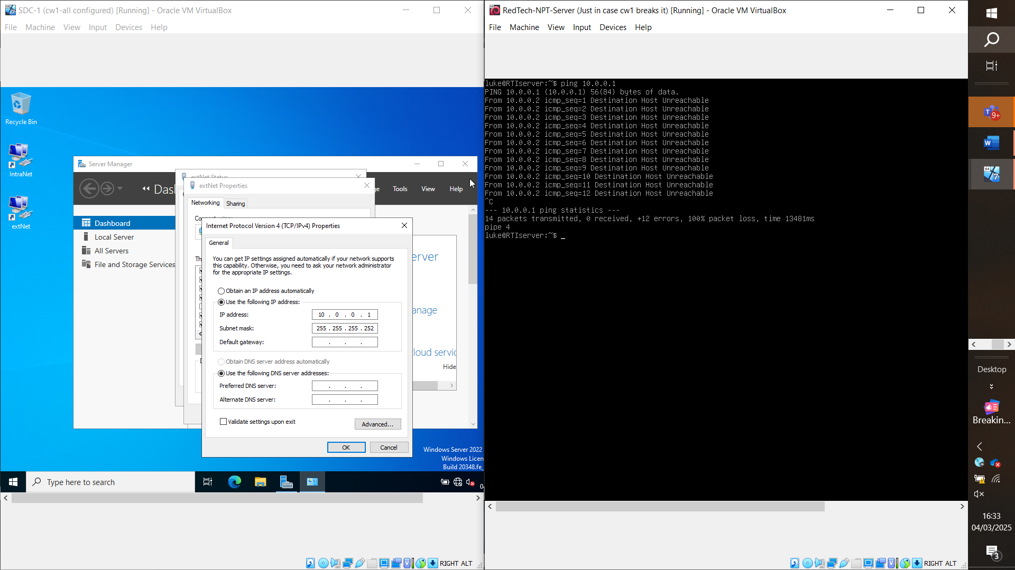
Fix:
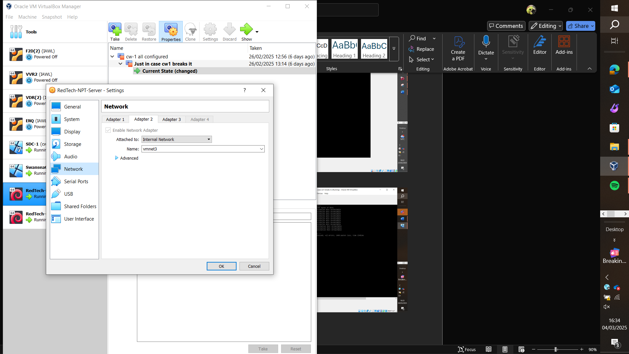
Move adapter 2 onto vmnet1
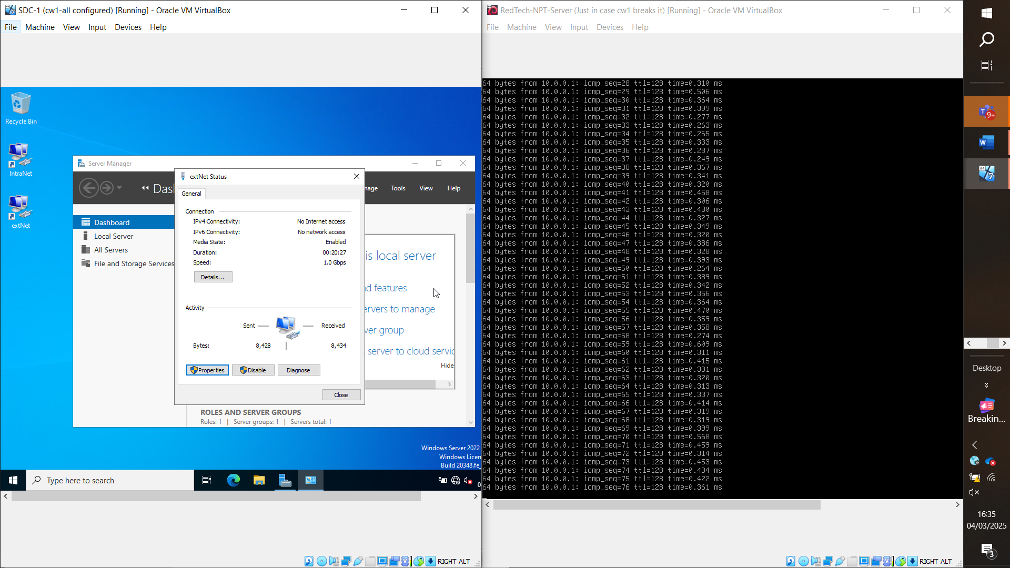

Pinged sdc windows server from linux server

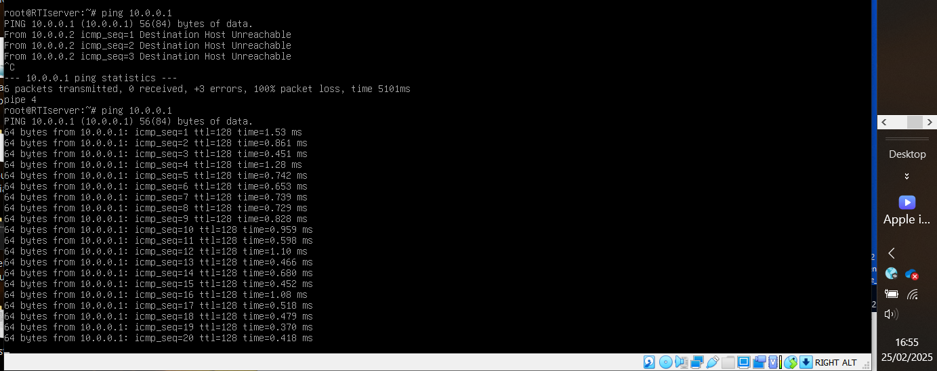

Ping linux host with client
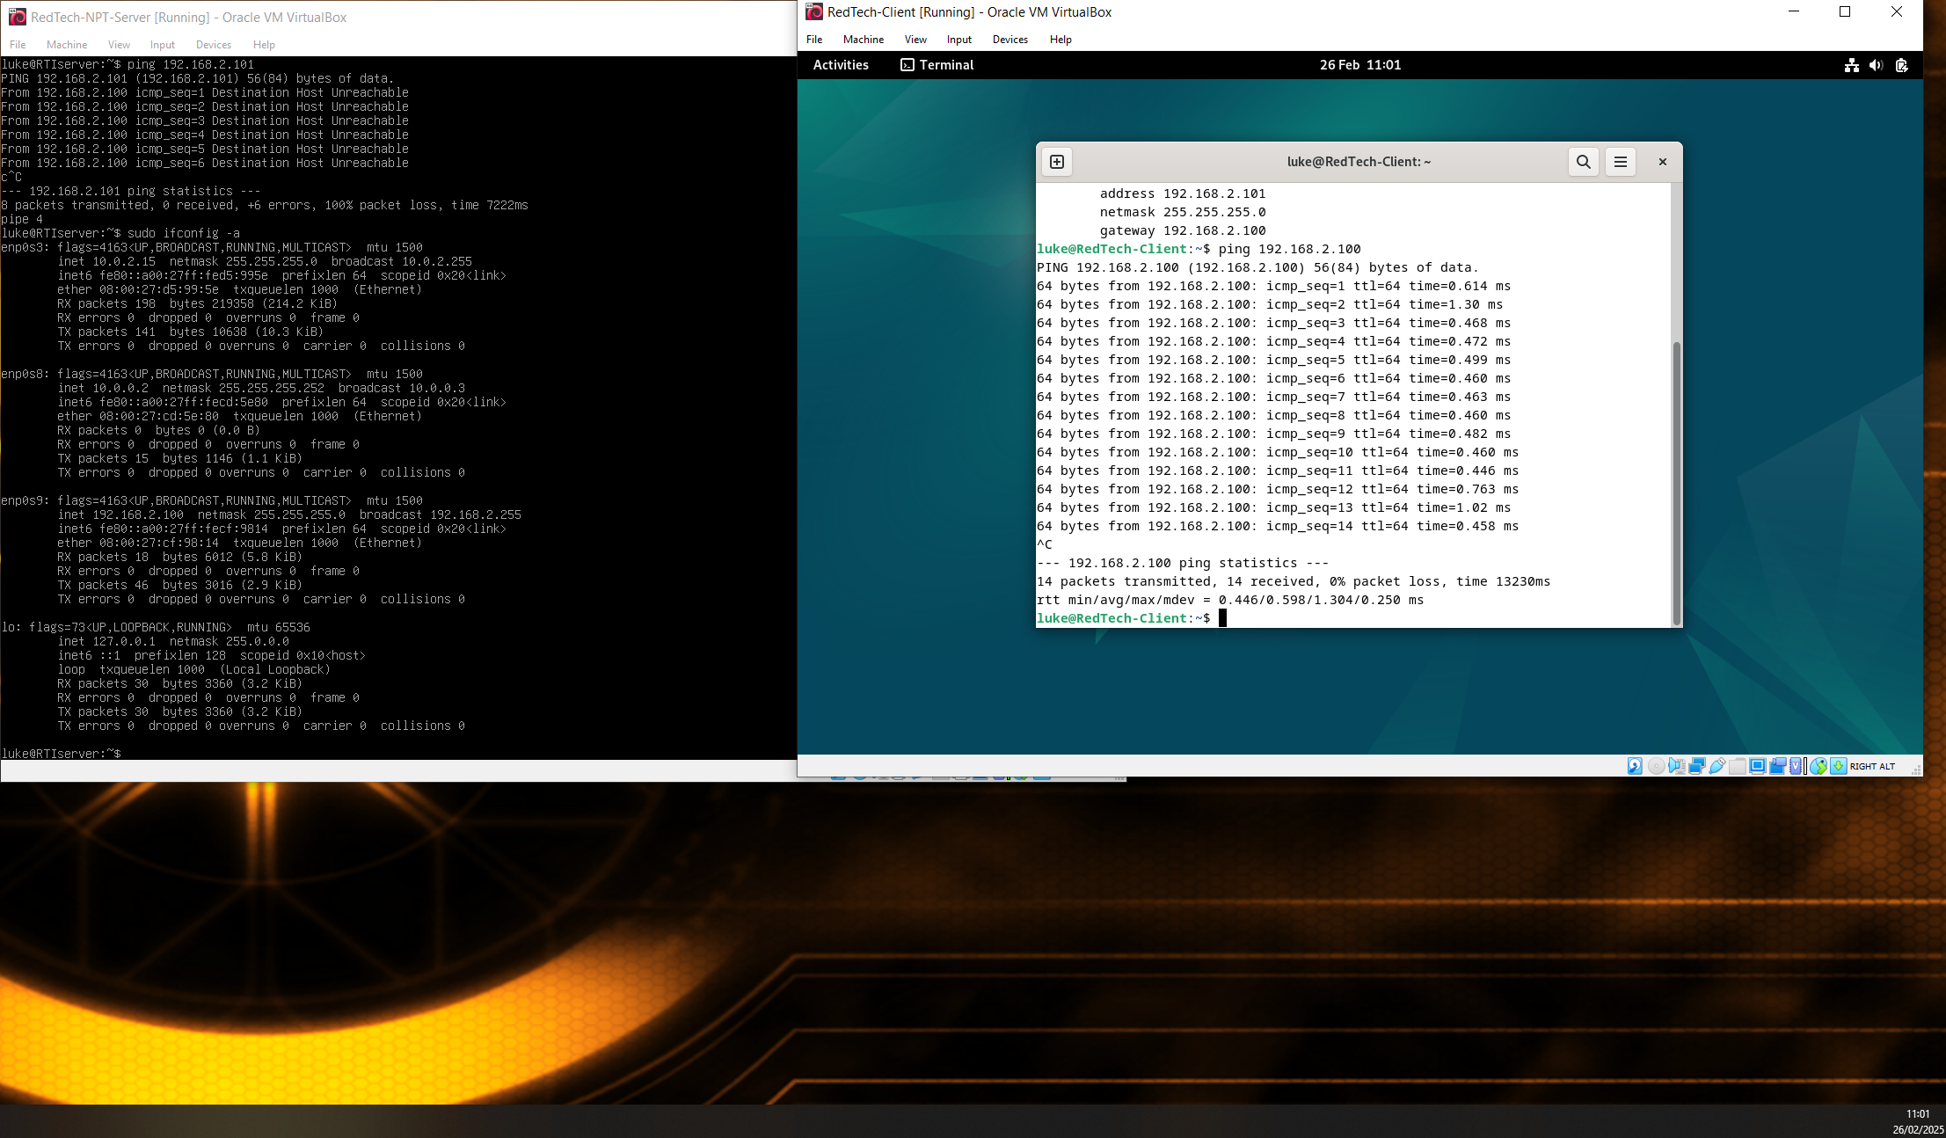

HOST to client (linux)
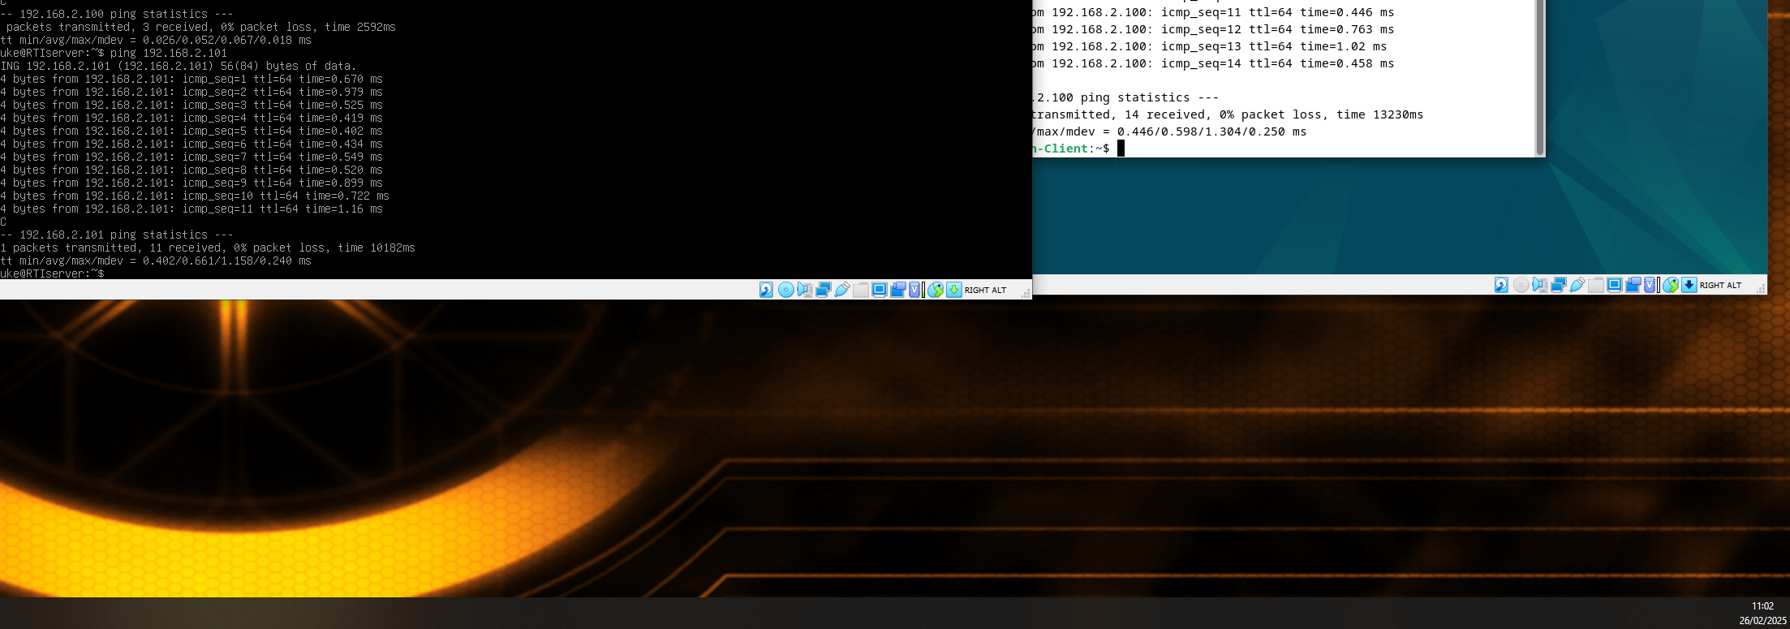

Verify linux configurations
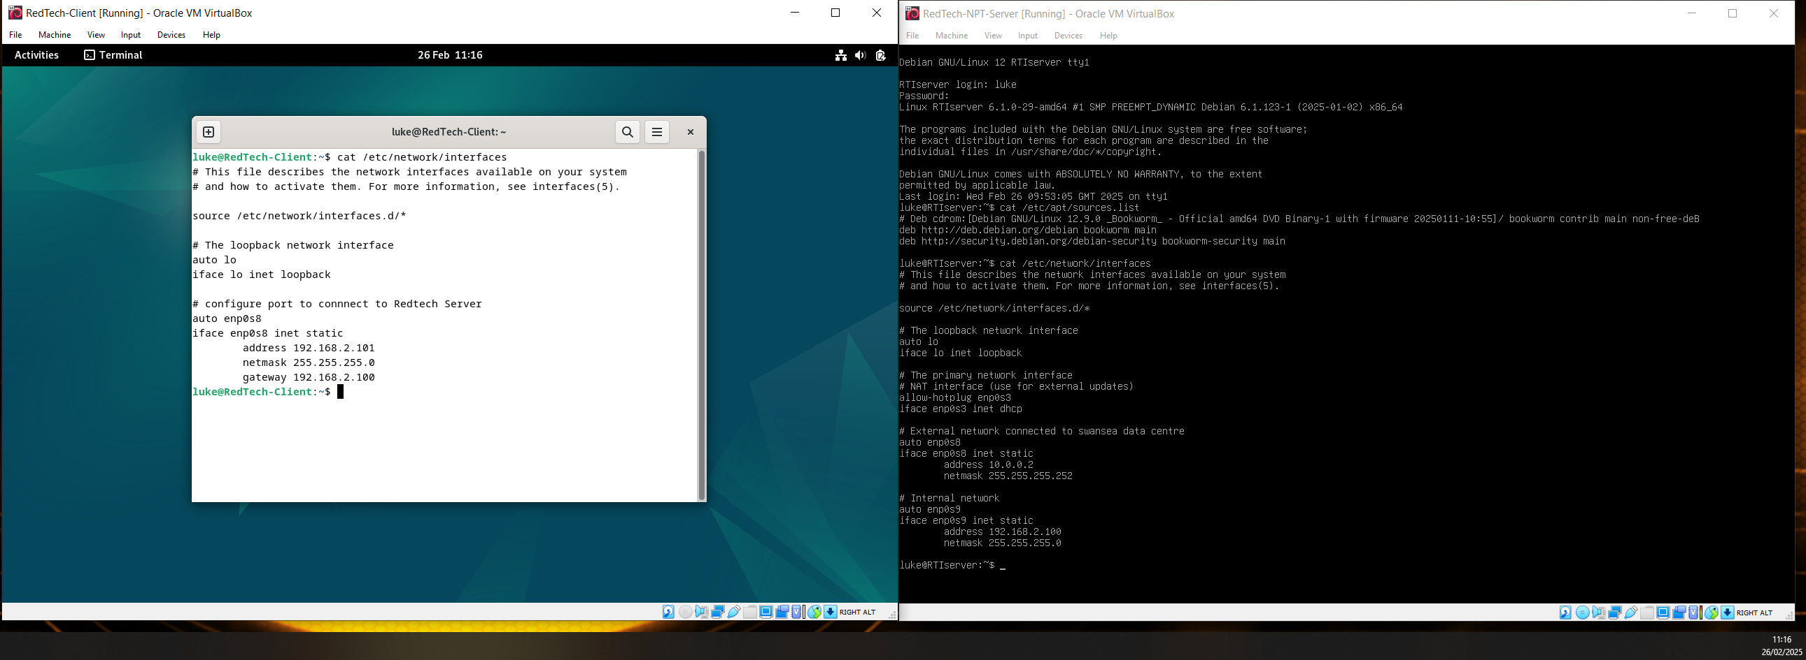

Conclusion / reflection
Deploying and configuring this virtual network was an enriching task that allowed for the development of many crucial networking elements, areas that typically would not be addressed in my line of work. Exploiting PowerShell to configure firewalls was particularly enjoyable, as well as addressing the issue of connectivity between networks via cables or in this case vmnet virtual adapters.
In fact, it was the adapters that caused the most issues as often the wrong cables would be connected to devices leading to no ability to communicate which allowed the use of ifconfig -a for Linux and similar in PowerShell with ipconfig /all to identify mac addresses and correct these mistakes.
All in all, valuable personal development took place as it was realised that it is often the simplest of issues that can cripple a network.

References

[1] | J. Brodkin, “Bare-metal desktop hypervisors a primer,” p. 1, 2010.
[2] | Oracle, System Administration Guide: Virtualization Using the Solaris Operating System, Oracle, 2010.
[3] | Z. Aalam, V. Kumar and S. Gour, “A review paper on hypervisor and virtual machine security,” Journal of Physics, August 2021. [Online]. Available: https://www.proquest.com/scholarly-journals/review-paper-on-hypervisor-virtual-machine/docview/2559689551/se-2?accountid=130472. [Accessed 5 Febuary 2025].
[4] | D. Z. H. J. Jinan Shen, “A Protective Mechanism for the Access Control System,” 1 Services Computing Technology and System Laboratory, Cluster and Grid Computing Laboratory, School of Computing Science and , 2016.
[5] | I. S. Stephanie Susanjara, “What are hypervisors?,” IBM, [Online]. Available: https://www.ibm.com/think/topics/hypervisors. [Accessed 5 Febuary 2025].
[6] | Oracle, “1.3 what are hypervisors?,” Oracle, 2017. [Online]. Available: https://docs.oracle.com/cd/E50245_01/E50249/html/vmcon-hypervisor.html. [Accessed 5 Febuary 2025].
[7] | Oracle , “How IP Addresses Apply to Network Interfaces,” Oracle, 2010. [Online]. Available: https://docs.oracle.com/cd/E19455-01/806-0916/ipplan-25/index.html#:~:text=Each%20network%20interface%20must%20have%20its%20own%20unique,it%20must%20have%20its%20own%20unique%20IP%20number.. [Accessed 6 Febuary 2025].
[8] | Oracle, “What Is a Network Interface?,” Oracle, 2010. [Online]. Available: https://docs.oracle.com/javase/tutorial/networking/nifs/definition.html. [Accessed 6 Febuary 2025].
[9] | J. Vance, “What is a VLAN and how does it work?: Virtual LAN (VLAN) technology enables network architects to segment physical devices into logical subgroups for performance and security reasons,” What is a VLAN and how does it work?: Virtual LAN (VLAN) technology enables network architects to segment physical devices into logical subgroups for performance and security reasons, pp. 1-5, 2022.
[10] | D. Walker and R. Millman, “What is subnetting?,” What is subnetting?, 2019.
[11] | S. Hijazi and M. S. Obaidat, “A New Detection and Prevention System for ARP Attacks Using Static Entry,” IEEE.
[12] | B. E. H. a. O. J. W. Huaiyuan Ma, “An Impact of Addressing Schemes on Routing Scalability”.
[13] | Cisco, “What Are Network Services?,” Cisco, 2025. [Online]. Available: https://www.cisco.com/c/en/us/solutions/enterprise-networks/what-are-network-services.html. [Accessed 10 Febuary 2025].
[14] | Z. Kerravala, What is a VPN? A secure network over the internet: VPNs can create secure remote-access and site-to-site connections inexpensively, are a stepping stone to software-defined WANs, and are proving useful in IoT., p. 4, 2022.
[15] | R. Droms, “IEEE Internet Computing,” IEEE Internet Computing, vol. 3, no. 4, pp. 45-53, 1999.
[16] | k.-k.-m.-t. iainfoulds, “Active Directory Domain Services Overview,” Microsoft, 2 Febuary 2025. [Online]. Available: https://learn.microsoft.com/en-us/windows-server/identity/ad-ds/get-started/virtual-dc/active-directory-domain-services-overview. [Accessed 10 Febuary 2025].
[17] | G. Guido, “Cyber Security,” Henry stewart publications cyber security , vol. 6, no. 3, pp. 242-260, 2023.
[18] | N. Gaur, “Inside Solaris,” Inside Solaris Louisvillie , vol. 8, no. 10, pp. 1-5, 2002.
[19] | I. E. senturk Zeynep, “Digital Forensics and security,” 12th International symposium on digital forensics and security (ISDFS), pp. 01-06, 2024.

