I acknowledge the use of ChatGPT on the 13th November 2025 to generate the initial “Time Travelers” picture (used in slide 1), using the following prompt “Can you produce a time traveller picture to be included in a PowerPoint presentation for the behaviourist movement?”
I confirm that I have not presented any AI generated text as my own work.
I confirm I have copies of my drafts, notes, and any other resources I used before and after the use of AI tools, which I may be asked to provide in evidence.

Link to video: The 20th Century Paradigm Shift.mp4

Script for group video Behaviourism
Slide 1
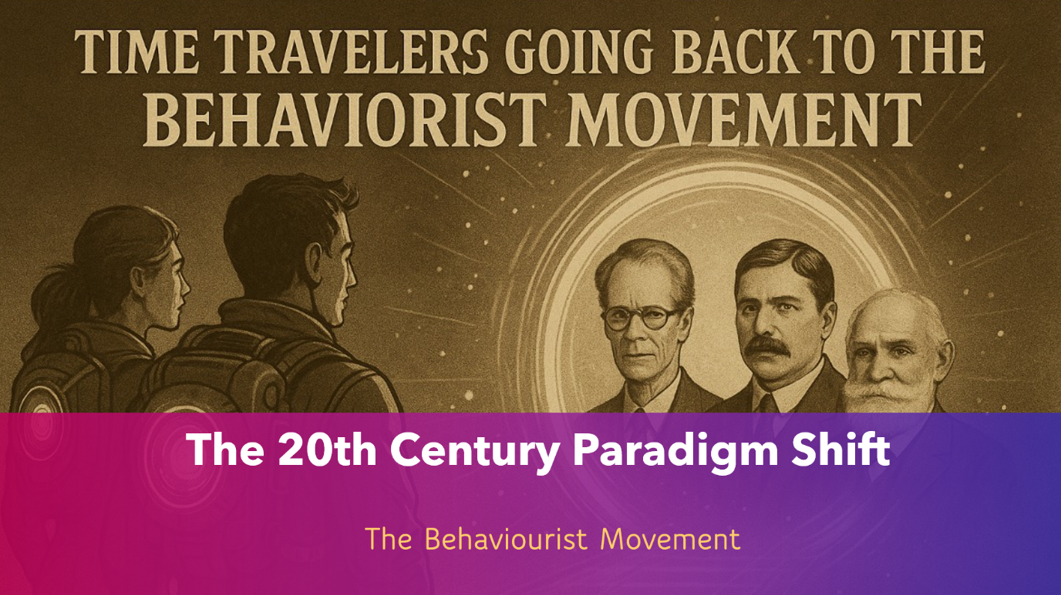
Hello everyone, I’ve travelled back to the turn of the twentieth century, a time when psychology was undergoing a scientific, paradigm shift.
Before this era, the mind was studied through introspection, but the Behaviourists changed everything. They argued that psychology should focus on what can be observed and measured: behaviour itself.
This shift marked the moment psychology moved from philosophy into the realm of true science, driven by evidence experimentation, and a desire to understand learning in both humans and animals.
Slide 2
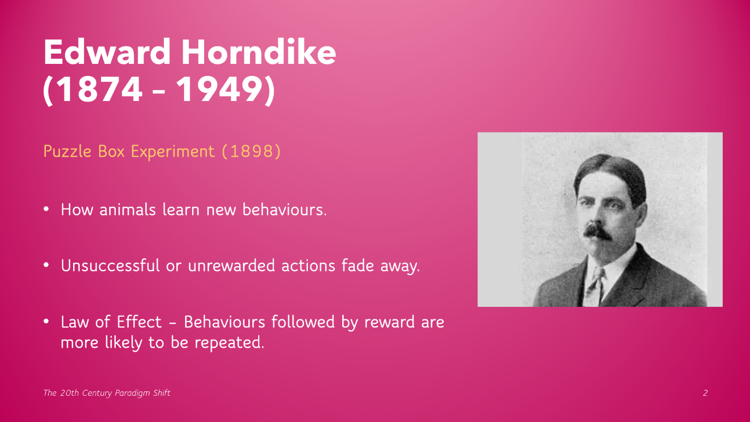
Our story begins in the 1890’s with Edward Thorndike, who showed through his puzzle box experiments that rewarded actions are likely to be repeated- the Law Of Effect (Thorndike, 1898).
Slide 3
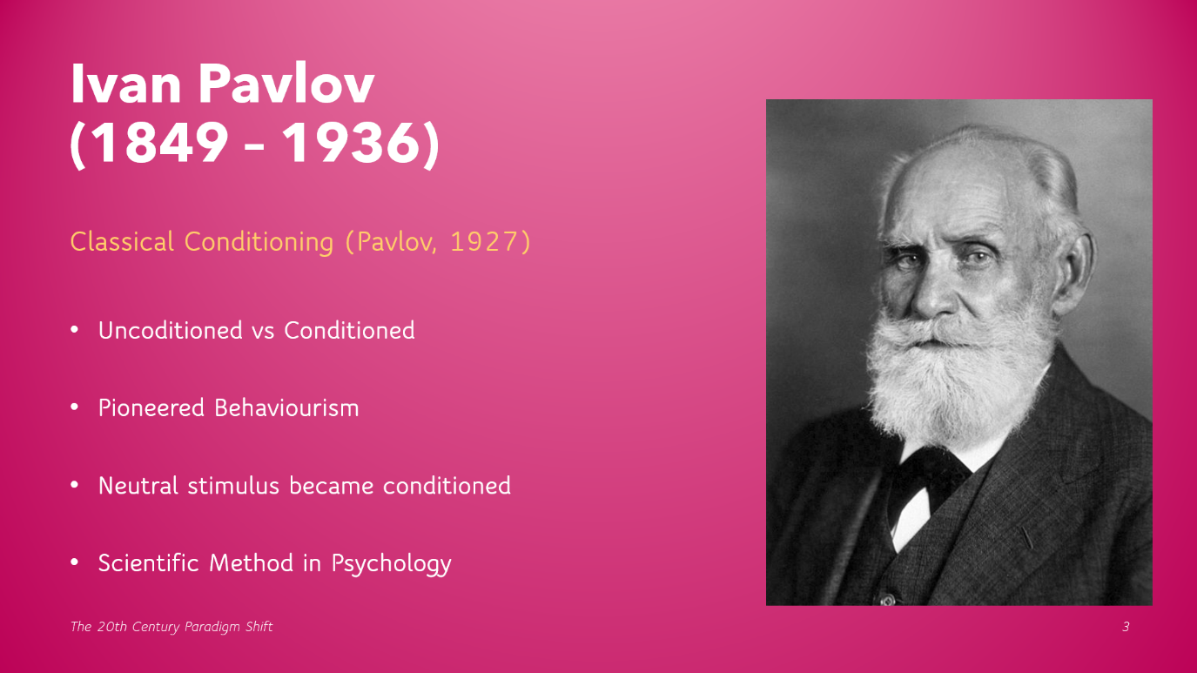Then came Ivan Pavlov, whose experiments with dogs revealed classical conditioning, showing how behaviour could be learned through association (Pavlov, 1927).
Slide 4
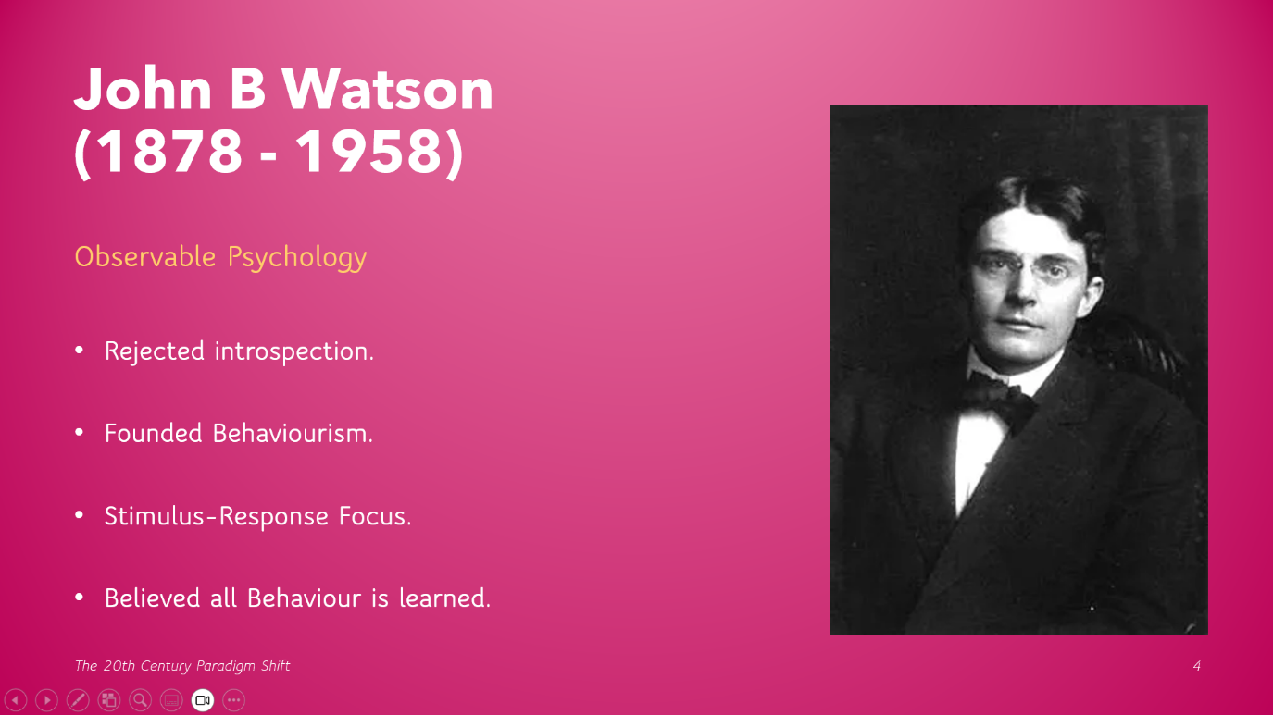
In the 1910’s John B Watson built on these ideas, formally founding the Behaviourist movement and declaring that psychology should only study observable behaviour (Watson, 1913).
With his research partner Rosalie Raynor, he later demonstrated that emotions could also be conditioned in humans through The Little Albert Experiment (Watson & Raynor, 1920).
Slide 5
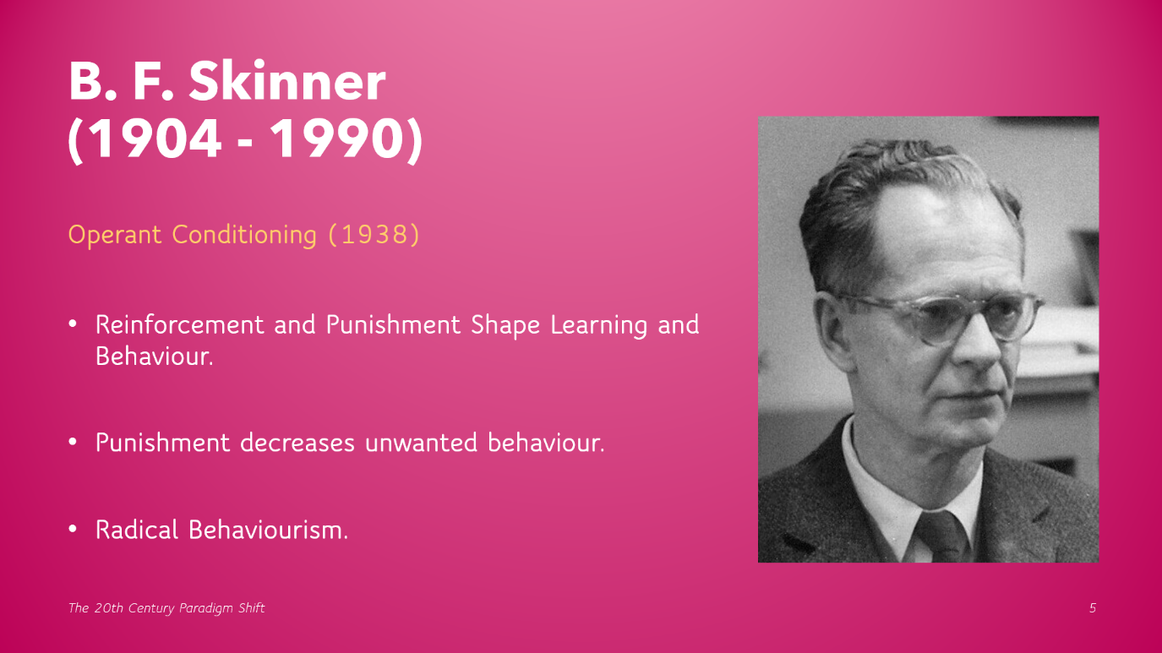Later B.F Skinner introduced operant conditioning, explaining how reinforcement and punishment shape learning and behaviour (Skinner, 1938).
Slide 6
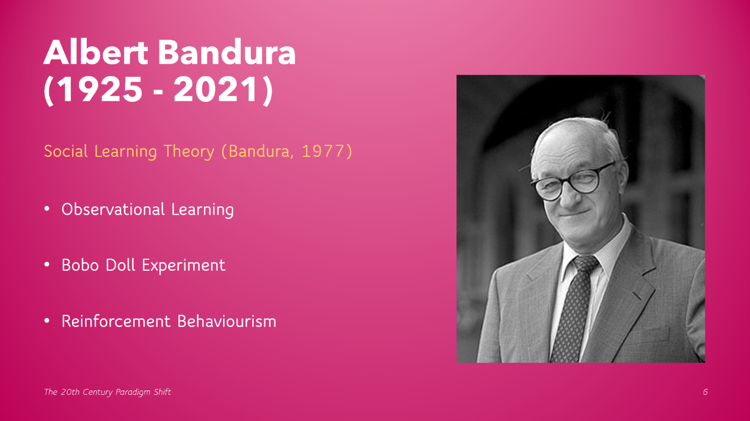Finally Albert Bandura expanded these ideas through social learning theory, showing that we can also learn by observing others (Bandura, 1977)
Although the Behaviourist Movement is alive and still active today, together they transformed Psychology into a measurable, evidence based Science, one that revealed the powerful role of the environment in shaping who we become.
Slide 7
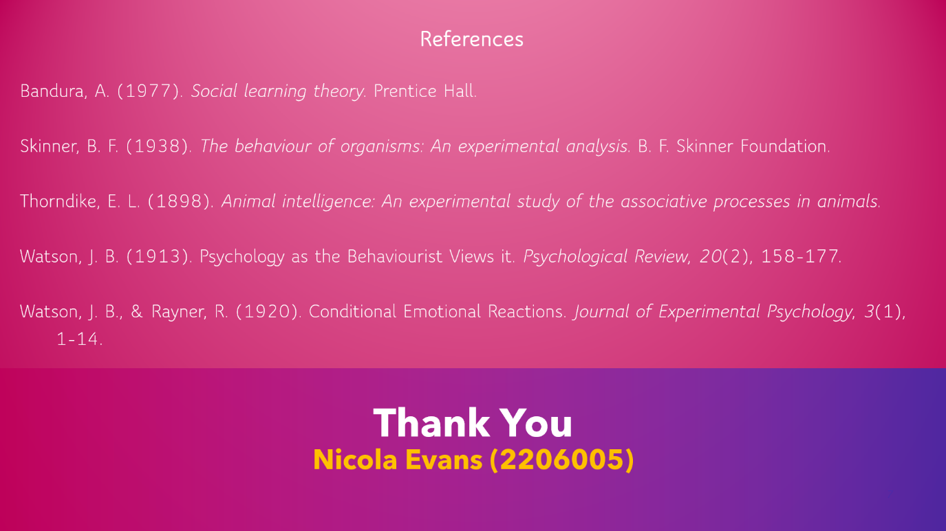
Lets meet the pioneers who made it happen.

References
Bandura, A. (1977). Social learning theory. Prentice Hall.
Skinner, B. F. (1938). The behaviour of organisms: An experimental analysis. B. F. Skinner Foundation.
Thorndike, E. L. (1898). Animal intelligence: An experimental study of the associative processes in animals.
Watson, J. B. (1913). Psychology as the Behaviourist Views it. Psychological Review, 20(2), 158-177.
Watson, J. B., & Rayner, R. (1920). Conditional Emotional Reactions. Journal of Experimental Psychology, 3(1), 1-14.

