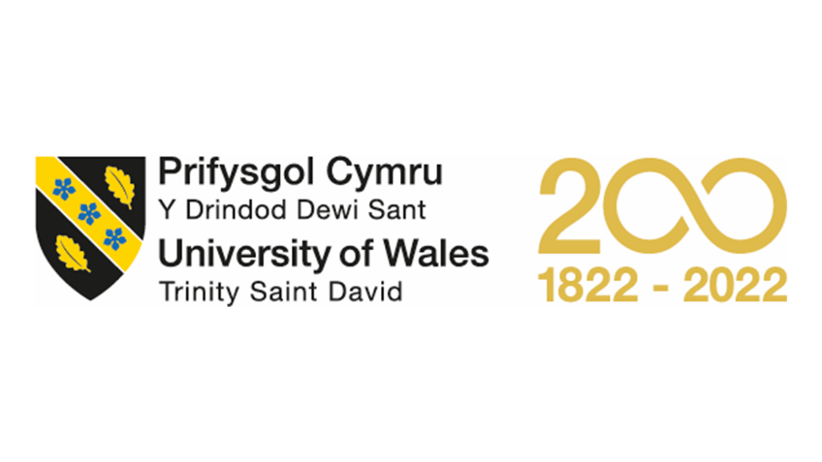

Assignment Title: Marketing Consultation Project

Module Name: Marketing Fundamentals

Module Code: LCBB4004

Program of Study: BA Business Management

Student Name: Hamdan Ahmad

Student ID #: 2208436

Lecturer Name: Ms. Efua Adams

Table of Contents
Introduction 3
Relevant theories used for research, approach and market segmentation: 3
7P’s of market 3
Maslow’s Hierarchy of Needs 4
Theory for Segmenting the Market 4
Branding, Marketing strategies and customers or audience 5
Establish Case for support documents 5
Plan and Analyse 5
Build the campaign 5
Research 5
Administration of multi-channel campaigns 6
Show and tell 6
Mail Marketing 6
Conclusion 6
References 8

Introduction
Therefore, the goal of this project is to put into practise a live marketing consultancy project to bring in financial sponsors for a local business run by Shane and Co. London was selected as it is the commercial hub of the UK since it will be easy to access various firms, agencies, and target people there for the marketing campaign. Email is the primary way of communication and marketing. You must determine if they are interested in supporting the group and its charitable endeavours. The project's major objective is for the groups to take part in the marketing-focused search for possible sponsors. From the above, we must offer the theories we utilised in our marketing study and divide the local market into appropriate segments in order to identify potential sponsors. Additionally, we provide the company marketing strategy, brand, and customer assistance.

Relevant theories used for research, approach and market segmentation:

7P’s of market
Since the 7Ps are the cornerstones of marketing theory, many businesses frequently employ them as the foundation of their marketing plans. Beginning in 1960, the idea was known as the 4Ps: product, location (Place), price, and promotion. However, Booms and Bitner, two researchers, modified the idea in 1981 to incorporate three additional components: tangible or physical evidence, people, and actual processes. The 7Ps could serve as the foundation for any company's marketing strategy. According to the notion, you need to accomplish at least three of the 7Ps for your campaigns to be successful (Akhouri & Kuhn, 2016). The 7Ps include:
- Product: the thing being purchased or sold
- Place: the location where you sell the merchandise
- Price: The item's cost
- Promotion: Sales, marketing, and advertising
- Physical proof that the item exists
- People or Individuals: the staff
- Process: How you distribute your goods to customers
Here is a great illustration of our campaign, which includes:
We provide other groups tailored data about how their brand and product performed on the marketplace after joining the campaign as part of our vision for a social work fundraising marketing campaign. Because of this, we can manage at least five of the seven Ps—Product, Place, People, Physical Evidence, and Promotion. In other words, describe your marketing objectives using the 7Ps. then create strategies to accomplish it (Akhouri & Kuhn, 2016).

Maslow’s Hierarchy of Needs
A five-level model of consumer demands is called Maslow's hierarchy of needs. Biological, safety, love or belonging, esteem, and self-actualization are the five categories into which it is divided in Maslow's five-step hierarchy of needs. According to this view, individuals must first take care of their most fundamental survival needs before moving on to demands of a higher kind. According to the theory, a person needs achieve a level in order to advance to a higher level. When applied to marketing, the principle essentially calls for you to identify and then cater to your clients' wants in order to develop successful marketing campaigns. We know that the ultimate aim of companies is: Status, recognition, power, self-esteem, and self-realization. This is exactly what we will do with the target organisation or clientele. Therefore, the core of our campaign is the promise of status, recognition, power, self-esteem, and self-actualization. With the change, the business strengthens its reputation and meets the demands of its clientele. As a result, it will benefit both of us (Brown, 2019).

Theory for Segmenting the Market
Marketing segmentation is not a brand-new idea. You may personalise your communications to each group to increase the probability that they will take the required action. Should you use a casual or official tone in your follow-up email? Should you use more text in your email, or should you use more pictures? Your segmentation's results will aid in providing the answers to these queries. By grouping your target audience according to shared traits like consumer behaviour, demographics, and geography, you may use social media segmentation. This makes it easier for you to produce material that appeals to a certain audience's interests. Market segmentation enables your company to maximise the return on its marketing expenditures. Three phases make up this process: targeting, aiming, and placing. The first step is rather straightforward: you need to identify your target market and divide your prospective client base based on factors like region, areas of interest, and behaviour. The market segment that is most likely to respond is referred to as segmentation. Whereas positioning is searching for market gaps that your brand can fill. You may choose the platform on which to disseminate the material that will work best for your audience by undertaking market segmentation. In other words, use market segmentation to identify your target audience's location and demographics, and then adjust the tone and topic of your campaign as necessary ( Covell; & Siddiqui., 2022).

Branding, Marketing strategies and customers or audience

Establish Case for support documents
Every campaign's most crucial component is the support case. It is essentially an organizational document that outlines your communication strategy with team members and your target audience. It outlines what you do, why you do it, and how you obtain the appropriate people's support (Meijel, 2019). Consider it the mission statement for your marketing campaign. The following questions are addressed in the support case:
- What distinguishes your campaign and why should any individual support it?
- How can anyone participate in your charity drive?
- What is the purpose of your organisation?
- What issues do you handle, and how do you manage them?

Plan and Analyse
An effective campaign plan frequently includes considering the sources of your desired funding. To avoid depending entirely on one source of income, you should have a diverse portfolio. Among the sources to take into account are:
- Churches, schools, and businesses in your neighbourhood are prepared to raise money for you.
- Private Companies: More established names and businesses that may support your cause on a national or worldwide level.
- Trusts and Foundations: The majority begin their fundraising efforts here and seek out donations around the nation.

Build the campaign
We can begin developing a campaign plan once we know where to advertise our project. For instance, we choose to collaborate with a consultant, a fundraising agency, or try to include many businesses simultaneously (Oudman, et al., 2010).

Research
Any brand development approach, even for a firm, must include research. We consider groups and individuals who can support us and who have a motivation to do so during the study process. In order to determine how you will reach your particular target, we also need to conduct some research.

Administration of multi-channel campaigns
Ultimately, a wide range of conventional media, website content, and social media solutions will be required if you want to get the most out of your campaign approach. Our campaign attempts to spread the message to those who are most likely to support us and engage with us before inspiring them to take action. To effectively communicate with the audience, we must be able to reach them wherever they are (Oudman, et al., 2010).

Show and tell
The secret to success is informing your audience what to do, whether you're soliciting their support for a new product or a charitable work. Make sure there is a call to action in the marketing plan. Keep in mind that we must persuade our audience that their participation will have an impact.

Mail Marketing
In addition to being a powerful tool for both big and small enterprises, email marketing is also a goldmine for any organisations. In order to reach and engage consumers over time, email marketing may be quite effective.
For a company that conducts email marketing:
- Enable communication with each of the chosen recipients using the fewest possible steps.
- Increase the impact of projects by speaking with more people in less time.
- One of the finest methods to establish and keep a channel with supporters is through email marketing.
- Additionally, it is possible to express the organization's appreciation and thanks to the contributors by email while also informing them of the outcomes of the gifts that have been gathered ( Covell; & Siddiqui., 2022).

Conclusion
This project's objective is to put into practise a live marketing consultancy project in order to draw in financial sponsors for a local company managed by Shane and Co. London was chosen as the commercial centre of the UK since it will be simple to contact numerous businesses, agencies, and the campaign's target audience there. The main form of marketing and communication is email. You must ascertain if they are motivated to aid the organisation and its charity endeavours. The organisations' participation in the marketing-driven hunt for potential sponsors is the project's main goal. As a result of the above, we must put the ideas we used in our marketing research into practise and split the local market into the proper segments in order to find suitable sponsors. We also offer the brand, marketing plan, and customer support for the business. We selected the Maslow Hierarchy of Need, the Theory of Market Segmentation, and the 7Ps of Marketing as our marketing theories and various marketing methods. Create a case for supporting documentation, construct the campaign, planning and analysis the management of campaigns across several channels. Some of the tactics that will be applied in this campaign include those listed above.

References
Covell;, T. & Siddiqui., W., (2022) A Market Segmentation Theory. s.l.: UK Essays.
Akhouri, S. & Kuhn, J., (2016) Using mark Using market segmentation theor et segmentation theory to select tar o select target mark get markets for sun ets for sun. s.l.: University of Wollongong,
Brown, J., (2019) 'Market Segmentation, Targeting, and Positioning'. Market Segmentation, 32(1).
Meijel, B. v., (2019) 'Applying market segmentation theory to student behavior in'. New Horizons in Education, 24(3), pp. 517-529.
Oudman, E., Postma, A. & Meijel, B. v., (2010) 'A Theory of Market Segmentation'. Journal of Marketing Research, 50(2), pp. 296-343.

