BEng Electrical and Electronic Engineering
Factory Control
Applied Programmable Logic Controllers
Joshua Hunt
17/01/2022

Contents
Introduction 3
Task 1 3
Types of PLCs 3
Compact PLCs 3
Modular PLCs 5
TASK 2 7
Flowchart 8
TASK 3 8
Network 2 9
Network 3 10
Network 4 10
Network 5 11
Network 6 11
Network 7 12
Network 8 12
Network 9 13
Network 10 14
Network 11 14
TAG Table 15
TASK 4 16
HMI 16
Main Screen 16
Screen 1 17
Screen 2 18
Conclusion 18
Bibliography 19

Introduction
This report investigates the different PLCs currently used in industries, identifying the pros and cons of each system in order to determine the best one. The design of a factory process, capable of sorting and arranging packages of different weight and height, using Siemens and Factory I/O is explained. The incorporation of a HMI device is also included for operation interaction.

Task 1
A PLC (Programmable Logic Controller) is a rugged industrial computer designed to control manufacturing processes. PLCs are made up of three main parts: Input, CPU and output. The input will receive information, this is then processed in the CPU according to the installed program which would have been written on a computer before hand, the CPU will then send the result to the output which will then turn the data to an electrical signal in order to execute the intended function.
PLCs are used in various applications in the industry. Below are a few examples of the different types of PLCs that are available, as well as the most popular PLC manufacturers that are currently used in industries around the world.

Types of PLCs
There are two main types of PLC; Modular PLC and Compact PLC. A Compact PLC is designed to perform basic tasks; it has a fixed number of I/O modules, which are chosen by the manufacturer, thus rendering the capability of expanding the modules. A modular PLC allows expansion through modules, I/O components can be increased and it’s easier to use as each component is independent of each other. (Muthukishnan, 2021)
As previously stated, there are also many different manufacturers of PLCs that are used in industries around the world. Here are just a few of the many available brands; Siemens, Rockwell Automation Allen Bradley, Mitsubishi, RS automation, Bosch. According to a study by Interact analysis back in 2017 the most popular PLCs used in industries were the first three listed, which were; Siemens, Rockwell Automation Allen Bradley, Mitsubishi. This was determined by analysing the market share of the various PLC manufacturers. (Ladder Logic World, 2020) (Kamillas, 2017)

Compact PLCs
Here are some of the compact PLCs that are on the market from the three most popular PLC manufacturers in the world in 2020. Here you can see the specification of each and the advantages and disadvantages. (RS Components Ltd, 2021)
IMAGE | 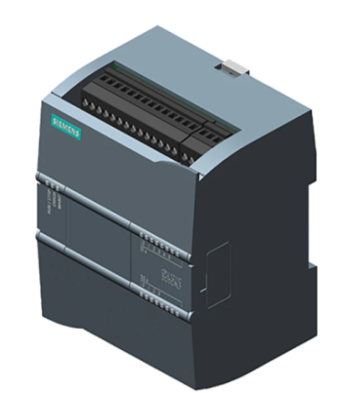 |  | 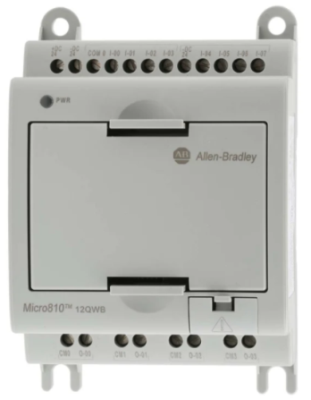
  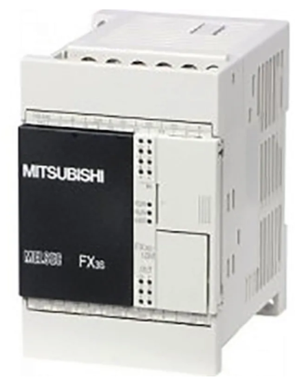
LINK | https://uk.rs-online.com/web/p/plcs-programmable-logic-controllers/8624468/?cm_mmc=UK-PLA-DS3A-_-google-_-CSS_UK_EN_Automation_%26_Control_Gear_Whoop-_-PLCs+-+Programmable+Logic+Controllers_Whoop-_-8624468&matchtype=&aud-827186183686:pla-418615222496&gclid=EAIaIQobChMIg4vr2orD9AIVk6ztCh0Wigm5EAQYAiABEgJnwfD_BwE&gclsrc=aw.ds | https://uk.rs-online.com/web/p/plcs-programmable-logic-controllers/1235959/?cm_mmc=UK-PLA-DS3A-_-google-_-CSS_UK_EN_Automation_%26_Control_Gear_Whoop-_-PLCs+-+Programmable+Logic+Controllers_Whoop-_-1235959&matchtype=&aud-842313741738:pla-301409975698&gclid=EAIaIQobChMI35uXypPD9AIVEYBQBh3-sgNHEAQYASABEgLjU_D_BwE&gclsrc=aw.ds | https://uk.rs-online.com/web/p/plcs-programmable-logic-controllers/7508602/?cm_mmc=UK-PLA-DS3A-_-google-_-PLA_UK_EN_Automation_%26_Control_Gear_Whoop-_-PLCs+-+Programmable+Logic+Controllers_Whoop-_-7508602&matchtype=&aud-772940708119:pla-326418213834&gclid=EAIaIQobChMIqPH9xqHF9AIV0N_tCh3eKA4MEAYYASABEgI0rfD_BwE&gclsrc=aw.ds
DESCRIPTION | Siemens S7-1200 PLC CPU | Mitsubishi FX3S PLC CPU | Allen Bradley Micro810 PLC CPU
MANUFATURER | Siemens | Mitsubishi | Allen Bradley
TYPE | Compact | Compact | Compact
NUMBER OF INPUTS | 6 | 6 | 8
OUTPUT TYPE | Digital, Relay | Relay | Relay
INPUT TYPE | Analogue, Digital | Sink, Source | Analogue, Digital
POWER SUPPLY | 24 V DC | 24 V DC | 24 V DC
NUMBER OF OUTPUTS | 4 (digital output, relay output) | 4 (relay) | 4
OUTPUT CURRENT | 2 A | 2 A | 8 A
MOUNTING TYPE | DIN Rail, Wall Mount | DIN Rail | DIN Rail
DIMENSIONS | 100(l)x90(w)x75(d)mm | 60(l)x90(w)x49(d)mm | 91(l)x75(w)x59(d)mm
OPERATING TEMP | -20°C to +60°C | 0°C to +55°C | -20°C to +65°C
MEMORY | 1MB | 16000 (EEPROM) steps | 4 Kb
PRICE | £182 | £139.20 | £85
LANGUAGE USED | LAD, FBD, SCL | Instruction List, SFC, Step Ladder | Function Block, Ladder Logic, Structured Text
IP Rating | IP20 | IP10 | IP20
Application | Suitable for temperature controls, pump and fan controls, as well as conveyor technology including packaging machines. | * Industrial automation * Robotics * Automobile industry | Lighting control  Heating and cooling  Compressor control  Elevator control
Advantages | *Good IP rating  * Good operating temp  * Although it is designed as a compact CPU, it can be equipped with additional IO modules to enlarge the capabilities of the PLC. | * Built-in USB port for the programming communication function to enable high-speed communication at 12Mbps | *support a USB adapter, and an LCD module, which can be used as a backup memory module.  * Cost
Disadvantages | * Cost  * Not as many inputs as allen bradley | * Operating temp not as good as others  * Not as many inputs as allen bradley | N/A

Modular PLCs
Here is a comparison of the modular type PLCs, again looking at the ones produced by the three most popular manufacturers in 2020. (RS Components Ltd, 2021)

IMAGE
  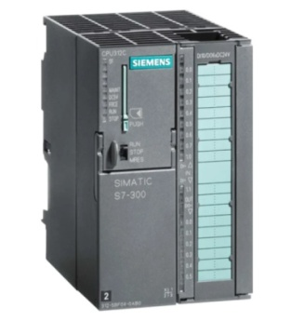
  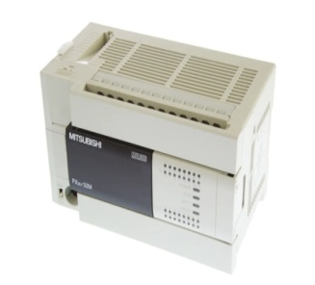
  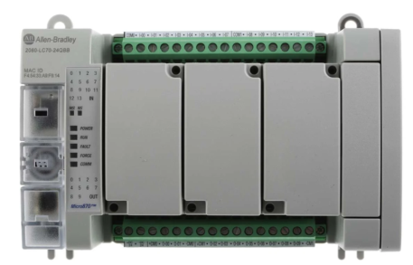
LINK | https://uk.rs-online.com/web/p/plcs-programmable-logic-controllers/7877989 | https://uk.rs-online.com/web/p/plcs-programmable-logic-controllers/5390689 | https://ie.rs-online.com/web/p/plcs-programmable-logic-controllers/1833562
DESCRIPTION | SIMATIC S7-300 Series | FX3U Logic Module | Micro870 PLC CPU
MANUFATURER | Siemens | Mitsubishi | Allen Bradley
TYPE | Modular | Modular | Modular
NUMBER OF INPUTS | 10 | 16 | 14
OUTPUT TYPE | Digital | Relay | Source
INPUT TYPE | Digital | Sink, Source | Voltage
POWER SUPPLY | 24 V DC | 100 → 240 V ac | 12 V, 24 V
NUMBER OF OUTPUTS | 6 | 16 | 10
OUTPUT CURRENT | 500 mA | 8 A | 8 A
MOUNTING TYPE | DIN Rail, Wall Mount | Rack mount | DIN Rail
DIMENSIONS | 125 x 80 x 130 mm | 150 x 90 x 86 mm | 90 x 145 x 80 mm
OPERATING TEMP | 0°C to +60°C | 0°C to +50°C | -20°C to +65°C
MEMORY | 64 (Integrated) kB, 8 (Load) MB | 64K steps battery-backed RAM memory | 128 kB
PRICE | £508.56 | £761 | £1,125
LANGUAGE USED | FBD, GRAPH, HiGraph®, LAD, SCL, STL | Ladder Logic | Function Block, Ladder Diagram, Structured Text
IP Rating | IP20 | IP20 | IP20
Application | Industrial automation  Robotics  Automobiles industry | Industrial sites  Factory automation | Industrial automation  Robotics  Automobiles industry
Advantages | * Low cost in comparison  * Many different languages used  * multiple mounting type | * More I/O | * many different languages used  * good operating temp
Disadvantages | * Not as many I/O | * Only one language used  * High cost | * High cost

These are just a few examples of the many PLCs which are available. Of the few samples above, I would say that the Allen Bradley is the best out of the compact types due to the fact it has more inputs, it’s less expensive and it also has the capability of increasing its memory. Now looking at the modular types I’d choose the Siemens SIMATIC S7-300 Series, although it doesn’t have as many inputs and outputs, it’s by far the cheapest but also allows many different languages to be used and good memory. However, choosing one depends on a number of things, there isn’t necessary a best one. The 6 most important things to consider when choosing a PLC are; system requirements, environmental requirements, inputs and outputs (I/Os), CPU speed, communication protocol types, and programming. (Jeffries, 2021)
Another key aspect in deciding what the best PLC is depends on the scan time. The scan time is basically the time it takes the PLC to read the inputs, solve the logic and write the output. The quicker the scan time, the better the PLC.

TASK 2
Using the components in factory I/O, a design of a factory process capable of sorting and arranging boxes based on their height and weight was created.
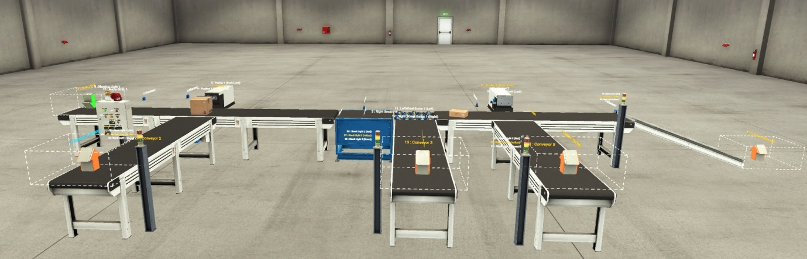
The components used in this design were;
- 6 Conveyors
- 2 Pushers
- 4 Stack lights
- 1 Weight scale
- 1 Roller conveyor
- 1 Emergency light
- 1 Siren
- 4 Push buttons (Start, Stop, Emergency stop, counter Reset)
- 4 Counters
- 4 Dif sensors
- 1 Package emitter
- 4 Package removers

Flowchart
Below is a simple flowchart to represent the operation of the factory I/O design.
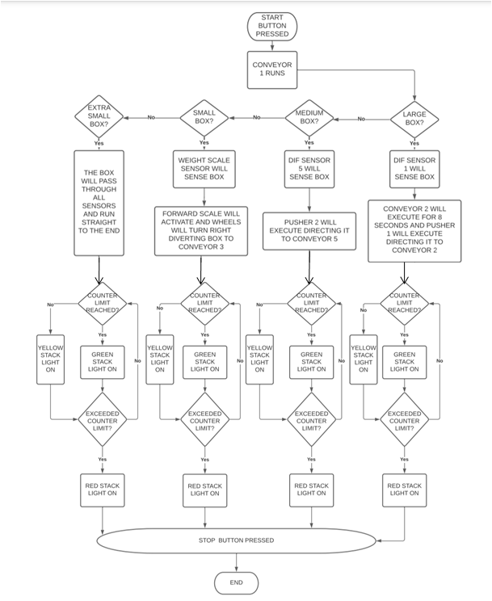

A working copy of this design is attached to the report.

TASK 3

To control the above factory process, a ladder logic process was written using Siemens. Below describes each step of the process and what impact it has on the Factory process designed in Factory I/O.

Network 2
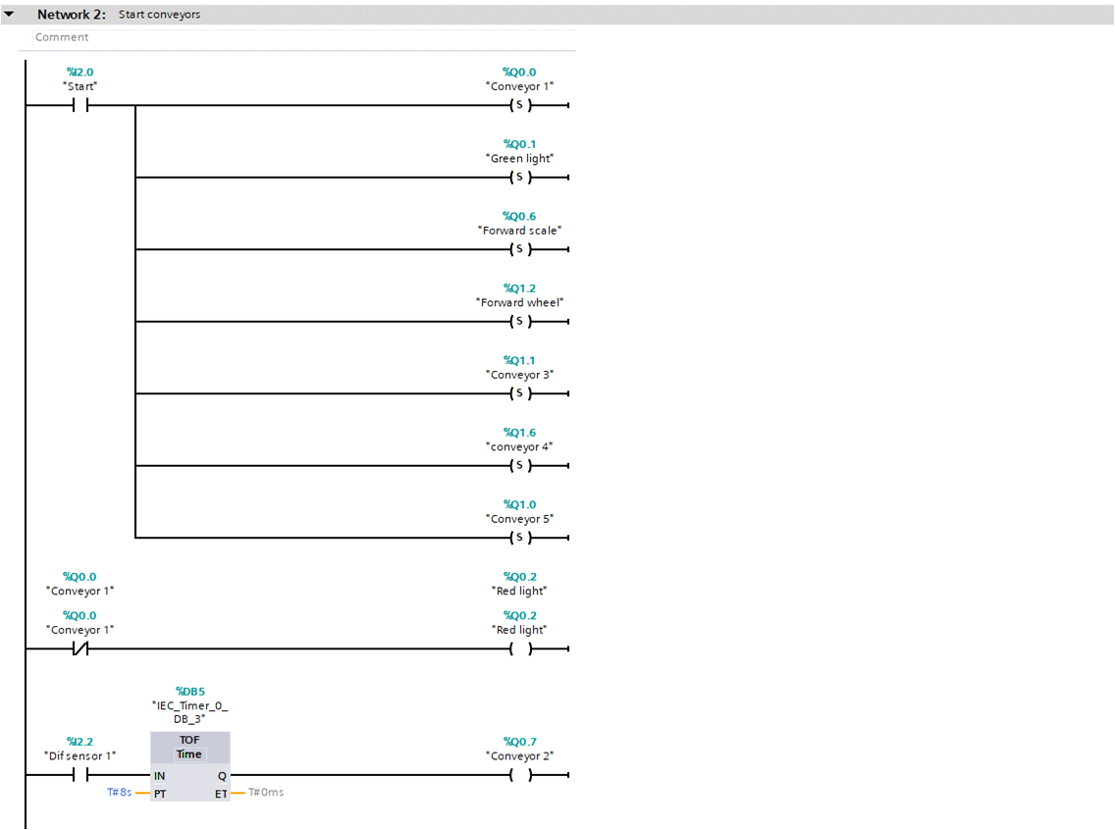
Each function is tagged so it makes it easy to understand what is going on. For example, the network above is merely used to operate the conveyors. The normally open contact (Start) does not flow current in its normal state; however when it is energized by pushing the start button, the outputs which are shown as set(S) will operate.
The normally closed contact flows current in its normal state, energizing it and switching it on will cause the contact to open, stopping current flowing. So, when conveyor 1 stops for whatever reason, the red light output will operate. (twcontrols, 2022)
The last section of this network is another example of how to operate the conveyors, when ‘Diffuse sensor 1’ is triggered and the input IN changes from 0 to 1 (positive edge), programmed time (PT) begins when the instruction is started, which in this case is 8S. The output Q will not be affected as long as the PT duration is running, meaning it will take 8 seconds from when the sensor is triggered for conveyor 2 to operate. This technique can be used to limit the current draw at start up; each conveyor can be started in sequence. (Bhavesh, 2021)

Network 3
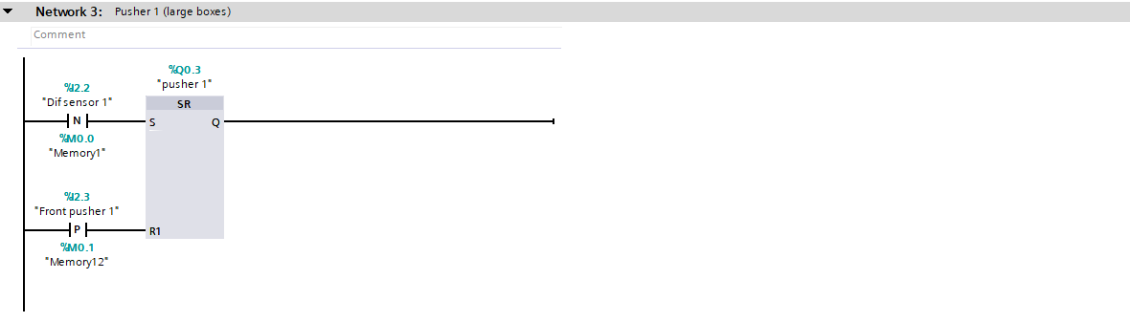
Network 3 controls pusher 1 to sort the large boxes. The SR function block acts as a set flip flop. As the diffuse sensor contact is set to negative and the box passes the sensor it will set the signal, activating the pusher. The pusher will then reset due to the positive contact, in this case labelled ‘front pusher 1’. When the pusher comes out, it resets the signal causing it to retract.

Network 4
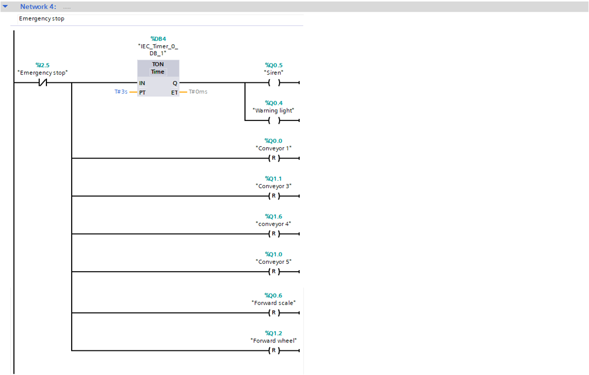
This network controls the emergency stop button. Using the normally closed contact, when the emergency button is pressed a signal will be sent to the on delay timer (TON) function block which will delay the Q output for however duration of time has been set at PT, when that limit is reached the siren and warning light will come on.
The remaining outputs that are set to (R) will reset back to its original state, causing the conveyors to come to an immediate stop.

Network 5
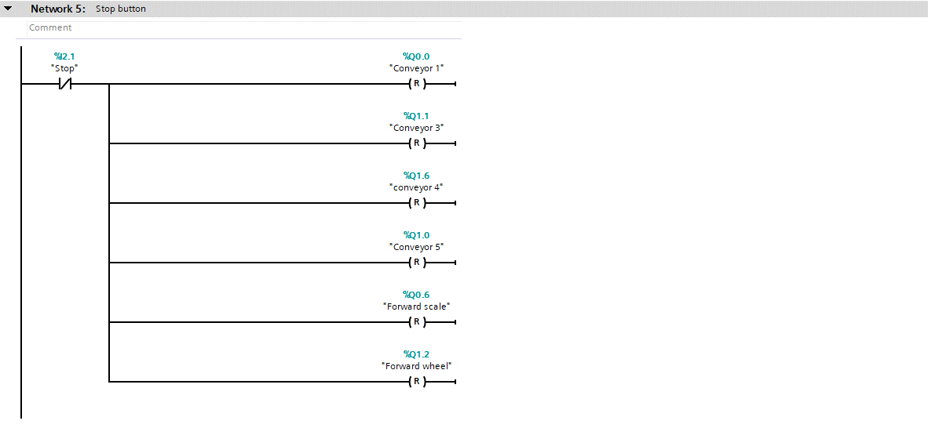
The exact same logic is used here, only this time it is operate the stop button to stop the conveyors.

Network 6
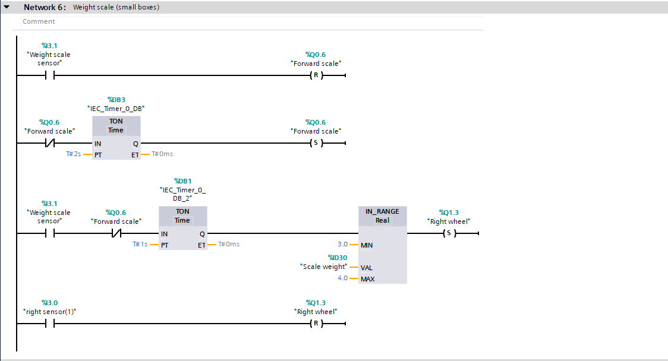
The ladder logic on this network is a key section in sorting the small boxes. From the top, when the weight scale sensor is triggered, the forward scale will stop (R), this is due to the weight scaling problems that were occurring (inaccurate weights calculated) so it gives it that couple of seconds to settle and measure the weight more accurately.
As stated, the forward scale only needs to stop for a couple of seconds, which is why a timer on delay function is used to set the forward scale after 2 seconds, whenever it is stopped.
Using another timer on delay instruction, the reading from the weight sensor scale is output 1 second after the forward scale is stopped, passing through to the IN RANGE function. The min and max values were manually set after measuring the weight of each box, if the weight measured from the weight scale sensor is within these values, the right wheel will be set and the small boxes diverted.
Finally another sensor is used, when a small box activates this, the right wheels will reset and revert to its original state.

Network 7
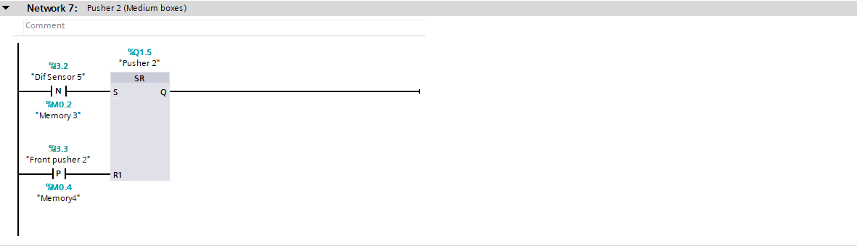
By this point the small and large boxes have already been taken care of, leaving just the medium and extra small size boxes. This made it easy to incorporate the height sensor technique to differentiate between the two remaining boxes in order to delegate them. Therefore network 7 operates in the exact same way as the ladder logic on network 3 with the help of the SR function block, only this time it is to control the second pusher of the factory process to sort the medium size boxes.

Network 8
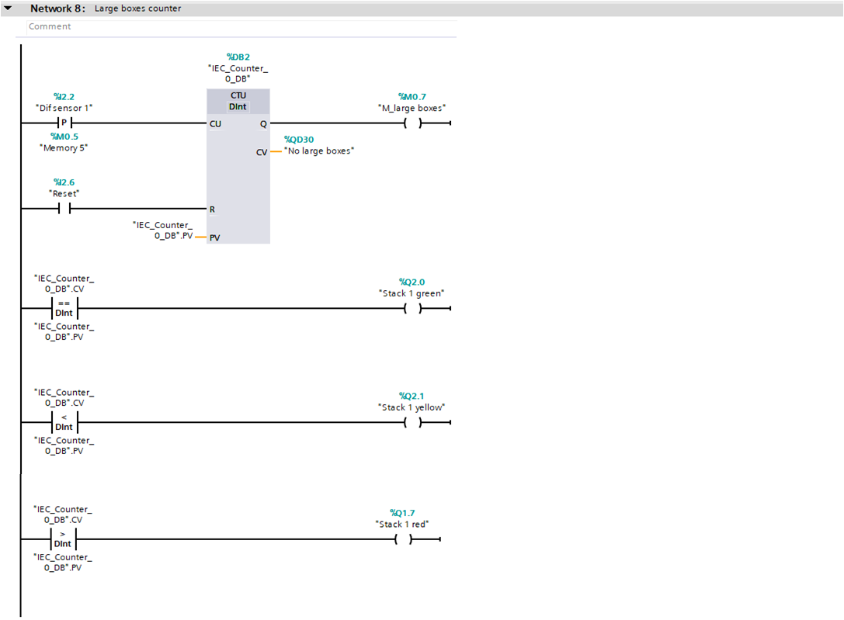
Each time a large box is detected by ‘Dif sensor 1’, a pulse is sent to the input of the up counter (CTU) function block, this will increase the current counter value (CV) by 1. When CV is greater than or equal to the counter limit (PV) the output (Q) is set. A pulse on the reset input (R) will reset the value of counter value to 0. (Peter, 2019)
Not only does this help to keep count of the large boxes, stack lights could then be introduced to keep track of the process. The green light comes on when the current counter value (CV) is equal to the counter limit (PV), the yellow light comes on when the CV is less than PV and finally the red light comes on if the CV is greater than PV. This process is used for of the different size boxes.

Network 9
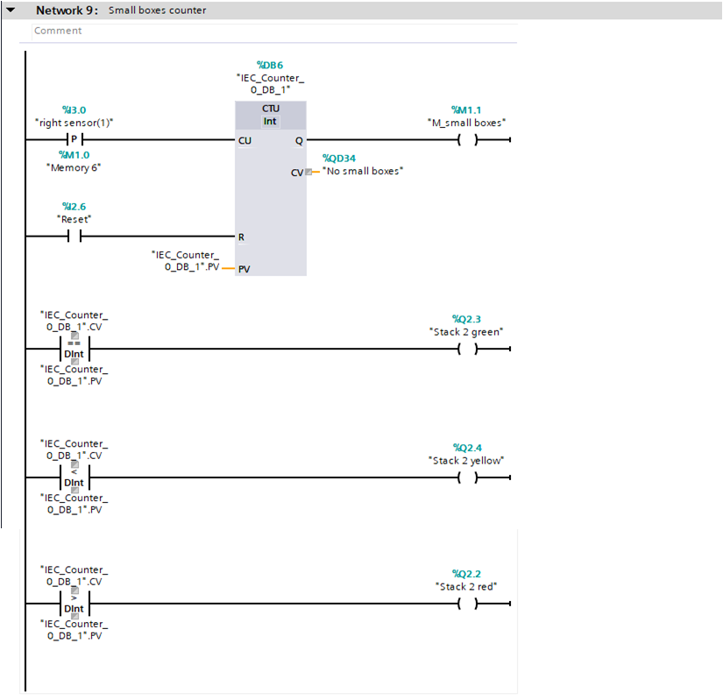
The same logic which was applied to network 8 is also implemented here to count and visually see the progress for the small boxes.

Network 10
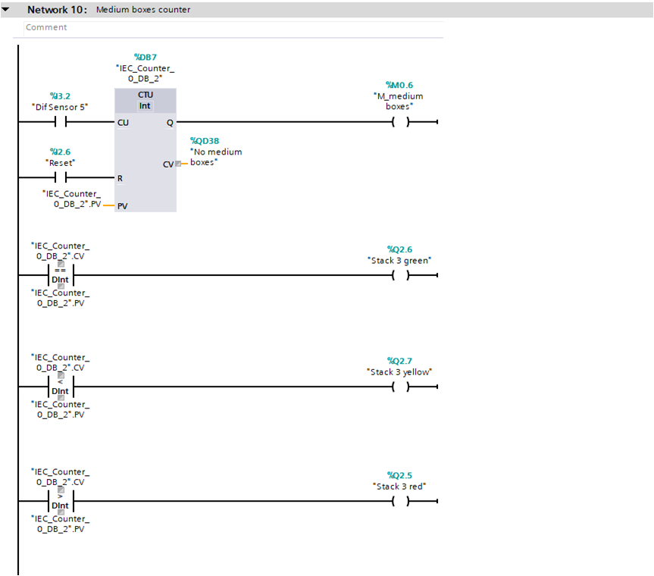
The previous ladder logic is then repeated here for the medium boxes.

Network 11
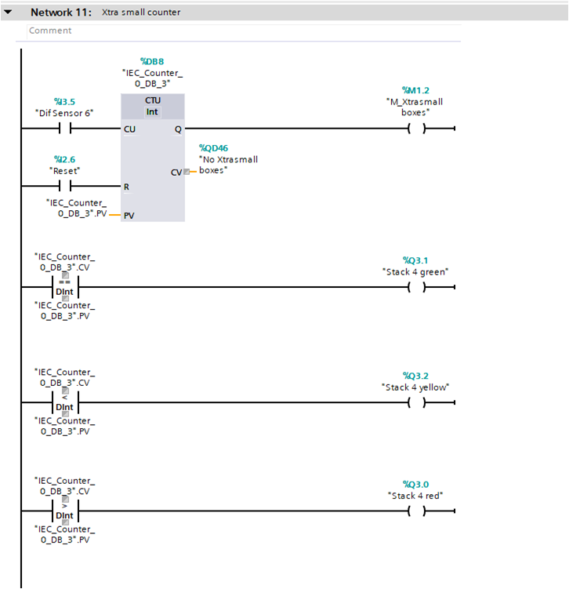
Finally, it is again used here, for the extra small boxes.

TAG Table
This is the Tag table which shows the names and address’ used for each tag in the ladder logic.
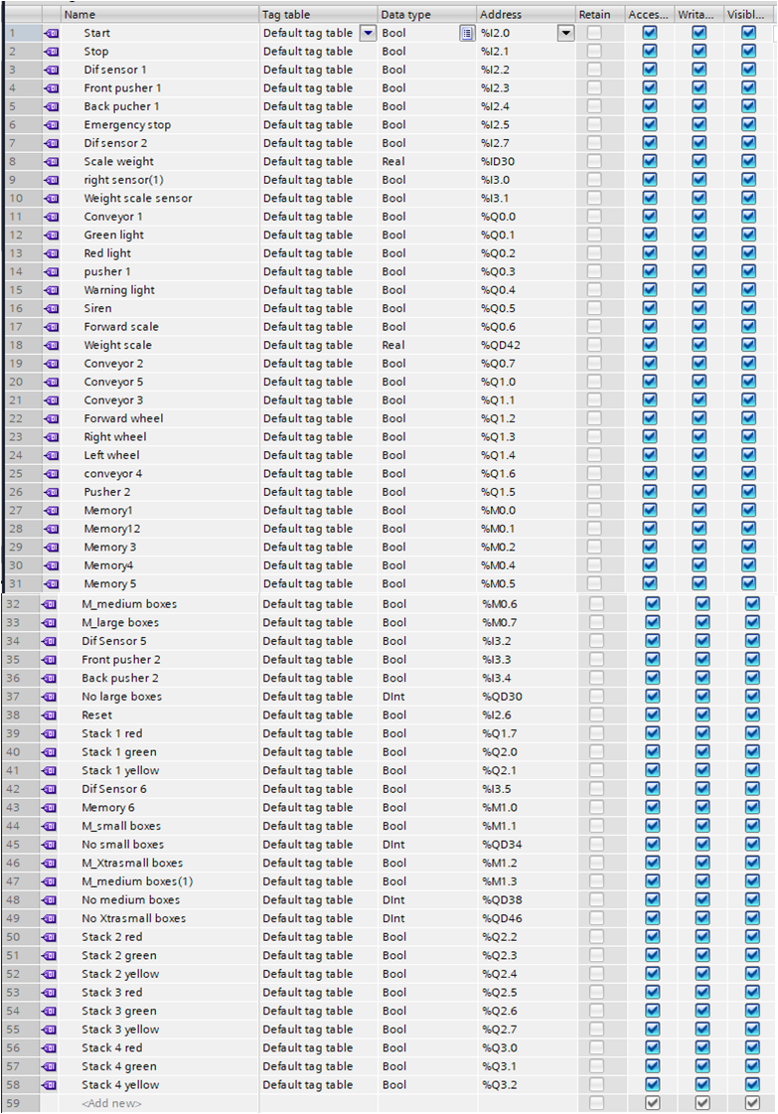

TASK 4

HMI
When the ladder logic was written and in working order in relation to the factory I/O, a HMI interface was incorporated. The Factory I/O can then be operated by the HMI screen, it also provides extra visual features to see what’s happening with the factory I/O design.

Main Screen
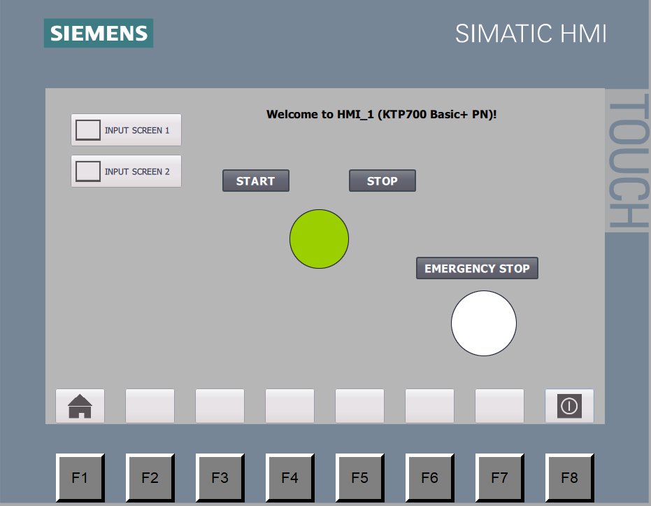
This is the main screen which is capable of starting and stopping the conveyors. If the process has started the circle will light up green as seen in the example above. If the stop button is pressed, it will stop the conveyors and turn the circle red. The emergency stop button can also be operated on this screen; the circle below the emergency stop will turn red once activated.

Screen 1
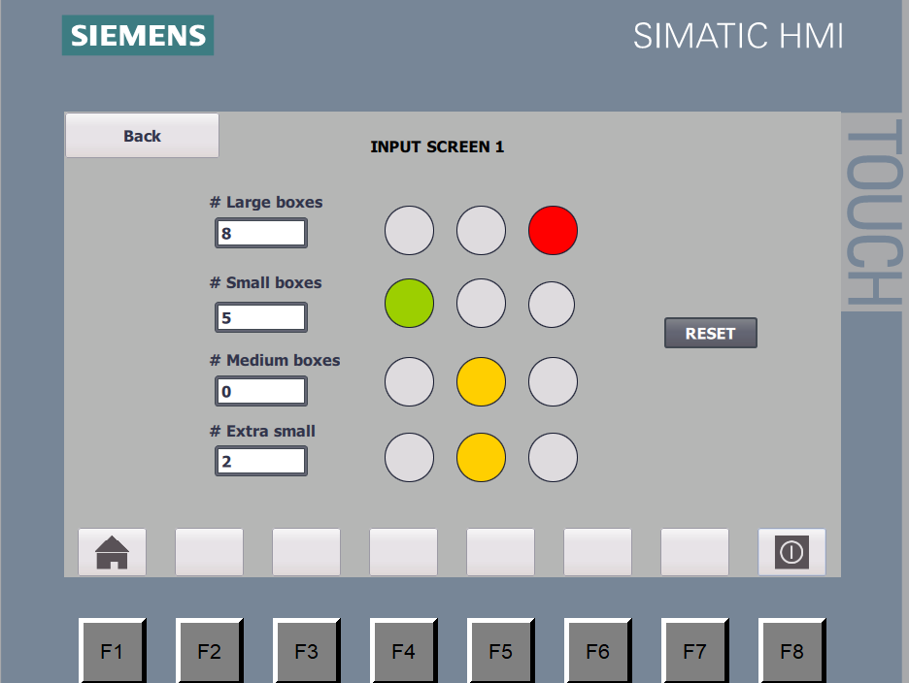
This screen shows the current number of boxes that has been processed for each size. The lights are linked to the stack lights on the factory I/O and will change depending on the pre set limit, for this example a pre set limit of 5 was set. When the number of boxes processed exceeds this limit the light will turn red, if the limit has not been reached it will turn yellow and if it reaches 5 then the light will turn green. The counters can also be reset on this screen.

Screen 2
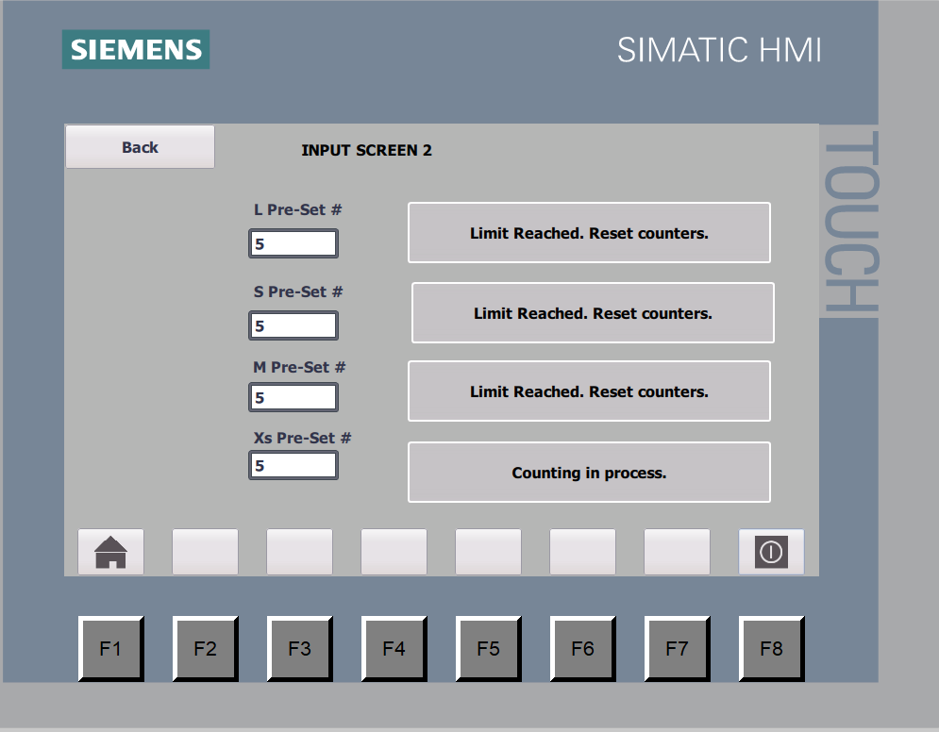
Finally, screen 2 gives the user the ability to set the pre set limit for the counters. An animated note has also been incorporated on this screen, which changes depending on the circumstances at the time. Depending on the box count, it will either read “Limit Reached. Reset counters” or “Counting in process”.

Conclusion
In conclusion, the most popular PLC brands in the world in recent times are Siemens, Rockwell Automation Allen Bradley and Mitsubishi. By comparing these it was determined that Siemens for modular and Allen Bradley for compact were the best, However choosing the best PLC depends on a number of things such as system requirements, environmental requirements, inputs and outputs (I/Os), CPU speed, communication protocol types, and programming.
A design of a factory process capable of sorting and arrange 4 different sized boxes is included, this was created in Factory I/O with the logic written in Siemens. A HMI is also included as an operational interface. Screenshots of this are present in the report; however copies of the Factory I/O scene and Siemens project have also been included.

Bibliography
Bhavesh. (2021). instrumentationtools. Retrieved 12 14, 2021, from instrumentationtools: https://instrumentationtools.com/plc-program-for-iec-timers-ton-tof-tp-tonr-used-in-s7-1200/
Jeffries, M. (2021, 02 15). Mader Electric.inc. Retrieved 01 16, 2022, from Mader Electric.inc: https://www.maderelectricinc.com/blog/choosing-the-right-plc-6-things-to-consider
Kamillas. (2017, 07 22). quora. Retrieved 12 17, 2021, from quora: https://www.quora.com/What-are-the-most-commonly-used-PLCs-in-industries
Ladder Logic World. (2020, 10 11). Retrieved 12 09, 2021, from Ladder Logic World: https://ladderlogicworld.com/plc-manufacturers/
Muthukishnan, V. (2021, 04 11). electrical4u. Retrieved 12 07, 2021, from electrical4u: https://www.electrical4u.com/programmable-logic-controllers/
Peter. (2019, 02 14). plcacademy. Retrieved 01 04, 2022, from plcacademy: https://www.plcacademy.com/plc-counters
RS Components Ltd. (2021, 10 11). Retrieved from uk.rs-online.com: https://uk.rs-online.com/web/p/plcs-programmable-logic-controllers/8624468?cm_mmc=UK-PLA-DS3A-_-google-_-CSS_UK_EN_Automation_%26_Control_Gear_Whoop-_-PLCs+-+Programmable+Logic+Controllers_Whoop-_-8624468&matchtype=&aud-827186183686:pla-418615222496&gclid
twcontrols. (2022). twcontrols. Retrieved 01 6, 2022, from twcontrols: https://twcontrols.com/lessons/plc-training-electrical-contacts-normally-open-and-normally-closed-contacts#:~:text=Normally%20closed%20-%20Is%20a%20contact,to%20not%20allow%20current

