Name: Kalpana Chiranjilal Mahawar
Student number: 2133406
Module: Human Resource Management(LCMB7000)
Lectures’s name: Glaudius Kulothungun
Date of Submission:
Word count: 2934

HRM is an activity of Recruiting, Hiring, deploying and Managing an Organization’s Employees.
Human Resource Management is the Strategic approach towards effective and efficient Management of people in an organization in order to help the business gain Competitive advantage and bring the most Productive results. It is design to maximize Employees performance in the service of an Employer’s Strategic Objectives.

The seven Basic Functions of a HR Executive or HR Manager includes Recruitment and Hiring, Training and Development, Employer- Employee Relation, Maintain the company’s culture, Manage the Employee Benefits, Handle Disciplinary actions among employees and Create a safe work Environment.

Why is HR a Crucial part of an organization?

Because it helps to Bridge the Gap between Employees’ Performance and Organization Strategic Objectives through various Strategies like Training and Development, Compensation, Employee Benefits, Employee Retention, etc. The actions of Human Resource Management affects the relation between the Organization and its Employees.

The Company’s Hierarchy Structure:
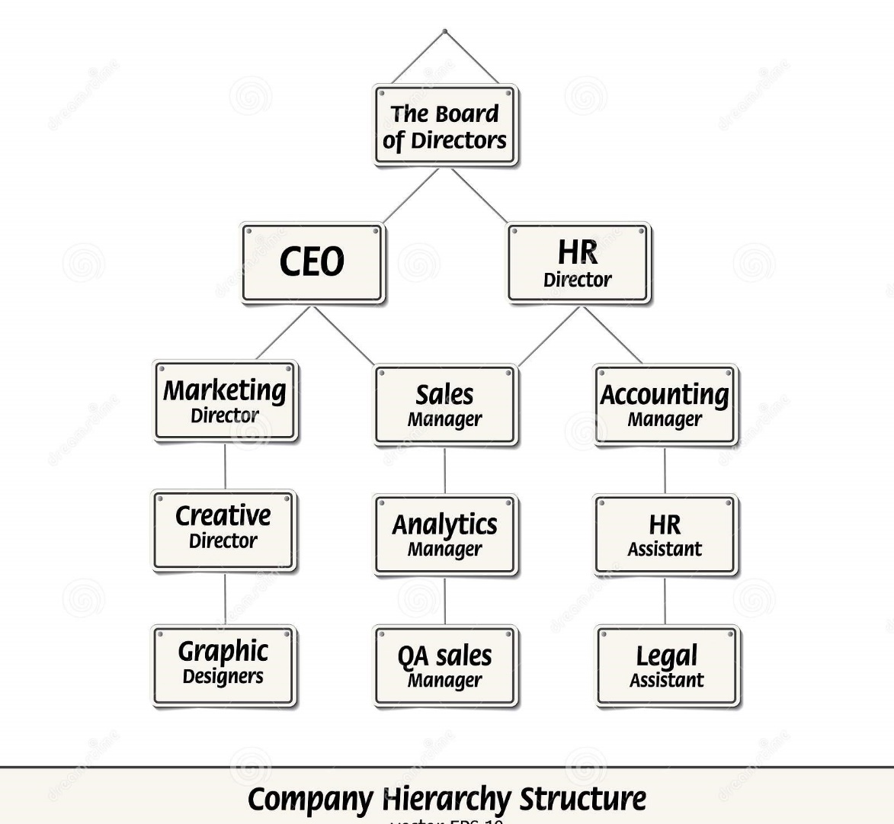

The Human Resource Director will plan, lead, direct, develop and coordinate the policies and activities. They also Manage the staff of the HR Department, ensuring legal Compliance and implementation of the organization whereas HR Managers are responsible for the day to day functions in an organization including the record tracking, performance Management, Processing payroll, Employee Retention, etc.

Being a Human Resource Director of an IT firm which is a Software Developing Company named Horizoncore pvt Ltd, i would like to Develop and make use of Human Resource Strategy for the below three areas:

- Change management:

Change Management is the Systematic approach and application of Knowledge, tools and resources to deal with the change which can occur due to several Factors like changing technology, Diversification, Globalisation, etc. It can also be in the form of merging two companies or even corporate expansion to another country or a continent.

Why is Change important for an Organization? Change is important for any organization because without that business would loose its competitive advantage and would fail to meet the rising demands of the customers.

The ever changing world of Technology: Without pacing with the changing technology an organization will become less competitive and will slow down its services and will lag behind in a competitive world.

Change in Customer’s needs: The Customer needs are evolving continuously with time, everyone wants the results quickly and at one step of an online application.

The changing Global Economy: A strong Economy and increasing demands for products and services means that a company need to expand its staff and adapt to new facilities. This will create quality employment which in turn will bring productive results and boosting economy directly.

The Strategies for Effectively Managing Organizational Change:

Managing Organizational change is a bit Complicated. Organizations are more likely to adapt a changes easily when they engage employees before, during and after the change has been made.

Below are the 7 ways a Leader can implement to manage change in their organizations more effectively:

- Put People First: People are the backbone of any organization in any department of an Organization. Leaders can implement changes when they engage employees in change by communicating with the employees frequently and making them understand the need to change to pace with the changing technology.
- Making change Compelling and Exciting: The change can be made exciting by making it appear easy and challenging in an exciting way rather than in a complicated and dull manner.
- Working with a change Model: There are many set models which can be used as an example to implement the changes in real scenario. Models like Lewin’s Change Management Model and Kotter’s Change Management Model.

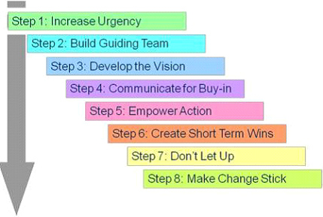

- Creating an Urgency: Highlighting the potential threats and repercussions which might affect the competitive environment.

- Forming Powerful Guiding Coalitions: Identifying the leaders who would be involving and committing towards entire process of change.

- Developing a Vision and a Strategy: Determining the long term vision and a strategy to implement it into mission.

- Removing Obstacles: Checking on the Barriers or people who are resisting change. Implement proactive actions to remove the Obstacles.

- Creating Short term wins: Creating short term goals instead of long term, which are achievable and less expensive and are less prone to failures.

- Not getting Complacent: Not getting complacent with short term success and improving on every stage of the change.

- Making Change Stick: Ensuring that change becomes integral part of an organizational culture and adapting as quickly as possible.

The 5 R’S of a Change Management Checklist:

Raised: Who raised or suggested the change?
Reason: What is the reason for change?
Return: What return is expected from the change?
Risks: What are the risks involved in the change?
Resources: What resources are required to deliver the change?

I, being an HR Director of a Horizon limited will implement the changes ensuring each and every employee of every sector are happy to adapt the change and take it as a challenge in a positive sense and deliver the best to implement the change to bring the best out of the changes.

- Learning and development
It is the continuous process of encouraging the Professional development of Employees. It involves analysing skill gaps and designing the training methods that can help empower employees enough knowledge and skills that can lead to improvement in overall performance.
It focuses on Upskilling and reskilling the employees so that they can be trained for the new roles in an organization, sometimes it helps to develop the new leadership skills that help employees in the Promotions in company.

Benefits of Learning and Development:

Better Performance: The more skills an employee has the better will they perform. The high productivity is directly related to better performance which can be acquired through continues Training.

Skill Development: The more skills an employee posses the more beneficial it can prove to a company and business will have more to offer to those employees.

Engagement: Survey has proven that companies with strong culture of Training and Development has more employee engagement.

Brand name: A company that invests in the Development of their Employees has strong brand reputation. Corporates like Google and Amazon are very vocal about their Learning- Focused approach, hence they are have the image of “Employer of choice”.

Growth: The process of identifying training gaps in a company help them address the weak areas which will eventually bridge the gap and improve the performance and help a company grow.

Role of HR Director in L&D:

- An HR Director is usually responsible in Making the front end Decisions for the Learning and Development programme.

- They work in coordination with the Human Resource Managers to determine the type of trainings that will be beneficial to the Employees.

- They can also work with Team Leaders to develop training programs in areas such as Leadership development and conflict resolution.

- Conducting performance review to evaluate employee performance and suggest ways to improve if required.

- Reviewing new technologies for Training applications and implementing the same for quality and better training.

Some of the most Effective Training Methods are listed below:

Onboarding: This is the method especially for new Employees so that they can understand the process that a company follows.
Coaching: This method basically involves one on one session with the Managers to understand individual’s skills.
Lectures/ Conferences: This method involves sharing a knowledge on a topic to large number of Employees at a time
Group Discussions/ activities: This is a Collaborative method which allows multiple employees to discuss a particular topic and Learn things simultaneously.
Online Training and e learning: This method of training involves learning through online videos and links. It is one of the easiest way that needs little effort for Employers and Employees both.

Being an HR Director, I would deploy all the methods as and when required to ensure each and every employee has access to Learning and get a chance to Develop their skills.

- Staffing: Retention

The Employee Retention is a process of preventing Employee’s turnover, or the number of employees who leave the organization either Voluntarily or involuntarily.

The Effect Of Employee Turnover on an organization:
The Staffing Retention is one of the key factors to maintain the Organizational productive outcome. Any organization bear more loss when the employee leave because they have to invest again in the training of new Employees. Also an existing employee can be hired with less increment compared to the new employee that demands for the huge hike.

The Reasons for Employee Leaving the Organization:

Survey carried out says that most of the Employees leave an Organization out of Frustration, Stress, workload and conflict with other Employees or the Managers. In some cases, lack of growth, low salary and Motivation also force employee to leave the organization.
However the scenario is different when it comes to women Employees, According to survey conducted the reason for a women employee to leave organization does not fall under the above mentioned reasons which is lack of growth and motivation, low salary, constant friction with their peers or Managers, etc but it is the Maternity reason, women tend to chose their family when they are on Maternity period.

Factors Affecting Employee retention:

A well defined Career path
Whether Experienced or inexperienced, any employee wants to be assure of the career growth. They wants to see tangible examples of how their counterparts have grown in their firm. A latter trace is as important as vertical Ladder. The young peers are is keen on having early experience of learning new things rather than doing the same mundane duties every day. Hence it becomes really important for to set well defined career paths so that employees stick to an organization.

Compensation
Compensation constitutes the largest part of Employee retention process. Compensation varies from industry to industry. Hence an attractive compensation plays a crucial role in retaining their employees. Compensation includes salary and wages, bonuses, benefits like dearness allowance, house rent allowance, travel allowance, Health Insurance, vacations, retail discounts, etc.

Work Relationships
Supervisory Management support and relation with co workers are the two main backbone of a positive and healthy work environment. This is never on record on paper but it plays an important role in making people worship their work rather than just an earning process to earn bread and butter.
Personal and work life Balance
Irrespective of the industry, it is important for working professionals to maintain work- life balance. While high- paying jobs demand longer hours of work and more commitment, organizations should implement Flexible working hours and remote working policies especially Hybrid working culture ensures that employees enjoys personal and professional life at a pace.

Retaining Good Employees for an Organization is difficult for an organization especially when Labor market is changing.

It is believed that the main reason people leave is because of money . Money definitely plays vital role because when an employee feels they are inadequately paid they are more likely to leave but if they are paid close to the competitive level of what they expect, other factors become more important.

Retaining during Organizational change is exactly the time to worry about retention. This is because during this period most of the workers are concerned about the Job security and their Employer’s future. If they do not feel the part in the early stages of merge or acquisition they may leave and search for alternatives. Cutting off some people’s job due to economic factors can be affordable for an organization sometimes.

2. How will the above chosen strategies going to help the Employees of my firm Valued, appreciated and develop a sense of belonging to the Organization?

Change Management strategy:
- Before implementing i would involve the discussions and Feedback from the employees of my organization so that each and every employee will fell that their opinions matters and they are informed at early stages itself so that they could be prepared beforehand and face challenges in the most effective way

- Also there would be transparency and it will build trust between Employer and Employee

Learning and Development:

Being an HR Director of the firm, I will focus more on the online Learning method and on one on one session that would allow employees to complete their daily target at work and attend the training sessions online even on days off and would implement some incentives for the same.

However the major focus will be on the offline Training programme during office hours, by conducting training for an hour daily with 50% employees on one day and the remaining on the other days. This would ensure that the daily targets are also met and employees are able to attend trainings as well keeping pace with Learning and working simultaneously.

Staffing Retention:

This is the most difficult task for any employer because it is unrealistic to retain each and every employee of the organization. Practically employee will resign and leave when they find better opportunity and every employer has backup for those employees. However it becomes crucial to retain employees who are more experienced and are Multitasking.

How can such employees be retained?

Yearly Appraisal and monthly bonus based on performance: I would like to implement the yearly Appraisal and monthly bonus to encourage the employees. This will not only help them financially but will also motivate them and boost the confidence. And doing so will make them feel appreciated and valued.

Extracurricular activities, outings and personal support: Conducting extracurricular activities like Sports, Annual functions and outings like picnic at a local spot or a short trip at nearby destination will give a chance for strong relationships among the piers. This will also make employees feel that they are humans and not just machines who only work to earn daily bread and butter.

Trends that changed Human Resource in the last decade

- Embrace Technology and Analytics: Nowadays HR are already using analytics to predict and assess from Talent Resourcing to Performance analysis to Tracking the Leaves and absenteeism to payroll to employee retention. For example majority of the organization uses a HR portal that allows employees as well as HR and Managers to track their Leaves and attendance. This has made the work easier, convenient and transparent.

- Focusing more on people: Embracing technology does not make human out of the equation because no technology can be successful without the intervention of human. Infact according to Cisco vice president Fran Katsoudas, HR will have more time to involve with individuals because analytics has improved the pattern. With competition fierce for good talent, successful HR managers need to give top workers a reason to come to work. According to Human Resource officer at Cleveland- based park Place, an HR needs to create an environment where people enjoy being there.

- Be Ready for the new workforce: HR needs to assess which tasks can be automated throughout the organization and then reskill the jobs that are affected by automation.

- Stay Abreast of the Compliance issue: Complying with tax regulations and laws of the government is a very crucial part of an HR Strategy. Also ensuring on updating them as and when required.

- Update the Skills: A few HR roles can be automated like payroll, recruiting, Compliance, etc however with the change in global market, an HR needs to update their skills in order to guide the employees of an organization in most effective way.

Reference 1: Lisa Hannum(2021), Beehive, available at: https://beehivepr.biz/7-strategies-for-effectively-managing-organizational-change/
Reference 2: https://www.forbes.com/sites/jeannemeister/2021/05/28/five-strategic-hr-priorities-for-2021/?sh=13e74ae854cb
Factorial HR, available at: https://factorialhr.co.uk/blog/learning-and-development/
Reference 2: https://www.shrm.org/hr-today/news/hr-magazine/1118/pages/7-critical-strategies-to-prepare-for-the-future-of-hr.aspx

