Ways of Perceiving

Curating an Imagined Exhibition, Festival, Fashion Show, Interior or Music Concert

Marie Risser | 1805273
BA Design Crafts

University of Wales Trinity Saint David
Historical and Contextual Studies: ADAD4010: Julia Lockhart

Contents

1. Light in the Making: Jack Storm 3
1. Introduction 3
2. Location and Time 3
3. Health & Safety 5
4. Music and Feelings 5
5. Jack Storm and his Work 6
6. Conclusion 10
Bibliography 11

Table of Figures
Figure 1: Sun shining through Stonehenge 4
Figure 2: Map of Stonehenge 4
Figure 3: My seating arrangements 6
Figure 4: ViviOvo 8
Figure 5: Optic Glass Sculpture 8
Figure 6: The Phoenix 9

Light in the Making: Jack Storm

Introduction
This composition will set out the curation of an outdoor space. The location choice will be investigated. The phonemics will be considered. A floor plan will be created. Security issues and health and safety will be assessed.

Location and Time
For this curation, of ‘light in the making’ by Jack Storm. I have chosen Stonehenge as the location. I am inspired by the unnatural beauty of its environment as well as its placement, aligned to ley lines and its position for the Equinox.
The stones were brought from very long distances – the” bluestones from the Preseli Hills, over 150 miles away, and the sarsens probably from the Marlborough Downs, 19 miles to the north”. (Stonehenge | English Heritage, no date)
There are many different ideas to why Stonehenge is important.
“These have included a coronation place· for Danish kings (Pearson et al., 2009), a Druid temple, an astronomical computer· for predicting eclipses and solar events (Pearson et al., 2009), a place where ancestors were worshipped or a cult· centre for healing (Pearson et al., 2009).”
My intention is to use the natural effect of ‘healing centre and an astronomical computer for predicting solar events’,(Pearson and Ramilisonina, 1998) so with that, using the time of the Equinox, the sun should burst through the stones, on to the main Alter shining through the artefact.
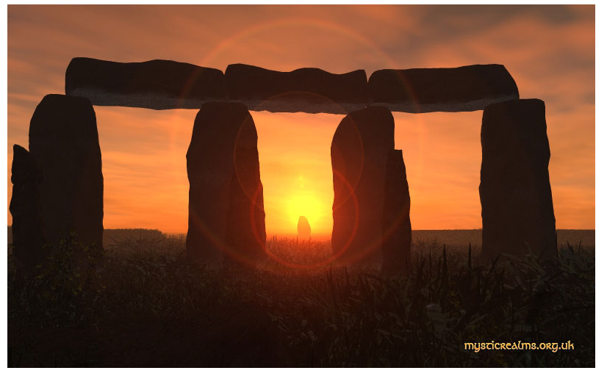
Figure 1: Sun shining through Stonehenge (Summer solstice at Stonehenge | Earth | EarthSky, no date)
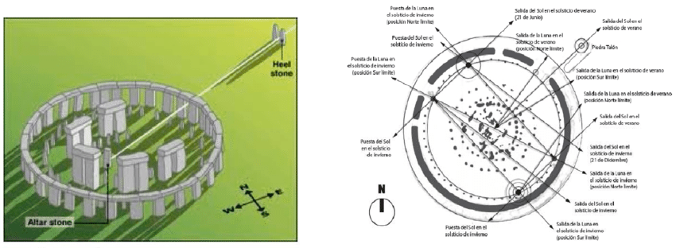
Figure 2: Map of Stonehenge Kweeped from news.bbc.co.uk by joelweb

Health & Safety
Health and Safety may be an issue.
There will be portable toilets, speakers, lighting, drinks, seating, cables, bins. Possibly food.
Walking: There must be a clear pathway. Rubber matts could be used for the stability of pathways and to keep cables tidy. Rubber does not conduct electricity.(Does Rubber Conduct Electricity? | Reference.com, no date) There will be staff at certain intervals to help with the audience, for example give directions.
There will be lights on the sides of the rubber mats, in the same was as an airport runway. They will also be torches and lights for the portable toilets.
Staff: security personnel will be available for the artefacts; paramedics and first aiders will be present. A defibrillation box will be required as will appropriate footwear and clothing.
Insurance would be required for Jack Storm’s work and for public liability (Compare Public Liability Insurance | MoneySuperMarket, no date) https://www.simplybusiness.co.uk/insurance/faq/what-is-public-liability-insurance/

Music and Feelings
The unusual acoustics of Stonehenge would add extra sensation to the curation, coupled with the music that has been chosen.
The author wants the audience to experience the feeling and the wonder of Stonehenge with the amazing work of Jack Storm, with his majestic collection of glass artwork.
To achieve the right feeling at the event vibrations were examined (Align your vibration to resonate with the Earth -, no date). The sound phenomenon of Stonehenge.
“Acoustic,’ effects such as echoes, resonances and whispering gallery effects, like Greek or Roman theatres.”(Martin Wainwright, no date)
By using music, facing in on the audience using the Schumann Resonance at 4.32Hz (the Earths Vibration Frequency) should help the audience, by allowing them to be more receptive, to the feeling rather than the thought. (N. J. Cherry1Human Sciences Department, Lincoln University, 2003)
Then when everyone was ready. The music would change to a higher frequency of Gaia Healing Earth's Frequency 7.83hz Music (Schumann Resonance) (Juan Pablo Barahona, no date) even though there is a calmness about the music, it should be a very connective feeling of Gaia (Earth) and the audience. (First David, 2003)
There would be the natural light, plus the light that would be procured, shining through the artifices. This would be a place of wonder, feeling of self and your place in the world and with the world.
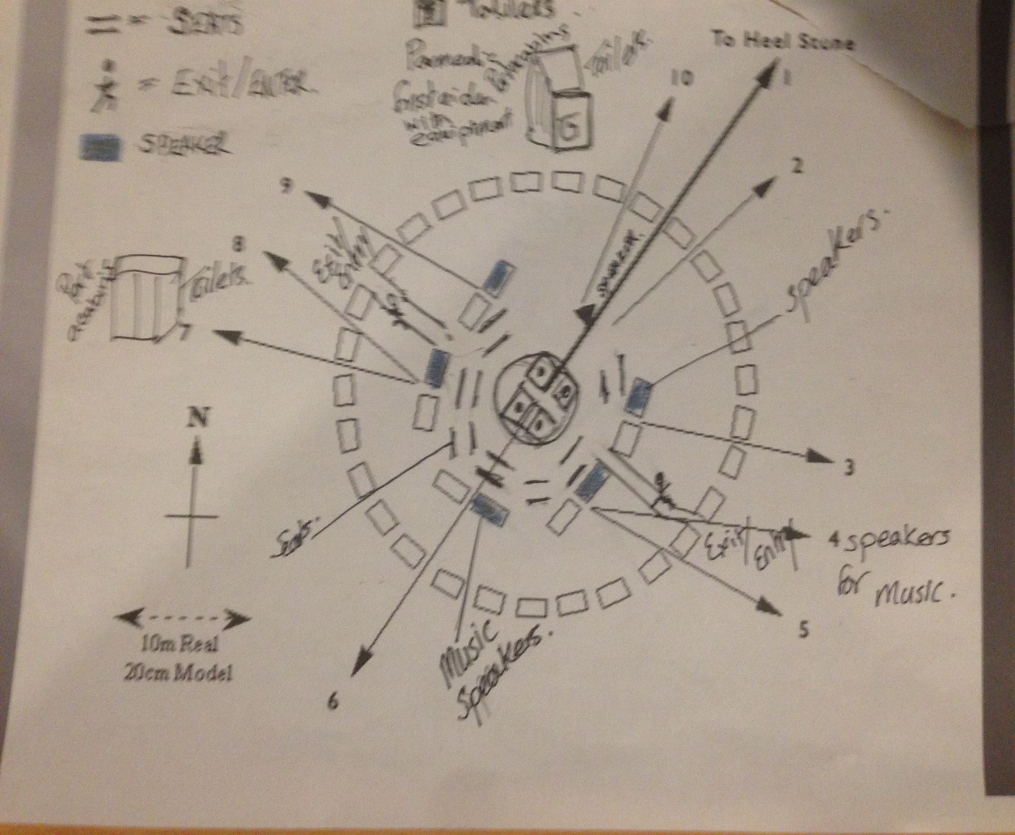
Figure 3: My seating arrangements

Jack Storm and his Work
During his junior year at Plymouth State University, Storm was employed with a glass artist who’d been experimenting with a technique that captured Storm’s imagination—combining lead crystal and dichroic glass using a cold-glass process there was a moment of revelation. It is unusual for people to make extreme beauty from cold glass. Expect for your more traditional stained-glass work and other shaping methods. (Glass Sculptures Designs by Fine Art Glass Artist Jack Storms, no date)
Most common techniques for producing glass art, are more commonly known as hot glass such as glass blowing, moulding and slumping.
Jack Storm’s unique sculptures takes 18 weeks to produce due to the hard and rare cold-glass process that is used. It is a unique art form.
Storm has a fascination with the Fibonacci Sequence and uses it each time in his artefacts. Storm says
“that he try's for perfection each time, knowing that perfection is an illusion.”(Glass Sculptures Designs by Fine Art Glass Artist Jack Storms, no date)
Presentation of Storm’s work: As the curation is of glass it would be an advantage to use lighting to emphasize the reflection and refraction of the artefacts.
As the sun shines through the stones and then hits the artefacts, it gives an outcome. The lighting can be used early in the morning to late in the night. Each time giving a different look for and feel the audience, thereby, heightening their experience.
The lighting would be placed under or on the side of the artefact to throw light through or against it. If the sun wasn’t giving enough effect on the artefact, then the lights would be deployed. Also, into the night the lights would be deployed.

ViviOvo
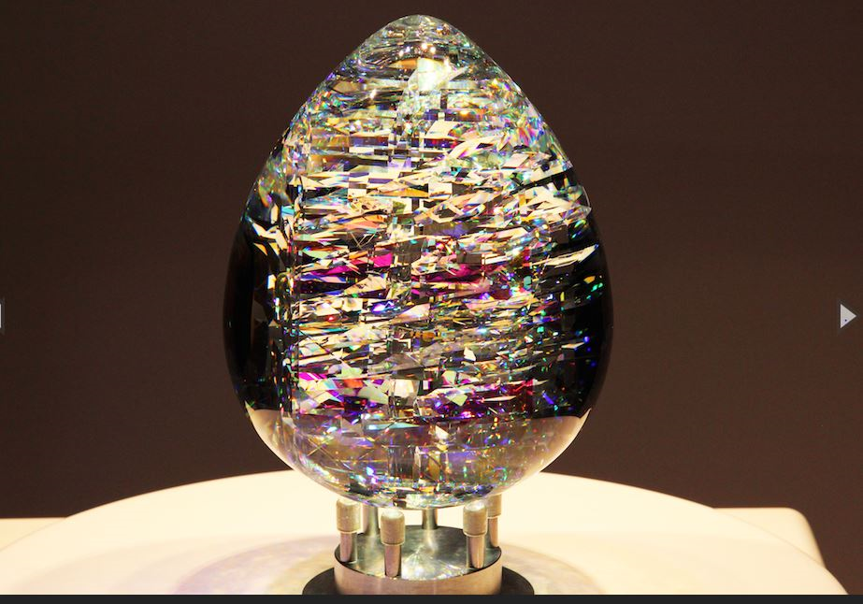
Figure 4: ViviOvo (Collections - Jack Storms, no date)
Storm found this one a challenge. Wanting to give up, his fiancée gave him the boost he need that helped him finish it. That is why is it called the ViviOvo, Vivi after his fiancée name and Ovo meaning egg.

Optic Glass Sculpture: Jack Storm-Spectrum Bevelled Cube with Lenses

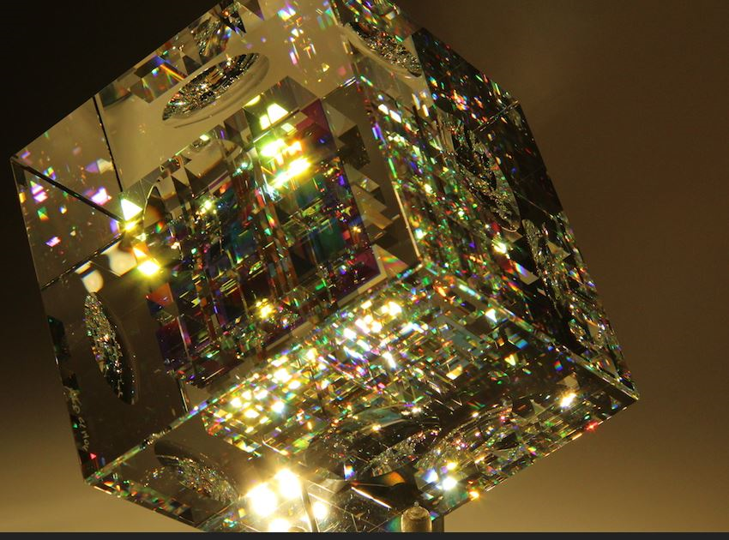
Figure 5: Optic Glass Sculpture(Collections - Jack Storms, no date)
The evolution of Storm’s work is astounding. Just when we think he cannot tantalise us with his work, he surprises us again with another one his new perfections, of geometry and art form and strikes out across the range of shining and shimmering pieces.

Phoenix
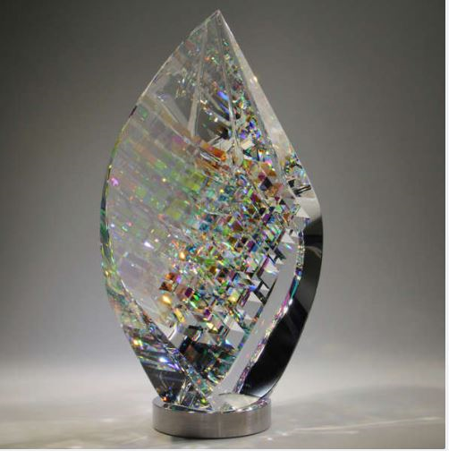
Figure 6: The Phoenix(Collections - Jack Storms, no date)
Storm was working on a project and the glass project fell and broke. After the shock of the glass shattering in pieces, he got his breath back. He picked up the pieces and held up to the light, he had come to realise he had created a new shape and went with it to create the Phoenix.

Conclusion
The elements of the earth were used to make the connections that have been forgotten, for some, between Gaia and us, to enjoy and feel. The excitement of light and life, to feel, instead of think, and to let your soul reconnect with the sensations of the earth on the equinox and the music with light.
The reason Jack Storm’s work was chosen is because it made the author stop and open their heart, feel the energy of wonder and inspiration.

Bibliography

(2)
https://www.english-heritage.org.uk/visit/places/stonehenge/history-and-stories/history/significance/
(Stonehenge | English Heritage, no date)
4. W Charleton, Chorea Gigantum: Or, The Most Famous Antiquity of Great Britain, Vulgarly Called Stone-Heng, Standing on Salisbury Plain, Restored to the Danes (1663) (accessed 18 Nov 2013).
6. G Hawkins, Stonehenge Decoded (London, 1965).
7. M Parker Pearson and Ramilinsonina, ‘ Stonehenge for the ancestors: the stones pass· on the message·’, Antiquity, 72 (1998), 308–26 (subscription required; accessed 3 March 2015).
8. T Darvill, ‘Towards the within: Stonehenge and its purpose’, in Cults in Context: Reconsidering Ritual in Archaeology , ed D A Barrowclough and C·Malone (Oxford , 2007 ) , 148 – 57 .
,(Pearson and Ramilisonina, 1998)

(3)
(Does Rubber Conduct Electricity? | Reference.com, no date)
(Compare Public Liability Insurance | MoneySuperMarket, no date) https://www.simplybusiness.co.uk/insurance/faq/what-is-public-liability-insurance/

(4)
(Phonemic Chart: What is a phoneme? Part 1, no date)
(Gaia Healing Earth’s Frequency 7.83hz Music (Schumann Resonance), no date)
(N. J. Cherry1Human Sciences Department, Lincoln University, 2003)
(https://www.youtube.com/watch?v=4wtG01ymIjE, no date)
(Juan Pablo Barahona, no date)
(FirstDavid.The Music of the Sphere: An Investigation into Asymptotic Harmonics, Brainwave Entrainment and the Earth as a Giant Bell.)
(5)
(Glass Sculptures Designs by Fine Art Glass Artist Jack Storms, no date)
(Align your vibration to resonate with the Earth)
(Obrist, hans Ulrich ways of curating): p139-145 Times and Exhibitions
Used some ideas and found the book intriguing. As in taking an exhibitor outside. Times - how that reacts with people.

Figure 1: Sun shining through Stonehenge (Summer solstice at Stonehenge | Earth | EarthSky, no date)
Figure 2: Map of Stonehenge Kweeped from news.bbc.co.uk by joelweb

Figure 3: My seating arrangements drawing Marie Risser
Figure 4: ViviOvo (Collections - Jack Storms, no date)
Figure 5: Optic Glass Sculpture(Collections - Jack Storms, no date)
Figure 6: The Phoenix(Collections - Jack Storms, no date)

