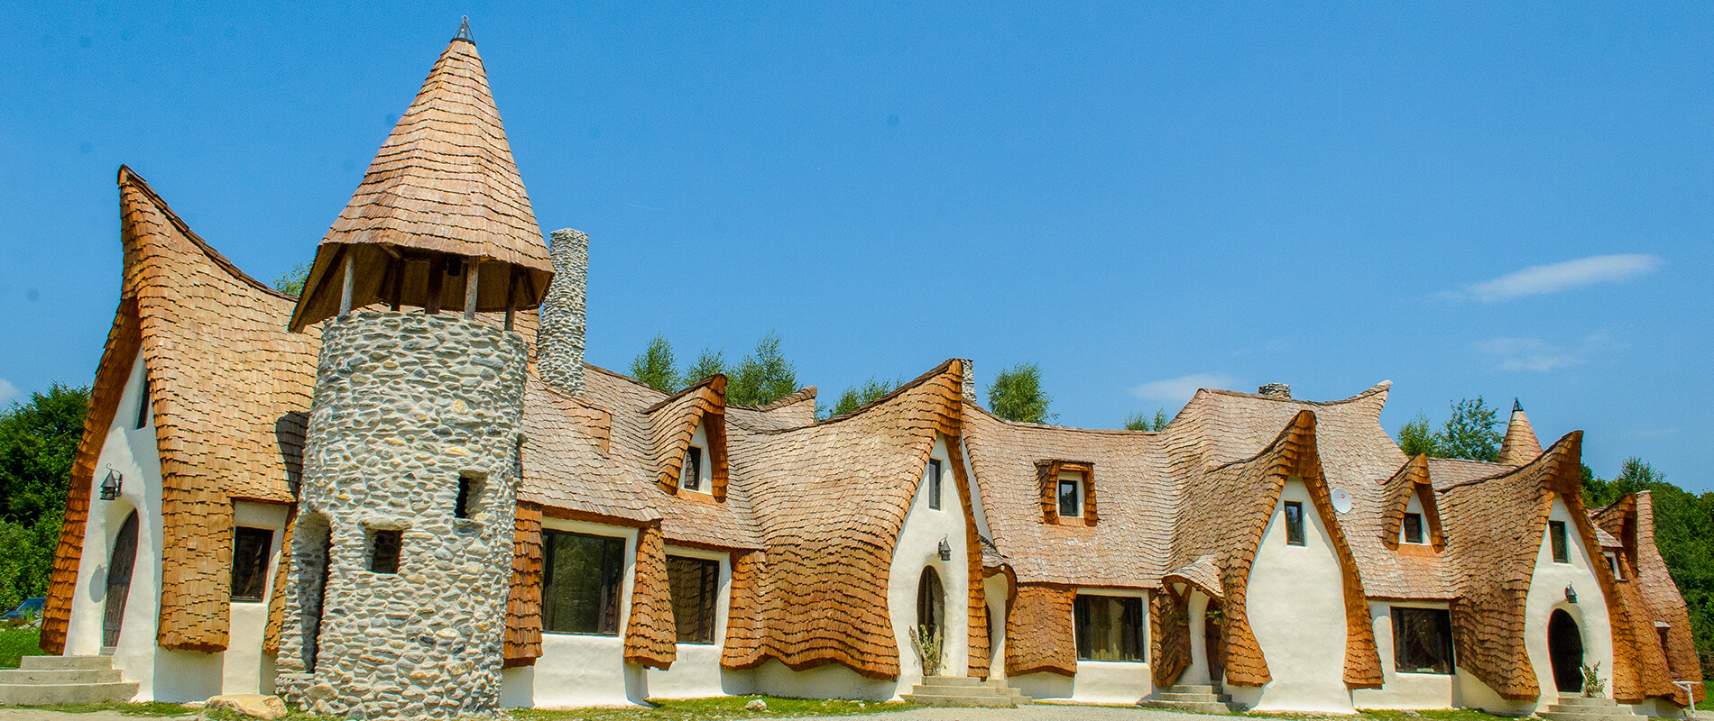

DESIGN THINKING
  - MUDBRICK

Vlad Constantin Timpau
2208334@student.uwtsd.ac.uk

Design Thinking

Design Thinking is a strategic and creative approach to solving problems and developing innovative solutions. It was initially developed in the field of design, but has also expanded into other fields such as business, technology, education and health.
The basic principle of design thinking consists in focusing on the needs of users or beneficiaries and not only on the characteristics or functionalities of the product or service. Instead of starting with a preconceived solution, the design thinking process involves a deep understanding of the problems and the context in which they appear.
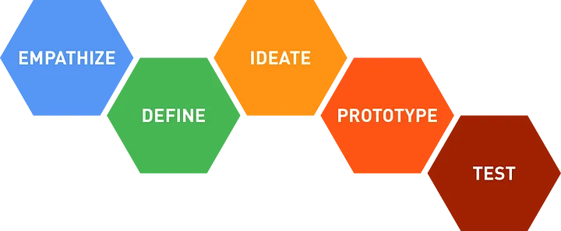

The design thinking process usually has 5 stages:

1. Empathy: In this stage, the emphasis is on understanding the needs, desires and experiences of the users. Design Thinking is based on the ability to embrace perspective and empathy to accurately identify the problem that needs to be solved.

2. Define: In this stage, the information collected in the first phase is synthesized to formulate a clear problem or challenge that must be solved.

3. Ideate: this stage involves the generation of a large number of ideas to address the identified problem.
Clear thinking is encouraged without being restricted to conventional solutions, we think outside the box.

4. Prototype: In this stage, the promising ideas generated in the previous stage are selected and prototypes or models are developed that can be tested and evaluated. It is a creative process in which improvements and adjustments are made to create efficient and effective solutions.

5. Test: In the last stage, the created prototypes or models are tested by users or beneficiaries to obtain feedback and to evaluate the effectiveness of the proposed solutions. This stage offers the opportunity to make adjustments until the optimal solution is found.

Design Thinking promotes the collective and multidisciplinary approach involving teams from different fields in the process of solving problems.
By applying design thinking principles, innovation, creativity and focus on users are encouraged, leading to the development of better solutions adapted to people's real needs.

In the modern era, concern for sustainability and environmental protection has become a priority in all areas of our lives. In the civil construction industry, innovative and ecological solutions are increasingly sought to reduce the negative impact on the environment and create more sustainable and nature-friendly living spaces. One of these revolutionary concepts is the use of environmentally friendly materials such as adobe / mudbrik (ro:CHIRPICUL)in the construction of buildings.

Mudbrick, a traditional and durable material, is made from a combination of clay, straw or hay and sand. It has long been used in rural construction and is now enjoying a rediscovery among architects and designers concerned with sustainability. The use of adobe in construction offers multiple advantages, both from an ecological point of view and from the perspective of the quality of the living space.

One of the main advantages of a mudbrick is the reduced impact on the environment. Compared to traditional building materials such as brick or concrete, mudbrick has a much smaller carbon footprint. The mudbrick production process is less polluting, requiring fewer natural resources and emitting less carbon dioxide. Also, mudbrick is a recyclable and biodegradable material, allowing the reduction of construction waste and the impact on landfills.

The proposed project explores the application of design thinking principles in the reimagining of mudbrick construction, a traditional construction technique used in many regions of the world. Using a design thinking approach, we will analyze the challenges associated with mudbrick and develop innovative solutions to transform this traditional technique into a sustainable and modern option for future construction.

The first stage of the design thinking process is "Empathy" or the deep understanding of the needs and desires of the end users. In the case of using mudbrick in civil construction, it is necessary to understand the perspective and experience of the potential beneficiaries.
To achieve this stage, it is very important to get in direct contact with the beneficiaries of these constructions. We can conduct interviews, questionnaires, observations and case studies to obtain a complete picture of their needs in terms of civil constructions.
During this stage we can discover the different motivations of the beneficiaries in order to use mud brick in construction.
Some may be concerned with green aspects and environmental impact, wanting to live in a sustainable home and help reduce their carbon footprint. Others may be interested in the economic benefits, such as reduced long-term energy costs or the financial affordability of green materials. There are also those who are attracted to the aesthetics and rustic character that mudbrick offers in construction.

The "Define" stage of the design thinking process helps us synthesize and clarify the needs identified during the empathize stage and formulate a clear problem and challenge statement to guide the solution generation process.

How can we use mud brick in an innovative and effective way to build sustainable and aesthetic civil buildings that meet user needs, reduce environmental impact and encourage sustainability?
In this stage, we will begin to analyze the information and data collected during the empathy stage, we will identify trends and patterns, we will identify the priorities and requirements of the beneficiary.
The "Ideate" stage of the design thinking process allows us to explore and generate a large number of innovative ideas and solutions for the use of mudbrick in civil construction, given the challenge statement formulated in the previous stage.

In this stage we will gather the whole team and all members will contribute ideas, there will be no good or bad ideas, all ideas will be recorded and analyzed later.
During the stage of ideate , we must not limit ourselves to traditional or conventional solutions. We have to think outside the box and be open to new things.

The "Prototype" stage is when we will turn general ideas into more concrete and tangible concepts. The main purpose of the prototypes is to test and iterate on solutions for using mudbrick in civil construction in a practical way.
Here are some essential steps in the prototyping process:
Selection of ideas, definition of prototype objectives, design and development, testing and evaluation.
Prototypes are an effective way to test and validate our ideas, they allow us to get practical information and make adjustments to develop a product as perfect as possible for the customer's needs

In the testing phase of the design thinking process, we put the developed prototypes into practice and subject them to evaluation and feedback from end users and other stakeholders. The main purpose of testing is to validate the proposed solutions and get information about how they work in a real environment.

Here are some examples of the test model:

1. Selection of participants: We identify the group of relevant people to participate in the test.
2. Setting test objectives: We define clear objectives for testing, such as evaluating user experience, measuring efficiency and performance.
3. Creating test scenarios: We develop specific scenarios and tasks for participants.
4. Observation and data collection.
5. Data analysis and interpretation

Testing is essential to validate and improve proposed solutions in the use of adobe in civil construction. End-user feedback and other factors involved in testing provide us with valuable information and help ensure that our solutions are functional, effective and meet the needs identified in the earlier stages of the design thinking process.

In conclusion, the use of mudbrick in civil construction represents an opportunity to develop sustainable and ecological solutions that meet the needs of users, reduce environmental impact and encourage sustainability. The design thinking process helps us to address this challenge in an innovative and effective way.
By applying the design thinking process to the use of mudbrick in civil construction, we have the opportunity to develop sustainable and innovative solutions that benefit users and the environment.

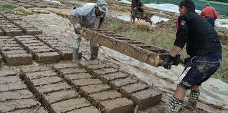 manufacture mudbrick

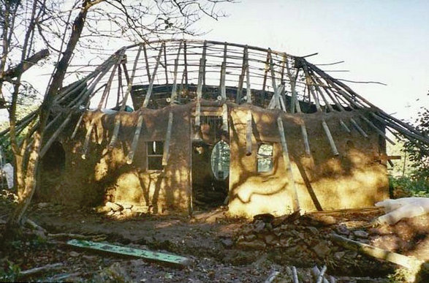

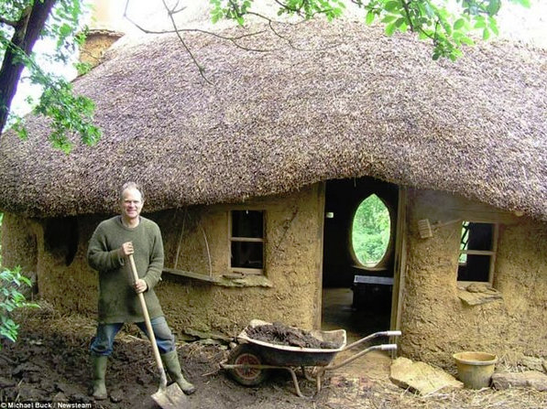
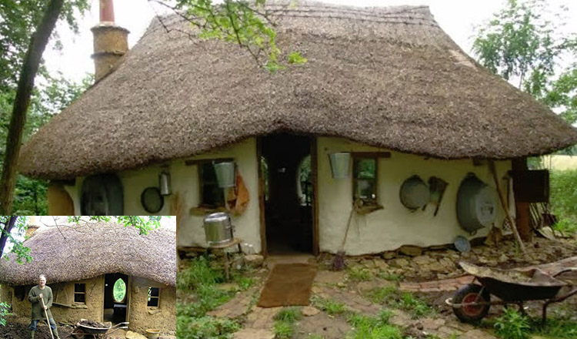

Michael Buck, an English farmer and former art professor, aged 63, from Great Britain, managed to build an ecological house from mud bricks.
https://hunedoaralibera.ro/casa-din-chirpici-construita-de-un-barbat-cu-doar-200-de-euro/

Reference :

- World Green Building Council: www.worldgbc.org
- United Nations Environment Programme (UNEP): www.unep.org
- Design Thinking for Innovation: www.designthinkingforinnovation.com
- Sustainable Building Materials and Design: A Handbook for Architects and Engineers by Gina Tsarouchi, Ioannis Tsarouchis, and Vasiliki Stournara
- Eco-efficient Construction and Building Materials: Life Cycle Assessment (LCA), Eco-Labelling and Case Studies by Fernando Pacheco-Torgal, Said Jalali, and Ana Ferreira-Dias

