Student Name: | Alana Quevedo Diaz
Student Number: | 2015376
Module No: | BMSK6005
Module Title: | Coaching and Mentoring Skills for the Workplace


Table of contents
Introduction
1.0 Explain the similarities and differences between coaching and mentoring within an organisational context………………………………………………………………………………………………………………………2
1.1Meaning of Coaching……………………………………………………………………………………………………………………2
1.2 Example of coaching……………………………………………………………………………………………………………………3
1.3 Importance of Coaching………………………………………………………………………………………………………………3
1.4 Meaning of Mentoring………………………………………………………………………………………………………………..4
1.5 Importance of mentoring…………………………………………………………………………………………………………….5
1.6 Similarities between Coaching and Mentoring…………………………………………………………………………….5
1.7 Critical reflection outcomes of Learning to Coach and Mentor…………………………………………………….6
1.8 Conclusion…………………………………………………………………………………………………………………………………..6
2.0 Critically explore the knowledge, skills, attitude and behaviour needed by an effective workplace coach or mentor……………………………………………………………………………………………………………………………….7
2.1 Critical overview of coaching………………………………………………………………………………………………………7
2.2 Coaching skills……………………………………………………………………………………………………………………………..8
2.3 Knowledge, Skills, Attitude and Behaviour…………………………………………………………………………………..8
2.4 Hulls theory…………………………………………………………………………………………………………………………………9
2.5 Culture of Coaching…………………………………………………………………………………………………………………….9
2.6 Core values…………………………………………………………………………….………………………………………………….10
3.0 Critically assess a model or process that should be followed when formally coaching or mentoring.........................................................................................................................................10
3.1 European Mentoring and Coaching Council………………………….………………………………………………..11
3.2 Grow Model……………………………………………………….…………………………………………………………………..11
3.3 Clear Model…………………………………………………………………………………………………………………………….11
3.4 Grow vs Clear………………………………………………………………………………………………………………………….12
4.0 Conclusion………………………………………………………………………………………………………………………………12
References……………………………………………………………………………………………………………………………………13
Appendices…………………………………………………………………………………………………………………………………..16

Introduction
This report will focus on the approaches of coaching and mentoring. Furthermore, knowledge, behaviour, skills and attributes are needed to be an effective coach and mentor. Moreover, the behaviours and values of coaching, and its abilities to achieve successful outcomes in practice highlight limitations in effectiveness and best practice models to support career development for the individual.

1.0 Explain the similarities and differences between coaching and mentoring within an organisational context
Coaching and mentoring are two approaches that have gained popularity in the workplace as professional and personal development tools, CIPD (2017). Both processes involve a collaborative relationship between a more experienced individual, the coach or the mentor. Furthermore, a less experienced individual, the coachee or mentee, supports learning, growth, and development.

1.1 Meaning of Coaching
Research undertaken by the author's and is in, agreement coaching helps individuals develop their skills and abilities, achieve their goals, and enhance their personal and professional effectiveness. According to Grant (2017), coaching typically involves a supportive and collaborative relationship between a coach and a coachee, with the coach providing guidance, feedback, and resources to help the coachee achieve their objectives. coaching can be defined as "a purposeful and collaborative conversation that enables individuals or groups to move forward and achieve their goals through the exploration of possibilities and the identification of actions and strategies that will lead to successful outcomes", Grant (2017). Furthermore, Whitemore (2009) states that coaching can be used in various settings, including personal development, career development, leadership development, and organisational effectiveness.
Concluding, the author agree that coaching typically involves a structured process, with the coach and coachee working together to set goals, assess current reality, identify obstacles and opportunities, develop action plans, and monitor progress. Effective coaching requires strong communication skills, active listening, empathy, and a deep understanding of coaching theories and techniques.

1.2 Example of coaching
Grant (2019) states Personal workplace coaching has become an increasingly important tool for individuals seeking to enhance their personal and professional growth. As an individual who has personally experienced the benefits of workplace coaching, the researcher can attest to its effectiveness in helping individuals to achieve their personal and professional goals.
Through personal workplace coaching, the manager identified her (the researcher’s) strengths and weaknesses, developed a plan for achieving personal and professional goals, and overcame obstacles impacting her professional performance. The coach provided a safe and supportive environment to explore her thoughts and feelings and helped to identify areas for improvement and personal growth.
In addition, the coach possessed strong communication and coaching skills and was able to tailor their coaching approach to her individual needs and goals. They could listen deeply, ask powerful questions, and provide constructive feedback that helped to progress towards her personal and professional goals.
The author concluded that personal workplace coaching has been a valuable tool for achieving their personal and professional aspirations. They have developed the skills and knowledge to achieve their career goal through coaching.

1.3 Importance of Coaching
Research undertaken signifies the author's agreement that coaching is crucial to individuals' personal and professional development. According to a study by The International Coach Federation, coaching can result in an 80% increase in self-confidence, a 70% improvement in work performance, and a 60% improvement in communication skills, Passmore (2016). The author finds many advantages of coaching, such as providing individuals with personalised attention and support. A coach can help individuals identify their strengths and weaknesses, set achievable goals, and develop strategies to overcome obstacles. (Appendix 1)
According to the International Coach Federation (n.d.), by working with a coach, individuals can better understand themselves, their values, and their aspirations, leading to greater self-awareness and personal growth. Moreover, coaching can be particularly valuable in the workplace. It can help employees improve their skills, enhance performance, and increase productivity. A coach can also assist employees in navigating workplace challenges, such as conflicts with co-workers or difficulty managing workload, which can lead to greater job satisfaction and decreased stress levels. Despite its many benefits, some concerns have been raised concerns about the effectiveness of coaching. For example, coaching may only suit some, requiring significant time and money, Grant and Cavanagh (2018).
While the author agrees that with the right coach and approach, the activity can help individuals achieve their goals and reach their full potential. Overall, coaching can be an invaluable tool for personal and professional growth. However, it is essential to carefully consider the costs and benefits of coaching and select a qualified and experienced coach. Additionally, there needs to be more regulation in the coaching industry, which can make it challenging to ensure the quality of coaching services.

1.4 Meaning of Mentoring
Ragins and Krams (2007) state that mentoring provides guidance and support to less experienced individuals to help them achieve their personal and professional goals. Mentors typically have more experience and expertise in a particular field or industry and use their knowledge and skills to provide guidance, feedback, and advice to their mentees. (Appendix 2).
Megginson, Clutterbuck, and Garvey (2014) also state that mentoring is "a process whereby a more experienced and knowledgeable person provides advice, support, guidance, and feedback to a less experienced person for their personal and professional development". Mentoring can be used in various settings, including career development, leadership development, and organisational effectiveness.
There is clear evidence that effective mentoring requires strong communication skills, active listening, empathy, and a deep understanding of mentoring theories and techniques, Clutterbuck (2004). The research identified that mentoring typically involves a long-term and supportive relationship between a mentor and a mentee. The mentor provides guidance and support on various issues, including career development, personal growth, and professional skills. Recognised in the researcher’s workplace, it is a powerful personal and professional development approach that has helped the researcher achieve goals and advance in her career. As an individual who has experienced the benefits of workplace mentoring, they can attest to its effectiveness in promoting personal and professional growth.
Through workplace mentoring, the author developed a supportive relationship with a more experienced individual who provided guidance and support as they navigated the complexities of the workplace. They also supported her in identifying her strengths and weaknesses, setting goals, and developing a plan for achieving them.
Consequently, the author identified strong communication and mentoring skills and was able to provide them with valuable work feedback and personal and professional growth. They identified blind spots and areas for improvement and provided her with insights into the industry and the company.
Furthermore, the mentor helped them develop leadership skills, allowing them to network and connect with others in the industry and challenging them to step out of their comfort zone and take on new and exciting projects.
In conclusion, implementation tools for themselves in their workplace establishing mentoring has been valuable for achieving personal and professional aspirations. Through mentoring, they have developed the skills and knowledge to succeed and become more fulfilled and effective professionals.
To summarise, workplace mentoring is a powerful approach to personal and professional development that can help individuals to achieve their goals and advance their careers. Individuals can grow and develop personally and professionally by creating a supportive relationship with a more experienced individual and receiving guidance and support.

1.5 Importance of mentoring
Mentoring is an essential aspect of personal and professional development that provides individuals with guidance, support, and opportunities for growth. Mentoring involves a more experienced individual (the mentor) providing guidance and advice to a less experienced individual (the mentee) to help them develop their skills, knowledge, and career, Eby & Lockwood (2018).
Despite the importance of mentoring, some have criticised it for perpetuating existing power imbalances and inequalities in the workplace. For example, women and minorities may have limited access to mentors who share their backgrounds or face similar challenges, Ragins & Verbos (2007). Additionally, informal mentoring relationships can sometimes need more precise goals or accountability and may not be effective in achieving desired outcomes, Allen, Poteet, & Burroughs, (1997). However, despite these challenges, the benefits of mentoring are numerous and significant. There is clear evidence that effective Mentoring can help individuals develop new skills, build confidence, expand their network, and achieve their goals. Research has shown that mentoring can increase job satisfaction, career success, and organisational commitment . Moreover, mentoring can be particularly valuable for individuals who need access to formal training or networking opportunities. A mentor can offer guidance on career paths, offer advice on networking and professional development opportunities, and help the mentee navigate workplace challenges. This can be especially important for individuals new to a field or seeking to advance their careers, Eby & Lockwood, (2018).
In summary, while there are valid criticisms of mentoring, it remains an essential tool for personal and professional development. Mentoring can provide individuals with guidance, support, and opportunities for growth and development, leading to increased job satisfaction, career success, and organisational commitment.

1.6 Similarities between Coaching and Mentoring
Megginson and Clutterbuck (2005) state that coaching and mentoring are two distinct but related approaches with crossover to supporting personal and professional growth. While coaching and mentoring involve building a supportive relationship. More experienced person and less experienced person these two approaches have some key differences, Megginson & Clutterbuck (2005). In agreement, one similarity between coaching and mentoring is that both involve setting goals and developing action plans to achieve those goals. For example, a coach may work with an employee to develop a plan for improving their time management skills, while a mentor may work with a new hire to develop a plan for advancing their career. Additionally, one key difference between coaching and mentoring is the scope and focus of the relationship. Coaching is more task-oriented and focused on developing skills or achieving specific goals. In contrast, mentoring tends to be more relationship-oriented and focused on providing guidance and support for broader personal and professional growth.

The author has experienced, for example, that a coach may work with an employee to improve their sales skills, while a mentor may work with a mentee to navigate the complexities of the workplace culture . Conversely the differences between coaching and mentoring are only sometimes clear-cut, and the two approaches can overlap. In some cases, a mentor may provide coaching-like guidance on specific tasks or skills, while a coach may develop a more long-term relationship with a client, Garvey et al., (2016)
In conclusion, research defines the difference between coaching and mentoring as the coach or mentor's experience level and expertise. While coaches typically have expertise in a specific area or skill, mentors may have more broad-based experience and expertise in navigating the workplace or industry. For example, a coach may work with an employee to develop their technical skills, while a mentor may work with a mentee to develop their leadership skills and advance in their career. Additionally, the author agrees that there is an overlap between coaching and mentoring, organisations and practitioners must maintain a distinction between these approaches to effectively support individuals' personal and professional growth in the workplace. By understanding each approach's unique benefits and challenges, individuals can tailor their interventions to the needs of individuals and the organisation while avoiding potential conflicts of interest or ethical dilemmas.

1.7 Critical reflection outcomes of Learning to Coach and Mentor
Research undertaken identifies coaching and mentoring theorists to emphasise the importance of reflection in the coaching and mentoring process. Reflection involves the process of thinking about and analysing one's experiences, identifying areas of improvement, and developing strategies to enhance performance.
Kolb's (1984), experiential learning theory emphasises the importance of reflection in the learning process. According to Kolb, individuals learn through experiencing, reflecting, conceptualising, and experimenting. The reflection stage involves thinking about and analysing one's experiences and developing insights and strategies for improvement.
Similarly, Schön's (1991), reflection-in-action and reflection-on-action theories emphasise the importance of reflective practice in professional development. Schön argues that professionals must engage in ongoing reflection to develop their skills and knowledge and to adapt to changing contexts and environments.
Overall, reflection is recognised as an essential component of coaching and mentoring, allowing individuals to gain a deeper understanding of their experiences, develop self-awareness and empathy, and identify strategies for improvement. By engaging in regular reflective practice, coaches and mentors can enhance their effectiveness and help their clients achieve their goals.

1.8 Conclusion
In conclusion, research has highlighted that coaching and mentoring are two approaches to professional development that share some similarities but have diverse differences, especially within the workplace. Coaching and mentoring are both centred on assisting individuals to reach their maximum potential by developing their knowledge, skills, and abilities. Both involve a collaborative relationship between the coach or mentor and the coachee or mentee. Additionally, both approaches prioritise building solid relationships based on trust, respect, and open communication.
Coaching and mentoring have different strengths and limitations, and the choice between them depends on the needs and goals of the individual and the organisational context in which they are working. Coaching is often used to address performance issues and achieve objectives within a set timeframe. In contrast, mentoring is a longer-term relationship that focuses more on overall professional development and growth and is often used for career development and preparation for leadership roles. Regardless of the approach chosen, effective coaching and mentoring require a skilled and experienced coach or mentor, as well as a willingness on the part of the coachee or mentee to engage in the process. Both approaches can enhance individual and organisational performance and promote ongoing learning and development in the workplace.
Coaching and mentoring are valuable tools for professional development and growth and can contribute to a positive and supportive work culture that values continuous learning and improvement.

2.0 Critically explore the knowledge, skills, attitude and behaviour needed by an effective workplace coach or mentor.
According to Clutterbuck (2017), effective workplace coaching is essential for individual and organisational growth, development, and success. effective coaching requires knowledge, skills, attitudes, and behaviours that enable the coach to establish and maintain a supportive and productive coaching relationship with the coachee. According to Clutterbuck (2017), the author will critically explore the knowledge, skills, attitudes, and behaviours needed by an effective workplace coach.

2.1 Critical overview of coaching
Coaching has become an increasingly popular approach to leadership development and personal growth. A significant body of literature explores the effectiveness of coaching in various settings, including the workplace. A critical overview of relevant literature highlights some key themes and trends in coaching.
For example, critical thematic literature on coaching emphasises goal-setting and accountability. Many studies have shown that coaching is most effective when it focuses on specific, measurable goals and when there is a clear plan for achieving them. For example, the GROW Model is a popular coaching framework emphasises goal-setting and action-planning as essential coaching components, Whitmore (2017).
Grant ( 2013) asserts that the literature on coaching is about trust and rapport between the coach and coachee. Furthermore, the coaching relationship's quality is critical to their success. Coaches who establish a strong rapport with their coachees and demonstrate empathy, respect, and active listening skills are more likely to achieve positive outcomes, Grant (2013)
An additional benefit of coaching is the importance of ongoing learning and development for coaches. Many authors and experts have emphasised the need for coaches to continually update their skills and knowledge, engage in reflective practice, and seek feedback from their coachees. This ongoing learning and development can help coaches to remain effective and adaptable in an ever-changing coaching landscape, Lunenburg (2011).
The author concludes that the literature on coaching highlights the importance of goal-setting, trust and rapport, ongoing learning and development in achieving successful coaching outcomes. By understanding these key themes and incorporating them into a coaching practice, coaches can maximise their effectiveness and help coachees achieve their full potential.
2.2 Coaching skills
Coaching skills are an essential component of effective coaching; according to Maltbia, Marsick, and Ghosh (2014), effective coaches possess many skills, including active listening, asking open-ended questions, providing feedback, setting goals and expectations, and creating a supportive and challenging learning environment.
Stober and Grant (2006) dictate Active listening is an essential skill for coaches to develop, allowing them to thoroughly understand the coachee's perspective and concerns. Asking open-ended questions can help the coachee explore their thinking and generate new insights and ideas. Providing feedback in a constructive and supportive manner is crucial for supporting the coachee to identify areas for improvement and develop an action plan, Stober and Grant (2006)
In addition, effective coaches are skilled at setting goals and expectations that are challenging yet achievable and that align with the coachee's values and aspirations, International Coach Federation (n.d.). Creating a supportive and challenging learning environment is also essential, as it can help the coachee feel comfortable taking risks and trying new things.
Similarly, Cox et al. (2013) state similarities that coaching skills are critical to effective coaching. Coaches should strive to continually develop and refine these skills to better support their coachees in achieving their goals.

2.3 Knowledge, Skills, Attitude and Behaviour
Effective workplace coaches require knowledge, skills, attitudes, and behaviours to succeed, Bachkirova, Cox, & Clutterbuck, (2014). In the context of a kitchen such as the author's workplace, an effective coach should possess the following competencies:
An effective coach should know relevant laws and regulations in the food industry and deeply understand kitchen operations, including food preparation, cooking techniques, and menu planning, CIPD (2018). As theorised by Kram (1985), effective coaching requires the coach to have the necessary knowledge and expertise in the specific area that they are coaching in. It also requires skills. An effective coach should know relevant laws and regulations in the food industry and have a deep understanding of kitchen operations, including food preparation, cooking techniques, and menu planning, CIPD (2018)
They should have strong communication skills and convey information clearly and effectively to the chef. They should also be able to demonstrate cooking techniques and provide constructive and supportive feedback, Bachkirova et al., (2014). In addition, they should possess strong coaching skills and tailor their approach to meet the unique needs of the chef, CIPD (2018). Grant and Cavanagh (2004) highlight that effective coaching requires the coach to have the necessary skills to facilitate learning and development. Moreover, a coach should have a positive attitude towards learning and development and be committed to helping the chef improve their performance. They should also be open to feedback and willing to adapt their coaching approach to meet the unique needs and circumstances of the chef, Bachkirova et al., (2014). As suggested by Clutterbuck (2013), effective coaching requires the coach to have a growth mindset and a willingness to learn and develop continuously. Furthermore, an effective coach should demonstrate behaviours that support learning and development, such as providing regular feedback, setting clear expectations, and recognising and celebrating achievements. They should also model positive behaviours, such as professionalism, attention to detail, and a commitment to quality, CIPD (2018). As Whitmore (2009) proposed, effective coaching requires the coach to demonstrate empathy, respect, and authenticity in their interactions with the chef.
In conclusion, effective workplace coaching in a kitchen setting requires knowledge, skills, attitudes, and behaviours. The coach should possess the necessary knowledge and expertise in the specific area they are coaching in, as well as solid communication and coaching skills. They should also have a growth mindset, be open to feedback, and model positive behaviours that support learning and development. By possessing these competencies, the coach can create a supportive learning environment that encourages experimentation, risk-taking, and growth, helping the chef to develop the skills and knowledge they need to succeed in their career.

2.4 Hulls theory
Hull's theory of coaching and motivation highlights the importance of understanding individuals' unique needs and goals to facilitate their motivation and development Hull (2017). However, the individualistic focus of Hull's theory has been criticised, arguing that it may overlook the impact of social and contextual factors on motivation, Deci & Ryan (2018).
The author believes that Hull's theory of coaching and motivation needs to fully account for the impact of organisational and cultural factors on individuals' motivation. Furthermore, social and contextual factors, such as organisational policies, practices, and cultural norms, can significantly influence individuals' motivation to achieve their goals, Deci & Ryan (2018). Therefore, coaches should also consider these contextual factors when working with individuals to enhance their motivation.
Deci & Ryan (2018) states that Motivation is not solely an individual attribute; it can be affected by the interaction between the individual and their environment. Therefore, coaches should adopt a more holistic approach to their interventions, considering individual and contextual factors influencing motivation. Moreover, the focus on the individual in Hull's theory may need to be more balanced with the complexity of the coaching and motivation process.
In conclusion, while Hull's theory of coaching and motivation provides valuable insights into the coaching process, it may need to be more balanced with the complexity of motivation and overlook the impact of contextual factors. Coaches should take a more holistic approach to their interventions, considering both individual and contextual factors to facilitate individuals' motivation and development.

2.5 Culture of Coaching
A culture of coaching in a workplace environment should promote coaching and learning as critical components of professional development, Whitemore (2017). According to Schein (2016), building a coaching culture requires a focus on relationships, openness, and trust. (Appendix 3).
Within the coaching culture, leaders and managers should view coaching as a critical part of their roles and encourage and support coaching throughout the organisation. This can include providing training and resources for coaches, recognising and rewarding coaching efforts, and fostering a supportive and collaborative work environment, Schein, (2018).
Openness is also critical to a coaching culture, Passmore (2010). According to Schein (2018), leaders and managers should be open to feedback and encourage honest communication between coaches and coachees. This helps create a safe and supportive environment where individuals feel comfortable exploring new ideas and taking risks. Furthermore, trust is another crucial element of a culture of coaching. Coaches and coachees must trust one another for coaching to be effective. Leaders and managers should work to build trust through transparency, authenticity, and consistency in their actions and communications.
As a result, the author concludes that coaching culture can benefit organisations by promoting growth, learning, and continuous improvement. Organisations can improve employee engagement and retention by prioritising coaching and developing a more skilled and effective workforce. Furthermore, Coaching culture fosters a sense of accountability and responsibility among employees, leading to increased productivity and performance. Overall, coaching culture can positively impact organisations and contribute to their success.

2.6 Core values
According to Meyer (2014), core values can be a powerful tool for individuals or organisations seeking to establish a clear sense of purpose and identity. By identifying and communicating these values to others, individuals or organisations can build trust, credibility, and respect and create a sense of alignment and shared purpose.
Respect is essential in coaching relationships as it involves acknowledging the value and worth of the other person. Coaches should demonstrate respect by actively listening, valuing their opinions, and showing empathy and understanding towards their experiences, Martin et al. (2016). Trust is another critical value in coaching relationships. Grant (2009) states that building trust involves establishing an open and honest communication environment where the coach feels comfortable sharing their thoughts and feelings. Trust is built over time through consistent actions and behaviours demonstrating reliability, consistency, and dependability. Confidentiality is the third core value in coaching relationships. It involves maintaining the privacy and confidentiality of any information shared between the coach/coachee. Therefore, coaches must ensure that any sensitive information the coachee shares is not disclosed without their consent, except in situations with a legal or ethical obligation. These three core values are essential for creating effective coaching relationships that promote growth, development, and learning. By upholding these values, coaches can create a safe and supportive environment where the coachee feels valued, respected, and empowered to achieve their goals, Passmore and Fillery-Travis (2011).

3.0 Critically assess a model or process that should be followed when formally coaching or mentoring.
The author has researched many coaching models that exist and are used in various fields, such as sports, business, education, and personal development. Some standard coaching models include GROW (Goal, Reality, Options, Will), OSKAR (Outcome, Scaling, Know-how, Affirm and Action, and Review), CLEAR (Contracting, Listening, Exploring, Action, and Review), and TGROW (Topic, Goal, Reality, Options, and Way forward). These models provide a framework for coaches to structure their coaching sessions and help their clients achieve their desired outcomes. Furthermore, the author has selected Grow and Clear coaching models based on their effectiveness in promoting clarity and growth. Furthermore, the paper will focus on Grow and Clear model.

3.1 European Mentoring and Coaching Council
The European Mentoring and Coaching Council (EMCC) is a non-profit organisation promoting best practices in coaching, mentoring, and supervision across Europe (European Mentoring & Coaching Council, n.d.). The EMCC provides a range of programs and services to support the development of coaching and mentoring professionals, including accreditation, training and development, research and innovation, and events and networking opportunities. The organisation also offers a platform for coaches and mentors to share their knowledge and expertise and contribute to developing the coaching and mentoring profession. The EMCC has developed a code of ethics and professional standards for coaching and mentoring to promote ethical and effective coaching and mentoring practices. The organisation is committed to promoting the highest standards of coaching and mentoring and supporting the professional development of coaches and mentors across Europe.

3.2 Grow Model
The GROW model, Whitmore (1980), (Appendix 4), is a widely used coaching model that emphasises goal-setting and action-planning. Grant (2019) indicates the model consists of four stages - Goal, Reality, Options, and Way Forward - and provides a clear and structured approach to coaching. The model has been praised for its simplicity, effectiveness, and emphasis on helping clients identify and achieve specific goals, Passmore (2018). However, some critics have argued that the GROW model can be overly simplistic and may only be appropriate for some coaching situations, Cavanagh & Grant (2019). In agreement, the author designates that the model may not provide enough flexibility for more complex issues or may not be suitable. Seen in the author's workplace as a foster carer, where deep-seated emotions can create low self-esteem, a barrier to communication skills when dealing with emotional or psychological issues. Additionally, some individuals may focus more on personal growth or self-awareness than on achieving specific goals. There may be more effective approaches for these clients than the GROW model. Overall, while the GROW model is a valuable framework for coaching, coaches should approach each client individually and be willing to adapt their approach to meet each client's unique needs and circumstances.

3.3 Clear Model
According to Stober and Grant (2006), a transparent coaching model can help coaches provide structure and guidance for their clients. The author proposes a model with several key components, including establishing rapport, setting goals, exploring options and strategies, creating an action plan, and providing ongoing support and accountability. The author agrees that this is flexible and adaptable, and it can be adjusted to meet the needs of each client. However, they also note that coaching models are not one-size-fits-all and that coaches must be able to adapt their approach to meet the unique needs and circumstances of each client.

3.4 Grow vs Clear
The GROW model, which focuses on goal-setting and action planning, is well-suited for clients seeking specific outcomes and results, Stober and Grant (2006). It provides a clear and structured framework for coaching and encourages clients to identify specific, measurable, achievable, relevant, and time-bound goals. This can be particularly effective for clients looking to change their personal or professional lives within a set time frame. Effectively in Clear coaching model, which emphasises building rapport and exploring the client's current situation, may be more appropriate for clients dealing with complex issues or developing greater self-awareness. By exploring the client's current situation and building a deeper understanding of their needs and challenges, coaches can help clients gain greater clarity and direction, Stober and Grant (2006).
Ultimately, it is the authors’ interpretation that the Clear model is more suited to an informal coaching structure based on the above research in difference to the grow model. The choice of a coaching model will depend on the needs and goals of the individual client. Coaches should be prepared to use a variety of coaching models and techniques and to adapt their approach as needed to support their clients best.

4.0 Conclusion
In conclusion, coaching and mentoring are two approaches that can support individual and organisational development. Both methods involve a collaborative relationship between a more experienced individual (the coach or mentor) and a less experienced individual (the coachee or mentee) to support learning, growth, and development.
Coaching is focused on specific goals and objectives related to job performance or personal development. At the same time, mentoring is more focused on providing guidance and support to help individuals navigate their careers and achieve their goals.
Both coaching and mentoring have numerous benefits, including improved job performance and satisfaction, career advancement, and psychological well-being. Occasionally they also have limitations, including the need for open and honest communication and the potential for cultural and individual differences in communication styles and preferences.
There are various models and theories related to coaching and mentoring, such as the GROW and the Clear models, which can provide a structured framework for the coaching and mentoring process. However, it is vital to critically evaluate these models and theories and adapt them to the specific context and needs of the coachee or mentee.
Coaching and mentoring can be valuable tools for supporting individual and organisational development, but they require careful consideration and implementation to be effective. By applying a critical lens to coaching and mentoring practices and theories, we can enhance their impact and contribute to the growth and success of individuals and organisations.

References
Alexander, G. (2006). GROW: Coaching and mentoring for individuals and teams. Breathing Space. https://www.mindtools.com/an0fzpz/the-grow-model-of-coaching-and-mentoring
Bachkirova, T., Cox, E., & Clutterbuck, D. (2014). The complete handbook of coaching (2nd ed.). Sage. Clutterbuck, D. (2013).
Coaching culture: A strategy for developing a diverse workforce. Kogan Page Publishers. https://radar.brookes.ac.uk/radar/file/44ebdb58-11bd-49f9-9595-4c60a1441704/1/Introduction%20to%20The%20complete%20handbook%20of%20coaching-9781473973046%20-%202018%20-%20Cox%20Bachkirova%20Clutterbuck.pdf
Barrick, M. R., Mount, M. K., & Li, N. (2013). The theory of purposeful work behavior: The role of personality, higher-order goals, and job characteristics. Academy of Management Review.
https://psycnet.apa.org/record/2012-35228-008
Brunner, C. & Hurni, R. (2004). The Johari Window revisited. Human Relations,
https://www.selfawareness.org.uk/2022/09/25/understanding-the-johari-window-model/
Burchell, D. N., & Robin, C. (1984). Johari Window and conflict resolution. Journal of Conflict Resolution, https://pubmed.ncbi.nlm.nih.gov/17412040/
CIPD. (2017). Coaching and mentoring. CIPD factsheet. Retrieved from https://www.cipd.org/uk/knowledge/factsheets/coaching-mentoring-factsheet/
CIPD. (2018). Coaching at work: An overview. Retrieved from https://www.cipd.co.uk/Images/coaching-at-work_tcm18-40874.pdf
Cox, E., Bachkirova, T., & Clutterbuck, D. (2013). Coaching Understood: A Pragmatic Inquiry into the Coaching Process. SAGE Publications. https://www.researchgate.net/publication/273077756_Coaching_Understood_A_Pragmatic_Inquiry_into_the_Coaching_Process
Cox, E., & Bachkirova, T. (2014). Dialogue and feedback in coaching: An exploration using grounded theory. The Coaching Psychologist, https://www.researchgate.net/publication/292652880_Coaching_understood_A_pragmatic_inquiry_into_the_coaching_process
Denton, H. (2019). Using the CLEAR model in mental health practice. The Journal of Mental Health Training, Education and Practice, https://www.ewin.nhs.uk/sites/default/files/Mental%20health%20and%20community%20wellbeing%20practitioners_Evidence%20Brief.pdf
Eby, L. T., Allen, T. D., Evans, S. C., Ng, T., & DuBois, D. L. (2008). Does mentoring matter? A multidisciplinary meta-analysis comparing mentored and non-mentored individuals. Journal of Vocational Behavior
https://doi.org/10.1016/j.jvb.2007.04.005
European Commission. (2010). Europe 2020: A strategy for smart, sustainable and inclusive growth. European Commission.
https://eur-lex.europa.eu/EN/legal-content/summary/europe-2020-the-european-union-strategy-for-growth-and-employment.html#:~:text=The%20Europe%202020%20strategy%20should,and%20social%20and%20territorial%20cohesion.
European Parliament. (2007). The European social model - stronger than ever. European Parliament.
https://www.europarl.europa.eu/doceo/document/A-6-2007-0446_EN.pdf?redirect
Feld, L. & Sterbenz, C. (2006). The European welfare state: an economic and social model? European Review, https://www.e-elgar.com/shop/gbp/the-european-social-model-and-an-economy-of-well-being-9781800378063.html
Garvey, B., Stokes, P., & Megginson, D. (2016). Coaching and mentoring: Theory and practice. Sage Publications https://books.google.co.uk/books?hl=es&lr=&id=OsxAEAAAQBAJ&oi=fnd&pg=PP1&dq=Garvey,+B.,+Stokes,+P.,+%26+Megginson,+D.+(2016).+Coaching+and+mentoring:+Theory+and+practice.+Sage+Publications&ots=CwDfgcpnC7&sig=Hj6OX_hLFUVcIyl9_LwjYSjtslU#v=onepage&q=Garvey%2C%20B.%2C%20Stokes%2C%20P.%2C%20%26%20Megginson%2C%20D.%20(2016).%20Coaching%20and%20mentoring%3A%20Theory%20and%20practice.%20Sage%20Publications&f=false
Grant, A. M. (2019). The third generation of workplace coaching: Creating a culture of quality coaching in your organization. https://www.researchgate.net/publication/311945197_The_third_'generation'_of_workplace_coaching_creating_a_culture_of_quality_conversations
Grant, A. M., & Cavanagh, M. J. (2004). Toward a profession of coaching: Sixty-five years of progress and challenges for the future. International Journal of Evidence Based Coaching and Mentoring, https://www.researchgate.net/publication/255667407_Toward_a_Profession_of_Coaching_Sixty-Five_Years_of_Progress_and_Challenges_for_the_Future
Grant, A. M., & Cavanagh, M. J. (2016). Coaching and Positive Psychology: Credentialing, Professional Status, and Professional Bodies. In Positive Psychology in Practice . John Wiley & Sons. https://doi.org/10.1002/9781118976220.ch28
Grant, M. (2019). The Coaching Habit: Say Less, Ask More & Change the Way You Lead Forever. Box of Crayons Press https://radar.brookes.ac.uk/radar/items/0b9c41fe-c2a4-4348-92cf-0284c107a51e/1/
Gupta, V., & Chandra, R. (2020). Corporate social responsibility in Europe: A comparative analysis. International Journal of Business and Globalisation, https://www.inderscience.com/info/ingeneral/forthcoming.php?jcode=ijbg
Irwin, J., & McLaurin, J. R. (1981). A case for open communication in small groups. Communication Quarterly,
https://doi.org/10.1080/01463378109369264
Jones, R. J., & Brazier, D. (2007). The GROW model: A problem with the problem-solving model. International Coaching Psychology Review, https://www.coachingcultureatwork.com/wp-content/uploads/The-GROW-Model.pdf
Kampa-Kokesch, S., & Anderson, M. Z. (2001). Executive coaching: A comprehensive review of the literature. Consulting Psychology Journal: Practice and Research, 53(4), 205-228. https://psycnet.apa.org/record/2002-00097-001
Kram, K. E. (1985). Mentoring at work: Developmental relationships in organizational life. University Press of America. Whitmore, J. (2009). Coaching for performance: GROWing human potential and purpose. https://www.researchgate.net/publication/232463073_Mentoring_at_Work_Developmental_Relationships_in_Organisational_Life
Luft, J., & Ingham, H. (1955). The Johari window: A graphic model of interpersonal awareness. Proceedings of the Western Training Laboratory in Group Development, https://www.researchgate.net/publication/343970513_Take_a_Look_at_Life_from_This_Window_The_Johari_Window
Maltbia, T. E., Marsick, V. J., & Ghosh, R. (2014). Executive coaching: A review and agenda for future research. Journal of Management, https://journals.sagepub.com/doi/abs/10.1177/1523422313520474

Martin, M., Connor, M., & Tyo, C. (2016). Coaching and Mentoring: Theory and Practice. SAGE Publications. https://www.researchgate.net/publication/321589754_Coaching_Mentoring_Theory_Practice

Meyer, E. (2014). The culture map: Breaking through the invisible boundaries of global business. PublicAffairs. https://digitalcommons.andrews.edu/cgi/viewcontent.cgi?article=1368&context=jams
OECD. (2018). The European model of inclusive growth: An introduction. OECD Publishing.
https://www.oecd.org/mcm/2018/documents/C-MIN-2018-5-EN.pdf
Passmore, J., & Fillery-Travis, A. (2011). Psychology of Coaching, Mentoring and Learning. John Wiley & Sons. https://www.researchgate.net/publication/233860109_Passmore_J_Peterson_D_Freire_T_2013_Psychology_of_coaching_and_mentoring_In_J_Passmore_D_Peterson_T_Freire_Eds_Wiley-Blackwell_Handbook_of_the_Psychology_of_Coaching_Mentoring_pp_1-11_Oxford_Wiley-Bla
Passmore, J., & Gibbes, C. (2018). The psychology of coaching, mentoring and learning. John Wiley & Sons. https://doi.org/10.1002/9781119026281
Ragins, B. R., & Kram, K. E. (2007). The handbook of mentoring at work: Theory, research, and practice. https://www.researchgate.net/publication/255662364_The_Handbook_of_Mentoring_at_Work
Schein, E. H. (2016). Humble leadership: The power of relationships, openness, and trust. John Wiley & Sons. https://mitsloan.mit.edu/faculty/directory/edgar-h-schein
Stober, D. R., & Grant, A. M. (2006). Evidence Based Coaching Handbook: Putting Best Practices to Work for Your Clients. John Wiley & Sons. https://psycnet.apa.org/record/2006-08496-000
Stowell, C., & Starcevich, M. (2007). The fundamentals of coaching. Cengage Learning.

Tuytens, M., Devos, G., & Stynen, D. (2018). The impact of coaching and mentoring: A critical reflection. In Human Resource Management, People and Organisations. Palgrave Macmillan, Cham.
https://www.researchgate.net/publication/318161935_Human_Resource_Management_and_Effects_of_Mentoring_on_Retention_of_Employees_in_the_Construction_Sector_A_Literature_Review
Wilde, S. & Garvey, B. (2014). The GROW model: a critique. International Coaching Psychology Review, https://www.coachingcultureatwork.com/wp-content/uploads/The-GROW-Model.pdf

Appendices
Appendix 1
Coach, Mentor and Trainer
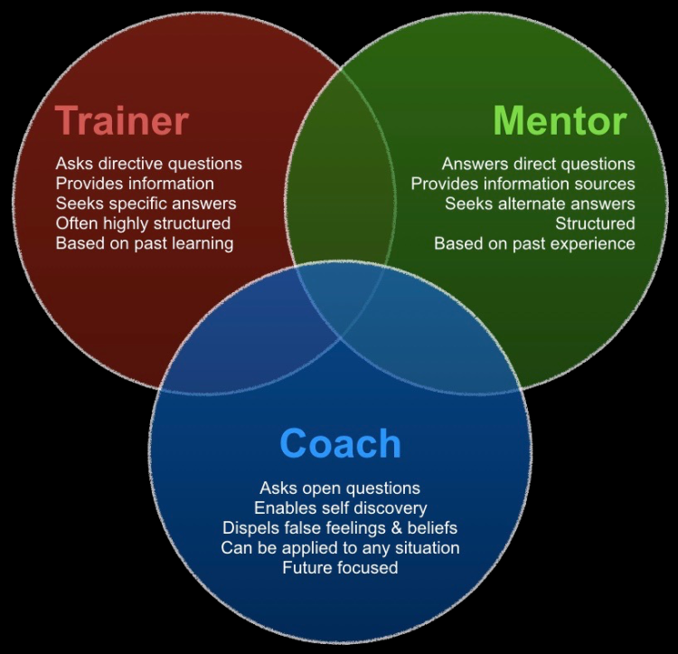

Appendix 2
Benefits of mentoring
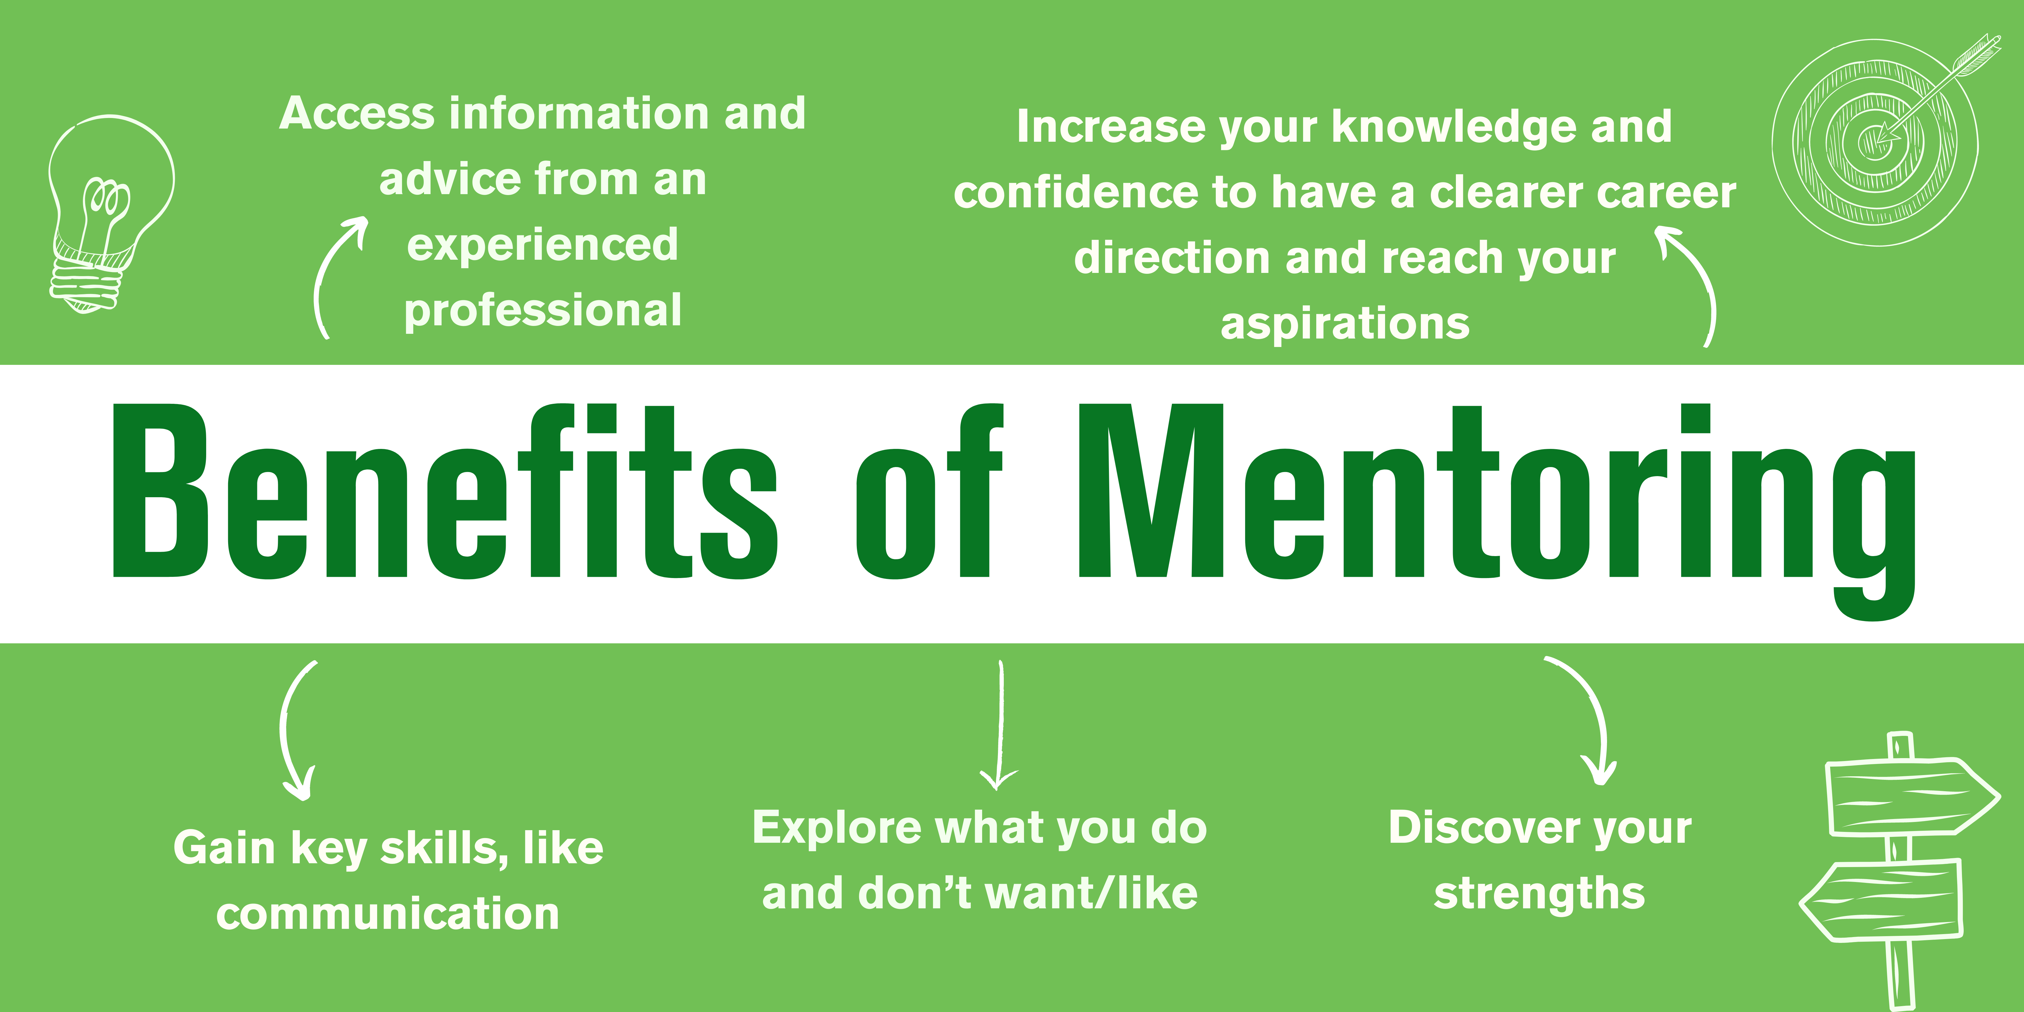

Appendix 3
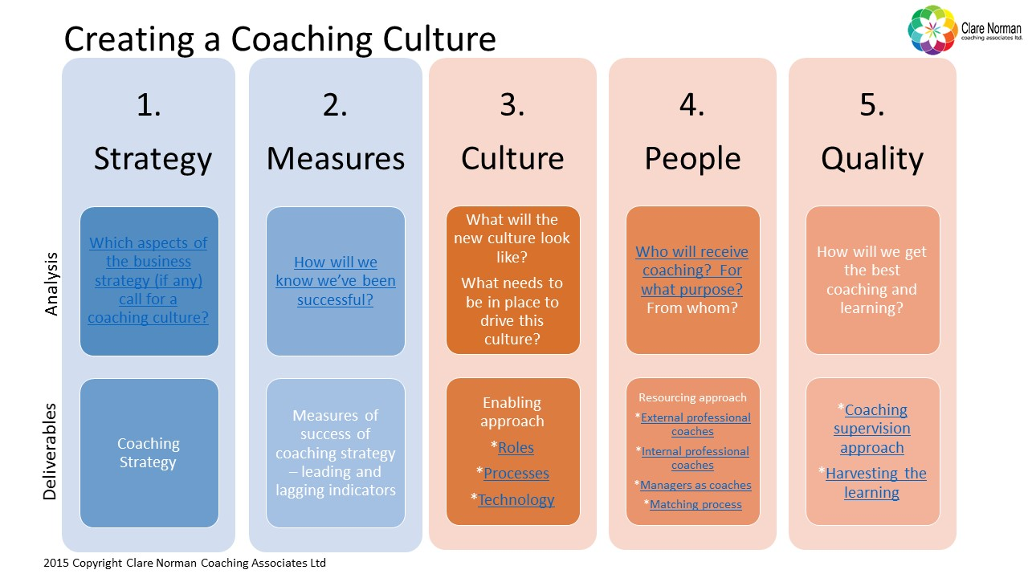

Appendix 4
SWOT and Grow models
Combining the SWOT analysis and GROW model can help individuals and organisations identify their strengths, weaknesses, opportunities, and threats and set achievable goals. The SWOT analysis comprehensively assesses the current situation, while the GROW model provides a clear framework for goal-setting and action planning.
Strength
Simplicity: The GROW model is a simple and easy-to-understand framework that anyone can use regardless of their background or level of experience. The four-step process is straightforward and can easily apply to various goals and situations.
Goal-oriented: The GROW model is specifically designed to help individuals or organisations set and achieve their goals. By following the framework, individuals or organisations can create specific, measurable, achievable, relevant, and time-bound (SMART) goals aligned with their vision and values.
Flexibility: The GROW model is a flexible framework that can be adapted to meet the needs of different individuals or organisations. The options step allows for creativity and exploration, and the way forward step encourages individuals or organisations to create an action plan that works for them.
Self-awareness: The reality step of the GROW model encourages individuals or organisations to reflect on their strengths, weaknesses, opportunities, and threats. This self-awareness helps individuals or organisations identify areas for improvement and create a more effective action plan.
Accountability: The GROW model encourages individuals or organisations to create a concrete action plan with specific deadlines and metrics for success. This accountability can help individuals or organisations stay motivated and on track towards achieving their goals.
Weakness
Limited scope: The GROW model is specifically designed to help individuals or organisations set and achieve their goals. While this is a critical component of personal and professional growth, the model may not be suitable for addressing more complex issues or challenges.
Lack of emphasis on context: The GROW model needs to emphasise the importance of context, such as the organisational culture or external factors that may impact the goal-setting process. This can limit the effectiveness of the model in certain situations.
Overemphasis on the individual: The GROW model significantly emphasises the individual or organisation being coached and may not consider the broader systemic issues or environmental factors that may impact their ability to achieve their goals.
Lack of structure in the options step: The options step in the GROW model can be very open-ended, making it challenging for individuals or organisations to generate creative solutions and strategies. This can limit the model's effectiveness in situations requiring more structured thinking.
Potential for rigidity: The GROW model can be very rigid in its approach, which may not be suitable for individuals or organisations that require more flexibility and adaptability in their goal-setting and action-planning processes.
Opportunity
Clarity: The GROW model can help individuals or organisations to gain clarity on their goals and how to achieve them. By setting specific, measurable, achievable, relevant, and time-bound (SMART) goals, individuals or organisations can develop a clear vision of what they want and how they will achieve it.
Creativity: The options step in the GROW model encourages individuals or organisations to be creative and explore different strategies to achieve their goals. This can help individuals or organisations identify and take advantage of new opportunities.
Collaboration: The GROW model can be used in a coaching context, which encourages collaboration between the coach and the individual or organisation being coached. This collaboration can help identify opportunities and develop strategies to exploit them.
Continuous Improvement: The GROW model is a continuous improvement tool that encourages individuals or organisations to reflect on their progress and adjust their strategies as needed. This allows individuals or organisations to adapt to changing circumstances and seize new opportunities.
Personal Development: The GROW model can be used for personal development, which can help individuals identify growth and development opportunities. By setting goals and working towards achieving them, individuals can develop new skills and knowledge that can help them to take advantage of new opportunities.
Threats
Lack of buy-in: Individuals or organisations must fully buy into the goal-setting process and be motivated to achieve their goals to maintain the GROW model's effectiveness. This can be mitigated by ensuring that individuals or organisations understand the model's benefits and are invested in the goal-setting process.
Lack of support: If individuals or organisations do not have the necessary resources or support to achieve their goals, the effectiveness of the GROW model can be limited. This can be mitigated by ensuring that individuals or organisations can access the resources and support they need to achieve their goals.
Inflexibility: The GROW model can be inflexible in its approach, which may not be suitable for individuals or organisations that require more flexibility in their goal-setting and action-planning processes. This can be mitigated by adapting the model to meet the needs of the individual or organisation being coached.
Cultural differences: The GROW model may not be suitable for individuals or organisations from different cultural backgrounds, as cultural differences can impact the goal-setting and action-planning process. This can be mitigated by being aware of cultural differences and adapting the model to meet the needs of the individual or organisation being coached.
Over-reliance on the model: While the GROW model is a valuable coaching tool, over-reliance on the model can limit creativity and the ability to adapt to changing circumstances. This can be mitigated by using the model as a starting point and adapting it to meet the unique needs of the individual or organisation being coached.

