Advanced Character Animation
ACCA5038
Rory Evans (2218702)

Model Research
Here are a few examples of 3D models that I researched for my project, first I wanted to go with a point of view camera position from inside the cockpit of the spacecraft for the animation. I then decided to go with a full view of the spacecrafts to be able to give both characters in the animation more depth and presence in the scenes.
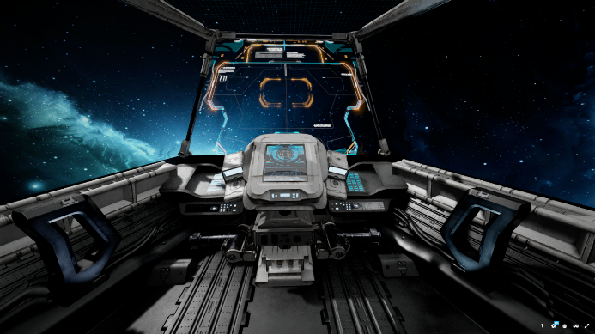
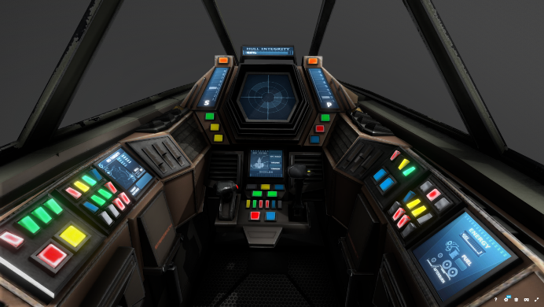
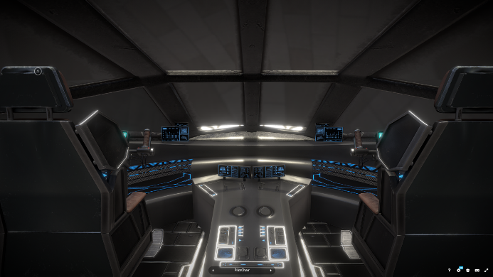
[3]
[3]
[2]
[1]
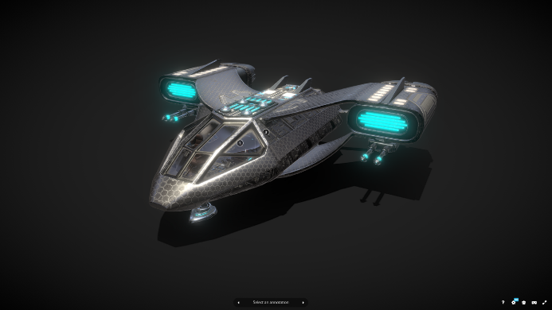
[5]
[4]
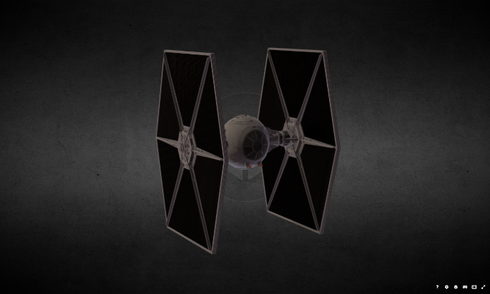
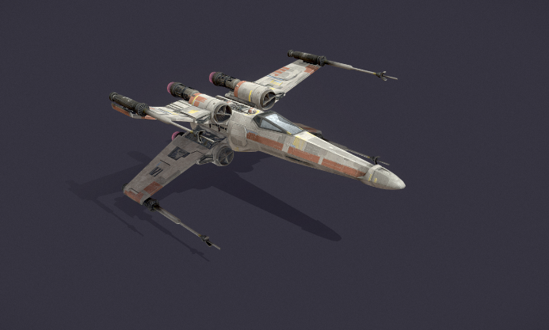

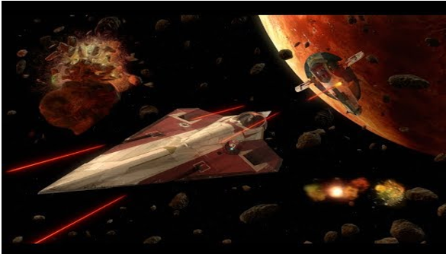
Scene Research
Star Wars: Attack of The Clones
Using inspiration from the film Star Wars Attack of The Clones on dynamic motion and action scenes. [6]

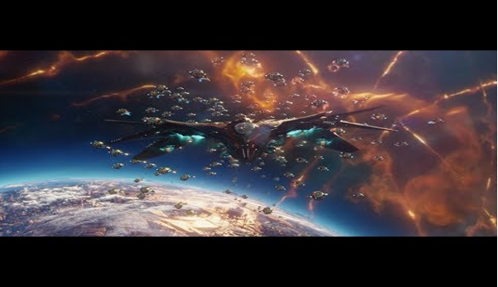
Guardians of the Galaxy Vol:2
I wanted to research similar genre of media of sci-fi and action material to compare the differences in theatre in similar scenes such as dogfights and space battles. [7]

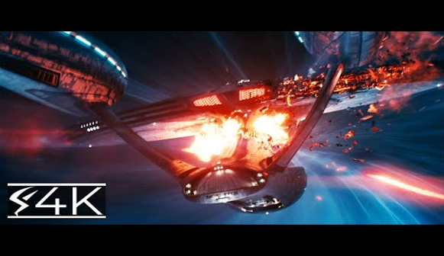
Star Trek: Into the Darkness
Using examples from star trek for visual examples of how to create impactful scenes and how effects might be used in this form of storytelling and animation/ FX. [8]
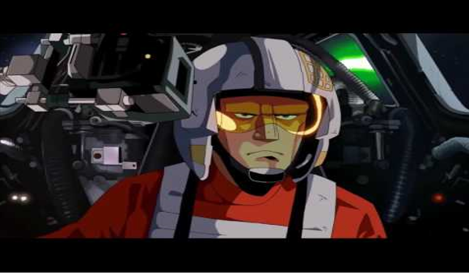

Tie Fighter Remastered: Star Wars Short Film
Other examples include the short 2D animated short film and how more independent fan films compare to the likes of blockbuster Hollywood films and what is to be expected. [9]

Star Wars Attack of the Clones - Obi-Wan VS Jango Fett (Dogfight over Geonosis) (1080p)
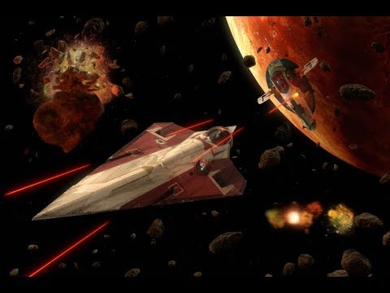
Vengeance VS Enterprise (4K) Star Trek
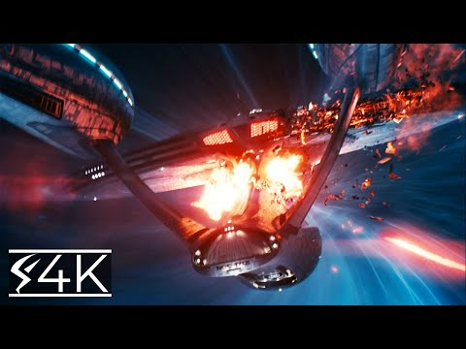

Guardians of the Galaxy Vol. 2 - Sovereign Fleet Chasing Thief
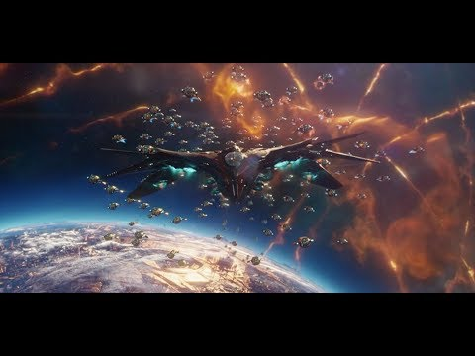
TIE Fighter Remastered - Star Wars Anime Short Film
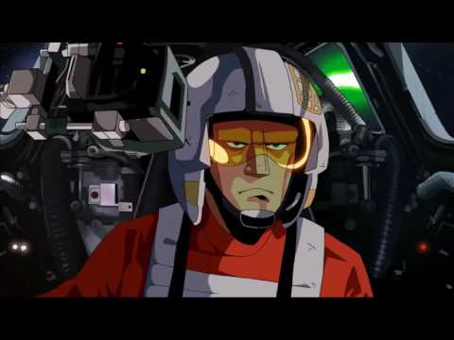

Storyboarding Research

Art 2 Animation: Taking the Leap | SPIDER-MAN: INTO THE SPIDER-VERSE [10]
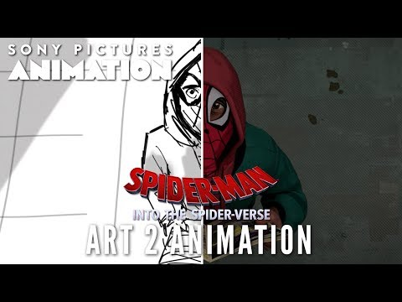
How to Make a Storyboard (ft. Star Wars) [11]
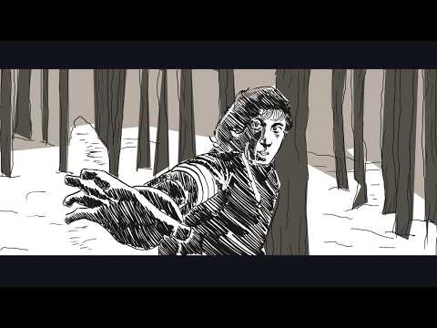
I chose to use storyboarding as a pre-production process because I enjoyed the concept of design behind each scene. This also opened up new ideas in filmmaking such as film making direction, include camera shots, scene set up and visual and sound design,

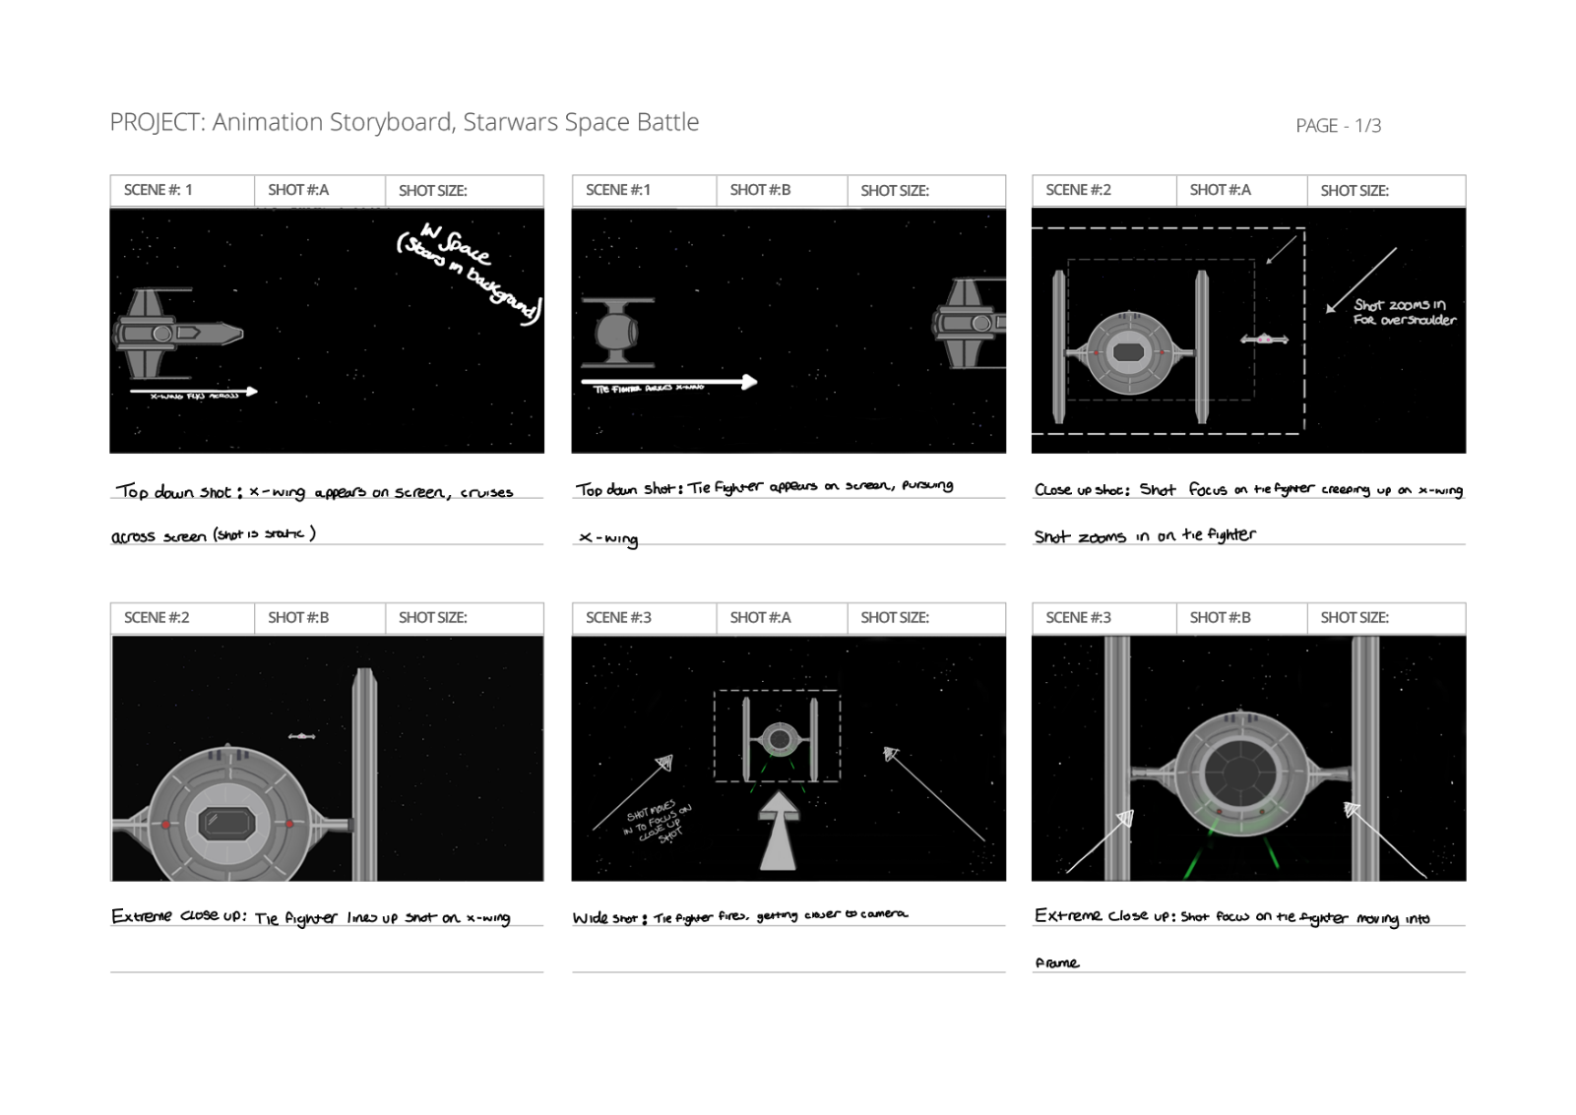
Storyboard Panels

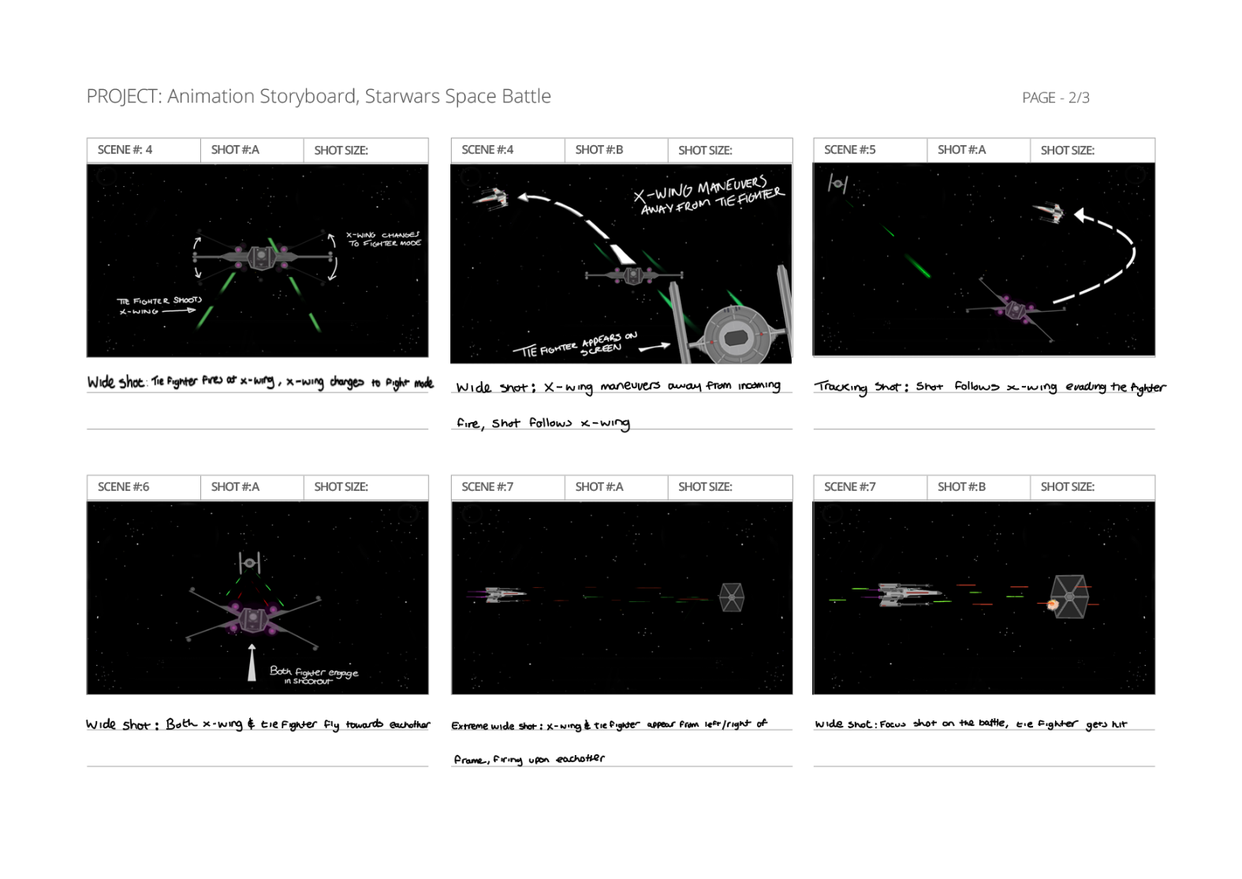

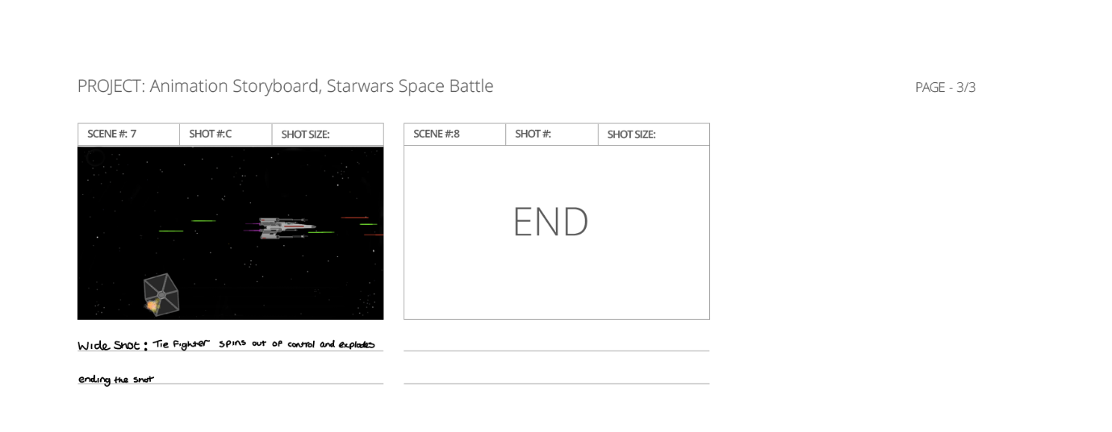

Above shows the beginning to end process of my storyboard process for my final animation, I used examples I observed from source material that I researched. Whilst completing the storyboard process I wanted to make sure that almost any individual would be able to understand or grasp the concept on the animation by including detailed annotations to the storyboard itself and in the notes below. I also included the type of camera shots I wanted to include in the animation.

Adobe aftereffects
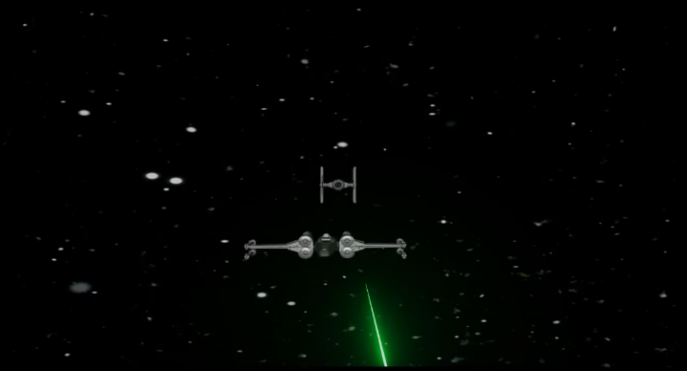
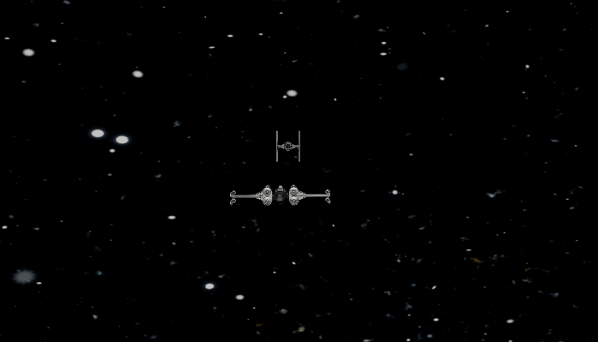

Above shows an example of adding in special effects to the scene, example shows the fighter now shooting lasers at the x-wing in the scene giving it a more authentic feel to the genre.
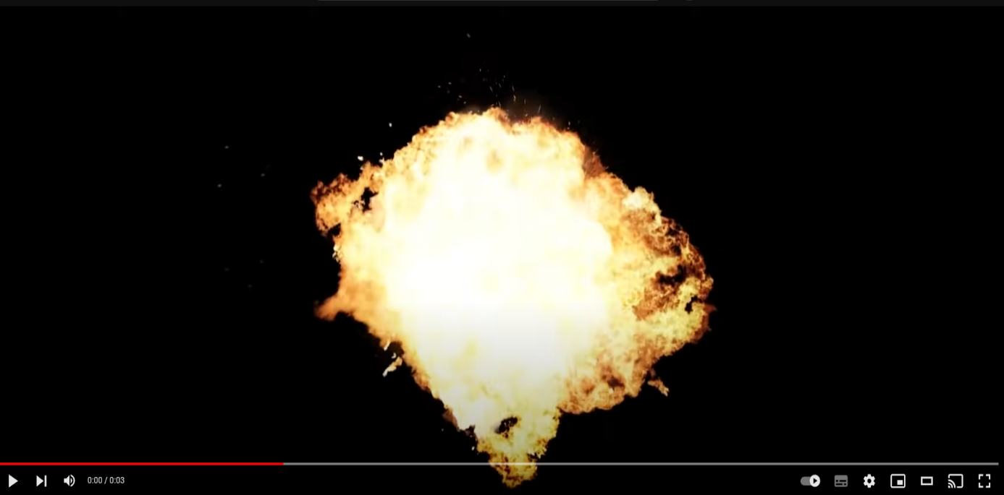
I also decided to add in the explosion effect for the finale to the scene, I sourced the explosion from a video online and then added the video to the main composition.

Final Animation Link
https://youtu.be/PMgx4PF6wnk
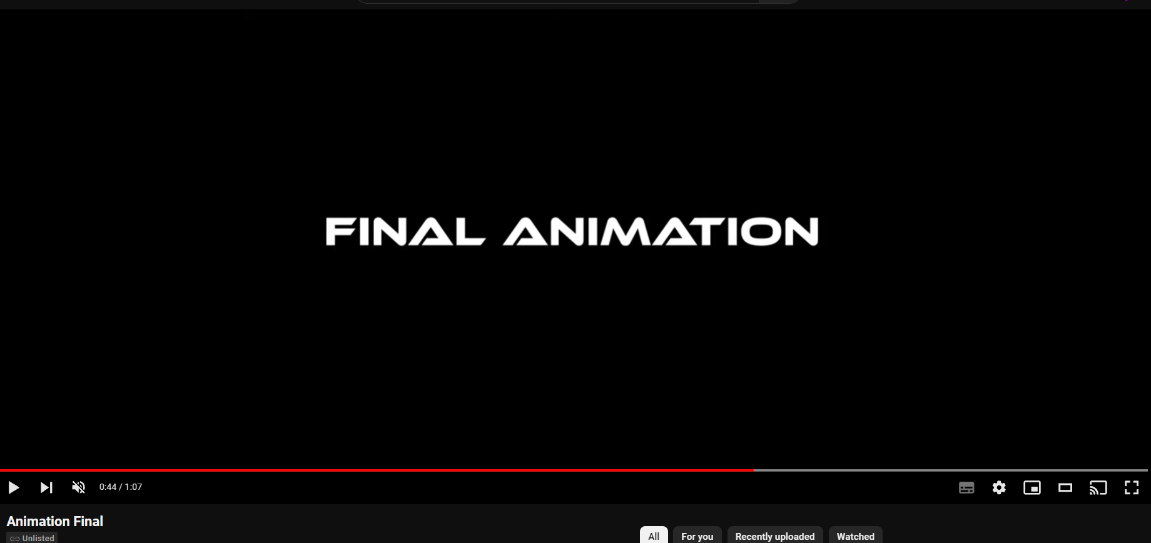

The above video includes the pre-production use of the storyboard for the final animation, followed by the final animation project.
To summarise my project, I really enjoyed the storyboarding process throughout, creating and designing the set and scene for my project animation. I would probably reduce the level of detail and time spent on the storyboard to be more efficient. I do feel that if I would have done this I would have been able to focus more on the final animation and get it to a better quality of animation but if feel the process has been a good learning curve.
The animation process was difficult at times when trying to be consistent with the storyboard, I do feel that the animation benefited from the storyboard process to give myself a good concept of what I wanted to achieve for my animation. I also really enjoyed learning adobe after effects and premiere pro for the first time and implementing VFX and SFX into my animation.

References
[1] ShaunTWilliams, “Sci-Fi Space Fighter cockpit - interceptor mk3 - buy royalty free 3D model by ShaunTWilliams,” Sketchfab, https://sketchfab.com/3d-models/sci-fi-space-fighter-cockpit-interceptor-mk3-0f7ee6f1f42d42218755c1f3558d729a.
[2] Cheboksary, “Spaceship Cockpit V1 Lowpoly PBR - 3D model by Cheboksary,” Sketchfab, https://sketchfab.com/3d-models/spaceship-cockpit-v1-lowpoly-pbr-676e71276cbc4615aaf0f9f7c3728460.
[3] D. Arts, “Spaceship with cockpit, interior and bonus - buy Royalty Free 3D model by Demonic Arts (@Jesterz86),” Sketchfab, https://sketchfab.com/3d-models/spaceship-with-cockpit-interior-and-bonus-de68d5cb9ae04722acdb054e75460293.
[4] chris_warstat, “X-wing - download free 3D model by chris_warstat,” Sketchfab, https://sketchfab.com/3d-models/x-wing-a185c8bb6e9d43e4b597b856b176d768.
[5] Daniel, “Star wars: Tie/LN fighter - download free 3D model by Daniel (@DanielAndersson),” Sketchfab, https://sketchfab.com/3d-models/star-wars-tieln-fighter-79d9403f15334c129ea5454daffe6b5c.
[6] “Star wars attack of the clones - obi-wan vs Jango Fett (dogfight over geonosis) (1080p),” YouTube, https://www.youtube.com/watch?v=4cejt0-UtOU.
[7] “Guardians of the galaxy vol. 2 - sovereign fleet chasing thief,” YouTube, https://www.youtube.com/watch?v=5ROiWmnWJHw.
[8] “Vengeance vs enterprise (4K) star trek,” YouTube, https://www.youtube.com/watch?v=35ob8NeUbQ4.
[9] “TIE fighter remastered - star wars anime short film,” YouTube, https://www.youtube.com/watch?v=E9GRYa_3gno.
[10] “Art 2 animation: Taking the leap | spider-man: Into the spider-verse,” YouTube, https://www.youtube.com/watch?v=IHrZYk1Pi9k.
[11] “How to make a storyboard (ft. star wars),” YouTube, https://www.youtube.com/watch?v=238eypcdOzU.

Animation Video References
[1a] “Jump to lightspeed,” Soundboard.com - Create &amp; Download Free Soundboard, Sounds, Sound Effects, Mp3, and more, https://www.soundboard.com/sb/sound/963806.
[2a] “TIE fighter fire 2,” Soundboard.com - Create &amp; Download Free Soundboard, Sounds, Sound Effects, Mp3, and more, https://www.soundboard.com/sb/sound/963766.
[3a] “TIE fighter flyby 1,” Soundboard.com - Create &amp; Download Free Soundboard, Sounds, Sound Effects, Mp3, and more, https://www.soundboard.com/sb/sound/963768.
[4a] “TIE fighter fire 1,” Soundboard.com - Create &amp; Download Free Soundboard, Sounds, Sound Effects, Mp3, and more, https://www.soundboard.com/sb/sound/963765.
[5a] “X-wing flyby 1,” Soundboard.com - Create &amp; Download Free Soundboard, Sounds, Sound Effects, Mp3, and more, https://www.soundboard.com/sb/sound/963778.
[6a] “X-wing fire,” Soundboard.com - Create &amp; Download Free Soundboard, Sounds, Sound Effects, Mp3, and more, https://www.soundboard.com/sb/sound/963775.
[7a] “Music - asteroid chase,” Soundboard.com - Create &amp; Download Free Soundboard, Sounds, Sound Effects, Mp3, and more, https://www.soundboard.com/sb/sound/963810.
[8a] “Star wars sound effects,” Soundboard.com - Create &amp; Download Free Soundboard, Sounds, Sound Effects, Mp3, and more, https://www.soundboard.com/sb/starwarsfx.
[9a] “Big explosion effect video MP4 HD sound,” YouTube, https://www.youtube.com/watch?v=bhZs3ALdL7Y.
[10a] chris_warstat, “X-wing - download free 3D model by chris_warstat,” Sketchfab, https://sketchfab.com/3d-models/x-wing-a185c8bb6e9d43e4b597b856b176d768.
[11a] Daniel, “Star wars: Tie/LN fighter - download free 3D model by Daniel (@DanielAndersson),” Sketchfab, https://sketchfab.com/3d-models/star-wars-tieln-fighter-79d9403f15334c129ea5454daffe6b5c.

Bibliography
https://www.youtube.com/watch?v=OYjYhb87rwo
https://app.gumroad.com/d/2697473e833254c5569c65787f3b1bc5
https://www.youtube.com/watch?v=bhZs3ALdL7Y
https://www.youtube.com/watch?v=utjziKyfJu4
https://www.youtube.com/watch?v=NCnq1FnQlCk
https://www.youtube.com/watch?v=reSXGxkyr0k
https://www.soundboard.com/sb/starwarsfx
https://wave.video/convert/youtube-to-mp4-330
https://www.schoolofmotion.com/blog/mp4-after-effects
https://fonts.adobe.com/fonts/ethnocentric
https://sketchfab.com/3d-models/sci-fi-space-fighter-cockpit-interceptor-mk3-0f7ee6f1f42d42218755c1f3558d729a
https://sketchfab.com/3d-models/spaceship-cockpit-v1-lowpoly-pbr-676e71276cbc4615aaf0f9f7c3728460
https://sketchfab.com/3d-models/spaceship-with-cockpit-interior-and-bonus-de68d5cb9ae04722acdb054e75460293
https://sketchfab.com/3d-models/x-wing-a185c8bb6e9d43e4b597b856b176d768
https://sketchfab.com/3d-models/star-wars-tieln-fighter-79d9403f15334c129ea5454daffe6b5c
https://www.youtube.com/watch?v=4cejt0-UtOU
https://www.youtube.com/watch?v=35ob8NeUbQ4
https://www.youtube.com/watch?v=5ROiWmnWJHw
https://www.youtube.com/watch?v=E9GRYa_3gno
https://www.youtube.com/watch?v=IHrZYk1Pi9k
https://www.youtube.com/watch?v=238eypcdOzU
https://www.youtube.com/watch?v=jvotBtvsmgo&list=PL94k-7pGx3MChG4GxKemppvN2fjDA9uK3&index=10
https://www.youtube.com/watch?v=urAnFZBx7rE&list=PL94k-7pGx3MChG4GxKemppvN2fjDA9uK3&index=11

