In today’s society the gender debate is a huge conundrum, society as a whole identify themselves as male and female. But there is much confusion about gender with more people being aware of the choice to be who they feel they are psychologically.
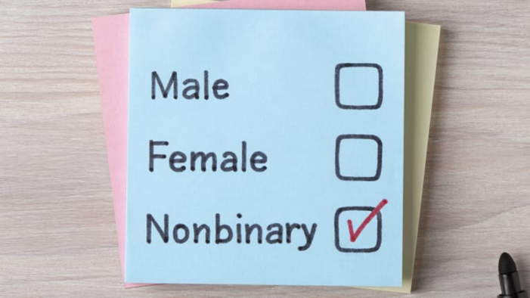
The gender debate
It has long since been decided that gender has two categories, either male or female (Cairney 2019). However, this doesn’t always match the identity of that person, although they may have been born male or female thus according to their genitalia, they may prefer to be identified as another gender or just no gender at all (Cairney 2019)
Image 2
One of the first questions a new-born parent is asked is ‘if the baby is a boy or girl’. Many feminists believe that gender is constructed and not individual. Hairstyles, clothes, hobbies even our names are decided by our parents. Allowing people to be characterized in society and culture in what is seen as the ‘norm’ (Cairney 2019).
The gender debate has become a ‘social norm’ but is there still a need to celebrate the differences of male and female as being different makes us human. Is it right that the gender we were born with be questioned? There is often a feeling that if somethings not broken then why try to fix it, questioning the effect being raised gender neutral would have on the child (Roberts 2017).
Most toys are stereotypically male or female, designed to appeal to both sexes. Feminine toys relating to beauty and nurture, while action and construction are more masculine (Blakemore &Centers 2005). Many believe that children’s gender socialisation can be determined by the toys that they are encouraged to play with (Kallmayer et al 2018). Kallimayer (2018) also describes boys’ characteristics as being more independent or forceful, while girls are more kind and helpful, this offers an explanation for different roles and interests. It can be believed that children will gradually internalize these social norms that correspond with their biological sex (Statham 1986).
Graham (2007) describes the changes to social structure and family life as challenging, giving way for people to self-fashion their lives by being able to express their individuality.
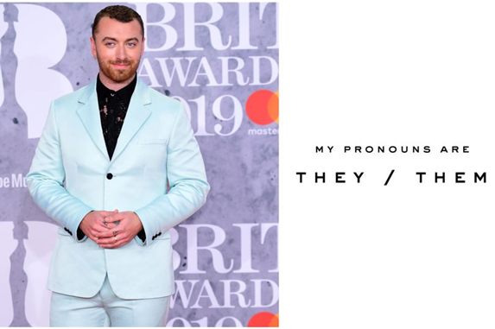
Much of the changes to society are highlighted by celebrities such as British artist Sam Smith. Sam Smith has won numerus awards for best Male artist, however, recently he has decided he is now gender neutral or non-binary, and would also prefer to be referred to as they or them pronouns instead of he or him (BBC news 2019)
Image 3
Transgender equality (2018) define non-binary as ‘people who don’t identify with any gender’ so are neither male nor female. Those who identify as non-binary are often described as ‘being confused’, or a fad, However, it has been perfectly acceptable in many different countries and cultures for over hundreds of years (transgender equality,2018). Although there is often a lack of knowledge in how to support and respect someone’s decisions to be referred to as non-binary (transquallity.org).
The Law
Under the Equality Act (2010), ‘a person has the protected characteristic of gender reassignment if the person is proposing to undergo or has undergone a process (or part process) for the purpose of reassigning the person’s sex by changing phycological or other attributes of sex’. It would appear that there is no protection for those who identify as non-binary under this act, unless they have had some kind of medical procedure. There is also no clear indication that it could be included as other ‘attributes of sex’ as this would possibly still refer to male or female (The Equality Act 2010). The Gender recognition act (2004) describes the legal requirements Identified in the context of the gender of their choice. This gives relevant information on all aspects of a person’s life, and the recognition of their acquired gender, with the issue of a new birth certificate, social security number and pension benefits (the gender recognition act 2004). There is currently a consultation in government presented to parliament in 2018, although there is provision for transgender under the gender requisition act (2004). Those choosing to identify as non-binary are not specified. However, this consultation requests the government make the existing process better, with more emphasis and clarification for those choosing to identify as non-binary (laura link).
Image 4

Case study ‘From the view of a parent’
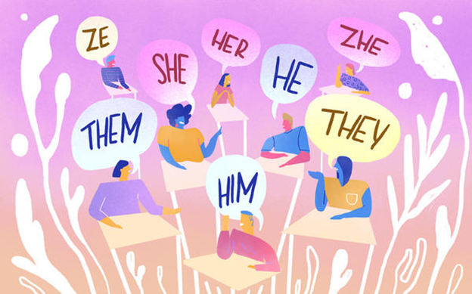
Susan Knoppow is an American parent to a non-binary child tells us of the heartache she feels at the loss of her daughter, and how hard it has been to adjust to using new pronouns. She explains how difficult it has been with friends and family who have often refused to accept the change and have continued to dismiss their feeling on order to protect their own (Knoppow, 2018).
Case study, ‘The silence will fall, not me’
Morgana (2018) explains their fear of living with the silent harassment they endure from choosing to be different. Having to deal with the muttering and dirty looks due to other people’s ignorance, causes them to question their choices Affecting their confidence and leaving them feeling victimized (Morgana, 2018).
The Theory
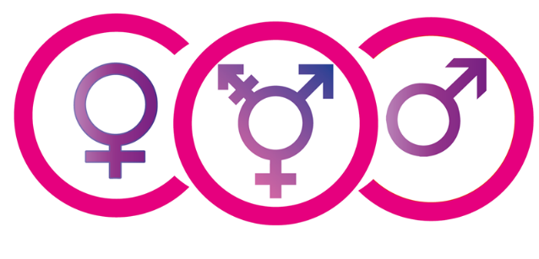
Erik Erikson developed a theory on personality and development, this contained 8 stages of child development. Stage 5 ‘identity verses role confusion considers how an adolescent child becomes aware of their ‘identity’ and a ‘sense of self’, developing a feeling of who they are. Verses those who struggle to find their ‘identity’ remain confused, and struggle to find who they are (Mcleod,2018). However, Freud’s theory explains the stages as psychosexual development, ‘the genital stage’. Where adolescents become sexually aware and need to form romantic relationships, while suggesting that they become attracted to the opposite sex (Mcleod,2019).
Image 5
The future
If your child is questioning their gender, here are some points to consider
- Support your child – Rejection or negativity can have an effect on how your child seeks support.
- Be fully informed – find out what services and support is available.
- Communicate – be approachable and stay open-minded, they are still your child.
- Patience – it takes time, but they will come to you eventually.
- Feeling confused – being anxious and feeling a sense of loss is only natural.
- Follow their lead – How do they want to be addressed? Listen and try to make an effort.
- Be aware – Look for signs of depression and seek support when needed.
- Respect – Its ok to not be ok but respect their decisions.
(Young minds 2018)
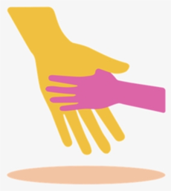

Image 6

Is your child
Questioning their gender?
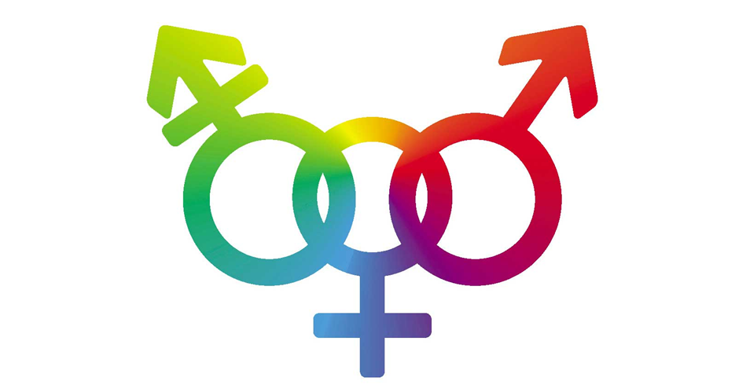
Image 1

Rationale
This leaflet has been designed with both parent and child in mind, it has considered some of the effects of growing up in a regular home, either male or female has on a child. Interestingly looking at how the names we give our children and the toys we buy can have such an influence on how they grow up and see themselves. This leaflet also looks at the argument of why change something that doesn’t need changing, and what affect being non-binary has on our children and those around us. While considering how young minds can be influenced by celebrities and those they admire.
The law section explains that much uncertainty for people who chose to change their identity, there is little security for them under the Equality act (2010). however, it is positive to see that there are wheels in motion to improve the rights of those choosing to identify non-binary under the Gender recognition act (2004).
It is interesting to see the compassion from a parent of a non-binary child, and a non -binary person, showing how one person can support a loved one, while the other lives in fear for being different. While considering the theory that describes the child’s development it is interesting to see that although it doesn’t directly address the subject of non – binary it is still relevant and offers an explanation onto how an adolescent child could feel. The points added at the end offer some clarity on how to address the issue should it arise, helping parents to think about how their child feels, and giving them the tools to show compassion and understanding.

References
Graham, H. (2007) Unequal lives. Croydon: CPI group.
Cairney, C. (2019) Feminism is. London: Penguin Random House
Kollmayer, M. Schultes, MT. Schober, B. (2018) Sex roles. 79:329. Available at: https://doi-org.ezproxy.uwtsd.ac.uk/10.1007/511199-017-0882-4 (accessed on 28 October 2019).
BBC news, (2019) ‘A brief history of gender-neutral pronouns’ 22 September 2019. BBC News[online]. Available at: https://www.bbc.co.uk/news/newsbeat-49754930 (accessed on 6 October 2019).
National centre for transgender equality. (2018). ‘Understanding Non-Binary people: How to be respectfull and supportive’ 5 October 2018. Transgender equality [online]. Available at: https://transequality.org/issues/resources/understanding-non-binary-people-how-to-be-respectful-and-supportive (Accessed on 8 November 2018)
Knoppow, S. (2018) ‘I am the parent of a Non-binary child’, 31 May 2018. Detroit free press [online]. Available at: https://eu.freep.com/story/opinion/contributors/2018/05/31/non-binary-gender-meaning/579154002/ (accessed on 8 November 2019).
Roberts, L. (2017) ‘Stop the sexual politicisation of childhood. We have gone too far’ 27 July 2017. The Daily Telegraph [online]. Available at: https://www.dailytelegraph.com.au/rendezview/stop-the-sexual-politicisation-of-childhood-we-have-gone-too-far/news-story/2025d0b4b57d76a145798fc2fbe2ce49 (accessed on 9 November 2019).
Statham, J. (1986) Daughters and Sons: Experiences of Non-Sexist Child raising. Oxford: Blackwell.
The Equality Act 2010, 7.1 Available at: http://www.legislation.gov.uk/ukpga/2010/15/section/7 (Accessed on 18 November 2019).
Mc Leod, S. (2018) ‘Erik Erikson’s stages of psychosexual development’ 2018. Simply Psychology [online]. Available at: https://www.simplypsychology.org/Erik-Erikson.html?fbclid=IwAR153UKQKLcesOhyCGo-AO6EMV7F6PNZ-lpaEbbYPWkWS7Ba2RHNYvQ-G8 (Accessed on 18 November 2019).
Leod, S. (2019) ‘Freud’s psychosexual stages of development’2019. Simply Psychology [online]. Available at: https://www.simplypsychology.org/psychosexual.html (Accessed on 18 November 2019).
Morgana, R. (2018) ‘The silence will fall, not me’ 29 January 2019. Beyond the Binary [online]. Available at: http://beyondthebinary.co.uk/silence-will-fall-not/ (Accessed on 18 November 2019).

Images
Image .1 Available at: https://equallywed.com/wp-content/uploads/2018/11/gender-your-guide-dating-a-nonbinary-person-featured-image.jpg (Accessed on 18november2019).
Image 2. Available at: https://cdn.shrm.org/image/upload/c_crop%2ch_3086%2cw_5491%2cx_0%2cy_347/c_fit%2cf_auto%2cq_auto%2cw_767/v1/Legal%20and%20Compliance/nonbinary_bwdtot?databtoa=eyIxNng5Ijp7IngiOjAsInkiOjM0NywieDIiOjU0OTEsInkyIjozNDMzLCJ3Ijo1NDkxLCJoIjozMDg2fX0%3d (Accessed on 18 November 2019).
Image 3. Available at: https://i2-prod.manchestereveningnews.co.uk/incoming/article16925015.ece/ALTERNATES/s810/0_BeFunky-collage-5.jpg (Accessed on 18 November 2019).
Image 4. Available at: https://mediad.publicbroadcasting.net/p/shared/npr/styles/placed_wide/nprshared/201908/748727079.jpg (Accessed on 10 November 2019).
Image 5. Available at: http://1077thejewel.com/wp-content/uploads/gender-Neutral-symbol-with-back-01.png (Accessed on 10 November 2019).
Image 6. Available at: https://www.clipartkey.com/search/parent-and-child-holding-hands/ (Accessed on 10November 2019).

