Digital Skills and Research Methods
The impact of Virtual Learning Environment (VLE) – Moodle on students’ learning experience

Student Name: Inna Zabulica
Student ID: 2134089

Table of Contents

Introduction 1
Background of the Research 2
Objectives of the Research 3
Literature Review 4
Methodology 6
Primary Data 8
Secondary Data 11
Conclusion 12
Recommendations 13
References 14

Introduction
Virtual learning environments, often known as VLEs, are currently seeing widespread use across the education industry. Their primary functions include the distribution of curricular content and the facilitation of communication. A Virtual Learning Environment, sometimes known as VLE for short, is a piece of software that runs on the internet and is designed to make teaching and learning easier by utilising various tools and activities. Students who are utilising a VLE have the capability of being assigned a "task" to accomplish in the classroom or at their preferred speed, time, and location. Additionally, they can participate in online and offline dialogues that will assist them in developing their learning (Annansingh, 2019.). This research will collect both primary and secondary research data for concluding the impact of the VLE on students' learning experiences. The excel table as well as the graphs generated from the data is also provided from the survey. Finally, inferences from the data will be drawn from the statistical analysis conducted here. This research provides an overview of the perspectives of students about the usage of the VLE as well as its influence on their education, and from these findings, there are suggestions for instructors and educator preparation programmes.

The impact of Virtual Learning Environment (VLE) – Moodle on students’ learning experience

Background of the Research
The term "Virtual Learning Environment" (VLE) refers to a collection of education and studying strategies that have been compiled to enhance the educational process of even an individual learner through the use of personal computers across academic tasks as well as the digital environment. There is actual data to show that using a Virtual Learning Environment (VLE) affects student success, supports autonomous learning, and boosts students' enthusiasm to study (Rienties and Toetenel, 2016). There seems to be easy access to a range of commercial editions of VLE programmes, including Whiteboard, Online lessons, Lotus Learning Space, and COSE, amongst others. The important components of an online educational system include syllabus classification which is the process of splintering the syllabus into sections that can be assigned and assessed, student tracking, online aid from both the teacher and the user, e-mail, looped forums, chat, web broadcasting, and internet access to exterior syllabus tools. VLE user groups may be distinguished by using something particular, such as a teacher ID or a learner ID, for example (Parsons, 2017). Anything a learner chooses to accept is understood by the teacher; nevertheless, the instructor has expanded access rights, allowing them to develop or modify material based on the curriculum and evaluate the quality of teaching and learning.
Students who put in the effort to better themselves as learners may discover that interactive classrooms are among the numerous advantages of online education. Classes at such a normal school would be conducted at a certain time of day, and the schedule would be created according to the distribution of available subjects. If a person has a career and is also pursuing higher education, balancing the two might be challenging due to the limited availability of courses outside of normal working hours. Education may be costly, but online courses provide several cost-cutting options for their pupils(Annansingh, 2019). Not having to go to school buildings will help them save even more money on transportation costs. The average student spends over a thousand pounds a year on books and other educational resources. There is a significant saving on textbook costs with digital coursework because of the incorporation of virtual services.

Objectives of the Research
Many of the benefits of interactive learning in the classroom are more obvious than others. Assignments that encourage creativity have many positive outcomes. And rather than making them wait days, or even weeks, for feedback on their exam performance, students will now get these critiques immediately (Cassidy, 2016). Tutorial videos allow viewers to rewatch sections as many times as they need, while a traditional lecture leaves them at the mercy of their note-taking skills. Keeping these in mind, the objectives of the research are:
- To determine the impact of VLE on students.
- To determine the impact of VLE on independent learning.
- To evaluate the experience of using VLE.

Literature Review
According to Ryan and Poole (2019), Students are transitioned from being inactive to active learners via the use of virtual learning environments, often known as VLEs. Active learning encourages the development of critical thinking abilities, which are crucial for the successful application of information gained in the classroom in the clinical environment. A Virtual Learning Environment (VLE) is becoming an increasingly important part of clinical skill development across many different fields. The most important takeaways from this research indicate that virtual learning environments (VLEs) might play an important part in the education of children. Because virtual reality has been demonstrated to boost students' pleasure, engagement, and memory, there is a pressing need for the use of cutting-edge technology in the education of healthcare professionals (Waheed et al, 2020). Although it is not yet known whether or if virtual learning environments qualify pupils better than traditional didactic education does, these first findings are promising.
However, Lacka and Wong(2021) suggested that like traditional classroom education, online study will provide students with several opportunities for professional growth. However, students who attend school online have more opportunities for cross-cultural communication and for deepening their connections with other students. The following benefits of VLE are making it an increasingly important tool for the next generation of globalisation. As word spreads about its many advantages, its popularity soars. All schools benefit from the VLE's ability to keep operating throughout the COVID-19 situation. Also, in light of the current epidemic, educational institutions that have not yet adopted VLE are scrambling to create new support systems for their pupils. The findings of this study will shed light on how virtual learning environments (VLEs) affect the educational community as a whole and provide suggestions for improving the process. On the other hand, Herrera Mosquera(2017) pointed out some of the disadvantages associated with this system along with its advantages. According to the findings of the research, students report feeling excited and motivated about the usage of virtual learning environments (VLEs), and they advise that all instructors should certainly include VLEs in their courses. Students also realised that, even though they are a part of a digital era in which the usage of individual digital devices is ubiquitous, it might be difficult for them to cope with some forms of instructional technology. On the other hand, the data reveal that the ability of labs and computers, in addition to Internet access, continue to be the primary obstacles to the way of adopting VLE. Despite this, the students who were learning English as a foreign language found that their experience with technology-based learning was positive after the obstacles that were holding them back were removed.
According to Smith and Hewston(2015), When designing suitable courses for a Foundation Degree careful thought was given to the many ways in which the content would be delivered and evaluated. The usage of a Virtual Learning Environment (VLE) was included in this process, and several methods for the transmission of module material were investigated. Engaging in consultation led to the creation of a Problem-Based Learning (PBL) scenario, which was used in a module that investigated how schools serve students with extra needs. This module is taught at the primary higher education institution (HEI) as well as the partner institutions, and it has given the team the chance to consider the application of PBL and the utilization of the virtual learning environment (VLE), as well as assess the outcome and teaching strategies that are utilised. The instructional techniques that are used provide a challenge to the conventional instructional approaches, which in turn presents a challenge to the student's mental processes. Moodle and Blackboard have both been used in the process of designing this programme. This has allowed for a discussion of the various interfaces that each platform offers and how this influences the level of participation shown by students.

Methodology
A research methodology lays forth how we can conduct the study. A research technique is a methodical approach to answering a research question. Research methodology is the study of research methodology. Research methodology refers to the overall process taken by scientists when describing, understanding, and forecasting occurrences (Phungsuk et al., 2017). It can also be seen as the investigation of how information is gathered. The purpose is to provide a framework for future study. A well-executed research methodology aims to help researchers arrive at useful conclusions.
There is no dichotomy between quantitative and qualitative approaches to basic and practical research. Quantitative research focuses on numerical data. In this case, the process is expressed or described in parts. Analysis of this type focuses on the study of phenomena of a qualitative nature. It is non-numerical and descriptive. Logic and language are employed. Its purpose is to understand and characterise the context. The study of substance or structure involves using scales and measuring tools.
There is no way to quantify or evaluate a pattern. We can measure neither the results nor the factors of practice. On the other hand, we need to map a set of relationships to analyse patterns. Structures deal with numbers, while patterns shape attributes. We must conduct qualitative research to determine why particular statistics are random. It becomes quantitative when its goal is to investigate randomness by calculating central tendency, dispersion, and other statistical measures (Tan et al., 2021). In many social sciences, the dispute over the best way to do research, quantitative or qualitative, has been raging for some time. Researchers take a wide range of stances, from viewing the two approaches as inherently incompatible since they are grounded in opposed worldviews to those who find no problem combining the two in their work (Mosquera, 2017). Different ontological and epistemological concerns and positivism, interpretivism, and critical perspectives must be considered while examining the differences between qualitative and quantitative research methods.
Three primary research questions have been constructed keeping the research objectives in mind. Multiple direct questions have been constructed for each research question. The primary research questions are described below.
RQ1: Did the VLE have a significant impact on the students?
RQ2: Did the VLE have a significant impact on students’ independent learning?
RQ3: Is the experience of using the VLE positively significant?

Primary Data
Primary data refers to first-hand data collected from a survey. The survey was completed by students who have used Moodle as their virtual learning environment. One hundred responses were collected for primary data.
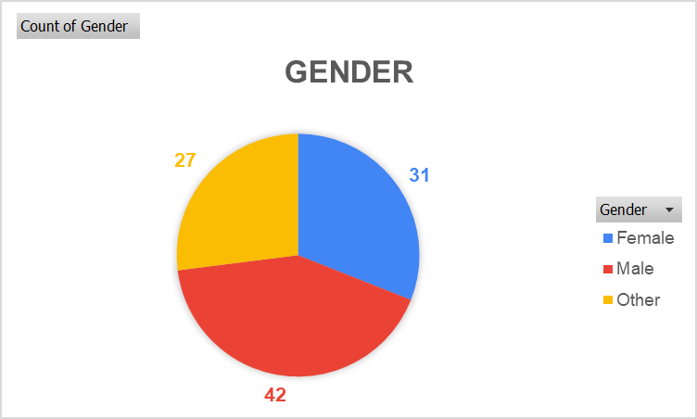
Figure: The gender demographic data of the respondents. Source: (Self-made)
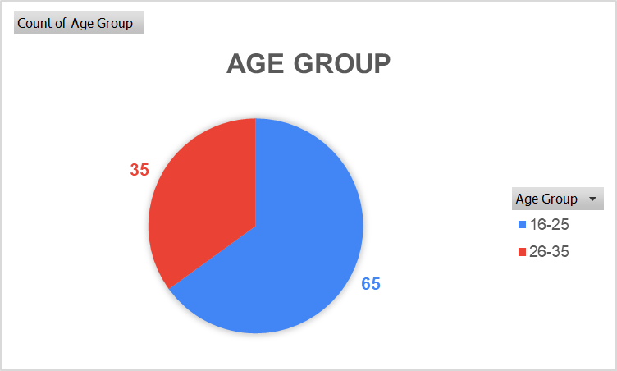
Figure: The age demographics data of the respondents. Source: (Self-made)
The respondents belonged to males, females and others. The respondents belonged to either the age group of 16-25 or 26-35. The three research questions were supported by multiple direct questions in the survey. Based on the responses, findings about the three research questions were found.
Research Question 1
There were three direct questions under research question 1. The first question asked whether VLE provided the opportunity for independent learning. The second question asked whether the VLE proved to be a valuable asset to students’ learning. The third question asked whether the student felt that the VLE had a positive impact on their learning.
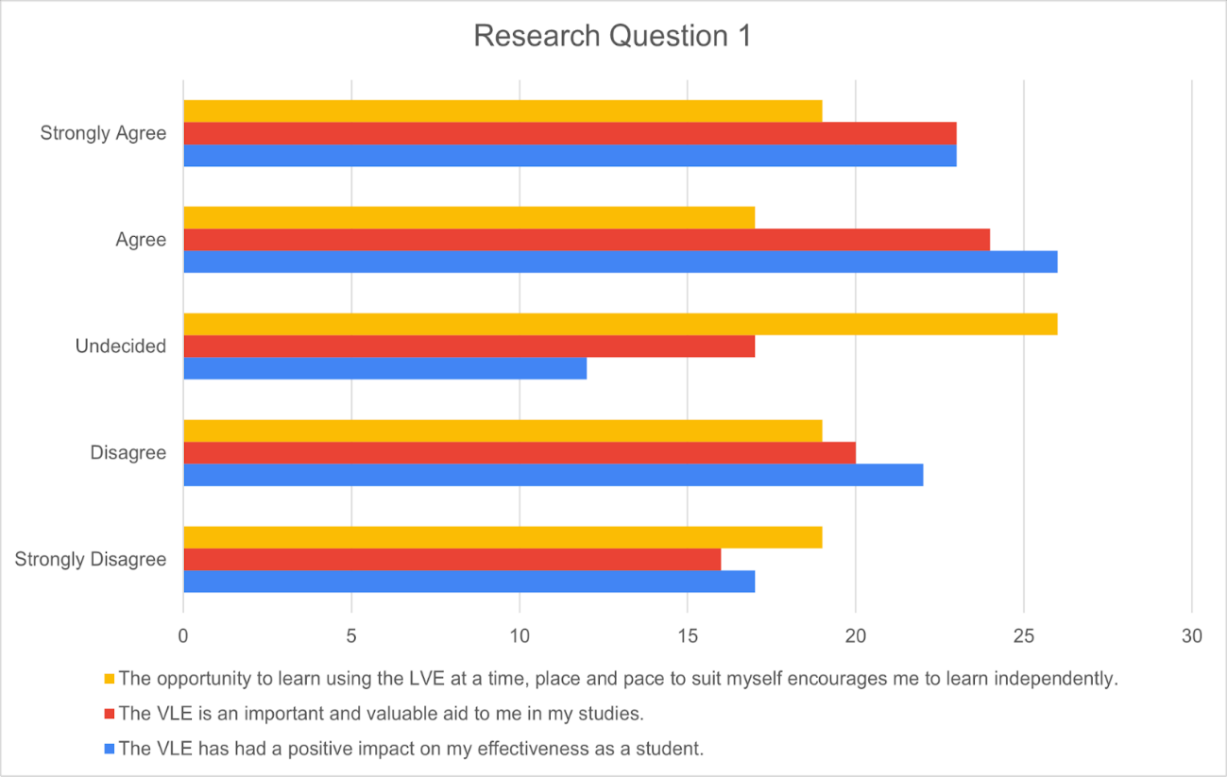
Figure: Summary of the First Research Question. Source: (Self-made)
From the graphical representation, we can see that the three questions mostly generated positive answers. Most of the students have either responded positively or neutrally. As such, it can be concluded that the VLE has a significant impact on the student.
Research Question 2
The second research question also had three direct questions. The first question asked whether VLE motivated students to communicate.
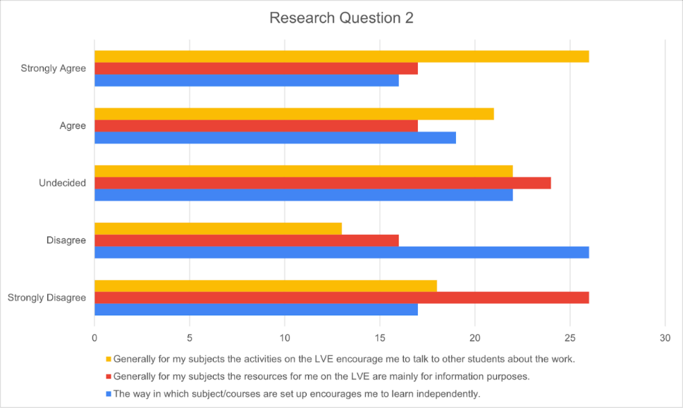
Figure: Summary of the Second Research Question. Source: (Self-made
Research Question 3
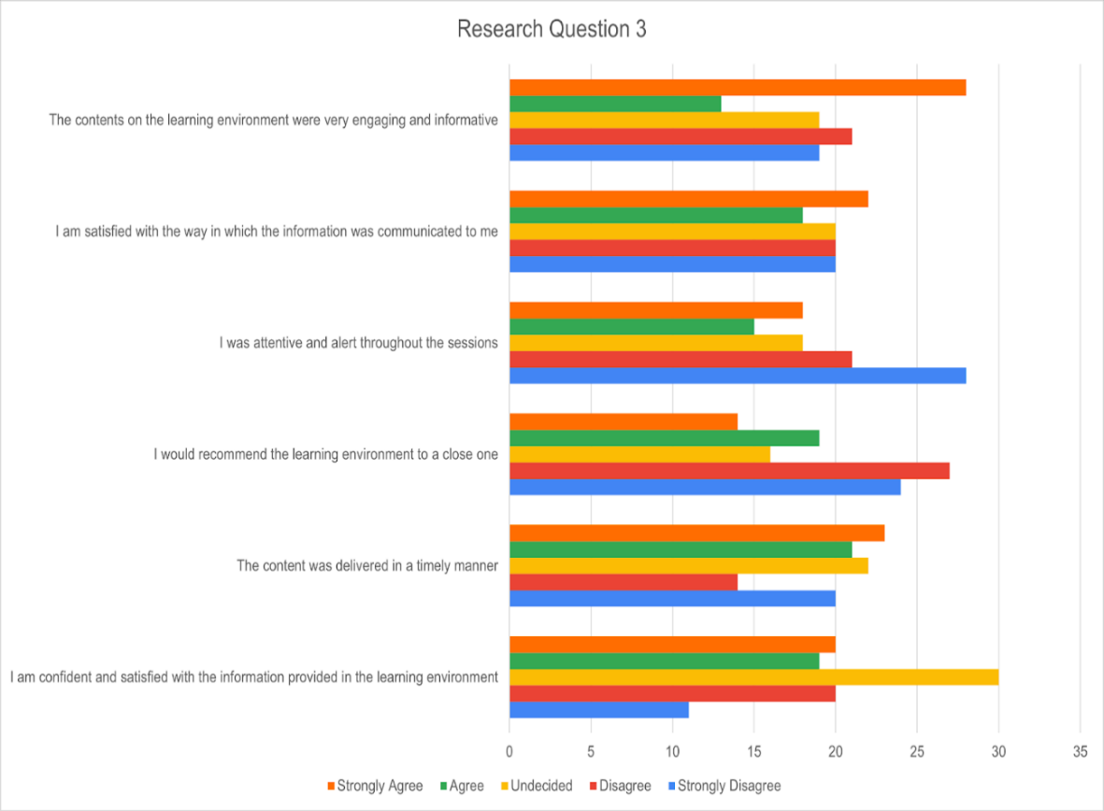
Figure: Summary of the Third Research Question. Source: (Self-made)

Secondary Data
The learners appreciate the advantages of a VLE and find the tools they employ to be simple and effective. It is no surprise that digital materials are more popular among students than textbooks nowadays. Students' perceptions of their digital competence were influenced by the fact that they were exposed to educational technology rather than the technology they use daily (Mohd Yusop et al., 2018). The students afterwards realised that their teacher's knowledge of technology was not as low as they had thought. It was discovered that using a VLE allows for differentiated instruction, which is the opportunity for teachers to proactively modify curricula, teaching methods, resources, learning activities, and student products to address the diverse needs of individual students and small groups of students to optimise the learning opportunity for all students in a classroom. When asked about their feelings toward using a VLE in class, most students reported feeling both encouraged and excited (Hlosta et al., 2018). Students' performance on assignments improved, and their self-assurance grew as they used a VLE, and the latter facilitated their progress in learning a new language. Students' engagement and behaviour in class improved; they stayed on track for the most part and made more contextual connections between previously learned material. Students have found that these activities are beneficial in fostering the growth of independent learning and productive dialogue between educators and their pupils (Odrekhivskyy et al., 2019). Students were eager to share what they had learned with others and generally had a positive experience using the VLE despite some technical issues. A minority of pupils still have trouble mastering curriculum-based software that calls for skills beyond those typically employed with personal electronic devices (Bogusevschi et al., 2020). Despite the drawbacks mentioned above, students found that utilising a VLE reduced their stress levels when studying.

Conclusion
Learners recognise the value of a VLE and find success in using the resources provided. It is hardly shocking that pupils choose digital resources over textbooks. The fact that students were exposed to instructional technology, rather than the technology they use on a day-to-day basis, affected their estimations of their digital ability. After more reflection, the students concluded that their instructor's familiarity with modern technologies was not as limited as they had first assumed. It demonstrates that the majority of students feel that the main value of virtual learning environments is the knowledge it provides. Most students think virtual learning environments (VLEs) are fun and useful. It has also been noted that some pupils seem to be paying too little attention in class.

Recommendations
- Proper steps should be taken to ensure that the students are being attentive during the session.
- The sessions should be focused more on independent learning.

References
Aluja-Banet, T., Sancho, M.-R. and Vukic, I., 2019. Measuring motivation from the virtual learning environment in secondary education. Journal of Computational Science, 36, p.100629.
Annansingh, F., 2019. Mind the gap: Cognitive active learning in virtual learning environment perception of instructors and students. Education and Information Technologies, 24(6), pp.3669-3688.
Bogusevschi, D., Muntean, C. and Muntean, G.-M., 2020. Teaching and learning physics using 3D virtual learning environment: A case study of combined virtual reality and virtual laboratory in secondary school. Journal of Computers in Mathematics and Science Teaching, 39(1), pp.5–18.
Cassidy, S.F., 2016. Virtual learning environments as mediating factors in student satisfaction with teaching and learning in higher education. Journal of Curriculum and Teaching, 5(1), pp.113-123.
Herrera Mosquera, L., 2017. Impact of implementing a virtual learning environment (VLE) in the EFL classroom. Íkala, revista de lenguaje y cultura, 22(3), pp.479-498.
Hlosta, M., Herrmannova, D., Vachova, L., Kuzilek, J., Zdrahal, Z. and Wolff, A., 2018. Modelling student online behaviour in a virtual learning environment. arXiv preprint arXiv:1811.06369.
Lacka, E. and Wong, T.C., 2021. Examining the impact of digital technologies on students’ higher education outcomes: the case of the virtual learning environment and social media. Studies in Higher Education, 46(8), pp.1621-1634.
Mohd Yusop, M.Y., Ramli, M., MN Mansor, Abd Samad, F.I., Saad, K., Hamid, S. and Mukhtar, Z., 2018. Impact of Virtual Learning Environment (VLE): A Case Study on Students Academic Performance by Subject. Journal of e-Learning & Higher Education, 9, p.1.
Odrekhivskyy, M., Pasichnyk, V., Rzheuskyi, A., Andrunyk, V., Nazaruk, M., Kunanets, O. and Tabachyshyn, D., 2019. Problems of the Intelligent Virtual Learning Environment Development. In: MoMLeT. pp.359–369.
Parsons, A., 2017. Accessibility and use of VLEs by students in further education. Research in Post-Compulsory Education, 22(2), pp.271-288.
Phungsuk, R., Viriyavejakul, C. and Ratanaolarn, T., 2017. Development of a problem-based learning model via a virtual learning environment. Kasetsart Journal of Social Sciences, 38(3), pp.297–306.
Rienties, B. and Toetenel, L., 2016. The impact of learning design on student behaviour, satisfaction and performance: A cross-institutional comparison across 151 modules. Computers in Human Behavior, 60, pp.333-341.
Ryan, E. and Poole, C., 2019. Impact of virtual learning environment on students’ satisfaction, engagement, recall, and retention. Journal of medical imaging and radiation sciences, 50(3), pp.408-415.
Smith, S. and Hewston, R., 2015. Using Problem-Based Learning (PBL) and a VLE to Promote Independent Learning.
Tan, K.H., Chan, P.P. and Mohd Said, N.-E., 2021. Higher education students’ online instruction perceptions: A quality virtual learning environment. Sustainability, 13(19), p.10840.
Waheed, H., Hassan, S.U., Aljohani, N.R., Hardman, J., Alelyani, S. and Nawaz, R., 2020. Predicting academic performance of students from VLE big data using deep learning models. Computers in Human behavior, 104, p.106189.

