University of Wales Trinity Saint David
School of Engineering

Discussion about the relationship between FE analysis and physical testing

Course: Mechanical Engineering
Student Name: HE XINXIN
Student number :1904657
Degree: Undergraduate level 6
Module: Advanced Stress Analysis & FEA (M6X00420)
Abstract

The development of computer technology make it more convenient and economic to analysis the products by using finite element analysis software in computer rather than doing physical testing with them. However, this does not necessarily mean that the FE analysis will replace the physical testing completely in the future. This report will discuss about the advantages for companies to use finite element analysis when they develop new products, the relationship between FE analysis and physical testing with a case study of modeling a superplastic process and finally the necessity of physical testing from different aspects.
In summary, finite element analysis is a powerful tool for companies to predict the behavior of products, but physical testing will also be necessary to verify the FE model and show some factors missed by FE model etc. Using these two methods properly can give a company the best result.
content

1 Why companies typically carryout FE analysis alongside physical testing. 1
1.1 FE analysis for New product developing 1
1.1 .1 Function of FE analysis to improve efficiency 1
1.1.2 Function of FE analysis to reduce the number of physical testing 1
1.1.3 The influences of FE analysis to engineers in the company 2
1.2 verifying the stress of a product 2
1.2.1 The function of FE analysis to predict the performance 2
1.2.2 The function of FE analysis compare with physical testing 2
1.2.3 The function of FE analysis in some special industries and special testing 3
1.2.4 The function of FE analysis in failure analysis 3
2. How a physical test may be correlated to an FE model. 3
2.1 Physical test can provide information to FE model 3
2.2 FE analysis gives prediction of physical testing 5
2.2.1 FE analysis gives a prediction about physical testings 5
2.2.2 FE analysis as a complement of the result of physical testing 6
3. If you think that FE analysis can (or should) ever replace physical testing. 6
3.1 To verify the FE model 6
3.2 Factors can not be considered in the FE model 7
3.3 The function of physical testing to provide data to FE analysis 7
3.4 The need to fulfill some laws about the product 7
4 conclusion 8
5 reference 8

1 Why companies typically carryout FE analysis alongside physical testing.
Usually, there are two functions of FE analysis, designing a new product or verifying the stress of a product.

1.1 FE analysis for New product developing

1.1 .1 Function of FE analysis to improve efficiency
When developing a new product, a lot of testing need to be done to make sure the property of the product. A traditional design cycle is a iterative process of designing, making prototype and testing, where the latter two some times can be expensive and time consuming. And because of the specialization of working, there is some idle time for different apartment in the company in different phase of this process, which causes the low efficiency of the company.
The advantage of FE analysis is that it can change the design cycle into a concurrent engineer. With the help of CAD softwares, represents from different apartments form a group and work together towards a common target. This can keep all members informed about the status of the product design, and reduce the idle time efficiently. And the effective time will also be cut down because of the decrease of number of physical testing, which will be discussed following. (Gokhale and Deshpande, 2008, p11)

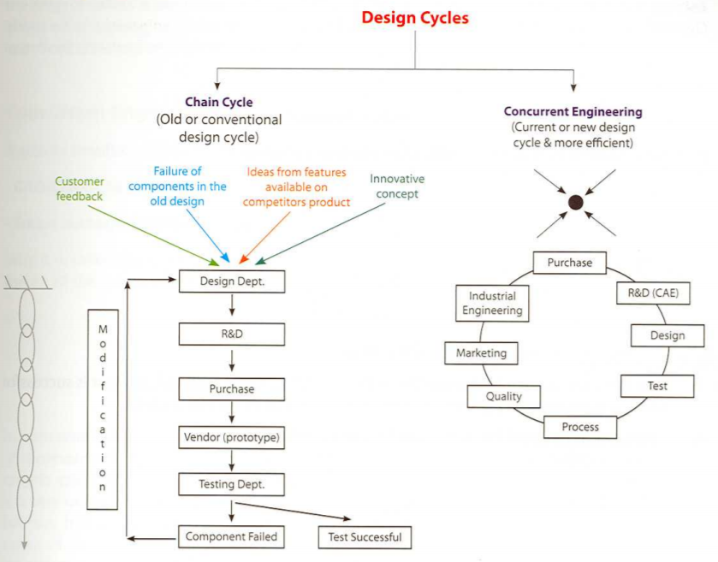
Picture 1 the design cycles of different methods (Gokhale and Deshpande, 2008, p11)

1.1.2 Function of FE analysis to reduce the number of physical testing
More importantly, with the FE analysis, the number of prototypes need to be made and physical testings through the entire design process can be reduced considerably. The main purpose of physical testing in the design process is to attain the information about the property of product, such as strength, stability, bearing capacity, or to find the places which prone to failure. And the earlier the information is gave, the more valuable it is, because changing the product early is much cheaper than it is lately. From the aspect, there should be as more tests as possible to avoid the false direction of design. But due to the limit of budget of a project, the time, number and fidelity of physical testing need to be arrange elaborately. (Thomke and Bell, 2001)
Most of aims of physical testing can be fulfilled by conducting FE analysis, which is much cheaper and convenient to do. Because of this advantage, it is comprehensible that many companies today include FE analysis as one of their important tools. And another factor that makes FE analysis prevalent is that given the availability of FE analysis, companies can do more analysis to make sure some properties of the product at the early stage of product developing. They can even do more analysis on other parallel product concepts to optimize their product.

1.1.3 The influences of FE analysis to engineers in the company
Considering the complexity of product performance in reality, which will be influenced by many factors like material, working condition etc, only engineers with lots of experience can be assigned to complete a project independently. However, with the help of FE analysis, novice engineers can gain lots of experience through analyze all kinds of products using software. It also give them the ability to complete a project confidently. And for company, this means that they do not have to hire a lot of experienced engineers, rather, a novice engineer with lots of analytical knowledge can also be a perfect alternative, which can help reduce the expenses on salary of engineers.

1.2 verifying the stress of a product

1.2.1 The function of FE analysis to predict the performance
Physical testing of a product is necessary before it can be launched. One function of FE analysis is to predict the performance of the product in the physical testing, which can give advice about the places that need to be paid attention to. With this prediction, experimenters can then know when they need to paste the sensors in addition to the places that they want to observe already.

1.2.2 The function of FE analysis compare with physical testing
The result of physical testing and FE analysis should correlate with each other within a tolerant extent if all the analysis and testing are conduced without any error. In the contrary, if there is any difference which surprise engineers, it is a signal that something is wrong, and it is necessary to find the reason behind this unexpected phenomenon. This process can help engineers to rethink their design and testing process. This may help them to get to know how to model a product better in the analysis software and to make a better assumption about the behave of the product because the reality is much more complex than they thought. During the process of finding the reason they may find the wrong operation during the testing or it is the flaw of the material that causes the failure of product.

1.2.3 The function of FE analysis in some special industries and special testing
There are some industries where it is very difficult to do the physical testing. A typical industry of this kind is bridge industry. In the bridge industry, it is difficult to do the destructive testing because of the enormous expense and the impact on normal life of ordinary people. In order to know the ultimate capacity of bridges, it is a practical idea to build a data base which contains the result of all kinds of physical testings, and then develop the relating FE analysis system to model and analysis these bridges so that other engineers can use the relative design method to design new bridges, which is comparing the new design with the previous model with can work satisfactorily in the field to know whether or not the new design can perform well. (Bechtel and Andrew etc, 2011)

1.2.4 The function of FE analysis in failure analysis
Nearly all products will have a warranty that a company promise if their product fail within the warranty they will take the responsibility for it. If the failure rate of a component in a product is much higher than others, which can only be discovered in the process of using by consumers, the FE analysis can help to model the dynamic load of this component to figure out the reason of high failure rate or to figure out that if it is caused by other reasons like misusing or working condition.

How a physical test may be correlated to an FE model.
Physical testing and FE model always need to be used appropriately during the process of developing new product or analysis of the product performances.

2.1 Physical test can provide information to FE model
To demonstrate this assertion, a case study will be discussed in the following.
Superplastic forming is a process to change the shape of steel sheet without heating the steel to very high temperature, and the efficiency of it is much high than other forms of manufacture. To design the superplastic forming dies using FE model, it is fundamental to consider how to model the forming process accurately. In the article [1], Luckey Jr, Friedman and Weinmann compared the result of experimental and the results of models with different parameters to determine the influences of these parameters.
The specially processed AA5083 aluminum sheet alloy is used in the experiment, and the constitutive model to describe the flow stress-strain rate-strain relationship was the power law equation.(Luckey Jr and Friedman, 2007) There are some questions they need to figure out.
- Before the forming process, the sheet will be heat up to 2 minutes which will cause the grain growth which may influences the constitutive behavior. Whether this grain growth will cause difference between experiment results and prediction of FE analysis?
- Is there a significant difference between using explicit FEA and implicit FEA?
- What is the best mesh size of FE model of this process?
- What is the influence of strain rate on the thickness prediction?
To find out the answers to these problem, they did 8 different FE analysis as follows:

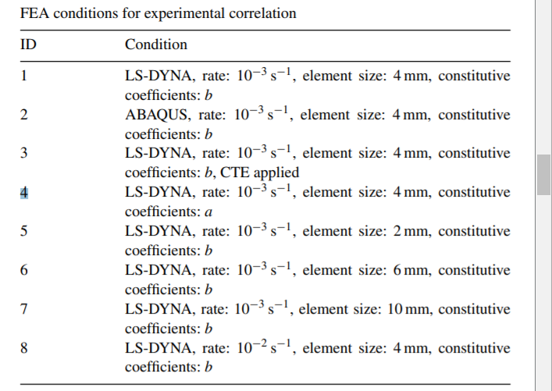
In this chart, LS-DYNA is explicit method, and ABAQUS is implicit method. The rate means the strain rate in the power law equation. FE model which uses constitutive coefficient did not consider the grain growth because of the preheat, and the others considered this factor. Through comparing results of these FE analysis and experimental result, it is more easy to see how these factors influence the result of FE model.
- Compare 1 and 4 and experimental result to see the influence of grain growth. The result showed that condition 4 gave poor prediction to the profile deformation, so grain growth should be considered in the finite element analysis.
- Compare 1 and 2 and experimental result to see the difference of explicit and implicit method. They found that result of both explicit and implicit method showed good correlation to the experimental result. And considering that explicit method require less time to get result and is more robust, they concluded that explicit method was more suited to industrial simulation.
- Compare 1, 5, 6, 7 and experimental result to see the influence of element size. It was clear that the prediction capability decrease when the element size increases. They used a correlation coefficient to find form with element size the prediction began to deviate form experimental result. Finally, they gave a recommend element size when the entry radius is a specific number.
- Compare 1 and 8 and experimental result to see the influence of stain rate. They discovered that accurate thickness profile can be predicted with a target stain rate of , which means they can apply a limited velocity scale of the process in FE analysis to improve efficiency without compromise the accuracy of the result.
Apart from giving the initial information to build FE model, physical testing also provides information to improve existing FE models. Article cited [2] provides a method to guide the parameter selection during the the updating existing FE model, i.e. minimise the differences between experimental result and FE analysis result.

2.2 FE analysis gives prediction of physical testing
There are different types testing, destructive testing, testing to get property of product, testing to mimic the possible work condition etc. And when testing a product, there are many aspects which can be measured. FE analysis can provide information about physical testing in several ways.

2.2.1 FE analysis gives a prediction about physical testings
If modeled properly, FE analysis can give a relatively high accuracy about what going to happen in the experiment. Take the physical testing of crane arm for example. This is a really big equipment, so it is nearly impossible and not necessary to measure the stress of everyplace of this arm. To work efficiently, engineers can use the finite element analysis firstly to figure out the place where the maximum stress will occur approximately according to the experimental load condition. With the prediction of FE analysis, engineers can paste more sensors on these places to monitor the stress and displacements to make sure that they get the data they need.
This process can also work conversely. If engineers want to know what the ultimate load capacity of this arm is, they can try different load in the FE model to find a possible region, and then use this information to organize the physical testing to find more accurate result of this question.
The process of using FE model to predict the result of physical testing and comparing the result of physical testing and FE analysis is a way to check the accuracy of the FE model and any mistake during the execution of physical testing. If any of the situation occurs, the result cannot match each other, which is signal to tell engineers something is wrong.

2.2.2 FE analysis as a complement of the result of physical testing
FE analysis helps engineer to understand the result of physical testing. In the fluid mechanics, there are some areas we do not know what will happen exactly. Take the physical testing of a reducing valve in hydraulic system for example. The valve is usually very small, so it is challenging for them to monitor what happens in the small cavity of the valve. Engineers can only measure the state of fluid outside and use the knowledge of fluid theory to surmise the situation in the cavity.
With the help of FE model, engineers can see what will happen in the cavity in the software and can better understand the state of fluid in this valve, which may help them make improvement to the valve.
Another information that FE model can provide is the ideal capacity of a product. The product produced inevitably have some flaws which can undermine the capacity of the product, but FE model is a ideal model, so it can tell engineers the potential capacity of a product compared with the result of physical testing. Then it is due to engineers to decide whether it is economy to improve the manufacture requirement level.

If you think that FE analysis can (or should) ever replace physical testing.
Even there are many advantages to use FE analysis in the process of developing products, physical testing can never be replaced completely. They are not rivals but friends who should work together to maximize the profit. The reasons are as follows.

3.1 To verify the FE model
Usually, the real condition of a product is very complex, so it is impossible to consider all aspects of the product and build a model which is exactly the same as it is in the reality. For example, a company need to design a crane arm, which consists several sectors and the connection between the sectors. In this case, some simplification about connections need to be made to model the crane arm. But even the simplification is made by experienced engineers, there still is a chance that it is not consistent with the real situation because of the state of friction between sectors or other reason which cannot be discovered easily. If there is not any physical testing during the process of designing a new product, chances are that they will discover some unexpected problem when they finally manufacture and test the product before launch it. It will cause a enormous economic loss to the company, because to correct these problems engineers will have to spend more time on this project and the product may miss the best time to launch. According to these analysis, it is clear that it is essential to do some physical testing to justify the accuracy of FE model in time.

3.2 Factors can not be considered in the FE model
There are some factors that the FE model will not include, for example, the flaw of material. The material used in the mechanical industry such as cast iron, steel, may not as perfect as the material applied to the FE model in the software, which can cause decrease of the capacity of the product. And considering the heterogeneity of cast iron, it is necessary to build a prototype and test it to give some guides and requirements to the following manufacturing process. Apart from these situation, there is some surface treatment to improve the quality of products in the mechanical manufacturing industry, for products with these treatments, FE model may cannot reflect their property accurately.
Another important factor that FE model misses is time. During the process of working, the products will go through running-in period, steady working period and rapid worn-out period. If engineers want to make sure the performance of the product during the whole life-span, they need to actually test it because there is no function like this in the FE analysis.
3.3 The function of physical testing to provide data to FE analysis
Sometimes, the physical testing may not necessary is the testing of the entire machine or new product, rather, it can also be the testing of some components of a whole body to provide the data and property of the component needed to build the model. For example, to make sure the model of a crane, engineers may need to do experiments to find the relationships between the friction force and different kinds of lubricate oil, so that they just need to input the data of friction force applied on the sectors rather than considering how it functions in reality. Similarly, they may do experiments about the property of materials, springs etc whose influence to the model can be describe accurately by data. This is a way to simplify the model without compromising the accuracy and quality.

3.4 The need to fulfill some laws about the product
There are some laws made by government requiring physical testings of new products to make sure that the product sold by the company is safe for consumers to use and consistent with their description.
Further more, even if there is no requirement from government, the competence between companies who produce similar products will force them to do the physical tests because the consumers will tend to choose the products which have physical testing have provides the properties of the products clearly

4 conclusion
This article discussed the reason that why companies uses FE model as a important tool, and the relation between this novel method and the traditional physical testing. Even FE analysis can realize most functions of physical testing, it cannot replace physical testing completely. In the third section, the necessity of physical testing is discussed from different aspects.

5 reference
[1] Luckey Jr, S. G., P. A. Friedman, and K. J. Weinmann. "Correlation of finite element analysis to superplastic forming experiments." Journal of Materials Processing Technology 194.1-3 (2007): 30-37.
[2] Kim, Gyeong-Ho, and Youn-Sik Park. "An improved updating parameter selection method and finite element model update using multiobjective optimisation technique." Mechanical Systems and Signal Processing 18.1 (2004): 59-78.
- Thomke, Stefan, and David E. Bell. "Sequential testing in product development." Management Science 47.2 (2001): 308-323.
- Gokhale, Nitin S. Practical finite element analysis. Finite to infinite, 2008.
- Bechtel, Andrew, Jennifer McConnell, and Michael Chajes. "Ultimate capacity destructive testing and finite-element analysis of steel I-girder bridges." Journal of Bridge Engineering 16.2 (2011): 197-206.

