May 12, 2025
Shalom Joseph
University of Wales Trinity saint david
Prepared For: Shaker Bitar
Office Building Design
Task 2
Table of Contents
1 Introduction 2
2 Design Criteria and Load Analysis 2
2.1 Design Criteria 2
2.1.1 Load Specifications 2
2.1.2 Material Properties: 2
2.2 Slab Design 3
2.2.1 Slab Thickness 3
2.2.2 Self-Weight Calculation 3
2.2.3 Total Load on Slab 3
2.2.4 Bending Moment Calculation 3
2.3 Beam Design 4
2.3.1 Load Calculation 4
2.3.2 Moment Calculation 4
2.3.3 Shear Force Calculation 4
2.3.4 Final outputs 5

Introduction
Maintaining general stability and guaranteeing sufficient load transmission throughout the structural framework depend much on the structural design of separate bays inside a building. This project emphasizes the structural analysis and design of a single 6m × 6m bay, with consideration given to the impact of neighboring bays under defined load circumstances. Strategically positioned under an 8m × 5m bay and next to another 8m x 5m bay and a 6m x 6m bay, the bay is
Analyzing the load distribution, computing bending moments and shear forces, and deciding the suitable beam size and reinforcement to handle applied loads will guide the design process. With particular attention to load combinations for serviceability and ultimate limit states, the structural analysis will follow pertinent standards including BS EN 1990, BS EN 1992, and BS EN 1993.
This focused method enables a more thorough study of structural behaviour in a specific area, hence enabling the precise evaluation of load transfer systems and supporting techniques vital for structural integrity.

Design Criteria and Load Analysis
Particularly considering the surrounding structural bays, the design of the chosen 6m x 6m bay calls for a thorough knowledge of the applied loads and load distribution systems. The load criteria, relevant design standards, and the theoretical basis for load analysis are described in this part.

Design Criteria

Load Specifications
- Dead Load: 6kN/m
- Imposed Load: 4kN/m

Material Properties:
- Concrete Grade: C30/37 (Strength of 30 MPa)
- Steel Grade: S275 (Strength of 275 MPa)

Slab Design

Slab Thickness
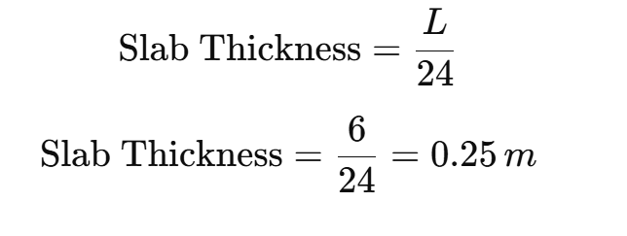
The minimum thickness as per code is taken as 0.2m, but the calculated thickness is sufficient.

Self-Weight Calculation
The self weight of the slab is calculated based on the density of concrete, which is approximately 25kN/m³ .


Total Load on Slab
The total load per square meter on the slab is the sum of the dead load, imposed load, and self-weight.

Bending Moment Calculation
For a simply supported slab, the maximum moment is calculated as:
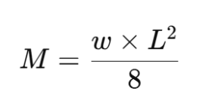
Where:
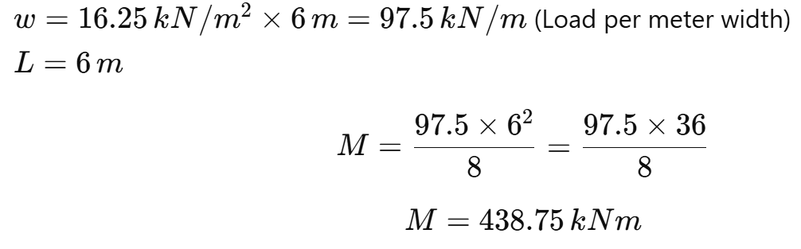

Beam Design

Load Calculation
The load on the beam is the total slab load per meter width:

Moment Calculation
The maximum bending moment for a simply supported beam under a uniformly distributed load is:
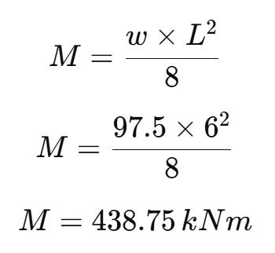

Shear Force Calculation
The maximum shear force is calculate as:
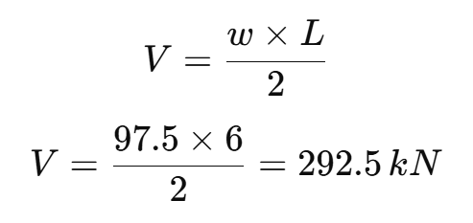

Final outputs
Slab Thickness: 0.25m
Slab Moment: 73.12kNm
Beam Moment: 438.75kNm
Beam Shear Force: 292.5kN

