DS 1

Screenshot/Photo 1
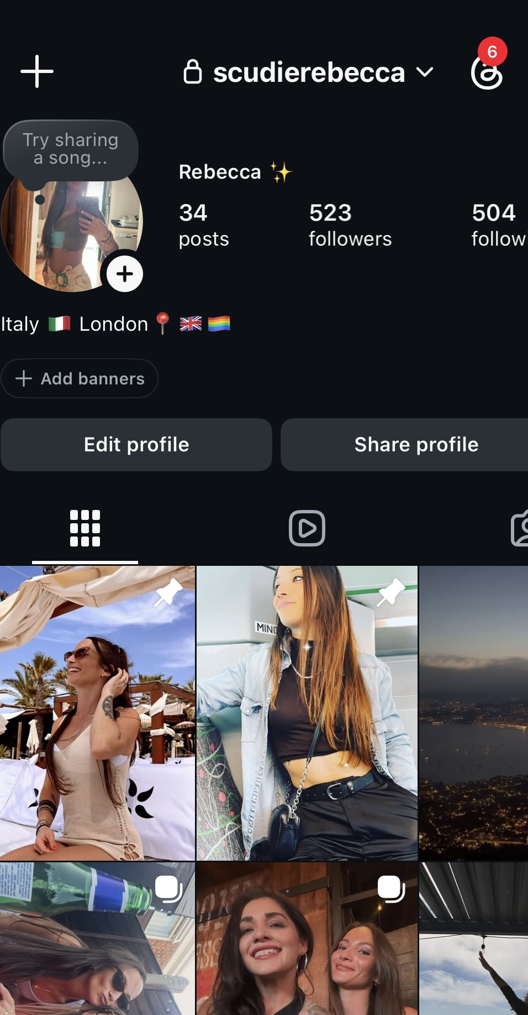
This is my Instagram profile

Screenshot/Photo 2
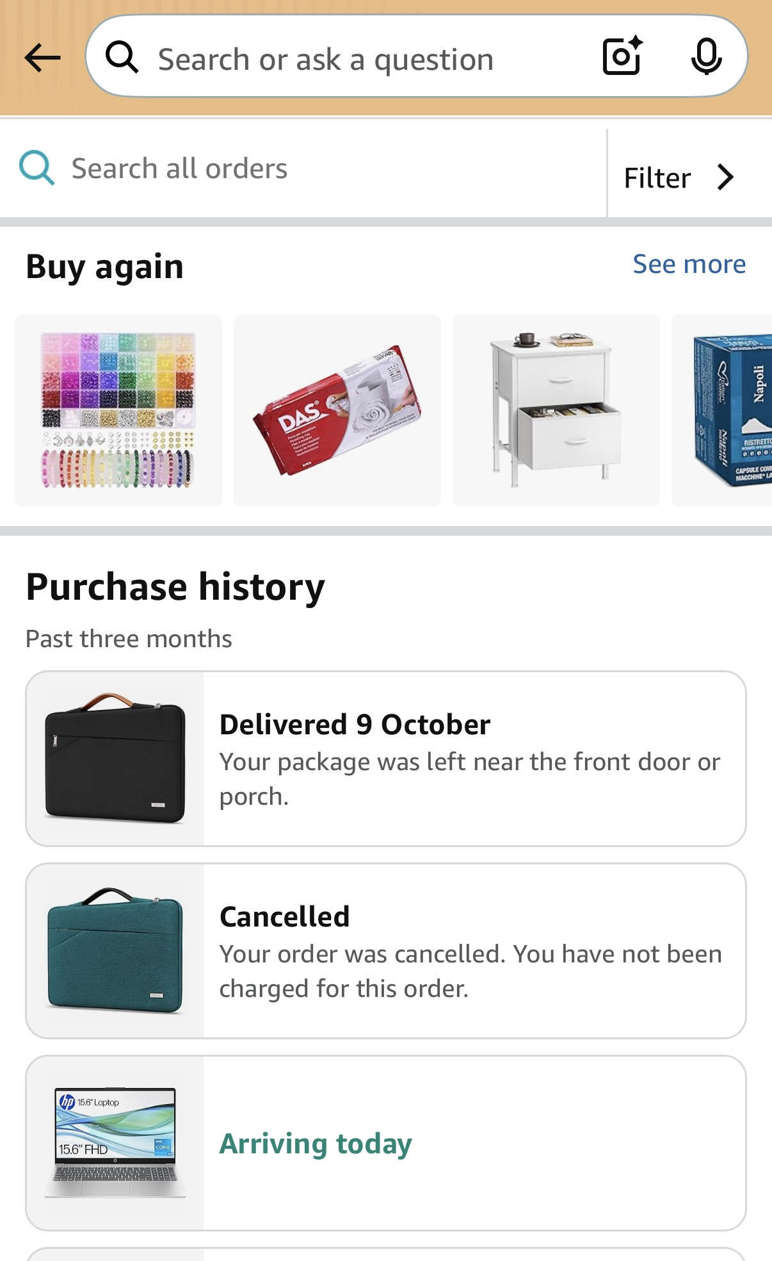
I upload orders that I made with Amazon

Screenshot/Photo 3
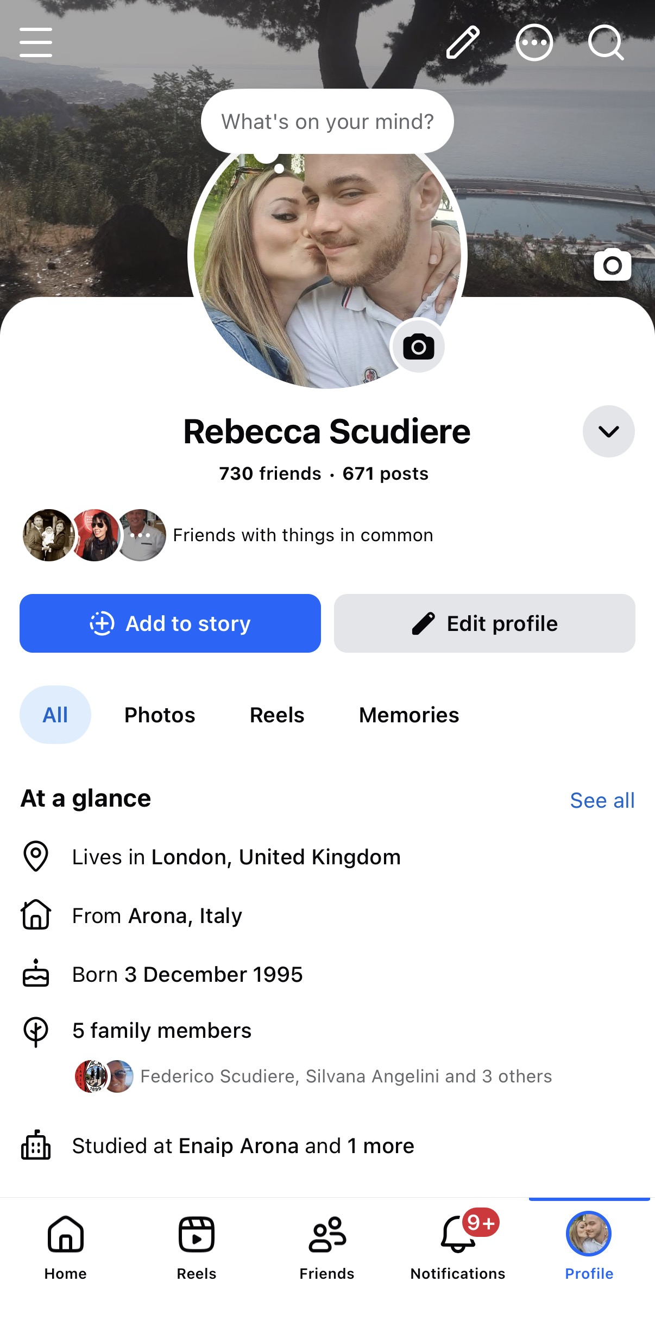
This is my Facebook profile

Screenshot/Photo 4
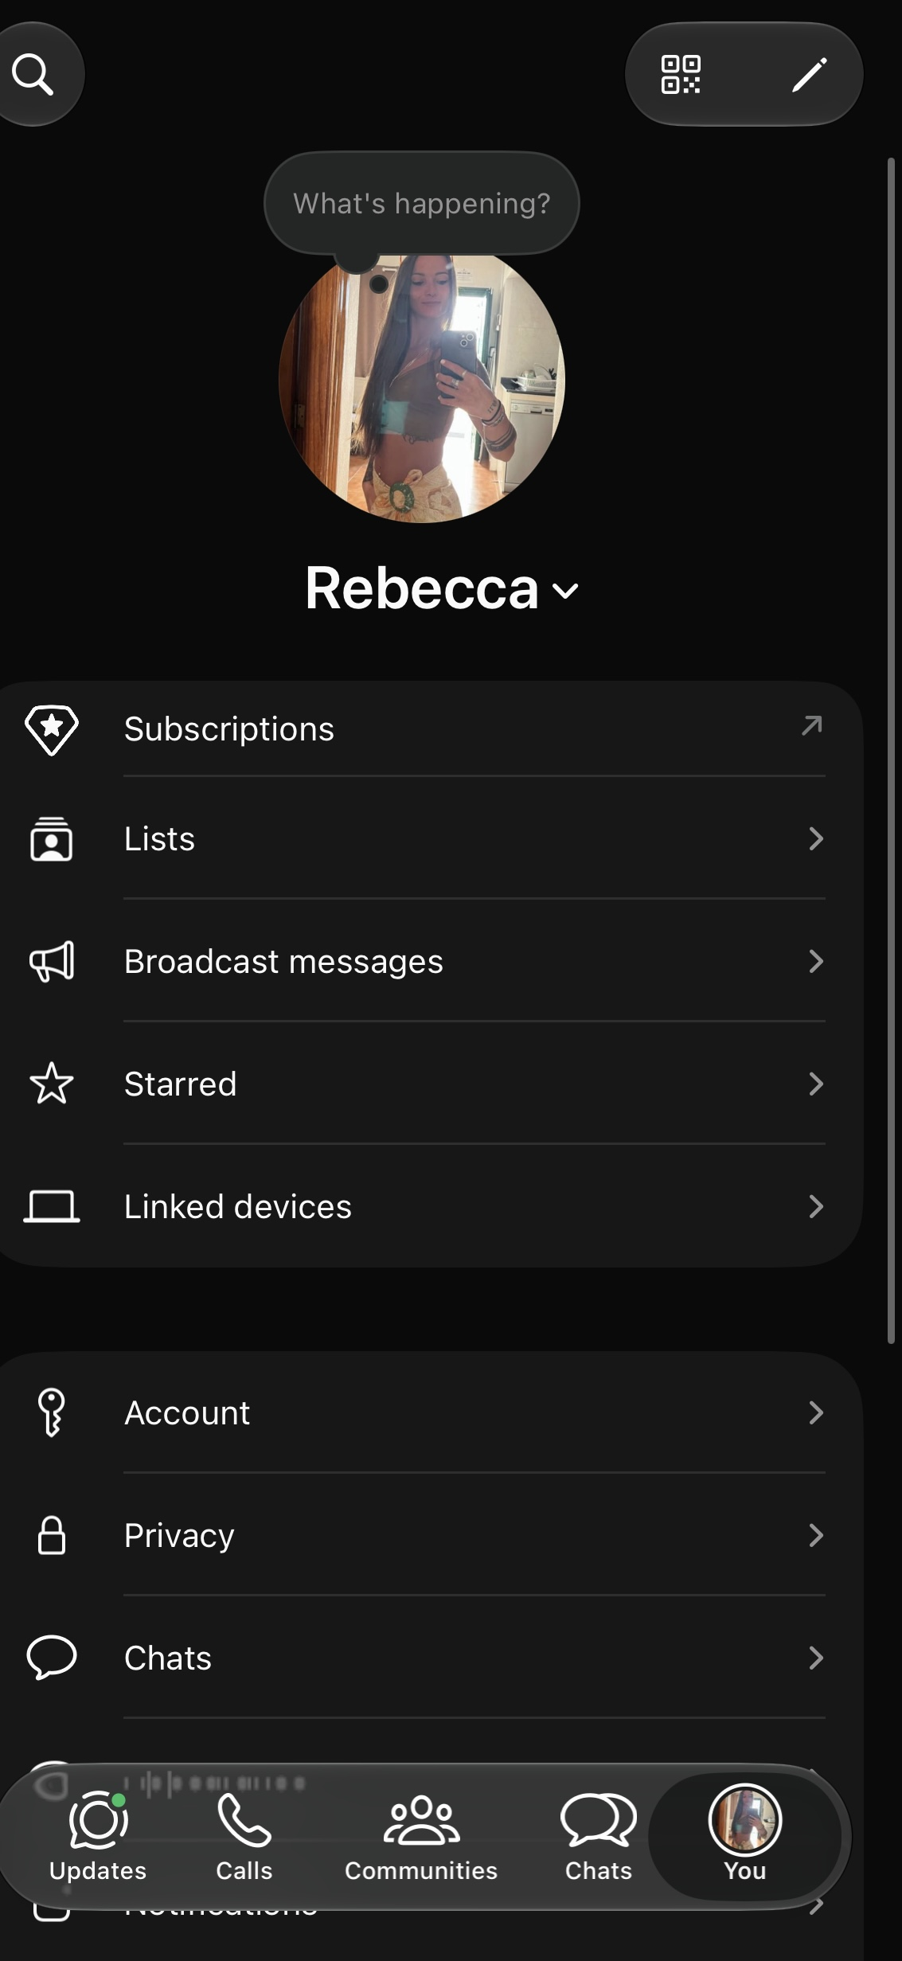
This is my WhatsApp profile

Screenshot/Photo 5
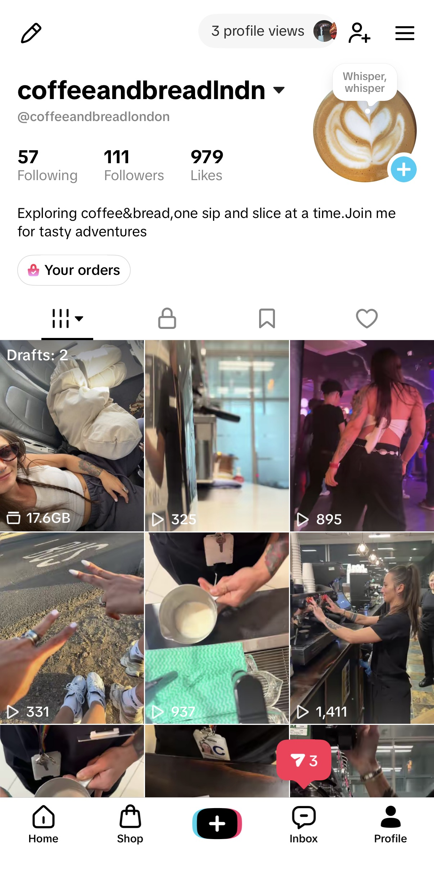
This is my TikTok profile where I upload vídeos of when I make coffee at work

My Short Reflection
- Write 5–8 simple sentences about your digital life.
- You can use the sentence starters below if helpful.
I use digital tools to comunicate with others,
I feel confident when I use this apps
I would like to learn how to navigate safely and improve my digital skills.
I use very often Instagram and Facebook to connect with friends and family
Sometimes I feel nervous online privacy
I hope this module will help me to be more confident
Digitale skills are important for me because help me to communicate and learn new things.

Submission Checklist
Before you submit, please check:
​​​ ☒ I added 4–6 screenshots
☒ I wrote short sentences for each screenshot
☒ I wrote my short reflection
☒ My work is my own
☒ My file opens correctly
​​☒ My file opens correctly

