

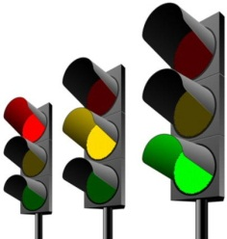
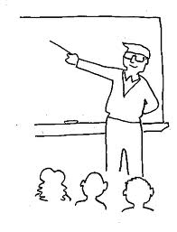


Stickability!
Engagement?
The BIG picture?
Objectives
along the way….
Teacher Led or Student Led?
Teacher Led or Student Led?
Teacher Led or Student Led?
Teacher Led or Student Led?
Learning
Episodes
….print and scribble your way to Outstanding!
The 5 minute Lesson Plan
AfL
Differentiation
Level 4
Level 5
Level 6
Level 3
Level 7

