
Managing Projects in the Organization
Student Name: Andrey Niche
Student ID: 2029595

Executive Summary:
The purpose of this project management plan is to detail Tesco's planned deployment of onsite food to alleviate congestion during lunch breaks, encourage a healthy lifestyle, and cut down on employee absences. A stakeholder analysis, work breakdown structure (WBS), cost and resource utilization, project timetable, and risk assessment are all included in the plan. We propose a holistic approach to effective project execution by adopting the Project Life Cycle model and incorporating pertinent project management theories and technologies. The strategy emphasizes efficient methods of communication and coordinates the project with Tesco's commercial goals. Putting this strategy into action will increase job happiness, output, and the company's bottom line.

Table of Contents

Executive Summary: 2
Introduction 4
Project Outline and Scope: 4
Project Methodology: 5
Project Execution 6
Stakeholder Analysis: 6
Work Breakdown Structure (WBS): 7
Resource Utilization and Costs: 10
Project Schedule and Gantt Chart: 11
Risk Assessment and Mitigation: 12
Communication Strategies: 14
Conclusion 15
Reference 16

Introduction
The purpose of report is to provide Tesco with a comprehensive project management approach for the introduction of on-site meals. The initiative's declared purpose is to reduce employee absenteeism by promoting a healthier lifestyle among workers and decreasing congestion during lunch hours. We explain the context of the proposed effort and highlight why it is important for Tesco's business and employees. It introduces the purpose of the study, which is to examine and recommend a practical approach to project management by relying on appropriate academic models, techniques, and theories. As a result of aligning project goals with the firm's broader business objectives, the corporation hopes to benefit its employees and the community at large.

Project Outline and Scope:
The goal of the initiative is to set up on-site catering services at Tesco so that the company's 1,000 workers may have access to healthy and easily accessible food. Two of the most important goals are encouraging workers to lead healthier lives and cutting down on unnecessary travel during lunch breaks, which causes traffic problems in the region. fortunately hope that providing food for lunch would improve morale, efficiency, and health for all staff members (Lock, 2020).
The project's scope includes the following essential elements:
- Construction and Facility Planning: In this stage, the space will be transformed into a state-of-the-art catering facility via careful design and construction. Building amenities will be designed to meet the varying needs of workers about their diets.
- Menu Development and Supplier Management: Expert chefs will help us plan a meal that includes a variety of healthy options. To further guarantee the availability of fresh, high-quality ingredients, the developers will forge solid ties with our suppliers.
- Staff Training: Catering employees will get intensive instruction in the areas of food preparation, sanitation, and customer service to provide the highest quality service possible (Lock, 2020).
- Regulatory Compliance: All catering facility licenses and permissions are secured and all food safety laws are followed.
- Communication and Stakeholder Engagement: An efficient communication strategy will guarantee participation from all relevant parties, including staff, management, the neighborhood, and vendors.
Key performance indicators (KPIs) including employee retention, satisfaction surveys, and absence rates will be used to gauge the project's success (Marchewka, 2016). These key performance indicators will be used to gauge the project's overall success and the extent to which it has benefited the company.
The strategy for managing the project is to make sure it fits in with Tesco's larger business goals, creating a more pleasant place to work and reiterating the company's commitment to CSR. This initiative is to have a long-lasting, beneficial impact on Tesco and its cherished workers via careful planning, coordination, and implementation.

Project Methodology:
In order to ensure a successful rollout of Tesco's onsite food service, a well-defined project methodology will be adopted. The chosen method conforms to the generally accepted Project Life Cycle framework. Initiation, Planning, Execution, and Closure are the four primary stages that make up the Project Life Cycle model.
- Project Initiation: The potential for success of the project is evaluated at this stage. The project's goals, parameters, participants, and threats will all be laid out in detail in the project charter. The project team will be formed, and a manager will be selected to oversee the endeavor (Fewings and Henjewele, 2019).
- Project Planning: During this phase, a thorough project management plan is developed, which includes a Work Breakdown Structure (WBS), resource allocation, cost estimates, and a timetable for the project. To maintain participation and enthusiasm for the project's duration, the stakeholder analysis will direct future communication efforts.
- Project Execution: Project tasks and activities will be carried out by the project plan and timeline. There will be planning, building, and provisioning of the catering facility. To guarantee a smooth operational setup, we will educate our staff and oversee our vendors.
- Project Closure: This is the last step before the project is officially turned over to the company. The project's success will be evaluated after completion using established standards. Any unfinished business will be wrapped up, and any relevant lessons learned will be recorded.
Project success is ensured, decisions are made quickly, and development can be tracked with ease thanks to the Project Life Cycle model. Tesco's on-site catering project can be more effectively managed using this approach, leading to the achievement of the expected results while minimizing negative impacts from any obstacles (Fewings and Henjewele, 2019). Additionally, the structure it establishes for ongoing improvement is conducive to the development and prosperity of the organization as a whole.

Project Execution
Tesco's onsite catering effort is being implemented in stages, with careful consideration given to each stage in order to ensure that all actions are in line with the project's objectives (Lock, 2020). In the Project Initiation phase, the project team, lead by the designated project manager, will define the project's scope, outline its goals, and identify its possible results (Fewings, 2019). During this stage, a thorough project management plan is developed, which includes the WBS, resource allocation, cost estimates, and a timeframe.
The Facility Design and Construction phase include the actualization of plans for providing for various dietary requirements and fostering wellness. Phase two, "Menu Development and Supplier Management," include working with chefs to develop a nutritious meal and forming relationships with food purveyors (Laufer, 2017). In the Staff Training stage, workers are given the tools they need to prepare and serve food safely, cleanly, and with a focus on the customer. In order to ensure a smooth launch, operational setup includes extensive testing and the creation of SOPs (Pries, 2020). The Project Closure stage is when the project is officially finished and handed over to the firm after a thorough review has been conducted.
This fast-paced phase of implementation shows how seriously the project team took Tesco's goal of creating a safer, more productive workplace (Marchewka, 2016). The team's goal is to realize Tesco's vision of a healthier, more efficient workplace that reflects the company's commitment to corporate social responsibility by deftly navigating each step and interacting with stakeholders.

Stakeholder Analysis:
Tesco's onsite catering initiative will not go off without a hitch if the team behind it doesn't have a firm grasp on who would be affected by it. Those who have a positive or negative interest in the outcome of a project are considered stakeholders. Ability to foresee and satisfy their needs and expectations is critical to gaining and maintaining their participation and support throughout the project's length.
- Employees: Employees' happiness and well-being are vital since they will be the project's key end users. Their suggestions for new dishes to try and criticisms of the catering staff will help the business thrive.
- Management: Management at Tesco is crucial since they approve project funding and provide direction. Their buy-in and participation are crucial to the completion of the project.
- Local Community: The initiative will have far-reaching effects on the neighborhood, notably in terms of improved traffic flow. To keep the peace, it's important to win over the locals and solve their issues (Larson and Gray, 2018).
- Suppliers: To guarantee the catering facility has access to fresh, high-quality foods, solid relationships with those who provide such goods must be established.
- Regulatory Authorities: For the project to be legal and run smoothly, it is crucial to adhere to food safety rules and secure the appropriate permissions.
- Project Team: The project team is responsible for planning, executing, and coordinating the project. To paraphrase what Larson and Grey (2018) have said, "their expertise and commitment will be the project's bedrock."
- Customers: Tesco offers onsite catering for its non-store customers, which might increase the value of their stay.
Stakeholders will be actively involved via the implementation of specialized methods of communication. Maintaining good ties with those who matter requires providing updates, holding feedback sessions, and responding quickly to concerns. Moreover, knowing what's most important to them can assist set realistic expectations for the project and guarantee that their demands are addressed (Larson and Gray, 2018). Throughout the project, the stakeholder analysis will be used as a reference to aid in decision-making and foster cooperation towards the achievement of set goals and the overall success of the organization.

Work Breakdown Structure (WBS):
Using the WBS, the onsite catering project at Tesco may be broken down into more manageable tasks and subtasks. At every stage of a project's life cycle, the WBS will guarantee efficient preparation, allocation of resources, and monitoring of outcomes.
Work Breakdown Structure (WBS):
Phase | Task | Description
Project Initiation | Project goals and scope must be defined. | Define the scope and objectives of the work to be done.
 | Develop a Business Plan and Feasibility Analysis | Think about how much money ones might make back from this venture.
 | Establish a Strategy for Communicating with Stakeholders | Determine who needs to hear what and devise a strategy for doing so (Laufer and Tucker, 2017).
 | Create Project Team and Hire Project Manager | Determine who will lead the project, and form a team to execute the plan.
Project Planning | Participant Input and Requirements Analysis | Involve the relevant parties to ascertain their needs.
 | Create a Plan for Managing the Project (Laufer and Tucker, 2017) | Make a comprehensive schedule that includes all of the project's activities, milestones, and deliverables.
 | Construct a Means of Interaction and Communication Plan | Organize means of interaction and dissemination of information.
 | Carry out a Risk Analysis and Contingency Planning | Find the threats that might happen, then figure out how to stop them.
 | Create a Budget and Resource Allocation Strategy | Determine how much money and time will be needed to complete a project (Cobb, 2023).
Facility Design and Construction | Plan the Construction of the Food Service Area | Work together with the planners and designers to come up with the best arrangement.
 | Get the Building Furnished and Outfitted | Find the necessary household furnishings and cooking equipment.
 | Manage Building and Remodeling Projects | Keep an eye on the development of the new kitchen.
Menu Development and Supplier Management | Consult Professional Chefs When Creating Dishes | Collaborate with chefs to create a cuisine that is both varied and healthy.
 | Locate Potential Food Vendors and Form Alliances with Them | Find trustworthy sources to get the food and cooking materials from.
 | Find and buy the necessary items for the catering menu. | Get the catering establishment some good stuff (Cobb, 2023).
Staff Training | Build Out Catering Staff Training Materials | Develop in-depth catering staff training programs.
 | Provide Extensive Instruction on Proper Food Preparation, Hygiene, and Service to Employees | Educate the workers on the fundamentals of cooking, cleanliness, and service.
Regulatory Compliance | Maintain Conformity with Food Safety Standards | Comply with all applicable rules and regulations about food safety.
 | Acquire All Necessary Approvals and Licenses for the Catering Establishment | Acquire the necessary licenses, registrations, and permissions for the catering establishment.
Operational Setup | Put the catering services through their paces. | Perform test runs to verify the catering establishment works efficiently.
 | Establish Facility-Wide Standard Operating Procedures (Cobb, 2023) | Developing standard operating procedures (SOPs) is crucial to running a smooth facility and providing quality service.
Project Closure | Project Completion and Turnover to Tesco in Writing | Turn over the project to Tesco once it's finished.
 | Review the project's outcomes and conclude. | Learn from past mistakes by doing a thorough project evaluation.
A useful technique for planning and managing large projects, the Work Breakdown Structure (WBS) breaks down the overall project into smaller, more manageable tasks. Each task will be assigned to a particular team member, and that person's progress will be monitored on a regular basis while the project is carried out (Laufer and Tucker, 2017). The WBS has proven to be a useful tool in the project team's efforts to bring Tesco's onsite catering project to reality.

Resource Utilization and Costs:
Careful assessment of available resources and projected expenses is crucial to the successful rollout of the onsite catering operation at Tesco. The cost of the most important resources is broken down in the table below.
Resource | Description | Estimated Cost
Personnel | Catering Staff (Chefs, Cooks, Servers) | £120,000 per annum
 | Project Manager | £70,000 per annum
 | Project Team (Administrative support, etc.) | £50,000 per annum
 | Training and Development | £10,000
Facilities | Facility Design and Renovation | £300,000
 | Equipment (Kitchen appliances, furniture) | £200,000
 | Catering Facility Maintenance | £15,000 per annum
Suppliers | Food and Beverage Ingredients | £150,000 per annum
 | Vendor Contracts and Supplier Management | £10,000
Marketing and Promotion | Advertising and Promotional Activities | £30,000
Regulatory Compliance | Food Safety Certification and Permits | £5,000
Miscellaneous | Contingency Fund | £50,000
 | Communication and Printing | £15,000
Total Estimated Cost |  | £1,025,000
Scheduling employees' shifts wisely, cutting down on waste, and keeping track of inventories are all ways to maximize resource utilization. Employee output may also be boosted by providing feedback on their performance and providing ongoing training opportunities. Supply chain interruptions will be minimized by vigilant vendor relationship management that guarantees competitive pricing and on-time delivery (Cobb, 2023). If any problems arise during the project, the contingency money may be used to fix them without increasing the overall cost.
With careful budgeting and planning, we want to build a sustainable on-site cafeteria at Tesco that contributes to the company's success while also improving workers' quality of life.

Project Schedule and Gantt Chart:
The project schedule details when various stages and tasks of the on-site catering project at Tesco will be completed. To effectively manage projects and keep tabs on their progress, managers might consult Gantt charts, which graphically display the project's timeline and the interdependencies between tasks.
Project Schedule:
Phase | Start Date | End Date
Project Initiation | 01/08/2023 | 15/08/2023
Project Planning | 16/08/2023 | 30/08/2023
Facility Design and Construction | 01/09/2023 | 30/11/2023
Menu Development and Supplier Management | 01/12/2023 | 31/12/2023
Staff Training | 01/01/2024 | 15/01/2024
Regulatory Compliance | 16/01/2024 | 31/01/2024
Operational Setup | 01/02/2024 | 15/02/2024
Project Closure | 16/02/2024 | 28/02/2024

Gantt Chart:
Task | Aug | Sep | Oct | Nov | Dec | Jan | Feb
Project Initiation | ✓
Project Planning |  | ✓
Facility Design & Const. |  |  | ✓ | ✓ | ✓
Menu Development & Sups. |  |  |  |  | ✓ | ✓
Staff Training |  |  |  |  |  | ✓
Regulatory Compliance |  |  |  |  |  |  | ✓
Operational Setup |  |  |  |  |  |  | ✓
Project Closure |  |  |  |  |  |  | ✓
Fortunately, plan for the onsite catering project to go off without a hitch by strictly sticking to the schedule and skillfully managing job dependencies (Cobb, 2023). Maintaining close tabs on the project and keeping the team in the loop will allow for timely course corrections that will boost productivity and ensure the project's ultimate success.

Risk Assessment and Mitigation:
To ensure that Tesco's onsite catering project is carried out without a hitch, the risks associated with its execution must be carefully examined. Below is a table detailing the hazards we've found, along with their possible consequences and our proposed solutions.
Risk | Potential Impact | Mitigation Strategy
Financial Risks | Out-of-control spending and economic uncertainty (Nardone, 2019) | Consistently reviewing the budget, implementing methods to reduce expenses, and setting aside money for unforeseen events.
Operational Risks | Construction delays, interruptions in the supply chain, etc. | Consistent project tracking, expert management, and anticipatory issue solutions.
Stakeholder Risks | Problems with workers, suppliers, and residents | Involvement of Stakeholders, Transparency in Communication, and Rapid Response to Issues (Nardone, 2019).
Health and Safety Risks | Violations of food safety, medical emergencies | Regular health inspections, stringent quality controls, and a focus on compliance with food safety requirements.
Reputation Risks | Problems with public perception and negative press | Superior product quality, responsiveness to client input, and innovative promotion (Pries and Quigley, 2020).
Resource Risks | Inadequate allocation of resources (Pries and Quigley, 2020) | Strategic allocation of means; Clearly defined roles; Constant oversight.
Timeline Risks | Phase-delay problems | Schedule tasks with care, manage task dependencies and keep an eye on any dangers.
The project team's goal is to lessen the occurrence and severity of possible difficulties, and they plan to do so by implementing the identified risk mitigation techniques. A successful rollout of Tesco's onsite catering project relies on regular risk assessments and constant monitoring throughout the project's life cycle (Pries and Quigley, 2020). The resilience of the project will increase thanks to the mitigation techniques, which will have a beneficial effect on the happiness and contentment of the employees, help the company achieve its goals, and ensure the project is completed successfully.

Communication Strategies:
The Tesco onsite catering initiative relies heavily on open lines of communication between all involved parties. The following methods of sharing information will be used throughout the project to keep everyone informed, involved, and on the same page:
- Stakeholder Engagement Plan: Each stakeholder group's informational requirements and anticipated responses will be specified in a detailed stakeholder engagement strategy. Stakeholders will be kept abreast of the project's development via regular feedback sessions and status reports.
- Internal Communication: The project's goals, timetable, and advantages will be communicated to staff regularly via internal channels of communication. Employees will be encouraged to provide feedback to resolve any issues and get buy-in and support (Margea and Margea, 2016).
- External Communication: To resolve any complaints that may arise and to maintain strong relationships with the local community, suppliers, and regulatory agencies, channels of communication will be developed (Margea and Margea, 2016). To maintain open communication, progress reports on the project's effect on the neighborhood will be posted regularly.
- Project Team Communication: To facilitate effective communication and teamwork between project team members, a standardized methodology for doing so will be devised. Teamwork may be improved by holding regular meetings to discuss progress and share ideas.
- Marketing and Promotion: A plan will be devised to advertise the on-site dining options to both staff and visitors. Marketing efforts like ads, flyers, and social media profiles are all part of this.
- Crisis Communication Plan: In the event of a crisis, the appropriate channels will be activated immediately. Having well-defined channels of communication in place during times of crisis can facilitate prompt action and resolution (Margea and Margea, 2016).
- Performance Reporting: To monitor the project's development regarding established metrics and key performance indicators, regular performance reports will be prepared. Stakeholders will be provided with these reports to ensure accountability and transparency.
The team's goal in using various methods of communication is to keep everyone apprised of developments, invested in the project, and enthusiastic about it as it progresses. Aligning with Tesco's corporate goals and improving staff happiness and well-being, the onsite catering project will be a success thanks to effective communication which will promote cooperation, reduce possible concerns, and guarantee the smooth execution of the project.

Conclusion
Tesco's proposed project management strategy for the introduction of onsite food takes a systematic approach to resolving these issues, including reducing traffic and encouraging employees to adopt better lifestyles. Project management theories and the Project Life Cycle model are included into the plan to provide a clear basis for carrying it out. The project's objective is to improve the organization and its surrounding community by thoughtful consideration of stakeholder demands, smart allocation of resources, thorough risk assessment, and transparent and succinct communication. If successful, this project will strengthen Tesco's image as a decent corporate citizen, as well as raise employee morale and productivity.
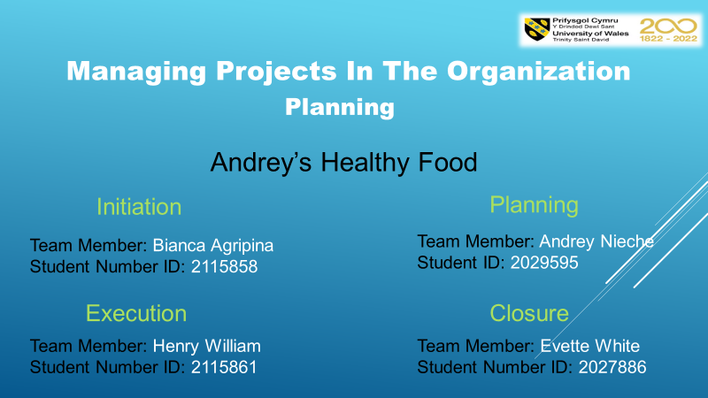
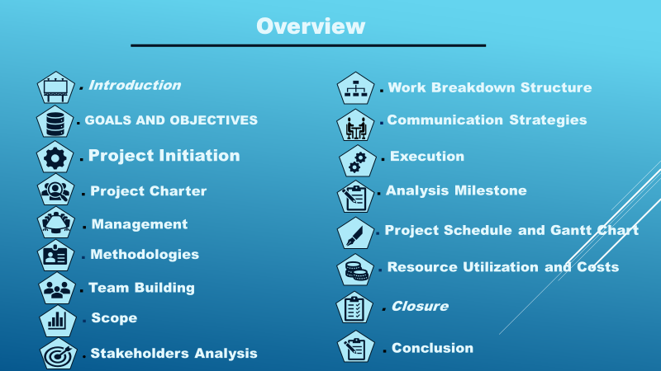
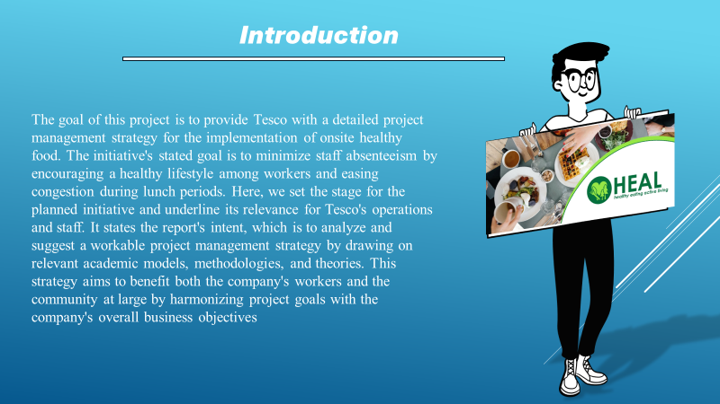
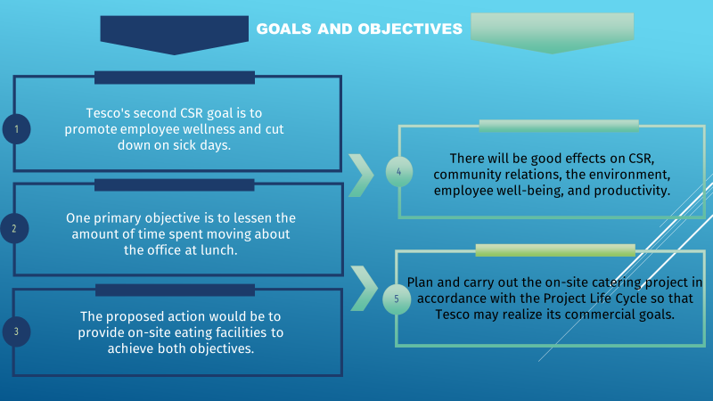
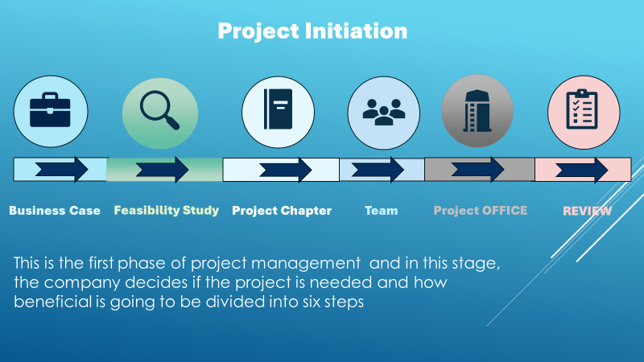
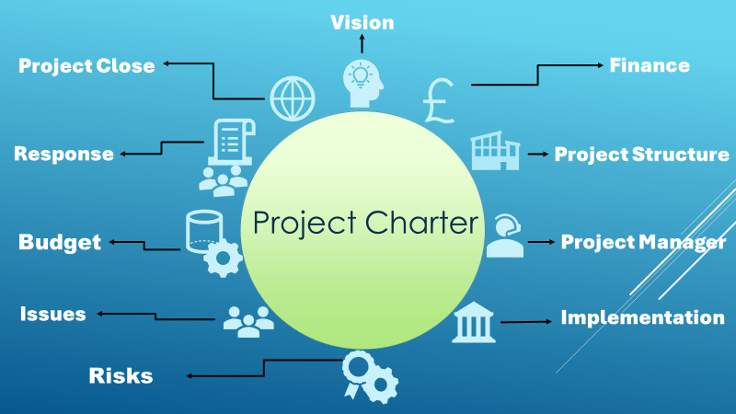
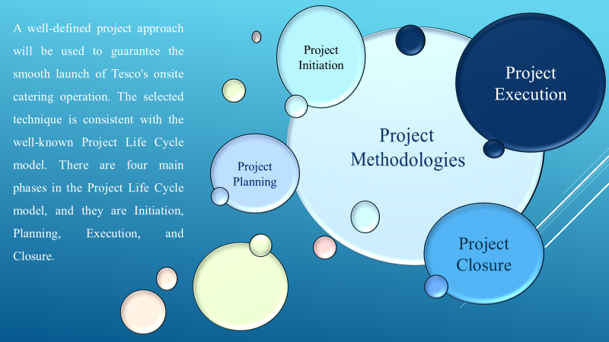
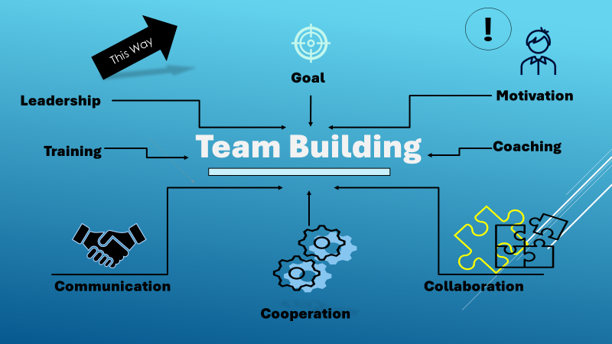
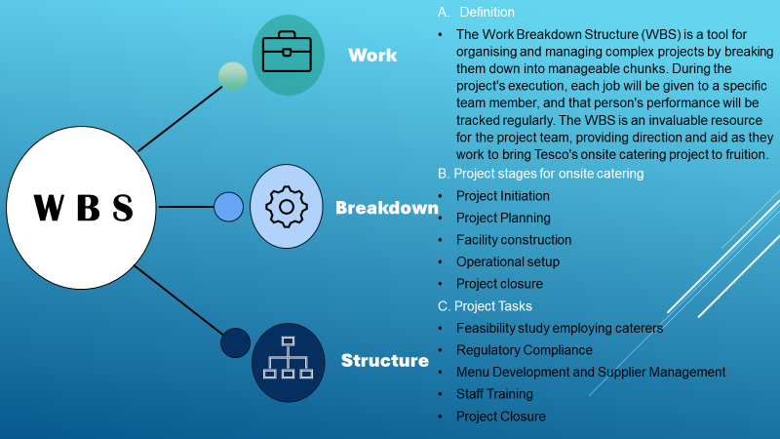

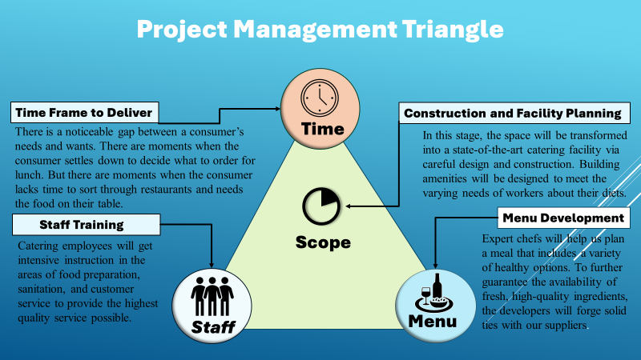
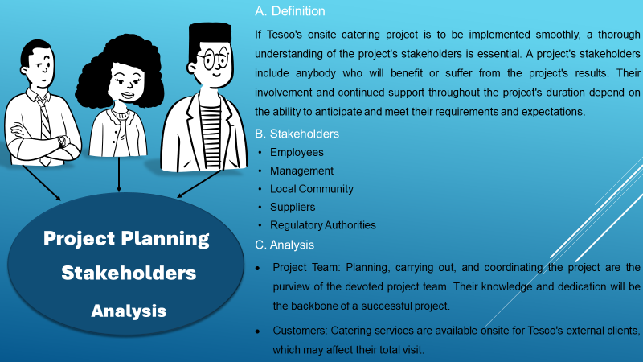
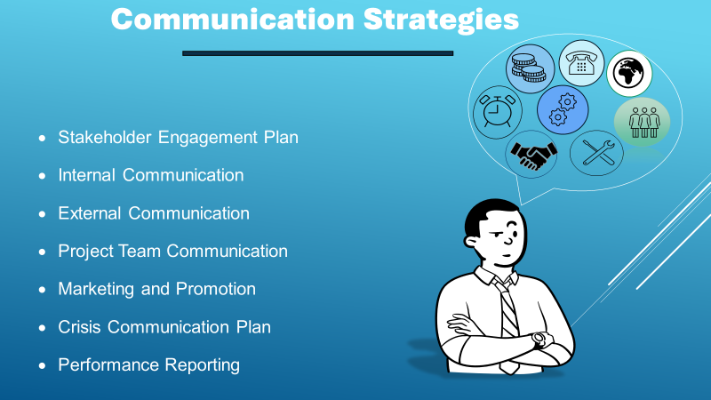
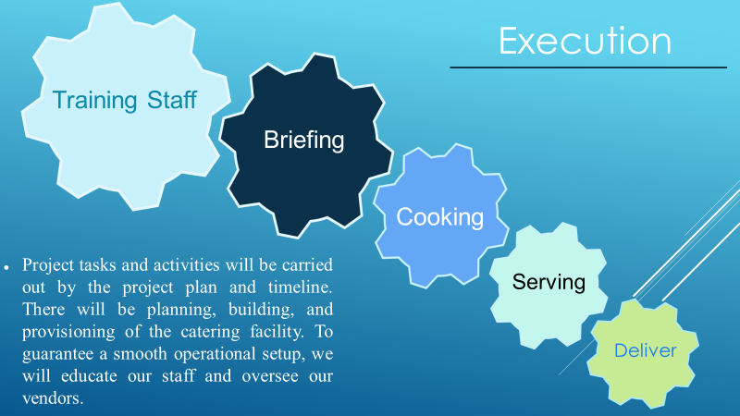
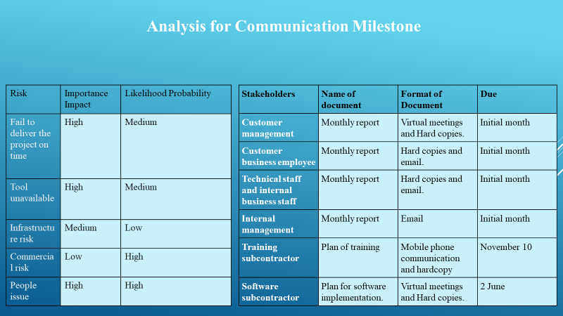
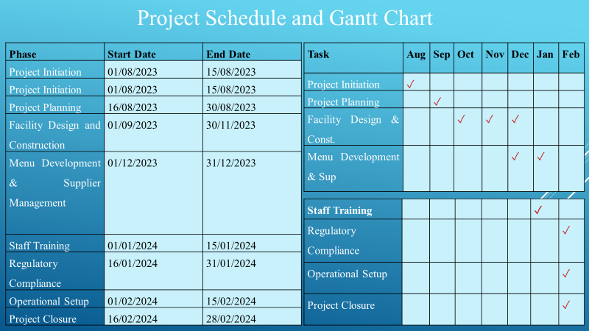
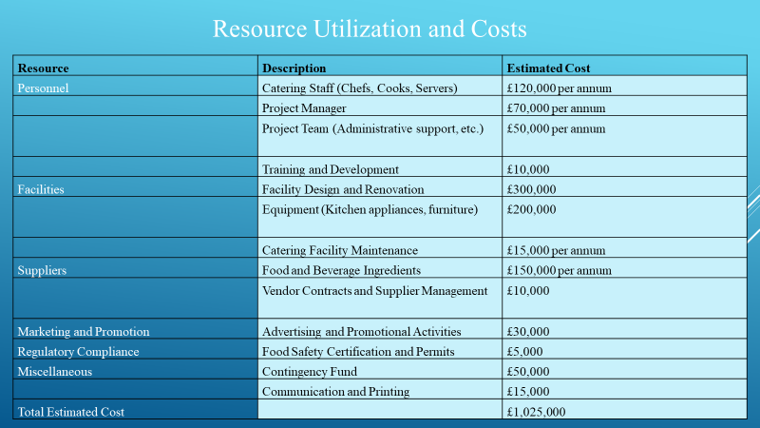
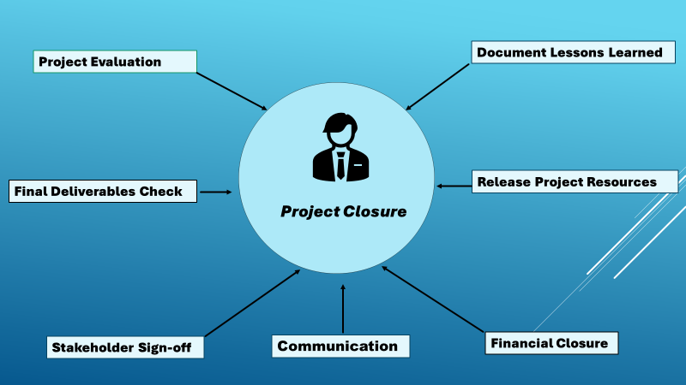
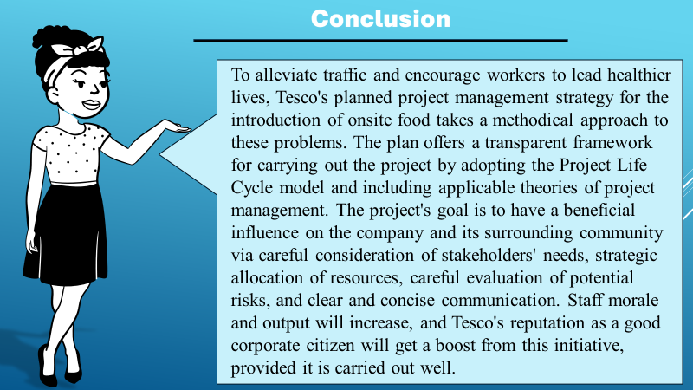
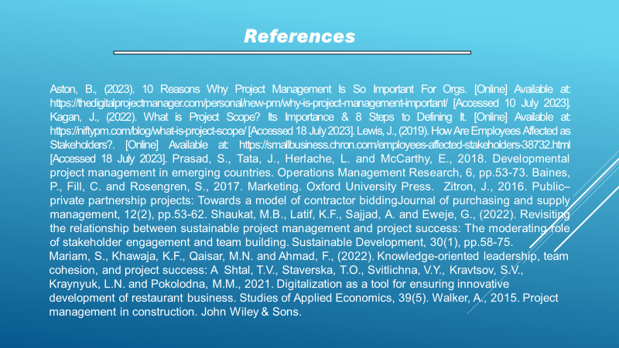
Marchewka, J.T., 2016. Information technology project management: Providing measurable organizational value. John Wiley & Sons.
Lock, D., 2020. Project management. Routledge.
Fewings, P. and Henjewele, C., 2019. Construction project management: an integrated approach. Routledge.
Larson, E. and Gray, C., 2018. Project Management: The Managerial Process 6e. McGraw Hill.
Laufer, A. and Tucker, R.L., 2017. Is construction project planning really doing its job? A critical examination of focus, role and process. Construction management and economics, 5(3), pp.243-266.
Cobb, C.G., 2023. The project manager's guide to mastering Agile: Principles and practices for an adaptive approach. John Wiley & Sons.
Nardone, P.J., 2019. Well testing project management: onshore and offshore operations. Gulf Professional Publishing.
Pries, K.H. and Quigley, J.M., 2020. Scrum project management. CRC press.
Margea, R. and Margea, C., 2016. Open source approach to project management tools. Informatics Economică, 15(1), pp.196-206.

